
Digital Skills Bmbs4003
Robert Eley 2543406

26 May 2026
BrightWave Cafe

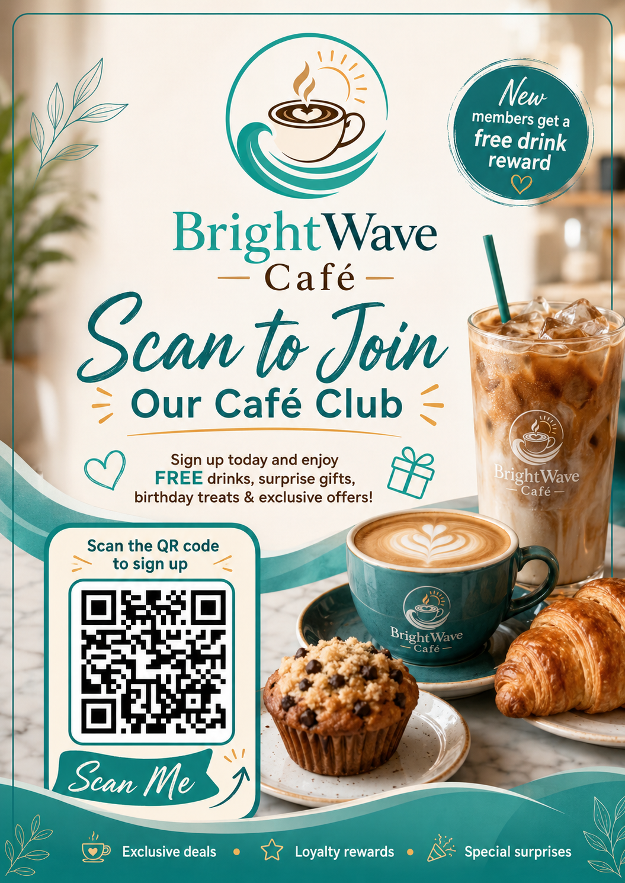

Digital Opportunities for Customer Engagement at BrightWave Café
Prepared for: BrightWave Café Owner
Prepared by: Robert Eley
Course: Digital Skills BMBs4003
Date: 26 May 2026

Section 1: Professional Report

Introduction
BrightWave Café does not need complicated technology to improve customer engagement. The best starting point is to use simple digital tools that save staff time, make customers feel remembered, and help the café stay visible outside opening hours. For a small café, the aim should not be to replace personal service. It should be to support it with better communication, quicker replies, and more reasons for customers to come back.
Interactive Digital Experiences
A practical first step would be adding QR codes to tables, receipts, takeaway cups, and the front counter. These could link customers to a digital menu, daily specials, allergen information, and a Google review page. This is low cost and easy to update compared with constantly printing new menus. Google explains that reviews can help businesses stand out on Search and Maps, so making the review process quicker could support local visibility (Google, 2026).
The QR code should not just be a basic menu link. BrightWave could make it more engaging by adding a “drink of the week”, staff recommendations, or short videos showing how certain coffees or cakes are made. This gives the café personality.

Smart Loyalty and Rewards
Instead of traditional paper loyalty cards, the café could use a digital rewards system linked to customer email addresses or phone numbers. AI tools could track customer habits and automatically send personalised rewards, such as discounts on favourite drinks, a free drink after so many visits or birthday offers.
Another creative idea is a “surprise reward generator” where customers scan a QR code after purchase to receive random prizes, discounts, or free drinks. This adds excitement and encourages repeat visits.
Systems like this are used with larger companies like Lidle and Tesco, but a more personalised reward system can be tailored to your customers.

AI Assisted Customer Communication
BrightWave Café could use AI tools to help create social media posts, email newsletters, and automated replies. AI can quickly generate captions, promotional ideas, and customer responses, saving staff time while keeping communication regular.
Automated messaging could answer common questions about opening hours, allergens, or table availability. However, staff should still review responses to maintain accuracy and a friendly tone.

Digital Feedback and Trend Analysis
BrightWave could use short QR-code surveys to ask customers what they liked, what could be improved, and what products they want next. AI tools could help summarise this feedback and identify patterns, such as popular items, slow service periods, or repeated complaints. Microsoft notes that AI can help small businesses with customer service, productivity, data analysis, and decision-making (Microsoft, 2025). This could help BrightWave make better decisions without a large budget.

Conclusion
Overall, BrightWave Café could benefit most from simple tools that improve communication and bring customers back more often. QR codes, Google reviews, email offers, digital loyalty, social media content, automated replies, and feedback tracking are realistic starting points. The key is to use technology in a way that supports the café’s personal service rather than making it feel less human.
AI Use Statement:
I used AI to create an initial structure and suggest digital ideas. I then edited the report myself to make the ideas more practical, realistic, and suitable for a small local café.

Section 2: Ethical and Professional Reflection
I checked the AI-generated content by reading through each idea and asking whether it would work in a small café with limited time, staff, and budget. Some ideas sounded good at first but were too advanced or too expensive, so I changed them into simpler options such as QR codes, Google reviews, digital loyalty, email offers, and basic automated replies.
One limitation I noticed is that AI can give quite general answers unless the prompt is specific. It can also make SME’s sound like large companies, which is not always realistic. There is also a risk of bias because AI usually repeats popular digital marketing advice instead of thinking about the individual business and how that businesses can adapt and implement these tools.
Responsible AI use means using it as a tool and not as a replacement for people. A small business should check facts, protect customer data, be honest, and make sure automated messages are accurate. Human judgement is still important because customers want communication that feels genuine, local, and trustworthy. AI can be very useful but people like genuine human connection.

References
Google (2026) Google Business Profile Help: Tips to get more reviews. Available at: https://support.google.com/business/answer/3474122?hl=en-GB (Accessed: 26 May 2026).
Mailchimp (2026) Email Marketing: Everything you need to know. Available at: https://mailchimp.com/marketing-glossary/email-marketing/ (Accessed: 26 May 2026).
Meta (2026) Meta for Business. Available at: https://business.meta.com/ (Accessed: 26 May 2026).
Microsoft (2025) AI for Small Business: A Beginner’s Guide. Available at: https://www.microsoft.com/en-us/microsoft-365/business-insights-ideas/resources/how-ai-help-small-business (Accessed: 26 May 2026).
OpenAI (2025) Usage policies. Available at: https://openai.com/policies/usage-policies/ (Accessed: 26 May 2026).

