University of Wales Trinity Saint David
School of Engineering

Engineering Design Project
Engineering Design M4X01160

Joshua Watson
1900149
10/03/2020

Contents
1 Introduction 1
2 Personal area of concentration 2
2.1 Overall Analysis 2
2.2 Time Management and Team Organisation 2
3 Positives Analysis 3
4 Negatives Analysis 4
5 What lessons have been learned which could benefit in future individual/group design challenges 5

Introduction
Overall, the line launcher fulfilled the specification set and performed to the expected standard. As with any engineering project there were some small obstacles to overcome but they will be discovered further within this report.
Since the project was done in groups, this meant that each member of the 5-person group undertook their own areas of concentration. For my section of the group project, I was in charge of the line management system.
The group was formed later than the other groups involved in the competition therefore this put the group at a natural disadvantage, however the group still managed to be successful with their line launcher.

Personal area of concentration

Overall Analysis
My area of the line launcher was the line management system, which was taken care of by using a fishing reel. A fishing reel offered a convenient way for the line to un-reel and be reloaded with ease. The existing mounting brackets were taken from the fishing rod too and were modified to fit the underside of the sine bar in the design.
This system was ideal for the situation and the context it was used in although there was some slight modifications that I had to make to house the fishing reel on the underside of the bar, for instance, the handle was too wide and was obstructing the side of the bar so had to be cut down to allow for it to fit comfortably.

Time Management and Team Organisation
Time management and team organisation were both huge things during the group project. It was vital that they were managed effectively to ensure that the group could meet the deadlines specified comfortably without issues.
Minute reports were used to record time management and to keep an accurate record of the meetings held throughout the project. These were also a good way to keep the team organised as we were able to schedule meetings and sub deadlines for our own respective areas of the launcher.

Positives Analysis
There are some considerable positives that have been taken from the line management mechanism used. They are bullet pointed below:
- The reel was effective and consistent in use.
- The device was easy to reload.
- The squash ball followed a straight and accurate trajectory when fired.
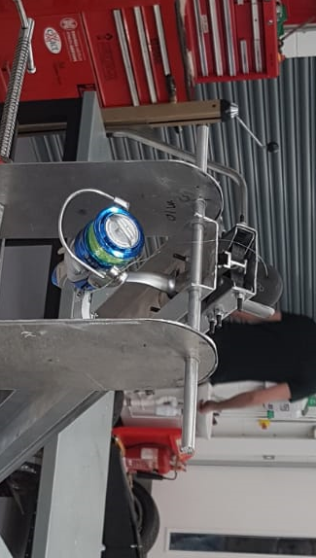
- Reel was strong enough to withstand stresses acting upon it.
As listed above, those are some of the positives that could be taken from the line launcher, there are some negative points which will be considered within the next section of this report.

Image 1 above shows the fishing reel mounted to the underside of the sine bar.

Negatives Analysis
There were also some negative things on the line launcher which are worth mentioning, they are listed below:
- When the brake was released on the fishing reel, because the line was so thick, it un-reeled very fast and sometimes caused tangles.
- The tip of the handle needed to be cut down to allow for the reel to be mounted on the underside of the sine bar.
- Because of the modified handle on the fishing reel, a small spanner was needed to turn the handle of the reel to reload the fishing line, although this wasn’t a huge issue.

What lessons have been learned which could benefit in future individual/group design challenges
Based on the work carried out with this group project. There are some things that would be reconsidered if the project was to be carried out again in the future.
In terms of the line management system, although it worked for the application needed, in future a more simplistic design could have been used to prevent tangles and to save space and weight on the sine bar.
A cone shape could have been used with a handle that would work in the same manner as the fishing reel to distribute and reload the line and squash ball. The cone shape is shaped in such a way that the line would distribute in the correct manor at a suitable speed also.
Some more testing of the device would have been beneficial as we encountered some late issues with the launcher, the stop plate on the end of the sine bar couldn’t initially withstand the impact of the carriage and warped on impact so this had to be replaced with some more thicker material and welded more securely. This is something that would have happened earlier in testing if it was available.

Three sentences I wish I could have told myself at the beginning of the project:
- Get ahead with research and analyse different ideas further in order to comprise the best possible concept idea for the group project,
- Be aware of the timescale of the entire group project, it really isn’t as much time as It initially seems, and set my own individual deadlines based on the general deadlines for the whole group.
- Spend a decent amount of time reading the iMechE specification and also testing the launcher in the workshop to refine any issues to prevent limiting the capabilities of the launcher based on lack of testing,

