Postgraduate/Distance Learning
Assignment coversheet & feedback form

THIS SHEET MUST BE THE FIRST PAGE OF THE ASSIGNMENT YOU ARE SUBMITTING (DO NOT SEND AS A SEPARATE FILE)

For completion by the student:
Student Name:
Sarah Bisby
Module code:  HPCA7008  Module title:  Foundations in Cultural Astronomy and Astrology | Student ID number:  2113745 |  |  | Educational support needs:No
Module tutor:
Nick Campion

Assignment due date: 2.12.21
If your module has multiple submissions please indicate which piece of work this is.

1st 2nd x 3rd 4th 5th 6th
I confirm that this is my original work and that I have adhered to the University policy on plagiarism.
Signed ……Sarah Bisby………………………………………………………
Email submission: if you are submitting this form via email, please tick this box □
(as a substitute for your signature) to confirm that you agree to the above declaration.
Assignment Mark
Final Mark | WILL BE GIVEN ON TURNITIN

NB. All marks are provisional until confirmed by the Final Examination Board.

PLEASE NOTE: ALL COMMENTS WIL BE POSTED ON TURNITIN

For completion by Marker 1 :
Comments:

Marker’s signature: |  |  | Date:
For completion by Marker 2/Moderator:

Comments:

Marker’s Signature: |  | Date:
AGREED INTERNAL MARK (where necessary):

Comment on process of arriving at agreed mark:

External Examiner’s comments (if relevant)

External Examiner’s Signature: |  | Date:

Title: Essay based on Sky Journal Word Count: 2100
‘Be clearly aware of the stars and infinity on high. Then life seems almost enchanted after all.’ Using this line from a letter that Van Gogh wrote to his brother as inspiration, I set out to engage with the night sky and made observations in the form of a sky journal from November 3rd – 14th 2021. I planned to focus on sunsets, but then as more features of the night sky began to reveal themselves, I incorporated these to make my approach more holistic. I critically analysed my observations and used primary and secondary literature to place my observations in a broader context. The following themes emerged, which I will discuss below: disorientation, collective experience of wonder, disappointment, participation and enchantment.
Setting out to watch a sunset didn’t seem like a difficult task – until I realised from the perspective of my local High Street, I didn’t know where I would get a view of what I wanted to see. My disorientation took me by surprise:
My rational mind told me to head towards the river as I remembered seeing sunsets there earlier in the year. No signs whatsoever in that direction. Then I saw a bright orange light between the trees and headed off towards it – only to find it was the church illuminations that had just come on. In the hustle and bustle of a late afternoon hight street, it was feeling a bit like I was on a wild goose chase.
Descartes, it seemed, had got his wish when he implored us to stop looking up, but to look down instead, ushering in the age of reason and the mind-body split. Feeling rather disconnected, and hemmed in by the tall buildings, I decided to go to a higher viewing point, and returned home. As I climbed the stairs to the attic, it was like I was moving up through the worlds:
The bustle fell away, and skyscape of kaleidoscopic colour came into view (see Fig 1 below). The sun was already lower than my urban horizon but the glow of its aftermath was breath-taking: translucent blue, streaked with fiery red, clouds billowing deep shades of indigo, and geese crossing the horizon, honking to the setting sun. A very different type of wild goose chase was now beginning to emerge!
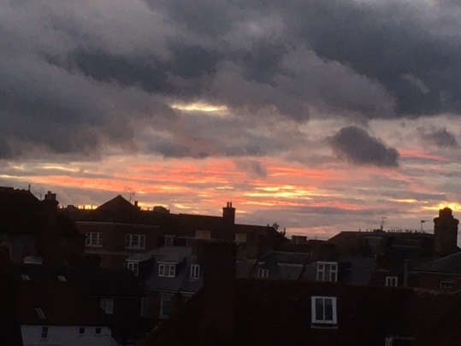
Figure 1: Sarah Bisby, Town Skyscape after Sunset, 3rd November 2021
As my physical position changed, so did my perspective. I had stepped up into a different realm, crossed over a threshold from where the bustle of the material world held sway, into a timeless world that spoke more to the soul than the mind.
The wonder evoked by the sight of a setting sun is surely one of the most primal of all our shared experiences. Since the advent of records mankind has mythologised or eulogized it; for the Egyptians, the Sky goddess Nut gave birth to then swallowed the sun on a daily basis; Turner used the interplay of light during sunset in some his paintings, for example ‘Sunset’ and some of our greatest poets and playwrights have all used them as inspiration for their work.
As the sunset fades, and with it the last traces of light, the sky takes on a different feel, one that is pregnant with possibility. For Rilke, as the ‘west reaches for clothes of new colours’ as we look ‘two worlds both leave you, one part climbs toward heaven, one sinks to earth.’
My eyes were now ‘drawn towards heaven’ and I watched as a bright light appeared, which my rational mind told me was Jupiter, then as other flecks of light gathered and began to form the familiar shape of the constellations. This was a display of a very different nature, all made manifest by the setting sun. Whereas the sunset had felt ‘universal’ - a shared experience that we have all experienced - the more subtle display of the dark night sky seemed elusive, more personal, as though it was just me seeing Jupiter and the Pleiades in all their fragile glory. This could, however, still be explained by a reason-based view of the world. As Dane Rudhyar wrote, ‘‘Each individual is in a very real sense the center of his own universe… In a deeper sense, he is the whole sky focused at a particular point of space-time.’ On a transpersonal level, though, are connected by the same sky.
According to Plato, ‘the god invented sight and gave it to us so that we might observe the orbits of intelligence in the universe and apply them to the revolutions of our own understanding.’ And for the Stoic Emperor Marcus Aurelius, contemplating the heavens purges away the dross of earth-bound life. In post-Modernist times, the painter John Ruskin also saw it as ‘fitted in all its functions for the perpetual comfort and exulting of the heart, for soothing and purifying it from the dross and dust.’ In contrast to Descartes, he was felt that God was asking us to look up, yet people persistently walked with their eyes to the ground. Though all these writers perceived a sense of wonder when they looked up, their perspective were still more aligned to ‘logos’ or a reason-based world view, than ‘mythos’, a more intuitive way of relating.
Though still also operating more from ‘logos’ than ‘mythos’, I was beginning to feel a growing sense of excitement each day as the prospect of sunset approached, and with it the revelations of a night sky. I set out at the appointed hour – only to be met with a blanket of thick cloud. ‘I went up to the common on Deakins Leas where I could get a great view of the evening sky. Alas! The cloud cover was so thick I couldn’t even tell the part of the sky where the sun was setting.’ This wasn’t Egypt with clear night skies, this was England with her unpredictable weather. No wonder our cultural relationship with the skies is so disorientated.
Walt Whitman sums up this sense of disappointment in his poem ‘On the Beach at Night,’ where a child and her father stand on the beach watching the autumn sky. They observe the splendid sight of ‘the lord-star Jupiter’ and ‘the delicate sisters of the Pleiades’ but already the ‘ravening clouds, the burial clouds, in black masses spreading’ and soon those ‘burial clouds that lower victorious soon to devour all,’ leaving the child weeping with disappointment.
In addition to cloud cover, artificial light also poses a threat to our night sky observations and is intimately linked to the onset of dusk:
‘I was in the garden as dusk fell, aware that the light was fading, and I looked up to see that the clouds, along with the last traces of sun, had all but disappeared. Over the rooves across the street, the thinnest sliver of the crescent moon appeared – and next to it a rosy-pink star that had to be Venus (see Fig 2 below). The streetlights immediately came on, and a plane flew across the landscape, but nothing could subdue the excitement I felt at seeing moon and Venus after such a long period of invisibility.’
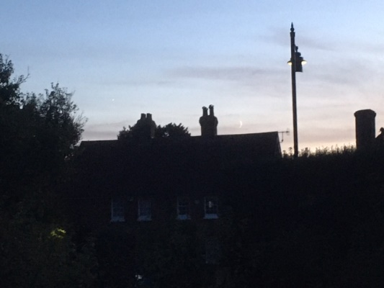
Figure 2: Sarah Bisby, Crescent Moon and Venus in city landscape with street lighting, November 2021
From the perspective of my city-scape, street lights are an integral reality of the night sky. Though at first the artificial light seemed like a blight, after a while I began to accept it as part of the landscape ‘The streetlights are inevitable; I stopped railing against then and tried to see them as part of the skyscape that was being revealed.’
Then I began to see the night sky in a different way. Not as something separate from the Earth and contaminated by it, corresponding to the dualistic approach that began with Plato (world of being versus world of becoming), but as an integrated whole. ‘Mythos’ was starting to gain the upper hand.
Van Gogh demonstrated in his paintings of starry skies a more imaginative way of relating to the cosmos, and he also used the interplay of the stars and streetlights in his painting (see Fig 3 below). He was the first artist to actually go outside at night and paint what he perceived. The effect was that, ‘both lights blaze with the same kind of buzzing, bursting of energy, a kind of weird kinship.’ And in doing so, his vision opened up in a different way, and ‘as (his painting) enacts, in line and colour, the birth of vision which, as it opens upon the cosmos, seems to explode like a shower of fireworks.’

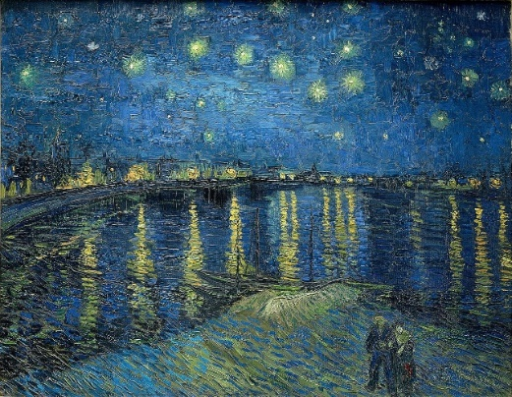
Figure 3: Vincent Van Gogh, (1888 ) The Starry Night Over the Rhone [oil on canvas] Musee d’Orsay. Image: Wikimedia
As if in confirmation, I too began to see fireworks displays every time I looked up into the night skies. ‘Was this the cosmos responding to my new way of interaction with it? Was it in some way being called in being by my observations, and was I being made manifest in a new way by IT? Was this ‘enchantment?’
I researched a definition that described this sense of deeply held wonder and found in what Freya Matthews called ‘ontopoetics’ the meaning I was looking for:
‘To experience for ourselves the intimately apposite poetic responsiveness to place or landscape to our communicative overtures…is to be shifted on our metaphysical moorings. It is to feel graced, even loved by the world, and flooded with a gratitude, or loyalty, that rearranges in us the deepest wellsprings of desire!’
Now as I watched the response of the landscape to the setting of the sun, the boundaries began to blur between me the observer and what I was observing and I began to feel I was under the night sky, rather than just observing it. Participation emerged as a theme. As Ingold observed, ‘Immersed in the swirling expanse, it is as though our minds and bodies are swept up in the flow, even as we are rooted to the spot.’
Like van Gogh, I was becoming ‘star-struck’ and as the ‘vivid patches of pure shimmering light pierced the cloud, slowly revealing bands of pink, lilac and purples between chimneys and clouds’ I began to wonder if this was how the cosmos showed to us something of the day that it had just experienced? Was this how a sunset participated in the unfolding of the world?
As Ingold says, the atmosphere is a ‘transparent life sustaining medium on which all perception depends,’ not a passive backdrop but an active participant in the skyscape. Particles are released into the atmosphere all the time through human activity and light refraction will influence the colour and nature of the sunset that we see. For example, after the eruption of Mount Tamora in 1815, Turner painted sunsets of blazing redness in the years afterwards, when the evening sunlight refracted through the ashen air really did appear blood-red.’ In this way, the chemical signature of the day became part of the sunset, which Turner then captured in his painting.
From an enchanted view-point, ‘when the communicative engagement of self with the world and the world with self’ results in ‘interactions that are not merely causal but also meaningful’ the interplay of light with particles is an expression of a conscious cosmos. And maybe too, whereas the sunset holds within it all that has passed that day, the sunrise holds within it a golden promise of renewal and hope (see Fig 4 below).
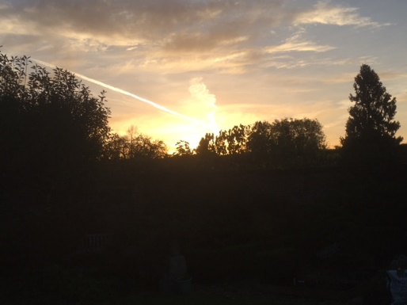
Figure 4: Sarah Bisby, The Golden Promise of Sunrise, November 2021
To conclude, as referenced in my Sky Journal and both primary and secondary literature, our urban landscapes and rational minds (‘logos’) have resulted in sense of disconnection and disorientation vis-a-vis the night skies, compounded by a propensity to ‘look down’ (Descartes). However, by changing our perspective both physically, and starting to ‘look up’ (Ruskin) we enter quickly into a world of shared wonder ‘(mythos’), which has been encapsulated in religions, myths, paintings, poems and literature for millenia. We begin to perceive not only a personal, but a universal shared experience with a sky common to us all (Rudhyar), which can be experienced with both the rational mind, and the intuitive mind (Ingold). In a world where cloud cover and light pollution can make sky watching disappointing, if we transcend a dualistic divide that sees heaven as perfection and earth as polluted (‘Plato’), we move to a unified perspective that experiences rather than observes, we begin to participate in what Freya Matthews calls ‘ontopeotics.’ The cosmos shifts in response, and as we step into the flow of grace, life becomes enchanted once again.

Bibliography
Aurelius, Marcus, Meditations, trans. Maxwell Staniforth, Harmondsworth,( Middlesex: Penguin, 1964), V.47,
Bisby, Sarah Sky Journal, 3 – 14 November 2021
Gogh, Vincent van, and Ronald de Leeuw. The Letters of Vincent Van Gogh, (London: Penguin Books, 1997)
Harris, Alexandra, Weatherland: Writers & Artists under English Skies, (London: Thames & Hudson, 2015)
Ingold, Tim, ‘Reach for the Stars! Light Vision and the Atmosphere’ in The Imagined Sky; Cultural Perspectives, ed. by Darrelyn Gunzburg (Sheffield: Equinox Publishing 2016)
Matthews, Freya ‘Introduction: Invitation to Ontopoetics,’ PAN Philosophy Activism Nature 6, (2009)
Matthews Freya, ‘Come with Old Khayyam and Leave the Wise to Talk’, O-Zone 1, (2013)
Pissarro, Joachim, ‘Painting by Night’ 9th October Nature, vol 455, (2008)

Plato. Timaeus. Critias. Cleitophon. Menexenus. Epistles. Translated by R. G. Bury. Loeb Classical Library 234. (Cambridge, MA: Harvard University Press, 1929.)

Rilke, Rainer Maria, ‘Sunset,’ Poemhunter.com (2003) <https://www.poemhunter.com/sunset/>

Rudhyar, Dane, Address to the American Federation of Astrologers 1970, Rudhyar Archival Project, 1970: xii

Turner, Joseph Mallord William, (1775 – 1851) Sunset c. 1830 -5, The Tate Gallery, London.

Whitman, Walt, ‘On the Beach at Night,’ poetryfoundation.org.[n.d.] < https://www.poetryfoundation.org>

Vincent van Gogh, and Ronald de Leeuw. The Letters of Vincent Van Gogh, (London: Penguin Books, 1997), p.392.
Sarah Bisby, Sky Journal, 5th November 2021, p. 1.
Alexandra Harris, Weatherland: Writers & Artists under English Skies, (London: Thames & Hudson, 2015), p.
Sarah Bisby, Sky Journal, 5th November 2021, p. 1.
Book of Day and Night, Tomb of Ramesses VI, Valley of the Kings, Luxor, Egypt
Joseph Mallord William Turner, (1775 – 1851) Sunset c. 1830 -5, The Tate Gallery, London.
Rainer Maria Rilke, ‘Sunset,’ Poemhunter.com (2003) <https://www.poemhunter.com/sunset/> (accessed 20.11.21)
Dane Rudhyar, 1970: xii
Plato. Timaeus. Critias. Cleitophon. Menexenus. Epistles. Translated by R. G. Bury. Loeb Classical Library 234. (Cambridge, MA: Harvard University Press, 1929) 47 b -c
Marcus Aurelius, Meditations, trans. Maxwell Staniforth, Harmondsworth,( Middlesex: Penguin, 1964), V.47, p. 112;
Alexandra Harris, Weatherland: Writers & Artists under English Skies. (London: Thames & Hudson, 2015), p. 258
Sarah Bisby, Sky Journal, 10th November 2021, p. 5.
Walt Whitman, ‘On the Beach at Night,’ poetryfoundation.org.[n.d.] < https://www.poetryfoundation.org> (accessed 15.11.21)
Sarah Bisby, Sky Journal, 7th November 2021, p. 4.
Sarah Bisby, Sky Journal, 8th November 2021, p. 5.
Plato. Timaeus. Critias. Cleitophon. Menexenus. Epistles. Translated by R. G. Bury. Loeb Classical Library 234. (Cambridge, MA: Harvard University Press, 1929.)
Joachim Pissarro, ‘Painting by Night,’ 9th October Nature, vol 455, (2008) p. 57.
Tim Ingold, ‘Reach for the Stars! Light Vision and the Atmosphere’ in The Imagined Sky; Cultural Perspectives, ed. by Darrelyn Gunzburg (Sheffield: Equinox Publishing 2016), pp. 234-251, p. 240.
Sarah Bisby, Sky Journal, 12th November 2021, p. 6.
Freya Matthews, ‘Come with Old Khayyam and Leave the Wise to Talk’, O-Zone 1, (2013) p.7. <OK-Ozone.pdf (freyamathews.net)> [29.11.21]
Tim Ingold, ‘Reach for the Stars! Light Vision and the Atmosphere’ in The Imagined Sky; Cultural Perspectives, ed. by Darrelyn Gunzburg, (Sheffield: Equinox Publishing 2016), pp. 234-251, p. 239.
Sarah Bisby, Sky Journal, 13th November 2021, p.7.
Tim Ingold, ‘Reach for the Stars! Light Vision and the Atmosphere’ in The Imagined Sky; Cultural Perspectives, ed. by Darrelyn Gunzburg (Sheffield: Equinox Publishing 2016), pp. 234-251, p. 244.
Alexandra Harris, Weatherland: Writers & Artists under English Skies, (London: Thames & Hudson, 2015), p. 212
Freya Matthews, ‘Introduction: Invitation to Ontopoetics,’ PAN Philosophy Activism Nature 6, (2009), p.1.

