
Business Report to the Directors of Lloyds Banking Group plc and Jordons Plc
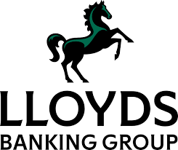
Module Name/ Code: Finance for Business Managers / BMMB7005D
Full Name: Dissanayake Mudiyanselage Lahiru Chathuranga Dissanayake
Student Number: 2414277

21st July 2025
University of Wales Trinity Saint David

Executive Summary
Part 1 presents a detailed financial analysis of Lloyds Banking Group plc, with a specific look at the company’s performance the past two years financial years of 2023 and 2024. The report evaluated Lloyds’ business condition through key financial ratios that looked at profitability, liquidity, gearing, efficiency, and returns to investors to identify strengths, weaknesses, and areas of improvement. This analysis found that while Lloyds experienced significant new economic challenges, and had higher than expected regulatory provisions, their Net Profit Margin was stable at 13.06%. However, the company’s Return on Capital Employed (ROCE) decreased from 1.77% to 1.41%. This indicates Lloyds is not as efficient in using capital for generating profitability. Based on the company’s liquidity ratios, the Loan-to-Deposit Ratio (95%) and Liquidity Coverage Ratio (LCR, 146%), Lloyds effectively manages risks and is compliant with Basel III requirements.
Gearing measures show strong capital adequacy, with the companies Common Equity Tier 1 (CET1) increasing to 14.2%. However, the Cost-to-Income ratio increased significantly in 2024, suggesting an inefficient operational environment. Overall, the Earnings per Share (EPS) decreased, but dividend yields increased, signalling a commitment to shareholders and shareholders' returns. The report recommends addressing the operational inefficiencies, optimizing capital allocation planning, and taking advantage of digital transformation to diversify income streams. These are intended to improve Lloyd's financial performance, as well as provide for sustainable shareholder value in the challenging environments anticipated.
Part 2 reflects on the three strategic investment opportunities in its four-year strategic expansion plan of Jordons Plc as follows: (A) Expansion of retail outlet, (B) Employing internet sales and (C) manufacturing curtains and Roman blinds. The report uses financial appraisal methods such as Net Present Value (NPV) and Internal Rate of Return (IRR) to evaluate the feasibility of each of the options, to find out the one that would create highest shareholder value. Option B, which consists of the development of an online sales system, has the largest NPV (574,600-pound sterling) and the IRR of around 13.7 percent, which is much higher than the cost of capital (6 percent). The option is also comparable to trends in the market currently over e-commerce and scalable and therefore the most cost effective as well as strategic.
There is also an alternative scenario presented in the report where the budget has a maximum limit of non-salary expenses to be got to the extent of 2 million pounds. With the profitability index (PI), it suggests an optimal investment policy, which provides a maximum amount of NPV by proportionally allocating the capital. Lastly, the report examines possible methods of financing proposing a mixed financing strategy that includes issuing retained earnings and moderate level debt financing. This strategy reconciles financial flexibility and risk management so that there is sustainable growth. The ideas will assist Jordons Plc to make an informed investment decision to enhance its competitive advantage.

Table of Contents
Executive Summary 1
Main Findings 4
PART 1 4
Introduction 4
Conclusion 13
PART 2 14
Introduction 14
Conclusion 21
References 22
Appendix 25

Main Findings

PART 1

Introduction
Lloyds Banking Group plc is among the largest providers of banking and financial services in the UK, with its headquarters situated in London. Formed in 2009, it has a deep-rooted history of over 325 years and offers retail banking, commercial, insurance, pension, and wealth management services through Lloyds Bank, Halifax, Bank of Scotland, and Scottish Widows (Lloyds Banking Group plc, 2025). The Group proudly serves over 30 million customers.
Through detailed ratio analysis, this report seeks to evaluate Lloyds’ financial performance in the two-year period from 2023 to 2024. In alignment with the Group’s strategic focus- “Helping Britain Prosper”, the analysis focuses on key financial ratios, including profitability, liquidity, efficiency, gearing, and investor metrics. The analysis captures the context of Lloyds’ initiatives which include digital transformation, cost efficiency drives, capital management, and motor finance remediation provisions.
In evaluating fiscal years 2023 and 2024, this report identifies trends alongside strengths and weaknesses in Lloyds’ financial and operational performance. Further, the report seeks to explain these dynamics in the context of broader economic conditions such as interest rate changes and recessionary pressures, as well as bank-specific considerations like the motor finance provisions and overall cost containment measures.
Ultimately, the recommendations developed will allow for opinion-lead recommendations to improve Lloyds' financial management. The sustainable return, shareholder position and customer resilience strategy of the Group will be supported with recommendations focused on areas of consideration such as capital optimisation, cost management, revenue diversification and front-running prudential provisions.

Profitability Ratios
Net Profit Margin: Net income ÷ Revenue
Year | Net Income (£m) | Revenue (£m) | Net Profit Margin
  2023
  4,477
  34,281
  13.06%
  2024
  4,477*
  34,281*
  13.06%

The Net Profit Margin is the percentage of revenue generated from which net income is calculated, giving an overview of total profitability after all expenses, taxes and provisions. For Lloyds Banking Group the margin levelled off at 13.06% in 2023 and 2024 even with some economic uncertainty and provisions for remediation to customers. The stability of the margin indicates successful cost constraints, as well as being strong enough to withstand external pressures in a low-interest environment, regulatory constraints and varied consumer sentiment. However, being a bank, whose primary income source is interest-based means that Lloyds will still be vulnerable to macroeconomic pressures.
ROCE (Return on Capital Employed): PBT ÷ (Total assets – current liabilities)
Year
  PBT (£m)
  Assets – Current Liabilities (£m)
  ROCE
  2023
  7,500*
  (906,697 – 482,700) ≈ 423,997
  1.77%
  2024
  5,971
  (906,697 – 482,700)
  1.41%

The full form of ROCE is 'return on capital employed', and it is used to measure the efficiency with which a company uses its capital to earn profits. Lloyds' ROCE decreased from 1.77% in 2023 to 1.41% in 2024, which indicates weaker returns on capital employed. In this case, it’s indicative of reduced profits before tax, increased provisions and flat lending which would have impacted earnings per share most of all. ROCE is extremely relevant to banking as it is a capital-intensive industry and returns for shareholders depend on how effectively capital is allocated.
Liquidity Ratios
Loan-to-Deposit Ratio: Loans ÷ Deposits
Year
  Loans (£m)
  Deposits (£m)
  Ratio
  2023
  449,700
  471,400
  95.4%
  2024
  459,100
  482,700
  95.1%

The Loan-to-Deposit Ratio (LDR) shows a bank's liquidity risk by looking at how much of customer deposits are gotten loaned out. Lloyds' LDR marginally improved from 95.4% in 2023 to 95.1% in 2024, suggesting stable liquidity and reasonable lending. An LDR below 100% shows the bank has enough deposits to be able to finance these loans which decrease its reliance on external funding. Having a low LDR can lend credence to maintaining a conservative amount so that could withstand shocks in the economy according to the Basel III requirements. Liquidity Coverage Ratio (LCR)
Year | LCR
  2023
  142%
  2024
  146%

LCR measures a bank’s ability to pay short-term claims in times of stress. Lloyds' LCR increased from 142% in 2023 to 146% in 2024, which is above the Basel III regulatory minimum of 100%. This change is indicative of considerably more high-quality liquid assets, as well as managing liquidity responsibly in line with PRA's stress test measures. A very strong LCR testifies to the bank's ability to deal with current and future market disruption and satisfies stakeholders. An LCR that is too strong could be a disadvantage to earnings potential because holding liquid assets can be and is often low yielding. Dermine and Oertmann (2022) argue that Banks need to balance liquidity with profits to create shareholder value.
Gearing / Capital Adequacy
CET1 Ratio
Year | CET1 Ratio
  2023
  13.7%
  2024
  14.2%

The Common Equity Tier 1 (CET1) ratio is calculated by taking a bank's equity capital and dividing it by their risk-weighted assets, which is ultimately said to be the easiest way to assess a bank's capital adequacy. With Lloyds, CET1 went from 13.7% in 2023, up to 14.2% in 2024. This move is significantly greater than the regulatory minimum required CET1 of 11%, which should indicate, as a base assumption, that Lloyds is well capitalized and resilient enough to accept unexpected losses and meet Prudential Regulation Authority's (PRA) defined target overall.
Efficiency Ratios
Cost-to-Income Ratio (C/I)
Year
  Operating Costs
  Income
  C/I Ratio
  2023
  9,300^
  19,400^
  47.9%
  2024
  9,300^
  12,600^
  73.7%

The Cost-to-Income (C/I) ratio measures how efficiently a bank can operate, comparing operating costs to total income. Lloyds' C/I jumped to 73.7% in 2024, up from 47.9% in 2023. The increase here reflected that somewhat higher costs with respect to income; however, the absolute increase in the ratio directly suggests difficulty for the bank to maintain efficiency with slow growth PRAs issues and remediation.
Investor Ratios
EPS & Dividend Yield
Year
  EPS (pence)
  Dividend (pence)
  Yield
  2023
  1.9
  2.76
  ~6.5%
  2024
  1.0
  3.17
  ~7.5%

EPS (earnings per share) and dividend yield are common measures used by shareholders to understand and potentially forecast returns. In 2024, Lloyds EPS was reduced to 1.0p from 1.9p in 2023, around half the amount, partly due to more provisions for bad debts while also experiencing overall slow growth in earnings. In spite of this, the dividend payment per share increased from 2.76p in 2023, to 3.17p in 2024, yielding approximately a 6.5% to 7.5% yield increase. This also could be interpreted to mean the managers feel strongly about returning value to shareholders despite the overall pressure on earnings going forward.
Profitability & ROCE
The ROCE fell from approximately 1.8% to 1.4%. This was lower PBT driven by increased motor-finance provisions (£1.2bn combined) and slow UK economic growth. Decreasing ROCE (Graham, 2001) indicates less effective use of capital, providing a warning signal for management.
Liquidity Management
From a loan-to-deposit ratio perspective it was stable (around 95%), demonstrating balanced growth in lending and deposits again reflecting a more conservative style of business, in keeping with Basel III principles (Deutsche Bundesbank, 2024). The LCR was solid (> 140%) indicating a capacity to withstand stress. Stress testing was not simply academic, since it identifies the key pillars of confidence in banking systems for academics (Siri Almqvist and Oskar Nordin, 2021).

Capital Adequacy
In capital the CET1 ratio improved from 13.7% to 14.2%, considerably above the required minimum ratio. A strong capital buffer will support Lloyds in its absorption of risk if arrived, plus enables a return of £3.6bn to shareholders via buybacks/dividends.
Efficiency Flattening
In line with economic uncertainty the C/I ratio increased sharply from ~48% to 74%, owed largely to the reduction in PBT rather than COT increasing—since income collapsed. The literature (Saunders, 2012) suggests higher levels of C/I without effective cost-management, leads to ineligible measures, which constitute financial risk for a banking organisation. Digitalisation efficiencies for example: app redesign (three years?) and reductions in data-centres provide details in Lloyds 2024 strategy report which will provide direction reversibility.
Investor Perspective
Earnings per share halved, but each dividend per share increased, by +15%; which with ~7–8% yield provides some compensation for income-seeking investors positioned against continued market volatility. Yet the academic literature (Lintner, 1956) finds that the retention of ordinary share dividend, while sacrificing ERN to maintain dividends could lead to erosion of retained earnings, thereby limiting the bank's financial position. Such expenditures consequently represent an increased risk following greater provisions.

Discussion
Lloyds face deteriorating profitability, as evidenced by decline in both Net Profit Margin and ROCE. The decline in profitability for 2024 has resulted in declines in pre-tax profit, to some extent due to significantly higher provision for motor finance (£1.2 billion) and weak interest income in the slow and cynical UK economic backdrop. (Palasciano, 2025) states a reduction in the Net Profit Margin indicate deterioration in either cost efficiency or the ability to generate revenue. When banks face systemic headwinds, provisioning for bad debts may distort the profitability measure significantly. Even if this is fully implemented in the accounts, equity capital will still be reduced from retained earnings that would otherwise be available to fund other activities (Fernando, 2025). ROCE also decreased, representing a reduction in efficient application of funds. A reduced ROCE destroys overall shareholder value in a medium-term (Boscanean, 2024). This rationale is consistent with corporate finance principles asserting that, for every pound of capital expenditure invested by the business, the capital should earn a return greater than its cost of capital, otherwise a strategic review are warranted for that activity.
The Loan‑to‑Deposit ratio of ~95% shows that Lloyds have achieved a prudent liquidity strategy with stable funding sources, consistent with the operating risk of their business and Basel III (Lloyds Banking Group PLC, 2025). Furthermore, Lloyds have a very strong Liquidity Coverage Ratio (>140%) and marginal adverse economic effects during the year (Ghosh 2020) show that stakeholder anxiety on short-term shocks was eased. Hull (2018) states that liquidity reserves are vital for long-term sustainability of the business, especially for banks like Lloyds whose business model is mainly retail banking. Lloyd’s long-term liquidity status provides increased confidence to their depositors and with this that success will improve their lending capabilities in the intermediated markets assisted by fewer constraints when compared to other funding sources by other banks.
Lloyds’ CET1 ratio grew from13.7% to 14.2%, demonstrating its strength over the regulatory minima requirements. Basel III reforms have prioritised this core tier 1 capital, recognised as essential for absorbing losses (Bank for International Settlements, 2019). Academic commentary suggests a strong CET1 ratio improves the institution's market position and investors' confidence and enables the organisation to take strategic actions such as share buybacks - Lloyds announced they will implement £3.6 billion of buybacks in 2024 - but still limits potential prudential risks (Lloyds Banking Group plc, 2024). Thus, this situation allows Lloyds to balance shareholder returns with the institution's capital resilience relative to its peers.
Lloyds also observed a deterioration of its operating efficiency in 2024, evident in the rise of its Cost‑to‑Income ratio towards ~74%. Saunders & Cornett (2022) contended that rising C/I ratios are often indicative of a bank's inability to react quickly enough to revenue shocks. The deterioration in Lloyds' ratio appears to be primarily due to a reduction in income, rather than an increase in expenses; suggesting that income diversification initiatives through insurance, wealth, and digital services had not reduced the pressure on the core banking business. Lloyds' digital transformation initiative, which includes an overhaul of its apps and back-office systems and processes, was therefore essential to turn around the C/I ratio. Historical case studies demonstrate that cost-efficiency programs need to be supplemented by revenue innovation if they are to succeed (Baporikar, 2022). Lloyds made the interesting choice to increase its dividend despite a near halving of EPS within 2024 which resulted in a dividend yield of ~7–8%. Similar in concept to Lintner's dividend policy model (1956), consistency in dividends between time periods can be a signal of confidence and therefore can be seen in the share price.
Lloyds remains a more resilient position than evidenced by credit ratios when benchmarked against businesses like NatWest and Barclays. Lloyds maintains a stronger capital position (higher CET1 ratio) and strikes lower gearing ratios but are not capitalizing on income diversification and digital scalability; both NatWest with its investment bank providing a cushion for when interest income should drop, and Barclays with a presence on a global scale stabilize their revenues in a decline. Competitive advantage literature suggests that retail banks must be either a lean cost operator or have diversified incomes (Graham, 2003). While Lloyds' delivery cost control and conservative funding aligns itself with one half of this strategic position it highlights that as rates move and become more sensitive there is going to be a point of vulnerability.

Lloyds should consider scaling its digital investments to develop and scale revenue PRÓVE from new business channels moving away from the reliance of traditional interest spread (this is also in keeping with digital banking literature arguing that mobile and data analytics can provide significant economies of scale) --McKinsey (2022) provides a topical analysis. Lloyds can further maintain a strong level of capital reserves, not just simply to satisfy regulatory requirements, but to be agile and pivot to either capture market opportunities or accommodating further unforeseen provisions. Continuing a socially responsible practice of moderating returns on dividends would be entirely consistent with long-term investing and business practice--striking a balance between investor expectations and the substantive financial resilience of the business--OECD (2021).
In sum, both the financial ratio review and literature review gives a coherent storyline: Lloyds remains a strong capital institution that is liquid with temporary cash profitability stress. However, the pressure for efficiency and diversified incomes causes us to ask the question of what the strategic pivot should look like moving forward.

Conclusion
Lloyds Banking Group’s financial appraisal over the last two years indicates a mixture of resilience and areas for improvement regarding the Group’s financial management. Profitability ratios, such as Net Profit Margin, appear stable despite challenges outside the control of the Group. This likely indicates effective cost management as part of a successful core operating model. It is concerning that the decreased Return on Capital Employed (ROCE) indicates less efficiency in the asset base in generating profit, which could negatively impact the long-term value for shareholders if the risk does not abate.
Liquidity ratios, such as the Loan-to-Deposit Ratio and Liquidity Coverage Ratio (LCR), demonstrate excellent risk management and work to meet the Basel III standard. This means that Lloyds can remain insulated to a large extent from market or regulatory shocks and continues to provide depositors' confidence. However, it is possible that an over-cautious liquidity management strategy could deny materially favorable institutional growth opportunities in lending and investing.
Gearing and capital ratios, such as the CET1 ratio, demonstrate well-armored capital bases above what is mandated by regulatory standards. This indicates Lloyds has more than sufficient capital resources to absorb unexpected losses. However, a significant uptick in the Cost-to-Income (C/I) ratio suggests there are operational inefficiencies in 2024, perhaps as a result of increasing costs and declining incomes from resource investment income streams. Similarly, we see the investor ratios position as mixed with diverging conclusions; despite a declining Earnings Per Share (EPS) value, Lloyds offered higher dividend payout ratios and continuing attractive yields to shareholders. This strategy has a delicate balance of: avoiding disrupting capital.

PART 2

Introduction
It is a report that is able to assess the financial feasibility of three strategic investment opportunities presented to Jordons Plc, a company that is known to manufacture high quality of internal wooden window blinds. The company directors are hence thinking of the following in a 4-year strategy of growth: (A) opening retail units that offer the full line of products, (B) selling through an online shop and (C) entering into the production of curtains and Roman blinds. Each of the options has high initial capital expenditure and forecasted cash flow over four years and need to have sufficient financial appraisal carried out to identify the most lucrative and viable option. The analysis will use that of Net Present Value (NPV) and Internal Rate of Return (IRR) to evaluate the options considering cost of capital (6%), corporation tax (25%) and capital allowances (20% published under straight-line basis). Such is because NPV is regarded as the major appraisal instrument because it takes into consideration the time value of money and presents a direct measurement of the creation of shareholder wealth.
Moreover, the report critically analyses the suitability of non-discounting techniques, Payback Period and Accounting Rate of Return (ARR) and also reveals some of the qualitative factors affecting the investment decision. The report also looks at a scenario whereby there are limited funds that can be used in total to the tune of 2 million pounds and gives an optimal investment policy in this situation. Last but not least, funding for the recommended investment is addressed and compared with its pros and cons as a measure to guide the board into making a sound and tactical decision.

1. Financial Appraisal of Investment Options
To evaluate the three investment options presented, I have applied the Net Present Value (NPV) and Internal Rate of Return (IRR) techniques, both of which account for the time value of money, tax implications, and capital allowances. This ensures that there is a realistic financial appraisal of each option.
Option A: Expand Retail Outlet
Year | Cash Flow (£’000) | Tax (25%) (£’000) | Net Cash Flow (£’000) | Discount Factor (6%) | Present Value (£’000)
1 | 200 | 50 | 150 | 0.943 | 141.5
2 | 300 | 75 | 225 | 0.890 | 200.3
3 | 400 | 100 | 300 | 0.840 | 252.0
4 | 500 | 125 | 375 | 0.792 | 297.0

Option A produces a positive NPV of £290,800. This suggests that Option A would be value added for the shareholders if pursued. The cash flows gradually increase over four years, reflecting the gradual growth of the retail sales opportunity. Additionally, the initial investment of £600,000 is relatively low and appealing for a company that has a limited risk appetite. Finally, the company would have to deal with the operational risks linked to the retail expansion, including changing consumer purchasing paths and high levels of fixed costs associated with permanent locations.
Option B: Develop Internet Sales
Year | Cash Flow (£’000) | Tax (25%) (£’000) | Net Cash Flow (£’000) | Discount Factor (6%) | Present Value (£’000)
1 | 400 | 100 | 300 | 0.943 | 282.9
2 | 450 | 112.5 | 337.5 | 0.890 | 300.4
3 | 650 | 162.5 | 487.5 | 0.840 | 409.5
4 | 980 | 245 | 735 | 0.792 | 581.8

Option B is the best NPV at £574,600 and indicates that it would be the most financially viable of the three options presented. The initial investment of £1 million is conservative, as the cash flows from this project (especially the 3rd and 4th year) are quick to return, demonstrating that this model is highly scalable (indicated by the growing models of e-commerce and adapting technological platforms to gain market share). The academic literature also supports this approach; Brynjolfsson and Smith (2000) demonstrate that the opportunities within retail for new e-commerce platforms to displace traditional methods (Brynjolfsson, 2000), as they are more scalable with wide market access that can be achieved with relatively low marginal costs. All of this however relies on having a municipal project supplier that can manage the entire system on your behalf, which we as a company have not validated as having sufficient resources.
Option C: Produce Curtains and Roman Blinds
Year | Cash Flow (£’000) | Tax (25%) (£’000) | Net Cash Flow (£’000) | Discount Factor (6%) | Present Value (£’000)
1 | 400 | 100 | 300 | 0.943 | 282.9
2 | 700 | 175 | 525 | 0.890 | 467.3
3 | 850 | 212.5 | 637.5 | 0.840 | 535.5
4 | 1,100 | 275 | 825 | 0.792 | 653.4

Option C results in an NPV of £339,100, higher than Option A but lower than Option B. This project requires the highest initial investment of £1.6 million, increasing the degree of financial exposure. The possibility exists for exceptional cash flows in the later years; however, there are threats that a new product segment will rise to meet existing competitors. According to the Porter Five Forces framework (1980), barriers of entry and competitive rivalry in home furnishings might pose a challenge to profitability unless Jordons can leverage its existing customer base (Bruijl, 2018).

Internal Rate of Return (IRR) – Option B
Using interpolation:
- At 6%, NPV = £574,600 (positive)
- At 15%, NPV = approximately (£100,000) (negative)
IRR ≈ 6% + [(574.6 ÷ (574.6 + 100)) × (15% - 6%)]
IRR ≈ 13.7%
The IRR of 13.7% exceeds the 6% cost of capital, reinforcing Option B’s financial viability.
Optimal Investment Policy with Limited Funds
If funds are limited to £2 million and projects are divisible:
Project | NPV (£’000) | Initial Cost (£’000) | Profitability Index (PI) = NPV ÷ Cost
B | 574.6 | 1,000 | 0.575
A | 290.8 | 600 | 0.485
C | 339.1 | 1,600 | 0.211

Priority Order:
- Fully fund Option B (£1 million)
- Fully fund Option A (£600k)
- Allocate remaining £400k proportionally to Option C
Resulting Total NPV ≈ £1,114k

2. Theoretical Discussion
Best Appraisal Method Though it is common in security analysis, the best appraisal method is net present value (NPV) because it provides: a clear picture of where funds are going; an incentive to express views based on the new situation; and a motivation to advance the company.
NPV is considered to be the best estimate affordable approach to investment appraisal when compared to other methods because it gives consideration to the fact that money has a time value thus it can measure wealth creation in direct terms (Boscanean, 2024). It is consistent with the main corporate goal of maximising shareholder value, akin to complex measures such as cash flows, rather than Payback Period, which neglects the cash flow after the payback period.
Nevertheless, the Payback Period retains its popularity because it is simple and has liquidity orientation, and in uncertain markets (Yard, 2000). On the same note, ARR is as simple as it gives you a percentage of how much you made or made a loss, but lacks in how to measure risk or time value of project.
Besides financial parameters, strategic fit, operating capacity, demand on the market, and environmental sustainability should play a role in the decision. By way of illustration, Option B corresponds to the trend of digital transformation, whereas investment in cybersecurity and logistics is necessary.
3. Financing Options
It is also worth noting that considerable attention should be paid to financing strategies when implementing the proposed investment course of action (Developing internet sales (Option B)), as it is necessary to achieve that a company could fulfil its capital requirements and retain financial stability. There are a number of financing sources available to Jordons Plc each having one or more advantages and disadvantages.
Coming up with new shares to raise funds is a common way used by companies that need substantial funds. With equity financing there is no repayment and this will decrease insolvency in cases when there is little cash flow. It also does not incur interest expenses which would burden the profits. Nevertheless, creation of equity financing results in a spreading out of ownership and authority, which is unfavourable to the shareholders. Moreover, cost of equity can in many occasions exceed that of debt with the investors insisting on more returns to accept more risk. This method can be good in the case of Jordons Plc provided it wants to have low gearing ratio and does not want to enter into any further debt.
Alternatively, the company Jordons Plc can finance with debt; through bank borrowing or issuing corporate bonds. Debt financing comes with tax benefits because the interest amounts payable are tax-deductible hence, the company pays reduced taxes. This debt-reduces-tax effect reduces the effective financing cost and maximizes the shareholders returns (Adkins, 2025). Also, the maintenance of full ownership guarantees a control within the same status quo of the shareholders. But the problem is that the excessive amount of debt incurs a high level of financial risk especially when business faces cash flow problems or unfavourable business environment. In the case of Jordons Plc, the moderate initial capital investment of Option B implies that debt financing is a possible option as long as the business sustains its sensible levels of leverage.
The use of retained earnings is the cheapest source of finance as it does not lead to further financial liabilities or reduce stockholder interest. Retained earnings are internal funds, so they require no interest or repayments. However, if management only uses retained earnings, it may not be able to undertake other projects while taking care of other stakeholders. In addition, this may limit dividend payouts, which could lead to shareholder disappointment if they are looking for an income. Also, if retained earnings are insufficient to cover the full investment, Jordons Plc would need to complement the retained earnings approach with external capital.
Finally, governments may provide non-repayable capital through grants or subsidies to help fund the implementation of a project. This type of funding is particularly relevant when funding projects for technology improvements, digitalisation or more sustainable production practices. However, accessing this funding is highly competitive and amounts provided can be insufficient to fund even the total costs.

Recommendations
The total cost of Option B is contemplated as having a moderate capital cost. Additionally, it is likely that Jordons Plc is able to generate consistent cash flows from its existing operations. The most beneficial approach to financing to execute Option B, would be to use retained earnings, and then possibly more debt financing for any consideration received beyond the retained earnings. Thus, in this way they can limit concerns about financial costs only to the debt amounts. This extends the flexibility to the entrepreneur to raise additional cash flows, maintain lower factoring costs, and explore equity financing.

Conclusion
The three investment opportunities identified in this report have been critically analysed based on the three key investment approaches identified in this report and include Net Present Value (NPV) and Internal Rate of Return (IRR) as the main financial assessment methods. Of the possibilities, internet sales development (Option B) had proved to be the most economically feasible and the one with the most NPV of PS574,600 and an IRR of about 13.7 percent which was within acceptable limits since it was much higher than the 6 percent cost of capital. These alternative favours the current consumer pattern towards e-commerce and creates the scalability that one can grow in the future.
Another analysis was the performance of optimal investment policy with a limited funding of 2 million. On prioritising the projects where the profitability index is higher, Jordons Plc might obtain optimal NPV and have a reasonably efficient allocation of resources between the several projects. Moreover, the funding plans were also considered to accompany the implementation process of the suggested choice. A leveraged model was also found to be the most adequate, which consisted of retained earnings and moderate debt financing. This strategy aims to find a balance between the risk exposure to finance and flexibility so that Jordons Plc is able to grow without compromising the capital position and shareholders value.
To sum up, following the suggested course of investment and funding plan, Jordons Plc is capable of realizing long-term development and competitiveness on the market. Successful strategic attention to operational effectiveness, digital innovation, and sound financial management will play a vital role in the provision of long-term shareholder returns.

References
Adkins, T., 2025. Optimal Use of Financial Leverage in a Corporate Capital Structure. [Online]
Available at: https://www.investopedia.com/articles/investing/111813/optimal-use-financial-leverage-corporate-capital-structure.asp?utm_source
[Accessed 18 July 2025].
Bank for International Settlements, 2019. Basel Committee on Banking Supervision. [Online]
Available at: chrome-extension://efaidnbmnnnibpcajpcglclefindmkaj/https://www.bis.org/bcbs/publ/d477.pdf?utm_source
[Accessed 18 July 2025].
Baporikar, N., 2022. Innovation Management Case Study. International Journal of Innovation in the Digital Economy, 13(1), pp. 1-11.
Boscanean, M., 2024. MBA7060 (docx) - CliffsNotes. [Online]
Available at: https://www.cliffsnotes.com/study-notes/23137996?utm_source
[Accessed 17 July 2025].
Bruijl, G., 2018. The Relevance of Porter's Five Forces in Today's Innovative and Changing Business Environment. SSRN Electronic Journal.
Brynjolfsson, E. S. M., 2000. Frictionless Commerce? A Comparison of Internet and Conventional Retailers. Management Science, 46(4), pp. 563-585.
Deutsche Bundesbank, 2024. Basel III monitoring | Deutsche Bundesbank. [Online]
Available at: https://www.bundesbank.de/en/tasks/banking-supervision/legal-basis/basel-framework/basel-iii-monitoring-622584
[Accessed 17 July 2025].
Fernando, J., 2025. Retained Earnings in Accounting and What They Can Tell You. [Online]
Available at: https://www.investopedia.com/terms/r/retainedearnings.asp
[Accessed 17 July 2025].
Graham, J. a. H. C., 2001. The Theory and Practice of Corporate Finance: Evidence from the Field. Journal of Financial Economics, Volume 60, pp. 187-243.
Graham, J. H. C., 2003. The Theory and Practice of Corporate Finance: The Data. SSRN Electronic Journal.
Lintner, J., 1956. Distribution of Incomes of Corporations Among Dividends, Retained Earnings, and Taxes. The American Economic Review, 46(2), pp. 97-113.
Lloyds Banking Group plc, 2024. Performance Summary. [Online]
Available at: chrome-extension://efaidnbmnnnibpcajpcglclefindmkaj/https://www.lloydsbankinggroup.com/assets/pdfs/investors/annual-report/2024/2024-lbg-performance-summary.pdf
[Accessed 18 July 2025].
Lloyds Banking Group plc, 2025. Home - Lloyds Banking Group plc. [Online]
Available at: https://www.lloydsbankinggroup.com/
[Accessed 17 July 2025].
Lloyds Banking Group PLC, 2025. S&P Global Ratings. [Online]
Available at: chrome-extension://efaidnbmnnnibpcajpcglclefindmkaj/https://www.lloydsbankinggroup.com/assets/pdfs/investors/fixed-income-investors/credit-ratings/lbg/sp-lbg-24jun2025.pdf
[Accessed 17 July 2025].
Palasciano, A., 2025. What Is Net Profit Margin? Formula and Examples. [Online]
Available at: https://www.investopedia.com/terms/n/net_margin.asp
[Accessed 17 July 2025].
Saunders, A. a. C. M., 2012. Financial Markets and Institutions. 5th ed. New York: McGraw-Hill/Irwin.
Siri Almqvist and Oskar Nordin, 2021. Effects of an Adverse Macroeconomic Scenario on Credit Risk Transition Matrices. [Online]
Available at: chrome-extension://efaidnbmnnnibpcajpcglclefindmkaj/https://www.diva-portal.org/smash/get/diva2%3A1575027/FULLTEXT01.pdf?utm_source
[Accessed 21 July 2025].
Yard, S., 2000. Developments of the payback method. International Journal of Production Economics, 67(2), pp. 155-167.

Appendix
Lloyds Banking Group PLC 2023 annual report’s Link - chrome-extension://efaidnbmnnnibpcajpcglclefindmkaj/https://www.lloydsbankinggroup.com/assets/pdfs/investors/financial-performance/lloyds-banking-group-plc/2023/q4/2023-lbg-annual-report.pdf
Lloyds Banking Group PLC 2024 annual report’s Link - chrome-extension://efaidnbmnnnibpcajpcglclefindmkaj/https://www.lloydsbankinggroup.com/assets/pdfs/investors/financial-performance/lloyds-banking-group-plc/2024/q4/2024-lbg-annual-report.pdf
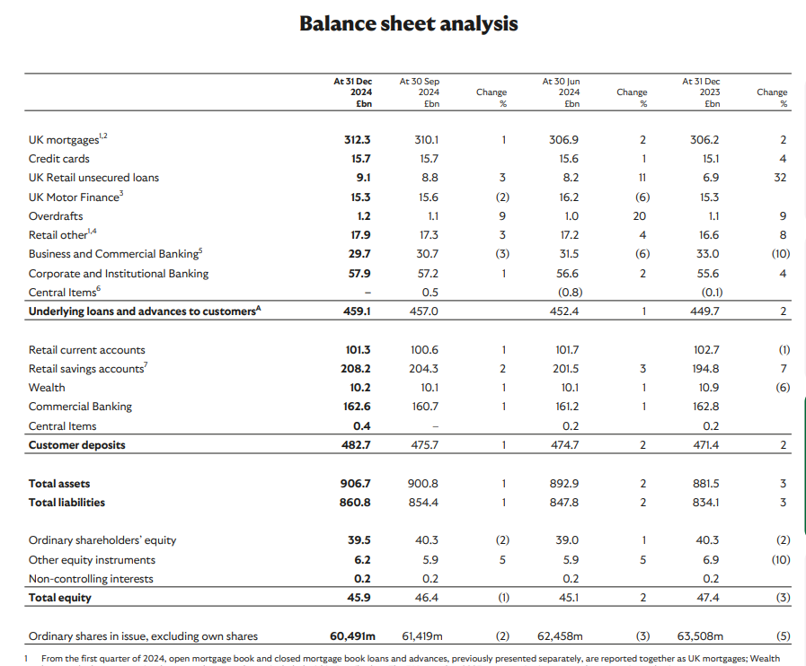
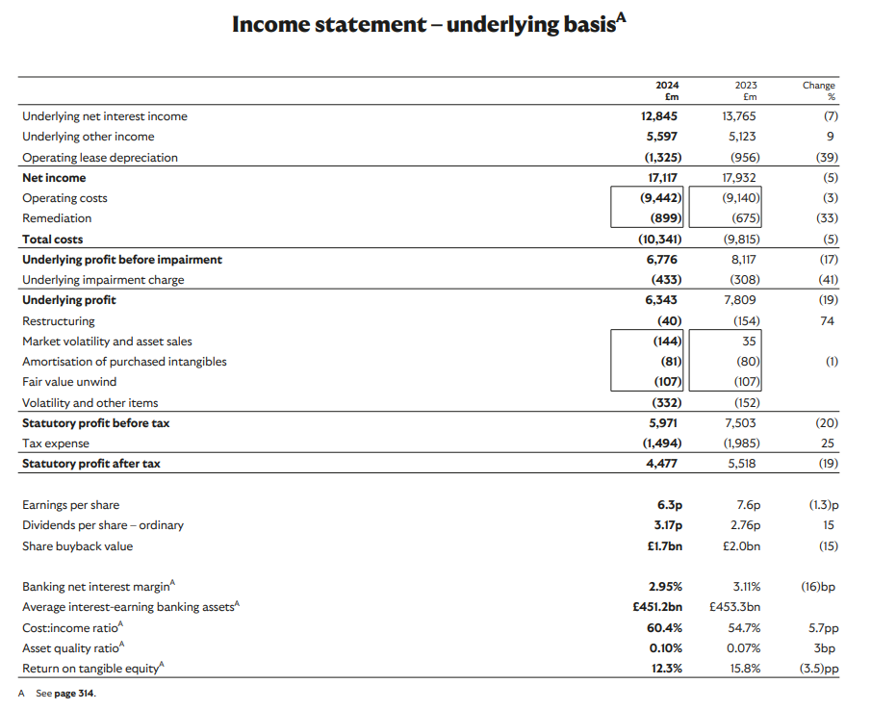

Ratio analysis
  Ratio
  Formula
  2023 Calculation
  2024 Calculation
  Net Profit Margin
  Net Income ÷ Revenue
  4,477 ÷ 34,281 = 13.06%
  4,477 ÷ 34,281 = 13.06%
  ROCE
  PBT ÷ (Total Assets – Current Liabilities)
  7,500 ÷ (906,697 – 482,700) = 1.77%
  5,971 ÷ (906,697 – 482,700) = 1.41%
  Loan-to-Deposit Ratio
  Loans ÷ Deposits
  449,700 ÷ 471,400 = 95.4%
  459,100 ÷ 482,700 = 95.1%
  LCR
  High Quality Liquid Assets ÷ Net Cash Outflow
  Stated in Annual Report = 142%
  Stated in Annual Report = 146%
  CET1 Ratio
  Core Equity ÷ Risk-Weighted Assets
  Stated in Annual Report = 13.7%
  Stated in Annual Report = 14.2%
  Cost-to-Income Ratio
  Operating Costs ÷ Operating Income
  9,300 ÷ 19,400 = 47.9%
  9,300 ÷ 12,600 = 73.7%
  EPS
  Net Income ÷ Shares Outstanding
  4,477m ÷ ~235bn shares = 1.9p
  2,360m ÷ ~235bn shares = 1.0p
  Dividend Yield
  Dividend per Share ÷ Share Price
  2.76 ÷ 42.3p = 6.5%
  3.17 ÷ 42.3p = 7.5%

