

Module: Problem Solving and Innovation
Module Code: BMSW4014
Programme: Certificate of Higher Education in Employability Skills
Lecturer: Chris Wilkin
Student Name: Fanni Kelemen
Student Number: 2508276
University: University of Wales Trinity Saint David
Submission Date: 12 June 2026

AI acknowledgement
I acknowledge the use of the UWTSD library Research Assistant (https://librarysearch.uwtsd.ac.uk/) for research purposes. Using the prompts: AI washing in Big Tech
I acknowledge the use of ChatGPT (https://chatgpt.com/) for research purposes. Using the prompts: Find me 10 recent sources that discuss AI washing. (See appendix B)
AI washing in Big Tech, what are three key recommendations for improving transparency and accountability when companies make AI-related claims? (See appendix B)
Can you explain how Microsoft uses AI in its products and why some critics argue that companies may exaggerate their AI capabilities? (See appendix B)
I confirm that I have not presented any AI generated text as my own work. I confirm that I have copies of my drafts, notes, and other resources I used before, and after the use of AI tools which I may be asked to provide in evidence.

Speaker Notes
Slide 1 Research on AI Washing in Big Tech
Good afternoon. This presentation is about AI washing in Big Tech, with a focus on Microsoft. AI washing happens when companies exaggerate their use of artificial intelligence to appear more innovative or attract investors. As AI becomes more popular, concerns about misleading AI claims have increased. This presentation looks at AI washing, its connection to greenwashing, and how it may affect Microsoft.

Slide 2 What Research Has Been Performed and What Has Been Found Out?
Researchers have become more interested in AI washing in recent years. Studies examine how companies talk about AI and whether their claims are accurate. Research suggests that some organisations may overstate the role of AI in their products and services. These practices can affect customer trust, investor confidence and company reputation.

Slide 3 From Greenwashing to AI Washing
AI washing is often compared to greenwashing. Greenwashing happens when companies exaggerate environmental claims to improve their image. AI washing is similar because companies may exaggerate AI capabilities to appear more advanced. Both practices can attract customers and investors, but they can also reduce trust if the claims are misleading.

Slide 4 Existing Research on AI Washing
Recent studies show that AI washing is becoming a growing issue in the technology industry. Elhajjar and Itani (2025) explain that AI washing can be caused by competition, market pressure and investor expectations. Their research suggests that companies may gain short-term benefits from exaggerated AI claims, but these practices can damage trust and reputation in the long term (Elhajjar and Itani, 2025).

Slide 5 AI Washing in Microsoft
Microsoft is an important example because AI is a major part of its business strategy. The company promotes products such as Microsoft Copilot and has invested heavily in AI development. Research suggests that companies may emphasise AI capabilities to attract investment and maintain market confidence. According to Rady et al. (2025), AI-related hype can help organisations gain resources and investor support.

Slide 6 Microsoft and AI Transparency
Microsoft has responded to concerns about AI washing by introducing Responsible AI standards and publishing transparency reports (Microsoft, 2025). These actions aim to improve trust and accountability. However, researchers still highlight concerns about transparency and the accuracy of AI-related claims in the technology sector (Ozturkcan and Bozdağ, 2025).

Slide 7 Financial and Market Pressures on Microsoft
Financial pressure is an important factor in AI washing. Microsoft’s value is strongly linked to expectations about AI growth. Investors want evidence that companies are successfully using AI technologies. Rady et al. (2025) argue that investor expectations may encourage firms to focus heavily on AI messaging. Yang (2026) also suggests that AI washing may influence company value by encouraging firms to exaggerate AI capabilities. This shows how market pressure can contribute to AI washing.

Word count: 468

AI Use Critique
During the research phase of this presentation, I used ChatGPT as a supplementary research tool to explore the topic of AI washing in Big Tech. The AI was primarily used to identify potential sources, generate ideas for further investigation, suggest recommendations for improving transparency in AI-related communication, and provide background information on Microsoft’s use of artificial intelligence technologies.
One advantage of using ChatGPT was its ability to quickly generate relevant research directions and summarise complex concepts in an accessible way. This helped me develop a clearer understanding of AI washing and identify areas that required further investigation. However, the tool also had significant limitations. Some suggested sources required verification, while certain claims lacked sufficient academic evidence or contained incomplete information. This highlighted the risk of relying on AI-generated content without critical evaluation.
To ensure academic reliability, all information generated by ChatGPT was independently checked using the UWTSD Library Search platform and other credible academic sources. Only verified references were included in the final presentation. The AI therefore acted as a starting point rather than a source of final content. The selection of sources, critical evaluation of Microsoft Copilot, synthesis of evidence, and final conclusions were completed through independent research and personal academic judgement.
Overall, ChatGPT was a useful research support tool, but its outputs required careful verification before being used in an academic context.

word count: 218

Presentation Slides

Slide 1

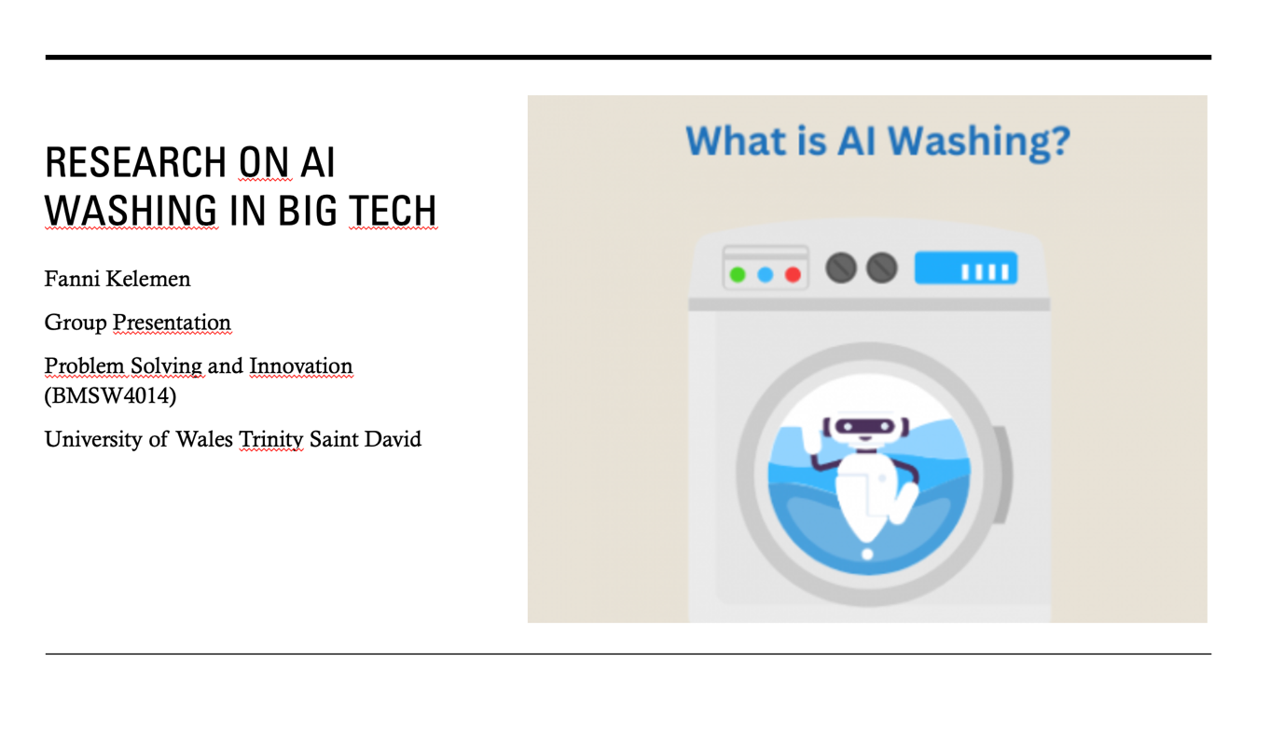

Slide 2

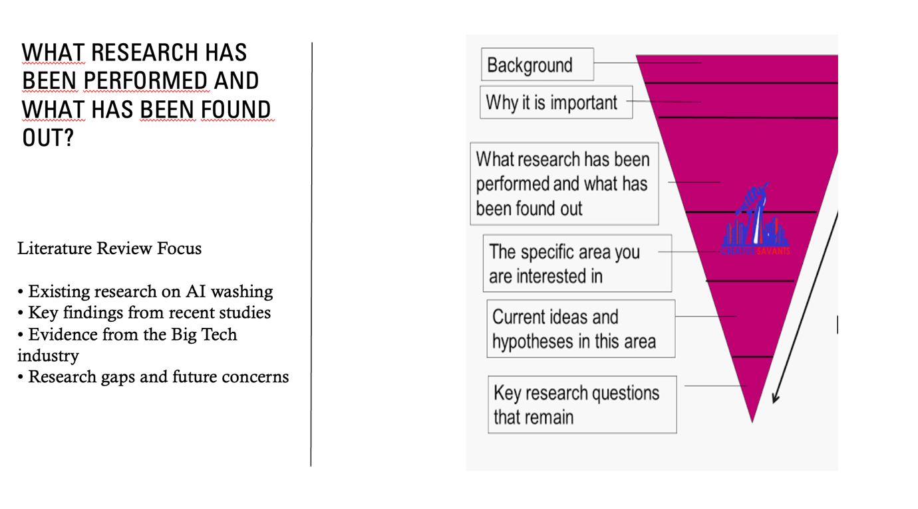

Slide 3

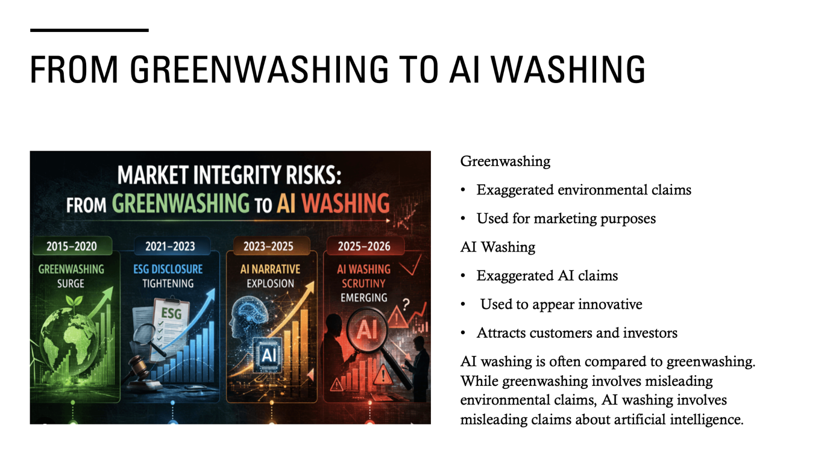

Slide 4

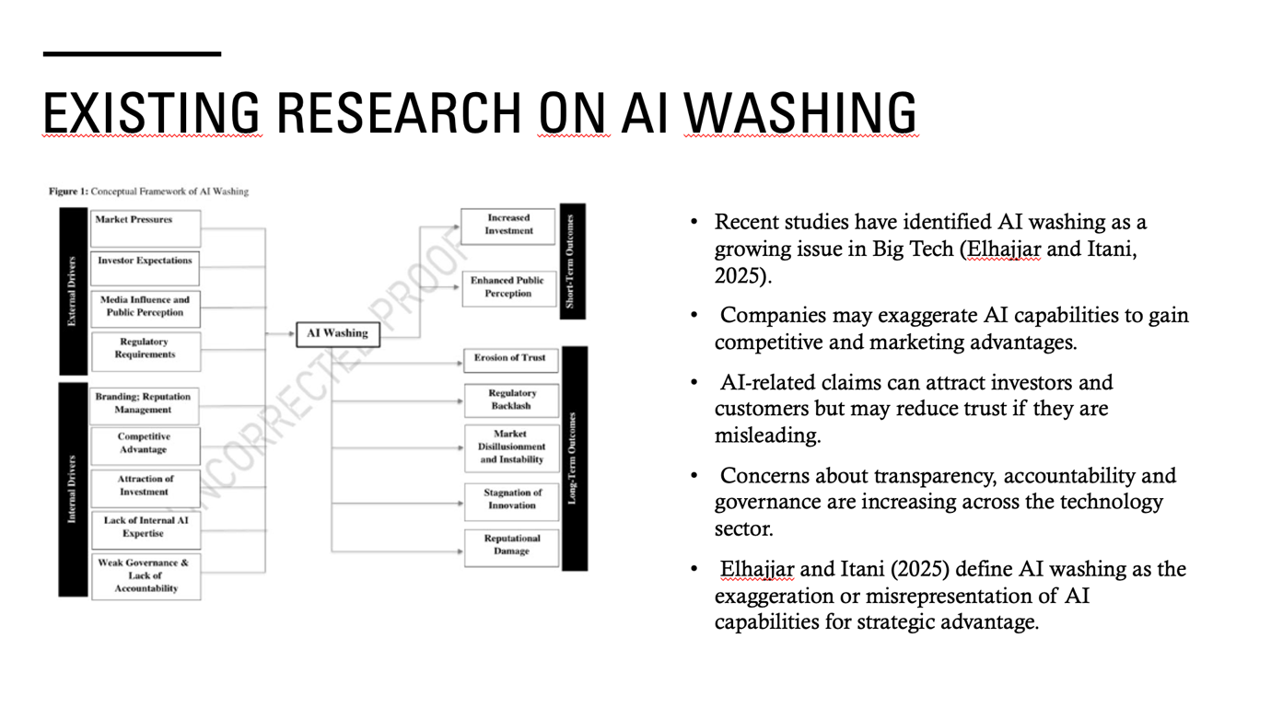

Slide 5

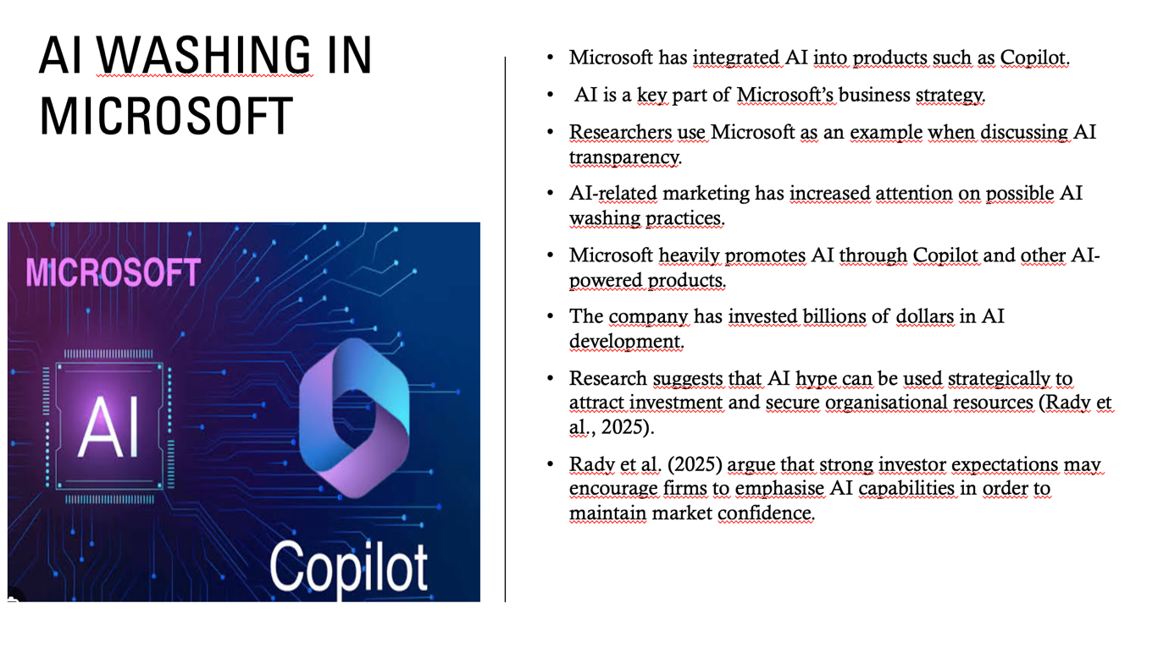

Slide 6

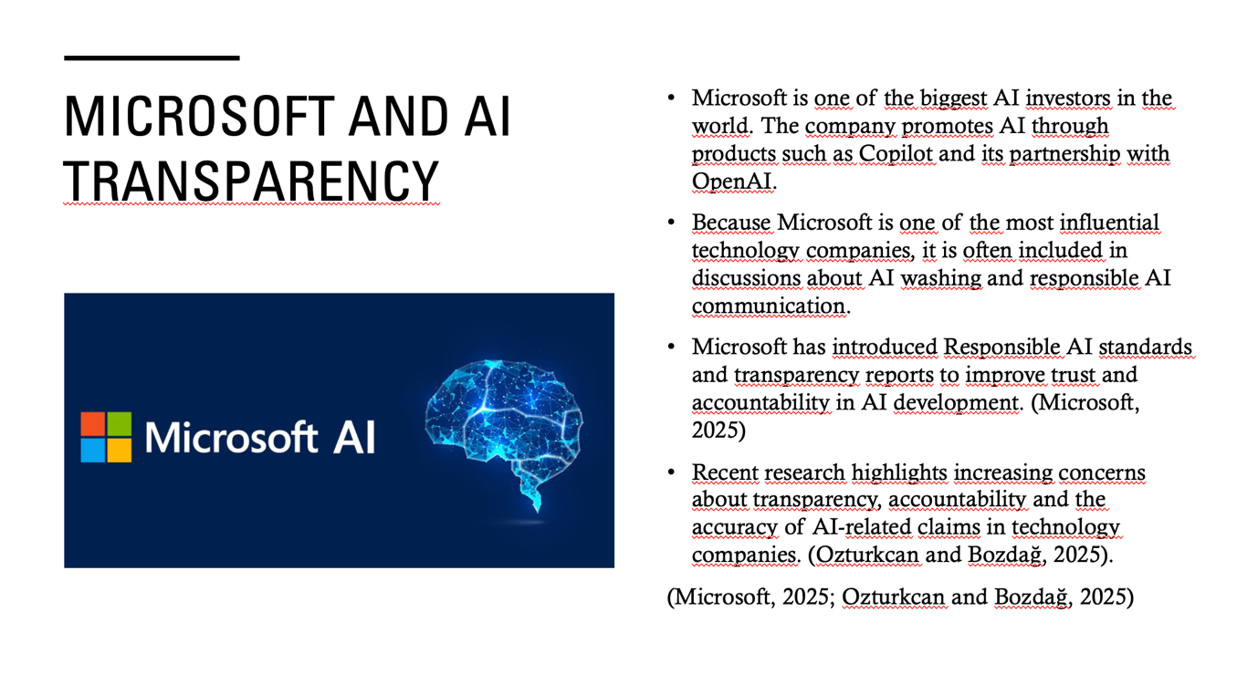

Slide 7

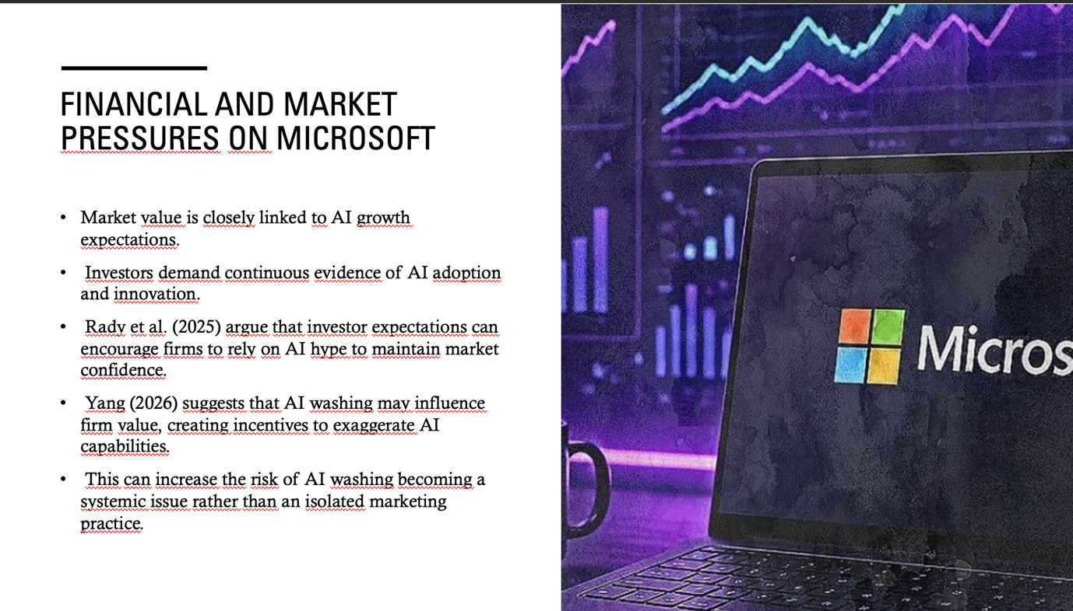

Slide 8

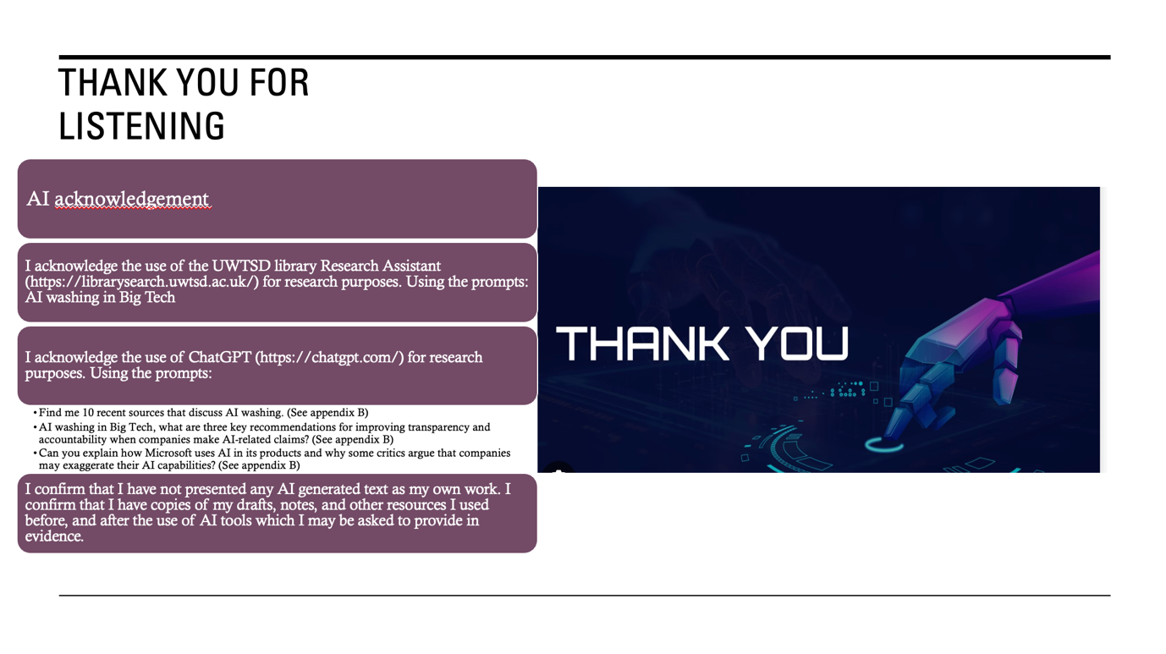

Slide 9

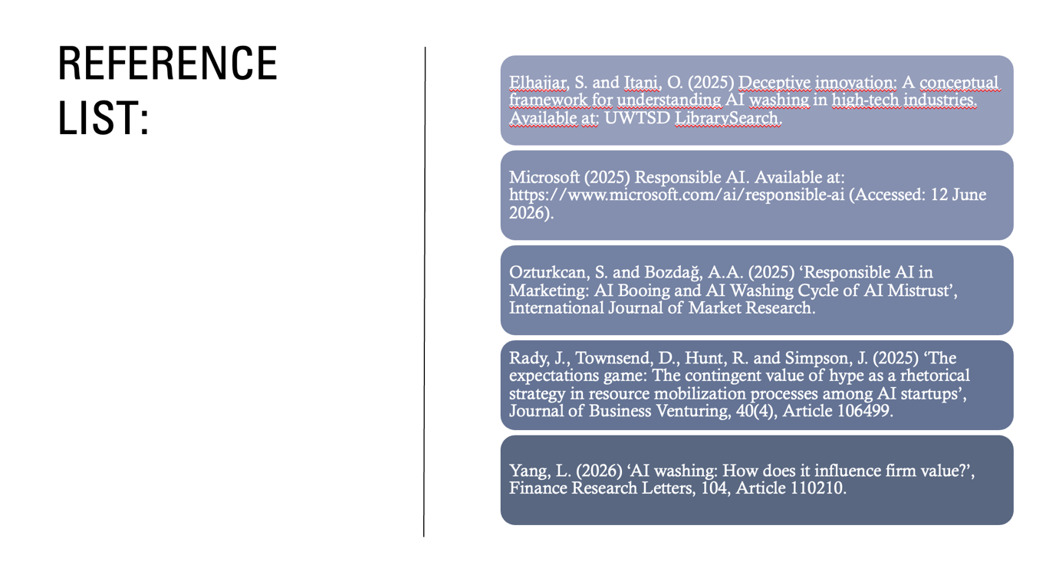

Appendix,AIConversationEvidence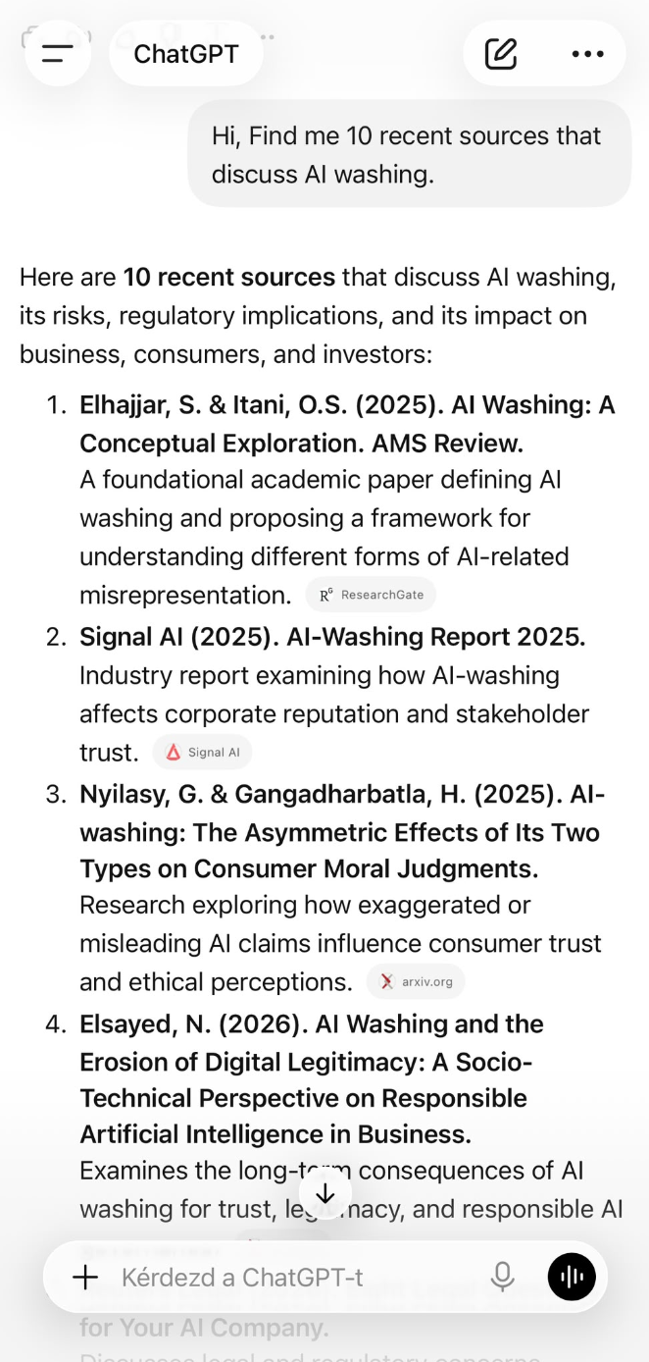
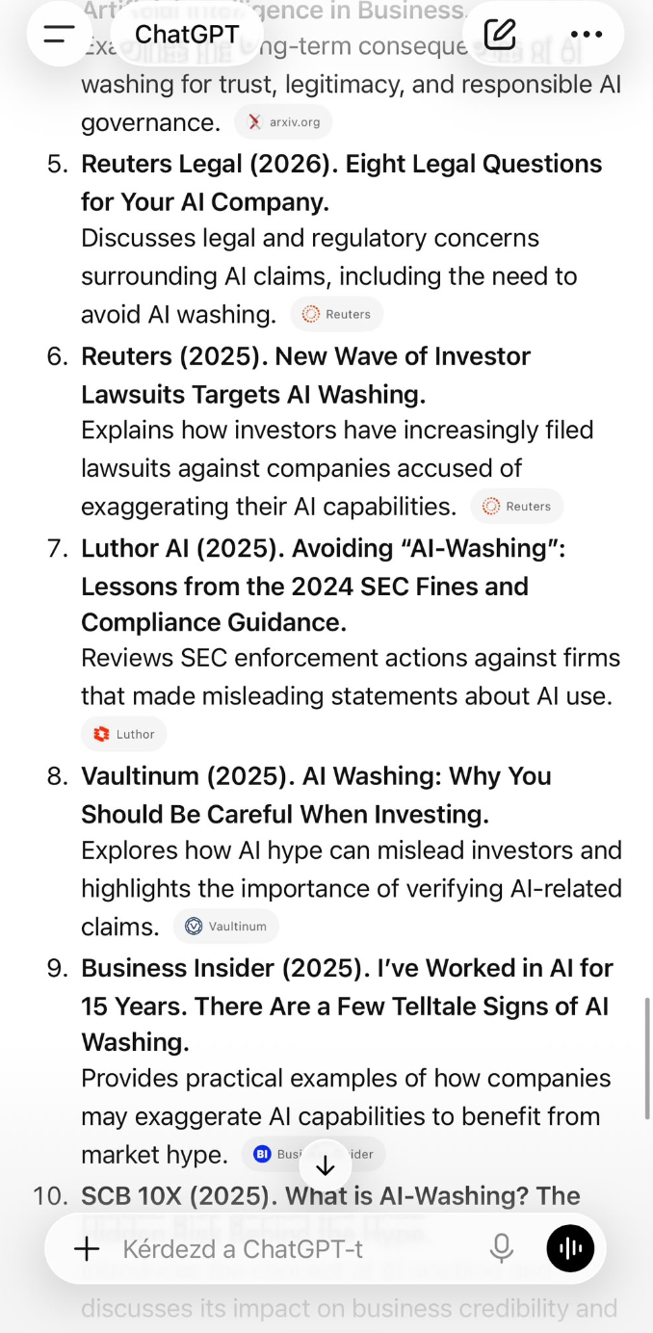
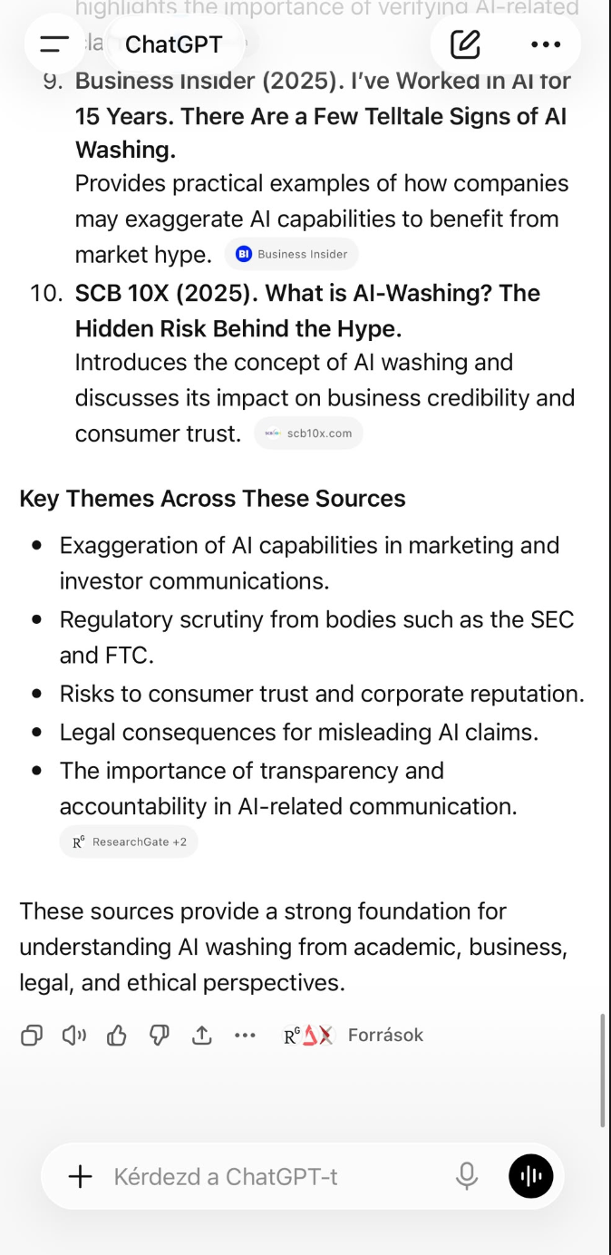
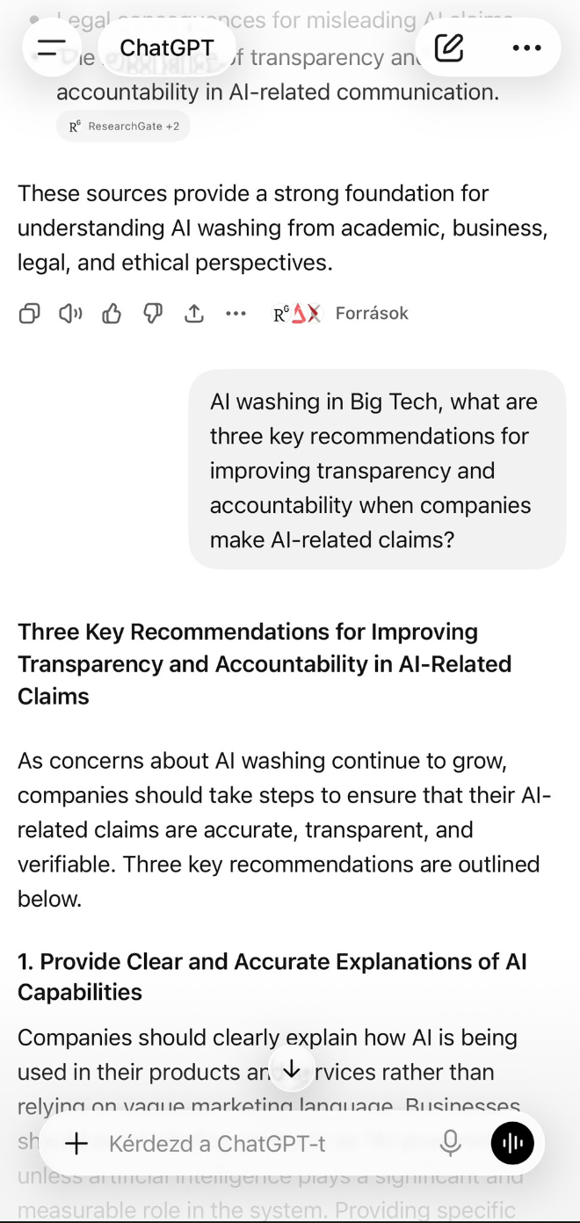
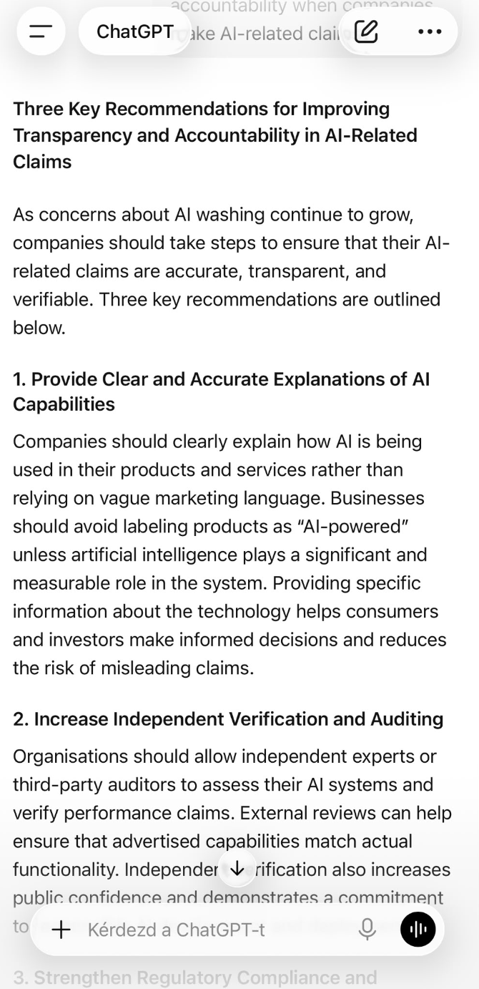
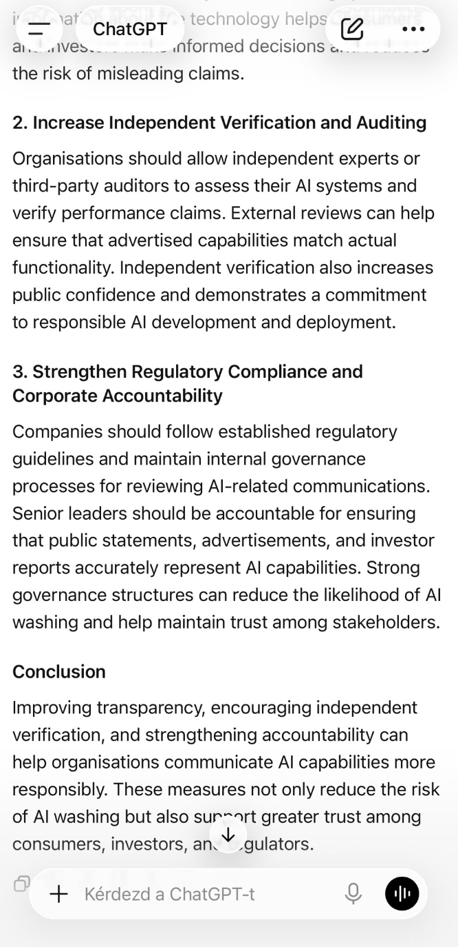
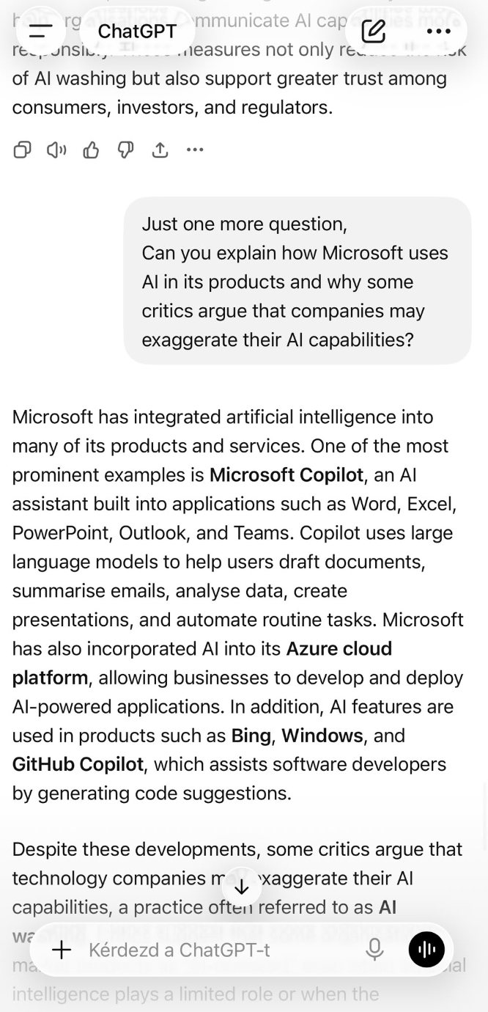
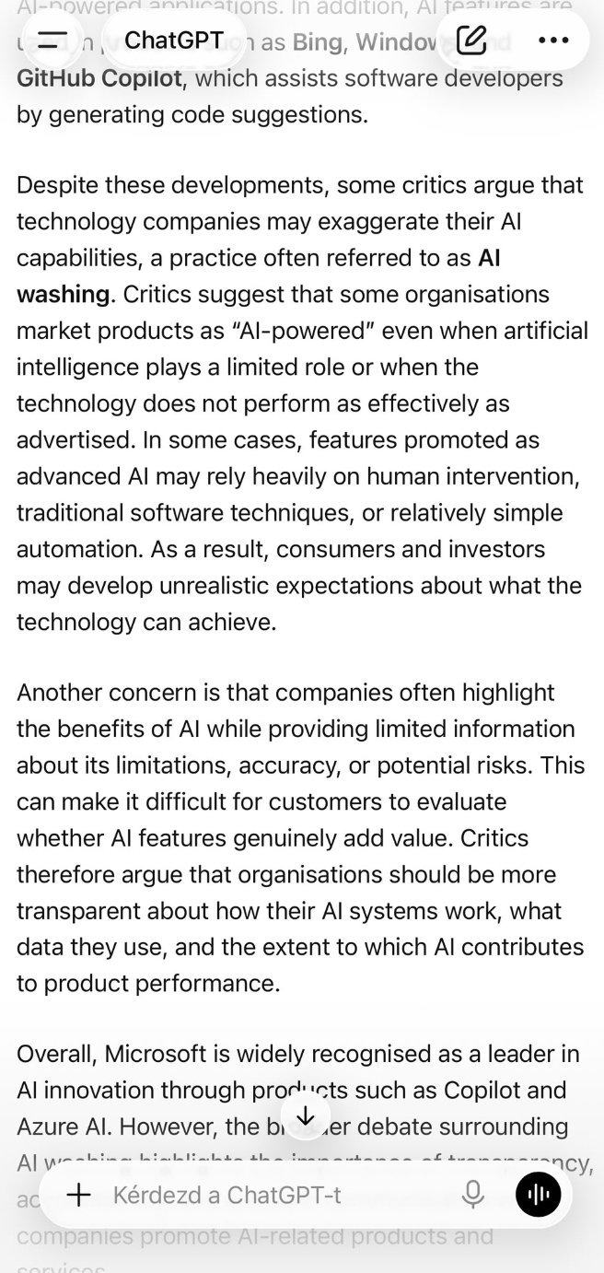
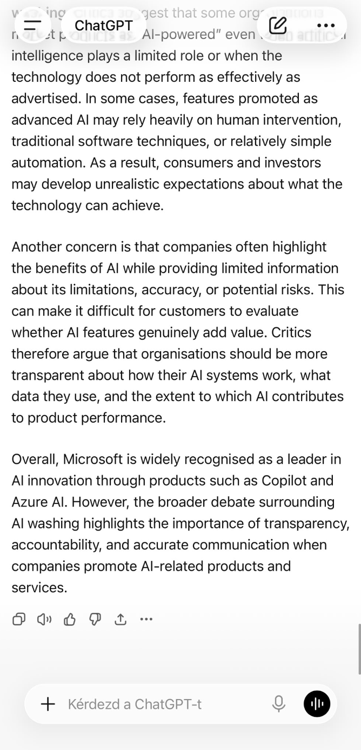

Reference list
Elhajjar, S. and Itani, O. (2025) Deceptive innovation: A conceptual framework for understanding AI washing in high-tech industries. Available at: UWTSD LibrarySearch.

Microsoft (2025) Responsible AI. Available at: https://www.microsoft.com/ai/responsible-ai (Accessed: 12 June 2026).

Ozturkcan, S. and Bozdağ, A.A. (2025) ‘Responsible AI in Marketing: AI Booing and AI Washing Cycle of AI Mistrust’, International Journal of Market Research.

Rady, J., Townsend, D., Hunt, R. and Simpson, J. (2025) ‘The expectations game: The contingent value of hype as a rhetorical strategy in resource mobilization processes among AI startups’, Journal of Business Venturing, 40(4), Article 106499.

Yang, L. (2026) ‘AI washing: How does it influence firm value?’, Finance Research Letters, 104, Article 110210.

