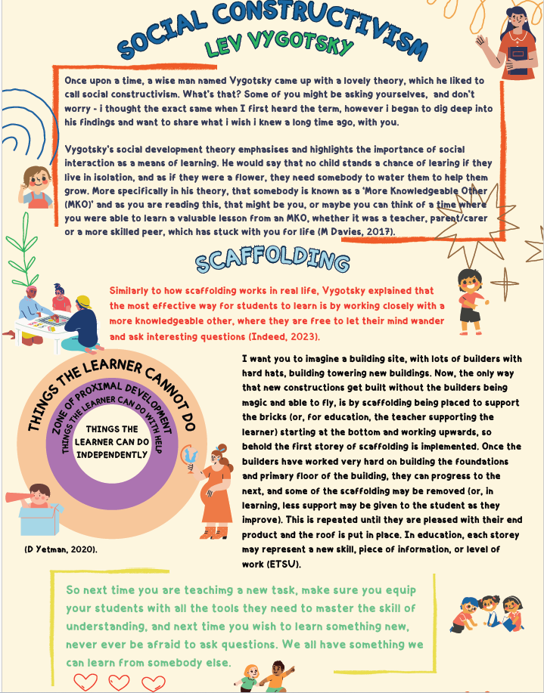

Blog 1 References
Michelle L. Davis, Jasper A.J Smits (2017): Social Constructivism https://www.sciencedirect.com/topics/psychology/social-constructivism
Daniel Yetman, medically reviewed by Timothy J Legg) (2020): What is the zone of proximal development? https://www.healthline.com/health/zone-of-proximal-development
ETSU – Vygotsky’s Theory https://etsu.edu/teaching/resources/more_resources/vygotsky.php
Indeed Editorial Team (2023): Vygotsky’s scaffolding: What it is and how to use it https://www.indeed.com/career-advice-development/vygotsky-scaffolding

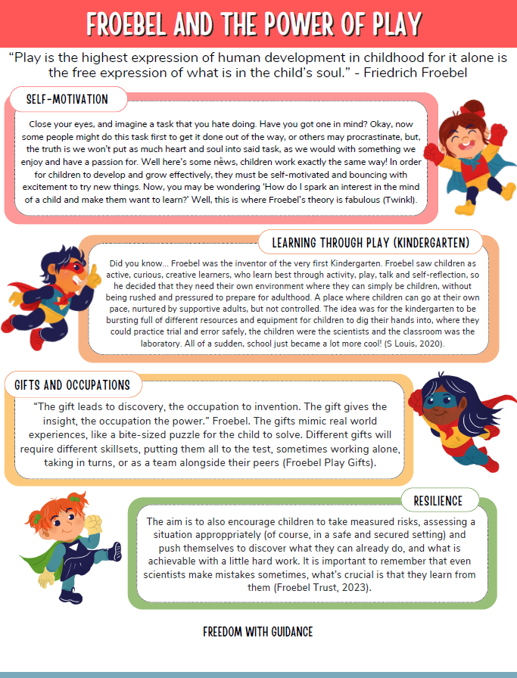

Blog 2 References
Dr Maria Cooper (2023): Froebel Trust – Froebelian Principles https://www.froebel.org.uk/uploads/documents/froebel-trust-research-highlight_babies.pdf
Dr Stella Louis and Dr Sacha Powell (2020): About Friedrich Froebel, who invented “Kindergarten” https://www.froebel.org.uk/about-us/the-power-of-play/about-friedrich-froebel
Play and Playground encyclopaedia: Froebel gifts (Op. cit, “Froebel Play Gifts”) https://www.pgpedia.com/f/froebel-gifts
Twinkl: What is Froebel’s Play Theory? Froebel's Theory | Froebel's Approach and Outdoor Play Ideas (twinkl.co.uk)

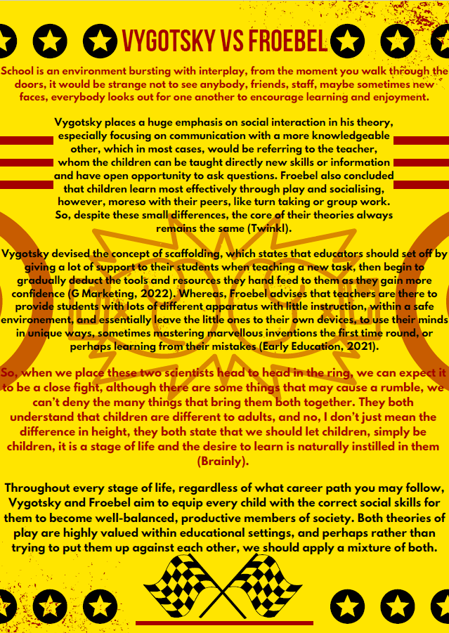

Blog 3 References
Mia Zo, Brainly (2018): How do Lev Vygotsky and Friedrich Froebel’s ideologies compare? https://brainly.com/question/11263036
Early Education (2021): Friedrich Froebel (1782-1852) https://early-education.org.uk/friedrich-froebel/
Gowrie Marketing (2022): Lev Vygotsky’s theory of child development – Gowrie NSW https://gowriensw.com.au/thought-leadership/vygotsky-theory?hs_amp=true
Twinkl: What are play theories in early years? https://www.twinkl.co.uk/teaching-wiki/play-theories-in-early-years



