GDD – Horror Game - Steve Ace
Game Title: Sanatorium
Target Platforms: Windows PC

Target Age of Players: 12+
Intended ESRB Rating: T = Teen

Intended PEGI Rating: Pegi 12
Project description:
- A single level of a 3d game.
- Created in Unreal Engine.
- Set in a horror theme/genre.
- Takes place in a Hospital/Sanatorium map.
Game Story:
The player wakes up in a hospital bed, not knowing how they got there, looking around for somebody in the hospital or a way out, discovers scary things happening in the hospital.
You have been possessed at the “Forest Hills Sanatorium” by a young girl named “Scary Mary” who died at the sanatorium
Once Spotted, the timer starts, 7 minutes to survive or escape.
Game Flow:
Single player, first person camera.
The Player awakens in a Sanatorium medical bed, in a single room.
Not knowing how they got there, they get up, and look around the room.
They find pickups and go outside their room to find out more.
The young possessed girl who haunts the Sanatorium, finds you have escaped and her voice screams out!
All the clocks in the map including the wrist watch pickup beep and change to a 7-minute countdown.
The player must survive or escape in this time or be killed and lose the game.
The player can escape by running jumping and surviving.

Unique Selling Points:
You can play as a male or female protagonist.
An exciting horror game

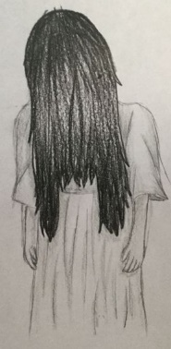
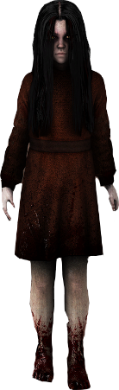

Characters:
- Young girl “Scary Mary” main Antagonist

- The player is the main Protagonist they have a selection of a male or female character before you start the game.

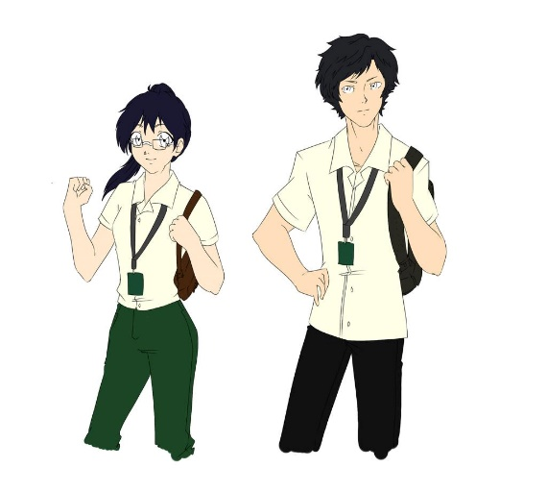

- Different character victims around the Sanatorium. Victims locked in other rooms.
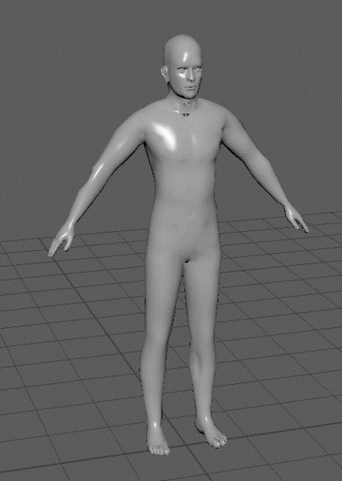

Character/Game Controls:
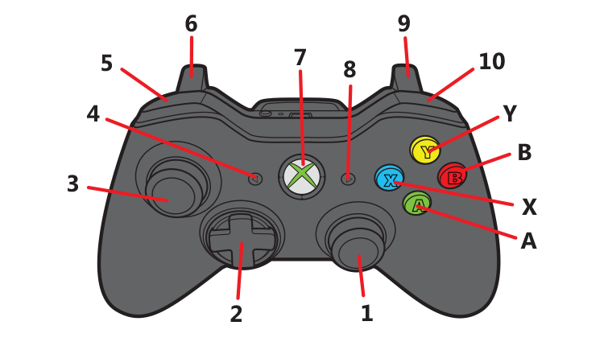

Gamepad:
- Aim/Look around
- Dpad: Movement
- Player Movement/Push in Crouch
- Back button: Inventory
- Lb shoulder trigger: Select next item left in hotbar.
- Left trigger: Push Object
- Home button: Usual functionality on windows.
- Start: Pause
- Right trigger: Sprint
- Right shoulder trigger: Select Next item right in hotbar.
Y: Flashlight/Lantern on/off
B: Kick
X: Bandage to stop bleeding.
A: Jump
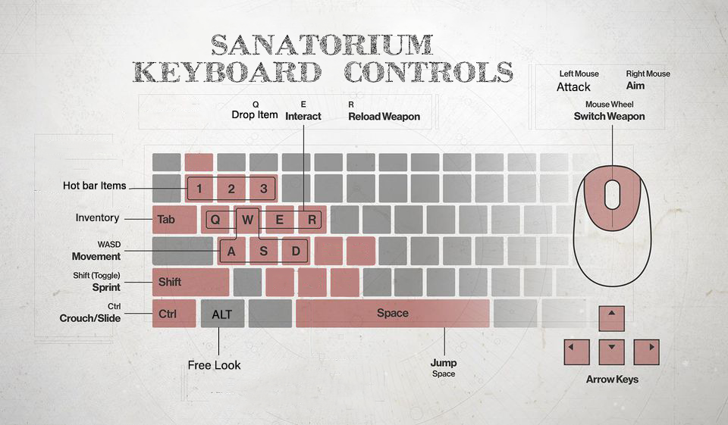
Keyboard Controls:

References:
Google images.
Fear 2 my favourite horror game.
The film: The Ring
Assets:
Collected from various sources until the creation of own models/assets replaces them in the future.
https://www.turbosquid.com/ / https://www.cgtrader.com/ / https://www.cadnav.com/
Unreal Marketplace
Theme:
This is a game about horror/being scared, set in a hospital.
Gameplay:
The player must survive the countdown clock or escape.

Taken from the book: The Art of Game Design – A Book of Lenses 2nd Edition p122-123
This section of the book shows the 5 different things males and females like to see in video games.

Males
5. Trial and error: Women often joke that men hate reading directions, and there is some truth to that. Males tend to have a preference for learning things through trial and error. In a sense, this makes it easier to design interfaces for them, since they actually sometimes prefer an interface that requires some experimentation to understand, which ties into the pleasure of mastery.
Females
5. Learning by example: Just as males tend to eschew instructions, favouring a trial-and-error approach, females tend to prefer learning by example. They have a strong appreciation for clear tutorials that lead you carefully, step-by step, so that when it is time to attempt a task, the player knows what she is supposed to do.
My project ties itself well with the needs of male/female gamers, where you learn by trial and error.

User skills
>Gameplay mechanics –
Running, Jumping, using a torch/flashlight, Crouch for hiding, pushing weighted objects?
- Power-ups/Pickups: - torch, Bandage, wrist watch
- Collectibles?
- Enemies
- Boss character
>Challenge - to survive or escape in 7 minutes.
Challenge and Play – A difficult challenge in the sweet spot.
Conflict and choice – deciding whether to run or fight.
> Losing - If the player loses, there is a losing screen and the player can either restart or go back to the main menu.

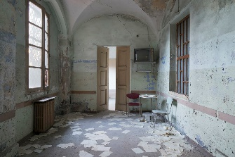
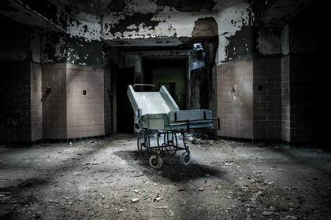
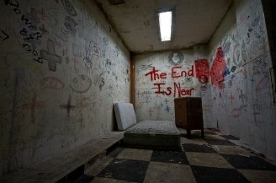
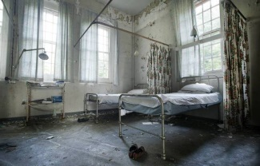
Art/Visual Style: A apocalyptic, ruin down, realistic style mixed with a modern hospital, 3d style.
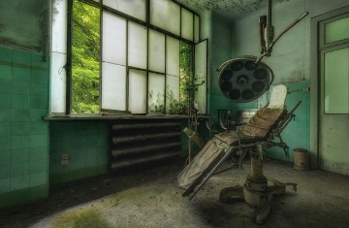
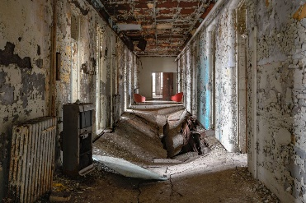
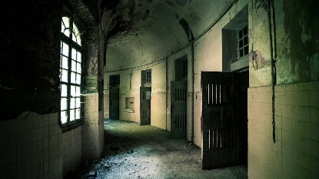

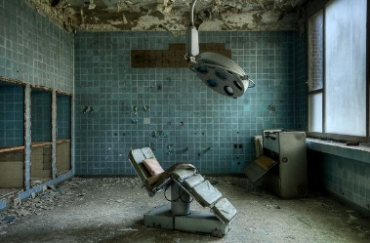
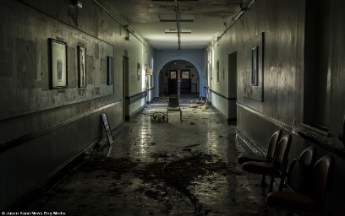
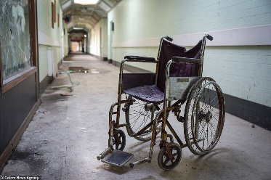

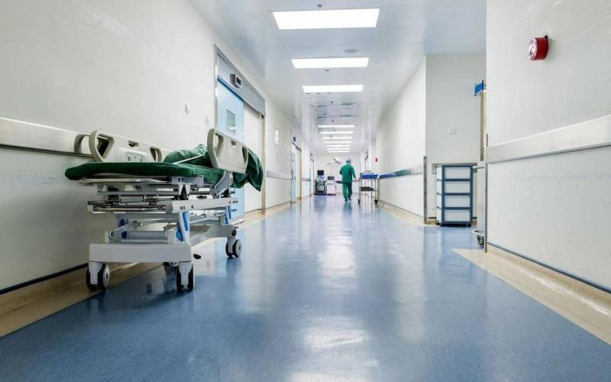
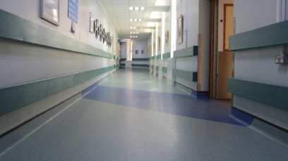
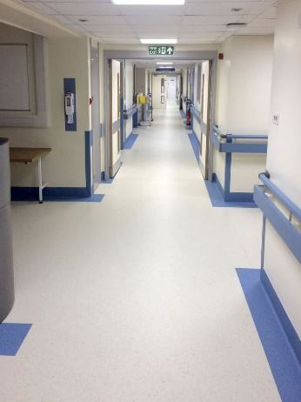
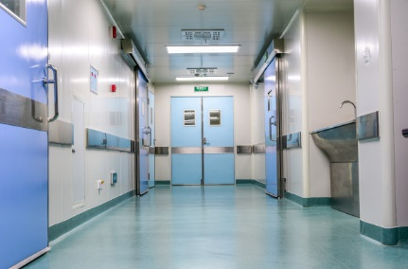
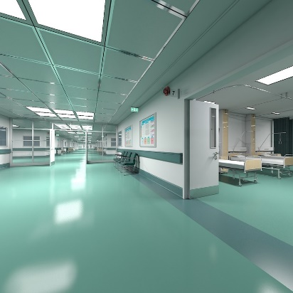


Music and Sounds:
- Menu Music: horror themed, maybe something with an organ?
- Ambience sound- stormy outside, lightning and cracks of thunder, rain?
- sounds effects/music when you are spotted and being chased.
- Footsteps? Sound of crickets outside?

Gameplay Experience:
Flowchart: Navigation of The Shell of the game.
Start Game

2D intro loading screen with slideshow of artwork/images

Attract Loop will be here!
Press Any Button/ Start

Main Menu

Exit
Options
Leaderboard
Load Game
Audio
Video
New Game

Controls
Select a load game
Enter name & pick character screen

Loading screen 2d artwork with controller config, to show player before the game starts.

Black Screen fades into vision pf the player and the game Starts.

Playing Game
Survive/Escape
Died – Death screen appears

Level Completed screen/leaderboard screen
Retry
Main Menu

Main Menu

Cutscenes:
After starting the game, there is a short 10 second in engine taken camera pan of the map and moves to the player camera first person position to start the game.
Death Screen:
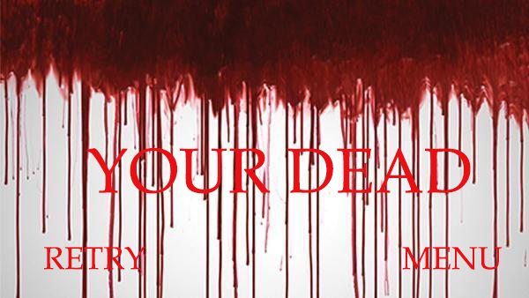

Technical Description:
Target Platform/Minimum Hardware:
Windows 10, Quad-core Intel or AMD processor, 2.5 GHz or faster. NVIDIA GeForce 470 GTX or AMD Radeon 6870 HD series card or higher. 8 GB RAM.
Its a pc game on windows, created in unreal engine with tools: Maya, substance designer, substance painter, bitmap 2 material.
Targeted to anyone over the age of 16, only in English language.
Bibliography
Rogers, S. 2014. Level up: The Guide to great video game design, Second Edition.
John Wiley & Sons, Ltd, UK

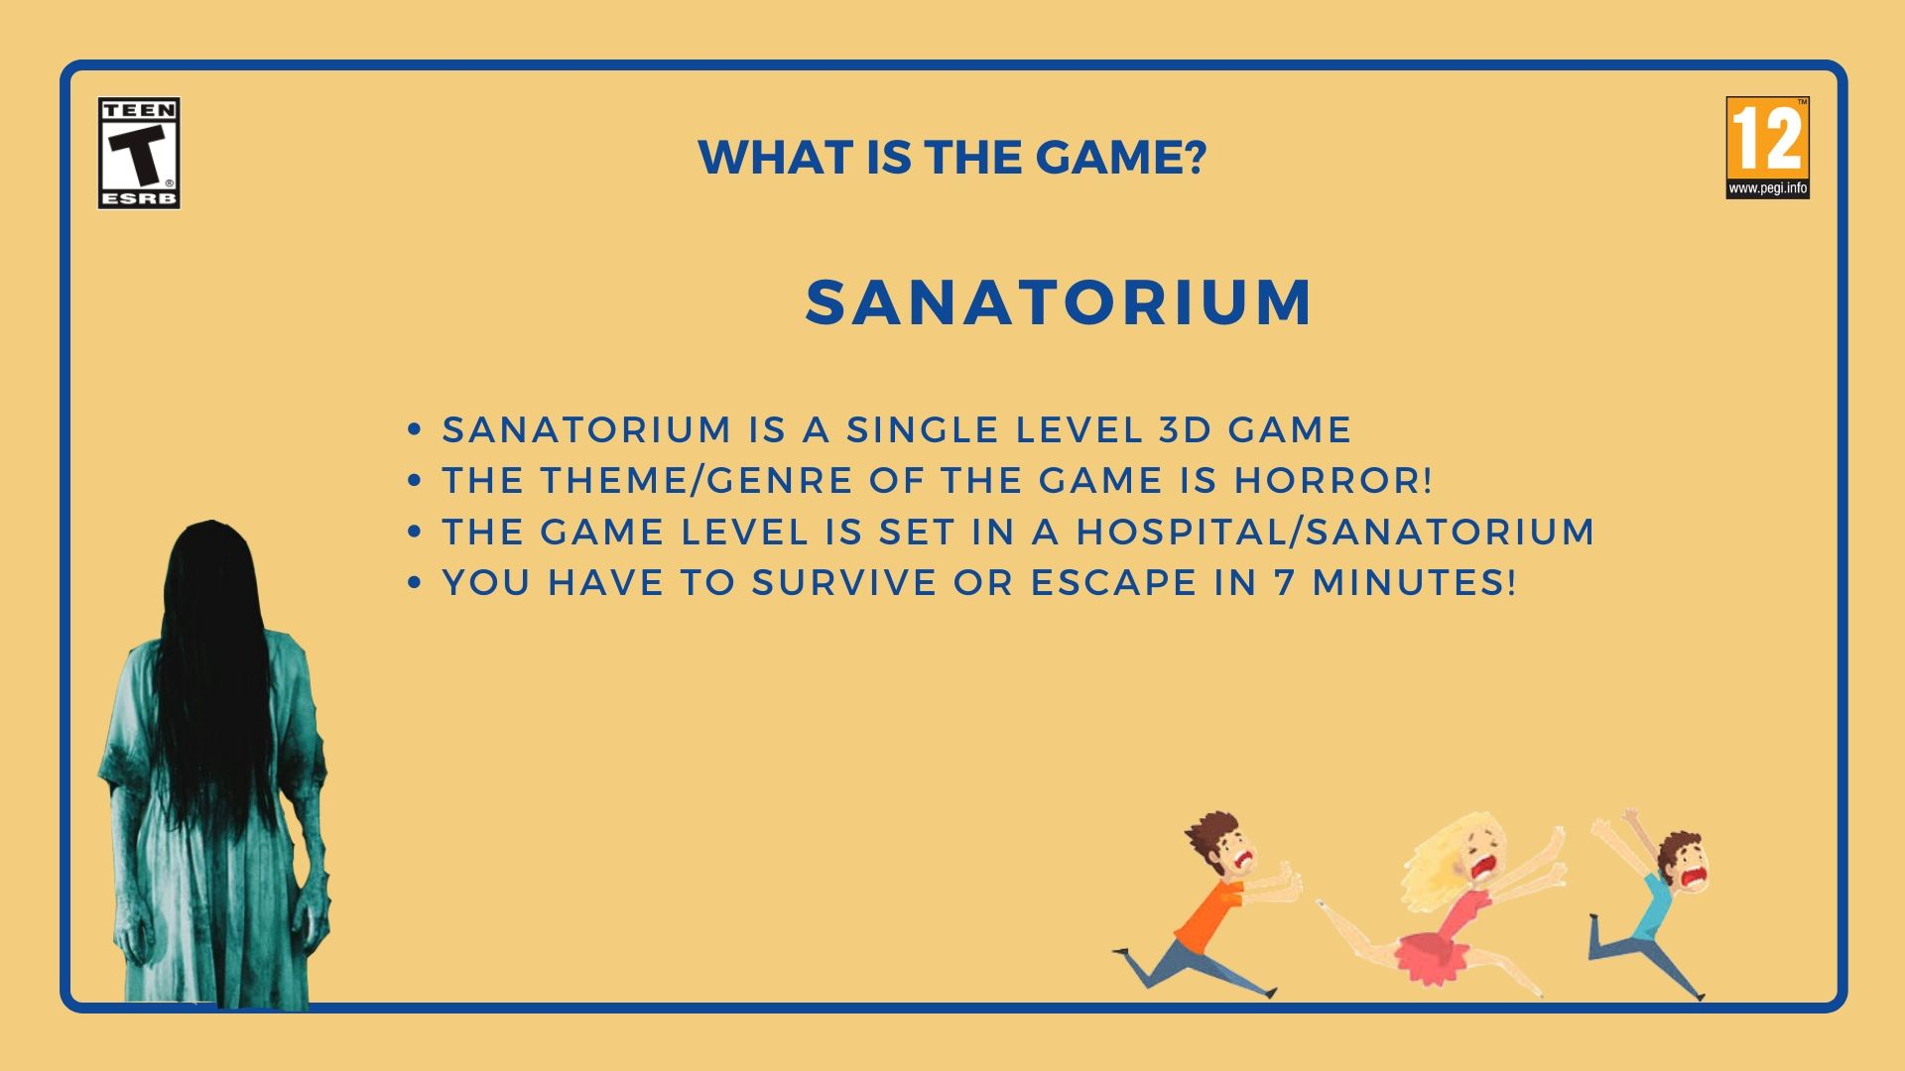
Game Presentation
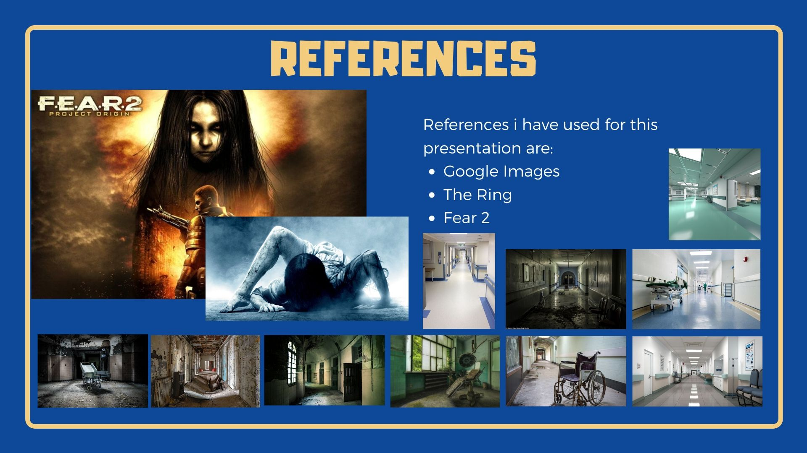
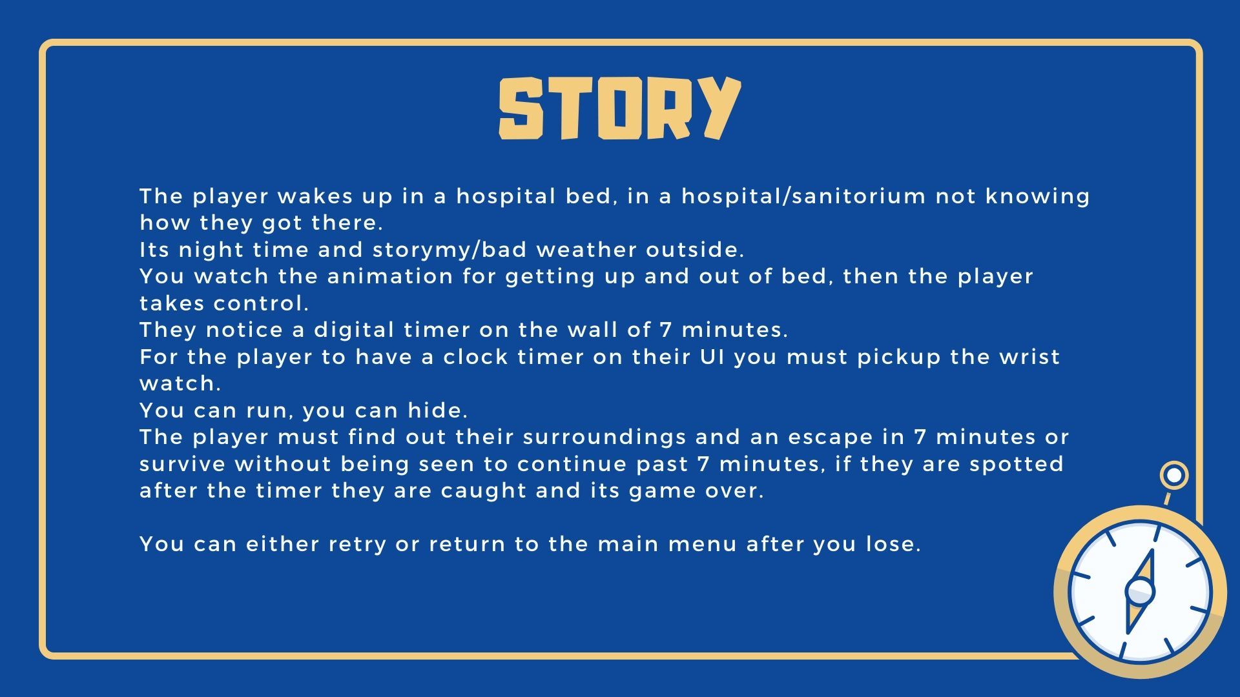

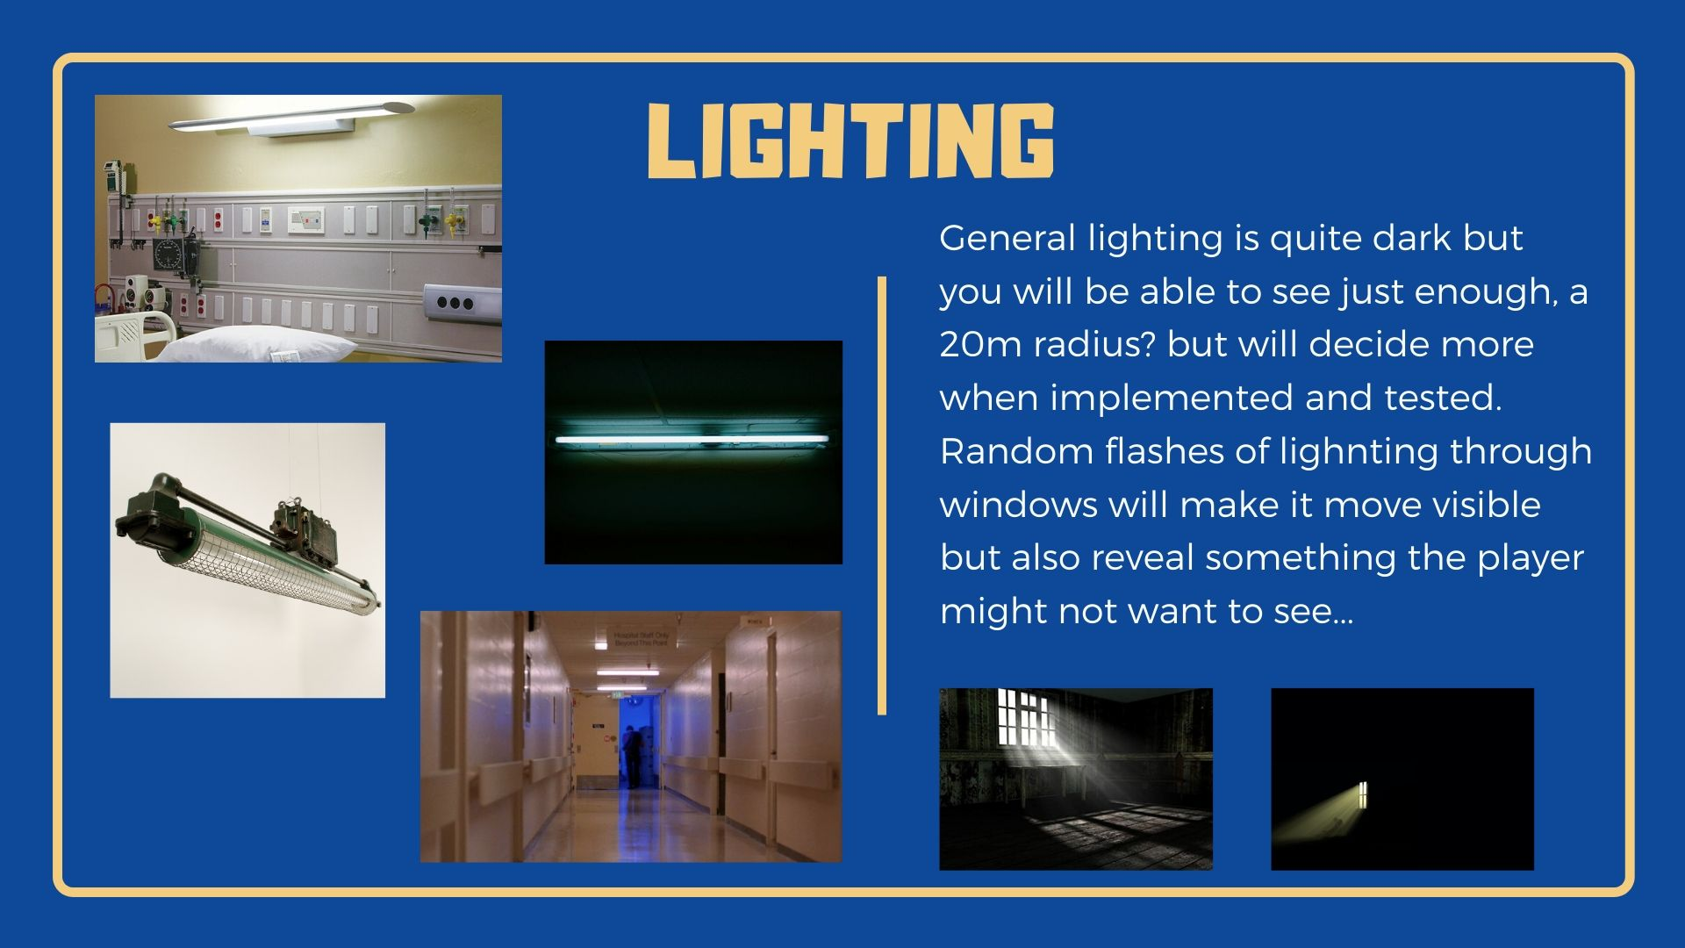
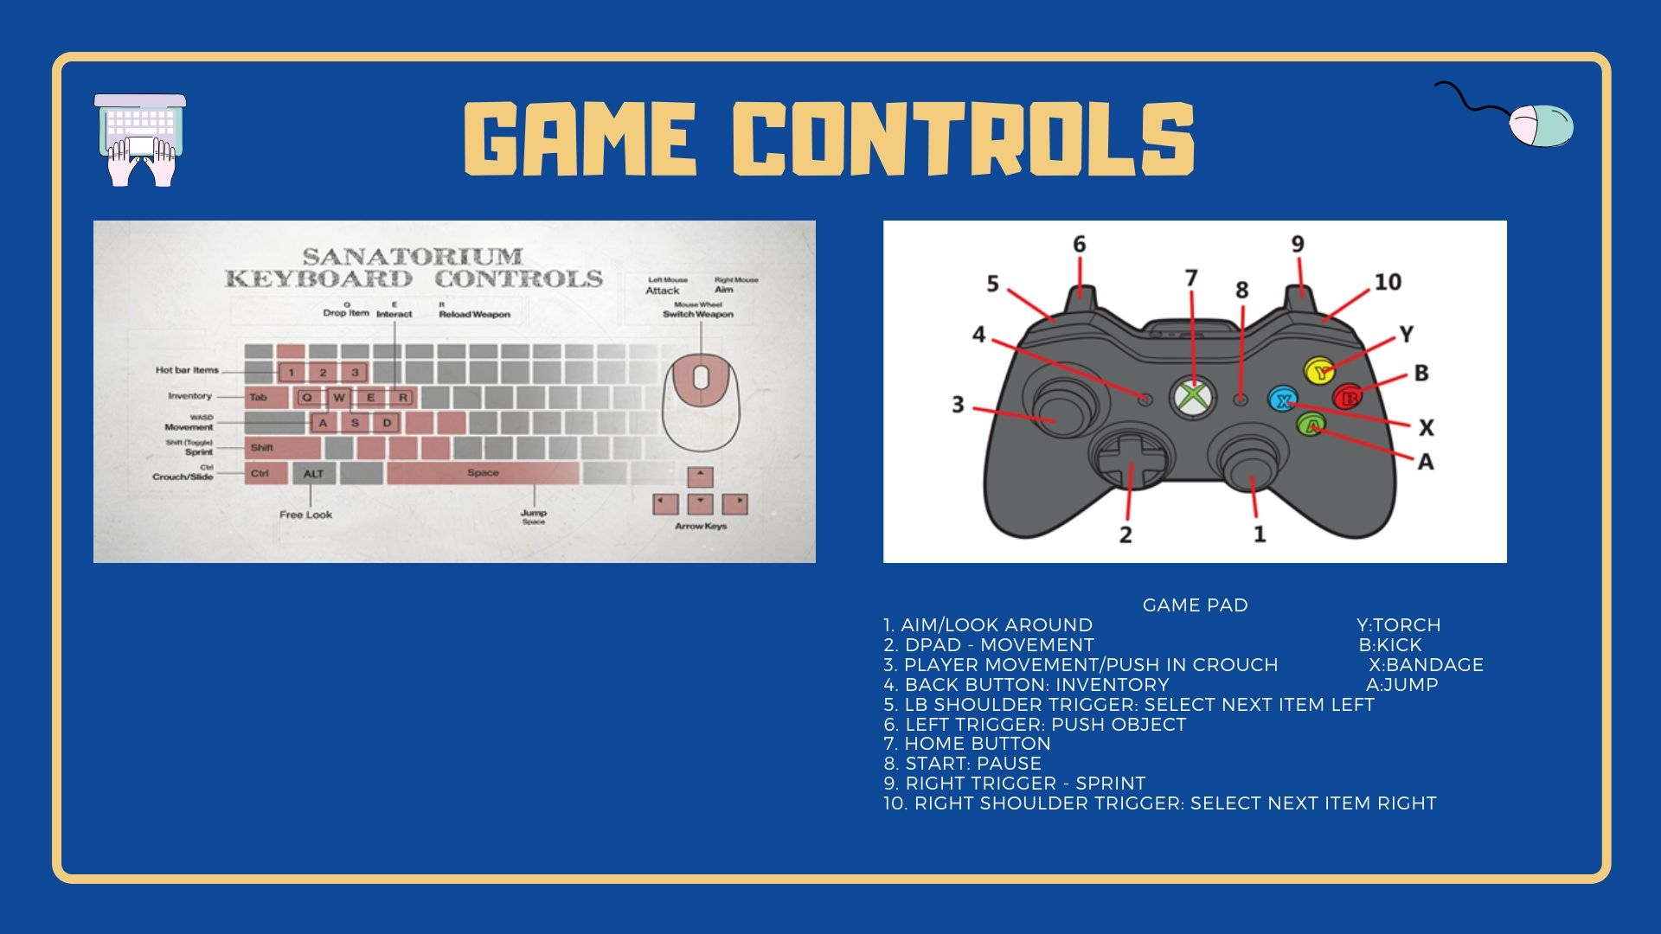

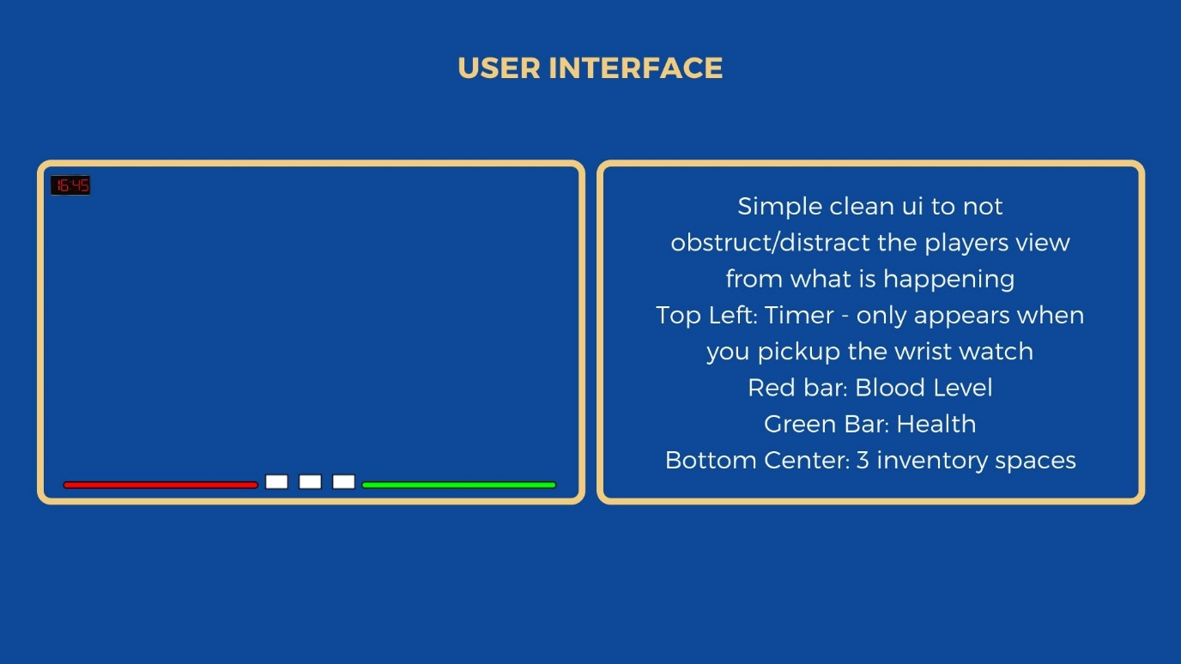
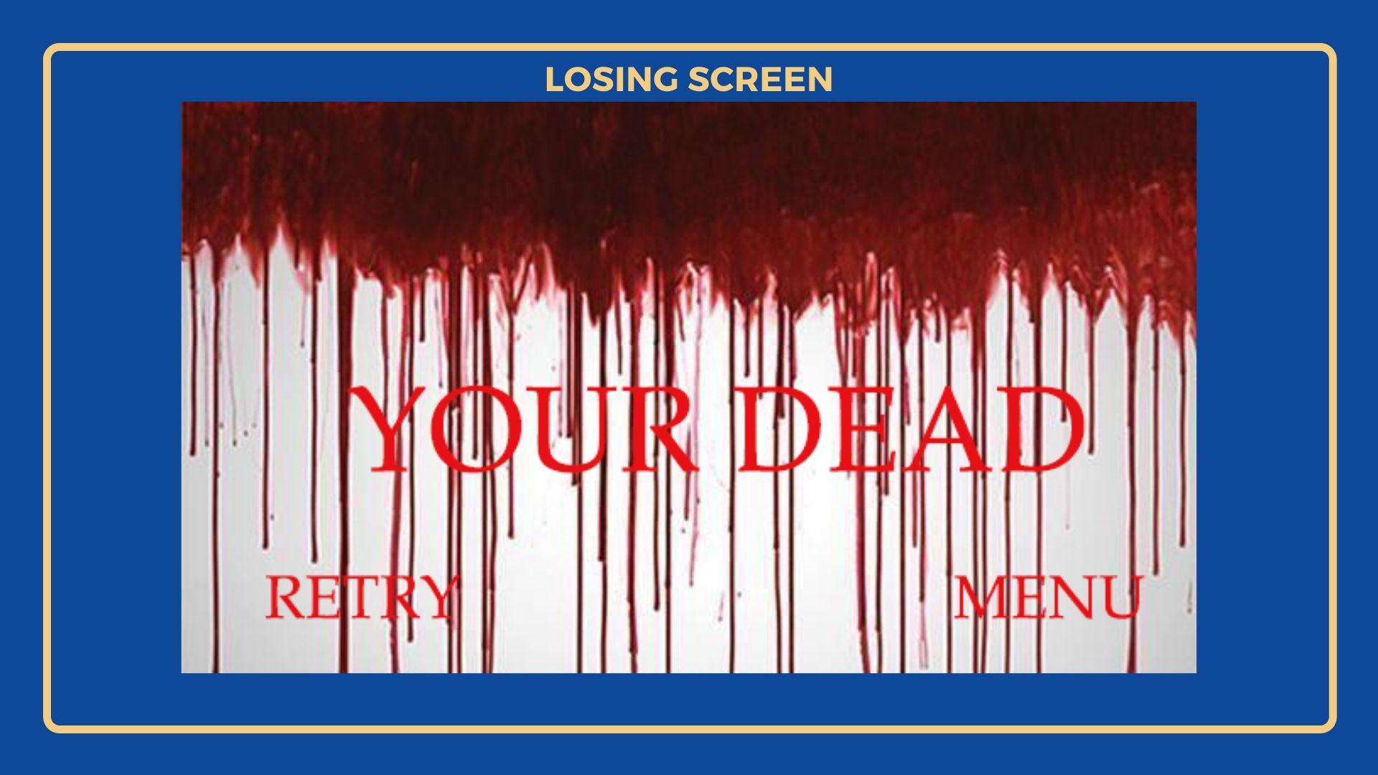

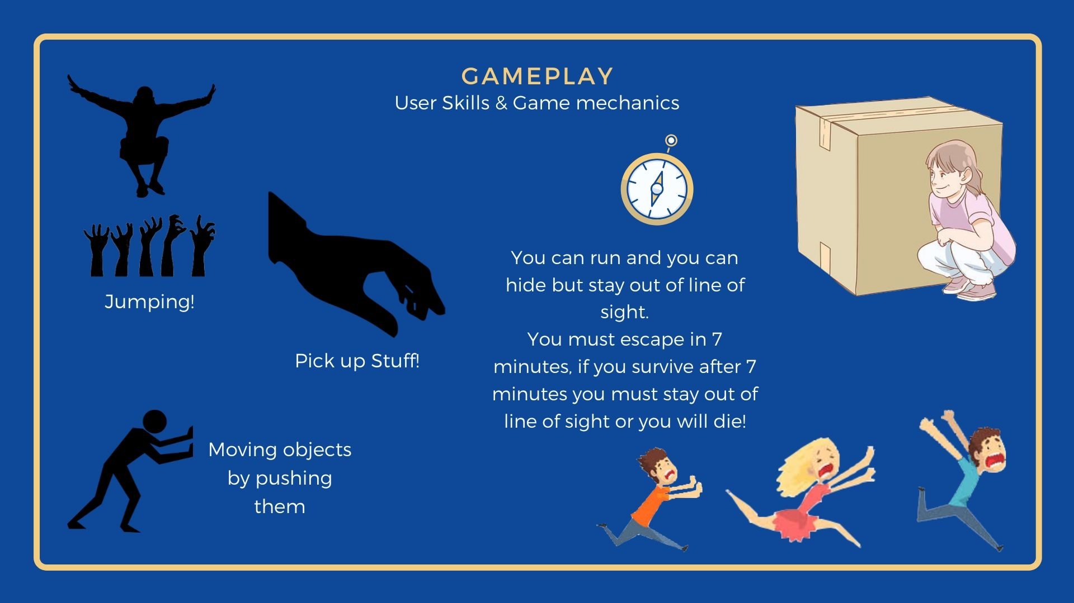
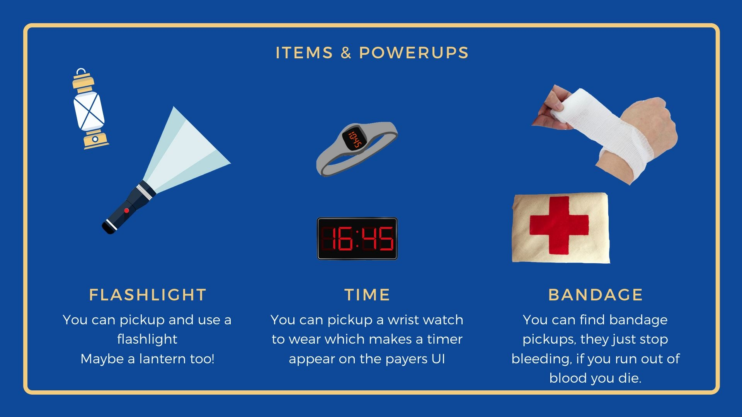

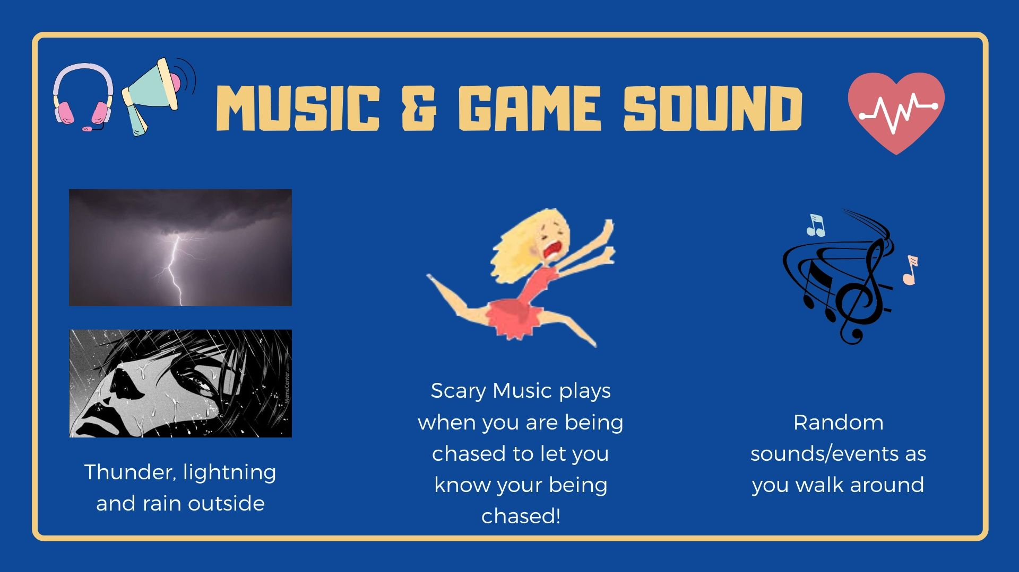
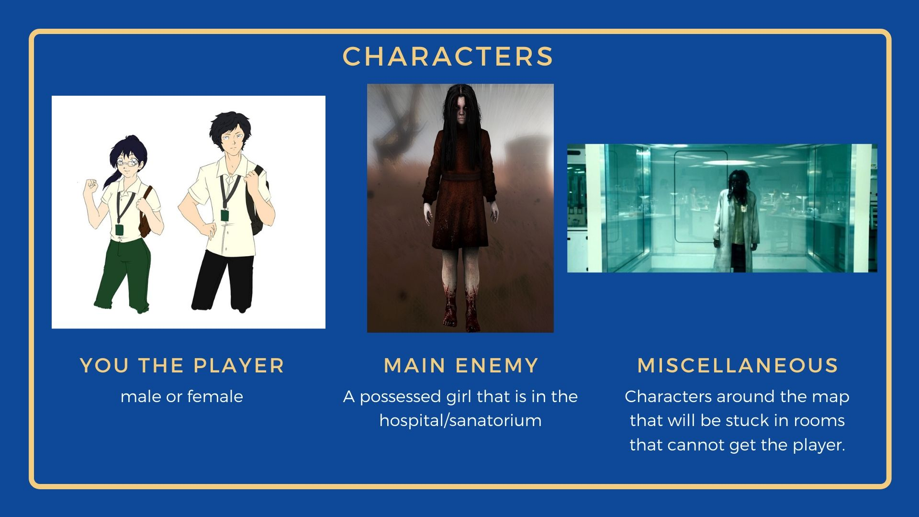

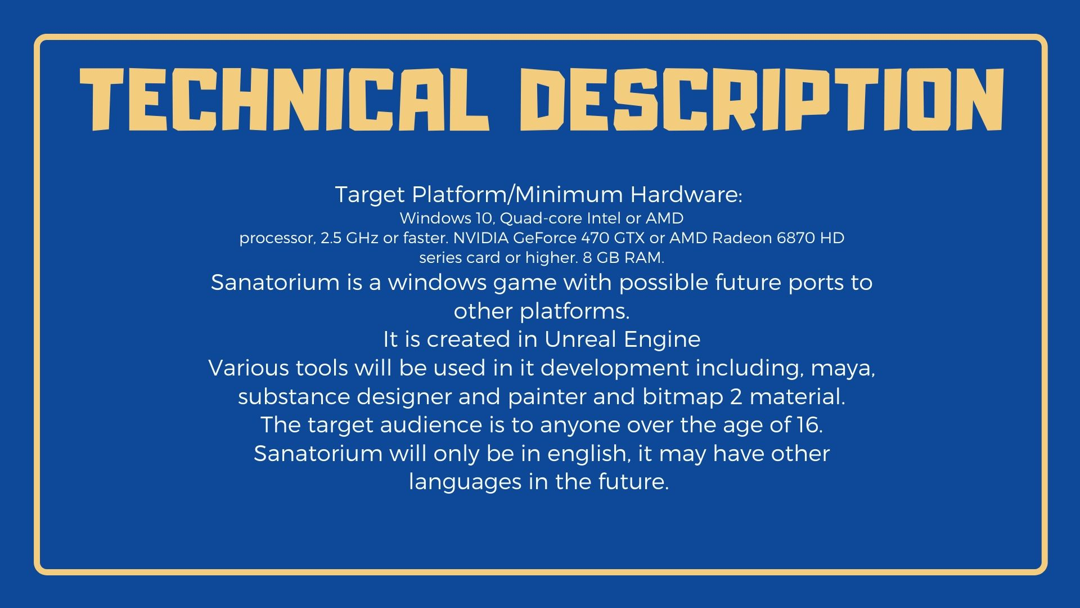

Stephen Ace - Production Diary – Sanatorium – Horror Game
30th September 2019  Time Spent: 4hrs | Given Brief/Task:  Ideas and planning.  I plan to record my production diary with screenshots and uploads of hand drawn work.  Research.  Sketches & notes

October 7th 2019  Time Spent:3hrs | Away on Holiday –  Sketch Drawing, ideas & story boarding.  Take pictures for textures and referencing.
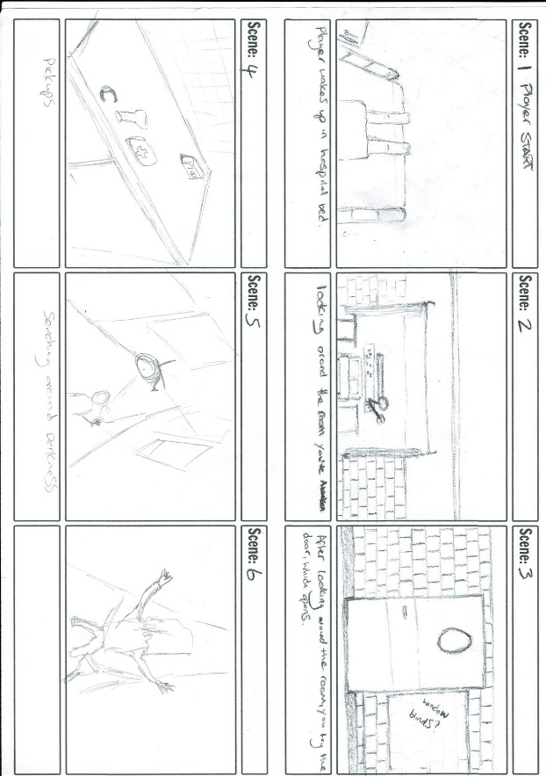
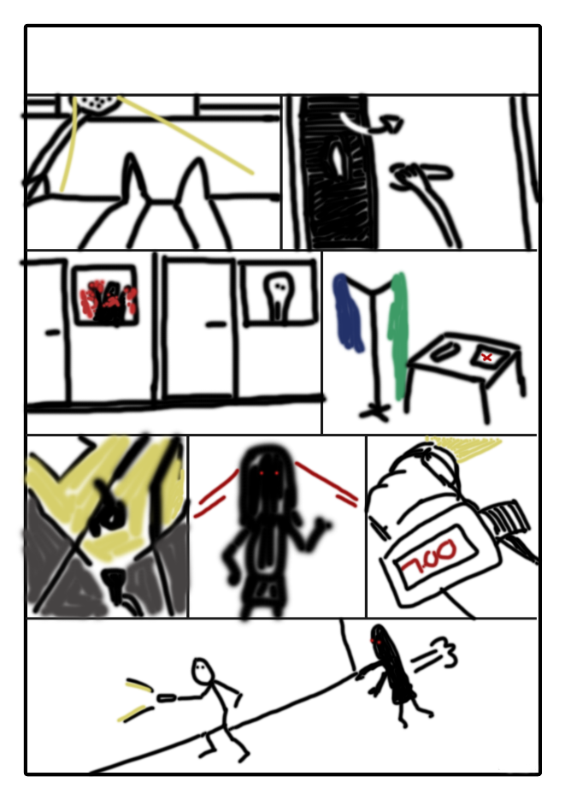

October 14th 2019  Time Spent:3hrs | Away on Holiday –  Sketch Drawing, ideas & story boarding.  Take pictures for textures and referencing.  Lots are more sketches but didn’t feel the need to add them here.




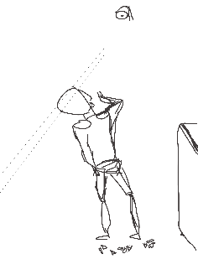
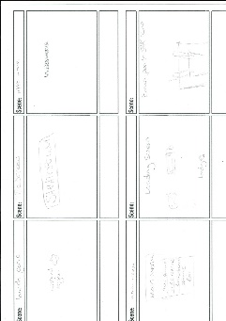
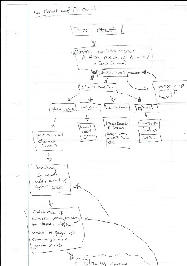

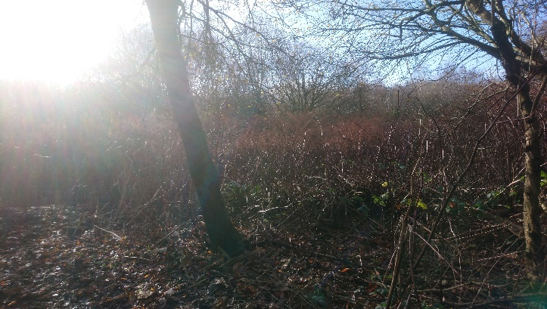
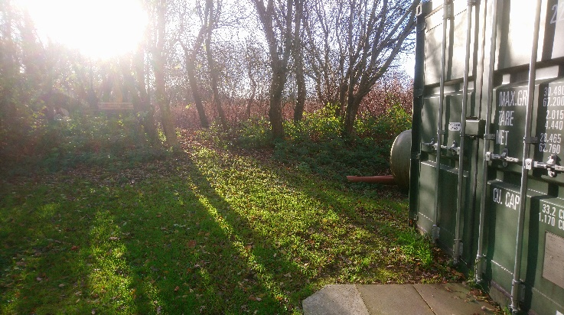
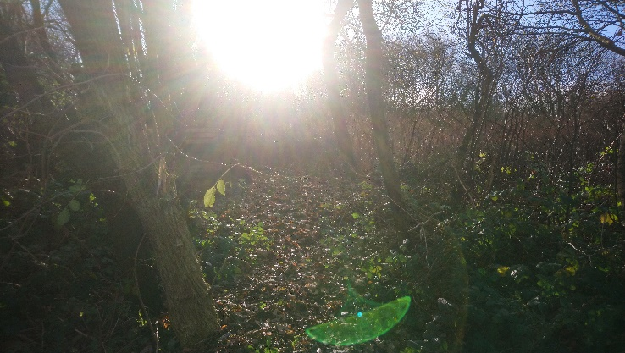
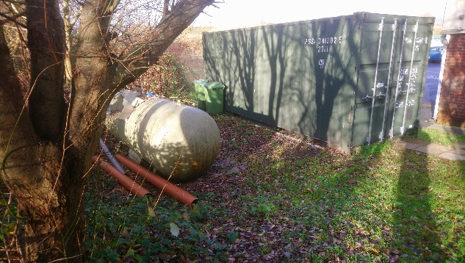
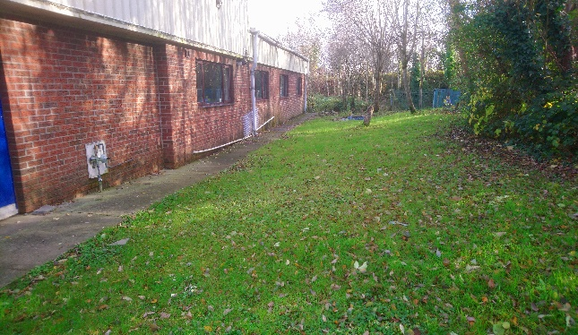
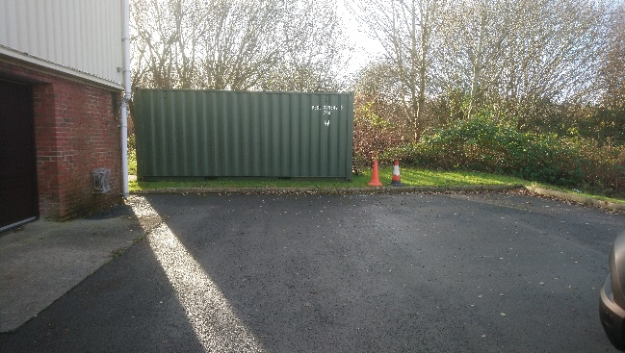
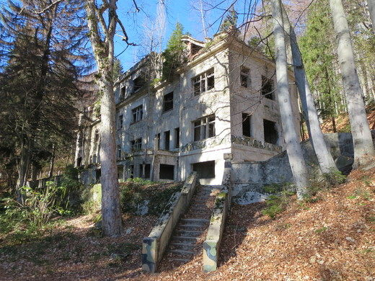
Referencing & Inspiration

October 21st 2019  Time Spent:6 | Design layout of level:  Sketches and concept.  Time spent on tutorials for Maya and unreal engine.
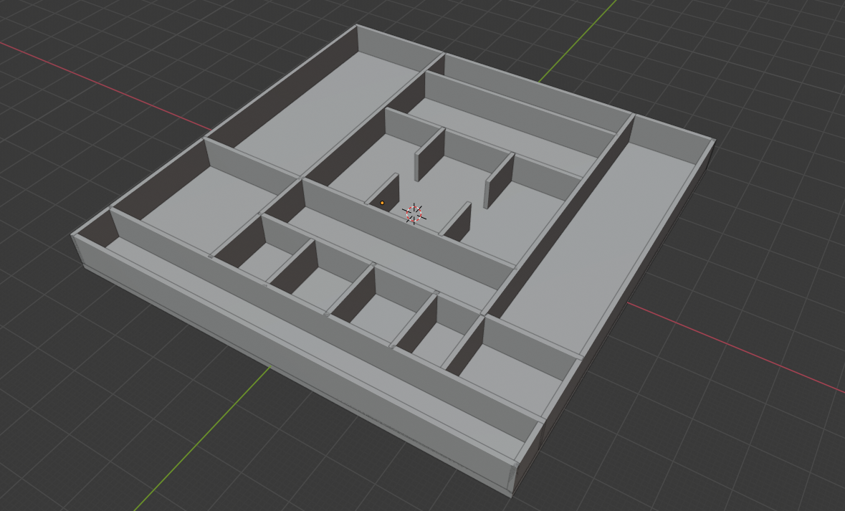
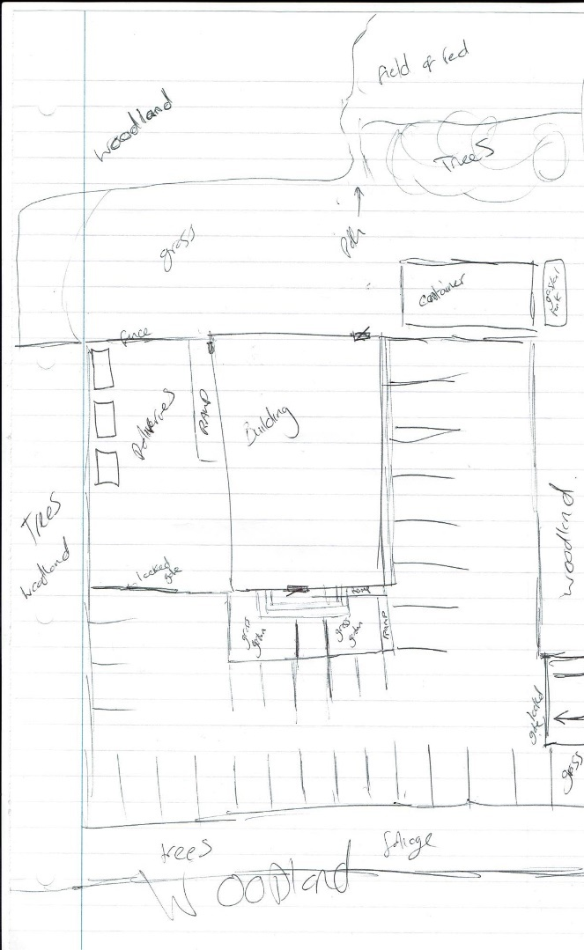
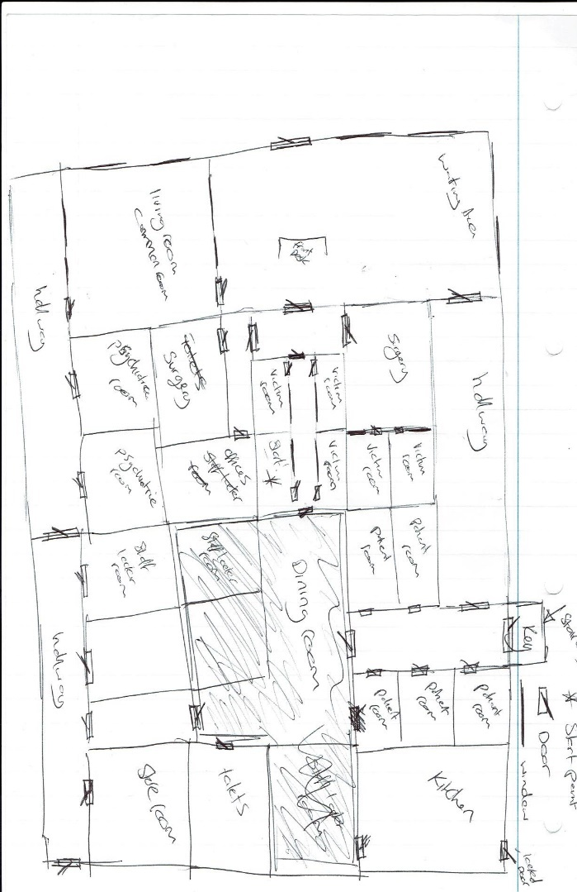
October 28th 2019  Time Spent:10hrs | GDD began on Trello, moved onto Microsoft word.  Time spent on tutorials for Maya and Unreal Engine.
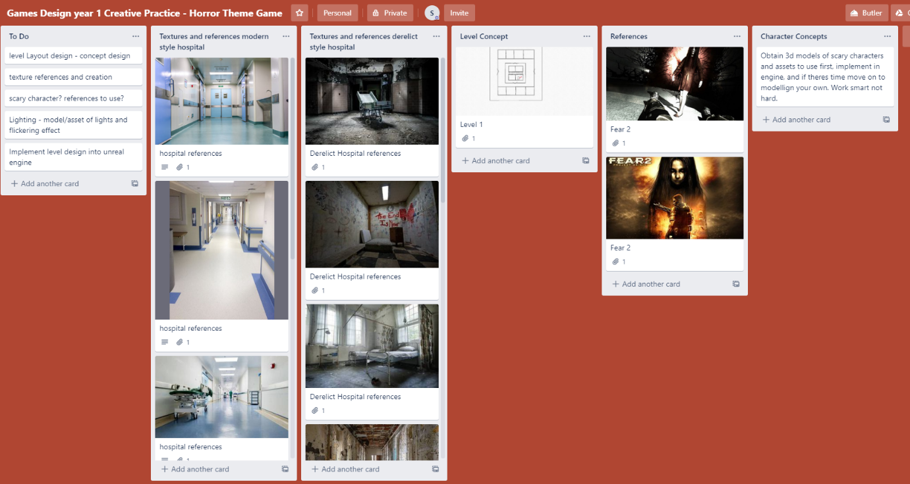

November 4th  Time Spent:10hrs | Start implementing map layout in Unreal Engine.  Planning where assets and textures will be.  Remember scaling in Unreal engine 1 unit = 1 Centimeter, this was hard to keep to.  Using the terrain tools, I wish I could give the outdoor and the terrain more time and detail.  Layout changed slightly as the design project moved forward.  Time spent on tutorials for Maya and unreal engine.  Learning about the skybox/sphere and lighting tools, an important area to learn to get a good setting/theme and ambience.  Lighting from assets is also important, research and finding lighting assets to use.

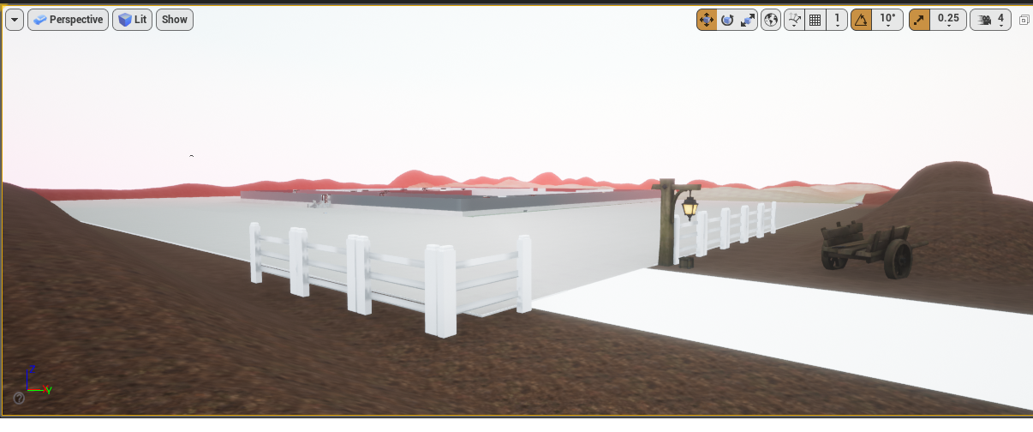

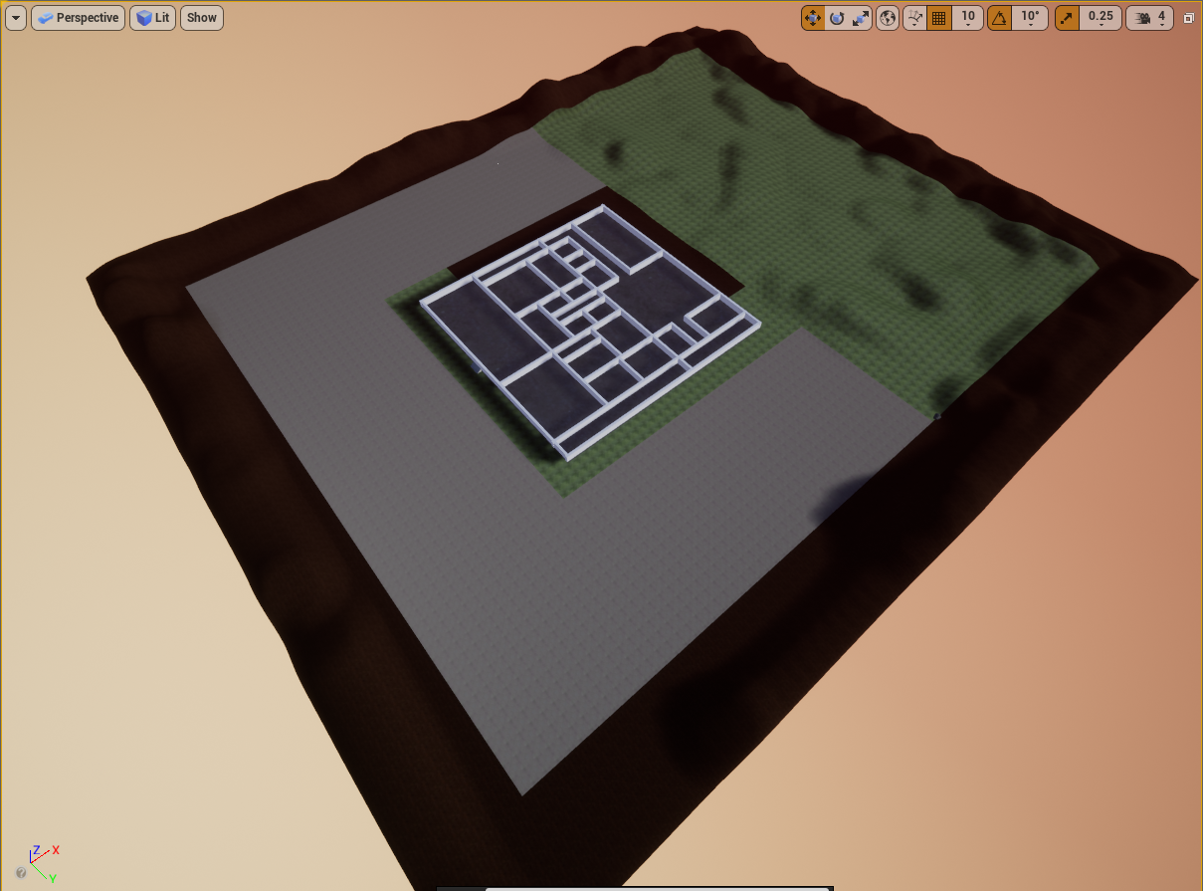
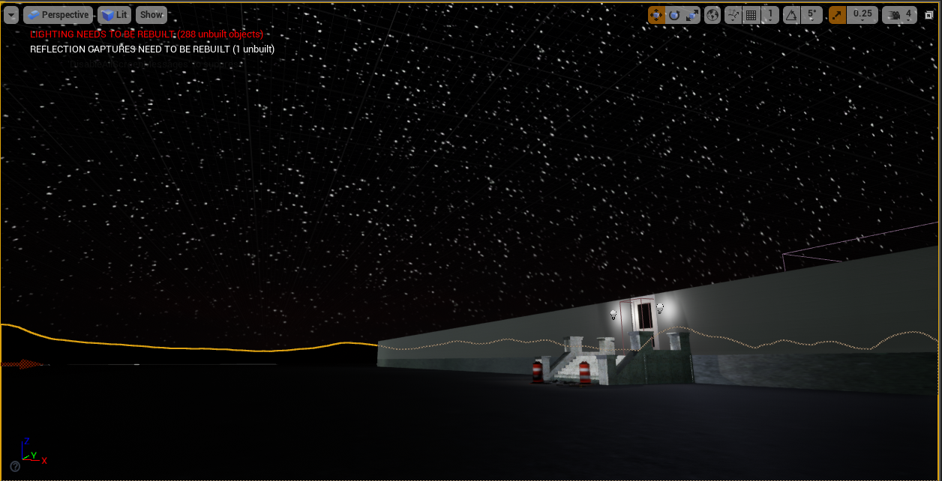
November 11th 2019  Time Spent:10hrs | Research, learning and reference textures and build up a library to test and try and use in unreal engine.  Research music/sounds to use in game.  Learn how to insert a main menu with sub menus

Some research into textures and learning how to make my own.




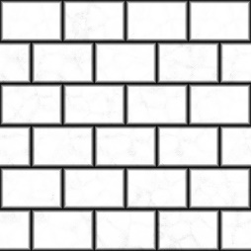

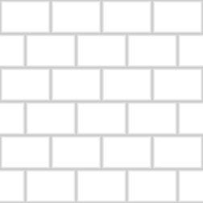
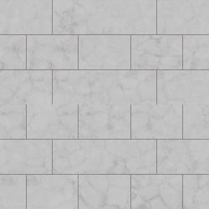
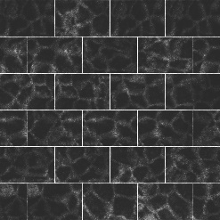

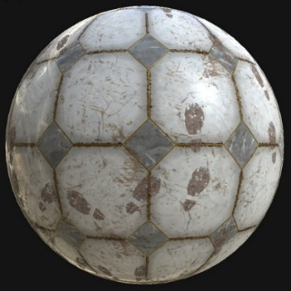

Realizing that Quixel and substance do a better job than me, and my time needs to be spent on the game more than the textures, I quit while im ahead and look at unreal engine documentation and tutorials instead.
Although very good, after downloading some beautiful textures to use, the file size of them is large and will affect the performance and will not be able to be played on the minimum spec computers for running this game.
November 18th 2019  Time Spent:10hrs | Research of Internet to see what 3D models I could find to use for free for now.  Custom models to be created in the future.  Time spent on tutorials for maya and unreal engine.
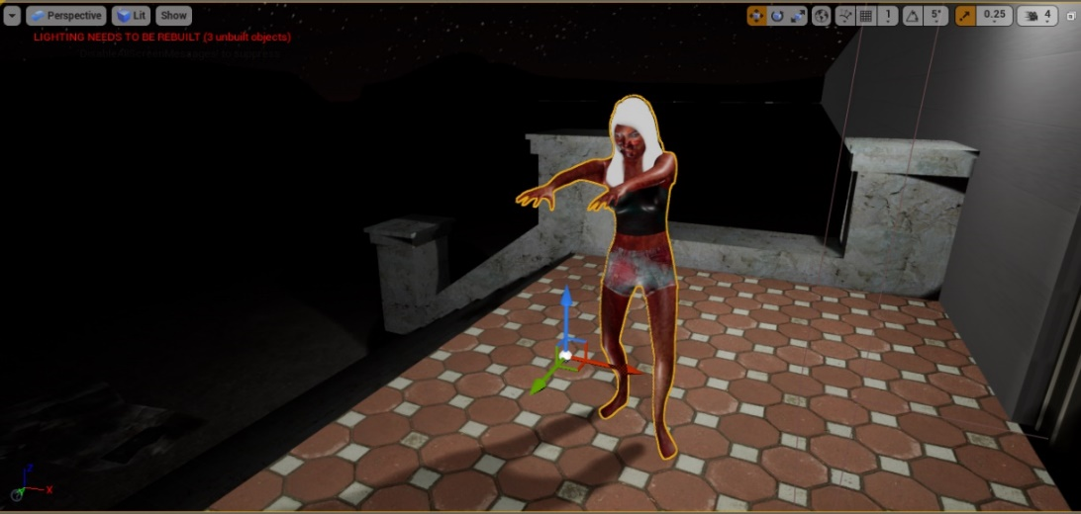
A female zombie model I found to use as the first enemy in the game.

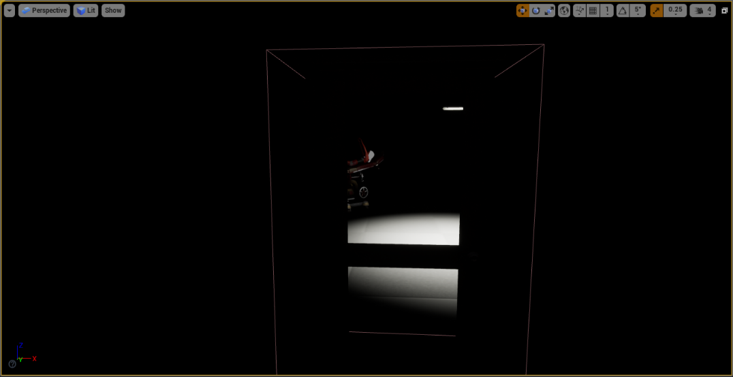

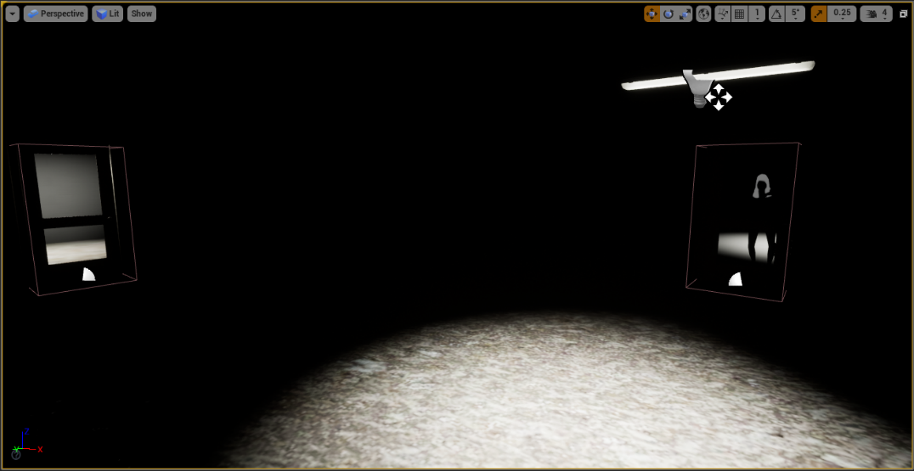

November 25th  Time Spent:10hrs | Asset research, reference and library build up to Spent a lot of time on working out a main menu.  Still need to learn AI and many other aspects of unreal engine still!  Testing and placing of assets.  Still need to finish changing all the static geometry to box brush’s!

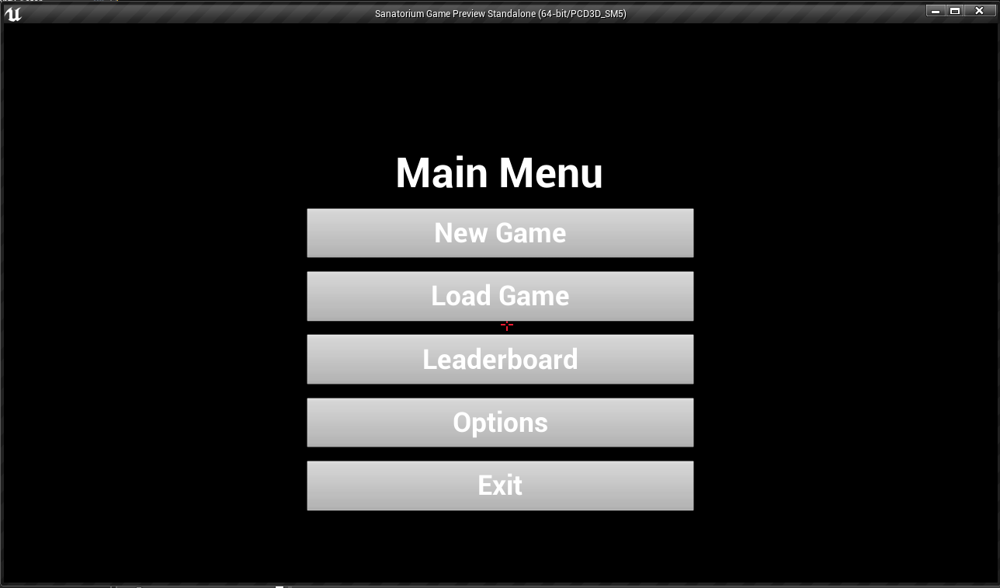
Some Geometry iterations for windows, NEED TO DO MORE!
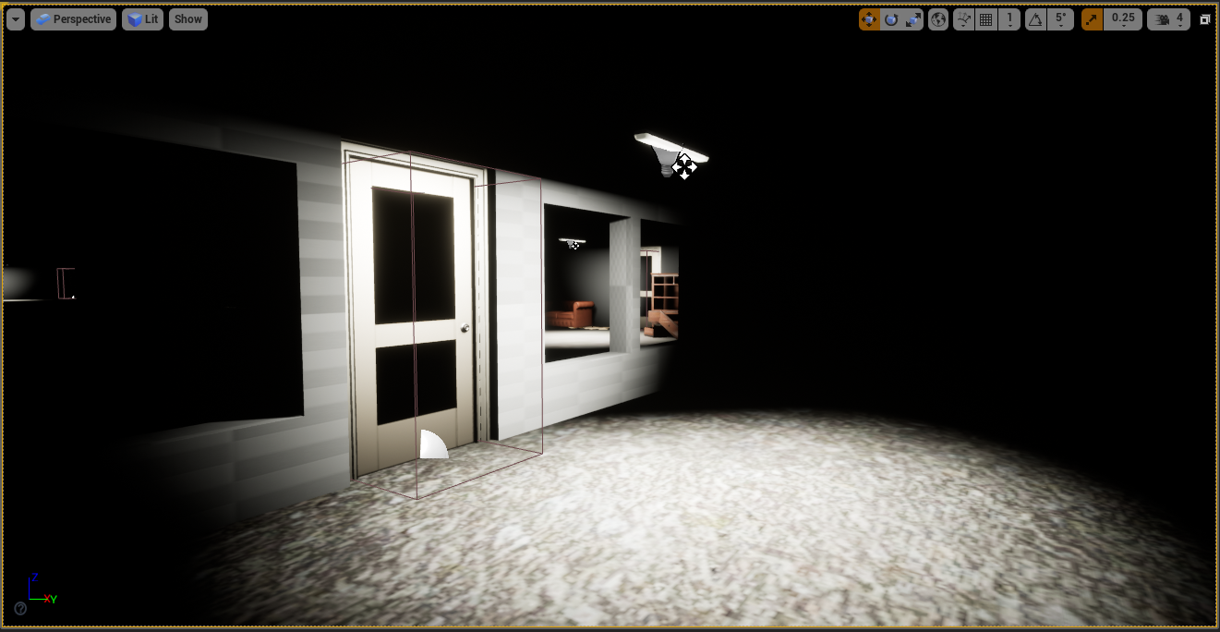
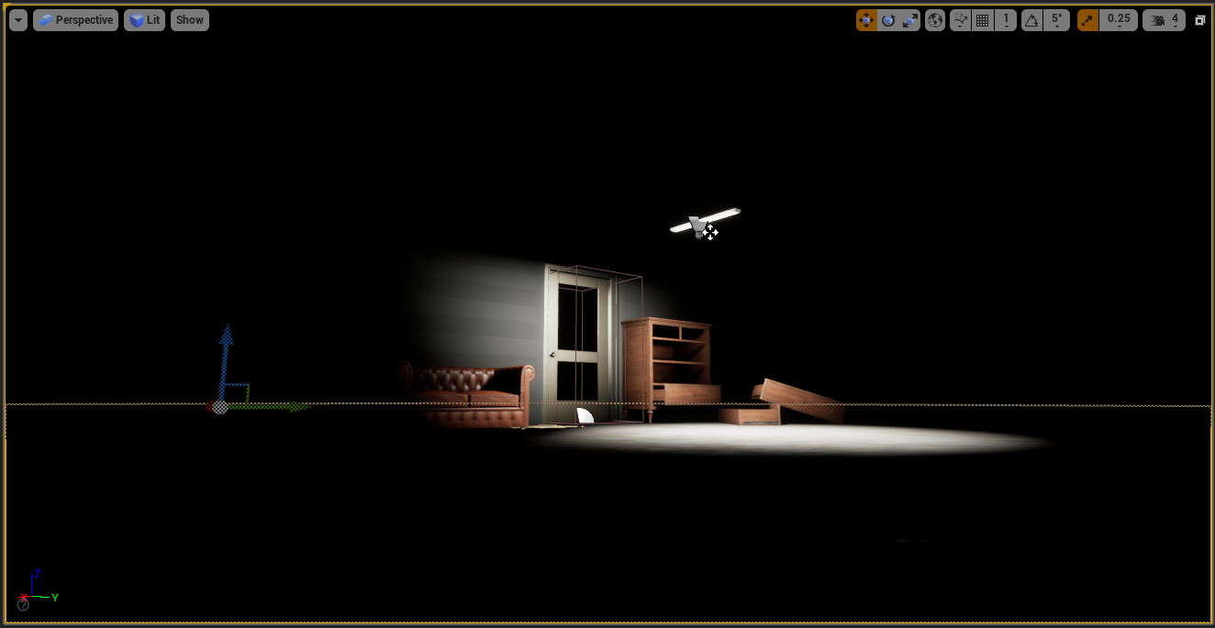
Placing some assets to improve the scene.
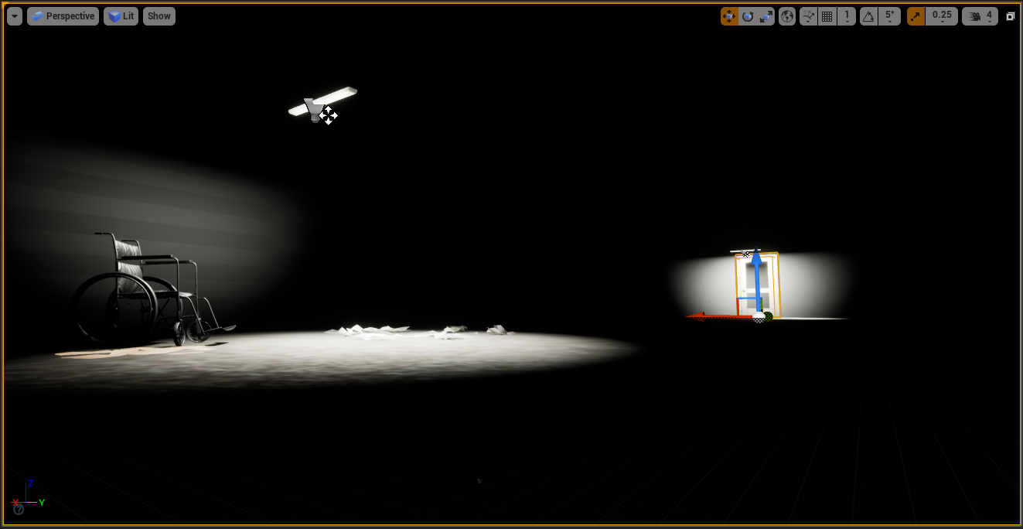

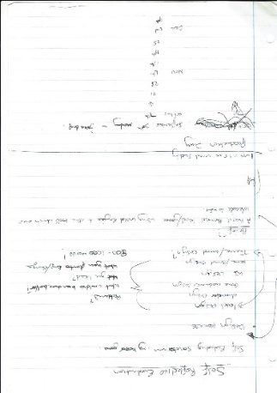
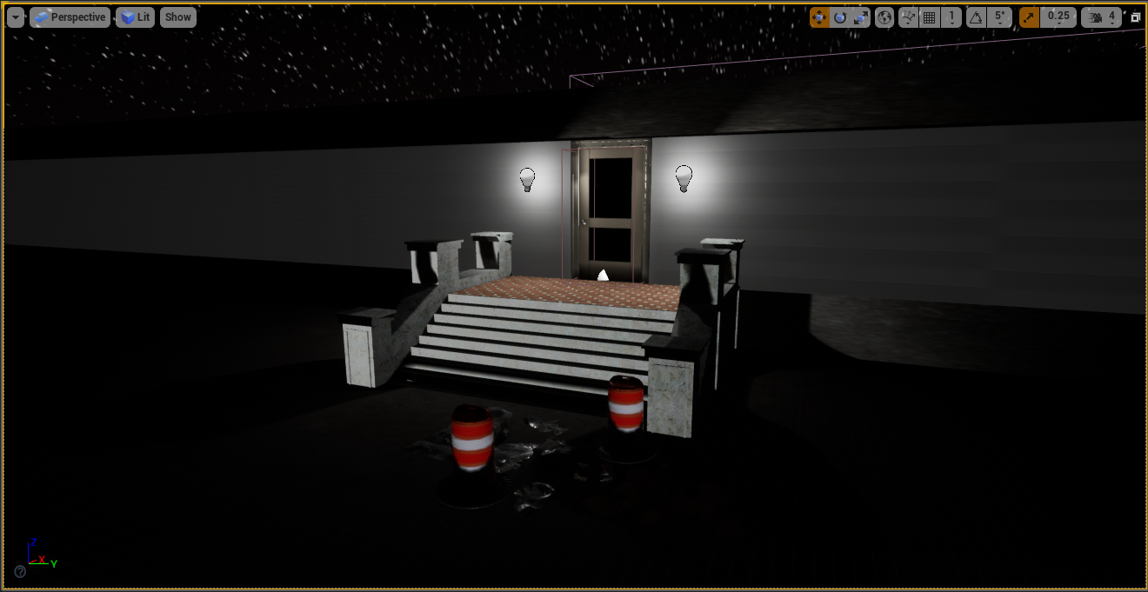
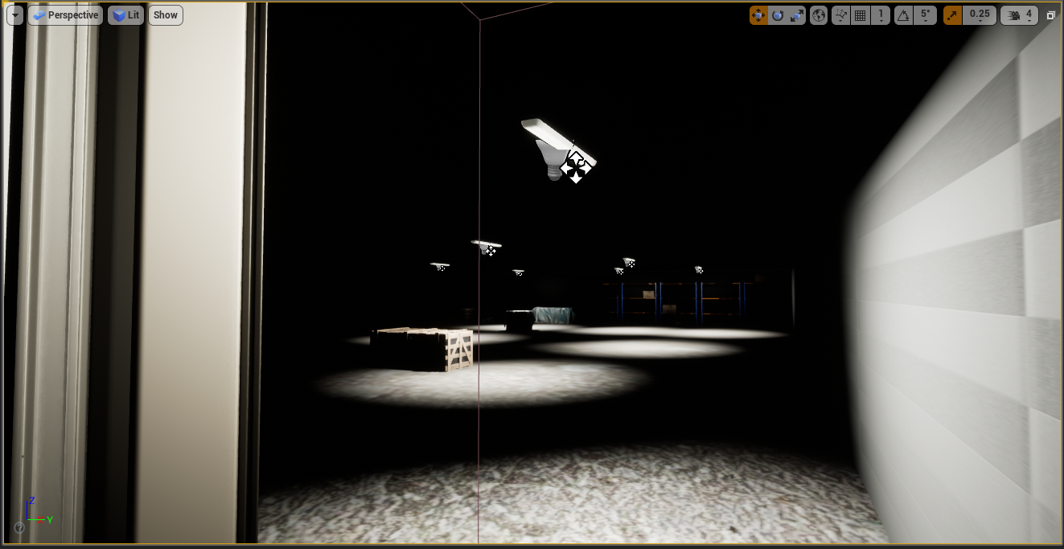
December 2nd 2019  Time Spent:4hrs | Self-Evaluative Writing  Trying to implement game mechanics but failing due to blueprint difficulties.

First notes:

December 9th 2019  Time Spent:2hrs | Deadline Day and Presentation!  Final go over of assignment hand ins.

