University of Wales Trinity Saint David
School of Engineering

Material Selection Report
  - Tomos Cole
  - 205508

Motorsport Engineering
Engineering Design and Materials
17/03/2024



Table of Contents
1. Introduction 2
1. Components Design Specification 2
2. Material Selection 3
3. Manufacturing Process Selection 5
4. Conclusion 6
5. Reference List 6

Introduction

The aim of this report is to show an understanding of what goes into a suspension system or a top tier engine, focusing on a specific part and then showing the knowledge, with the aid of research to show the process in which the part was chosen to be a part of the car, how it was designed and what it does.

Components Design Specification

Market Requirements Design Specification

Performance Requirement | Design Requirement | Design Specification
Price must be appropriate for what the product offers | Product must be affordable for the customer | Less than £500
Product must be in good condition | Product must not have any deforms, scratches etc once in the hands of the customer | Have good packaging
Table 1 - Market Requirements Design Specification

In Service Requirements Design Specification

Performance Requirement | Design Requirement | Design Specification
Product must be easy to install/remove incase the customer needs a new one | Product must be the same size as the existing one | Use the same dimensions to manufacture a new one
Product must be easy to transport | Must have as low weight as possible as long as it carries out its function | Less than 10kg to be safe
Table 2 - In Service Requirements Design Specification

Production Requirements Design Specification

Performance Requirement | Design Requirement | Design Specification
The product must be made from a material that’s appropriate as to the environment the product will be in | The product must be able to withstand heat as it’s connected to the engine | Use a heat resistant material
It is important that the requirements of the product are met | The manufacturing process must be as straight forward as possible | Have the correct tools to carry out a manufacturing process
Table 3 - Production Requirements Design Specification

Material Selection

The component that I have decided to base this report on is the from the Volkswagen Golf MK8, as seen in figure 1.

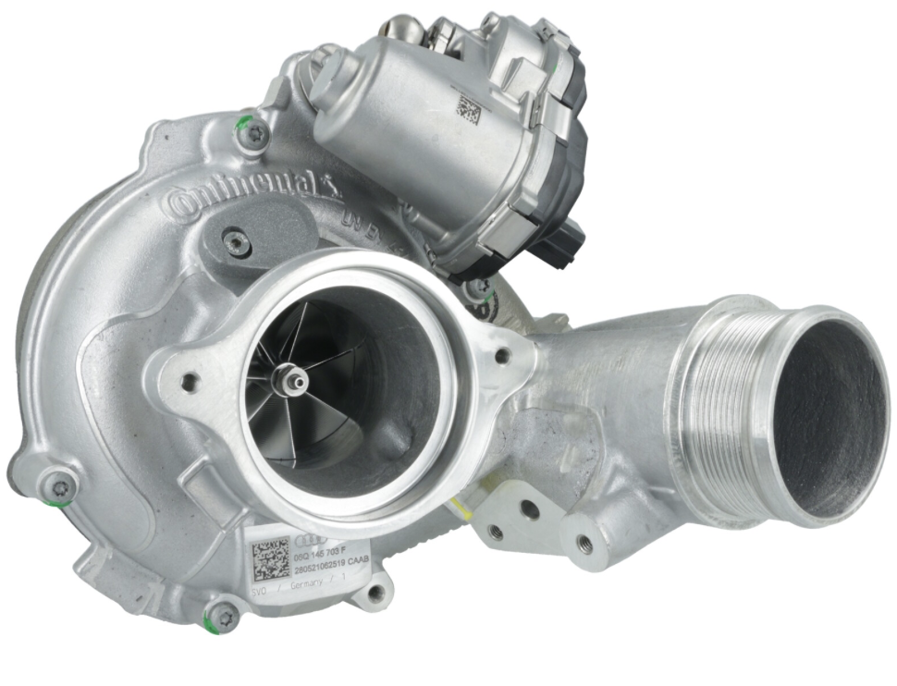
Figure 1- Volkswagen Golf MK8 turbo

To select a material for a turbocharger, there are several requirements that the material must meet before selecting it with a couple of those requirements mentioned above the design specifications.

Before selecting the material though there are a couple of things that must be mentioned and considered. For example:

The function of the component. The turbochargers job is to act as an induction device that compresses more air that flows into the engines cylinder together so that more fuel can be added.

Conditions that must be met. The product must be easy to install/remove incase the customer needs to replace the product as, according to Goldfarb&Associates (2023), “On average, turbos last up to 150,000 miles. But with good care, they may last up to 200,000 miles of have a life expectancy of 30 years.” So it would be rare that you’d have to replace them unless you don’t take good care of it. This is all solved by making the product the same size as previous products so there should be no problems.
Another way to make it easy to install/remove is to make the product easy to transport e.g. making it as light as possible whilst making the product reach all the requirements.

Things that should be thought about but are not required. The price of the product should be appropriate to what it offers. The product should be affordable for the customers but also should be a profitable product. A fair price would be less than £500 considering the prices on ebay and one price on ProxyParts, where there was a bunch of car parts from a Volkswagen Golf donor car and the turbo was listed at £344.21. The cheapest one that I’ve seen is listed at £102.

When choosing the material, the first actual step towards getting a final material is to narrow down the options down to 1. The options are between metals, polymers, ceramics, and composites. For this component the only viable option is metals because of the conditions that the product will have to go through.

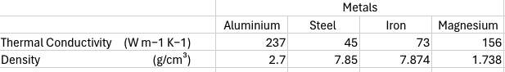
Table 4 - Metals comparison
These are the 4 materials I had narrowed it down to and because the component needs to be able to withstand heat, I have decided to narrow it down to Aluminium and Iron because of this next bit of information.
When it comes to tensile strength, iron blows aluminium out of the water meaning it can handle a lot more before breaking.

Manufacturing Process Selection

When it comes to manufacturing a turbo there are only two processes that can make it. The first process is sand casting in which you would pour a molten material into a mold and then it is allowed to solidify. The other process would be the 5-axis machining process. According to Mazak (2024), the term ‘5-axis’ refers to “the number of directions in which the cutting tool can move. On a 5-axis machining centre, the cutting tool moves across the X, Y and Z linear axes as well as rotates on the A and B axes” so that it can approach the component from any direction.

The sand-casting process seems a little bit simpler and that is why it has dominated this field for so long but in recent year the 5-axis machining process has become more popular and seems like the better process to go with for this component.

One factor that plays into the decision of what manufacturing process to go with is the fact that the turbo isn’t made from one part. The turbo is made from 3 main parts. The first big part being the turbine which is made from the turbine wheel and the turbine housing. The second big part is the compressor which is made from the compressor wheel and the compressor housing. The last part is the steel shaft.

The 5-axis machine process seems like the easiest manufacturing process for many of these parts. Linking back to the design specification, it is important that the appropriate tools are used in the 5-axis cnc machine. The only part I think would be best made by sand casting would be the turbine housing. There is a video published by Codices (2011), that shows the process of making the turbine housing using the sand-casting method.

The 5-axis manufacturing process is better for this component but using both processes would be better especially for the turbine housing as it would be very complicated to make on the 5-axis cnc machine.

Conclusion

The chosen component, the turbo from the Volkswagen Golf MK8 is a very interesting part which is made from several mini parts that are made from the same material, after some research it was quite clear that it was going to be made from steel and the two manufacturing processes are kind of obvious as they are the best ways to make all parts of this component.

Reference List

How a turbocharger is made (2011) YouTube. Available at: https://www.youtube.com/watch?v=0oXMH9sp7LM&t=224s (Accessed: 28 April 2024).
Turbo Volkswagen Golf VIII 1.0 ETSI 12V - 05C145701 Dla Borgwarner (no date) ProxyParts.com. Available at: https://www.proxyparts.com/car-parts-stock/information/make/volkswagen/model/golf/modelcode/4340-golf-viii-(cd1)/part/turbo/partid/15316676 / (Accessed: 28 April 2024).
How long do Turbos last? (no date a) Goldfarb & Associates Inc. Available at: https://goldfarbinc.com/blogs/news/how-long-do-turbos-last#:~:text=On%20average%2C%20turbos%20last%20up,you%20regularly%20drive%20your%20vehicle. (Accessed: 28 April 2024).

