Unscheduled Care Escalation Dashboard
To design and construct data pipelines and perform data collection and cleansing on acquired data. To power the Unscheduled Care Escalation Dashboard.

Karen Windsor
Digital Health and Care Wales
Dr Nik Whitehead

Contents

1 Introduction 4
2 Background to the Proposed Research 5
2.1 What dashboards have already been created and published. 5
2.2 Data Mapping 5
2.3 Extract Transform and Load 5
2.3.1 Data cleansing 6
2.3.2 Uploading Data to SQL servers 6
2.3.3 Automation of data transfer 6
2.4 Dedicated Servers 6
2.4.1 Table name conventions. 7
2.5 Information Governance 8
3 Aims & Objectives 9
3.1 Research Methodology 9
3.2 Philosophy 9
3.2.1 Approach 10
3.2.2 Strategies 10
3.2.3 Risks & Limitations 11
3.2.4 Ethical Issues 12
3.2.5 Validity, Reliability & Generalisability 12
3.2.6 Data Evaluation Methods 13
3.3 Development Methodology 14
3.3.1 Data Mining Methodology 14
3.3.2 Agile Methodology 14
4 Resources and Planning 15
4.1 Hardware Resources 15
4.2 Software Resources 15
4.3 (Optional) Information Resources 15
4.4 Human Resources 15
4.5 Planning 16
5 References 17
6 Appendix 20
6.1 What is Unscheduled Care 20
6.2 SSIS packages 20
6.3 Project scope document 21
6.4 Example of Impact Assessment Form 21
6.5 Example of VAS checks [29] 22
6.6 CRISP-DM 22
6.7 Gantt Chart 22
6.7.1 Link to Gantt chart 22
6.7.2 Today’s Date 23
6.7.3 Gantt chart display week 23
6.7.4 Gantt chart possible error message 23

Figures
Figure 1 Data Mapping 5
Figure 2 Server Layout 6
Figure 3 User Structure DHCW [21] 8
Figure 4 Information Lifecycle Management [23] 10
Figure 5 CRISP-DM lifecycle curtsey of Holt [31] 14
Figure 6 Gantt Chart 16
Figure 7 SSIS Package 20
Figure 8 SSIS Data Flow 20
Figure 9 Impact Assessment 21
Figure 10 UCE Dashboard mock up landing page 22
Figure 11 Gantt Todays date 23
Figure 12 Gantt chart Display Week 23
Figure 13 Date Picker 24

Tables
Table 1 Column Naming Convention [19] 7

Introduction
Since the COVID pandemic the need for timely and accurate healthcare data has become ever more critical tool to ensure effective resource allocation. Bragazzi et al [1] states in their research the requirement for real time health data to monitoring of services and forecasting health trends to efficiently allocate resources.
To enable Welsh Government(WG) to be able to monitor how unscheduled care pathway (see appendicle 6.1) is performing it has funded Digital Health and Care Wales (DHCW) [2] to construct the data pipelines, collect and cleanse the data to create a real time Unscheduled Care Escalation (UCE) Dashboard.
The information displayed on the dashboard needs to present the prerequisite Unscheduled Care data, and also be able demonstrate the introduction of WGs 6 Goals for urgent and emergency care [3], which are WGs proposals rationalise the steps need to be taken in order to reduce Unscheduled Care waiting times and improve care for the citizens of Wales.
The specific skills I bring to the project are an NHS Wales experience of over 20 years, working in both Primary and Secondary Care, a clinical terminology knowledge gain through working in Clinical Coding for over 15 years, and technical remit which includes a command of Microsoft SQL Server Management and experience interrogating DHCW’s Information Services Servers.

Background to the Proposed Research
The research will be conducted will cover these areas:
- What dashboards are currently available for comparison?
- Data mapping techniques.
- Extract, transform and load methodologies.
- Data Warehouse structures.
- Information Governance.

What dashboards have already been created and published.
Strategic Health Resilience Early Warning Dashboard (SHREWD) [4] has been designed for use by English Trusts by a Private Organisation, and although it has been built for English NHS Trusts the constructed visualisations does identify what data streams could be incorporated into USC Dashboard.
The USC Dashboard should also conform to the PowerBi template and meta data elements mandated by DHCW [5], which will influence what data is collected and the data format.

Data Mapping
Data mapping is the foundation of data integration to facilitate accurate data analysis and resulting visualisation and though it is time-consuming , omitting this stage could according to Tableau [6] lead to problems with data accuracy later in the project. Logical and Physical Data Mapping are two types of data mapping used in warehouse design according to Shahbaz [7]:
- Physical Data Models is used to map the structure of the servers, databases, and tables.
- Logical Data Modes map relationships between data elements, attributes, and keys.
Data mapping will establish where data elements are stored, their values, and their relationship to each other, and will require a mixture of both methods. There are data mapping tools available to automate this task according to Fatima [8] who recommends Astera Centerprise. This project is limited to the software endorsed by DHCW and after communicating with DHCW’s Client Services them it was agreed to use Microsoft Visio [9].
Figure 1 Data Mapping
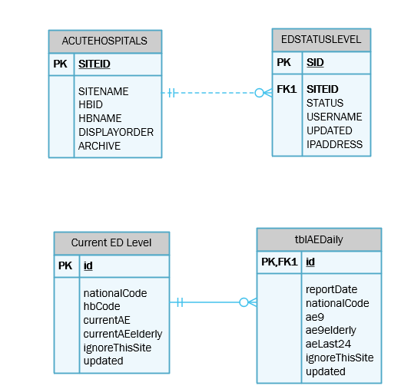
Created courtesy of Visio [9]

Extract Transform and Load
Not all of the data sources required to power the dashboard is sourced through SQL-2-SQL uploads into DHCW’s data warehouse. Several of the data sources are presented in the form of excel spreadsheets, which requires process to cleanse the data and then upload it to automatically refreshed as required by the dashboard dynamics.
One approach is Extract, Transform and Load (ETL) which according to Taniar [10] is an effective method of defining and loading data into an organisations data warehouse from various different sources. Wen [11] states this step is essential to ensure the quality and standardisation of the data imported into the data warehouse, which if not done correctly will detrimentally impact data analysis and dashboard visualisations.

Data cleansing
Before any of data from spreadsheets is uploaded into the data warehouse their elements must be examined to ensure they comply with Welsh Information Standards specifications listed within NHS Wales Data Dictionary [12]. To prove compatibility of analytics and findings to ensure commissioning stakeholders have confidence in the resulting.

Uploading Data to SQL servers
The next step is to investigate a method of uploading the cleansed excel files into the SQL server, there are two methods of accomplishing this task:
- SQL Server Management Studio (SSMS) Import and Export Wizard, a Microsoft application which is a simple to use process of uploading data into the server [13].
- SQL Server Integration Services (SSIS) packages created using Visual Studio, this is DHCW’s preferred method of uploading data into the SQL server. This is the application recommended by Wu [14] as it solves complex data transformation problems by creating control flows and data streams, which combine to create a SSIS data package. Packages consists of one control flow, but contains multiple data streams, which increases the efficiency of data transfer. (see appendicle 6.2)

Automation of data transfer
To ensure the dashboard displays the latest available information the deployment of the SSIS packages needs to be automated, Barley [15] recommends 3 different ways of deploying a SSIS package:
- Creation of a deployment utility from the project
- DTUTIL command line tool
- SQL Server Management Studio (SSMS)
The recommended process endorsed by DHCW data warehouse team is SSIS Catalog Database (SSISDB), a Microsoft application which provides developers and database administrators the facility to manage and deploy integration service projects. This is according to Das [16] one of the most important concepts to be employed by warehouse administrators to ensure the structure and stability of warehouse environment.

Dedicated Servers
Research of the ISD Infrastructure Redesign Paper [17] shows the Warehouse is made up of dedicated servers each with their own specific remit. ISD3 Reporting Server feeds all the dashboards created by DHCW.
One of the benefits of a dedicated server is it enhances the security of information stored on servers and increases the control administrators have over who accesses databases on the server [18]. Potentially increasing the speed of the other servers. As dashboard extracts are only taken from one server, this prevents the ‘locking’ of critical data, which could have a detrimental outcome to NHS Wales data users.
Figure 2 Server Layout
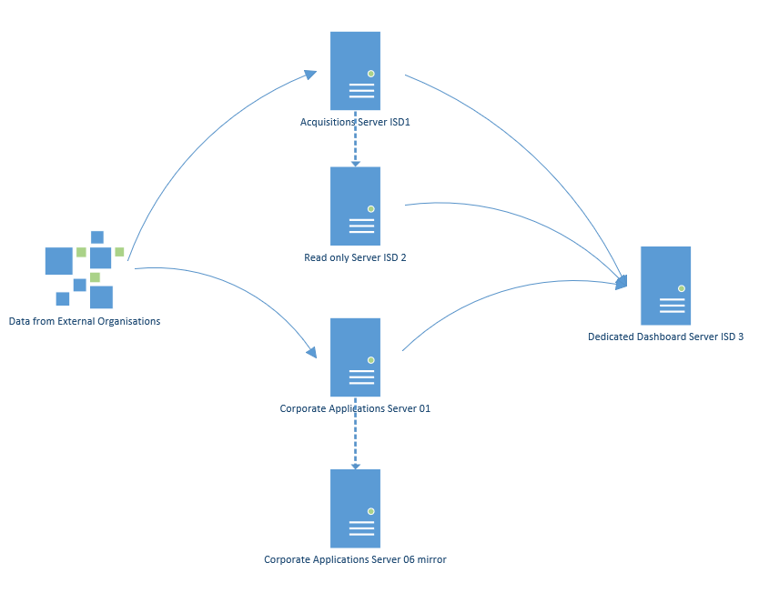

Table name conventions.
DHCW employs a naming convention for tables created within the ISD warehouse [19], this increases readability of table names and is used to detail, dimension, extension and the purpose of each table.
Table 1 Column Naming Convention [19]

Information Governance
As the USC Dashboard is being funded by and designed for WG, data will have to be scrutinised to ensure that it does not contain any Patient Identifiable Information (PII), and it complies with DHCW’s Information Governance polices [20] for use in external accessible dashboards. To be able to exclude PII it is important to research exactly what data could be classed as PII, according to NHS Digital [21]PII would include :
- Patient demographic – name, address, NHS Number
- Administrative – appointment details or whether they are currently awaiting a specific place or type of care.
- Medical – any condition which would identify a patient (rare diagnosis) which when combined with demographic information.
DHCW Dashboard policy [22] governs the external access to dashboards, which is dependent on whether the data contains PII or if it identifies a patient cohort to ensure patient confidentiality.
Figure 3 User Structure DHCW [22]
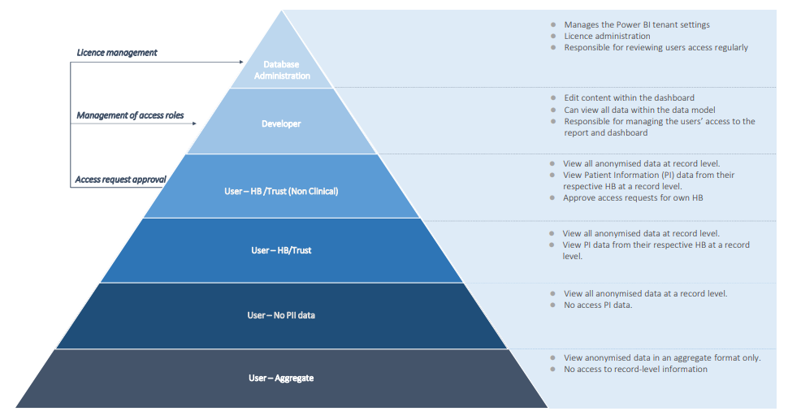

Aims & Objectives
The project aim is to source data required to power the USC Dashboard, thereby improving resource allocation and emergency healthcare in Wales. By collecting real-time Unscheduled Care data, the dashboard will enable Welsh Health Boards(HBs)/Trusts in conjunction with WG to identify and respond promptly to surges in demand. This proactive approach will result in optimising patient care delivery and ensure necessary resources are allocated efficiently and effectively to manage emergent situations. Ultimately this data will facilitate informed decision making to improve patient experience, outcomes and Unscheduled Care for citizens of Wales.
Project objectives:
- To understand WGs expectations and requirements, how these relate to their 6 goals for urgent and emergency care [3] and are the requirements feasible with available data and within specified timeline.
- To map data held within DHCW servers and work with DHCW’s Business Intelligence team to analyse data and investigate what other data needs to be sourced.
- To engage with DHCW’s Data Warehouse team to create tables on the acquisition server, to facilitate SQL-2-SQL data upload from external organisations. And to create processes to refresh tables and SSIS packages at specified times.
- To create tables and views on the reporting server to power the dashboard and construct SSIS packages to extract data from excel spreadsheets, acquisition server and transfer data to tables/views created on the reporting server.
- To document all processes and steps in a Standard Operating Procedures reports.

Research Methodology

Philosophy
Creating pipelines and collecting data necessary to power the dashboard will involve applying a comprehensive research philosophy to align with set project objectives. For this project a mixed research approach is most suitable due to a balanced integration of positivist and phenomenological elements.
The positivist aspect of mixed approach involves quantitative methods. It focuses on collecting objective , measurable data from internal and external sources. Data metrics will include:
- Number of patients currently in Critical Care.
- Waiting times in Eds.
- Number of 999 calls.
- Ambulances currently waiting outside of ED.
Quantitative analysis of this data would provide valuable insights into trends, patterns and performance metrics which would contribute to informed evidenced based decision making in resource management.
The phenomenological component of mixed approach involves qualitative methods, to capture any impact pipeline creation could have on data providers. Meetings will be held to gain insights from stakeholders, to ensure the dashboard meets their requirements. By understanding data providers concerns this will ensure the project collects data in an efficient format to create the analysis and visualisations required by the dashboard has a positive benefit unscheduled care patients and guarantees resources are in the right place to facilitate this.
By employing a mixed method research approach for pipeline creation, data cleansing and collection the research will be balanced, as it combines the objectivity of quantitative data with qualitative insights gain from end users and data providers. This mixed approach enables a comprehensive understanding of the data needed to create a dashboard which will improve healthcare in Wales.

Approach
For pipeline creation, data cleansing and collection a mixed method approach offers a comprehensive and effective approach strategy. This approach combines deductive and inductive reasoning which when coalesced includes strengths from both methodologies.
Starting with the deductive approach to construct a theoretical framework and predefined hypothesis, would formulate specific research questions and hypotheses based on existing knowledge and standards used in NHS Wales. Utilising NHS Welsh Data Dictionary [12] ensure data structures conform to mandated standards, and assurance processes. Using impact assessment (IA) forms and meetings with end users to establish project objectives for data collection and development of pipelines. Deductive approaches will facilitate the use of recognised metrics to target the correct data elements.
Inductive approaches allow for investigation, exploration and discovery. It collects data without a predetermined hypothesis which could lead to new avenues of thoughts and insights . To facilitate this approach ‘hackathons’ are held to examine new ideas, issues and solutions. This approach is a constructive method of uncovering unexpected correlations and user requirement which might not have been anticipated at initial meetings. Inductive exploration would provide valuable insights into the practical requirements and user perceptions of what data will be available in the dashboard.
The mixed approach combines the best elements of both approaches by utilising deductive reasoning to guide the initial framework of data collection and pipeline development, while incorporating inductive exploration to capture the complexity of NHS Wales data used to power the dashboard. This combination will ensure the data used to power the dashboard remains beneficial and meets initial requirements and provides stakeholders with additional data which are analysed to create a dashboard that is not only theoretically sound but also adaptable and responsive to the diverse needs and challenges of unscheduled care in NHS Wales.

Strategies

Literature Review
The Data Integration Theory [23] underscores the importance of unifying data from diverse sources into an interconnected and standardised structure. This theory emphasises the need to integrate data from various different external sources, to ensure the necessary data is captured. By adopting this theory data pipelines are designed which adhere to Welsh Data Standards, which eliminates data redundancies and enable a seamless flow of data into the dashboard. The methodology behind this integration theory enhances accuracy and reliability of data analysis on the dashboard.
Figure 4 Information Lifecycle Management [24]  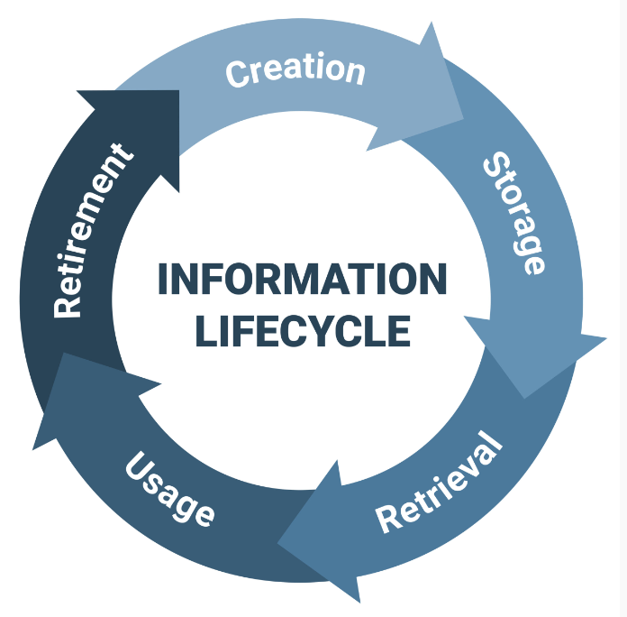 | The Information Lifecycle Management theory described by Brook [24], focuses on how data is managed systematically throughout its lifecycle. This theory highlights the importance of classifying data based on its relevance to the project and how it will be used. Data pipelines are designed to prioritise the collection and processing of real-time data, whilst removing any redundant data. This theory will ensure only current and functional data will be presented in the dashboard.
Prominent researchers in data pipeline creation for health dashboards have significantly contributed to advancing the interoperability of and integration of healthcare data. Fredric Blavin’s research focuses on the opportunities to improve data interoperability and integration has on supporting value-based care [25]. Malekloo has conducted influential research on real-time data processing and analytics for healthcare dashboards [26], investigating uses of big data processing of critical-care information for use in decision making.
Positive factors identified include an ever-increasing emphasis on data-driven decision making within in NHS Wales and a growing recognition by WG of how the utilisation of dashboard optimises resource allocation. One negative factor is potential resistance by external organisations to share data, this could be due security concerns or the organisation’s inability to share the data.
Mainly data needed to power the dashboard is available for collection, and ongoing work ensure it conforms to data standards and is valid and accurate.
Dashboards available to NHS staff provide some of the information required by WG, however the pipelines to provide real-time data are not present. The creation of these pipelines is possible as they have been constructed for before for the COVID Dashboard. Data analysis and formulas will be compared to dashboards previously designed by DHCW and those available to NHS England constructed by SHREWD [4].
The presumption intelligent dashboards powered by accurate and timely data improves healthcare decision making is backed up by research completed by Rouhani and Zamenian [27] whom state it accelerates decision making.

Experiments
One factors to be researched is how ‘frequency of data collection’ could affect the visualisation and how this effects stakeholders decisions. Data provided by WAST updates status of ambulances in service every 5 minutes, DHCW’s warehouse does not have the capacity to accept this frequency of uploads. Trials will be needed to investigate the optimum update frequency, taking into account daily strategy meetings held by WG.
Another usability experiment would be how RAG statues are displayed and how different drill downs would affect decision making. Levels are available for All Wales, HBs, and hospital sites, users would decide what level is optimum for decision making.

Action Research
One process to be investigated is how Same Day Emergency Care (SDEC) data is sourced and standardised. Presently there is no mandate from WG for HBs/Trusts to collect this data. WG require SDEC data as part of their 6 Goals programme. Action research would evaluate what data is needed by WG , how it can be collected and uploaded into DHCW’s warehouse. Assessing what methodology should be employed to upload excel spreadsheet into the warehouse or should SQL-2-SQL processes be implemented before data is uploaded?. How it impacts data providers and what resources will need to be put into place by DHCW’s data warehouse team.

Risks & Limitations
Possible risks could include:
- Not being able to source data need for the project, due to external organisations being unwilling/unable to share their data.
- WG withdrawing their funding.
- Though aggregated data is being used there is a risk the dashboard could breach a data protection principle.
- Resources needed to amend the dashboard to account for data protection issues may be costly.
- The damage to DHCW’s reputation if the dashboard is not successfully implemented.
To mitigate any risks to DHCW the Partnership Project Scope Document has been completed in conjunction with the Principal Lead Information Governance Specialist, see appendicle 6.3.

Ethical Issues
Potentially if the project is not delivered on time and to a standard expected by WG there could be a detrimental impact on DHCW’s reputation as a leader in Digital Healthcare.
Potentially stress incurred during the life cycle of the project could cause harm to the researcher, leading to sickness due to work related stress.
There are also Information Governance and Data Protection risks as although the dashboard will use aggregate data it may not take into account privacy by design or it may breach a data protection principle, and making changes to counter this could be costly.

Validity, Reliability & Generalisability

Validity
Each step of creating the data pipelines, cleansing and collecting of the data will be validated and structured to ensure comprehension of each comparable measure . An example of this would be to ensure data from HBs is consistence and contains the same analytical measure to prevent comparison of ‘average wait time’ with ‘median wait time’, which would compromise the validity of dashboard.
Data collected for the dashboard will be checked to ensure its compliance with measures set out by WG in their Health and social care reports [28]. Data analytics are checked to ascertain they conformed to WG’s CURRENT Healthcare measures. Healthcare measurables are continually changing and using the incorrect ones would impact the analytics.
The analytics and measures will be reproducible; a process will be initiated to verify comparable results are reproduced using data from differing sources.

Reliability
Data collected for NHS Wales Healthcare Dashboards is mandated to conform to standards in the Welsh Data Dictionary [12] and analytics are governed by measures published by WG, to ensure data produces the same results.
A different researcher would still need to conform to DHCW’s internal policies , including data collect methodologies and data protection principals. An Information Governance IA and a Project Scoping Form will to be completed to ensure the project is working within data protection guidelines and will not bring disrepute onto DHCW.

Generalisability
Data is being collected/transferred using SSIS packages contains Unscheduled Care Health data, it examines waiting times and treatment times for citizens who contact NHS Wales for non-planned care.
This process could be replicated in any of the English Trusts who required to analyse the statuses of their EDs and how it effects bed availability. England’s counterpart NHS England also publish data standards and modelling on the NHS Data Model and Dictionary website [29] , which contains information on unscheduled care activities. Methodologies used for this project are adapted for use in NHS England or individual Health Trusts.

Data Evaluation Methods

Data Collection
There will be 2 types of data collected:
- Aggregated Unscheduled Care data.
- IAs – which are sent out to external organisations to discover what issues they might encounter with the requirement to upload new data items to DHCW’s servers.
IAs are created in excel spreadsheet (see appendicle 6.4).
Collecting data for the new measures (SDEC), UPC) will be challenging due to the lack of data and the manual methods of collecting data elements. Any analysis gained from these data items will need to be caveated to inform the users of possible irregularities of the analytics and comparisons. The remainder of the aggregated data is held on health organisations servers, and the issue will what is the minimum amount of data need to provide clear and concise visualisations.

Data Evaluation
The first step of data validation will be to validate and cleanse the data, this is performed by DHCW’s Data Acquisitions team when it uploaded onto the Acquisition server, using a set a of stored procedures known Validation at Source (VaS) checks [30].(see appendicle 6.5)
For data sourced from Excel spreadsheets there is currently no automatic validation and for some areas no current data standard. A good example of this would be SDEC data, the main issues are:
- No definition what constitutes a SDEC appointment
- No real time data
- How are the HBs recording SDEC appointments?
- HBs not mandated to collect or submit to DHCW SDEC data.
As WG have stated they want SDEC data displayed in the visualisation it will be included but will be caveated to highlight these issues.
Once data has been loaded into the Reporting Server, various statistical analysis will be performed:
- Calculating average times to treatments.
- Calculating median times to treatment.
- Calculating RAG statuses for critical care and other care services.
- Calculating standard deviation for returns to unscheduled care within 7 days for each of the HBs.
- ANOVA to compare waiting times in Emergency Care between the HBs.
Data will be display using an appropriate PowerBi visualisation.
Access is limited to WG , HB Information Teams and DHCW analysts.
Data collected via IAs forms will be checked with providers, once agreed it will be collated and results made available for discussion at the next meeting.

Development Methodology

Data Mining Methodology
This project will involve ‘mining’ data held on DHCW’s servers and as such will use CRISP-DM methodology, which Plotnikova et al [31] states is a preferrable methodology for this project type.
CRISP methodology consists of 6 steps performed on each area of the dashboard to ensure data pipelines contain data elements needed to fulfil WGs requirements. (appendicle 6.6)
Figure 5 CRISP-DM lifecycle curtsey of Holt [32]
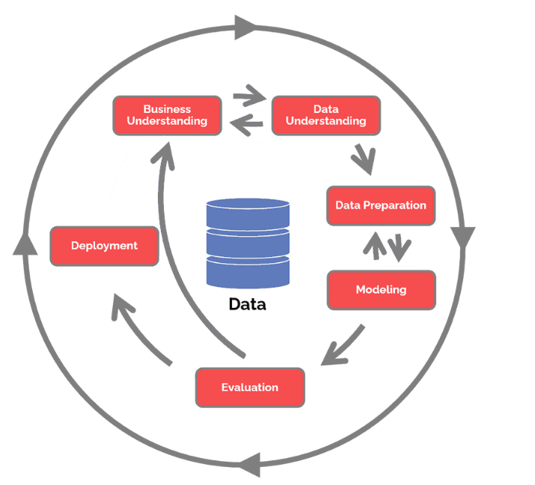 | - Understanding business – what are WG’s requirements? What actions do we need to complete to meet those requirements.  - Data Understanding – what data do we have? What do we need to source from external organisations? What data cleansing is need? How is data formatted and sourced?  - Data Preparation –What data elements are required and what views/tables need to be created on the Reporting server?  - Modelling – mapping and organisation of data elements  - Evaluation – does the data model meet WGs requirements?  - Deployment – load data to the dashboard.

Agile Methodology
Agile methodology will be adopted to ensure adaptability should WG’s requirements change. Agile methodology [33] promotes team working and communication skills, which are vital for a project needing assistance from other teams and engagement with external organisations to source data flows.

Resources and Planning

Hardware Resources
No additional hardware will be required.

Software Resources
- Visual Studio Community 2019 to enable creation of SSIS packages.
- Microsoft Office 365 applications Visio, Excel and Word
- SQL Server Management Studio 18
- PowerBi Desktop.

(Optional) Information Resources
Quantitative data will be sourced from:
- Welsh Hospital HBs/Trusts
- WAST
- Primary Care – including 111, Urgent Primary Care, Out Of Hours.
- Data Cymru – Care home data
External organisations will be consulted using IAs to ensure compliance with agreed data submission processes. WG will provide data, to clarify their analytic requirements, suitability of data flows and usability of the dashboard.

Human Resources
Input will be need from these teams.
- Project management
- Information Governance
- Business Intelligence
- Data Warehouse
- Data standards
- Information Teams (external organisations)
- Stakeholders – at least 5 staff members to test usability and accuracy.

Planning
This project brief is for a live project and the tasks reflect the milestones that have been agreed between DHCW and WG. Presently we are working towards gathering WG’s requirements to ensure that we understand exactly what data is required for the project, where that data is stored and how frequently it needs to be refreshed.
The Gantt chart will be an invaluable tool to ensure that the project runs smoothly and in the agreed time frames.
Figure 6 Gantt Chart
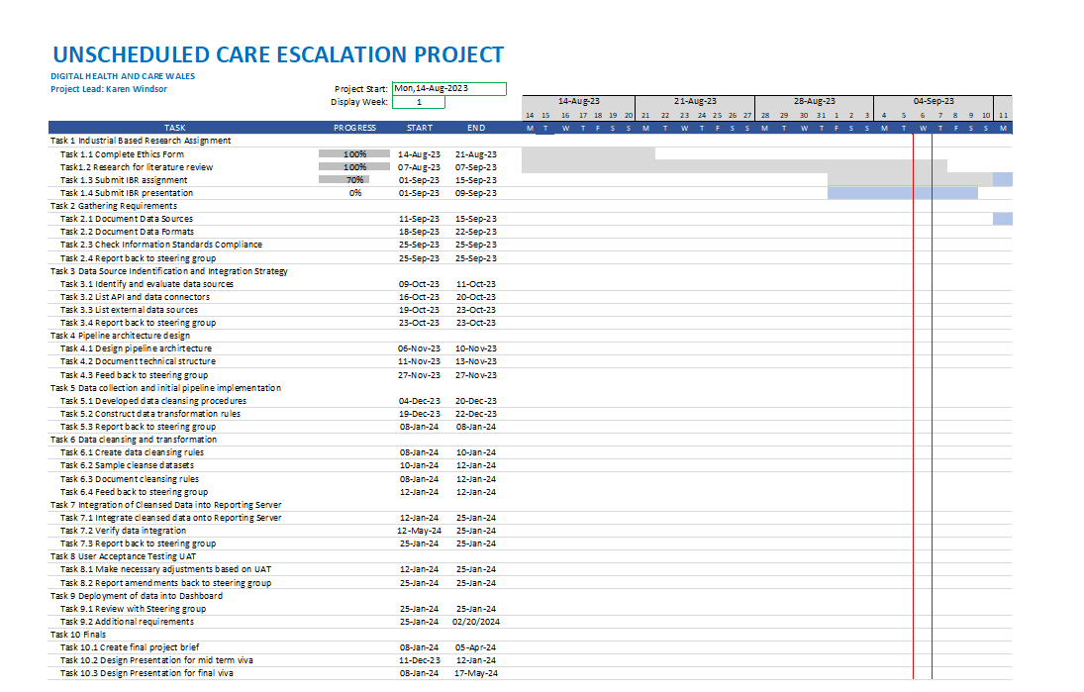
(Full Gantt chart appendicle 6.7)

References

[1] | N. Bragazzi, H. Dai, G. Damiani, M. Behzadifar, M. Martini and J. Wu, “How Big Data and Artifical Intelligence Can Help Better Manage the COVID-19 Pandemic,” International Journal of Environmental Research and Public Health , vol. 17, no. 9, 2020.
[2] | “Digital Health and Care Wales,” Digital Health and Care Wales, 25th July 2023. [Online]. Available: https://dhcw.nhs.wales/. [Accessed 26th July 2023].
[3] | Welsh Government, “Six goals for urgent and emergency care: policy handbook for 2021 to 2026,” 19th May 2023. [Online]. Available: https://www.gov.wales/six-goals-urgent-and-emergency-care-policy-handbook-2021-2026. [Accessed 22nd August 2023].
[4] | “SHREWD Resilience,” GOV UK, [Online]. Available: https://www.applytosupply.digitalmarketplace.service.gov.uk/g-cloud/services/435540006644851. [Accessed 15th August 2023].
[5] | “Internal Intranet DHCW PowerBi Home page,” Digital Health and Care Wales, 2023. [Online]. Available: https://app.powerbi.com/home?ctid=bb5628b8-e328-4082-a856-433c9edc8fae&experience=power-bi. [Accessed 22nd August 2023].
[6] | “The Essential Guide to Data Mappiong,” Tableau, 2023. [Online]. Available: https://www.talend.com/uk/resources/data-mapping/#:~:text=Good%20data%20mapping%20tools%20streamline,the%20possibility%20of%20human%20error.. [Accessed 15th August 2023].
[7] | Q. Shahbaz, Data Mapping for Data Warehouse Design, Waltham: Elsevier, 2016, p. 5.
[8] | N. Fatima, “Selecting the right data mapping tools and techniques in 2023,” Astera, 26th July 2023. [Online]. Available: https://www.astera.com/type/blog/understanding-data-mapping-and-its-techniques/. [Accessed 15th August 2023].
[9] | “VISIO,” Microsoft, 2023. [Online]. Available: https://www.microsoft.com/en-gb/microsoft-365/visio/flowchart-software?legRedir=true&CorrelationId=2b1e428e-36ef-4c9c-9f95-9276c68ab62f&rtc=1. [Accessed 15th August 2023].
[10] | D. Taniar, Emerging perspectives in big data warehousing, Hershey Pennsylvania: 2019, 2019.
[11] | W. J. Wen, “Design of Marine Data Warehouse ETL System,” Applied Mechanics and Materials , Vols. 668-669, no. Mechanical Components and Control Engineering III, pp. 1374-1377, 2014.
[12] | “NHS Wales Data Dictionary,” Digital Health and Care Wales, 16th May 2023. [Online]. Available: https://www.datadictionary.wales.nhs.uk/. [Accessed 2nd June 2023].
[13] | “Import and Export Data with the SQL Server Import and Export Wizard,” Microsoft, 2023. [Online]. Available: https://learn.microsoft.com/en-us/sql/integration-services/import-export-data/import-and-export-data-with-the-sql-server-import-and-export-wizard?view=sql-server-ver16. [Accessed 20th August 2023].
[14] | T. Wu, “ETL Function Realization of Data Warehouse System Based on SSIS Platform,” 2nd International Workshop on Database Technology and Applications, pp. 1-4, 2010.
[15] | R. Barley, “Deploy SSIS Packages,” mssqltips.com, 2023. [Online]. Available: https://www.mssqltips.com/sqlservertutorial/213/deploying-ssis-packages/. [Accessed 20th August 2023].
[16] | A. Das, “Introduction to the SSIS Catalog database (SSISDB),” SQLShack, 7th July 2020. [Online]. Available: https://www.sqlshack.com/introduction-to-the-ssis-catalog-database-ssisdb/. [Accessed 20th August 2023].
[17] | Olney, George, “DHCW Internal Document ISD Infrastructure Redesign Paper,” DHCW, Cardiff, 2010.
[18] | “What is a Dedicated Server,” Inmotion Hosting, 23rd May 2023. [Online]. Available: https://www.inmotionhosting.com/blog/what-is-a-dedicated-server/. [Accessed 20th August 2023].
[19] | “DHCW Internal Spreadsheet Naming Convention,” DHCW, 2010.
[20] | “Internal Intranet Welsh Information Governance Toolkit,” Digital Health and Care Wales, 2023. [Online]. Available: https://dhcw.nhs.wales/ig/information-governance/welsh-information-governance-toolkit/. [Accessed 22nd August 2023].
[21] | “Patient data and confidential patient information,” NHS Digital, 2nd August 2019. [Online]. Available: https://digital.nhs.uk/services/national-data-opt-out/understanding-the-national-data-opt-out/confidential-patient-information. [Accessed 7th September 2023].
[22] | “Internal Document DHCW Dashboard User Management,” Digital Health and Care Wales, 2023.
[23] | L. Morgan, “What is Data Integration and How Does it Work?,” Datamation, 14th September 2018. [Online]. Available: https://www.datamation.com/big-data/what-is-data-integration/#:~:text=Data%20integration%20theories%20are%20a,feasibility%20of%20data%20integration%20problems.. [Accessed 27th August 2023].
[24] | C. Brook, “What is Information Lifecycle Management? ILM Explained,” Vera , 25th May 2023. [Online]. Available: https://www.vera.com/intellectual-property-protection/information-life-cycle-management/. [Accessed 27th August 2023].
[25] | F. Blavin, c. Ramos, L. Smith, G. Ozanich and A. Horn, “Oppportunities to Improve Data Interoperability and Integration to Support Value Based Care,” Urban Institute, 2022.
[26] | A. Malekloo, E. Ozer, M. AlHamaydeh and M. Girolami, “Machine learning and structural health monitoring overview with emerging technolgoy and high dimensional data source highlights,” Structural Health Monitoring, vol. 21, no. 4, 2022.
[27] | S. Rouhani and S. Zamenian, “An architectural Framework for healthcare dashboard design,” Journal of healthcare engineering, vol. 2021, no. 1-2, pp. 1-12, 2021.
[28] | “Health and social care,” Welsh Government, 2023. [Online]. Available: https://www.gov.wales/health-social-care. [Accessed 29th August 2023].
[29] | “NHS Data Model and Dictionary,” NHS England, 28th June 2023. [Online]. Available: https://www.datadictionary.nhs.uk/supporting_information/hes_data_dictionary.html. [Accessed 29th August 2023].
[30] | A. Team, “Internal Document DHCW,” Digital Health and Care Wales, 2015.
[31] | V. Plotnikova, M. Dumas and F. Milani, “Adaptions of data mining methodologies: a systematic literature review,” Peer J Computer Science, vol. 6, 2020.
[32] | N. Hotz, “What is CRISP DM,” Data Science Process Alliance, 19th January 2023. [Online]. Available: https://www.datascience-pm.com/crisp-dm-2/. [Accessed 29th August 2023].
[33] | S. Haque, “Agile: 3 Key Factors,” Checkpoint Technologies, 6th August 2023. [Online]. Available: https://checkpointech.com/agile-3-key-factors/. [Accessed 29th August 2023].
[34] | S. Iman, T. Mahmood, A. Morshed and T. Sellis, “Big Data Analytics in Healthare - A Systematic Literature Review and Roadmap for Practical Implementation,” IEEE/CAA Journal of Automaica Sinica, vol. 8, no. 1, 2021.
[35] | R. Patan, G. Ghantasala, R. Sekaran and D. Gupta, “Smart healthcare and quality of service in LoT using greay filter convolutional based cyber physical system,” Sustainable Cities and Society, vol. 59, 2020.
[36] | P. Kulkarni and A. Shingavi, “Data Migration Using SQL Server Integration Services,” International Journal of Engineering Research and Technology, vol. 12, no. 5, pp. 640 - 643, 2019.
[37] | R. Gupta and S. Garg, “Introduction to SQL Server Integration Services (SSIS),” International Journal of Engineering and Computer Science, vol. 6, no. 4, pp. 20599-20603, 2017.
[38] | “SQL Server Integration Services,” Microsoft, 2023. [Online]. Available: https://learn.microsoft.com/en-us/sql/integration-services/sql-server-integration-services?view=sql-server-ver16. [Accessed 20th August 2023].
[39] | Taylor, Sarah, “The Barnett formula: How it operates and proposals for change,” UK Parliament, 6th March 2023. [Online]. Available: https://lordslibrary.parliament.uk/the-barnett-formula-how-it-operates-and-proposals-for-change/. [Accessed 27th August 2023].
[40] | J. Wang, Y. Liu, P. Li, Z. Lin, S. Sindakis and S. Aggarwal, “Overview of Data Quality: Examing the Dimensions, Antecedents and impact of Data Quality,” Journal of the Knowledge Economy, 2023.

Appendix

What is Unscheduled Care
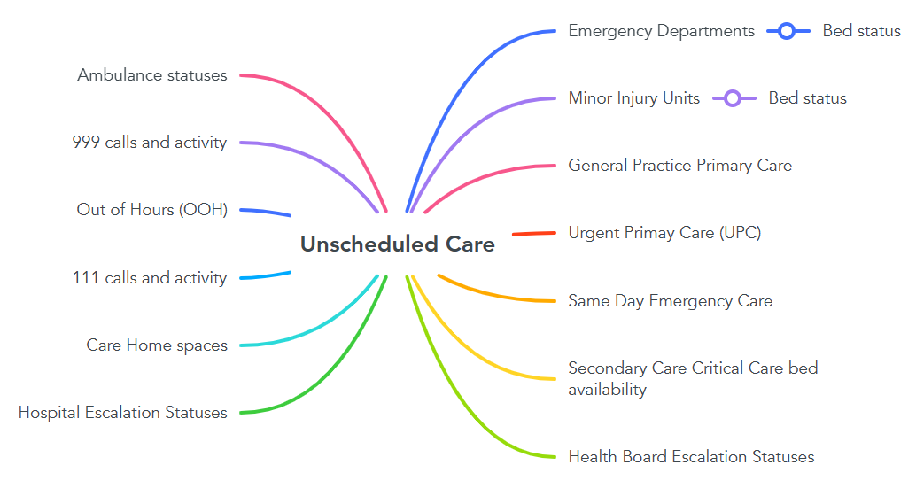

SSIS packages
Figure 7 SSIS Package
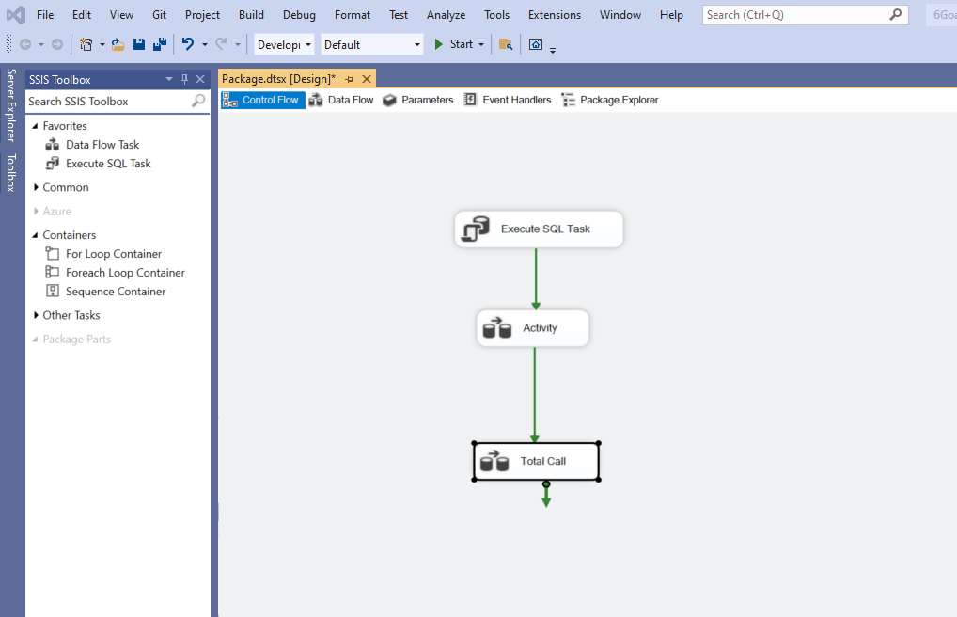

Figure 8 SSIS Data Flow
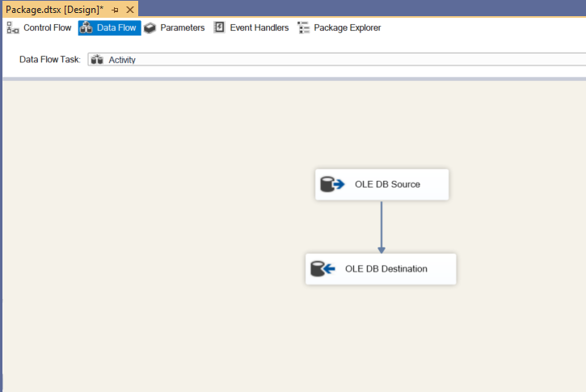

Project scope document

Example of Impact Assessment Form
Figure 9 Impact Assessment
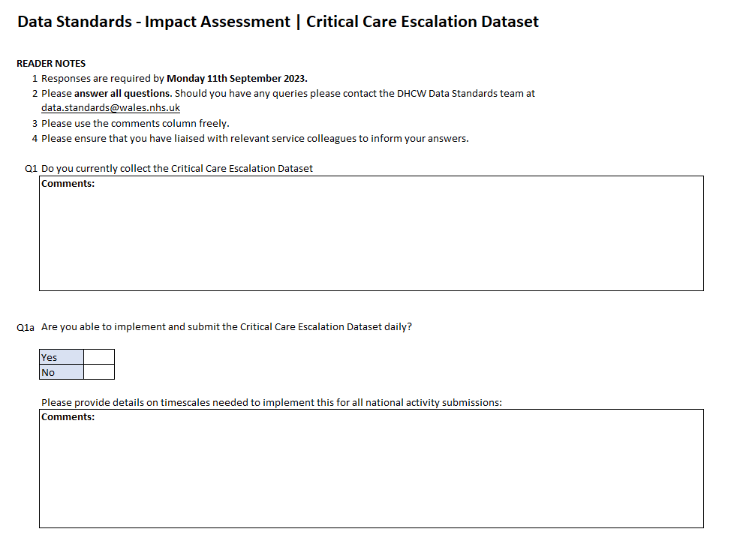
IAs are sent to all external organisations supplying dashboard data, with an instruction to complete in 10 working days. Returned forms are collated to understand the concerns and requirements of data providers. It is expected that all NOT all IAs will be completed , a discussion will take place to debate whether to go with the information received or defer the next step until all IAs have been returned. As this project is time limited it would be pertinent to proceed to the next step with available data.

Example of VAS checks [30]
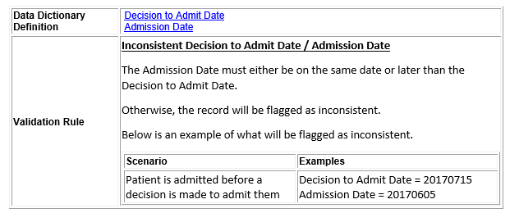 | 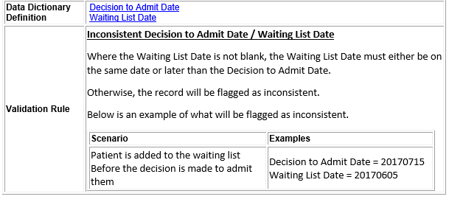

CRISP-DM
Areas of the dashboard to be explored using CRISP data mining methodology would include:
- Primary Care
- 111
- Out of Hours
- Emergency Departments
- Hospital bed availability
- Critical Care availablitiy
Figure 10 UCE Dashboard mock up landing page
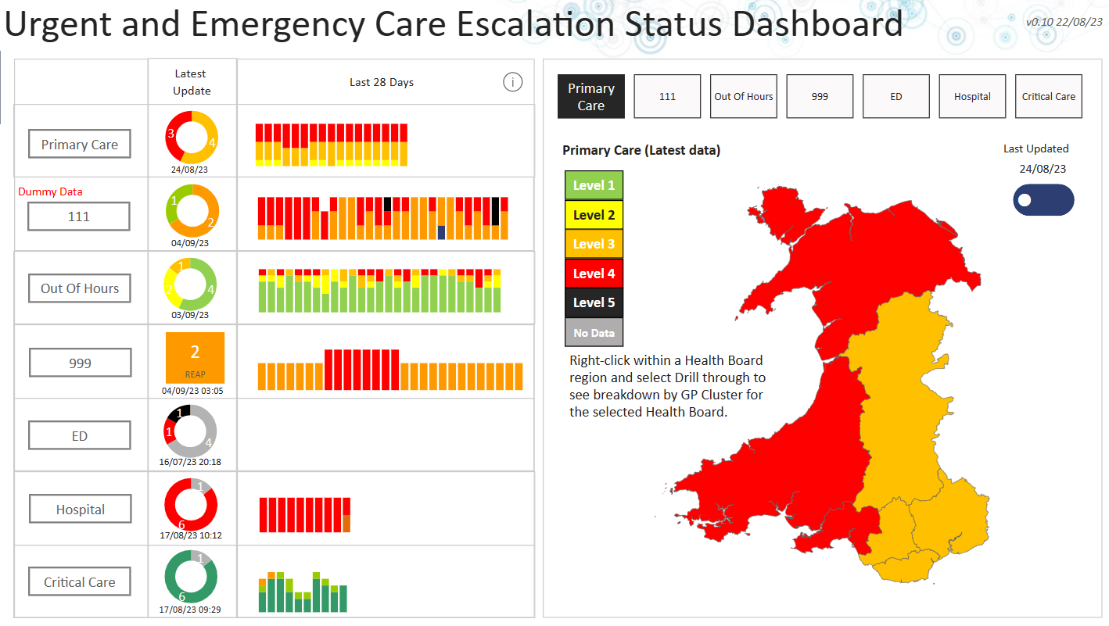

Gantt Chart

Link to Gantt chart

gantt chart_v2a.xlsx

Today’s Date
Formulae has been added to the Gantt chart to display today’s date
Figure 11 Gantt Todays date
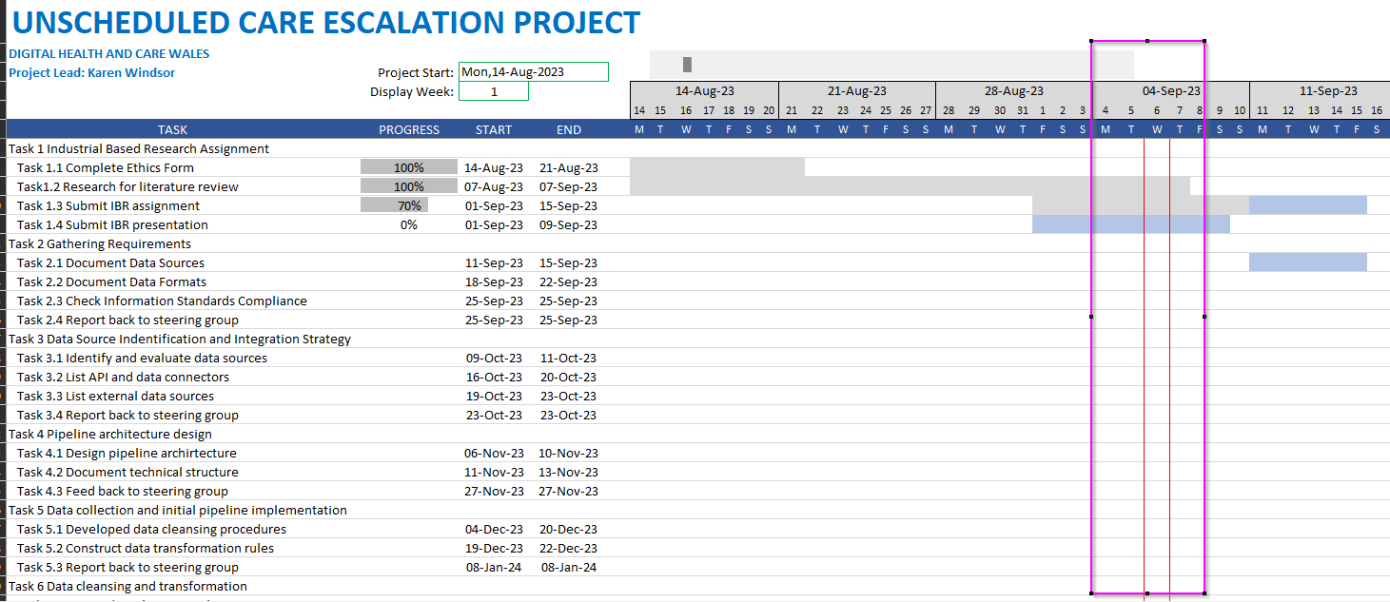

Gantt chart display week
A formulae within the field ‘Display Week’ is linked to the date column and when updated automatically moves displays the week column from the week number entered.
Figure 12 Gantt chart Display Week
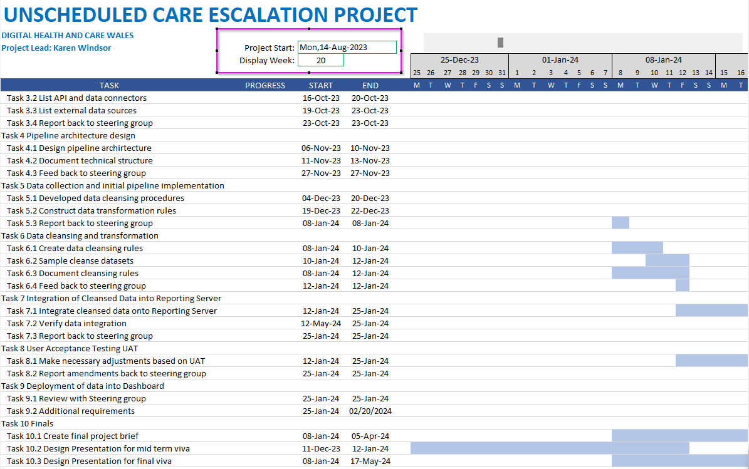

Gantt chart possible error message
This message might appear on the link – as there is an internal application for setting dates, it has been disabled for this chart, but if appears just click ok to view chart.
Figure 13 Date Picker


