MA Dissertation – Rachael Marsh
Violetta Valery - A role study: The tragic, true story of the woman who loved Camellias.
Student Number: 1903075

Word Count 7033
[Pick the date]

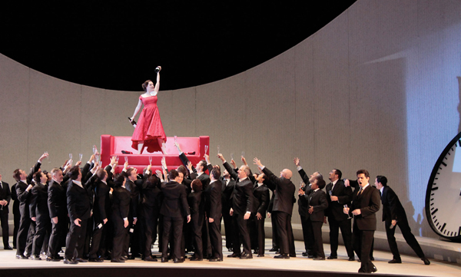
Violetta Valery: La Traviata’s Donna di prima forza
Violetta Valery is from Verdi’s masterpiece, La Traviata, is an iconic and incredibly difficult role for sopranos taking on the part. To understand the role in its entirety, we will look at the opera as a whole and who Violetta Valery really is. La Traviata was based on a very true story and makes Violetta a more complex and dynamic character than she may appear. We will also discuss what type of soprano Verdi had in mind when casting his first Violetta and the struggles of finding the perfect voice type as he composed La Traviata and how he brought her to life. With a range from Low C to top C sharp with an optional E). In addition to this, the opera will be broken down in to the separate acts to look at Violetta’s role and the challenges she has to face vocally and dramatically which truly makes her the Donna di prima forza. La Traviata most probably is among the most loved operas of all time. The Royal Opera House in London have staged no fewer than thirty performances of Traviata, their Violetta’s include the legendary sopranos Renee Fleming and Angela Gheorghiu (Page 1, The Real Traviata: The Song of Marie Duplessis 2015). When Renee Fleming was interviewed by The Telegraph about playing Violetta, she was asked about why she hadn’t taken the role on until well in to her forties:
‘The difficulty is absolutely the Act 1 aria [Sempre Libera] for me. It is just not natural for my voice. When I start singing the aria I think “Well let’s see if we get through it tonight… she muses, ‘if Verdi actually just didn’t like the soprano he was writing for’
Telegraph.co.uk – Renee Fleming Interview
Fleming who had taken on many difficult roles in her life including Mozart’s Donna Anna, explains the difficulties of the role of Violetta as the role requires pushing the parameters of most lyric soprano voices.
Ermonela Jaho, who sang the role for the Royal Opera House, London, gave an insight in to what she believes is important for singing Violetta well and encompassing the character.
‘You need the whole vocal range – the coloratura, the bel canto, the drama. Technically, I know I can deliver this opera. Emotionally – which is the most important thing for me – Violetta is the most beautiful soul of a human being. We see emphasised in Violetta those human feelings of sacrifice, of unconditional love.’
Bachtrack.com – Ermonela Jaho interview.
Young soprano Jennifer Carter took on Violetta, in her interview with schmopera.com, she explained the pressure surrounding this iconic role for all sopranos taking it on:
‘For an artist, sometimes it can be intimidating to sing iconic roles. With Violetta, I feel a sense of freedom in that there is not a right or wrong way to be Violetta… many sopranos have made her their own… it is my job to make the audience feel the connection too.’
Schmopera.com – Jennifer Carter interview
Violetta requires a demanding coloratura within the first act and then well sustained dramatic, lyrical singing in the second and third act. Coloratura is a term used for a rapid succession of short notes ung without interspersed consonants.’ Physiologically, it is performed by means of synchronised undulations of fundamental frequency and pressure’ (Leandersson et al., 1987) (Journal: The KTH Rule for System for Singing Sythesis 1995). This often leads to people talking of being an ‘Act 1’ Violetta or an ‘Act 2 and 3’ Violetta, which shows how contrasting and flexible the soprano voice needs to be to successfully sing Violetta well.
When messaging Lisette Oroposa, who recently won the Richard Tucker Award, she gave some insightful comments towards the role.
‘It feels difficult to play her sometimes because the story is so sad, and she is not an optimistic person in general. But the music is just so beautiful so as a singer it is very fulfilling once you get past the technical challenges. I love the character but feel so bad for her lot in life. Trying to maintain the dignity in her tragedy is a challenge.’
Instagram direct message 29.12.19 (image in references)
When asked about the controversy about being branded an Act 1 or 2 Violetta she replied:
‘They do but that’s an unfair expectation to put on a singer. You just have to take one act at a time and let the story and the music colour the voice. It’s a role for an interpreter. It can be done well by coloratura voices as well as dramatic ones.’
Instagram direct message 29.12.19 (image in references)
Lisette gives another interesting insight in to which soprano fach can sing the role as the demands are challenging for both coloratura and dramatic voices but both can take on the role and the character comes through on the interpretation of the music rather than the accuracy and technicalities. These technicalities and challenges will be discussed in detail when we go through Violetta’s role and arias within La Traviata as a whole.
The real Violetta Valery
Although many different people speculate on who the ‘real’ Violetta Valery was but the most common theory is that she was a creation from the very real and most fashionable courtesan of the 1840s, Marie Duplessis. In January, 1847, a young, 23 year old woman lay dying of consumption at 11 Boulevard le Madeleine in Paris: this was Marie Duplessis. Marie was a well-known courtesan who serviced the city’s bourgeoisie, the upper classes, artists, writers and musicians. Franz Liszt was one of her many known lovers, it is believed that he had spoken about her saying that she had the sweetest nature, pure and serene, despite her shadowy world that worked in. These traits are quite clear traits of the heroine Violetta Valery, who despite the life she lived, there was something special about her that made her more vulnerable and inviting beyond what her job provided.
The French press gave many tributes to her death in the newspapers which showed how adored and well-loved she was. The famous poet and novelist Theophile Gautier reminded his readers with this obituary of how she captured the city:
‘More than once, on the boulevard of des Italians, at the opera, at all the shows where it is almost impossible to secure a seat, Parisians will undoubtedly have spotted, in the most desirable box in the theatre, a young woman of exquisite demeanour…’
Page 1 The Real Traviata: The Song of Marie Duplessis.
Within a year of her death, another of her believed to be former lovers: Dumas Fils (celebrated author and playwright), wrote the novel dedicated to her called ‘La Dame aux Camellias’ The Girl who loved Camellias. The novel became so popular that it was very soon written in to a play, depicting the dramatic adaptation of her life. The premier of the show was in the Theatre du Vaudeville in Paris, in which, Verdi himself had attended. It is almost certain that through this, Verdi and his companion, the singer Giuseppina Streponni, first heard the story of Marie Duplessis. Not long after the viewing of this play, did Verdi clearly find inspiration to compose and create LaTraviata. Verdi’s librettist Francesco Maria Piave, ensured that he kept the integrity of Dumas’ dramatic adaptation. (WNO website). Piave’s Violetta, idealized as she is, becomes so intensely human and heroic which makes her death all the more impactful (121:1973).
When Verdi planned to write Verdi for the carnival season of 1853 at Teatro la Fenice, he seemed to have a ‘donna di prima forza’ in mind as he showed particular interest in a leading soprano proposed for the season (as seen in letters to Marzari) (115:1973). ‘Verdi would have preferred that the prima donna should be Alaymo rather than Salvini-Donatelli’ (Letter from Brenna to Mazari 26.4.1852 Archives of the Teatro la Fenice. 115:1973).
Marie Duplessis was originally born ‘Rose Alphonsinse Plessis on 15th January 1824, she was the inventor of her name ‘Marie Du Plessis’. Marie within her life had returned to Normandy to give birth to a baby boy which she could not keep due to his rich father had taken him away to be raised a nobleman. Marie’s own father was also a difficult subject as he had traded her for money to an older man. Her short life was given lasting and universal fame as Violetta Valery turning her tragic story in to an artistic legend. (Renee Weis Article: The Saintly Courtesan).
Violetta has many similarities with Marie Duplessis The Girl who loved Camellias. The camellias are a profound symbol to show her sexual availability: if the flower was white, she was available; if the flower was red, she was not available. She also provides Alfredo with a flower which she says when it dies then he must return to her. Throughout the opera it is quite clear that she is very much respected by the people the surround her and she was loved, very similar to Marie Duplessis judging by the outpourings and tributes to her when she passed.
La Traviata has been taken on in many ways from the abstract to the very traditional setting. Its first performance was at La Fenice, Venice in 1853 and its first UK performance in 1856 at Her Majesty’s Theatre, London. The most famous abstract, modern version of this opera is Willy Decker’s production with the very distinctive black, red and white theme. Willy Decker uses a clever amount of symbolism to help convey some quite complex emotions, including the doctor as an impending figure over the whole opera; the clock also provides an impending sense of Violetta running out of time.
In the more traditional productions (Marta Domingo’s production with LA Opera), the surroundings are very lavish ballroom settings with the added luxury of traditional costuming and airs and graces of the time period. These productions hold true to the time period where being a courtesan was a respected profession although a less talked about one. The one thing that remains consistent is the story that reflects Marie Duplessis’ story of a well-loved woman who finally found love conflicting with her entire lifestyle, but all too late from the grips of tuberculosis.
Breakdown of the Acts – Synopsis, Arias, and Difficulties encountered
Act 1
Synopsis
Act 1 opens the opera in Violetta’s house in Paris at one of her many lavished parties. The overture opens with melodies of Violetta’s past, reminiscing about her life before her death. This then opens in to an opening party scene; Gaston (a nobleman) presents his friend Alfredo to Violetta as an admirer. Alfredo had been calling daily during her illness and had persisted to show his affections. Violetta is currently with the Baron Duphol, who is not amused about Gaston’s proposal of Alfredo. Baron Duphol watches from afar as Alfredo proposes a toast to beauty and love with the infamous Brindisi.
The party then continues in to a neighbouring room after Violetta suffers a fainting spell. Alfredo remains to talk to Violetta and profess his love to her. Knowing her status and lifestyle choices, Violetta only offers friendship to Alfredo rather than love. She offers him a flower and asks him to return when the flower has withered away then she may offer him more. Alfredo, full of joy, leaves knowing that he will be with her again.
Violetta then begins to reflect on what Alfredo has offered her starting ‘E strano’ ‘how strange’ which she repeats throughout the opera as she has never felt true loving feeling until this moment. She then sings the tasking and brilliant aria ‘Ah forse lui’ and ‘Sempre libera’. During the recitative, she ponders about how she is feeling and how she could fit love in to her lifestyle. She exclaims ‘Oh joy!’ many times to finally know what it is to love and to be loved in return. Violetta then quickly starts to talk herself out of these romantic notions by describing the positives of her life including the lavish parties and racy lifestyle. This leads in to the aria ‘Sempre libera’ where she continues to convince herself of enjoying the lifestyle she has and how glorious it is to be free and live life without care. *Dee volare* Part way through the aria, she hears an echo of Alfredo to which she suddenly stops and responds with love and longing to him, before shaking off the folly of these feelings. As the aria ends, she leaves the stage convinced that she must remain in her current lifestyle and choices and that she cannot afford to fall in love and become vulnerable.
Act 1: Scene 2
Violetta will probably find the staging of this quite difficult as seen in Willy Decker’s take on Traviata, she spends a lot of time being pursued by the chorus to show how in demand and how loved she is. Within this particular production, there is an added difficulty of being lifted on top of a red sofa and having to traverse around it whilst singing her part in. Although in most traditional settings, Violetta is seen usually within a ballroom scene mingling with all guests to show her popularity. All this builds to the introduction of Alfredo and the beginning of the toast to love and life. She also has a line that integrates within the chorus on stage which must stand against and blend with other chorus members.
Duet – Brindisi
One of operas most loved and well known duet and ensemble, the Brinsidi has a jubilant melody embellished with playful grace notes, triplets and trills. This begins the coloratura section to show Violetta’s playful nature. With Alfredo leading the duet, Violetta echoes his melody but not with same sentiment. Where Alfredo toasts to love and life, Violetta simply replies that it is a folly but during this duet, Violetta needs to provide a coquettish air around Alfredo reflecting that she is interested but not so that it interferes with her façade. Dramatically, the acting skills required are very subtle but need to be there to begin the love affair. This duet is difficult due to how well it is known which tends to add pressure for perfection. All the ornaments and turns within the melody must be precisely sung in order to create the nuances we all know and love. Ending the duet on a high B flat, she then goes on to suffer a fainting spell, dramatically, this is helped by the way the soprano line is written which reflects her breathlessness at this point, this is a pure interaction with Annina her maid which in turn gives the chorus a chance to leave stage and leave Violetta with Alfredo for their first intimate encounter.
Alfredo declares his love for Violetta through his aria Un di felice, which is followed by the short duet between the two of them. Requiring a laugh like coloratura, to deal with the descending scales, once again, in Violetta’s light and carefree style. This laugh like coloratura can be used as a good dramatic device to help with portraying her personality. This response to Alfredo is frightfully written with the words unnaturally placed within the line which can be difficult to articulate for the soprano. Violetta’s line is contrastingly different to Alfredo’s showing the contrast in their attitudes towards love. Alfredo showing a more lyric and romantic line whereas Violetta shows a carefree and light line. Towards the end of the duet, Violetta and Alfredo sing a passage where her decorative coloratura must line up perfectly with his more syncopated simple line, both of which are unaccompanied and exposed.
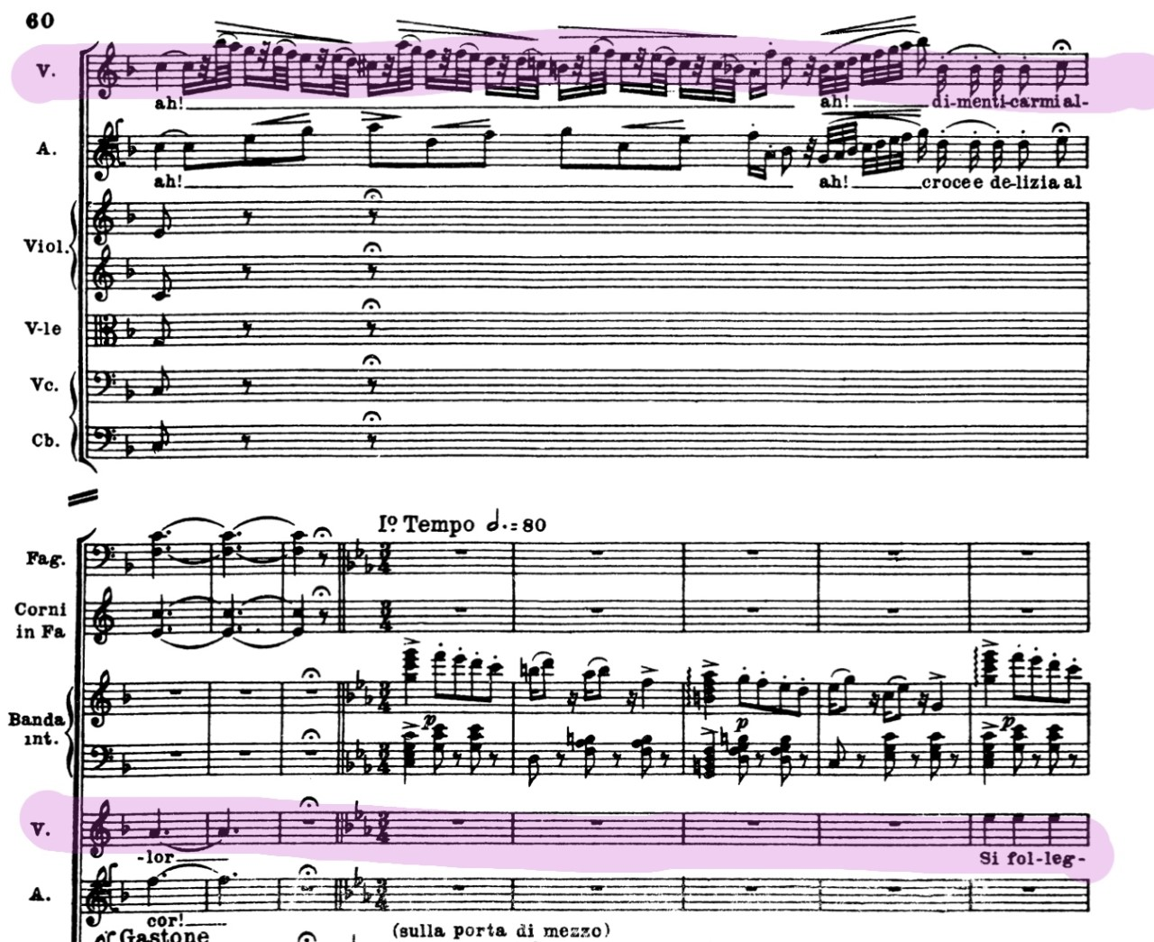
This requires precision and working together with the tenor to perfectly time this section to finish perfectly together usually with ‘ah, si’. Good listening skills are required to ensure this falls perfectly in time. Before going in to Violetta’s famous aria and recitative, they part saying their goodbyes in which she hands Alfredo a flower and says to him that he must return to her when the flower has wilted. Violetta’s lines become more lyric as he leaves, showing her vulnerability towards Alfredo.
Recitative, Ah Forse lui and Sempre Libera
Vocal range: Low C to High C (Optional Top E)
Violetta is finally left on stage alone for her first realisation of feeling love for the first time. Her recitative is started with the phrase ‘E strano, e strano!’ which gets repeated at many points throughout the opera. Literally translating to ‘it’s strange’ reflects Violetta’s confusion by her own vulnerability for this man. She talks about imagining what life would be like with the happiness of loving and being loved in return. When she finally gets to the phrase, ‘oh gioja ch’io non conobbi, esser amata amando,’ there is a definite change in mood from the previous phrases in which she is contemplating what this feeling is and why this man has made her feel this way. These contrasts in the recitative are vital for the meaning of the text to be portrayed in the correct manner. The soprano singing this passage must understand the meaning of each piece of text to truly convey the contrasts correctly. She ends the recitative with internal questioning of ‘can I really allow myself to love this man within the aridness of my lifestyle?’. The entire recitative is one of questioning and internal struggle to deal with a new emotional feeling, which must be shown within the phrasing and intention.
The andantino begins to start ‘Ah fors’e lui’ and presents a major- minor design at its simples; the major melting in to the minor in the most natural way possible (134: 1973 The operas of Verdi: Vol 2). This major-minor transition really reflects the positive and negative thoughts in Violetta’s mind and how she is always going between the two notions of happiness. The aria begins on a descending minor phrase which must be kept controlled, as descending phrases can be a danger point in which the voice can go flat. This is then followed by octave jumps with the upper note of the octave being marked dolcissimo which requires the soprano to ensure that the upper note of the octave is placed well and not under sung.
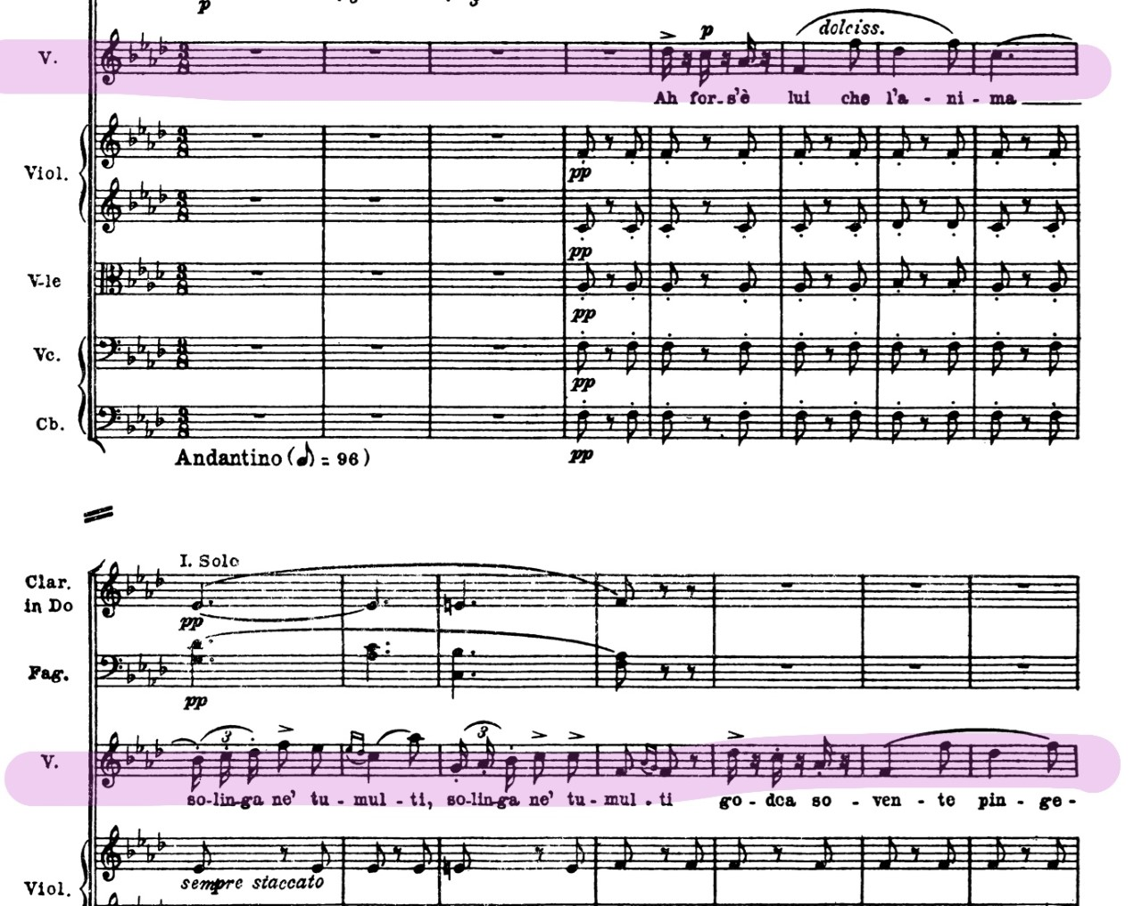
‘Lui che l’anima’ despite its octave jumping also is marked with a long legato line which requires the transition to be smooth and beautiful requiring a good connection and support within the voice. All the phrases that Violetta sings seem to have these beautiful long, lyrical lines which reflect her vulnerability and change in her heart towards Alfredo. Verdi then uses his characteristic marking of staccato with the legato line over the top for the following phrase ‘solinga ne’ tumult.’ This requires a certain marking of notes without showing any detaching of the phrase. Verdi uses this technique in a lot of his works usually to denote a subtle, emotional surge for the character. This can be seen within many works including Ernani and Othello. Traditionally, a short fermata is allowed on the high A-flat of that phrase.
Then we first hear Violetta sing Alfredo’s long, lyric line which appears throughout the opera within Violetta’s lines. Verdi begins the special introduction to Alfredo in Violetta’s thoughts by making her sing higher and with a more full voice.
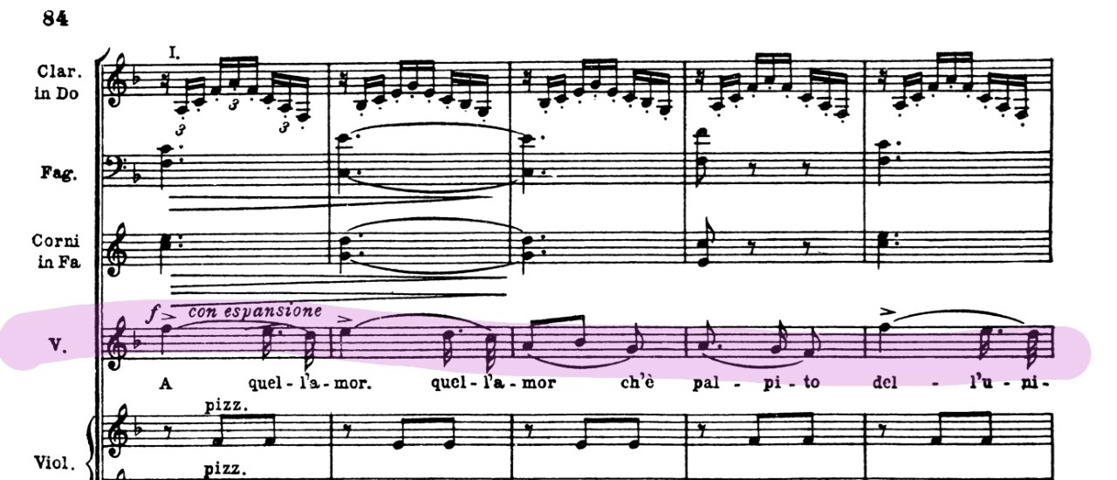

This long, lyrical phrasing continues until the phrase ‘croce, croce delizia, croce delizia, delizia al cor’. Verdi draws a climax for this section and theme by accompanying with clarinet arpeggios, which still sounds resplendent providing the major and giving the effect of emerging from the darkness of the minor in to the major (135: 1973). Although Violetta is not aware of it yet, the meaning of that phrase ‘the heart’s torment and delight’ is poignant to her throughout the opera and appears many more times. This section is finished off with a flourishing candenza, which highlights the beginning of this coluotora section of Act 1 which is so contrastingly different to the other two acts which requires soprano to have good flexibility and accuracy within the voice. In order for the cadenza to express the emotional surge for the character, the singer needs to experiment with phrasing the candenza within itself, providing a natural flow of notes which is emotionally driven. This descending cadenza pattern highlights the high B flat, then the G, followed by the E etc. These can be classed as anchor notes in order to give the cadenza more structure. There is one very difficult interval in the cadenza, particularly going from the high B flat to the D sharp which requires an attentive ear and good intonation. When working down through the cadenza it is also important to keep a clear vowel shape that does not change through out the voice as this avoids any closing on the notes and ensuring good control and consistency throughout the range.
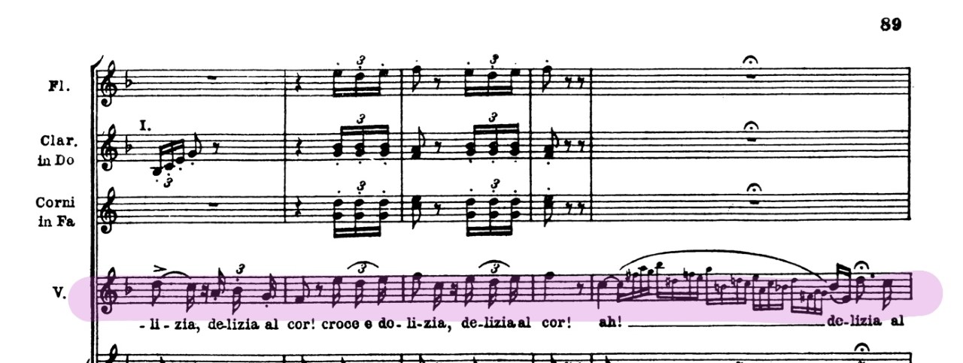

Thus starts the short recitative section before throwing herself in to Sempre libera. She starts claiming ‘what folly!’ and how crazy of her to think these thoughts. Then begins the inner pity, on how she alone and abandoned such a busy place called Paris, continuing on the C which is echoed within the orchestra and interjected by a syncopated rising minor triad to build an anxiousness throughout the simplistic vocal line. This is followed by a questioning of what she has to hope for, before realising the joys of her current lifestyle. Sopranos will have to show a range of colours and emotion through this small section, once again showing how torn Violetta is and how she is trying to convince herself that she does not need Alfredo’s love.
The key then becomes settled in the major providing a jubilant and playful melody to begin Sempre libera. Sopranos singing this aria will now have to navigate through their range carefully to ensure that all sections are supported well and sang with the carefree nature of which Violetta sings about. This requires a tension free technique although the music sounds energetic and at times quite hectic.
After the phrase ‘sempre lieta ne ritrovi’ a then very jubilant high C comes from the text after Violetta insisting that she must be happy and essentially ‘party’. This C is well sustained and has a pause provided to show that this is an expression of joy. Traditionally, sopranos will condense the previous word ‘ritrovi’ into a shorter notation in order to sing the C in a pure ‘ah’ vowel. This also provides another tricky element for the singer in which they must have a very open and well sustained ringing C. Continuing on the melody picks back up until dee volar, dee volare il mio pensier which provides another tricky turning point as each phrase is made up of descending chromatic scales that go straight down through the upper passagio of the voice. Each of these downward chromatic scales is also marked with a diminuendo mainly to ensure that the phrasing of the words is correct, but also to provide a needed pick up for the following phrase. Each ‘dee volar’ also includes an accent at the begin of each one. Conductors can usually provide a slowing of the tempo round this section in order for the soprano to be able to navigate this section without building more tension and difficulty. This then turns in to an almost ‘laugh-like’ section of descending scales that each are ascending as groups.
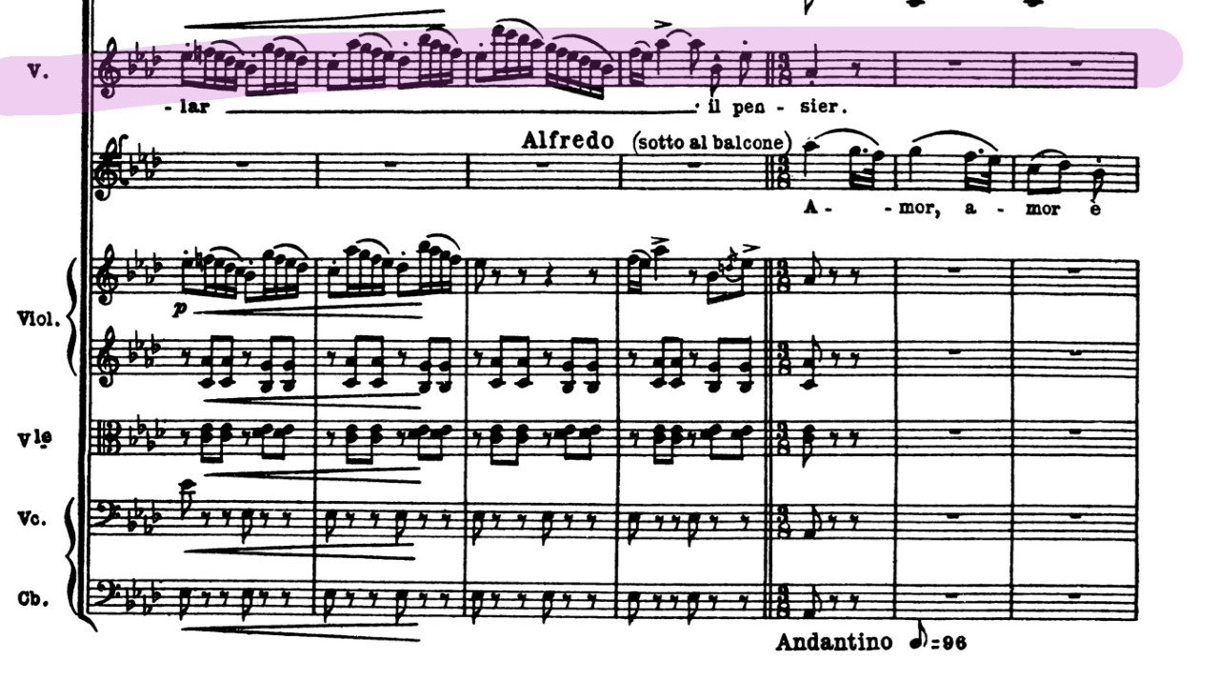
Each of these scales require a good navigation of the upper passagio and a certain lightness to them without disconnecting from the support as the last of these descending scales starts on a top D flat. When descending through this upper passagio, there can be a tendancy for the voice to drop below the passagio resulting in difficulty to get back up to the next note, which makes this section difficult to control and to keep a relaxed larynx. If this small section is not sung carefully, the rest of the aria will begin to life off the voice and has tripped many a soprano up which most sopranos feel is the most difficult part of the opera.
Violetta then gets an interrupted moment to hear Alfredo echoing the melody she sang previously on O quell amor, quell amor che palpito. When looking at this dramatically, Violetta immediately stops and her mood changes for one of longing for him, despite her best efforts of trying to convince herself otherwise. Some may interpret this as a voice inside her head telling her to be with him and can portray this on stage through actions of holding on to their head or trying to stop herself from going to him. This long lyric line from Alfredo once again interrupts Violetta’s light, coluotora line, like the interruption of her thoughts. Violetta can’t help but respond during Alfredo’s line as she feels drawn to him.
Violetta then pulls herself away from him by repeating the phrase from before ‘Follie, follie!’ followed by another flourishing candenza which could signify an internal struggle or outburst. She then picks up the melody again of Sempre libera to fully convince herself again to remain as she is. The aria is finished with ascending scales that are eventually finished on top accented C’s and very difficult semi quaver groups which provide a great accuracy to sound clean and emotive. Alfredo’s line punches through this last section as an unwanted interruption in her train of thought. On Violetta’s last two ‘il mio pensier’ it can be a common custom to omit the second phrase of ‘il mio pensier’ in order to allow the soprano a chance to catch her breath for the ending. The ending of this aria can also be alternatively and somewhat traditionally given a top E if the conductor wishes and if the soprano is capable but is not necessary as Verdi writes to return to the A finishing with the orchestra racing towards an exciting finish and Violetta’s exit ending Act 1.
Act 2
Act 2: Scene 1
Synopsis
We re-join Violetta in a small country house near Paris in which she now lives with Alfredo having abandoned the luxuries of life to pursue her loving feelings. However, Violetta is struggling to pay her debts and has sold all of her belongings to try and resolve them. Annina, Violetta’s maid, is still with her and caring for her. Annina begins to tell Alfredo about Violetta’s sacrifices to be with him as he did not know about the sacrifices she has given to live with him. Alfredo, with best intentions, decides to leave for Paris to try and help settle the debts himself so Violetta is free from this stress.
Violetta arrives back at the country house once he has gone and discovers an invitation to a party with a good friend of hers, Flora. She has no intention of going and stays home as all of her previous status has left her. She then receives an unexpected visitor in the form of Alfredo’s father , Giorgio, who does not bring good news. He demands that she is to leave Alfredo as he believes that keeping her as a mistress is beginning to ruin Alfredo’s life. Violetta begs him and tells of all her sacrifices she has made for Alfredo, however this is not enough to satisfy Giorgio who demands she is to announce Alfredo and leave. He adds that their relationship is now threatening the engagement of Alfredo’s sister having Violetta as a mistress within the family. Violetta, feeling guilty, then surrenders to the pleas and agrees to leave Alfredo.
Violetta begins to write a letter to Alfredo to bid him farewell, during this time Alfredo meets his father on his way back in and finds out what he has asked of her and implores with Violetta reaffirming his love for her. However, Violetta leaves knowing all of the trouble their relationship had caused. Once she has left, Alfredo reads the letter that Violetta left which devastates him and despite his father trying to console him, Alfredo finds Flora’s invitation and he sets off to pursue and confront Violetta.
Duetto
During this section with Alfredo’s father, Violetta takes on a more dramatic, lyric line as tensions become higher as he asks her to sacrifice her love for Alfredo completely. After Act 1, Violetta has completely different demands vocally and requires a good dramatic top range and vocal stamina to be able to sing the phrases that come next. This is what shows most sopranos what range of styles they must carry in their voices and flexibility. These lines begin after she says that she has predicted that all this would happen and she was too happy. She has a sense that love is not for her, which she says throughout Act 1, unfortunately, this encounter with Germont confirms her apprehensions and suspicions. The dramatic qualities in the voice appear evidently in the build from Ah il supplizzio e si spietato, che a morir, a morir preferiro, si! This builds up to an expressive top B flat over a very thick texture within the orchestra.
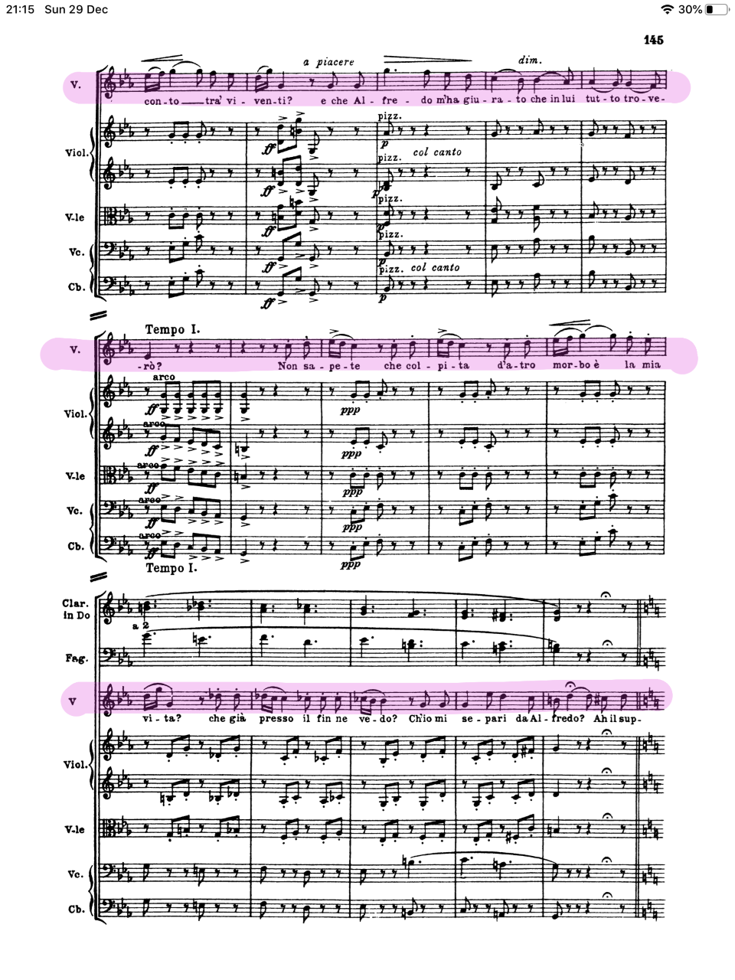
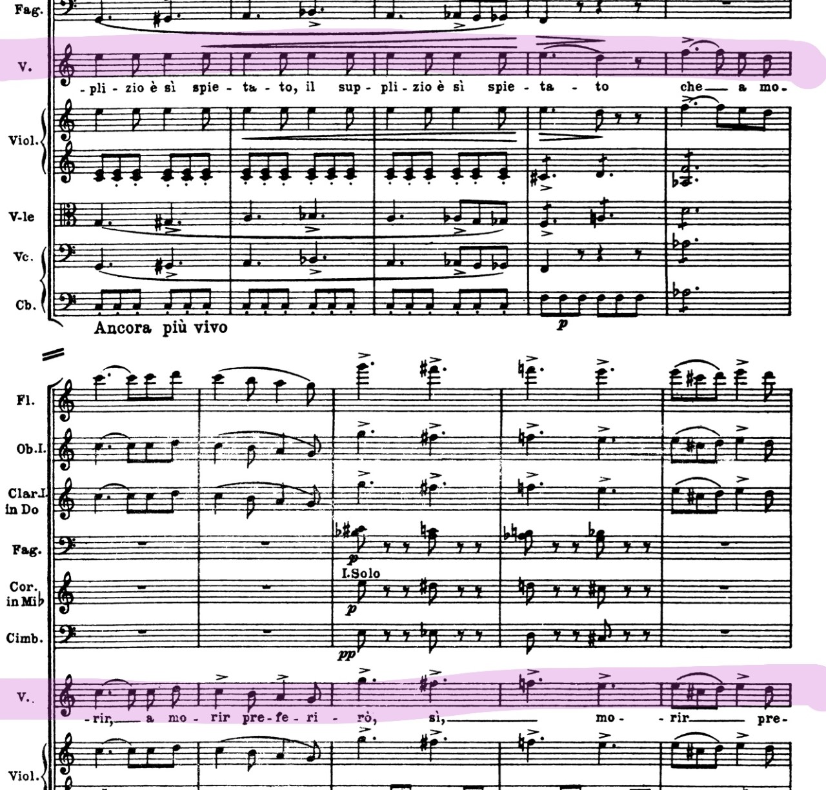
After her emotional meeting with Alfredo’s father, she then accepts to leave him and then begins the even more emotional process of writing her farewell note to Alfredo. She always has a moment with her maid Annina to express her true feelings, this happens also in Act 3 which gives us a short glimpse in to Violetta’s mind. But this is interrupted by Alfredo himself, meaning dramatically she has to try and conceal her emotions by trying to somehow get away from him. She really has to show dramatically the internal struggle to leave him, then saying that she needs to be free. This section provides a good stable middle voice that is well supported. Then begins the long, lyrical lines echoed from before, requiring a more dramatic sound for Amami, Alfredo quant’io t’amo, Addio… before leaving him completely. This final line from Violetta reflects the lyric lines of Alfredo in Act which shows us that what she is saying is heartfelt which makes her departure even more heart breaking.
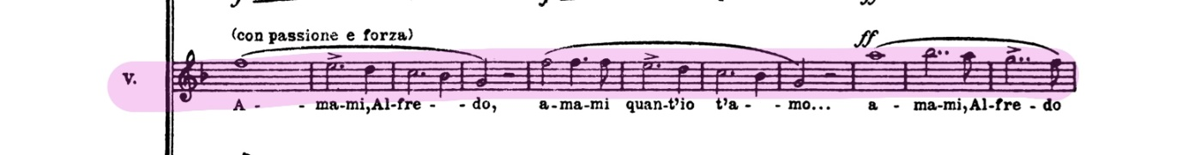
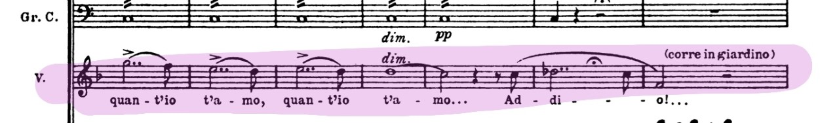
Before Violetta returns in the next scene, Alfredo cries to his father about his loss of Violetta which makes Germont express his guilt and remorse whilst trying to comfort his son. He then find the invitation to Flora’s party which he says he will go to in order to confront Violetta and ask why she had really gone for he doesn’t believe that she doesn’t love him anymore.
Act 2: Scene 2
Synopsis
We are taken to the party scene within Flora’s house and Violetta is now being escorted by Baron Duphol once more in an attempt to appear back in the life she once had. Alfredo is spotted gambling and professing that he may be unlucky in love but not in the cards (a directed barb directly at Violetta) as he is successful with his winnings. Baron Duphol having spotted Alfredo, challenges him to a game, where Violetta has short lines to herself showing her panic and anxiety about the confrontation between these two men. Duphol then loses the game which causes higher tensions and causes him to leave and indirectly leaving Violetta with Alfredo. Having noticing the tension between the Baron and Alfredo, Violetta implores Alfredo to leave knowing that the Baron will challenge him to a duel. He then asks one final time for Violetta to leave with him, which she refuses and lies saying she cannot be with him as she now loves the Baron. Then Flora begins to question after Violetta, amongst the other characters acting as a chorus. Violetta is telling them to be quiet. Alfredo finally reaches the end of his patience as he now is convinced she loves the Baron. Now in a fit of jealous rage, Alfredo throws his winnings at her feet claiming that he is ‘done with her’ and that he has paid her for her services. Due to this public outburst, the Baron returns insulted by Alfredo’s actions and challenges him to a duel in the field.
Duetto with Alfredo
This scene is the build up to Violetta being made a scene of by paying her for her services. The challenges for this are many but dramatically she can have a lot to contend with. From the production by Willy Decker, she has to be thrown down with money thrown at her and stuffed in to her mouth. This can be quite a shocking experience and requires full trust and consent with those you are working with. Also this type of direction must be done with care as she has to sing not long after this incident. The phrases after this demand long, lyrical singing with very well-articulated dynamics that need to be adhered to in order to provide the dramatic intent of her vulnerability. Verdi writes very clear dynamic contrast throughout for Violetta to highlight her frailty and vulnerability which requires a good control of particularly high pianissimos and dramatic contrast. Violetta’s vulnerability is now the centre of this very dramatic scene that paints Alfredo as a monster in his jealous rage. Germont disgusted with his sons behaviour arrives to effectively tell off Alfredo for his treatment of Violetta considering what he had asked her to denounce. Violetta then sings passionately to Alfredo of her remorse and love for leaving him, accompanied by a chorus of voices from the other characters who are all expressing their shock at the situation.
Act 3
Synopsis
Violetta is now very close to her death which has been imminently looming throughout the entire opera. The physician tells Annina that Violetta only has a few hours to live. Violetta reads aloud a letter from Alfredo’s father saying that Alfredo has left to go abroad after wounding the Baron in the previous duel. Violetta sings the famous yet harrowing aria ‘Addio del passato’ where she says goodbye to her life and love.
Suddenly, to her surprise he appears with minutes to spare to tell her that he finally found out her great sacrifices she made to be with him and to beg for forgiveness as Violetta shouts to him ‘Alfredo Alfredo!’. They reunite and for a brief moment Violetta feels a restored strength and they believe that they can run away together and find happiness. She falls as she wishes to leave realising that she has not got long left for this world. Georgio arrives to beg forgiveness from Violetta, embracing her as his own daughter. Although all is forgiven, it’s all too late and sadly she can hold on to life no longer and dies within Alfredo’s arms.
Scena and Addio del passato
The whole scene demands Violetta to go through a range of colours and emotions. She goes from wanting to cling on to life, rekindling love, accepting forgiveness, realising weakness and accepting death. Before she sings her final aria, she once again talks to Annina which reflects that Violetta is close to giving up and shows us her frailty and that she really has given in to her illness. She then pulls out a letter that she received from Germont a while ago asking for her forgiveness. The letter is crumpled which one can assume is an older letter that she has read from many times. The finality of this last act shows that this will be the last time she reads the letter aloud.
When reading the letter that Giorgio Germont send her, Violetta has to use a spoken voice and read the letter aloud over a solo violin. Although she is not speaking over a thick orchestra texture, she has to ensure her voice is well projected but does retract from where the next sung phrase will come from. The letter translates: You kept your promise… The duel took place… The Baron was wounded but is recovering… Alfredo has gone abroad… I have let him know of your great sacrifice… He will come back and ask for your forgiveness… I shall come too… Take care of your health… You deserve a better future.
Verdi ensures that the text is conventionally spoken instead of sung, the violin melody we hear is reminiscent of Alfredo’s theme O quell amor (157:1973) These flashes back to Alfredo’s original love melody to her keep showing Violetta’s most tender and heartfelt moments throughout the opera. This once again creates an emotional pull over a spoken text section. She finishes the letter a top of a diminished seventh chord to say E tardi – it’s too late. This highlights the finality of her health and how she seems to have waited but no one has come.
Addio del passato, is a very difficult aria for all sopranos. It is introduced by a melancholic solo oboe, Violetta’s farewells are accompanied by halting figures in the orchestra that call to mind her shortness of breath and as she recalls Alfredo’s love her lines begin to soar; when she prays for redemption the orchestra presses forward in the ascending harmonic progression. Having expended all her energies, her line descends, punctuated by isolated chords in the strings, and she ends on an unaccompanied high A. (https://operalively.com/forums/content.php/166-Opera-In-Depth-La-Traviata-5-Musical-Analysis-opera)
In addition to all these nuances is the particularly quiet dynamics on the higher sustained notes which is a reoccurring theme of Violetta’s vulnerability. This becomes more apparent towards the end as she becomes more vulnerable and closer to death. This aria is Violetta’s final farewell to all of her hopes and dreams which demands a sensitivity that reflects that. This short aria reflects a very bel canto style but contrasts in three parts. The initial first section addio del passato until she goes in to the reminiscent long lyric romatic lines whilst reflecting on her love for Alfredo. Accents are placed and marked in unusual places during this aria, not highlighting the languages natural stresses but quite the opposite. This creates a tension and uncomfortable sensation reflecting Violetta’s uncomfortable manner, a clever and effective stylistic device if performed correctly. Once again despite being so close to death, her love for him remains. This is then brought in to a major section where she talks about herself and pleads to God for help. This repeats again as she says goodbye to all of the things she loved in life.
Following the aria, there is an offstage chorus that harkens back to an earlier Mardi gras scene earlier in Act 2 Scene 2. This is like a distant reminder of the life Violetta was leaving behind. Within Willy Decker’s interpretation, half of the chorus come back on stage with another courtesan wearing Violetta’s symbolic red dress. This new courtesan and Violetta lock eyes as if Violetta knows she has been replaced and is fading away in to death. This requires the soprano to really be able to portray a longing for her old life followed by a sad acceptance of her fate. Within Willy Decker’s production of Traviata he uses a very clear symbolism of the doctor as an acceptance of death, which can help the soprano direct her emotions to a concrete being. This is also seen in this production through the reference to the giant clock throughout, as a symbol of Violetta trying to stop time in an attempt to stop her impending doom. In most traditional productions, Violetta is usually pictured in her bed or ‘deathbed’ as all this final scene continues.
Annina then calmly prepares Violetta for Alfredo’s arrival, in which they meet excitedly and begin their duet Parigi, o cara in which they begin planning to leave, Violetta echoing Alfredo’s lines. Violetta then tells Alfredo they should go to the church to thank God for his return, in state of heightened joy she tells Annina to tell the doctor that she wishes to live now Alfredo has returned. Alfredo’s return has filled her with an unexpected surge of energy however it is short lived as cannot leave the door. Violetta needs to now portray that pitiful hope as she says in phrase so chilling (after the powerful brass union) ‘that if Alfredo’s return cannot restore her health then nothing can prevent her from dying’ (160: 1973). Violetta needs to be showing a desperation in her actions whilst those around her are starting to realise the severity of her condition.
Germont appears for a final farewell to announce Violetta like a daughter in his eyes. He shows pity on her and doesn’t realise until this moment how close to death she is. Once Alfredo and Germont have expressed their distress, Violetta then begins her final goodbye. She once again repeats ‘e strano’ as she begins to talk about the feeling of spasms in her chest, then feelings of being reborn ‘rinasce’ before singing ‘ma io ritorno a viver!’ saying she feels that she is returning to life exclaiming ‘o gioia!’ as she collapses in death feeling that she has been reborn in life. Although the impending ending is coming, the soprano must have a good control over emotions, as she must portray Violetta’s optimism and love for life. She truly believes that these symptoms are the life and energy returning to her. However, her final fall in to death must be carefully staged and practiced in order to seem convincing yet safe.
Conclusion
Violetta is a complex, fragile character who goes through a very human and very emotional journey in a short life. Torn between a courtesan life or a life with true love, which ultimately conquers all. Verdi’s La Traviata has been a favourite for a long time and it is not hard to see why. Many sopranos who have played the roles have highlighted the technical challenges of this role but most of all, they all relate to the emotional challenge of portraying Violetta in the right way to show all of her emotions and fragility. In all this, we must remember that Violetta was based on a very real, very human woman: Marie Duplessis, who was greatly loved and touched many lives. She was the true inspiration for this iconic masterpiece and La Traviata really reflected all of the facets of her unique and vulnerable character.
References (Oxford referencing style)
G. Berndtsson, ‘The KTH rule system forsinging synthesis’, Dept. for Speech, Music and Hearing Quarterly Progress and Status Report, 1995, http://www.speech.kth.se/qpsr/ (accessed October 2019)
Jasper Rees, Renee Fleming interview: La Traviata. 10th June 2009 [interview] www.telegraph.co.uk/culture/music/opera/5497061/Renee-Fleming-interview-la-traviata.html (accessed October 2019)
Jenna Simeonov, Jennifer Carter on La Traviata: “Violetta is an everywoman.” 10th April 2015 [interview]www.schmopera.com/jennifer-carter-la-traviata-violetta-everywoman/ (accessed October 2019)
Julian Budden, The operas of Verdi: Volume 2 From Il Trovatore to La Forza del Destino. *PLACE OF PUBLISHING* 1973.
LA Opera’s Traditional setting of La Traviata with Renee Fleming and Roland Villazon. https://www.youtube.com/watch?v=gVbAdncN3JY (accessed November 2019)
Mark Pullinger, “On stage, your soul is naked”: Ermonela Jaho on her heartbreaking soprano roles. 17th Febraury 2017, [interview] www.bachtrack.com/interview-ermonela-jaho-traviata- butterfly-angelica-opera-month-february-2017 (accessed December 2019)
Rene Weis, The Real Traviata: The Song of Marie Duplessis. London, Oxford University Press, 2015.
R. Weis, ‘The Saintly Courtesan’ in Renee Weis, The Real Traviata: The Song of Marie Duplessis. London, Oxford University Press, 2015.
The real story behind La Traviata. 9 November 2018, www.wno.org.uk/news/the-real-story-behind-la-traviata (accessed October 2019)
The tragic true story that inspired La Traviata, 2nd December 2019,www.roh.org.uk/news/the-real-traviata-the-tragic-true-story-that-inspired-la-traviata (accessed December 2019)
Willy Decker’s La Traviata, Anna Netrebko and Rolando Villazon. https://www.youtube.com/watch?v=OJm62JgE5uY (accessed November 2019)
Image – Instagram conversation with Lisette Oropesa


