

FOOD AND BEVERAGE OPERATIONS: ASSIGNMENT 2
Module code: BMIH4002

Hotel Trinity - A 4 Star Independent Hotel

Address: “SA2, ALEXANDRA TERRACE, COAST OF SWANSEA, SOUTH WALES, UK, CF39 9AA”
Contact number: +44 7911 123456

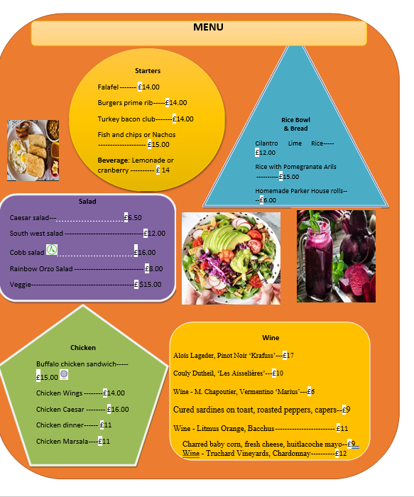

The menu contains both the options for the vegetarians and the non - vegetarians. People can opt for starters with beverages like lemonade or cranberry and the juice quantity is 100 ml. There are 5 options in the salad section. The rice bowl and breads have been included. It can be specified that the menu has been designed keeping in mind the preferences of customers in terms of their health and taste in the present days. It is expected that the exclusive wine section will be loved by the people. There are 2 wine pairing food as well such as “Cured sardines on toast, roasted peppers, capers with Wine - Litmus Orange, Bacchus”, “Charred baby corn, fresh cheese, huitlacoche mayo with Wine - Truchard Vineyards, Chardonnay”, along with single wine options and the quantity to be served is 240 ml. It can be highlighted that all the foods are primarily prepared with vegetables and the addition of meat of their choice are for the non - vegetarians. The menu has also specific category for allergy and vegan food-based on the preferences which were mentioned in the menu card. In this manner all the items can be available for all kinds of customers. This newly opened hotel is expected to serve the people in the region delightfully.
Time availability: The timing for placing order with the hotel is 12 pm (noon) to 10 pm.
Contact details: people can place orders via telephone by dialling +44 7911 123456. The public has the option to visit the hotel website: Trinityhotel.com to check out the entire menu and other details and can opt for the online order option to order the selected food and wine. In addition to that, the third - party application “Just Eat” is available. In that case, people have to log in to the website or the application of Just Eat, type the postcode, then search Trinity Hotel for the food menu to open and then select items for placing the order.
Collection or delivery instructions: Customers can visit the address “SA2, ALEXANDRA TERRACE, COAST OF SWANSEA, SOUTH WALES, UK, CF39 9AA” if they wish to collect the ordered items on their own. In that case, they can place the order beforehand via phone or online and choose for the self - collection option and they will be provided with an estimated time. They can visit the place and then order in that case there is a waiting area available. Further, customers can be assured that all Covid - 19 protocols or guidelines are followed by the hotel and therefore they need to abide by the same in case of collection of the food. On the other hand, there is the choice for delivery.
Payment Options: there are different options made available ranging from cash payment, card payments, online payments such as using UPIs and other means like internet banking. It can be mentioned that in all the cases in terms of place the order, the option of “contactless delivery” has been made available where no cash will be accepted. Customers can choose from a wide variety of order placing options as well as payment options as per their convenience.

