Title: A written assignment showing how a series of learning opportunities can be inter-linked to demonstrate progression in an area of learning and experience.
In this assignment I will be examining and critically assessing the different types of assessment for learning (AFL) strategies and theorists’ work on AFL. To begin with, I will be examining three areas of learning and experience (AOLE) with a year 3 class that has 26 pupils set in a rural part of West Wales. The class is of mixed ability therefore planning for the learner’s ability not age is key, as Donaldson advocates in his ‘Successful Futures’ report (Welsh government, 2015). Differentiation is considered good practice in order that all learner’s needs are met (Sousa and Tomlinson, 2011) therefore I have ensured that I have differentiated throughout. There is one learner present who is on the register of children with additional learning needs as they have Attention Deficit Hyperactivity disorder (ADHD). They have been allocated a teaching assistant who works closely with them on a 1:1 basis. The classroom also benefits from a general classroom teaching assistant who, on occasion, works closely with the lower attaining pupils (LAP) or with the more able and talented learners (MAT). The current class theme is ‘Tyler Fish - Adventure to the Artic’ and the learners are two lessons into this topic.
The three AOLEs being covered in the lessons are Science and Technology; Language, Literacy and Communication (LLC) and Expressive Arts as these are some of the areas that the learners wanted to explore during the theme. The Estyn Thematic Report (2017) supports thematic teaching as it offers a broad range of enriching experiences that the learners can engage with as it’s in their best interest (ESTYN, 2017). Prior to the science lesson learners will have planned and made predictions to the outcome of the experiment leaving them with the investigation to carry out in the planned lesson. In the LLC lesson the learners will be re-capping personal and past tense styles of writing by putting their skills and knowledge learned in a previous topic into practice. The task consists of writing a diary entry from the Artic. Prior to this lesson the learners will have studied Tyler Fishs’ Adventure to the Artic by carrying out a number of research lessons, learners will have the opportunity to choose between writing about the night before he set off to the Artic, during the hike or when he had reached his destination. This task will be carried out independently however it will be differentiated. The lower attaining pupils will be given support by having templates provided, the average year 3 learners will have dictionaries provided however the MAT learners will be expected to carry out the task independently and to a higher standard.
In the AOLE which focuses on Expressive Arts the learners will be creating a collage of an animal using recycled materials. Prior to this lesson the learners will have carried out a research lesson where they will have researched different animals in groups and created a fact file on the animal. Following on from that lesson the learners will use the knowledge they have gained about the animal to create their collage. Learners will have to use teamwork skills to agree on what type of recycled material they will use, and they will be expected include reasons relating to global warming and climate change when rationalising their decisions.
I will be using a variety of AFL strategies throughout the learning experiences as it will provide me with reliable knowledge and understanding of where the learners are at, what they need to do to improve and how we are going to get them there. William (2011), supports this process as he outlines that the purpose of feedback is for the learners to take ownership of their own learning. Some of the AFL strategies I have used in the lesson plans are think pair share, mini plenary, what a good one looks like (WAGOLL), traffic lights, peer assessment, self-assessment and different types of questioning. However, the strategies that I will be critically assessing are peer and self-assessment, different types of questioning and WAGOLL.
Over time assessment has changed dramatically as assessment was separate from teaching and learning as Graue quoted, ‘assessment and instruction are often convinced as curiously separate in both time and purpose’ (Graue, M. 1993). However, it has now become a part of teaching and learning and is going to be an integral part of the new curriculum. According to Donaldson’s report ‘Successful Futures’ ‘assessment is a vital and integral part of learning and teaching and so needs to be fundamentally linked to the curriculum’ (Donaldson, 2015, p. 6).
There are two types of assessments - formative and summative. Firstly, when evidence from assessment provides feedback and is used to modify the teaching and activities to meet the needs of the learners the assessment becomes formative (Black and Wiliam, 1998). There are both benefits and disadvantages to formative assessment as discussed by the Cambridge International Education Teaching and Learning Team; advantages such as: Learners get to work with the teacher to know what level they are working at, what they need to do to progress and how they are going to do that; It is short term so there’s ongoing feedback from the teacher and finally the learners become independent in their own learning (Cambridge-community.org.uk, 2019). By using formative assessment it encourages the learners to become aware of their own learning this is supported by Donaldson, one of the four principles Donaldson states that we should create healthy confident individuals that have the skills and knowledge to manage everyday life as independently as they can (Donaldson, 2015, p.32).
Disadvantages of formative assessment could be that the teacher will go by the appearance and the quantity of the work and neglect its quality in regard to learning, the learners often get compared, self-esteem gets lowered and the mindset of the child changes to believing they are unable to learn. Another issue is that teachers can predict results from the other tests causing the teacher to miss a misunderstanding or misconception and run off results from different test or assume the learner wasn’t paying full attention (Black and Wiliam, 1998).
Secondly, summative assessment is usually referred to as assessment of learning. It gives a ‘summary of achievement at a particular moment’ (Conner, 1995, p.6) it provides an overview of the learner’s achievements, the assessment of learning and is usually carried out by taking end of unit tests. Summative assessment is used by teachers to create end of term reports, so it is clear to the parent where their child is at, it enables the teacher to track the learner’s progress in a variety of ways and over extended periods of time. On the other hand Black and William go onto state that individuals are incompetent in tackling problems under test conditions rather than everyday situations (Black and Wiliam, 1998). However, it is argued that AFL, is the drive of assessment, rather than the nature of it, that is important’ (Cambridge-community.org.uk, 2019).
Black and William produced 4 key recommendations, these are: increase ‘think time’ before answering the questions, rather than giving learners grades provide them with constructive comments, encourage the learners to peer assess and involve the learners when creating the marking scheme or success criteria so they are aware of what they are getting assessed on (Black and William, 1998). It has been shown that teachers wait only for 0.9 seconds on average before seeking an answer. (Cox, 2019)
In the book Planning and Implementing Assessment, AFL strategies are interpreted as a tool ‘to judge the extent of students’ learning’ (Freeman and Lewis, 1998, p. 9). Questioning is recognised as an essential part of teaching (Black et al., 2011). By using different types of questions, it allows the teacher to have a greater understanding of the level the learner understands, the topic behind the question and measures progression. This is supported in the (Cox, 2019) as it outlines that teachers use it as a gauge to review the learner’s progress, measure weather they need to make the task more challenging or less complex and to constantly assess whether or not the learners are ready for the learning to be moved forwards and for new information to be given. By using Blooms Taxonomy, questions can be differentiated to meet the needs of the learners and diagrams clearly highlight hierarchical tasks that will challenge MAT learners.
There are different types of questioning approaches as outlined in the (Cox, 2019). One strategy is basketball questioning. It engages the learners, moves the question around the room enabling learner’s thoughts and ideas to move forward and it allows their opinions to get challenged by peers (Roberts, 2019). 'Pose, Pause, Pounce, Bounce' (PPPB) is another way of describing this technique. The teacher 'poses' a question then pauses giving students time to formulate a response. The teacher then 'pounces' on a student and then 'bounces' the answer off another student (Prior, 2019). Dylan Williams supports this strategy by advocating the rule ‘no hands up’, he described a classroom with every learners’ hand us as ‘maladaptive’ (Dylan William on PPPB - Pose, Pause, Pounce, Bounce, 2019).
Another AFL strategy that is promoted by D. Royce Sadler is ‘What a Good One Looks Like’ (WAGOLL). D. Royce Sadler outlines that learners need an evaluative skill for them to compare their work to the higher quality work for them to develop a store of tactics or moves which can be used to modify their own work (Sadler, 1989). This strategy won’t be successful if the learners don’t have those skills. However, if this skill is taught it will result in better quality of work from the learners (Chappuis and Stiggins, 2002). Sadler’s point is valid however it was published in 1989, causing it to be less reliable, as teaching styles have changed and more research into AFL has been carried out and published.
Mini plenaries are usually mis used and are used as an opportunity for learners to share work with peers or as a class rather than for its purpose: assessment, feedback, consolidation, evaluation and linking one lesson to the next (Beadle, 2019). It is also argued that a mini plenary comes at a cost and take vital teaching time away from learners (Didau, 2016). However, data shows that mini plenaries are extremely beneficial because ‘educational research suggests 60% of learning is lost within 20 minutes if it isn’t reviewed at points in the lesson’ (peresourcesbank, 2017).
It is often argued what should come first - peer or self-assessment, however in the book ‘Inside the Black Box’ it’s highlighted that both self and peer assessment are beneficial, but peer assessment should be developed first (Black and William, 1998). Peer assessment enables learners to deepen their understanding of what is needed in their work whilst becoming more familiar with the success criteria which can be given or created as a class resulting in furthering the learner’s understanding (Freeman and Lewis, 1998). Peer assessment can cause problems especially with lower attaining pupils as the learners are not skilled in what they are trying to give someone else feedback on (Black et al., 2011).
Self-assessment is when an individual judges their own achievements and reflects on what they have learned and how they have worked (Grigg, 2010). Black (1998) states that it takes time for learners to overcome the fear of tests and understand what the criteria is before they embrace formative assessment including self-evaluation. However James et al.(2007) argues that reflective thinking is crucial to developing autonomy and it’s the stepping back from the learning and analysing how they are working with others is what needs to be taught to improve learning. (Grigg, 2010, p.380). Plenaries provide an opportunity for learners to review their progress independently and quietly before handing in their work, so they are confident in it being completed to a high standard. (Grigg, 2015).
Within my lesson plans I have used several different AFL strategies to assess the learners in my class. In the first AOLE I have planned is a Science and Technology lesson (see appendix 1). Throughout the lesson I will be tracking how the learners can recognise trends in the data they have collected from their investigation and how they carry out the investigation asking appropriate scientific questions throughout. To start the lesson learners will recap what was planned in the last lesson to consolidate what the learners need to be aware of, this is activating the learners prior knowledge (APK) by Research from Carnegie Mellon psychologists confirms that if you can link something you are going to learn with something you have previously studies and have some knowledge on it is easier to learn (Ferlazzo, L. and Hull Sypnleskl, K. 2018) However, if a learner has declarative knowledge they can do well in this part of the lesson as they have good surface knowledge on this topic so you will not be assessing what they have learnt but what they know about the topic (Activating students’ prior knowledge: the core strategies, 2012).
After the experiment the learner will be expected to transfer the results from a table to a graph this can cause some difficulty so by using the AFL strategies that will help assess this is by showing the learners WAGOLL. This strategy will assess and support learners that struggle to set out tables because when people visually see a concrete example the standard of work is risen and it helps them visualise the information in their mind to help them to remember it (Vaks, 2018). There are a variety of resources in this lesson due to differentiation. The types of tables and support given during the experiment will differ, the LAP pupils will work closely with the TA to help support them if they come across obstacles on the other hand by working independently the MAT learners will be given the opportunity to give explanations and gain experience in problem solving.
The second session is a Language Literacy and Communication lesson (see appendix 2). Learners will be writing diary entries by placing themselves in the shoes of Tyler Fish. The learners will be assessed on the use of appropriate language and punctuation to make the reader feel as though they are there in the Arctic. This will be an independent task however for aspects of the session learners will be required to work in mixed ability pairs, this is so the MAT pupils can support and stretch the LAP. The AFL’s that I am going to focus on in this lesson plan are peer and self-assessment. During the plenary learners will be given the opportunity to peer and self-assess each other’s work. Peer assessing will enable the learners to gain knowledge and ideas from peer’s work that they could use in theirs to improve the quality of their work, it will also provide the learners with a deeper understanding of the success criteria by becoming more familiar with it, they will know exactly what the marker will be looking for when making their work. When self-assessing the learners will get the opportunity to reflect on their work and make amendments to improve their work so that they are confident with handing in work that is to their best potential. To improve the lesson during the introduction learners could create the success criteria as a class so that they decide what is needed to make a high-quality diary entry, this will make the learners even more aware of the criteria and this could result in a higher quality work.
The final AOLE that I have chosen is Expressive Arts (see appendix 3) the learners have to use recycled materials to create a portrait of the animal studied and created a fact file on in the previous lesson. Learners will work in the same mixed ability groups learners will use the information from their fact files to show that they can recognise the fine details that they’ve learnt about the animal of focus. During this activity the learners will get the opportunity to magpie ideas from peers’ work this will remind learners of the points in the assessment criteria that they might have forgotten to include in their work. Learners will then participate in a walking gallery this is a type of peer assessment where learners will have the opportunity to receive feedback off peers and give feedback to peers in the class. The learners will then get the opportunity to put the feedback into practice. Peers that give feedback and then together make decisions about the next steps that they are going to do to improve their work (Black & Wiliam, 2009 p. 9). Walking galleries are a active type of learning that is flexible and it challenges pupils misconceptions (Gallery Walks, n.d). There are some disadvantages that can occur with a walking gallery for example there could be a lack of student participation causing them not to learn anything during the walk, there could be limitations with class room space and it could have an effect on the peers confidence if their work is getting criticized. (Gallery Walks, 2019)

Conclusion
The reason for assessing learners is so that they can be provided with clear feedback and are able to improve their performance (Grigg, 2015). Using assessment for learning in a classroom is extremely beneficial as statistics have proven that by using assessment for learning you are guaranteed an extra 8 months of learning per year (Dylan William, 2009). AFL is throughout the 2020 Curriculum and is touched upon in ever AoLE. I will use several AFL techniques during my time at the school including tracking the learners’ progress and their understanding of any particular trends in data during their investigations in their Science and Technology lesson. I will also be using a recap strategy in my lessons to enable the pupils to analyse past mistakes and consolidate previous knowledge; the effectiveness of this AFL can be backed up by education psychologists. Alongside AFL techniques, I’ll be demonstrating potential WAGOLL examples that will allow students that struggle with certain aspects of the lesson, for example the creation of a table during our Science and Technology lessons. The WAGOLL example will provide them with a visual representation of what they should aspire to create themselves. It’s important for me to realise that these AFL techniques must accommodate a wide-range of learning abilities, from the LAT to MAT. A strategy that will most benefit pupil learning in a mixed-ability classroom would be peer assessment. This will allow pupils of every ability to learn from others and therefore improve their own quality of work, for example, MAT students offering LAT pupils constructive criticism. Furthermore, the strategy of self-assessment will also be demonstrated in my lessons in order for the pupils to reflect on their work and any mistakes they may have made, this will hopefully prevent the same common mistakes being made in the future. During my Expressive Arts lesson, I will demonstrate the AFL technique of collecting ideas from other peer groups to remind them of any potential points in the assessment criteria that might have been forgotten or overlooked. Lastly, I will be implementing the walking gallery strategy in the classroom that allows pupils to receive feedback and then collectively work together to brainstorm ideas of ways forward and consequently, ways to improve their work. All of these collective AFL techniques will allow for more adequate and effective lessons that will ensure pupils the best chance of retaining the information and techniques taught during the school day. Through implementing a range of strategies, I am ensuring that all abilities in the classroom cohort are accounted for and accommodated; pupils will be able to learn and improve their work from each other and view feedback as a positive ideal that will allow them to receive potential praise in reference to their work. As previously stated, using AFL enables pupils to retain 8 months extra of education proven by educational psychologists. There fore any use of AFL techniques will be effective in the classroom and will benefit all learners as the quality of work will rise across the board.

References
ESTYN. (2017). Good practice in the humanities. welsh government.
Dylan, W. (2011). Embedded formative assessment. Bloomington, IN: Solution Tree Press.
Conner, C. (1995). The Primary File guide to - assessment. London: Primary File, p.6.
Sousa, D. and Tomlinson, C. (2011). Differentiation and the brain. Bloomington, IN: Solution Tree Press.
Gallery Walks. (2019). challenges in implementing Gallery Walk. [online] Available at: https://serc.carleton.edu/introgeo/gallerywalk/challenges.html [Accessed 1 Nov.2019].
Ferlazzo, L. and Hull Sypnleskl, K. (2018). Activating Prior Knowledge With English Language Learners. [online] Edutopia. Available at: https://www.edutopia.org/article/activating-prior-knowledge-english-language-learners [Accessed 1 November. 2019.]
Gallery Walks. (n.d.). What is Gallery Walk?. [online] Available at: https://serc.careton.eud/introgeo/gallerywalk/what.html [Accessed 1 Nov.2019].
Activating students' prior knowledge: the core strategies. (2012). world applied sciences journal.
Dylan Wiliam (2009), Assessment for learning: why, what and how? London: Institute of education.
Black, P., Harrison, C., Lee, C,. Marshall, B. and William,D. (2011). Assessment for learning. Berkshire: Open university Press.
Tom Cox 2019 Effective Questioning and class room talk Learning: what, how and why am I teaching [online] Available at: https://moodle.uwtsd.ac.uk/pluginfile.php/316574/mod_resource/content/1/Effective_QuestioningTalk.pdf [Accessed 1 November. 2019]
peresourcesbank. (2017). Mini Plenaries - Pedagogy - Ideas > peresourcesbank. [online] Available at: https://www.peresourcesbank.co.uk/mini-plenaries-pedagogy-ideas/ [Accessed 30 Oct. 2019].
Chappuis, S. and Stiggins, R.J., 2002. Classroom assessment for learning. Educational leadership, 60(1), pp.40-44.
Black, P., Harrison, C., Lee, C., Marshall, B. and Wiliam, D. (2011). Assessment for learning. Berkshire: Open University Press, p.32.
Freeman, R. and Lewis, R. (1998). Planning and Implementing Assessment. Kogan Page: London, p.9.
Roberts, R. (2019). Questioning Strategies - Rohan Roberts. [online] Sites.google.com. Available at: https://sites.google.com/site/winchestercpd/questioning-strategies [Accessed 25 Oct. 2019].
Dylan Wiliam on PPPB - Pose, Pause, Pounce, Bounce. (2019). [video] Directed by H. Mahmood. England: Hamid Mahmood.
Grigg, R. (2010). Becoming an outstanding primary school teacher. New York: Longman, pp.379-381.
Prior, G. (2019). Less Ping-Pong more Basketball: Effective Questioning. [Blog] Available at: https://www.tutor2u.net/the-professional-teacher/blog/less-ping-pong-more-basketball-effective-questioning [Accessed 27 Oct. 2019].
vaks. (2018). Visual learning style - definition, techniques and activities | Vaks. [online] Available at: https://vaks.co.uk/inspire/visual-learning-style-definition-techniques-and-activities/ [Accessed 3 Nov. 2019].
Freeman, R. and Lewis, R. (1998). Planning and Implementing Assessment. Kogan Page: London.
Donaldson, G. (2015). successful futures. Independent Review of Curriculum and Assessment Arrangements in Wales. [online] Wales: Welsh Assembly Government, p.6. Available at: https://gov.wales/sites/default/files/publications/2018-03/successful-futures.pdf [Accessed 26 Oct. 2019].
Black, P. and Wiliam, D. (1998). Inside the black box of assessment. Phi Delta Kappa, p.2.
Donaldson, G. (2015). successful futures. Independent Review of Curriculum and Assessment Arrangements in Wales. [online] Wales: Welsh Assembly Government, p.32. Available at: https://gov.wales/sites/default/files/publications/2018-03/successful-futures.pdf [Accessed 26 Oct. 2019].
Cambridge-community.org.uk. (2019). Getting started with Assessment for Learning. [online] Available at: https://www.cambridge-community.org.uk/professional-development/gswafl/index.html [Accessed 26 Oct. 2019].
Sadler, D. (1989). Formative assessment and the design of instructional systems. Instructional Science, 18(2), p.120.
Grigg, R. (2015). Becoming an outstanding primary school teacher. 2nd ed. New York: routledge, p.390.
Didau, D. (2016). Why mini-plenaries are a waste of time. [online] David Didau. Available at: https://learningspy.co.uk/learning/mini-plenaries-waste-time/ [Accessed 26 Oct. 2019].
Beadle, P. (2019). The Book of Plenary: Here Endeth the Lesson.... [ebook] Available at: https://books.google.co.uk/books?hl=en&lr=&id=31ggBQAAQBAJ&oi=fnd&pg=PT7&dq=mini+plenary+AFL&ots=yuO5vpGUe8&sig=vVuhtUxSUsklzsHm4RKLndcZdPA&redir_esc=y#v=onepage&q=mini%20plenary%20AFL&f=fals [Accessed 26 Oct. 2019].

Appendix
Appendix 1- Science and technology
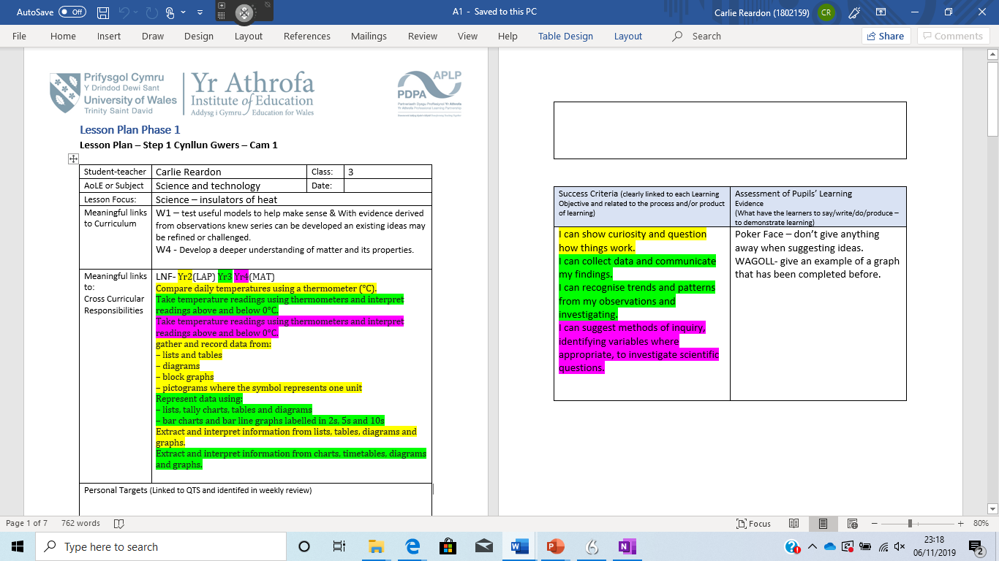
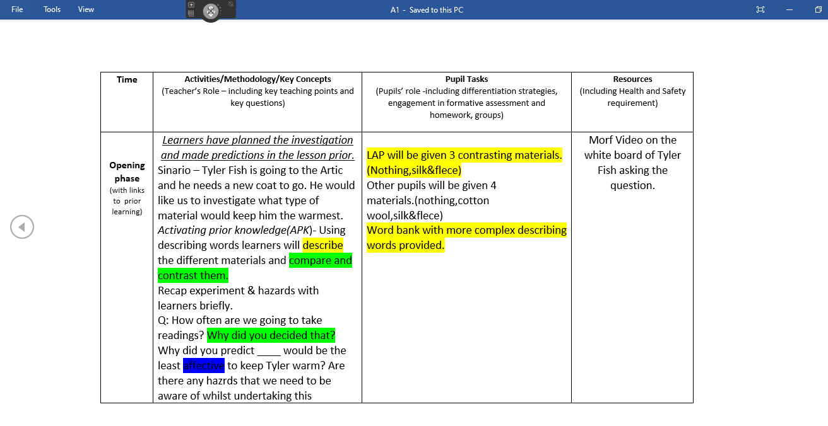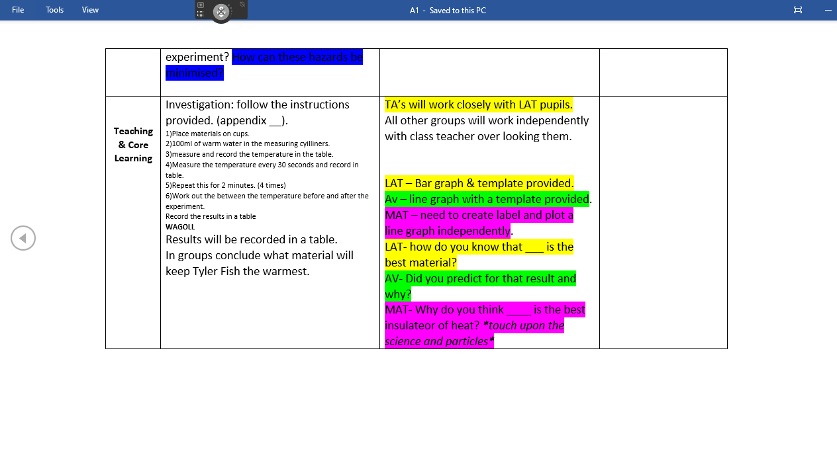
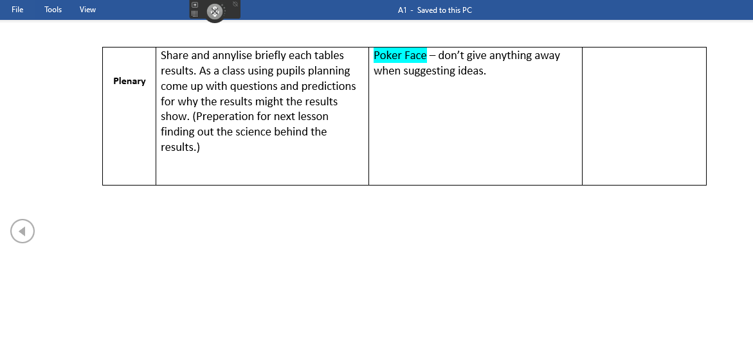
Appendix 2 – Language literacy and communication
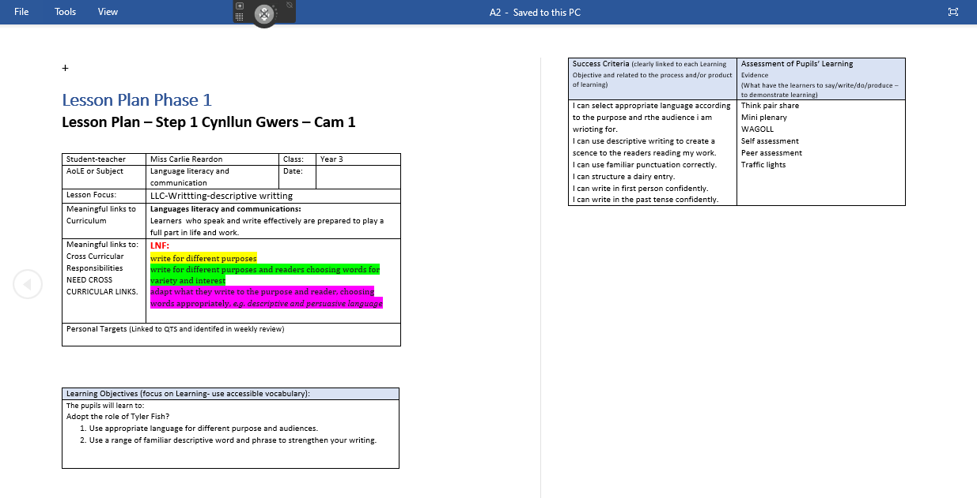
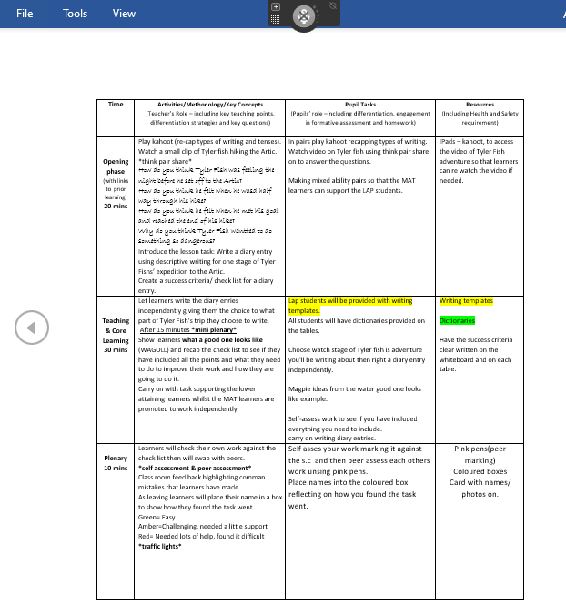
Appendix 3 – Expressive arts


