BMSW4002
Effective Team Working and Communication
Assignament Title: Component 1 Report Effective Teamworking for team success

Student Name: Tatiana Mocanu
Student ID: 2122525
Lecturer Name: Akash Puranik

Executive Summary
The report is designed Next Plc regarding their challenges of teamwork and communication. People of the company are facing issues in effective teamwork implementation. Therefore, a team leader can focus on team building. As cooperation is essential for achieving better results, a leader might follow the five-stage team development model to ensure optimal team formation. As a group leader, responsibilities include coaching team members, identifying their strengths and limitations and working appropriately, resolving problems, etc. Ensure effective teamwork by adhering to these to improve organizational output. But in the other hand, ineffective teamwork may result in continuous inefficiencies.

Contents
Executive Summary ii
Introduction 1
Overview of Teamwork 2
Model of Team Development 3
Team Roles for Cohesive and Effective Team Creation 5
Discussion 6
Advantages of effective teamworking in Next Plc 6
Disadvantages of ineffective teamworking in Next Plc 6
Conclusion and Recommendations 8
References 9

Introduction
Teamwork can be defined as the cooperative effort made by a group of individuals toward the accomplishment of a shared objective or the conclusion of a project in the manner that is both the most productive and the most efficient.This report focuses on significance of effective teamwork to ensure better organisational outcomes in terms of Next Plc. Firstly, an overview of teamwork is given. Then, with support a model of five stages, teamwork development strategies are formulated. Then some roles and responsibilities of team leader are defined, which can support a leader to ensure better team outcomes. Finally some advantageous points of effective teamwork are examined along with negative consequences of poor teamwork.

Overview of Teamwork
The concept of a team refers to a collection of individuals who collaborate on a series of interconnected projects with the end goal of achieving a predetermined goal or undertaking. A collection of individuals who cooperate toward achieving a common goal might be referred to as a team (Berge, 2018). The individuals who make up a team need, in an ideal scenario, to share a common set of aims and objectives and to, to a large extent, think along the same lines. People that are incompatible with one another will never be able to work together effectively as a team. Teamwork requires individuals to cooperate in an environment characterized by trust and mutual support; they must also work cohesively together while maintaining positive connections with members of other groups. We place a high importance on each other's capabilities. It is the process by which a segment of the population works cooperatively toward the accomplishment of a common objective in an effective manner (Bourgault and Goforth, 2021). Continue reading to learn 11 of the most important benefits of working together on the job, along with some examples of each benefit. When it concerns to the effectiveness of an organization, teamwork was among the most significant and useful elements.
There are some fundamental components that must be present in order to build an efficient team and assure the efficiency of effective teamwork. They are referred to as Processes, Goals, Roles, and Interpersonal Relationships respectively. Teams have the ability to succeed as well as flourish in the center of uncertainty and chaos if they communicate well, trust one another, and clearly define their roles. When all these three factors are robust, success comes naturally yet effectively from the combination of them. When there is trust among the members of the team and when they are able to communicate openly and honestly with one another, successful communication results.
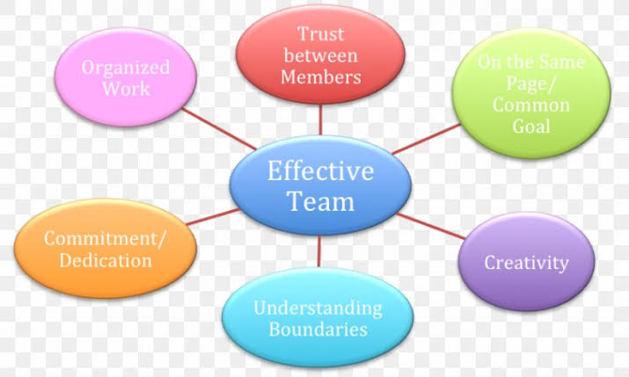
Figure: Teamwork Diagram
Source: (Ortiz, 2019)

Model of Team Development
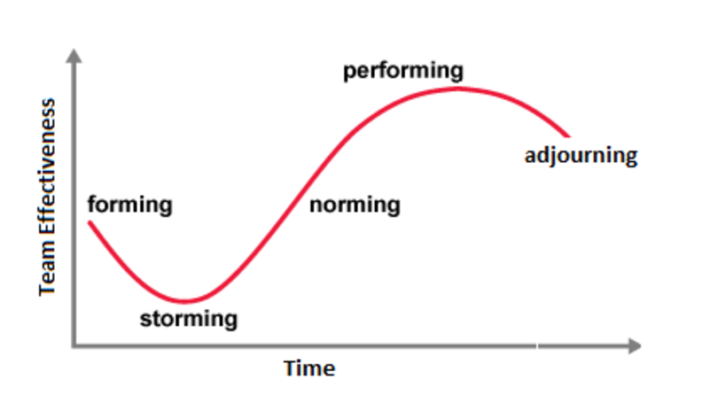
For ensuring effective team development, a theoretical model of five stages, including forming, storming, norming, performing and adjourning will be followed. This model is explained and justified here.
Figure: Team Development Model
Source: (Hopf et al., 2021)
To begin, during the first stage, there is a significant increase in the level of developing uncertainty, and people are yearning for leadership but also authority. I will concentrate on what people may anticipate from the team, what is anticipated of them, and whether or not they will fit in with the group.
Getting through the storming stage is when things will be at their most challenging and critical (Logan, 2016). If there is a possibility that members will have conflicting ideas regarding the team's tasks and objectives, and if there is also a possibility that subgroups and cliques will form around dominant personality characteristics or areas of consensus, then I will need to require that members work to face adversity, accept uniqueness, and work via conflicting ideas regarding the team's tasks and objectives.
During the norming stage, my primary focus will be on the development of a consensus regarding the roles of each individual member. I will concentrate on the performance of the team improving throughout this period as members become more adept at working together and beginning to pay attention to the team's objectives (Barak et al., 2019).
During the stage where we are actually performing, my primary focus will be on the successful establishment of collaboration and cooperation, as well as the maturity, organization, and well-functioning of the team. There is still the possibility that problems and conflicts will arise. Having said that, these will need to be treated with in a productive manner.
In the last step, known as adjourning, the majority of the team's objectives are expected to be fulfilled. An focus will be placed on finishing up any remaining chores and documenting the work that was done as well as the results. It is possible that individual members will be assigned to other departments, and that the team itself will be disbanded when the amount of work decreases (Logan and Michael Malone, 2018). Because there is a possibility of melancholy when the team disbands, the formal recognition of the hard work and achievements of the team will be the focus of my attention.
By putting my attention on these 5 stage of group development, which are necessary for effective group work in the company, I will be able to get games started, resolve conflicts in a more amicable manner, effectively share information, accomplish top results, and thereafter review outcomes in order to continue finding ways to make improvements. Therefore, the obstacles that were discovered during the training session of Next Plc can indeed be circumvented by using this model. As a result, concentrating on the five-stage approach is an appropriate choice.

Team Roles for Cohesive and Effective Team Creation
As a team leader, I will be required to perform some major roles and responsibilities to ensure creation of effective and cohesive team. Some of the defined responsibilities, which are to be performed in Next Plc can be-
Coaching team members: It will be important for me to act as a mentor to the members, guiding them toward the accomplishment of their objectives and the growth of the relevant abilities (Khawam, 2017). The development of the performance of team members, the provision of feedback, and the demonstration of the required abilities and acceptable work ethic are all components of coaching.
Defining strengths and weaknesses:In addition to that, it will be up to me to evaluate the capabilities of the team and determine its shortcomings (Vallas, 2013). I will be able to allocate the necessary responsibilities to the proper person once I have determined which member of the team is most skilled at which task. It is also helpful to identify potential improvement areas and the activities that should be taken to achieve those improvements.
Team goals and team progression:It is essential to define success before attempting to quantify the level of success achieved by a team. Miscommunication can be avoided by first evaluating the team's goals and deciding how they will measure their level of success (Jiang et al., 2022). In addition to this, members of the team will have a crystal clear awareness of the tasks that are expected of them. Teams are able to work together more effectively when they have well-defined goals and regularly assess their progress toward those goals.
Conflictresolution:Because I will be the leader of the team, one of my responsibilities will be to ensure that conflicts are avoided wherever it is feasible and to find solutions to them whenever they do occur. I am able to eliminate many potential causes of conflict if I establish ground rules and allocate work in a transparent manner (Logan, 2016). If there is a disagreement, I will work to settle it before it can get more serious.
Importance of team roles while recruiting new staffs
When hiring new employees, it is essential to put a strong emphasis on team roles. To further explain, the new employee will work in groups that are now being recruited. In the case of Next Plc, successful teamwork will be a measure of the company's success (Brock et al., 2017). As a result, the ability of the candidate to operate well in a team setting can be evaluated during the recruitment process. Again, the existing roles of the existing members need to be analyzed in order to guarantee the creation of an effective team with both the newly hired personnel.

Discussion
In case of Next Plc, issues have been found regarding teamwork and communication challenges. Effective teamwork and communication can ensure various benefits in terms of efficiency and effectiveness of Next Plc. On the other hand, ineffectiveness in teamwork may result in lower productivity (Vallas, 2013). These are examined here with point, evidence and explanation.

Advantages of effective teamworking in Next Plc
When employees work together, friction and delays are reduced because everyone can communicate more efficiently and often in real time. At the end of the day, all of this leads to an increase in production at Next Plc that is of greater quality. Team members come from a diverse range of backgrounds, education levels, and skill sets. As a whole, this variety can yield an outcome that exceeds the aggregate of the individual contributions (Berge, 2018). It's possible that team members will become more cooperative when they work on a project together and learn from one other's achievements and failures. An open-minded workplace where people are more likely to communicate their opinions, analyses, proposals, and concerns can lead to better ideas. This opens the door to a richer exchange of ideas and perspectives on fresh concepts, ultimately leading to more continuous innovation. Every participant is aware of their duties and responsibilities, and they are happy to assist out when another participant is unable to do a specific task. As a result of this, the team has the ability to respond swiftly and effectively to any challenges that Next Plc puts at them (Jiang et al., 2022). Again, when a team is faced with a dilemma, they can use their different experiences and knowledge to draw up multiple solutions to the issue that they are trying to solve. As a result, teammates are better able to deal with difficulties that arise along the way since they have each other's backs. They might also be able to alert one another of impending threats before they happen.

Disadvantages of ineffective teamworking in Next Plc
There are many different causes that might be at the root of a failed team, but the results are always the same: they are unsatisfying. In the situation of Next Plc, whereas if efficacy of teamwork continues to decline, it is possible that factions will form, battle lines will be drawn, and communication would come to a halt. and a sense of unease may develop (Barak et al., 2019). There is a significant risk of a reduction in productivity and efficiency, as well as a significant risk that any form of collaboration or creativity will be nearly impossible.
Therefore, poor performance by the team may have a variety of adverse impacts for Next Plc. It may serve as a poor example for others, result in work that is not completed satisfactorily or on time, and ultimately have an effect on the bottom line of the firm (Clark, 2019). It is imperative that poor team performance be tackled at the earliest stage feasible; but, before that can happen, its root cause must be comprehended.

Conclusion and Recommendations
People of Next Plc are facing challenges regrading teamwork and communication. As teamwork is significant for ensuring better outcomes, as a leader the model of five-stage team development can be followed to ensure effective team build up. As a team leader, some roles can be performed as coaching the members, defining strengths and weaknesses and working accordingly, resolving conflicts and so on. Ensuring effective teamwork following these can result in beterorganisational output. On the other hand, poor teamwork may lead to continuous continuousness inefficiencies. However, the following recommendations can be followed to ensure effective teamwork.
- Putting an emphasis on working together as a team and being rewarded for it.
- Defining each person's specific position, responsibility, and accountability.
- Establishing concise objectives.
- Keeping in close contact with one another.
- Collaboration in the making of choices.
- Developing trust while getting to know one another better is a priority.
- Developing trust while getting to know one another better is a priority.
- Creating teams that are diverse and welcoming to everyone.
- The assignment of distinct duties and responsibilities to each individual member of the team.
- Developing a culture of trust among the team members.
- fostering communication that is both clear and frequent.
- Providing teams with independence in terms of decision-making.
- Managing staff meetings wisely.

References
Barak, M., Maymon, T. and Harel, G., (2019). Teamwork in modern organizations: implications for technology education. International Journal of Technology and Design Education, 9(1), pp.85-101.
Berge, Z.L., (2018). Differences in teamwork between post‐secondary classrooms and the workplace. Education+ Training.
Bourgault, A.M. and Goforth, C., (2021). Embrace teamwork to create and maintain a positive workplace culture. Critical Care Nurse, 41(3), pp.8-10.
Brock, S.E., McAliney, P.J., Ma, C.H. and Sen, A., (2017). Toward more practical measurement of teamwork skills. Journal of workplace learning.
Clark, P.R., (2019). Teamwork: building healthier workplaces and providing safer patient care. Critical care nursing quarterly, 32(3), pp.221-231.
Hopf, S.C., Crowe, K., Verdon, S., Blake, H.L. and McLeod, S., (2021). Advancing workplace diversity through the culturally responsive teamwork framework. American Journal of Speech-Language Pathology, 30(5), pp.1949-1961.
Jiang, Z., DeHart‐Davis, L. and Borry, E.L., (2022). Managerial Practice and Diversity Climate: The Roles of Workplace Voice, Centralization, and Teamwork. Public Administration Review.
Khawam, A.M., DiDona, T. and Hernández, B.S., (2017). Effectiveness of teamwork in the workplace. International Journal of Sciences: Basic and Applied Research (IJSBAR), 32(3), pp.267-286.
Logan, T.R. and Michael Malone, D., (2018). Nurses’ perceptions of teamwork and workplace bullying. Journal of nursing management, 26(4), pp.411-419.
Logan, T.R., (2016). Influence of Teamwork Behaviors on Workplace Incivility as It Applies to Nurses. Creighton Journal of Interdisciplinary Leadership, 2(1), pp.47-53.
Ortiz, L., (2019). Unions' responses to teamwork: differences at national and workplace levels. European Journal of Industrial Relations, 5(1), pp.49-69.
Vallas, S.P., (2013). Why teamwork fails: Obstacles to workplace change in four manufacturing plants. American Sociological Review, pp.223-250.

