Name: Paulina Ruskyte
Student number: 2027459
E-portfolio report
Learning in the Digital Era – BMPL4007/BMPS4009

Table of Contents

Task 1 – Written summary 2
Task 2 – Mind map 3
Task 3 – Presentation 4
Task 4 – Reflection 5
Reference list 6

Task 1 – Written summary

Preparing for higher education, nowadays become easier than ever before. University of William Place written and said ‘’ The world is changing’’ (12 reasons why higher education is important 2022) this phrase have deeper meant and saying that thing upon our comfort zone now become more accessible than was few decades ago. Higher education helps student to prepare for challenges that they come across in their life, helps to gain new life lasting skills, qualities, and knowledge so they can be use anywhere in their life. The higher education brings brighter and wiser future, more chances to be successful. ‘’We cannot just argue that higher education has broad benefits and hence earnings are not the only indicator of ‘value’, we need to demonstrate it. ‘’ (Vignoles, 2020) benefits of higher education need to be shown out loud with a confident and knowledge and preparation. Now days trends proving that everyday more and more new opportunities appearing online, and it is reachable to everybody. Various online sources of different information, article, books can be reached with ins a minute of time. The most important is our time investment, attitude, and dedication forward to education that we trying to gain. The environment and bad habits can have negative effects so it could be useful to follow some tips such as advised by great online sorcerer:
‘’Getting regular physical exercise, which is linked to improvements in memory and brain health, eliminating distractions so you can focus on what you are learning, getting enough sleep, organizing the information, you are studying to make it easier to remember’’ (Cherry, 2022)
Preparation for learning in higher education can be the key to successful progress upon completion and continues higher levels of chosen profession.


Task 2 – Mind map
According ofcom.org.uk ‘’ UK adults are now spending more than a quarter of their waking day online ‘’ (UK's internet use surges to record levels 2022). Internet usage jumped to the highest levels through the Covid-19 pandemic years. The world was forst to become digital, and people from offices, and institutions of the education was moved to virtual environment. From 2020, future become completely digital, and businesses, and people had to learn how to communicate without physical interaction. IT skills become useful and more important than ever before. Digital learner improved their skills and basic knowledge about virtual environment and how to use IT equipment. That is also become a moment when home environment become an office, a classroom and meeting room for many people around the world. But there are two sides of that wich is good and bad. A view of small picture in this situation we see people spending more time at home surrounded by family members and this is their comfort zone while still work and study. Also become more available opportunities to contact anybody in a world and gain new friendship and partnership with less stress and more confident behind screen. But if we look at the wider picture of digital era, people gaining digital skills but loosing physical interaction and people skills as they stop using it for long time. To come back to traditional learning in physical facilities after few years of digital learning can be stressful, cause the anxiety and hard to adapt. To leave a comfort zone never was easy. Since digital learning progressed quickly, the world might be never the same as everything we need now can be reached through click of one button while physically it might take a lot more effort and cost more money and time.

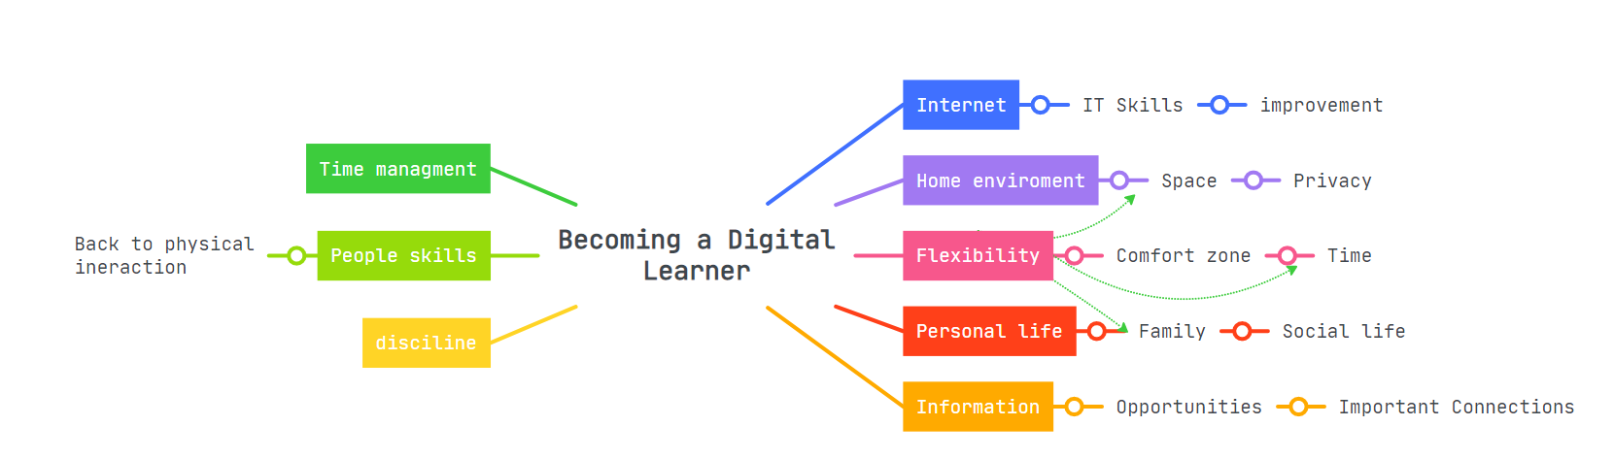

Task 3 – Presentation
Please follow this link to view my presentation:
https://youtu.be/ON_nL49cqVY

Task 4 – Reflection

Starting the University, it was always a personal goal for myself. As soon as I got accepted, I felt happy and excited to start studying. As University of South Wales St Davis Trinity at the moment have to offer 26 online blended courses (The University of Wales Trinity Saint David 2022). So, I had an opportunity to study online course that was the most interesting and that gave me a flexibility that I would not be able to have if I was attending to physical classes. After induction week, I was given a time to prepare for writing two assignments on a topic that is completely new to me. Topics that were related to information that I never was looking in before and in the beginning, it seemed to be very hard. As I was given about four weeks to complete given task, I kept postponing the writing process as I thought to myself ‘’I still have time’’.
However, time was flying by and day by day submission date came very quickly. As my busy lifestyle I didn’t realise how hard is going to be to complete two tasks in almost the last minute before submission date, and so I when I start writing I also find out that Harvard referencing is going to be a challenge for me too. After researching and trying to learn at least basis of Harvard references style I was website called ‘’Quick guide to Harvard referencing (Cite Them Right)’’ (Smith, 2020).
I realise that I should never postpone any academic writings. I take not a few hours and not even a day but multiple days. After experiencing a stress and anxiety related to bad time management, I feel like I gain an understanding and ideas how to avoid from experiencing same feeling again. Next time I will manage my time accordingly and wiser.

Reference list
Cherry, K. (2022) How to learn more effectively, Verywell Mind. Available at: https://www.verywellmind.com/how-to-become-a-more-effective-learner-2795162 (Accessed: November 7, 2022).
Smith, O. (2020) The Open University. Available at: https://www.open.ac.uk/library/referencing-and-plagiarism/quick-guide-to-harvard-referencing-cite-them-right (Accessed: November 7, 2022).
The University of Wales Trinity Saint David (no date) The University of Wales Trinity Saint David | University Info | 26 Online Courses in English - Distancelearningportal.com. Available at: https://www.distancelearningportal.com/universities/438/the-university-of-wales-trinity-saint-david.html#:~:text=The%20University%20of%20Wales%20Trinity,Courses%20in%20English%20%2D%20Distancelearningportal.com (Accessed: November 7, 2022).
UK's internet use surges to record levels (2022) Ofcom. Available at: https://www.ofcom.org.uk/about-ofcom/latest/media/media-releases/2020/uk-internet-use-surges (Accessed: November 7, 2022).
Vignoles, A. (2020) How do we define 'value' in higher education, The British Academy. Available at: https://www.thebritishacademy.ac.uk/blog/how-define-value-higher-education/ (Accessed: November 7, 2022).
12 reasons why higher education is important (2022) William Peace University. Available at: https://www.peace.edu/news/why-is-higher-education-important/ (Accessed: November 6, 2022).

