
Module Assignment Submission
Student Name: | Kirsty Rees
Student Number: | 1917792
Module Code: | BMSK4009
Module Title: | Learning in the Digital Era

Statement of Confirmation of Authenticity
By the act of making this submission, the student declares that this is the work of the student named above. The work has not, in whole or in part, been knowingly presented elsewhere for assessment, or where assessment has been built on a previous assessment, this has been identified. Where materials have been used from other sources it has been properly acknowledged. If this statement is untrue, the student acknowledges that an assessment offence has been committed.
Attention is drawn to the plagiarism and unfair practice policies of both the University and of ILM.
Permission for ILM to use this script
ILM uses learners’ submissions – on an anonymous basis – for assessment standardisation. By submitting, both the centre and the learner agree that ILM may use this script on condition that identifying information is removed. However, if you are unwilling to allow ILM use this script, please refuse by ticking the box: □

Table of Contents
Summary 3
Digital Skills in Higher Education 4
Referencing 4
Mind Map 5
Personal Development Plan 6
Conclusion 7
References 8

Summary
The purpose of this assignment is to assess and summarise the transferable skills required when progressing onto higher education.

Higher education preparation is a difficult process that requires meticulous planning and commitment. In order to assist in the students progression to higher education transition the author has researched and assessed their own skills from their student experience, here are some aspects to consider which can assist smooth transition to higher education and an academic career if adhered to.

According to reports, there has been a significant growth in higher education enrolment (Cox Et Al, 2014), with this in mind it is important to highlight the essential skills and expectations within higher education and the differences between a school environment.
A variety of abilities are needed to perform academically and adjust to the demands of higher education when studying at the university level. The increase in accessibility that is granted by technology has increased the leaners interest (Dias & Victor, 2022) and contributes to their experience. Based on the research and personal experiences here are a selection of the many skills needed to develop or improve before embarking on a higher education journey :

Time Management - Effective time management is essential for managing courses, assignments, and social life due to higher education demanding schedules and requires self-discipline. According to Macan and others (Macan Et Al., 1990), students who felt in control of their time gave much higher performance reviews and expressed more job and life happiness. A survey of 165 students' attitudes and behaviours on time management was completed to obtain this data.
Digitally aware – Students can benefit from gaining a variety of digital abilities in today's digital world in order to achieve success in both academic and professional life. Many universities offer hybrid lessons and to enable the student to provide thorough research and to
Organisational – Effective organisational skills are essential for students to be able to keep track of deadlines for assignments and course materials. There are various resources available to help students stay organised, including online diaries, planners, and digital tools.
Research Skills – Thorough research is essential when studying at a higher education. It is vital to develop your research skills by learning how to use academic databases, conduct research, and assess the reliability and applicability of sources.
Critical Thinking – Critical thinking and problem-solving techniques are essential skills in higher education. Learn to evaluate arguments, analyse facts, and develop your own conclusions.
Academic Writing – with writing being one of the main skills assessed in higher education (Fitzmaurice & O’Farrell, 2013) strong written communication skills are required when writing assignments, reports, and research papers. Aim for clarity, style, and correct grammar.
Academic Reading – In-depth reading is equally as important when demonstrating strong writing abilities. Learn to analyse and summarise materials to enhance your ability to read and comprehend challenging literature effectively by practising reading comprehension. According to Hermida 2009, universities often assume students learn academic reading at a secondary level, this is usually not the case.
Self-Motivation - Independent study is required in university, this is something less practiced within secondary education. A student would need to demonstrate self-motivation when adhering to deadlines. Data obtained by Dinther (Dinther et al, 2011) reports how educational initiatives may help pupils become more self-sufficient.
Problem Solving – problem solving in higher education would present differently to lower education. Design thinking as a method of education to enhance innovative problem-solving skills (Thienen et al, 2017).

Digital Skills in Higher Education
The phrase "digital native" refers to those who were born during the digital era. In contrast, the phrase "digital immigrant" refers to those who were born before 1964 and grew up in a pre-computer era (Zur & Zur, 2011).
Digital skills are crucial in a range of academic industries and are highly regarded in the corporate field. Universities acknowledge the significance by incorporating digital skills into their curriculum to prepare students for the rapidly evolving employment sector and world of technology which in turn provides the student with transferable skills which are appealing to the corporate world.
During the COVID-19 pandemic students and the rest of the world saw huge adjustments to their education, work and personal life. One of the many adaptions being the prompt shift to online learning and meetings. Students were required to adapt quickly to the changes.
Online learning and classes are now offered within the education setting and education is now deemed accessible and available to everyone thanks to the advances (Nambier, 2020). It is believed that that flexible hybrid options are still available at many universities (Anderson, 2021) and advocates for disabled students highlight how remote learning is a reasonable adjustment that should continue to be offered post pandemic (Morris & Anthes, 2021) ensuring inclusivity.
It appears the pandemic accelerated the use of digital learning, there are huge advantages to this however there some negative effects such as impacts to students physical and mental health (Fathoni et al, 2021) due to the social exclusion experienced by digital advancement.
The author herself saw her studies impacted by this change. As the author identifies as a ‘visual learning’ she found herself withdrawing from studies as she had a negative experience during the transition to online learning.

Referencing
Referencing is an essential skill for students for several important reasons, the serious academic offence of plagiarism can lead to poor marks or even expulsion. In order to avoid accidental plagiarism, students should properly reference the authors and sources of any information used within an assignment. The correct use of referencing adds credibility to your work. Using reputable sources in your arguments or comments to demonstrate that your work has been well researched and is reliable and accurate data. This evidences the student has researched and assessed existing literature. As a result, the students understanding for the subject is enhanced. Referencing is a new skill which will need to be embraced, it is often not experienced at lower level education situations.

Mind Map
In higher education, interconnecting skills refer to the development and integration of a variety of abilities and skills that are required for success in both academic and real life settings. Some of which has been captured within the following mind map:

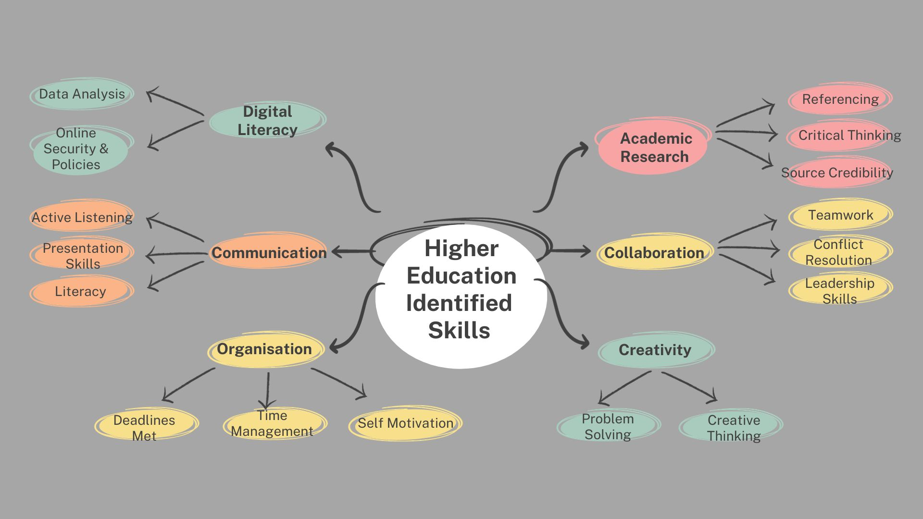

Growing evidence suggests that in order for students to succeed in their academic careers and personal lives, they need a wider range of abilities than just subject-specific knowledge. These overlapping skills frequently include:

Academic Research - This skill requires the ability to evaluate, analyse, and generate data and concepts. Making educated decisions and resolving complex problems. It involves critical thinking and in depth referencing and citations.
Communication – Both written and spoken skills are necessary for effective communication. Whether in presentations, papers, or everyday discussions, students need to be able to express their thoughts in a clear and concise manner.
Collaboration – In many professional environments, it is essential to have the ability to work effectively in teams and with different groups of individuals. Working in teams and on projects with others is an established method to improve this talent. It can enhance leadership skills within some team members but unfortunately will not suit all individuals. Some may find it difficult to engage within groups. Laal & Ghodsi reports collaborative learning ‘establishes a positive atmosphere’ and ‘develops a social support system’ (Laal & Ghodsi,2012) whereas Tudge argues how some collaboration can lead to regression (Tudge,1989).
Digital Literacy – In a technology-driven world digital tools and platforms must be applied by students with competency. This includes not just the basic principles of technology but also cybersecurity and GDPR awareness. This will also include the ability to analysis data critically and provide credible sources.

Personal Development Plan
The author felt it was appropriate to access their own skills via a PDP :
Goal : | Expectations : | Actions I will take : | Success criteria : | Deadline :
Organisational skill | Become more organised | - Create study calendar  - Organise a study area | Meet deadlines  Be more organised for study, research & attending university | 31 Oct 2023 (1 month)
Research skills | Conduct academic research & credible resources | - Use Google Scholar  - Evaluate references  - Explore local library for physical & online resources  - Develop research plan  - Clearly define research question | Critically evaluate & complete academic research and recognising of reliable resources | 15 Oct 2023  (2 weeks)
Verbal Communication | Overcome nerves, deliver presentations to team & participate in group discussions | - Practice with family & friends  - Research coping methods online | Be able to successfully engage with team.  Deliver a presentation.  Participate in group discussions. | 31 Oct 2023 (1 month)
Written communication | Write academically & take clear notes | - Practice neater handwriting  - Revise and edit written work  - Proof read  - Read a variety of books and articles  - Welcome constructive criticism | To be able to write with diverse writing skills.  Produce academically written pieces. | 7 Nov 2023 (5 weeks)

Conclusion
To summarise, transferable skills acquired via higher education serve a critical role in developing students into well-rounded, adaptable, and accomplished professionals. Higher education not only delivers academic information but also develops a set of skills that can be applied across a variety of career opportunities and life situations. Learning and living in the current digital era has transformed the learning experience. First and foremost, information is now available at unprecedented levels. Libraries are accessible in person and online 24 hours a day. Articles and papers are downloadable at any time meaning there is no time constraints when students access research resources meaning a vast range of knowledge is available in just a few clicks.
However if the student is not of a technical mind this can cause barriers to their learning. Concerns have also been expressed concerning the possibility of social isolation in learning as a result of the digital era.
‘Digital Native’ students should have the ability to embrace the challenges that come with digital learning.
During the COVID-19 pandemic students saw huge adjustments to their learning, one of the many being the shift to online lessons. This shift in delivery for lessons provides flexibility to learners which enables them to meet the needs of students who perhaps due to their complex needs wouldn’t have enrolled prior to the adaptions. Enabling universities are appealing to a wider range of student and encouraging an inclusive environment.
The author herself saw her studies impacted by this change. As the author identifies as a ‘visual learning’ she found herself withdrawing from studies as she had a negative experience in the adjustments to online learning. Sadly this prolonged her studying and set her back from her fellow students who thrived from such an environment.
There are skills in which the author has recognised require a

References

Anderson, N. (2021). The post-pandemic future of college? It’s on campus and online. Washington Post.

Dias, L., & Victor, A. (2022). Teaching and learning with mobile devices in the 21st century digital world: Benefits and challenges. European Journal of Multidisciplinary Studies, 7(1), 26-34.

Fathoni, A., Mustadi, A., & Kurniawati, W. (2021). Higher education students and covid-19: challenges and strategies in facing online learning. JPI (Jurnal Pendidikan Indonesia), 10(3), 396-408.

Fitzmaurice, M., & O’Farrell, C. (2013). Developing your academic writing skills: a handbook. Dublin, Ireland, 1-36.

Hermida, D. J. (2009). The importance of teaching academic reading skills in first-year university courses. Available at SSRN 1419247.

Laal, M., & Ghodsi, S. M. (2012). Benefits of collaborative learning. Procedia-social and behavioral sciences, 31, 486-490.

Macan, T. H., Shahani, C., Dipboye, R. L., & Phillips, A. P. (1990). College students' time management: Correlations with academic performance and stress. Journal of educational psychology, 82(4), 760.

Morris, A., & Anthes, E. (2021). For some college students, remote learning is a game changer. New York Times.

Nambiar, D. (2020). The impact of online learning during COVID-19: students’ and teachers’ perspective. The International Journal of Indian Psychology, 8(2), 783-793.

Tudge, J. (1989). When collaboration leads to regression: Some negative consequences of socio‐cognitive conflict. European Journal of Social Psychology, 19(2), 123-138.

Van Dinther, M., Dochy, F., & Segers, M. (2011). Factors affecting students’ self-efficacy in higher education. Educational research review, 6(2), 95-108.

von Thienen, J., Royalty, A., & Meinel, C. (2017). Design thinking in higher education: How students become dedicated creative problem solvers. In Handbook of research on creative problem-solving skill development in higher education (pp. 306-328). IGI Global.

Zur, O., & Zur, A. (2011). On digital immigrants and digital natives: How the digital divide affects families, educational institutions, and the workplace. Zur Institute–Online Publication. Retrieved on February, 21, 2012.

