By
Tatiana Maceluica
Student ID: 1807722

Professional Career Development
Contents
Introduction 2
Skills and knowledge which contribute toward working effectively 2
Readiness of the skills and knowledge for employment 6
An understanding of personal strengths and areas for further development, as well as establishing their employment goals 7
A personal action plan/development plan 10
Conclusion 12
References 13

Introduction
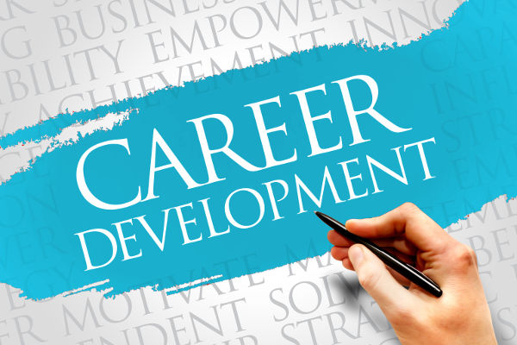
For the job seekers and other who complete the academic life would like to get job or get into the professional life. Apart from that, they would like to develop their career which will be like those of world class corporate leaders or employees. In doing so, employees or staffs of specific company or organization they must take a deep look into the lacking and strong sides of them as well as they must take care for the issues which they can develop further (Jackson, 2015). Moreover, they must develop some plans and procedures through which they could reach the goals related to career development and the improvement of the goals and objectives related to the development of weaknesses. Apart from the discussion, this evidence based portfolio will elaborate the skills and knowledge which are required to work effectively, the readiness of these skills and knowledge in case of employment, personal strengths and the areas where further developments are needed, and lastly, and action plan based on the overall situation or discussion in the context of my job position (marketing manager) at Tesco plc., UK as well as my perspective as a job holder.

Skills and knowledge which contribute toward working effectively
In profession or any other aspects of life there needs working effectively. Virtually, in the corporate sector in every country the young and hard work ones are preferred as well as who are effective in working. For working effectively there have some skills and knowledge which can help considerably and these skills and knowledge are needed. In this segment these skills and knowledge will be investigated. Such some skills and knowledge are-
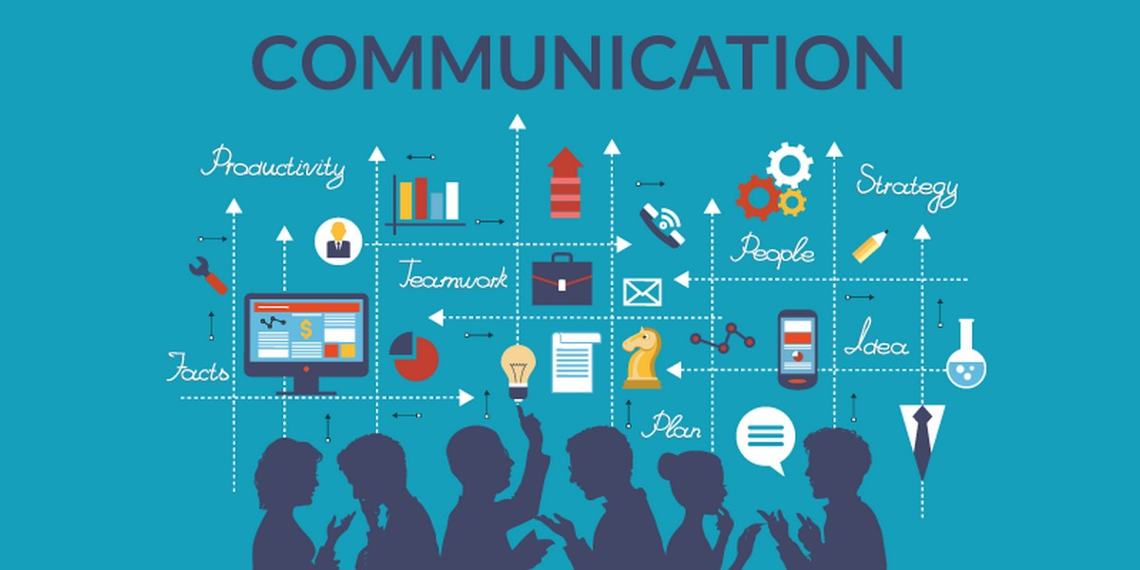
Communication skills
Communication for long has been a skill which is significant for gaining and sharing information from others and with others. over the time across the globe due to the globalization and other modern waves information turned as one of the most sought and worthy resources which can be used for discoveries ,innovation ,invention and for many other reasons and activities (Elder, 2014) .For working effectively there need the communication skill which can help to gather information from others and keep good social and personal relationships which might also result in stress management and getting collaboration from others while doing any task .
Analytical and research skills
Research is the way which is needed to get developed in current world for any nation or organization. If we take a look the developed countries like the America, China and European ones then it will be very clear the contribution of research. While on the other hand, the analytical thinking is required for solving different problems and making decisions as well as in research. Apart from these , analytical and research skills and knowledge are required in working effectively due to conducting research on various aspects related to the workplace and job positions , while the analytical capability is needed for making decision and problem solving in the workplace .
Resistency
The ability to adapt with any circumstances or incidents or changes in any setting either in personal or professional or academic is defined as resistency. In other word, it can be called as the adaptability skill which is needed for various reasons and activities in an organization or workplace setting or working effectively (Malley, 2014) .Such as- when one will do bad performance in his job or task then he or she might be punished at that case he or she should not be embarrassed rather should stick to the position and grow the confidence to do that task next time perfectly which might bring reward.
Problem solving and decision making
These are the two fields in any job or organization which are taken into consideration significantly. Due to the emerging various situations and circumstances in workplace their needs decision making while on the other hand , when any difficulty or problem will arise then it should be solved through making proper decision making . In organization or workplace setting there might be problem like conflicts, demotivation of employees or profit loss of employees which should be addressed through making decision. Not only problem solving but also for strategic decision making, client satisfaction, and other factors decision making is needed.
Analytical thinking and strategic planning
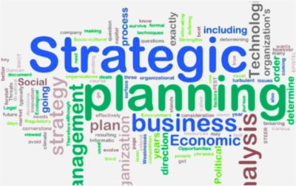
In workplace, there will arise various situations which are needed deep thinking for addressing these. While on the other hand, for forecasting any situation and for strategic planning there also need the analytical thinking. In strategic planning and decision making the analytical thinking is needed due to analysis the alternatives, the benefits and disadvantages associated with them and at last choosing the best alternative etc. for all of these procedures the analytical thinking is needed (Twyford, 2012). Again, the strategic planning is needed for prioritizing different or the best choice in line with the emerging needs and situations.
Leadership
In almost every organization there needs motivation which can come from various sources like incentives ,work-place environment , incentives and leadership etc. out of these leadership has enormous impact on employees and broadly on the whole organization (Forthcoming Changes toBoard Leadership, 2013) . Good leadership can take an organization easily to its goals and objectives while bad can do otherwise. For working effectively leadership is badly required as who are the leaders they scheme, executive and enforce a policy or plan or anything else. Thus, the workplace productivity, and environment in the work-place become super-fast.
Public speaking and presentation
In the world only 20-40% people have no speaking or presentation related phobia while rest percentile have problems with. Public speaking and presentation can improve the workplace performance, and productivity significantly. When a person gets motivated from a specific task then he or she becomes more motivated towards his or her own task or position. In the corporate sector the people or candidates who have the skills like public speaking and presentation then are prepared ahead of others. Moreover, it is said that the world is slightly inclined towards the people who can speak publicly and present well.

Time management

Time management can be defined as the master skill among others. Time management is the root behind every particular goals and objectives achievement and following discipline. Over the time, who became successful in the corporate sector, if we do an investigation on them we will find that they had a common trait to manage and use time properly (Jackson, 2000). Time management is badly required in workplace and doing work effectively due to accomplish tasks on time, doing lots of tasks within shortest possible time which is the major indicator of efficiency.
Strong professional ethics
Professional ethics is required to accomplish all the tasks in a profession properly and as per the rules and regulations of that specific profession. Professional ethics has been checked at the probationary level while continuous application of professional ethics is virtually a personal task. For the lack of professional ethics in employees an organization might be in peril apart from the productivity, reputation and customers’ dissatisfaction. Hence, the factor professional ethics must be in consideration. Again, the ethics must be strong in any sort of situation .Strong professional ethics can increase productivity with perfection.

Computer skills

The world is currently running on technology while the technology is running via computer and internet. Various computer skills like- programming, coding, excel, hacking, and different official activities need the computer related skills. Every employee in a corporate or in public office now-a-days must have skills related to computer otherwise tasks cannot be accomplished properly and on time. With the advancement of the world we have been facing various challenges and novel difficulties which should be solved properly. Apart from these, computer can be productive to solve problems and other tasks as well. Currently, computer skill is thought as one of the significant parts of efficiency in workplace or any other spheres.
Innovation and creativity
Something new, attractive, unique, and innovative is always desired by customers or others in an organization. Innovation and creativity are the two fundamental factors which are considered with utmost priority in the job sectors recently. The persons or candidates who are innovative and creative are prioritized over others in organizations. Innovation and creativity can make the tasks or activities which must be carried out in a workplace setting (Linkedin.com, 2019).Efficiency doesn’t only depend on doing task within time or before time it also depends on beauty and nuanced of a task. Apart from these, innovation and creativity are badly needed currently.

Readiness of the skills and knowledge for employment
Readiness refers to the preparedness of the skills and knowledge that means either they are ready for anything or not .From my point of view some skills and knowledge are ready for employment while other are not ready. For example-innovation and creativity ,professional ethics , public speaking and presentation , leadership ,decision making and strategic planning ,research skills , resistency ,and communication skills are ready for employment .As a manager , I have a good ground on the mentioned skills and knowledge while have lack in the skills and knowledge like computer skills ,time management ,analytical thinking, problem solving which should be developed .
Innovation and creativity are the skills and knowledge which I have been developing over the time from my academic life and applying in different activities in my any situation. Apart from that, they have employability (Youthcentral.vic.gov.au, 2019). Professional ethics is the major concern for professionalism which directs us to comply with all sorts of professional norms or practices relevant a job or position. From my academic life I am well at this skill .Moreover, in our team members and all activities in our organization we strictly follow professional values and norms. In public speaking and presentation I am very effective from my academic life which has been in work still now. In leadership I am a lessees-faire style a leader and manager in my organization. I would like to every activity sharing with my colleagues and subordinates which pay off .Decision making and strategic planning are the two fundamental foundations in any organization .They are inextricably associated. In both skills and knowledge I am strong enough that’s why I am at that position currently. I developed both quantitative and qualitative research skills at my academic life and still applying these at various occasions in my professional and academic life. Resistance is eh skill or knowledge which is needed to get adapted with any situation no matter what and how in professional or academic lives. In this skill I am strong enough and lastly the communication skill which is also developed in my academic life. I have better command over the written and verbal communication skills while I can also develop the network based communication which is very effective for any company. It can be said strongly aside from the discussion that all the skills and knowledge discussed are ready for employment.

An understanding of personal strengths and areas for further development, as well as establishing their employment goals
Personally a person might have many strong sides as well as weaknesses for the purpose of getting employed the weaknesses must be reduced while the strengths should be further developed. Thus, a person turns as a perfect employee. Now, the employment goals refer to the how they can be helpful to achieve personal or academic goals and objectives and how they are associated with these goals or objectives. Moreover, how they can be used for personal or professional life etc. Throughout this section these will be illustrated.
Personal strengths
Personal strengths mean the skills, capabilities and knowledge one has which are employable. Apart from that, I have some personal strengths or skills or knowledge or competencies which can be employed. Such as- innovation and creativity, professional ethics, public speaking and presentation, leadership, decision making and strategic planning, research skills, resistency, and communication skills. Among these skills at innovation and creativity I am the strongest one. In my organization for innovation and creativity I was rewarded several time. I am a motivational speaker in my organization which is another strong side for me (Truity, 2019). In almost all the task the Tesco plc. choses me to lead and accomplish the task. We as a team in our organization make decision where who can give the innovative ideas and thoughts are prioritized over others. Therefore, a culture has developed over the time which is based on strategic and analytical thinking which results in decision making and strategic planning. Almost all of us are well at decision making and strategic planning as well as thinking critically and creatively .Research is the skill which for the time immemorial has been considered as the fundamental or prime skill among others. Currently, which organization is trying to go forward or making headway is investing billions of dollars in this sector. This is the only way which can bring a sustainable change and something new in organization .From my academic life I am perfect in research and scored the highest marks in the research based courses . Adaption in any situation is critically required and has been so for long. There is the proverb goes like “survival of the fittest” that means who have the capability to fit with any situation can survive in any situation (Encyclopedia Britannica, 2019). In business there will have many situations which need the persons who can survive and make a difference .Lastly, the communication skill which is also developed in my academic life. I have better command over the written and verbal communication skills while I can also develop the network based communication which is very effective for any company.
Areas for further development
Development takes place the areas which are underdeveloped or where need development. Although I have several strong areas but still I have some areas in which I am not strong that means in these areas I am weak and there further development must be taken place .These areas are-computer skills ,time management ,analytical thinking, and problem solving. In case of computer as it is changing time to time that means with the changes in the technology world the skills , and complexities in this world change as well as something new comes in every time . Therefore, I need to adopt with these changes and situation every time .Every time I need to learn something new which is really challenging for me and I find that I have lack in doing so to get adopted with these changes (Interskills.edu.au, 2019). Time management is another areas where I think I have weakness and development should be taken place here. As a manger I have maintain a lot of tasks which sometimes I cannot handle on time properly which is a difficulty for me. Analytical thinking is the area which needs deep thinking and procrastination which I find myself sometimes weak. That means sometimes I cannot think so deeply or critically which is needed every time for an effective and successful organization. I think if I need further promotion and good performance I need development in this arena. Lastly, the problem solving which is also a difficult area for me. In problem solving me sometimes find myself at bizarre condition. In marketing department there have diverse problems I unfortunately I cannot solve all the problems but some of them I could able to solve very intelligently which is a credit or success for me. Altogether, these are the areas where I need development immediately otherwise it will be difficult to me to do better my performance or the career goal and objectives I am desiring for.

Employment goals of the skills discussed
The skills which I discussed throughout the segment have their employment goals or they are associated with some career goals and objectives without which they cannot be achieved .Such as-
Innovation and creativity- is currently required for any sector, especially in the multinational organization there is no alternative to this skill where competition is everywhere. Moreover, other organization in international markets bringing diversification and innovation which are driving competing other organizations to bring changes .Professional ethics is required for making performance better, and it might be in any organization. Moreover, it is required for carrying out the responsibilities in a position properly. For almost every organization to achieve goals and objectives within shortest possible time and efficiently there need good public speaker and presenter, leader, decision maker and strategic planner. While on the other hand without these any organization traditional or modern cannot go forward with its goals and objectives. Critical thinking and strategic planning are required to take any crucial decision and making choice which is best or satisfactory among other alternatives (Coates, 2015). Both in academic and professional lives there need these skills to get success. As already discussed on research skill which is the skill which for the time immemorial has been considered as the fundamental or prime skill among others. Currently which organization is trying to go forward or making headway is investing billions of dollars in this sector. This is the only way which can bring a sustainable change and something new in organization. It is required to achieve any goal in all sphere of any life (professional or academic or personal).Resistency- is required in almost every job and specifically in the jobs or positions which are challenging . If a person cannot adapt with the challenging and other difficult situation then he or she will not be able to carry out different assigned responsibilities properly .Communication skills are needed for all sorts of organizations and currently ,it is prioritized more as the world is changing with the influence of information which is the main element for communication .Computer skills- are thought as the master skills now-a-days due to the technological revolution which has been going on in full swing across the globe . In almost all sorts of jobs currently, there the computer skills are attached or asked specifically. Time management is required in almost every job which is also significant part of our academic and personal life. Analytical thinking and problem solving- in the current world as it is changing rapidly it is coming up with various challenges ,difficulties and opportunities which should be predicted smartly and on it the growth of an organization and a person itself depend . Therefore, both for organization and individual these two skills are very much needed. Broadly, these the Employment goals of the skills discussed.

A personal action plan/development plan
Personal action plan or development plan is undertaken to get out of the skills in which one has lack as well as in the skills in which one has strengths these are developed further (Jensen, 2013) .My personal action plan for developing or getting out of the problems I have is as follows-
Name of skills | Aims |  | Criteria for success | Measures | Execution
Computer skills | The computer skills which are currently needed like programming, hacking, coding and other advanced skills which are currently on demand I would like to achieve these (Fernandez-Sanz, 2009). |  | In coaching center my teacher or coach will measure my performance regularly alongside of my personal monitoring. | Through motivation and meaning this goal or skill can be achieved and I will achieve this goal or skill. Moreover, to achieve this skill computer related advanced skills and training must be achieved by coaching. | I will apply in my positional various tasks like statistical and others.
Time management | Time management skill should be achieved to do better my performance. |  | Through peer review and personal check and review this skill improvement will be measured. | Individual learning method will be applied to achieve the learning outcomes regarding to this skill. | This will be applied both in my personal and professional life and activities.
Analytical thinking | Analytical ability or thinking is another one which I would like to achieve. |  | My peers will review my performance while I will apply this in my department or activity as well as the team members. | Motivation method will be applied to achieve this skill or learning outcomes regarding to this skill (Reed, 2019). | In my departmental different activities and personal activities this skill will be applied.
Problem solving | Problem solving skill also I would like to achieve. |  | In team activities this skill will be reviewed by the members of the team. | Motivation method will be applied to achieve the learning outcomes of this skill. | This skill will be applied in both the personal and professional life.

Conclusion
Career development or the performance development is very much needed for a person or employee who would like to do something great in his or her life. Moreover, career goals and objectives must be set by an employee who would like to go at the highest positions in his or her life. For doing so , the strengths and weaknesses of a person must be identified and action plans should be developed in accordance with these .However , this portfolio focused on the issues like the skills and knowledge which are required to work effectively ,the readiness of these skills and knowledge in case of employment ,personal strengths and the areas where further developments are needed ,and lastly , and action plan based on the overall situation or discussion in the context of my job position (marketing manager) at Tesco plc., UK as well as my perspective as a job holder.

References
- Coates, J. (2015). Skills required for twenty-first century employment. Employment Relations Today, 22(3), pp.17-24.
- Elder, B. (2014). Communication skills. South Melbourne, Vic.: Macmillan Education Australia.
- Encyclopedia Britannica. (2019). adaptation | Definition, Examples, & Facts. [online] Available at: https://www.britannica.com/science/adaptation-biology-and-physiology [Accessed 25 Jul. 2019].
- Fernandez-Sanz, L. (2009). Personal Skills for Computing Professionals. Computer, 42(10), pp.110-111.
- Forsyth, P. (2016). Successful time management. London, United Kingdom: Kogan Page.
- Forthcoming Changes toBoard Leadership. (2013). Board Leadership, 2013(S1), p.I-I.
- Interskills.edu.au. (2019). Importance of developing your skills. [online] Available at: http://www.interskills.edu.au/ForIndividuals/Importanceofdevelopingyourskills.aspx [Accessed 25 Jul. 2019].
- Jackson, T. (2015). Career development. London: Institute of Personnel and Development.
- Jensen, D. (2013). Your Personal Marketing Plan. Science.
- Linkedin.com. (2019). The Importance of Creativity and Innovation in Business. [online] Available at: https://www.linkedin.com/pulse/importance-creativity-innovation-business-siyana-sokolova [Accessed 25 Jul. 2019].
- Malley, G. (2014). The resistance. [London]: Bloomsbury Childrens.
- Reed, P. (2019). Learning and Motivation, Editorial. Learning and Motivation, 65, p.A1.
- Truity. (2019). Personal Strengths Inventory. [online] Available at: https://www.truity.com/test/personal-strengths-inventory [Accessed 25 Jul. 2019].
- Twyford, L. (2012). Strategic planning. [Adelaide]: Law Society of South Australia.
- Youthcentral.vic.gov.au. (2019). Employability Skills | Job Skills | Youth Central. [online] Available at: https://www.youthcentral.vic.gov.au/jobs-and-careers/plan-your-career/8-job-skills-you-should-have [Accessed 25 Jul. 2019].

