

BMSW_5009
Managing Projects in the Organisation

Module Lead: Lan Zhang
Student: Karolina Kruczynska
Student number: 2330380

Executive Summary
This report critically examines the project management tools and techniques employed during a team-based project to plan and develop a one-week Inclusive STEM Camp for Children with Disabilities, exploring how these frameworks were applied in practice. The report evaluates the effectiveness of structured project management approaches. Using a range of academic literature, including textbooks and peer-reviewed journals, the report assesses tools such as SMART objectives, the Iron Triangle, Quad Charts, Gantt Charts, Work Breakdown Structures (WBS), Risk Analysis, SWOT, Stakeholder Analysis, Belbin Team Roles, and evaluation methods. The findings identify both successes and limitations in the application of these tools, with conclusions offering recommendations for improving the planning, delivery, and future development of inclusive STEM projects.
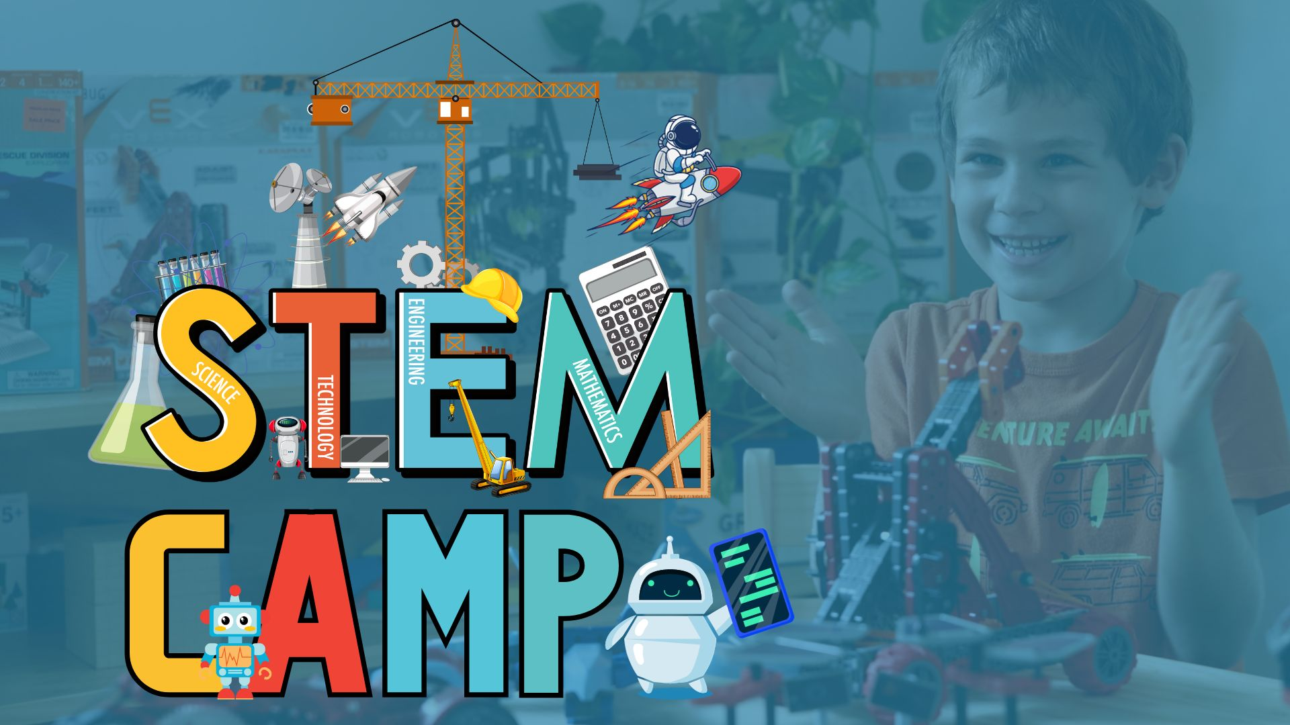Source: (Digital Schools 2026).

Table of contents
Executive Summary 2
Introduction 4
2.0 Findings 4
2.1 Critical Discussion of Project Management Tools and Techniques 4
2.1.1 Aims and Objectives 5
2.1.2 The Iron Triangle and Quad Charts 5
2.1.3 Work Breakdown Structure and Gantt Chart 6
2.1.4 Risk Analysis and SWOT 7
2.1.5 Stakeholder Analysis and Evaluation Methods 8
2.1.6 Belbin Team Roles 9
2.2 Application of Tools and Techniques in the Project 9
2.2.1 Critical Reflection on Tool Effectiveness 10
2.2.2 Communication and Stakeholders 11
3. Conclusion 13
References 14

Introduction
This report was prepared by the student as part of the Managing Projects module. It critically evaluates project management tools and techniques and explains how they were used during the team project, which involved planning a one-week Inclusive STEM Camp for Children with Disabilities. The report also discusses how planning, communication, risk management, and project monitoring helped the team achieve its objectives and deal with challenges.
Project management is a structured way of planning and completing a project within an agreed scope, budget, and timeframe. Project management tools are important because they help teams organise tasks, manage resources, and improve the chances of project success (Harrison and Lock, 2017). This report uses relevant academic literature to evaluate the effectiveness of common project management tools and techniques. The report is divided into four sections: a critical discussion of project management tools, their application in the project, a critical reflection on their effectiveness, and a conclusion with recommendations for future projects.

2.0 Findings

2.1 Critical Discussion of Project Management Tools and Techniques
Every project is unique and has its own benefits and challenges, so project management tools need to be selected and applied appropriately (Kerzner, 2025).

2.1.1 Aims and Objectives
The three key elements of project management are setting clear aims and objectives. SMART objectives (Specific, Measurable, Achievable, Relevant, and Time-bound) provide a clear framework that helps teams stay focused and work towards the project's goals (Doran, 1981). In our Inclusive STEM Camp project, the aims and objectives helped the team plan activities, improve accessibility, and create a supportive learning environment for children with disabilities. However, fixed objectives can make it more difficult to respond to unexpected changes, meaning objectives should be reviewed regularly throughout the project lifecycle (Stray et al., 2022; Kerzner, 2025).

2.1.2 The Iron Triangle and Quad Charts
One of the most widely used project management models is the Iron Triangle, which focuses on three key elements: scope, time, and cost. It helps project teams understand how changes to one element can affect the others and supports effective project planning (Atkinson, 1999). In the Inclusive STEM Camp project, the team defined a clear project scope, planned a six-month preparation timeline, and considered the available budget of £42,500 to deliver an accessible STEM camp for children with disabilities.
A Quad Chart is another useful project management tool because it provides a simple one-page overview of the project's objectives, schedule, risks, and resources, making it easier to communicate with stakeholders (Kerzner, 2025). In the Inclusive STEM Camp project, it summarised the project's aims, key risks such as funding and accessibility, and the resources needed to deliver the camp.
However, the Iron Triangle does not consider other important measures of success, such as quality, accessibility, or stakeholder satisfaction, which were essential in this project (Gadda and Lucertoni, 2022). Despite this limitation, both the Iron Triangle and the Quad Chart remain useful because they support project planning, communication, and decision-making.

2.1.3 Work Breakdown Structure and Gantt Chart

The Work Breakdown Structure (WBS) is a project management tool that breaks a project into smaller, manageable tasks. This helps to define the project scope, organise the work, and assign responsibilities to team members (Odedairo, 2024). In the Inclusive STEM Camp project, the WBS divided the work into key areas such as planning and funding, venue and accessibility, STEM activities, participant care, staff training, and project evaluation. When used together with a Gantt Chart, it provided a clear view of the project schedule and progress.
A Gantt Chart is an easy-to-use project scheduling tool that shows the order and timing of project tasks and helps monitor progress throughout the project lifecycle (Westland, 2021). In this project, it was used to plan the six-month preparation period, including funding, booking an accessible venue, designing STEM activities, training staff, and preparing learning materials. However, in larger or more complex projects, Gantt Charts can become difficult to manage and need regular updates to stay accurate (Demerouti, 2025).
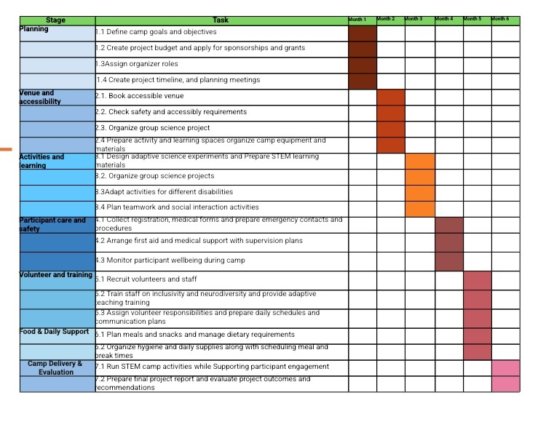Source: Prepared by students

2.1.4 Risk Analysis and SWOT
Risk analysis helps project teams identify, assess, and manage potential problems before they affect the project. In the Inclusive STEM Camp project, the main risks included accessibility challenges, funding uncertainty, the need for trained staff and volunteers, health and safety issues, and ensuring that every child could take part in the activities.
SWOT analysis (Strengths, Weaknesses, Opportunities, and Threats) is a useful tool for understanding the internal and external factors that may affect a project. In the Inclusive STEM Camp project, the SWOT analysis identified strengths such as the inclusive project design, specialist disability expertise, strong stakeholder engagement, and a clear project structure. It also highlighted weaknesses including funding dependency, limited planning time, recruitment challenges, and high resource requirements. The analysis identified opportunities such as new sponsorships, partnerships with disability organisations, and increased community engagement, while threats included funding shortages, medical emergencies, equipment delivery delays, and weather disruption. However, SWOT analysis can be subjective and may not provide enough detail for complex projects (Kumar et al., 2025).

2.1.5 Stakeholder Analysis and Evaluation Methods
Stakeholder analysis helps project teams identify the people and organisations involved in a project, understand their level of influence and interest, and choose the best way to communicate with them (Tampio et al., 2022). In the Inclusive STEM Camp project, key stakeholders included children with disabilities, parents, educators, sponsors, volunteers, healthcare professionals, and disability organisations. The Power-Interest Grid helped the team decide which stakeholders required the most attention, especially parents and sponsors. However, stakeholder priorities can change during a project, so the analysis should be reviewed regularly rather than used only once.
Project performance can be evaluated using both hard and soft evaluation methods. Hard evaluation focuses on measurable results, such as securing funding, completing the project on time, delivering the planned activities, and meeting accessibility requirements. These measures are useful because they provide clear evidence of project performance. Soft evaluation methods focus on qualitative factors, including participant feedback, team collaboration, stakeholder satisfaction, and the overall experience of children and their families. Although these results are more difficult to measure, they provide valuable information about the project's success. Using both hard and soft evaluation methods gives a more complete assessment of project performance (Project Management Institute (PMI), 2021).

2.1.6 Belbin Team Roles
Belbin Team Roles help project teams understand the strengths of individual members and allocate responsibilities effectively (Belbin, 2010). By assigning roles based on people's skills and behaviours, teams can improve communication, collaboration and teamwork. However, Belbin roles are based on observed behaviours, which may change depending on the situation. Therefore, they should be used as a guide rather than fixed roles.

2.2 Application of Tools and Techniques in the Project

At the beginning of the project, the team agreed on clear aims and objectives to guide the planning process. These objectives focused on creating an accessible STEM learning experience, encouraging teamwork, and providing suitable training for staff and volunteers. Having clear objectives helped the team stay focused throughout the project, although some activities had to be adjusted because of funding and accessibility requirements.
To organise the project, the team created a Work Breakdown Structure (WBS), which divided the project into smaller tasks such as planning and funding, venue preparation, STEM activities, staff training, participant care, and project evaluation. These tasks were then organised into a six-month Gantt Chart, which helped the team schedule activities and monitor progress. The combination of these tools improved organisation and communication within the team. However, some tasks, particularly securing sponsorships and funding, took longer than expected, so the timeline had to be updated as the project progressed. This showed that Gantt Charts are only effective when task durations are estimated realistically and the schedule is updated throughout the project (Ljung and Tallgren, 2024; Wadhwa, 2024).
A risk register was used throughout the project to identify and monitor risks such as accessibility, health and safety, funding, and the recruitment of trained staff and volunteers (Firoozi and Firoozi, 2024). This allowed the team to prepare actions to reduce potential problems before they affected the project. The team also used stakeholder analysis to identify key stakeholders, including parents, sponsors, educators, volunteers, healthcare professionals, and disability organisations. Using the Power-Interest Grid helped the team decide which stakeholders required the most communication and support during the planning stage. In addition, the Iron Triangle helped the team balance the project's scope, time, and cost when making planning decisions. Together, these tools improved communication, supported decision-making, and contributed to the successful planning and presentation of the Inclusive STEM Camp project.

2.2.1 Critical Reflection on Tool Effectiveness
It was clear during the project that project management tools were most effective when they were regularly reviewed and updated. For example, the team used a Gantt Chart to organise the project timeline and plan the six-month preparation period. However, some activities, especially securing funding and sponsorships, took longer than expected, so the timeline had to be updated. This showed that project management tools should not be treated as one-time planning documents but should be reviewed throughout the project to reflect any changes.
The Work Breakdown Structure (WBS) was effective because it divided the project into smaller tasks and made it easier to allocate responsibilities. It also improved teamwork by giving each team member a clear understanding of their role. The risk register was another valuable tool, as it helped the team identify risks related to accessibility, funding, health and safety, and staffing. Assigning responsibility for each risk improved accountability and allowed the team to prepare suitable responses before problems occurred.
Stakeholder analysis also supported the project by helping the team identify the most important stakeholders, such as parents, sponsors, educators, and volunteers, and plan appropriate communication with each group. However, the project also showed that regular discussions and informal communication between team members were just as important as the formal project management tools, particularly when quick decisions had to be made. Overall, the experience showed that project management tools are most effective when they are combined with good communication, flexibility, and regular review. In future projects, the team should schedule formal review meetings to ensure that project management tools remain accurate, relevant, and useful for decision-making.

2.2.2 Communication and Stakeholders
Communication is an important part of successful project management, and poor communication is often one of the main reasons why projects experience problems. Throughout the Inclusive STEM Camp project, the team used different communication methods to keep both internal and external stakeholders informed and involved (Kerzner, 2025).
During the planning stage, the team identified key stakeholders, including parents, sponsors, educators, volunteers, healthcare professionals, and disability organisations. Regular team meetings and online communication tools were used to discuss progress, share project documents, and coordinate tasks, supporting effective collaboration throughout the project (Johnston, Taylor and Ryan, 2024). Emails, meetings, phone calls, WhatsApp groups, posters, and social media were selected as the main communication methods, depending on the needs of each stakeholder group. This helped improve teamwork and ensured that important project information was shared effectively.
Communication priorities were based on the stakeholder analysis. Effective stakeholder engagement throughout the project lifecycle is considered essential for project success (Asiedu and Iddris, 2022). Stakeholders with high power and high interest, such as sponsors, camp coordinators, healthcare professionals, and the module tutor, received regular updates throughout the project. This approach shows that regular communication with key stakeholders reduces issues and improves collaboration (Bannor et al., 2026). Parents were also given a high priority because they played an important role in ensuring the safety and participation of the children. Other stakeholders, such as volunteers and community partners, were kept informed through regular meetings, group chats, and social media updates. Although this communication approach worked well, more frequent contact with some stakeholders, particularly sponsors, could have helped reduce delays during the planning stage.
The team also worked together to review project deliverables, including the camp programme, learning materials, staff training, and evaluation reports. Feedback from team members was used to improve these deliverables throughout the project. Looking back, involving parents and disability specialists earlier in reviewing these materials could have improved accessibility and ensured that the final project better met the needs of participants. This supports the idea that stakeholders should be involved throughout the project lifecycle rather than only at the end.

3. Conclusion
This report has critically reviewed a range of project management tools and techniques, both in theory and through their application in the Inclusive STEM Camp project. The findings show that these tools provide valuable support for planning, organising, and managing projects. However, they are only effective when they are applied correctly, reviewed regularly, and adapted to meet the changing needs of the project and its stakeholders.
The project also identified several opportunities for future improvement. First, more contingency time should be included in the project schedule to reduce delays caused by funding and sponsorship applications. Second, project management tools such as the Gantt Chart, Work Breakdown Structure (WBS), Risk Register, Stakeholder Analysis, and Belbin Team Roles should be reviewed regularly to ensure they continue to support effective planning, teamwork, and decision-making. Third, communication with key stakeholders, particularly parents, sponsors, healthcare professionals, and volunteers, should be reviewed at each stage of the project to improve collaboration and respond to changing stakeholder needs. Finally, both hard and soft evaluation methods should be used throughout the project, with regular feedback collected from participants, parents, and volunteers to identify improvements before the project is completed. Implementing these recommendations would improve the planning, delivery, and overall success of similar inclusive projects in the future.

References
Asiedu, R. and Iddris, F. (2022) “Value Co-Creation Approach to Management of Construction Project Stakeholders,” Journal of construction in developing countries, 27(1), pp. 1–23. Available at: https://doi.org/10.21315/jcdc2022.27.1.1 .
Atkinson, R., 1999. Project management: Cost, time and quality, two best guesses and a phenomenon, it's time to accept other success criteria. International Journal of Project Management, 17(6), pp.337–342. https://doi.org/10.1016/S0263-7863(98)00069-6
Bannor, P., Nani, G., Osei-Tutu, S., Asamoah, R.O., Kyong-Ire, S. and Mensah, J.A.P. (2026). Barriers to Stakeholder Management in Public Projects: A Case of Pre-Tertiary Educational Infrastructure Projects. African Journal of Applied Research & Sustainable Development, 4(1), pp.135-147.
Belbin, R.M. (2010). Management Teams: Why They Succeed or Fail. 3rd ed. Oxford: Butterworth-Heinemann.
Demerouti, E. (2025). “Job demands-resources and conservation of resources theories: How do they help to explain employee well-being and future job design?,” Journal of business research, 192. Available at: https://doi.org/10.1016/j.jbusres.2025.115296.
Doran, G.T. (1981). There's a S.M.A.R.T. way to write management's goals and objectives. Management Review, 70(11), pp.35–36.
Digital Schools. STEM Camp. Available at: https://neo-playagrande.com/stem-camp/ (Accessed: 06 June 2026).
Firoozi, A.A. and Firoozi, A.A., 2024. Risk Management and Contingency Planning. In: Revolutionizing Civil Engineering with Neuromorphic Computing: Pathways to Smart and Sustainable Infrastructure. Cham: Springer Nature Switzerland, pp.73–80.
Gadda, A. and Lucertoni, M. (2022). Measuring What Is Missing in Megaprojects: Social Sustainability Assessment Through the Analysis of Secondary Stakeholders' Satisfaction. Available at: https://www.politesi.polimi.it/handle/10589/210821 (Accessed 29 June 2026).
Harrison, F. and Lock, D. (2017). Advanced Project Management: A Structured Approach. 5th ed. Abingdon: Routledge.
Johnston, K.A., Taylor, M. and Ryan, B. (2024). Evaluation of community engagement for resilience outcomes: A pre-engagement approach. International Journal of Disaster Risk Reduction, 110, p.104613. https://doi.org/10.1016/j.ijdrr.2024.104613
Kerzner, H. (2025). Project Management: A Systems Approach to Planning, Scheduling, and Controlling. 14th ed. Hoboken, NJ: John Wiley & Sons.
Kumar, K.R., Ponnaganti Navyasree, N.C.P., Rathod, S. and Kumar, P. (2025). SWOT Analysis: Tool for Strategic Planning in an Organization. Spatial & Agricultural System Modeling for Abiotic Stress Management, 4.
Ljung, E. and Tallgren, M.V. (2024). The significance of a shared breakdown structure for work preparation planning for a predictable execution. In Proceedings of the Creative Creative Construction Conference. Prague, Czech Republic. doi (Vol. 10).
Odedairo, B.O. (2024). Assessing the influence of various work breakdown structures on project completion time. Engineering, Technology & Applied Science Research, 14(2), pp.13773-13779.
Project Management Institute (PMI) (2021). A Guide to the Project Management Body of Knowledge (PMBOK® Guide). 7th ed. Newtown Square, PA: Project Management Institute.
Stray, V., Gundelsby, J.H., Ulfsnes, R. and Brede Moe, N. (2022). May. How agile teams make Objectives and Key Results (OKRs) work. In Proceedings of the International Conference on Software and System Processes and International Conference on Global Software Engineering (pp. 104-109).
Tampio, K.P., Haapasalo, H. and Ali, F. (2022). Stakeholder analysis and landscape in a hospital project–elements and implications for value creation. International Journal of Managing Projects in Business, 15(8), pp.48-76.
Wadhwa, K. (2024). The Role of Gantt Chart in the Project Management.
Westland, J. (2021). The Project Management Life Cycle. 3rd ed. London: Kogan Page.

