11/3/2026
University of Wales Trinity Saint David
London campus
E-Portfolio Link: Do not forget to share your e-portfolio (Wix) link here
Module Name: Learning In the Digital Era
Module Code: ACCA 4025

Student Name: Moises David Reyes Motino
Student ID: 2612561
Group: 3

Lecturer’s Name: Koushik Modak

LDE Assignment 1
E-Portfolio
Table of Contents
Introduction 2
Main Body 2
Task 1: Essential Academic and Employment Skills for the future career Path 2
Task 1 (a): Report on Essential Academic and Employment Skills 2
Task 1 (b): AI Assistant Tools 3
Task 1 (c): Evaluation of Task 1 (a) based on Similarity report 3
Task 2: Collaborative Mind Map and Individual Poster 3
Mind Map (Collaborative) 3
Poster (Individual) 4
Task 3: Virtual Collaboration and RefWorks 4
Report on Virtual Collaboration 4
Step-by-step process of using RefWorks with visuals 4
Task 4: E-Portfolio Creation and Evaluation 4
Task 4 (a): E-Portfolio Creation 4
Task 4 (b): Illustrative Review of E-Portfolio tool Selection 4
Conclusion 4
References 4
Task 1 References: 4
Task 3 References: 4

Introduction
(approx. 100 words -Remove this part after completing).

Main Body

Task 1: Essential Academic and Employment Skills for the future career Path

Task 1 (a): Report on Essential Academic and Employment Skills

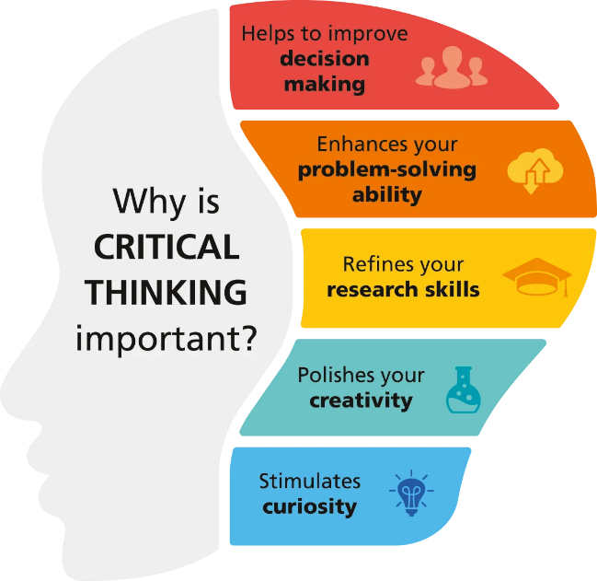
To achieve success in your academic studies, you will need to develop a specific set of cognitive and organizational competencies. Skills such as critical thinking are an essential requirement you must have. Imagine it as developing the ability to analyse information objectively or having to evaluate an extraordinarily complex argument instead of just accepting facts without any reliable evidence. Critical thinking is a vital skill you must develop to succeed in your academic studies. It will help you to openly synthesize many viewpoints from different perspectives and to construct very logical and persuasive arguments in your written assignments [1].In this modern digital era, another essential academic skill students must develop is information literacy. At this point in their academic studies, students are expected to be capable of managing, evaluating and locating vast amounts of scholarly data to make sure that their research is valid and is authoritative and reliable information. Assignments, task and academic workloads, most of the time, will involve independent study. Effective time management is indispensable for completing these assignments. Also, the ability to prioritize tasks and learn to manage schedules is a crucial part of completing rigorous deadlines and maintaining a very consistent chronological level of academic competence and productive learning. These combinations of academic skills, like analytical and critical thinking, time management to meet deadlines and discipline are the foundations of a successful academic performance for students in Higher Education [1].

Image-Sources: Here and Here
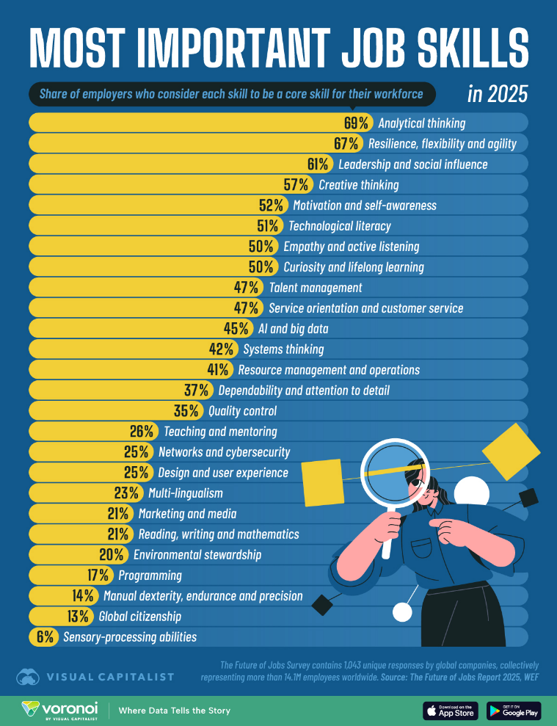
The job market landscape is evolving more quickly than ever. The reason behind this phenomenon is the rise of Artificial Intelligence and Automation. For this reason, students who have technical knowledge are no longer enough to be suitable candidates for employment opportunities. If you wish to stay relevant in this digital era, you will need to develop a specific set of interpersonal and cognitive abilities. This report focuses primarily on the essential employment skills you will need for the coming future. The focus of this report is pointing out how academic discipline can give us an advantage to be more prepared and to develop a more competent and successful employable profile. The most important shift in the modern workforce is the move from “doing task manually " to "solving complex problems”. Because machines and automation are taking over repetitive work in the job market, humans now are being hired to handle ambiguity and make high level decisions. And for this reason, is essential to have the ability to think critically in moments of pressure when working alone with companies, clients, or stakeholders. This is no longer about finding a quick solution to a challenge but about having an in-depth understanding of the logic behind the corporate challenges. One major part of this involves the employment skills we develop during our academic studies. Having the ability to conduct deep research and analyse complex data is a requirement core to modern corporation roles. The World Economic Forum highlights that analytical thinking is one of the most powerful skills in the current global economy [2] [3]. If you do not develop the ability to dissect information from a fundamental skill obtained through rigorous academic studies, you will struggle to make the right professional decisions under pressure in a role. Another critical area is having communication skills developed for the workplace. In a more professional saying, you need to develop the ability to explain a concept that is extraordinarily complex in a simple and straightforward way and learn to collaborate with your team or department in a company is essential. Academic training studies teach us how to construct, deconstruct and structure stronger professional arguments and write with clarity to read the environment and reach the right word rhythm. As noted in recent educational research, the ability to synthesize information and communicate effectively is what bridges the gap between academic theory and professional application [2]. The future of work belongs to those who can think critically, to those who can communicate effectively and work with stakeholders in a team. Technical tools like Artificial Intelligence and Automation will change and evolve the job landscape, but the ability to solve problems and interact with others will always remain a constant requirement. Developing these skills through disciplined academic work is the best way to ensure career success in the job market [2] [3].

Image-Source: Here

Task 1 (b): AI Assistant Tools
Criteria | ChatGPT | Copilot | Gemini
Generating answers | It is very powerful in overall knowledge.  And its performance is outstanding when it answers to complex questions. [4] | The best usage of this AI assistant is when you need summaries or explanations with work-link Microsoft 365 data tools or files. [5] | This artificial assistant tool shines when it comes to working on Google environments and is also perfect for digital tracking of legal documents. [6]
Creative work, code/diagram generation | It has a sophisticated user interface capable of creating charts and diagrams. It is also excellent with coding support helping developers and vibe-coders that want to know what their code is doing. [4] | The Agents in Microsoft 365 based applications like Word and PowerPoint can help you produce outstanding documents and presentations for your assessments. [5] | You can know create boilerplate code using Gemini Omni to speed the creation of your applications. Also, Omni is perfect for making educational videos helping students visualise complex topics. [6]
Data analysis | Having the option to upload your files is a need and ChatGPT got you cover. It analyses any uploaded document like an audio a pdf a PowerPoint or basic code templates. [4] | Agents can be set to behave with a specific mindset. You can order an agent to behave as an Analyst and perform a Java-backed visualization and analysis of raw datasets. [5] | Gemini Omni facilitates the extensive processing of datasets and files in their native formats helping you speed up your assignments. [6]
Problem-solving | ChatGPT has so many robust reasoning capabilities when working with tasks or issues that need the use of across diverse domain referencing. [4] | I think many experts will agree when I say that Copilot agents for multitasking workflows inside Microsoft Office applications is if not the best AI assistant you can possibly have now. [5] | I think Gemini best use case for solving problems is multi-step operations interactions with a broad or general scenarios or contexts. [6]
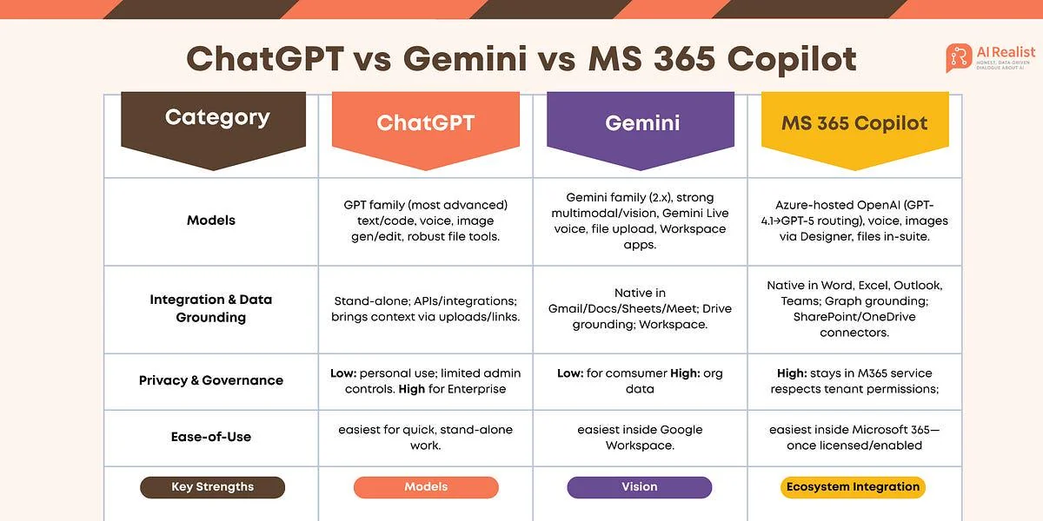



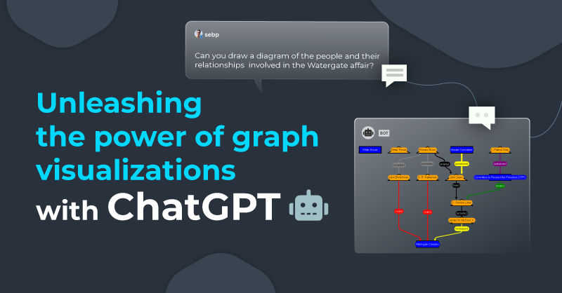

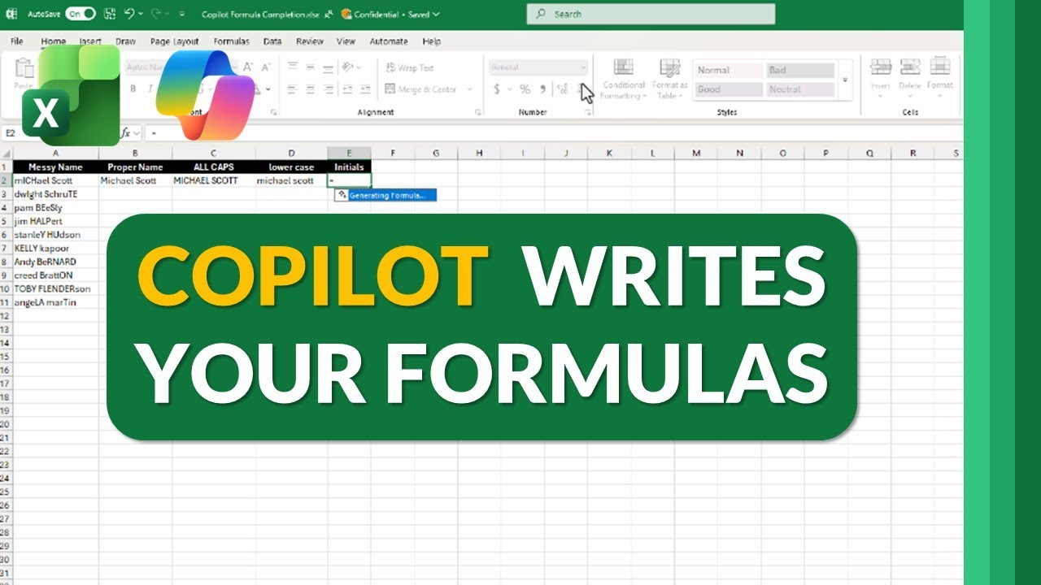

Identify a course available in LinkedIn which talks about AI assistance. (Remove this part after completing)

Task 1 (c): Evaluation of Task 1 (a) based on Similarity report
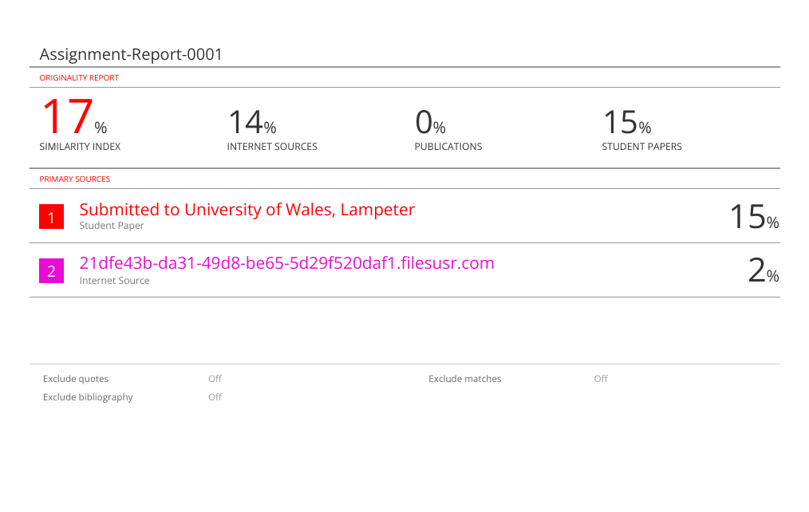
Submit the document prepared in Task 1 (a) to Turnitin and generate the similarity report and take a screenshot of your similarity report and paste it here. Please evaluate your similarity percentage. (200 words) – self-evaluation (approx. 200 words and 2 paragraphs where the first paragraph is about your similarity index and your areas of improvement. Then the second paragraph is about how much mark you deserve on your work with an appropriate justification-Remove this part after completing).

Task 2: Collaborative Mind Map and Individual Poster

Mind Map (Collaborative)
(approx. 450 words where 3 persons in one group and the contribution from each person should be 150 words approx..).

Poster (Individual)
No word limit. Mind Map must be inserted in the Poster

Task 3: Virtual Collaboration and RefWorks

Report on Virtual Collaboration
(approx. 350 words and 4-5 sources-Remove this part after completing).
Put your Chosen topic here and write a summary of that topic with IEEE referencing using RefWorks-Remove this part after completing.

Step-by-step process of using RefWorks with visuals
Put screenshots with appropriate discussion explaining what has been demonstrated in that screenshot-Remove this part after completing (100-150 words)

Task 4: E-Portfolio Creation and Evaluation

Task 4 (a): E-Portfolio Creation
Explain how you have created your e-portfolio with screenshots as evidence-Remove this part after completing.

Task 4 (b): Illustrative Review of E-Portfolio tool Selection
(approx. 100-150 words and 1-2 sources (if used)-Remove this part after completing).

Conclusion
(approx. 100 words -Remove this part after completing).

References

Task 1 References:

Task 3 References:

