

STUDENT NUMBER: 2320589
STUDENT NAME : Amina Diallo
MODULE CODE: BMHP5015
MODULE NAME: Building your Personal Brand for Sustainable Employment
PROFFESSOR NAME : Dr Raheela Shaikh
ASSIGNMENT TITLE: Component 1 : Online Portfolio of Set Exercises
Table of Contents
Task 1 – Personal Brand 2
Task 2 - Network Map and Rationale 2
Task 3- The Challenge of Workforce Shortages in UK Social Care 3
Task 4- NHS Equality, Diversity and Inclusion Quiz 4
Task 5- A Letter to Yourself 5
Task 6- GANTT Chart 6
Task 7- Making Changes- Report 7
Task 8- Self-Reflection 8
Reference List 8

Task 1 – Personal Brand
A person's professional image is reflected in their personal brand. As part of my personal brand, I want people to know that I am committed, trustworthy, and able to collaborate with a variety of individuals in the health and social care sector. I constantly make an effort to support coworkers, do my best, and adjust to changing circumstances. I will enhance my abilities by learning more about my work, paying attention to criticism, and participating in training in order to build my own brand. Using LinkedIn and social media can also help me demonstrate my experience and get the trust of potential employers. My brand is strengthened via effective communication, cooperation, and a robust web presence. Increasing my self-assurance and showcasing my accomplishments will also draw in employers. I want people to feel comfortable working with me and trusting me. “By focusing on learning, staying positive, and connecting with others, I will reach my employment goals and find new job opportunities in the future (Nursing Education, 2024).”

Task 2 - Network Map and Rationale
. 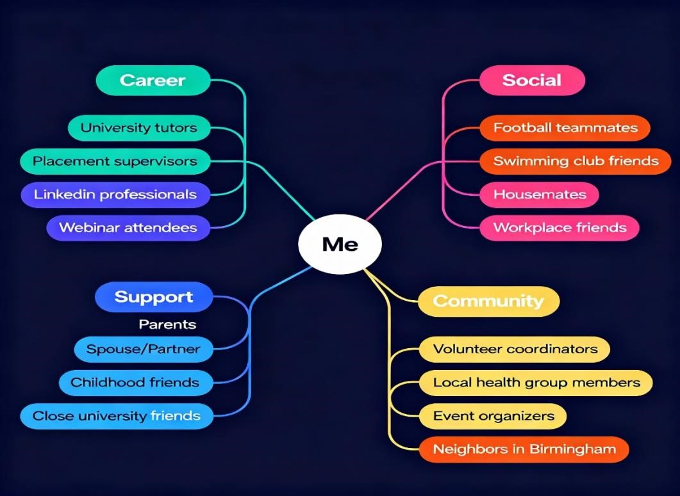
Figure 1 – Network Map
Career, Social, Support, and Community are the four primary categories into which my personal network is divided. Every group adds something unique to my life, both personally and professionally. Professionals on LinkedIn, placement supervisors, and university tutors are examples of career contacts that assist me in finding new possibilities, exchanging advice, and developing my employment abilities. Social ties, including study group members, friends from local events, roommates, and coworkers, are crucial for exchanging ideas and supporting one another during stressful times. During both good and bad times, I get emotional support and encouragement from my support group, which consists of my parents, boyfriend, childhood pals, and close university friends. I can learn about topics that are important outside of work or school from persons in the Community group, such as volunteer coordinators, members of health groups, event planners, and neighbours.
Although my network is rather diversified, a closer examination reveals that I occasionally rely more on friends and family than on mentors in my career. I should concentrate on meeting new individuals from diverse backgrounds and join more professional organisations in order to get better. “Research shows that having a bigger and more varied network helps people find better jobs, deal with change, and learn new skills (Putnam, 2000).” This means keeping my network active and building new links is important to reach my goals

Task 3- The Challenge of Workforce Shortages in UK Social Care
The lack of employees is one of the main issues affecting health and social care in the UK at the moment. Finding and retaining enough nurses, carers, physicians, and other critical staff is a challenge for care facilities, hospitals, and community health organisations. Although this issue is not new, it is becoming much more severe in 2025 as fewer individuals are entering these professions and the need for care increases.
Staff shortages may result in longer wait times and less access to services for those who depend on health and social services. Staff members may feel worn out, overburdened, and under pressure, and families may find it difficult to acquire assistance for older family members. The lack of competitive wages and working conditions in some places is one factor contributing to the shortage. Many employees experience stress, and they occasionally work with too few coworkers to provide safe and efficient care. Recruitment has become much more challenging as a result of Brexit and the epidemic, particularly for those who formerly travelled from the EU to work in the UK.
Though experts think more is required, the government has taken certain actions, such as providing additional chances for professional growth and training. Pay increases, employee wellness initiatives, and more flexible scheduling might all help recruit and retain workers in these vital positions. As the population ages over the next few years, the UK may experience even worse disparities if nothing changes. “Everyone— government, employers, and local communities—needs to work together to make careers in health and social care attractive and sustainable for the future (Care Show London, 2025).”

Task 4- NHS Equality, Diversity and Inclusion Quiz
- What is the primary goal of the NHS Equality, Diversity, and Inclusion Improvement Plan?

Establishing a just and inclusive workplace where everyone is valued and treated equitably is the main objective of the NHS EDI Improvement Plan.
- How does the NHS EDI Improvement Plan propose to tackle the gender pay gap?
By examining compensation patterns and advocating for equitable career progression possibilities, the approach addresses the gender pay gap.
- What is meant by the term ‘intersectionality’ as used in the NHS EDI Improvement Plan?
Understanding how many facets of an individual's identity, such as gender and ethnicity, interact and influence their experiences is known as "intersectionality."

- Why is it important for the NHS to create a psychologically safe work environment?
It's critical to establish a psychologically secure workplace so that employees may speak up without fear of retaliation or prejudice.
- How does the NHS EDI Improvement Plan suggest improving the experience of internationally recruited staff?
Through improved assistance, equitable treatment, and defined career paths, the strategy recommends enhancing the experience of foreign-hired employees.
- What role does leadership play in advancing EDI objectives according to the NHS Improvement Plan?
By establishing inclusion priorities and ensuring that EDI objectives are fulfilled in companies, leadership plays a crucial role.

- Identify one way the NHS EDI Improvement Plan aims to reduce health inequalities within the workforce.
Offering training to increase awareness and lessen prejudice in the provision of treatment is one strategy to lessen health disparities.
- Why does the NHS EDI Improvement Plan emphasise the importance of collecting and analysing data on protected characteristics?
The NHS can better understand disparities and enhance policy by gathering and evaluating data on protected characteristics.
- Explain how flexible working policies can contribute to equality and inclusion in the NHS workforce.

Flexible employment arrangements contribute to the NHS's increased inclusivity by meeting a range of demands and living circumstances.

- What is one strategy mentioned in the NHS EDI Improvement Plan to combat bullying and harassment in the workplace?

Establishing an atmosphere that eradicates the circumstances that lead to bullying, discrimination, harassment, and physical violence is one tactic included in the NHS EDI Improvement Plan to address bullying and harassment in the workplace..

Task 5- A Letter to Yourself
I can recall my initial days in Italy as a support worker. Meeting the demands of many individuals and handling stressful situations were only two of the numerous obstacles that came with the work during that period. In retrospect, I realise how crucial emotional intelligence was to me. Even in difficult situations, I was able to react with love and patience because I understood how I felt as well as how others I cared about felt. This ability increased the effectiveness of my work and helped me gain people's trust. Resilience had similar significance. I occasionally felt overburdened or demoralised but being able to persevere in the face of obstacles had a significant impact. The work became simpler and more fulfilling as a result of learning how to bounce back fast, maintain a happy attitude, and adjust to shifting needs.
If I could go back in time, I would advise myself to prioritise early resilience and emotional intelligence development. I would take some time to think about how I feel and figure out good strategies to deal with stress. I wouldn't think twice about asking close ones or coworkers for help. These abilities have benefited me in both my professional and personal lives as a support worker. I've discovered that every obstacle presents an opportunity to get stronger. The secret to success is the capacity to comprehend people and deal with challenges.

Task 6- GANTT Chart
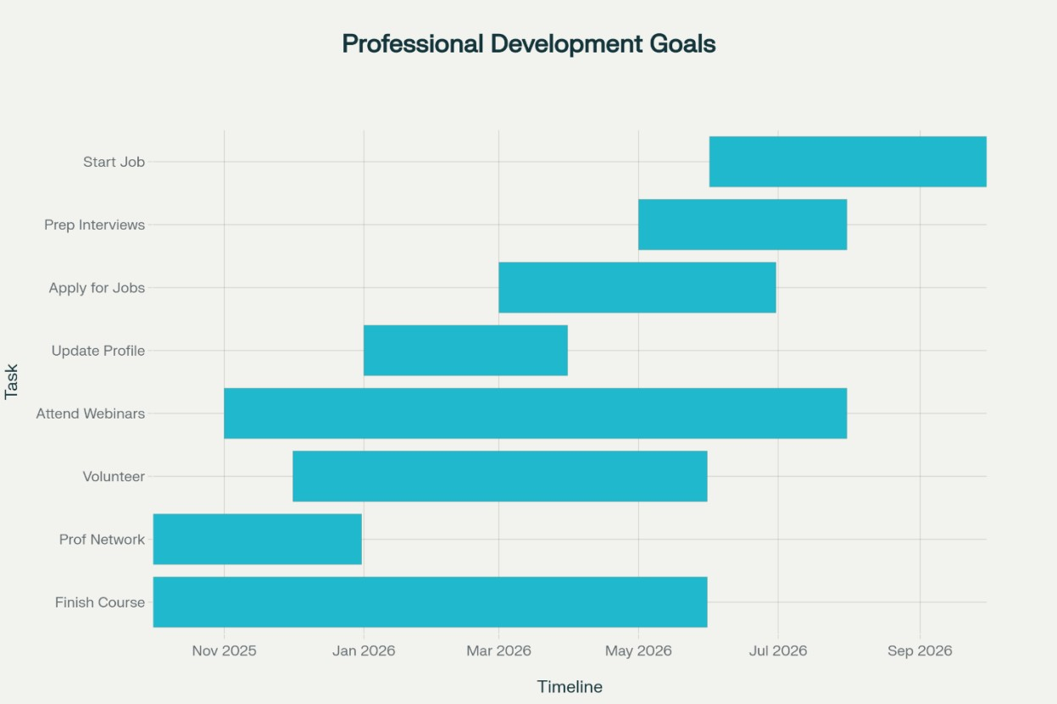
Figure 2 - Gantt Chart
A schedule for professional development objectives from October 2025 to September 2026 is depicted in this Gantt chart. The chart displays a series of activities intended to help you get ready for and begin a new career. Completing an October 2025–June 2026 course is the first step. The process of establishing a professional network begins in early October and concludes in December 2025. Volunteering that supports skill development and community participation takes place between November 2025 and May 2026. Attending webinars, which offer continual learning opportunities, takes place from October to July 2026. A professional profile can be updated from January to April of 2026. March through July 2026 is when job applications will be accepted, and May through August 2026 is when interview preparation will take place. Lastly, a new position is scheduled to begin in July 2026 and last through September 2026. The professional growth process stays on course and objectives are methodically met with the aid of this chart, which helps arrange the assignments and deadlines.

Task 7- Making Changes- Report
As the manager of the care facility, I wish to switch from paper to digital records for our residents. Employees will save time and make fewer mistakes with digital documents. Using a computer or tablet to update care notes is quicker and more readable. This keeps everything orderly and protected while enabling employees to locate critical information fast. We must get a few PCs or tablets and pick a reliable system for our house in order to do this. Employees will receive basic training on the new system's operation. I'll encourage them and remind them that everyone learns at their own rate, even if some employees might be anxious about making errors or learning something new. In order to assist if something goes wrong, we will also listen to everyone's concerns and queries.
Teamwork is a crucial ability for this shift. Everyone must cooperate and support one another. To ensure that all employees understand what is going on and how the change will benefit our residents, effective communication is also essential. Since it can take some time for everyone to become used to the new method, patience is also beneficial. Fear of technology, a lack of training time, and worries about the security of personal data are among potential obstacles. We'll carefully prepare the training and demonstrate how digital records protect data. “By starting slowly and helping each other, the care home can become better for staff and residents (Local Government
Association, 2023).”

Task 8- Self-Reflection

I gained a lot of knowledge about who I am and how I collaborate with people during this program. Knowing my emotions and how they influence my choices has helped me to appreciate the value of emotional intelligence. I also discovered that resilience is crucial, particularly in the health and social care sectors where difficulties might arise often. I made an effort to remain composed and consider my options before acting when presented with challenging group projects or assignments. I was able to support my team and solve difficulties more effectively as a result.
I was able to consider these events in detail by using Gibbs' Reflective Cycle. I talked about the positive and terrible things that happened, as well as how I felt. I examined these emotions and discovered that I might develop by being patient and receptive to criticism. I came to the realisation that I occasionally need to have more self-assurance and ask for clarification when I don't understand something. My ability to listen more and articulate myself clearly has improved as a result of this information. My ability to work in a team and solve problems was also enhanced. I'll apply what I've learnt about reflection in my future work to keep becoming better. I'll reflect on what I've done, grow from my errors, and acknowledge my accomplishments. This will enable me to collaborate effectively with my coworkers and deliver better treatment.
“Gibbs’ Reflective Cycle is a useful tool for learning and growth in any job, especially health and social care (Gibbs, 1988).”

Reference List
Burnes, B. (2017) Kurt Lewin and the Harsh Realities of Change Management: Reflections on the Legacy of Lewin. International Journal of Management Reviews, 19(4), pp. 357–372.
Care Show London. (2025) Welcome to 2025: what lies ahead for social care?
https://www.careshowlondon.co.uk/edition-10/welcome-2025-lies-ahead-social-caree834.
Gibbs, G. (1988) Learning by Doing: A Guide to Teaching and Learning Methods. Oxford: Oxford Polytechnic.
LinkedIn. (2025) Building a Personal Brand as a Healthcare Professional.Available at: https://www.linkedin.com/pulse/building-personal-brand-healthcare-professional-guidesyed--x9kbc.
Local Government Association. (2023) Implementing digital social care records.
https://www.local.gov.uk/our-support/partners-care-and-health/digitaltransformation/implementing-digital-social-care.
MindTools. (2025) Psychological Safety at Work: Creating a Psychologically Safe Workplace. https://www.mindtools.com/ajm9l1e/psychological-safety-at-work.
NHS England. (2023) NHS Equality, Diversity and Inclusion Improvement Plan.
https://www.england.nhs.uk/long-read/nhs-equality-diversity-and-inclusionimprovement-plan/.
Nursing Education. (2024) How Can Nurses Build a Personal Brand?
https://nursingeducation.org/insights/personal-brand/.

Putnam, R.D. (2000) Bowling Alone: The Collapse and Revival of American Community. New York: Simon & Schuster.

