Material Science and Building Services ACBA4006
Lighting layout, heat and sound
Jocasta Napier
Student Number 2136860

Table of Contents
Introduction 2
Task A 2
Part 1 2
Room Index (RI) 2
Utilisation Factor (UF) 3
Numbers of lamps required. 4
Suitable layout (the S value) 4
Part 2 6
Task B 7
Part 1 7
A building’s internal design and service support 7
The design layout and service support can have a major impact on any structure. Depending on the size of the space of the room the sound will either need to be absorbed, reflected, or transmitted, when working out the room’s boundaries and the figuring out which one is needed to be maximised. 7
A partition wall’s construction technique 7
Choice of insulation types available 8
Part 2 8
Thermal Transmittance also known as the ‘U’ Value 8
Thermal Resistance also known as the ‘R’ value 9
Thermal Conductivity 10
The Rate of Heat (Conductivity) 11
Conclusion 11
References 12
Table of Figures 12

Introduction
This assessment is going to show the workings out for a lighting design plan for a factory and what will be best layout to maximise the light in the space given. It will then carry on talking about the frequency and the wavelength of sound and what impacts they can have within the design of a house. It will discuss the thermals aspects of transmittance and resistance and how they can calculate heat loss. Then finally will give a diagram on Thermal Conductivity is measured and how the material type and distance can be considered in the calculation.

Task A

Part 1

A factory has a new production room being set up to keep up with demand of their customers they have come to us, to set out an effective and suitable lighting design to make sure their workers are in the best lighting possible during their workday.

We have been to the factory and get all measurement we need. Below is going to show the breakdown of the calculation for our lighting design set up.

Room Index (RI)

60m in length, 24m in width and 8m in height with the work bench height of 1m.

Firstly, the height of the work bench needs to be taken away from the height of the ceiling as this is the main point the lights need to hit.

8 – 1 = 7m

For the lighting distance to the work bench.

$$RI=\frac{( L x W)}{( Hm ( L+W ) }$$

$RI=\frac{(60 x 24)}{7m (60+24)}$

$RI= \frac{1440}{7 x 84}$

$$RI=\frac{1440}{588}$$

RI = 2.448

Utilisation Factor (UF)

The Utilisation factor is the number of fluxes which will reach the work bench compared to the total output of the flux from the lamps.

The utilisation factor is found by measuring the areas of reflectance at the factory. When looking into this it was found that the ceiling had a reflectance of 0.3 and the walls had a reflectance of 0.5.

The factory has specified they want fluorescent lamps, in recessed louvre with downward light output ratio (DLOR).

Using this information along with the room index, as shown in the table below the utilisation factor is 0.46. As the room index is 2.448 which isn’t on the utilisation chart, the measurement needs to be rounded up to 2.5.
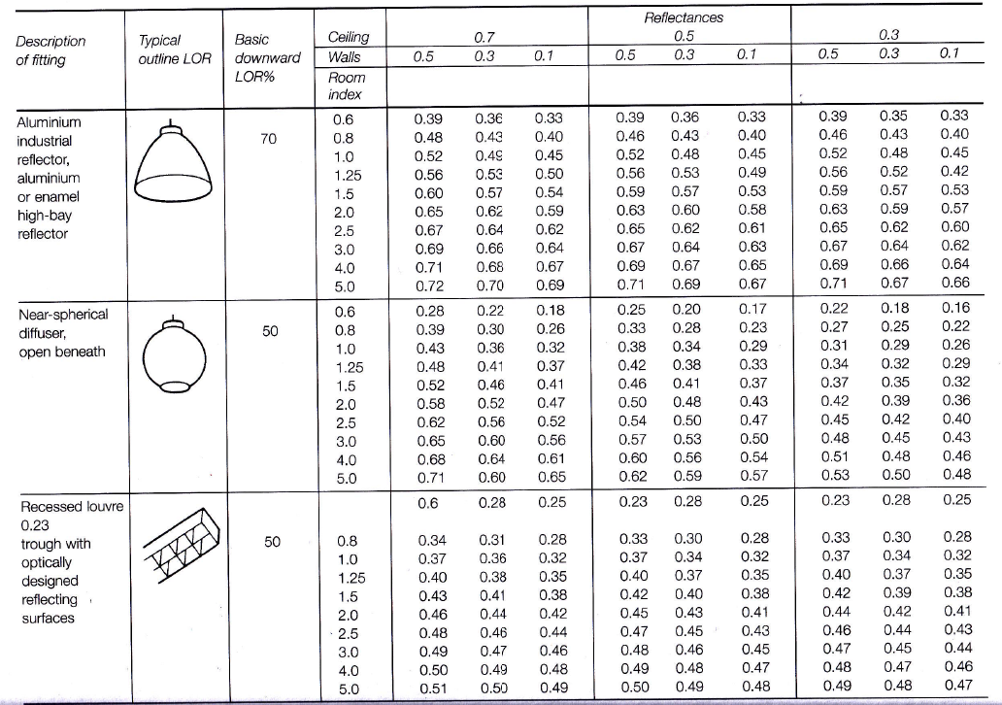

Figure 1 Utilisation Factor

Numbers of lamps required.

The lighting output required for this space is 18,000 lumens, with an illumination requirement of 200 lux on the work planes.

The light loss factors (LLF) at the factory are 0.75.

$$N=\frac{E x A}{F x UF x LLF}$$
N = numbers of lamps required.
E = illuminance level required = 200 lux
A = area at working plane height = 60 x 24 = 1440
F = average luminous flux from each lamp = 18,000 Lumen
UF = utilisation factor = 0.46
LLF = Light Loss Factor = 0.75
$$N=\frac{200 x 1440}{18,000 x 0.46 x 0.75}$$

$$N=\frac{288,000}{6210}$$

$$N=46.378116$$

As the number of lights needed, will need to be a total number, it needs to be rounded up, however in this case we would round up to 48 lamps instead so there is an even illumination disturbed across the factory floor rather than the 47, We are also able to do this as we are working to 70% of the maximum lux required.

Suitable layout (the S value)

Finally, to work out the most suitable design layout for the room, the distance needs to be worked out between each light fixture to have as well as measuring the hight of luminaires measured from the work tops.

As there are industrial florescent lights the measurement used to work out the S value is 1.5.

1.5 x 7m = 10.5m

Meaning the maximum S value for the room is 10.5m when it comes to working out the distance between the wall and lights, this can be half the maximum distance of the S value, meaning half the S value is 5.25m.

When setting up the distance of the lights in the room, they need to be an equal distance between each lamp across the entire ceiling.

The area in which the lights are placed is 60m in Length and 24m in Width as we have decided that the total number of lights being used, it now needs to be broken down into rows.

One row of lights would be too many lights in one central row and cause lower lighting around the edging of the room. It would be similar if there were two rows of 24 lights, although some areas of the room will be lit well it still does not allow optimal lighting for the room. This would be the same if the rows were divided into 8, there would still be sections of the room without optimal lighting.

Therefore, it works out 4 rows of 12 (48 / 4 = 12) would be the best layout for full coverage for the factory.

As the length of the room is 60 meters to work out the spacing between the walls from the lights, the width of the room 24 meters needs to be subtracted from the rows to find out the maximum distance between each row.

24 / 4 = 6

As the distance then is half of this for the spacing between the lights and the wall.

6 / 2 = 3

24m
3m

60m

To then work out the spacing between the row of lights along length of the room. As there needs to be equal spacing between the wall and light of the room this will need to be taken away from the total distance used for the spacing of the lights. As there will be an equal distance at the end of both walls, this will remove 3m from each corner, therefore 6 meter will need to be taken from the total distance of the room, so that the lights are placed within the 3-meter distance of the total ceiling.

60 – 6 = 54m

54 meters is now the distance allowed for the spacing on the lighting, as there will be 12 lights per row, the distance between each light now needs to be worked out.

54 / 12 = 4.5m

Therefore, in each row will have 12 lights at 4.5m apart which is within the maximum space distance of 10.5m.

Part 2

The lighting design in the factory is shown below in figure 2.

As noted in the first draft of the drawing in figure 2, the calculation had been made for the 12 lights, but when placing this on the drawing it was only allowing a maximum of 11 lights within the space. Meaning the equation needs to be done for spacing in between the lights rather than these lights. Therefore, the equation needs to be: 54 / 13 = 4.15. When laying this out again to scale, the lightings wasn’t fitting within the space.

The diagram below shows the correct workings out for the space for the best layout design.

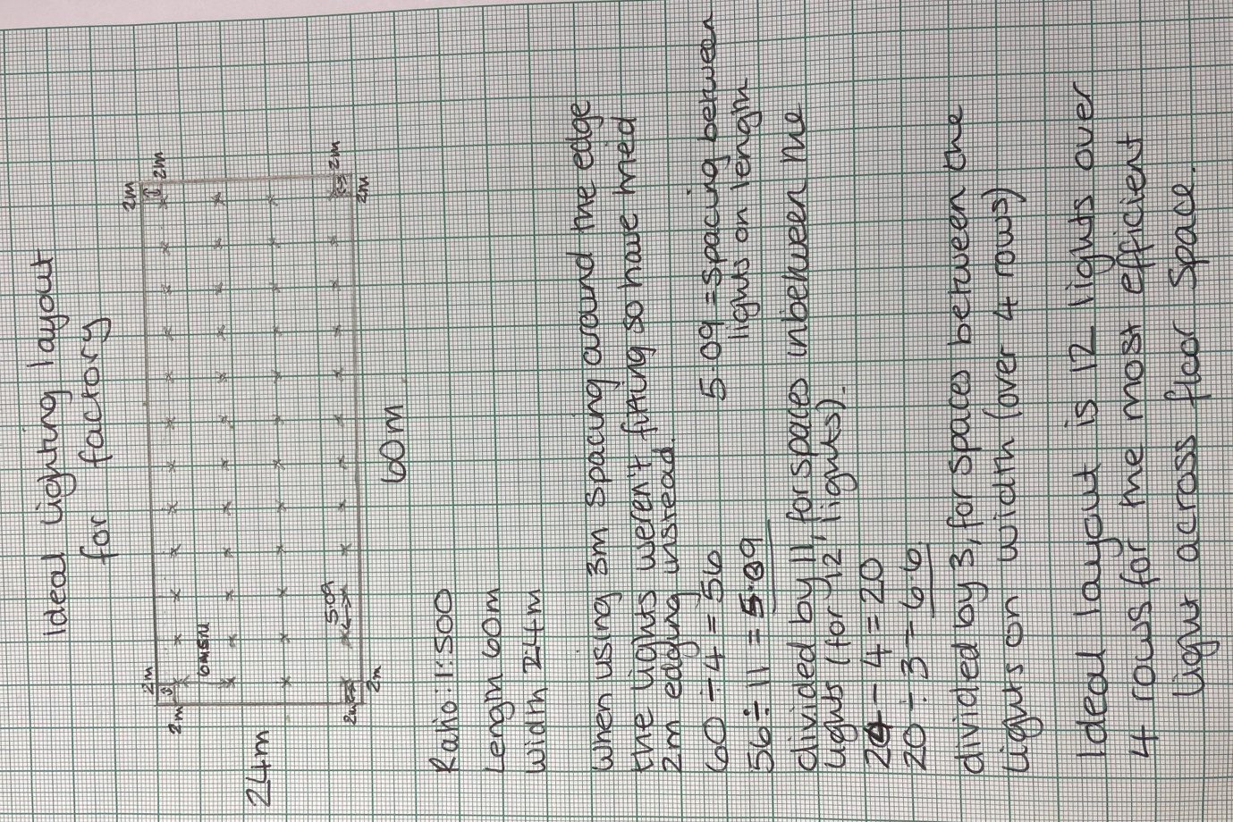
Figure 2 Ideal lighting layout with calculations

Task B

Part 1

A building’s internal design and service support

The design layout and service support can have a major impact on any structure. Depending on the size of the space of the room the sound will either need to be absorbed, reflected, or transmitted, when working out the room’s boundaries and the figuring out which one is needed to be maximised.

With a concert hall, it is important that the sound is amplified and reflected around the entire room, so that everyone in the audience can hear clearly, to do these adjustable planes are suspended above the stage to pushes the sound out to the audience.

Whereas absorption is mainly used within homes, so that the sound in one house doesn’t pass through to adjoining houses or separate rooms in the house. The sound from a TV will reduce after it hits different surfaces within the room, each surface it hits, some of the sound if then absorbed. This then reduces the sound energy with each surface it hit.

Therefore, it’s important to think of the set-up of a room, from the materials used in the building element, such as concrete will have thicker walls, or if there is a layered brick wall with thermal insulation, it will reduce the reflection and absorption of the sound in each room.

A partition wall’s construction technique

The role of a partition wall within a building can have different purposes, it can provide function to a room (by causing separation) and privacy, especially in an office setting. It also provides an extra barrier for airborne soundwaves, with the hope of reducing or more ideally preventing the sound travelling to other rooms, within the building. If there are window or door placed within these partition walls it will have a different sound barrier as they will have different thicknesses to each other. Acoustic Products (2018)

When deciding on the partition type it is useful to know what the room is going to be used for, to then be able to decide what materials is best to use in the partition. An example of this is for a recording studio, thicker walls are required to make sure no sound gets in or out of the recording room, so that there are no distributions to the recording, along with this they use extra insulation within these rooms, to not only make the room soundproof to the outside but to stop any echoing or noise feedback within the room.

Choice of insulation types available

The reason for sound insulation in properties is to reduce the movement of airborne (any sound which travels through the air such as music or passing traffic) and Structural borne also known as impact sounds (sound which travels through solid materials such as footsteps from upstairs or a knock at the door). To work out the movements of the sounds each individual sound needs to be calculated. (McMullan, 2007, p.193)

When considering sound insulation good principles to consider are –

Heaviness – the heavier the structural mass is the larger the reduction of the amount of sound waves which, will pass through the wall. Whereas the thinner the walls the more sound waves will pass through. (McMullan, 2007, p.195)

Completeness – it is important that build structures are airtight to allow, air and sound to pass through which will reduce the insulation properties. To reduce this risk, it is important to have sealing around any opening to such as doors.

Insolation – Another way which can reduce the transmission of sound is disconnected within the structure, by having air gaps it breaks up the path in which the wave travels through, there will always be some connection through the walls due to stud links and nails. (McMullan, 2007, p.198)

Part 2

Thermal Transmittance also known as the ‘U’ Value

Thermal transmittance is the motion of heat moving from a hot surface to a colder surface, this process continues until both surfaces are of equal temperature.

As there can be multiple layers for the heat to pass through which have different depths and densities. Meaning the heat moves at different rates, this causes heat loss through each layer the heat must pass through.

For this process to happen there needs to be three elements which are:

Conduction – which is where there is a transfer of heat through a material without the materials changing their position (McMullan, 2007, p.322)

Radiation – Where the movement of the electromagnetic wave transfer the heat energy (McMullan, 2007, p.324)

Convection – is the process of heat transferring through materials with the help of moving particles (McMullan, 2007, p.323)

These three elements combined to with the convection and conduction elements transfer through the air with the effect of radiations. (McMullan, 2007, p.19)

The ‘U’ Value is shown in units as W/m² K -

The heat flow is measured in Watts through the surfaces, but this can only be done if there is a temperature difference of 1 degree or more across the two surfaces.
This will then help calculating the cost for replacing the heat, which is lost, the more layers there are the cost will be halved as less heat should be lost through the layers, a lower ‘U’ Value indicates more thermal insulation.

Thermal Resistance also known as the ‘R’ value

Thermal resistance is opposite of thermal transmittance, this is where the heat can’t pass through the surface.
The thermal resistance aids the calculations of the ‘U’ value, the unit for this measurement is m² K/W

The ‘R’ Value is used as a guide for the insulation performance of the material if the products are installed correctly and the same ‘R’ value will have same insulating factors.

Higher the ‘R’ value the better insulation. (McMullan, 2007, p.24)

Each layer of the structure has its own. ‘R’ value, once each layer is calculated they are added together to make a total thermal resistance which is shown as R_{T.} These layers can be seen in the figure below.
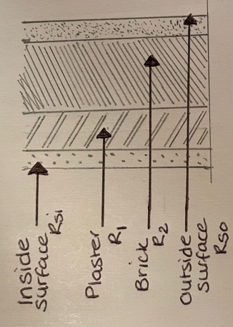

R_{T} = R_{SI} + R₁ + R₂ + R_{SO}

This can also be shown as

R_{T} =$ΣR$

Figure 3 Thermal Resistance example

Once the R_{T} is found this can then be put into the calculation to find ‘U’ value in the below formula.

$$U=\frac{1}{R_{T}}$$

Thermal Conductivity

This section is going to show thermal conductivity and discuss the different
contributing factors in material types and differences.

Thermal conductivity coefficient shown as the unit – $λ$ the measurement of the rate in which heat is conducting through materials, show as the unit – W/m K.

This rate is the measured by the thermal conductivity of heat flow across a materials thickness of 1m with a temperature different of 1 degree, Kelvin with a surface area of 1m².

An example of this is show in the figure below, which shows the heat conduction of a hot water cylinder. The hot water enters the cylinder at the bottom of the tank, this water is then contained within the tank until it is needed, as the heat rises to the top of the cylinder although it will still be hot, it will be cooler than the water which is at the bottom of the cylinder. When required the water will then exit through the top of tank and go where required such as a hot water tap or shower. To ensure the hot water stays hot within the tank the tank is also insulated with either fibre or foam around the cylinder and then also cover with an outer case.

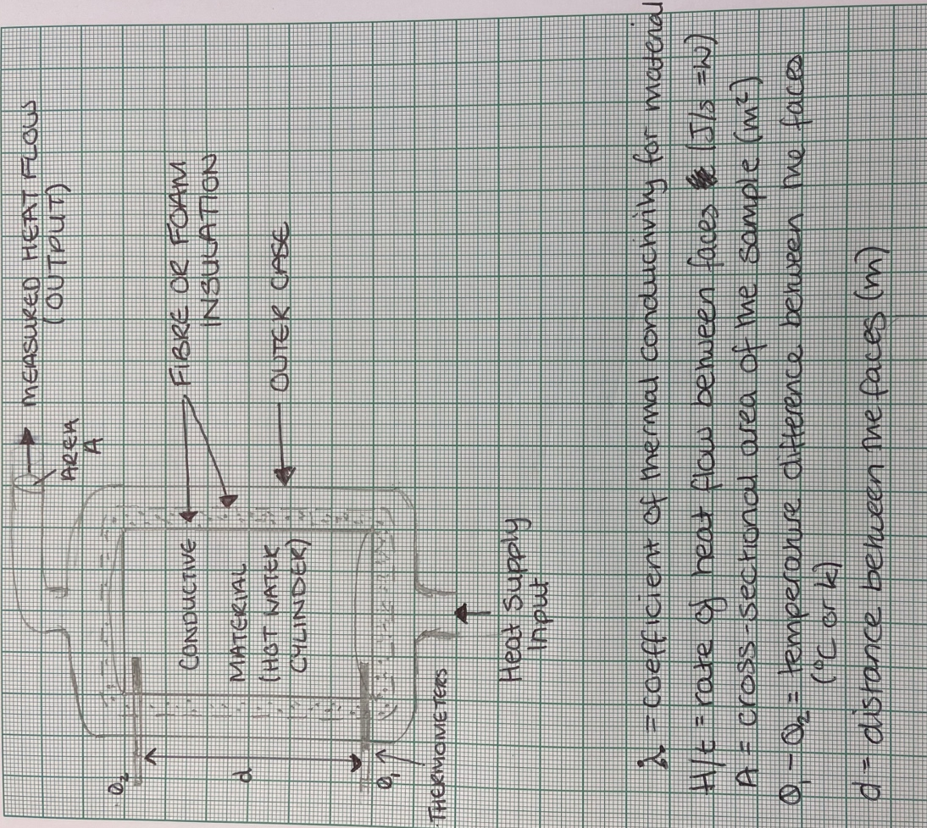
Figure 4 Diagram of heat conductivity

To then measure the difference between the top and bottom of the hot water a cylinder two thermometers will be placed and either end of the cylinder and then the reading will be taken and added into a calculation to find out the rate of the heats conductivity.

The Rate of Heat (Conductivity)

$$\frac{H}{t}=\frac{λA\left(θ_{1}-θ_{2}\right)}{d}$$

Different building materials will have a conduction rate due to insulating properties and how long it takes for the insulation to be installed. (If the insulation is exposed to outside elements this can cause a break down insulation causing to be less insulated in parts of the structure an example of this is if the materials get wet, there will be higher moisture content in the exposed part of the insulation, therefore will take longer to dry in the future.

Another factor that can change the conduction rate is different thickness and density during the manufacturing process, this can happen within different batches during the production this will affect the thermal conductivity, this is most likely to happen in materials such as concrete, stone and brickwork.

The moisture content in a building can vary over time and the position of them within the building, if the area is in a more shaded area of a building it can cause a build-up of the moisture, which is left over time can cause further problems such as damp. Whereas if it was in an area where the bricks are in the sun any moisture, will have the chance to dry in the heat.

Conclusion
When trying to work out any lighting, heating, or sound elements it is important to check the building regulations 2010 section E, resistance to the passage of sound and section C, site preparation and resistance to contaminants and moisture. This will ensure that the structure being built is meeting the building regulations as well as allowing anyone using the space to be a comfy environment, where no outside factors can affect their daily comforts of a well-lit area to work in, a well-constructed building which can have multiple sounds without interruption, along with a well heated area, which are basic humans needs.

References
McMullan, R. (2007), Environmental Science in Buildings. Sixth Edition. New York: Palgrave Macmillan.

Acoustic Products (2018). Acoustics in building – the role of the partition wall. Available at: https://www.acoustic-products.co.uk/faq/acoustics-in-buildings/ Accessed 27th Mach 2024

Nantel, A (2024) Heat and Thermal Energy. https://www.acoustic-products.co.uk/faq/acoustics-in-buildings/ (accessed 24th March 2024)

Nantel, A (2024) Principles of Sound 1 https://uowtsd.sharepoint.com/:p:/r/teams/ACBA400620232024MATERIALSandBUILDINGSERVICES_GRP/_layouts/15/Doc2.aspx?action=edit&sourcedoc=%7B9b3451d3-e409-473c-b21d-79e7930c514e%7D&wdOrigin=TEAMS-MAGLEV.teamsSdk_ns.rwc&wdExp=TEAMS-TREATMENT&wdhostclicktime=1711626239976&web=1 (accessed 25th March 2024)

Nantel, A (2024) Principles of Sound 2 https://www.acoustic-products.co.uk/faq/acoustics-in-buildings/ (accessed 25th March 2024)

Welsh Government (2010). The Building Regulations, Approved Document C, Site preparation and resistance to contaminants and moisture. https://www.acoustic-products.co.uk/faq/acoustics-in-buildings/ (accessed: 26th March 2024)

Welsh Government (2010). The Building Regulations, Approved Document E Resistance to the passage of sound. https://www.acoustic-products.co.uk/faq/acoustics-in-buildings/ (accessed: 26th March 2024)

Table of Figures
Figure 1 Utilisation Factor 3
Figure 2 Ideal lighting layout with calculations 6
Figure 3 Thermal Resistance example 9
Figure 4 Diagram of heat conductivity 10

