Destination Management: Wales

Student: Eduard Slavu
ID:2022664
Module: BMIH5006
Lecturer: Dr. Huw Thomas

Table of content

Introduction 1
Principles of sustainable tourism 1
Wales as a tourist destination 3
Traveling aspect of Welsh tourism industry 4
Butler’s life cycle model 5
Doxey’s irridex model 6
Sustainable recommendations for future development of Wales 8
Conclusion 8
References 9

Introduction
Businesses in the tourism industry that are successful understand the significance of effective destination management. If this is done, it will be possible to make more money, attract a greater number of customers, and develop a plan that is sustainable in the long run. A destination might be any part of the world: a country, a region, a province, a municipality, a district, a park, a museum, or even a neighborhood (Fyall and Garrod, 2019). The overarching process of keeping track of all the moving pieces that go into creating a certain tourist destination is referred to as "destination management." By utilizing the local businesses and the skills of the community's members, site management may help to produce experiences for tourists that are more genuine and enjoyable. Every DMS is special and distinct in its own way. It's possible that some will focus on the local services and hotel options, while others will promote the events, sights, and activities available to tourists. The "destination" region, which was selected for several different reasons, reaps the benefits of effective destination management (Van Niekerk, 2017). The unbalanced viewpoint that tourism can only have a beneficial impact on the economy is held by many individuals. However, this is just one of the many benefits that come from carefully deliberating and implementing a plan for the management of destinations.

Principles of sustainable tourism
Researchers define sustainable tourism as an approach to business, travel, and leisure that seriously examines its present and future economic, social, and environmental ramifications, serving the needs of visitors, the industry, the environment, and host communities (Ivars-Baidal et al, 2019). To put it another way, this technique makes it possible for tourists and business visitors to travel in a manner that is kind to the community while also being kind to the environment.
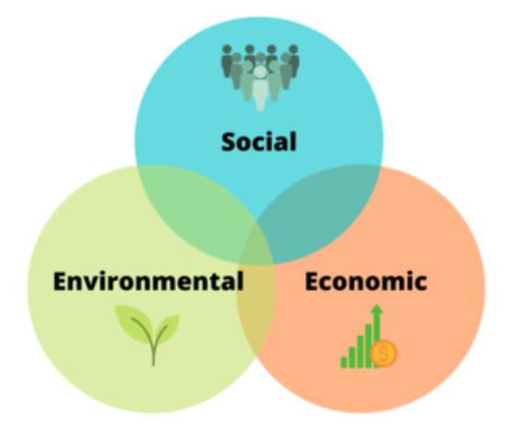
Figure 1: Pillars of sustainable tourism
Source: (Carlisle et al, 2021)
Similar to sustainable development, sustainable tourism is built around the three pillars of environmental sustainability, social sustainability, and economic sustainability.
In order to achieve social sustainability, it is necessary to pay attention to issues such as access to high-quality education, human and environmental health, the safety of resources, and environmental justice. According to the strategy known as the "three pillars," efforts to enhance social sustainability should simultaneously attempt to improve economic and environmental conditions. It is possible that an additional environmental benefit will arise from actions taken to increase social sustainability (Gössling et al, 2018). For instance, promoting diets that are healthier can be beneficial to both human and environmental health since the decisions we make about what and how much we consume have a substantial influence on both.
The formation of new jobs, a rise in corporate earnings, and the application of proper price to environmental services are all essential aspects of a functioning economy that contribute to its continued existence over the long run. According to the findings of recent studies, high employment rates are advantageous to both the economy and the social well-being of individuals due to the fact that they provide access to essential resources (Coban and Yildiz, 2019). If employment offers stability, the economic forces that push enterprises to recruit and individuals to hunt for work will also support social sustainability. If the job does not provide stability, however, those factors will not encourage social sustainability.
Concern for the well-being of the environment is central to the notion of environmental sustainability. This principle concerns not just the quality of the air and water we breathe, but also the reduction of environmental pressures such as carbon dioxide emissions. The quality of one's environment has a substantial influence on one's health (Carlisle et al, 2021). Humans gain from ecological protection and restoration.

Wales as a tourist destination
The 8.7 million people who visited different travel destinations around Wales in 2002 and the 9.39 million who visited Conwy in 2018 are evidence of Wales's growing attractiveness as a tourist destination. The tourist industry in Wales is expected to generate £4.8 billion over the next few years.
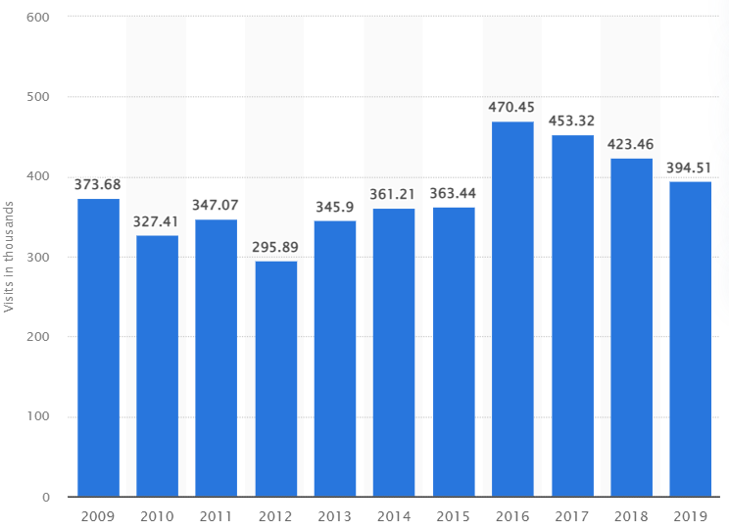
Figure 2: Number of tourists visiting Wales over the last few years
Source: (Carlisle et al, 2021)

More than eight percent of all jobs in Wales were supported by the tourism industry in 2005, and as a direct result, more than one hundred thousand people were employed in the service sector. Walking, shopping, mountain climbing, and going to museums and historical sites were the top five things that visitors to Wales did while they were there (Thomas et al, 2017). A record number of international visitors came to Wales in 2015, totalling 970,000, which generated £410 million in income for the country. Germany, the United States of America, and the Republic of Ireland were the top three countries of origin for visitors coming from outside of the country. Despite the fact that the vast majority of visitors originate from different parts of the United Kingdom, we welcome everyone (predominantly England).
In 2009, the number of people working in hotels in Cardiff climbed by 26,300 as a direct result of the 14.6 million tourists that visited the city (Gustavsson and Riley, 2018). Conwy and Cardiff came in second and third place, respectively, in terms of the amount of money spent by visitors in 2004.
The spectacular natural beauty of Wales is a major contributor to the success of the country's tourism economy. The Brecon Beacons, Snowdonia, and the Pembrokeshire Coast are the three national parks that may be found in Wales. There is a wide variety of outdoor recreation available in national parks, including but not limited to hiking, trekking, canoeing, mountain biking, kayaking, and climbing (Price, 2021). In recent years, Wales has seen an increase in the number of people participating in extreme sports.

Travelling aspect of Welsh tourism industry
Because of the deployment of a consistent branding strategy, Wales is now better known as a destination to live, work, study, invest, and travel. This is an improvement on the previous situation. It has helped to boost Wales' reputation as a place to visit for tourists. According to brand tracking conducted in the tourist business of the United Kingdom, Wales is still connected with several different sorts of vacations (Dove, 2016). The name Wales evokes visions of idyllic weekend trips in the countryside or by the water with a significant other or loved one. Recent investments in innovative product experiences and concurrent brand marketing campaigns have led to a strong connection between adventure activities and vacations in Wales.
There hasn't been a lot of research done on how people in other countries see Wales. Wales is not as well-known as other well-known areas of the UK, particularly in international markets and among those who have not recently visited the country. This is especially true among people who have not recently visited the country.
In general, local, and regional tourist destinations in Wales are less well-known than their counterparts in other regions of the United Kingdom (O’Shea et al, 2022). It is important to take into consideration the fact that travelers traveling shorter distances are more likely to have a predetermined destination in mind. The Wales Visitor Survey conducted in 2016 found that an overwhelming majority of respondents felt that Wales is an outstanding location for environmentally conscious tourism. According to the findings of the research, most tourists like having an experience that is exclusive to Wales when they are on vacation in that country.

Butler’s life cycle model
When Professor Richard W. Butler published his groundbreaking work on tourism's carrying capacity and long-term viability in 1980, the world took notice. He understood the vulnerability of tourist hotspots and the need for vigilant surveillance to prevent out-of-control crowds. The Butler Model states that there are six stages of development that a tourist attraction goes through throughout time (Butler, 2019). For the sixth stage, however, Butler provides five options, from full regeneration to full degeneration.
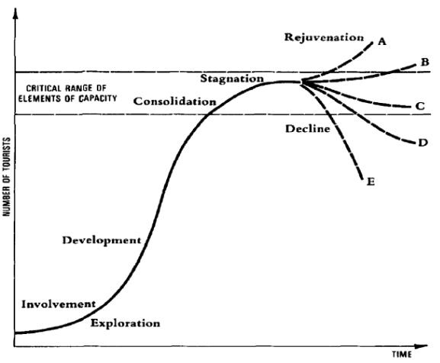
Figure 3: Butler’s life cycle model
Source: (Butler, 2019)
The tourist business in Wales offers a helpful illustration of how this concept works in reality by displaying how it is utilized in the real world. This is an extremely good example of how this notion works in practice. Wales has seen an upsurge in the number of tourists traveling to the nation as the United Kingdom has gradually begun to recover from the ravages of the virus. Following the brief period of stagnation that was caused by the epidemic, this surge is suggestive of the beginning of a phase of resurrection, which will occur after the pandemic. The aftermath of the outbreak was responsible for this halt in progress.

Doxey’s irridex model
The Irritation Index, often known as the "Irridex," was developed by Doxey in 1975 to consider the fact that locals' opinions of tourists and the growth of their destination inevitably alter over time.
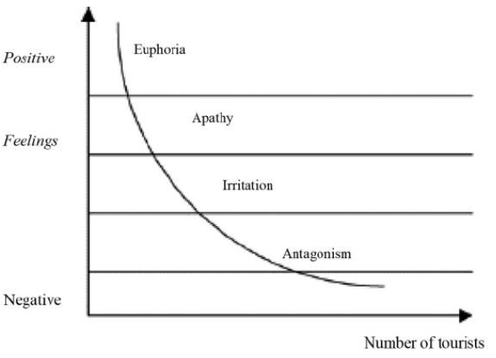
Figure 4: Doxey’s irridex “irritation” index
Source: (Butler, 2019)

Because tourism may have a range of unpleasant effects, including those on society, the economy, and the environment, it goes through a number of phases wherever it is practiced. These stages include reducing the negative effects of tourism and increasing the positive effects of tourism. According to this idea, the unfavorable impacts that one culture has had on other societies may have been a contributing factor in the development of social disputes. It consists of four phases: euphoria, apathy, irritation, and antagonism. These stages describe how natives react to visitors from outside their society (Vazquez et al, 2016). When the first visitors arrived in Wales many years ago, the natives were ecstatic about the possibility of the country's tourism business expanding. Apathy has resulted in a growth in the number of tourists as well as a more structured engagement between visitors and inhabitants, as has been the case in recent years at some of Wales' most well-known tourist locations throughout the country. This is the situation throughout the country. Due to the fact that this region is still going through the process of growth, irritation and antagonism have not yet shown themselves here.

Sustainable recommendations for future development of Wales
Wales is experiencing certain difficulties as a modern tourism destination, and these issues require immediate attention from the relevant authorities. showcasing the absolute best that Wales has to offer as a true and genuine holiday destination, with a broad array of historical, cultural, natural, and therapeutic activities and attractions. It is possible for Wales to improve its reputation by marketing itself as a trendy and up-to-date holiday destination that offers visitors a diverse selection of fascinating festivals, events, and cultural experiences (Midmore, 2018). It is important to make potential tourists aware of the numerous great things that Wales has to offer so that they may make the most of their vacation (Bell et al, 2018). Constant advertising of appealing reasons for people to visit different parts of the world. If a popular location wants to keep its reputation as an appealing option for vacationing, it is necessary for investments to be made in cutting-edge products, improvements to be made to the experience that is provided to guests, and increased brand advertising to be increased in strategic locations.

Conclusion
Planning for a significant influx of visitors requires considering both tourist preferences and zoning regulations. Investors and other capital providers gain a lot from knowledge about the sectors that are expected to expand. Wales is widely recognized for its kind people and welcoming atmosphere, but the nation needs constant investments in new infrastructure to handle the influx of tourists. Investors may broaden the selection of vacation rentals they provide since vacationers place a high importance on social interaction when selecting a destination. An opportunity for investors to build cultural tourist attractions may arise because of government attempts to encourage socio-cultural tourism. It is necessary to upgrade the public transportation, communications, and energy infrastructure as well as the tourism infrastructure in cultural and coastal areas. The entire community, not just tourists, would profit from new and better infrastructure. Government efforts to develop human capital have the potential to have multiple impacts if they are effective.

References

Bell, M., Bristow, D. and Martin, S., 2018. The future of work in wales. Public Policy Institute for Wales: Cardiff, UK.
Butler, R.W., 2019. Tourism carrying capacity research: a perspective article. Tourism Review.
Carlisle, S., Zaki, K., Ahmed, M., Dixey, L. and McLoughlin, E., 2021. The imperative to address sustainability skills gaps in tourism in Wales. Sustainability, 13(3), p.1161.
Coban, G. and Yildiz, O.S., 2019. Developing a destination management model: Case of Cappadocia. Tourism Management Perspectives, 30, pp.117-128.
Dove, J., 2016. Geographical board game: promoting tourism and travel in Georgian England and Wales. Journal of Tourism History, 8(1), pp.1-18.
Fyall, A. and Garrod, B., 2019. Destination management: a perspective article. Tourism Review.
Gössling, S., Scott, D. and Hall, C.M., 2018. Global trends in length of stay: implications for destination management and climate change. Journal of sustainable tourism, 26(12), pp.2087-2101.
Gustavsson, M. and Riley, M., 2018. Women, capitals, and fishing lives: exploring gendered dynamics in the Llŷn Peninsula small-scale fishery (Wales, UK). Maritime Studies, 17(2), pp.223-231.
Ivars-Baidal, J.A., Celdrán-Bernabeu, M.A., Mazón, J.N. and Perles-Ivars, Á.F., 2019. Smart destinations and the evolution of ICTs: a new scenario for destination management. Current Issues in Tourism, 22(13), pp.1581-1600.
Midmore, P., 2018. Rural development in Wales: looking backwards, looking forwards. Welsh Economic Review, 26, pp.21-28.
O’Shea, M., Duarte Alonso, A., Kok, S.K. and Vu, O.T.K., 2022. Entrepreneurial action and unprecedented uncertainty: The cases of New South Wales regional hospitality and tourism firms. Tourism and Hospitality Research, 22(3), pp.362-375.
Price, W.R., 2021. Mining for Tourists: An Analysis of Industrial Tourism and Government Policy in Wales. Tourism Planning & Development, 18(4), pp.435-456.
Thomas, B., Thomas, S. and Powell, L., 2017. The development of key characteristics of welsh island cultural identity and sustainable tourism in wales. Sci. Cult, 3, pp.23-39.
Van Niekerk, M., 2017. Contemporary issues in events, festivals, and destination management. International Journal of Contemporary Hospitality Management.
Vazquez, J.B.B., Puls, S.L. and Breton, M.R.L.G., 2016. Is Cancun dazed and confused with the butler’s life cycle model? Journal of Tourism and Hospitality, 5(3).

