MINAKHIL MIR
STUDENT NUMBER: 2437898
MODULE CODE: LCHS4003
MODULE TITLE: INTRODUCTION TO HEALTH AND SOCIAL CARE
TITLE: PORTFOLIO

Page 1
TASK 1: POSTER
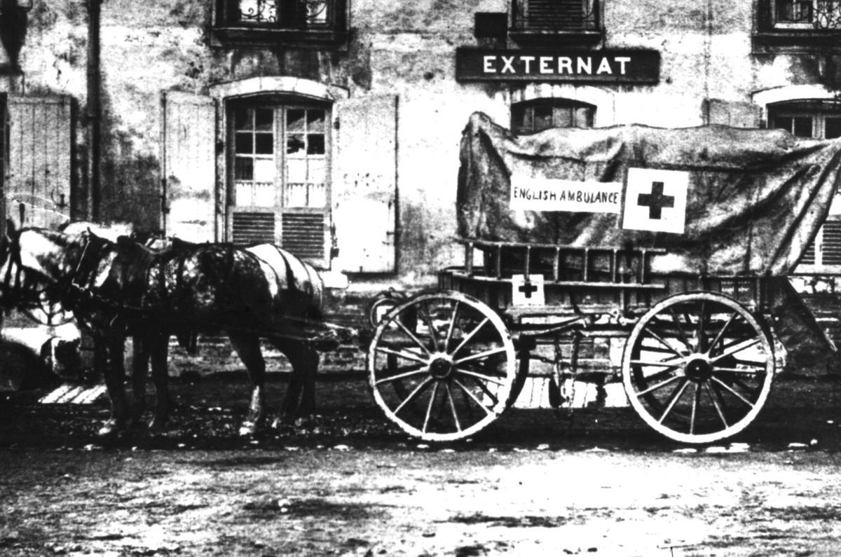

Ambulance service
Introduction
The ambulance service, which plays a significant role in the NHS requires highly skilled professionals that can perform at an excellent standard to keep the ambulance service running effectively and at the right pace. This is because being part of the ambulance service requires many responsibilities, big and small. This includes skilled dispatchers guiding service users over the phone and giving them correct instructions, the paramedics who must make it to the scene in a timely manner and run all important checks and procedures on sight and finally concluding on what the patient’s outcome or next step should be. The ambulance service must work hand in hand with the hospital to ensure any patient using this service receive the right outcome and are informed on what the next steps are. This holistic approach is what helps the ambulance service carry out their everyday tasks and duties in a proper manner. This service is used by anyone in the UK in an emergency, or life-threatening situation. (NHS England, 2023)

Current functioning
Today, the NHS operates many other systems apart of the ambulance service. This includes the NHS 111 system, which is a service used by patients in a non-emergency situation, to be able to receive advice and guidelines on their condition and even help with booking referrals to the GP Or any other required service. If 111 feel as though your condition may be worsening or life threatening, they will contact 999 for you, requesting an ambulance. (NHS England, n.d.)
To improve the ambulance services quality and standard of care, the NHS changed and introduced new aims and expectations for the service. This includes things such as:
- Safely reducing the number of patients being taken to hospital if it isn’t required
- Prioritising ambulance patients and getting them seen within 30 minutes
- Improving response times
(NHS England, n.d.)
Figure 1: Early British Red Cross horse-drawn ambulance (British Red Cross, n.d.)
History
The Ambulance service originally started when the St john ambulance service introduced the first ambulance by gathering volunteers and developing a supportive community happy to help transport patients from emergency scenes using transport such as a horse and carriage. (AmbulanceCPD, n.d.)
Later in 1948 when the NHS was created, the NHS and local authorities partnered up to help people from all walks of like to access healthcare without having to worry about the financial burden that it comes with. Later in 1973, with the NHS reorganisation act, the ambulance service was officially handed over from local authorities/councils to the NHS to take over and run the ambulance service solely under the management of the NHS to help improve the service and reduce any issues that were caused by being run my multiple systems. (AmbulanceCPD, n.d.)
Challenges faced
One challenge faced by the ambulance service would be the staff shortages. This effects the ambulance service by causing many delays and limiting the care provided by the service. This also means less calls are being answered, resulting in patients waiting longer to be accommodated to in an emergency. This can cause someone in a life threating situation to lose their life. (UK Parliament, n.d.)
Another challenge faced by the ambulance service is the lack of effort put into their other services such as the 111 service, or any other non-emergency organisations. This puts a strain on the NHS 999 service as they are answering more calls that are not an emergency or relevant to them, delaying care to patients who are in a life threating situation and need the service. This also causes the ambulance service to send out valuable paramedics and ambulances for a non-emergency situation, wasting the time of the ambulance service and taking away from patients who need it. (UK Parliament, n.d.)

Summary
In conclusion, the ambulance service has massively improved since it was first introduced. From being an organisation run by volunteers, to an essential service in the UK and NHS, the ambulance service has become a highly skilled service provider. Despite its success, the ambulance service must improve massively in certain areas such as delays, staff shortages and expand all their services to improve the ambulance service as a whole and reflect what the NHS stands for.

Page 2
Task 2:
Introduction
Before 1948 there were many families struggling to afford healthcare and treatment in Britian, this was because there was no proper healthcare system in place. Britian had a mixture of charities, local authorities and privately run places that were depended on for emergencies, diagnosis and treatment. (Nuffield Trust, n.d.)
History
The national health service that started in 1948 after the passing of The National Health Service Act in 1946, was created to make healthcare accessible to everyone for free. (UK Parliament, n.d.) It was created to reflect the post war agreement to commit to an equal society. During the second world war the government realised the huge lack of a proper healthcare system that provided the right medical services during the war and therefore pushed for change. (Gorsky, 2008)
The vision of the labour minister of health was to be able to support the citizens welfare from the moment they are born till the moment they die. This idea was supported by a report written by Sir William Beveridge, which focused on “the five giants” of want, disease, ignorance, squalor and idleness. (Beveridge, 1942; The National Archives, n.d.)
Key principles
The main priority of the NHS became to build the foundation of the NHS, this meant bringing together many organisations, healthcare workers and working together to take away the responsibility of a proper healthcare system away from charities and local authorities and bring it into one big funded and reliable organisation. This was a significant moment in the history of the NHS, it was now starting to become a more centralised system that would only evolve and improve from here on. The NHS continued to change and improve without forgetting their main principles of free access and equality.
Development
The NHS is now run through four different systems, this includes: NHS England, NHS Wales, NHS Scotland and Health and social care in Northern Ireland. All systems are run with the same goals, morals and targets. Despite being operated under one system each of the systems have their own policies and procedures based on their own individual cases and priorities. (The King’s Fund, 2020)
Page 3
The main operator of the NHS is the Department of Health and Social care which operates the main policies, procedures and finances for all departments. Under this department are many other smaller departments that work on equally as important things such as the national standards of care and budgets. (NHS England, 2022)
The NHS is one of the biggest publicly funded organisations. It is funded by tax and cover things such as, optician care, dental care and prescriptions. (The King’s Fund, 2020)
Conclusion
To conclude, the NHS was an organisation made from one of Britian’s toughest times. It was a post war declaration that became a success. Today it continues to thrive every day and continues to keep its promise for an equal and free of charge service.

Page 4

Reference list:
AmbulanceCPD (n.d.) The history of the UK paramedic. AmbulanceCPD. Available at: https://ambulancecpd.com/the-history-of-the-uk-paramedic/#:~:text=in%201973%20with%20the%20NHS, 'Extended%20trained%20ambulance%20staff'.
AmbulanceCPD (n.d.) The history of the Uk paramedic. AmbulanceCPD. Available at: https://ambulancecpd.com/the-history-of-the-uk-paramedic/#:~:text=in%201973%20with%20the%20NHS,'Extended%20trained%20ambulance%20staff'.
Beveridge, W. (1942) Social Insurance and Allied Services (The Beveridge Report). London: His Majesty’s Stationary Office.
British Red Cross (n.d.) Photograph of a horse-drawn ambulance from the Woolwich Division [image]. Available at: https://museumandarchives.redcross.org.uk/objects/27925 (Accessed: 12 October 2025)
Gorsky, M. (2008) ‘The British National Health Service 1948-2008: A Review of the Historiography’, Social History of Medicine, 21(3), pp.437-460. Available at: https://pmc.ncbi.nlm.nih.gov/articles/PMC2639094/
NHS England (n.d.) Accessing NHS 111. NHS England. Available at: https://www.england.nhs.uk/urgent-emergency-care/nhs-111/accessing-nhs-111/ (Accessed 12 October 2025)
NHS England (2023) How to organise transport to and from hospital. NHS. Available at: https://www.nhs.uk/nhs-services/hospitals/going-into-hospital/how-to-organise-transport-to-and-from-hospital/#:~:text=in%20an%20emergency,about%20when%20to%20call%20999.
Page 5
NHS England (2023) Improving ambulance services. NHS England. Available at: https://www.england.nhs.uk/urgent-emergency-care/improving-ambulance-services/ (Accessed: 12 October 2025)
NHS England (n.d.) Improving ambulance services. NHS England. Available at: https://www.england.nhs.uk/urgent-emergency-care/improving-ambulance-services/ (Accessed: 12 October 2025)
NHS England (2022) Structure of the NHS [online]. NHS England. Available at: https://www.england.nhs.uk/long-read/structure-of-the-nhs/
Nuffield Trust (n.d.) Health care before the NHS. Nuffield Trust. Available at: https://www.nuffieldtrust.org.uk/chapter/inheritance (Accessed: 12 October 2025)
The King’s Fund (2020) How is the NHS structured? [online]. The King’s Fund. Available at: https://www.lingsfund.org.uk/insight-and-analysis/animations/how-nhs-structured
The King’s Fund (2020) How is the NHS structured? [online]. The King’s Fund. Available at: https://www.kingsfund.org.uk/insight-and-analysis/animations/how-nhs-structured (Accessed: 12 October 2025)
The National Archives (n.d.) The Beveridge Report [online]. The National Archives. Available at: https://www.nationalarchives.gov.uk/education/resources/attlees-britian/Beveridge-report/
UK Parliament (n.d.) Access to emergency services – Ambulance Service [written evidence]. UK Parliament. Available at: https://committees.parliament.uk/writtenevidence/112259/pdf/#:~:text=situation-%E2%80%A2,until%20they%20come%20across%20them.
UK Parliament (n.d.) Access to emergency services – Ambulance Service [written evidence]. UK Parliament. Available at: https://committees.parliament.uk/writtenevidence/112259/pdf/#:~:text=situation-%E2%80%A2,until%20they%20come%20across%20them.
UK Parliament (n.d.) 1946 National Health Service Act. UK Parliament. Available at: https://www.parliament.uk/about/living-heritage/trasformingsociety/livinglearning/coll-9-health1/health-01/#:~:text=The%20National%20Health%20Service%20Act,maternity%20clinics%20and%20community%20nurses (Accessed: 12 October 2025)
Page 6
Page 6

