(Wrath)
(DELETE GUIDANCE TEXT IN BRACKETS WHEN COMPLETING YOUR GDD)

INTENDED PLATFORMS | (Platforms you can realistically develop for. We have no PS5 Dev Kits, nor can you develop for the Atari 2600. This will determine what control systems you have to design later in the document.)  I want develop the game in x-box and pc.

TARGET AGE / DEMOGRAPHIC OF PLAYERS
(Demographic is not just an age! It is interests, lifestyles and personality. Who is your ideal customer? Who is this game experience going to appeal to most?)
The ideal customer will be for someone who is interested in violence and also interested make the hard choices in any situation. The player has the power to choose whether one should live or die and live with consequences for those action.

INTENDED PEGI / ESRB RATING
(Look up ESRB and PEGI sites online – they contain the official listings on their age ratings and what content dictated the awarded rating.)
For the Esrb the ratings:


For the PEGI-ratings-


CONTRIBUTING TEAM MEMBER: | (YOUR NAME HERE)

SECTION 2: GAME OUTLINE

GAME STORY SUMMARY
(Flesh out the game’s story using the one-sheet’s story outline as a starting point. This should be no more than a few paragraphs – Keep this fairly brief!)

The story is about a guy named Allen Smith who is an alien who landed on Earth when he was an infant. He was raised by a rich people who runs a drug cartel and part of a crime syndicate. Allen used is powers for hurt people and force people into giving money to him and his family. He had encounters with the heroes and supervillains in his life.

He left the life of crime when he has a family of his own. But Allen was forced to come back when his daughter got kidnapped by the heroes to catch the bad guys whom he was tied to in his life of crime, in order scare the villains. But the villains found out the that the heroes were using his daughter as key to snitch on them, so every crime syndicate in the country is try and kill him.

For Allen, he has to join his crime syndicate family. He and his crime family team up, he’ll fight the heroes to save his daughter and his crime family fight other crime syndicate family behind the scenes. There will be times where Allen and his family fight both teams together.

GAME FLOW
(Briefly describe the flow of the game’s action.)
(Example: ‘Tomb Raider: Legend’
“A third-person action adventure that finds archaeologist Lara Croft searching the jungles of Bolivia to the mountains of Tibet for the mysterious Ghalali key; an artifact which may be the key to finding Lara’s own long-lost mother.”)

The game is a third person action, thriller, crime of Allen Davies rescuing his daughter from the heroes and protecting himself from supervillains by travelling across continents making allies along the way to help him all the required equipment to from saving his family.

CONTRIBUTING TEAM MEMBER: | (YOUR NAME HERE)

SECTION 3: MAIN CHARACTER(S)
& PLAYER CONTROLS

CHARACTER APPEARANCE
(Include concept art and/or reference images sourced from online / books / movies / games / etc. here to help give an idea what your character might look like)

(repeat this for any central characters, NPCs or antagonists core to your game experience)

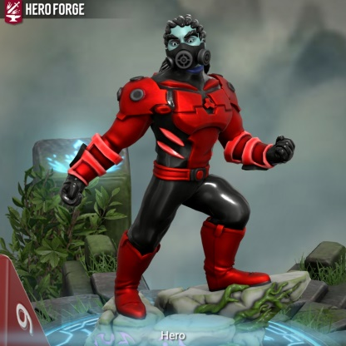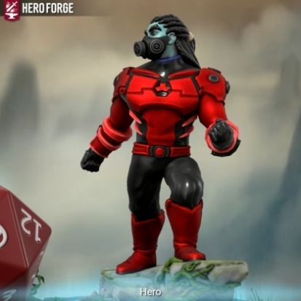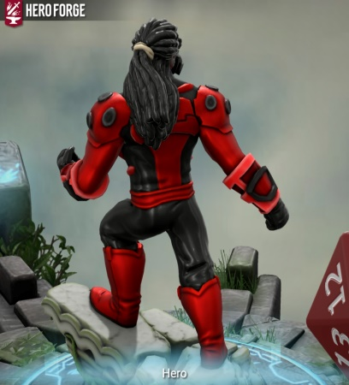

CHARACTER DOSSIER / DETAILS (Add/adjust categories as appropriate)
NAME: | Allen Davies/ Destroyer
GENDER: | Male
SPECIES: | Martian
AGE: | 30 (human years) / 78 (Martian years)
FACTION: | Criminal /anti-hero
KNOWN ASSOCIATES: | Crime syndicate
(Extra categories)
(Extra categories)

CHARACTER’S BACKSTORY
(What is the character’s backstory? How did they end up here? What is their personality type? How does this information relate to the gameplay? Does the character have any signature moves, abilities, weapons or attacks?)

(Make sure you mention every style of play in the game.)

Allen Davies is a Martian who was sent to Earth by his parents due to a civil war on his planet. He landed on earth to a rich crime syndicate family as a baby. He was raised by them and was taught how to get away with crime. The character personality is that he is feared and scary. But he will show mercy when it is required. He got several superpowers such as superspeed and strength, he telepathic and a shapeshifter which includes mimicking other superpowered beings to his advantage. His attacks is mainly planned before and also have contingency plans if anything goes wrong.
The way this relates to the gameplay is that someone past can catch up to them when they have a family of their own which is a risk

CHARACTER CONTROLS / PLAYER CONTROLS
(Scott Rogers suggests providing a basic map of the character controls. Use images of the controller/input devices for every platform you are proposing your game for and clearly label where the controls are and what each button is going to do.)

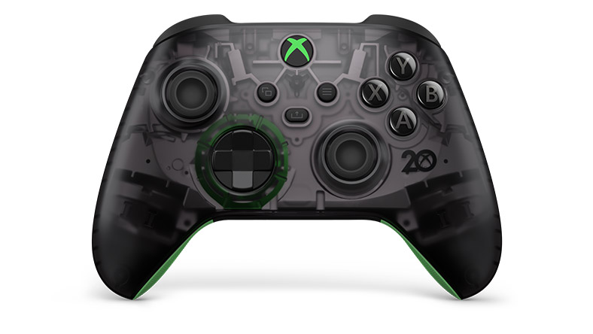

…





CONTRIBUTING TEAM MEMBER: | (YOUR NAME HERE)

SECTION 4: GAMEPLAY

SEQUENCE OF PLAY
(Detail how the sequence of play is presented here.

- Are there multiple story chapters or is the game divided up into levels or rounds?
- Are there any big set pieces? These will get a reader interested in the game.)

The beginning of the game the player see the main character is spending time with his daughter during dusk. He and his daughter gets attacked in a alley way by a unknown figure. He then plans and go into a rage to find his daughter and take revenge on person or the group who took his daughter.
The sequence of play does consist of different levels and there will be good amount set pieces at finish of each level.

UNIQUE SELLING POINTS (USPs)
(Provide detail of your game’s Unique Selling Points [USPs] here.

Additionally, include any minigames featured within the game, with supporting descriptions and illustrations.)

The main USP of this game is that there is no game where the villain turns out hero but was shocked when people who suppose to protect turn evil. This game will bring people who loves to play as a anti-hero who loves to go against people who is powerful.

PLATFORM-SPECIFIC FEATURES
(List and describe platform-specific features here.

Example: If the game makes the use of memory cards, motion controllers, touchscreens, etc.)

For this game, there will not be any platform specific features.

CONTRIBUTING TEAM MEMBER: | (YOUR NAME HERE)

SECTION 5: GAME WORLD

GAME WORLD
(Present images and descriptions of the game world here, with short descriptions that outline what the player will find in the environments they are placed in. How do these locations fit into the story?)
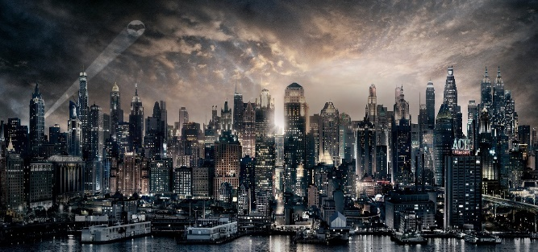

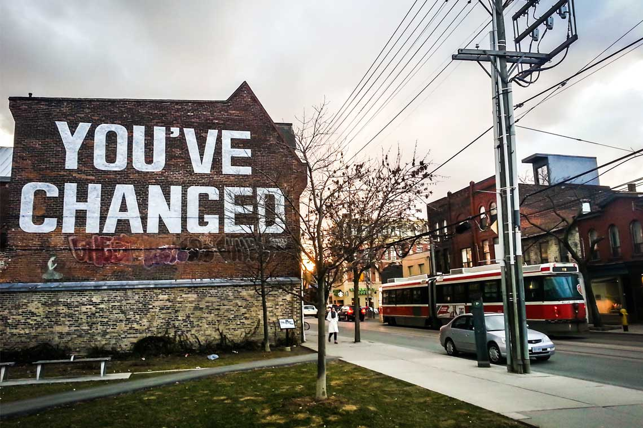
The player will definitely goes through major populated cities like New York city, Toronto, Chicago but also go through poor communities as well. They will definitely will go through forests due to having safe houses.

LOCATION DETAILS
NAME: | North America
WHAT DOES IT LOOK LIKE? | The cities have tall buildings but also dark theme but the player can also see some buildings are renovating due to the constant fight between heroes and villains. There are poor sub-urbans towns of the cities. There are safe houses in the forest.
WHAT MOOD IS BEING INVOKED IN THIS LOCATION? | The environment is gritty, dark, unpleasant in some areas of the cities and the sub urban areas. Bit mildly warm in the forest
WHAT KIND OF MUSIC WILL BE USED FOR THIS LOCATION? | Dark, bass music, it will also have fast paced to tell the player that there is danger around or something suspicious going around him. There will be slow music when player feels powerless.
HOW ARE THE LOCATIONS CONNECTED IN THE GAME WORLD? | (example: via central hub, linear progression, open world, unlocked by quests, etc.)  Its an open world where the player travel around. The games locations are connected, it will also show some linear progression but can come back to previous level if it is required.

(NOTE: Copy-paste the table in this section as necessary for each location you wish to feature.)

GAME FLOW
(Scott Rogers suggests that a simple map or flow chart diagram should be provided to indicate how the player will navigate the game world.)

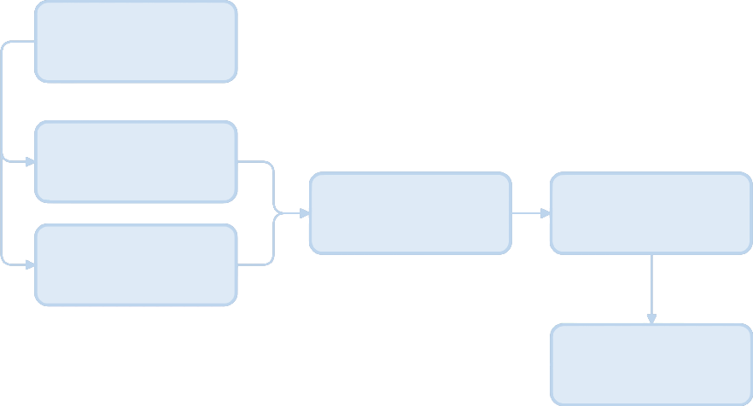

CONTRIBUTING TEAM MEMBER: | (YOUR NAME HERE)

SECTION 6: GAME EXPERIENCE

GAME EXPERIENCE
(What is the overall theme of the game – e.g. humourous, horrific, thrilling, hardcore, sexy?)

Overall theme is dark, hardcore, gruesome mainly with details of characters dying. There is no mercy for the weak.

HOW IS THIS FEELING GOING TO BE PRESENTED TO THE PLAYER?
Well the character already has dark force energy but he does show people mercy when they help him. But when his daughter gets kidnapped he has no mercy. The game almost 3d realistic feel for the player.

ARE THERE ANY SPECIAL MODES OR INTERFACES FOR GAMEPLAY?
There will be a interface for the players health, score and what weapons or powers they are currently using. The game also utilise boss fights in the game.

WHAT DOES THE PLAYER FIRST SEE WHEN THEY START THE GAME?
(Rough sketches / images can be used here to help convey this.)

The first thing that player will see when they start to play the game will be main character’s daughter getting kidnapped by a flying stranger in the dark alley way.

WHAT EMOTIONS ARE MEANT TO BE INVOKED BY THE GAME?
(How do you want your audience to feel when playing certain sections of your game? Consider your genre and theme here.)

I want the audience to feel hyped in certain section and also feel the little bit scared about the character that they are playing. I want them to feel that they can do anything with this character and nothing is holding them back.

HOW ARE MUSIC AND SOUND GOING TO BE USED?
(Think of how audio effects can help invoke a mood. Do you want players to feel a rush of adrenaline, a feeling of dread, to feel heroic, romantic, etc? You could provide example links of audio here to help your team understand your intentions for sound design.)

The music varies depending on the mood of the character and the scenario. I want the players to feel a rush of adrenaline, rage/rampage. It also change depending on the level.

HOW DOES THE PLAYER NAVIGATE THE SHELL MENUS/ SCREENS OF THE GAME?
(You could provide a flow chart diagram of the Shell Menues/Screens here.

Shell menus are any aspects of the game such as title screens, options, character/vehicle selects and any other interactive part of the game that does not directly have an immediate effect on gameplay.)

Start game

title

difficulty

Options

Sound/volume

Exit game

CONTRIBUTING TEAM MEMBER: | (YOUR NAME HERE)

SECTION 7: GAMEPLAY MECHANICS

GAMEPLAY MECHANICS
(List examples of mechanics, hazards, power-ups and collectibles here. More details can be provided in the tables below.)

MECHANIC: Something the player interacts with to create or aid gameplay e.g. moving platforms, opening doors, slippery ice.

HAZARD: A mechanic that can harm or kill a player but doesn’t possess intelligence e.g. spike pits, swinging blades, jets of fire. Describe SOME – not every one!

POWER-UP: e.g. Ammo, extra lives, invulnerability, etc. Provide examples of power-ups and what they do.

MECHANIC DETAILS
NAME: | spaceship
WHAT DOES IT LOOK LIKE? | It’s a cross between a jet and a rocket
EFFECT ON PLAYER: | Helps the player to travel
WHEN WILL IT FEATURE IN THE GAME? | Pretty much in every level

HAZARD DETAILS
NAME: | Nuclear bomb
WHAT DOES IT LOOK LIKE? | It looks like a space shuttle.
EFFECT ON PLAYER: | It will slow down the player but if too many are used it can kill the player
WHEN WILL IT FEATURE IN THE GAME? | This will feature towards the final levels of the game
HAZARD DETAILS
NAME: | fire
WHAT DOES IT LOOK LIKE? | fire
EFFECT ON PLAYER: | It will slowly kill them unless it put down
WHEN WILL IT FEATURE IN THE GAME? | This will feature from the second level

POWER-UP DETAILS
NAME: | Time arm gauntlet
WHAT DOES IT LOOK LIKE? | looks like robotic clothing with a watch
EFFECT ON PLAYER: | It help the player to makes thing go slower or faster.
WHEN WILL IT FEATURE IN THE GAME? | It will feature in the 3rd level.

COLLECTIBLE ITEMS
(List items that are collected by players that don’t have immediate effects on gameplay e.g. coins, puzzle pieces, trophies etc.)

- What does the player collect and what are the benefits of collecting them?
- Can they be used to buy items/new abilities/unlock material in the game?
- Will they earn the player achievements?

COLLECTIBLE DETAILS
NAME: | Battle armour
WHAT DOES IT LOOK LIKE? | It looks military outfit
BENEFIT FOR PLAYER: | Protect them from attacks
WHEN WILL IT FEATURE IN THE GAME? | Each part will be featured in 5 levels
CAN IT BE USED AS CURRENCY? | Yeah it can be traded for a better equipment
WILL IT EARN PLAYERS AN ACHIEVEMENT? | Yes it makes easier to take some villains and heroes

(NOTE: Copy-paste the tables in this section as necessary for each gameplay mechanic you wish to feature.)

GAME ECONOMY
(If the game has an economy system, briefly discuss this - as well as how players collect money and buy things in-game.)

(Finally, if an economy is required in game, describe the shopping environment the player will used in order to spend their currency, and on what items.)

There is an economy system. They will earn the money by destroying the enemy, they can have more range of weapons if required. If the weapons reached it maxed out the player can customize their guns, for them to do that they have pay for it.

CONTRIBUTING TEAM MEMBER: | (YOUR NAME HERE)

SECTION 8: ENEMIES

LIST OF ENEMIES
(Provide an overview of in-game enemies here. Further details of each can be provided by using the table below.)

Over-Lord
Henchmen
Mutates

ENEMY DETAILS
NAME: | Hench men
WHAT DOES IT LOOK LIKE? | humans
ATTACKS: | Strength, guns, speed
WHEN WILL IT FEATURE IN THE GAME? | Every level
HOW DOES THE PLAYER DEFEAT IT? | using different combo attacks and a final bow to the head
WHAT DOES THE PLAYER EARN FOR DEFEATING THEM? | It helps them get closer to the leader of the villains
ENEMY DETAILS
NAME: | mutates
WHAT DOES IT LOOK LIKE? | Evolved Humans
ATTACKS: | Usual powers are speed, strength but can change
WHEN WILL IT FEATURE IN THE GAME? | Every level
HOW DOES THE PLAYER DEFEAT IT? | The player can defeat the them by upgrading their weapons throughput the level
WHAT DOES THE PLAYER EARN FOR DEFEATING THEM? | It helps them get closer to the leader of the villains

LIST OF BOSS CHARACTERS
(provide an overview of more powerful end-of-level/mission/quest enemies here. Further details of each can be provided by using the table below.)

Overlord-villain

Superior ( will be in the sequel)

BOSS CHARACTER DETAILS
NAME: | Overlord
WHAT DOES IT LOOK LIKE? | Smart, wears a suit and tie
ATTACKS: | Strength, smart, sly, hand to hand combo, fast, firepower, body armour attacks
WHEN WILL IT FEATURE IN THE GAME? | They will appear at the level before the final when the players fight against the heroes
HOW DOES THE PLAYER DEFEAT IT? | They player must slow down the boss and destroy the enemy’s suit. The player must shoot or beat the villain by hurting their heart.
WHAT DOES THE PLAYER EARN FOR DEFEATING THEM? | Taking over the enemy is army to fight against the heroes who took his daughter.

(NOTE: Copy-paste the tables in this section as necessary for each enemy / boss you wish to feature.)

CONTRIBUTING TEAM MEMBER: | (YOUR NAME HERE)

SECTION 9: CUTSCENES

CUTSCENES
(If the game has cutscenes or movies, they should be documented here.)

(Include rough storyboards - to help instruct your art team - for at least one essential cutscene, such as the introduction of the player to their world, a meeting with the antagonist, etc.)

CUTSCENE DETAILS (use this table for each unique cutscene you include)
VISUAL STYLE: | (examples: 2D pre-rendered cutscene, live action, etc.)  Introduction it will be a 3d
BRIEF DESCRIPTION OF SCENE: | Player’s character short backstory e.g birth, crime and daughter getting kidnapped.
WHEN WILL IT FEATURE IN THE GAME? | I will appear in the beginning.
PURPOSE: | (examples: is this scene included to introduce a new character, ability, plot point, etc.)  Just the character, his daughter,villains, heroes and family

CUTSCENE DETAILS (use this table for each unique cutscene you include)
VISUAL STYLE: | (examples: 2D pre-rendered cutscene, live action, etc.)  This happens halfway through the game. The player finds out who took his daughter
BRIEF DESCRIPTION OF SCENE: | The player is fighting the villains but finds out who actually who took his daughter by getting it out from the villains
WHEN WILL IT FEATURE IN THE GAME? | It will appear halfway through the game.
PURPOSE: | (examples: is this scene included to introduce a new character, ability, plot point, etc.)  Just the character, his daughter,villains, heroes and family

(NOTE: Copy-paste the tables in this section as necessary for each cutscene you wish to feature.)

CONTRIBUTING TEAM MEMBER: | (YOUR NAME HERE)

SECTION 10: BONUS MATERIALS

BONUS MATERIALS
(Any bonus materials or unlockables that encourage the player to replay the game are mentioned here. Give examples of things players will be able to unlock if your design includes it.)

(Multiplayer modes, downloadable content, episodic content, etc. would feature on this page.)

There is multiplayer modes where they can chose a side character to help the main character throughout the levels. they can get free health by watching ads. The player can change the skin colour of the character’s in their human form. They can change the colour outfits as well in their Martian form.

REPLAY VALUE
(What incentives are there for players to replay the game?)

There are alternate endings to the game where the main character finds out who kidnapped his daughter from reliable source or the getting killed at the end by the unknown person.

CONTRIBUTING TEAM MEMBER: | (YOUR NAME HERE)

