MANAGING ENTERPRISE IN THE 21ST CENTURY
Assessment 2
Student Name - Sadiya Afrin Tarin
Student ID – 1714273
Module Code – BMSK4006
Module Lecturer – Ze Zook


Contents
Introduction 3
Summary of the Business Plan Presentation That We Have Undertaken 3
Learning Journey Arising from the Business Plan 3
Development of Personal Skill Set for Self-employment 4
Skill Gap and Personal Development Plan 7
Reference 10
Conclusion 11

Introduction
I and my group members have successfully completed the group business plan presentation on “Mother Nature Foods”. This assignment has been done to evaluate and reflect on the experience, learning and skills that I have developed by being an active part of the group presentation that has been completed by me and my group members. This assignment also covers my skill gaps and also the personal development plan that I have thought of to complete a similar task in the future with more preciseness.

Summary of the Business Plan Presentation That We Have Undertaken
We have proposed a business named “Mother Nature Foods". The theme of this business started with our gardening hobby and the aim of the business is to supply farm fresh vegetables in the superstores like Waitrose. Our business will be formed based on a partnership deal and well planned to complete all the registrations requirements and attain d-organic food certification. We didn't plan to attain profit in the first year of operation as we have planned to grab the customers first. We three partners will perform the operational and management responsibilities initially. Initially, we will establish four greenhouses and we will directly reach our customers. For marketing purpose, we will set our stalls in fairs and exhibitions initially. For our operation, we will need 1 tractor, 4 automatic seeding machines, 1 soil testing kit and 1 foam disinfector. Our cash flow forecast statement shows that by the year end we will be able to make a profit of net profit of $£$205850 and our main strong points are that we will be able to produce organic foods in all the time of the year and serve them at the reasonable price.

Learning Journey Arising from the Business Plan
The participation in the business plan presentation has helped to improve my learning horizon significantly. This is the first time I have participated in a business plan project and so it was a great opportunity for me to gain details idea regarding the ins and outs of the business plan preparation and presentation. The best part of this group presentation was that I have been delighted with two other amazing group members who have helped me and guided me very efficiently throughout the group presentation process. The first learning that I had received from the group presentation is the way to identify the business opportunity. I have learnt how to develop a thought process to generate a business idea. I have also learnt how the business idea can be organized as the plan by this group presentation.
The next thing that I have learnt that I got the full exposure of the elements of both the internal and external environment of the business. I got to know about the elements of external environment such as political, economic, social, technological and legal issues and have also learnt how the elements of these can create an impact on the business performance (Adair, and Allen, 2016). I have also learnt how internal factors also affect the business operation. I have got to know about the legal requirements that are required to be filled up for a new business. I have also gained details ideas regarding how to meet those effectively. I have also learnt regarding the implications of forming a partnership business organisation and also have learnt how a partnership business is organized and operated. I have also gained the details ideas regarding the marketing of a newly formed business. I have generated deep knowledge regarding the different tools that are applied for the new business marketing and also how they create implications on the business performance. I have also come to know the tools that best suit the new business context and also how they can be effectively applied in the business environment (Barcham, 2011).
My knowledge regarding the financial management of the new business has increased significantly by participating in this group presentation task. I have gained ideas on how to make an effective operational plan for the new business to organize the business smoothly and give it a real shape. My knowledge regarding the financial statement preparation was very much limited. Participation in this group presentation task has helped me significantly in overcoming my financial knowledge limitation to a great extent. I have generated details knowledge regarding the preparation of the pro-forma cash flow statement. I have also come to know how to project the income and expenditure for a new business. I have come to know how to speculate profit for new business as well. this has helped me to enhance my thinking horizon and analytical capability (Beausaert, et al, 2011). In summary the most important learning that I have received by participating in this group assignment is that I had the opportunity to apply my theoretical knowledge in the practical aspects and learning from this task has helped me increase my knowledge depth and enhance both personal and professional skills that I believe will help me in a long way.

Development of Personal Skill Set for Self-employment
There are different skills that I have mastered from this group business plan presentation session. I have been an active part of the presentation preparation. My main task in the proposed business was to act as an administrative officer. This presentation has helped me to identify some of the weaknesses that I have also has helped me to identify my strong zones as well. this presentation has helped me immensely in developing some of the core skills and also rectify the weaknesses that I had in some of the core skill areas. The skills and experiences that I have received from this group presentation session can be highlighted by the Kolb’s reflection model:
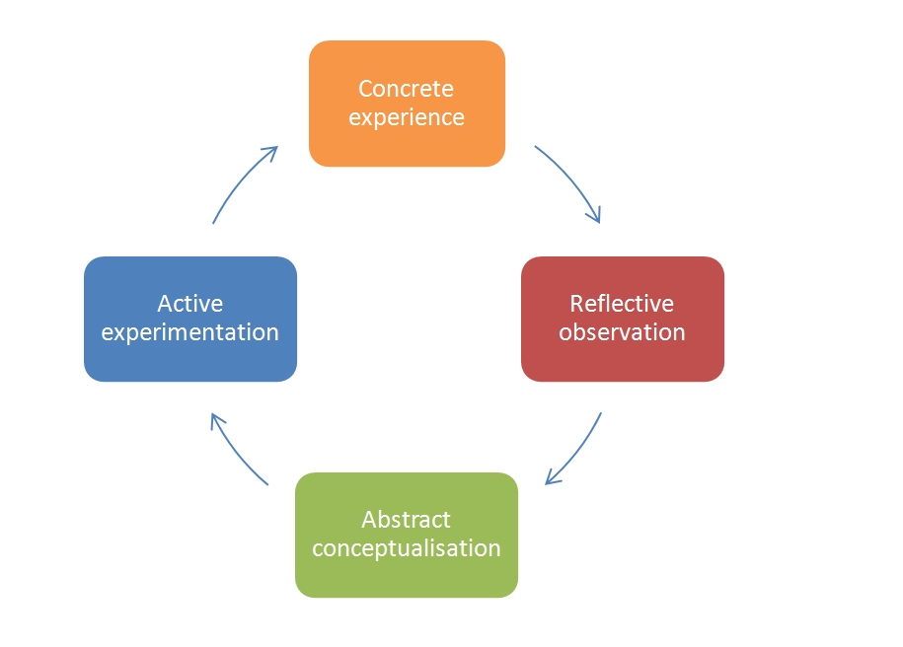
Figure 1: Kolb's reflection model
Source: (Ellwood, 2015).
Kolb’s reflection model is a complete model by which the self-evaluation can be done efficiently based on experience, conceptualization, observation and also based on the active participation in a project (George, et al, 2017). At first, this group presentation has helped me to develop my competency in communicating with the people. I am an introvert in nature hence it was not easy for me to communicate with strangers. Communication skill is one of the most important business skill that I have improved from this module. I had been allocated with two group members with whom I had no previous connection. Participation in this module has influenced me to make and maintain an effective connection with them and communicate them frequently. These have helped me turn around the ices that I had regarding my communication difficulties. This group presentation has helped me immensely to overcome my team performing the skill at the same. I was not a good team player but this group presentation has helped me to become an efficient team player. My team performing the role in this task can be illustrated with the help of the Belbin's team role model:
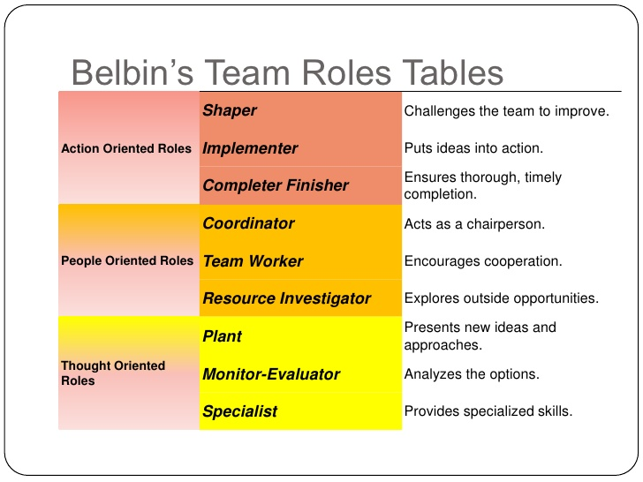
Figure 2: Belbin's team role model
Source: (Grainger, 2014).
We have divided our group tasks according to the Belbin's team role model theory. We three group members have divided and allocated our tasks according to the action-oriented, people oriented and thought oriented roles. As I was good at thinking and organizing skills my group members have allocated the thought oriented roles such as organizing ideas and presenting them effectively on the slides on me. My other two group mates have performed the action-oriented and people-oriented roles that are needed to be played for this group presentation effectively. Application of the Belbin's team role model has helped me understand the team dynamics precisely and also finding out the ways to perform meeting the team member's expectation at the same time (Horton, and Horton, 2017).
The next important skill that this group presentation has helped me to develop is the development of business management skills. By preparing the operational plan and also resource planning for the newly proposed business I have learnt how to organize things to reach the desired results level. I have come to know how to align things effectively and give shape for real-world exposure. My organisation skill has developed this. My ability to think and also my analytical ability both got significantly improved by the participation of the group presentation process. I have learnt to think differently because throughout the business presentation preparation I needed to think differently to establish the business idea. My mathematical ability also got significantly increased by participating in this group presentation session because I had to prepare cash flow statement for which I had to assume different mathematical assumptions and also at the same time I had to apply them effectively as well in the business process as well. My calculation and mathematical accuracy capacity got increased thus.
This group presentation has helped me to develop my influencing and leadership skill as well because as a part of the thought oriented role I had to guide my group members in some ways regarding the presentation of ideas and also regarding the techniques that are required to be applied for completing the group task. This group presentation has helped me develop my marketing capacity and knowledge as I had to prepare a marketing plan for the newly proposed business (Kneale, 2013). While preparing the marketing plan I had to attain details knowledge regarding different tools and techniques that are used in the marketing and how they can be applied in the real world to present the new business in a differentiated manner at the same time.
My time management skills have also got improved while this business plan presentation preparation. We had been allocated a specific time for completing the group presentation. I and my group members have prepared a structured schedule breaking down the details tasks that are required to be completed while completing the group presentation. We needed to be exactly in the schedule to complete the group present in an effective way. My speaking power and also the presentation skill have also received a significant boost while completing this group presentation task as we had to present the full business plan in front of the audiences effectively. Thus, my presentation skills got furnished.

Skill Gap and Personal Development Plan
Participation in the business plan group presentation task has helped me to identify my weaknesses in some of the skill areas that are important for my future professional career and also important for me to undertake a similar task in the future. I noticed I have some weakness regarding the people management as I had arguments with my group members regarding some issues. I had problems in using IT tools such as Microsoft Excel and Microsoft PowerPoint to complete the preparation of the presentation. I still feel that my analytical skills should go up for me to perform as an employee in the future. I think these three skills need further development. To improve these three employability skills, I have thought of preparing a personal development plan which can be viewed as follows:
Skill Areas | Duration | Start Date | End Date | Recommended courses of actions
People management skills | 6 months | 25/12/2018 | 25/05/2019 | Participating in the volunteering task and also joining training and development courses on people’s management.
IT Skills | 6 months | 25/12/2018 | 25/05/2019 | Joining a professional training course on Microsoft Office program, practising and watching video tutorials.
Analytical Skills | 6 months | 25/12/2018 | 25/05/2019 | Solving a lot of demo cases and also reading different books and enhancing the knowledge base.
Team Performance Skills | 6 months | 25/12/2018 | 25/05/2019 | Being active and open to team tasks and also undertaking different voluntary team tasks.

Conclusion
For me, it is important to capitalize on the learning and the skills that I have developed by joining this group presentation task. I think the knowledge regarding the business environment and operation and the skills related to communication, IT, analytical thinking capacity and also the financial knowledge that I have gained will help me immensely to fulfil my dream to work as a successful business manager in the future. I firmly believe that the improvement plans that I have suggested will help me overcome the current weaknesses that I have and will help me immensely to perform to the expected level in the next future tasks precisely.

Reference
Adair, J. and Allen, M. (2016). The concise time management and personal development. London: Thorogood.
Barcham, L. (2011). Personal development for learning disability workers. Exeter: Learning Matters.
Beausaert, S., Segers, M. and Gijselaers, W. (2011). The Personal Development Plan Practice Questionnaire: the development and validation of an instrument to assess the employee's perception of personal development plan practice. International Journal of Training and Development, 15(4), pp.249-270.
Ellwood, F. (2015). Understanding the importance of a personal development plan. Dental Nursing, 7(3), pp.160-163.
George, B., McLean, A. and Craig, N. (2017). Finding your true north. San Francisco, CA: Jossey-Bass.
Grainger, A. (2014). Your personal development plan. Br J Healthcare Assistants, 8(1), pp.6-6.
Grit, R., Guit, R. and Sijde, N. (2008). Managing your competencies. Groningen [etc.]: Wolters-Noordhoff.
Horton, J. and Horton, L. (2017). In hope of liberty. New York: Oxford University Press.
Ireland, B., Cure, R. and Hopkins, L. (2009). Perfecting your personal development plan. Vital, 6(2), pp.40-41.
Kneale, P. (2013). Personal Development Planning (PDP) really happens at work. A planet, (18), pp.33-35.

