Michael Leather
2218482
Objective
Having raised the question “is not can they reason, nor can they talk, but can they suffer?” (Bentham). We are asked to look at this statement in relation to Animal rights using the Extract from Peter Singers publication All Animals are Equal.
What is an animal?
The first thing we need to establish is what is an animal? Clive Wynne alludes to an animal liberation activist Barry Horne who, in 1994, set off 4 bombs on the Isle of Wight in various premises that had connections with the exploitation of animals in Industry. The Author goes on to question why Horne chose commercial premises rather than the farmers who do a lot more to harm to animals on a regular basis.
James Serpell argues that we treat our domestic pets, who have no economic contribution to make and are treated like members of our family and humans display outrage when others subject them to ill treatment yet farmed pigs are reared to produce food, expensive leather goods and even ersatz ice-cream and in return for this outstanding contribution to society we treat them like worthless objects devoid of feelings and sensations.
Further to the above reflection, The North American Press Office of the Animal Liberation Front report lists the direct action of persons involved in the liberation of such animals and in the 2001 edition, dedicated to Barry Horne, reported the 5000 animals were saved in such actions that year…..but not one was a pig!! Why? Has the focus on animal rights and equality come to accept the practices of farmers in rearing animals for consumption as accepted practice. (See figs 1 & 2.). The problems that are faced in putting an end to the intensive farming practices are issues like farm subsidies which encourage production, weather extremes and corporation profits.
Singer starts his arguments by referring back to a 19th Century publication for vindication of the rights of women which was satirically responded to by a Thomas Taylor with a publication called The Vindication for the Rights of Brutes, stating that if rights for women was sound then why not dogs? The obvious differences between man and woman, and even dogs eventually come to the conclusion that it is not equality for all but the equal consideration which does not need identical treatment.
I think we have made the distinction as to what is an animal much harder for ourselves to draw that line as we have over recent times there has been a tendency towards anthropomorphism where we have humanised animals into a reflective understanding that they are like us. The use of this anthropomorphism has, in my opinion exacerbated the question of where we as humans draw the line of what is an animal because of the sub-conscious bias we have towards the images that are projected. Let me draw your attention to all the children’s books and television programmes that spew the moral issues through talking animals and thereby “humanising” them.
The debate on animal rights and equality has been further explored as this phenomenon of anthropomorphism, as it now, asks questions like should animals be treated as moral persons with the same rights as those afforded to Homo sapiens. If this is the case, then those rights, if applied, would imply that humans ought to move over to vegetarianism and cease to wear animal skin of any sort and stop any experimentation that does not serve any non-human species interests. And if we move over to a total meat free diet based on moral and environmental issues, do we have to find and extinguish the civilisations that practice cannibalism.
The greatest example I can give you in in anthropomorphism is DisneyTM, a $8.106 billion industry in 2022 that all came about by the short cartoon of a singing mouse. So, if we are to accept the arguments raised by anthropomorphism that animals should be seen as equal, would it be too much to see in the future an American Law Firm, (It could only happen in America), bringing a class action against Disney because of the exploitation and objectifying of the Muridae family in the hope of winning an apology and compensation to be spent on their welfare!!!!! (See figs 3 & 4).
What is equality and suffering?
Peter Singer quotes Bentham who argues that the measure of who should stand either side of the “insuperable line” when being considered worthy of equality and rights are those who answer affirmative to the question “is Not can they reason, nor can they talk, but Can they suffer” as a species that can feel pain. He then goes on to discuss how we know non-humans can feel pain and to be honest it would be a waste of paper for me to include it as it was for him to write it. It is a given that we accept we can all recognise, if not acknowledge, when an animal is in pain. Where to draw the line on all species is a subjective one. Clive Wynne discusses the honeybee in one of his chapters and describes their actions in existence as a mechanical process. Does that make them excluded from inclusion as a species and does that make them devoid of the ability to suffer?
Now here is the real problem. It is not “do non-humans have rights?”, “Are all species equal?” Or “what is an animal?” The big unanswered question is How do you apply all this and action it through legislation when the species that are policing it are…. Humans!! Utopia would decree that all living things should live and let live equally. But it is not an equal world. Humans are the only species on the planet that dig, extract and destroy its own environment supposedly to profit and live and, such is the power of some of these conglomerates, that even close to a utopian approach is near impossible. To my knowledge, Humans are the only species that experiment on other species in the pursuit of knowledge which is, more times than not, of no further use except for satisfaction. The scientists would argue that it is of benefit as it expands our knowledge of the species and the advancement of our universal knowledge library. However, there must be a better way than through the suffering of animals other than humans and surely the equality has to extend to the right to life?
If animals cannot achieve equality during peacetime because of their exploitation by humans, there is certainly no chance for those animals used in Conflicts and Wars. In short, they are just ‘weaponised’ and just become another tool to be used in the pursuit of victory. The Geneva Conventions make no allowances for the use of animals in conflict and has been described as Human centric by Dr Ann Marie Brennan. She argues that there is no legislation for the animals used in war to protect them however then cites the example of one dog that was taken prisoner by the Taliban in Afghanistan and was treated as a prisoner of war and returned. She goes on to discuss what happens to them in the aftermath of the conflict as many of them would be suffering from the animal equivalent of PTSD. The truth of the matter is that animals are used in conflict as expendable instruments, should the situation arise, that is economically the best option. What cost to rehabilitate a limbless human against the cost of a dog? I have intimate knowledge that the cost of a leg on a colleague of mine is over £50,000, and needs upgrades whereas if a sniffer dog had been deployed in the incident, the cost would have been 1 dog!! That said, animals used are not mis-treated, and in fact are very well fed, housed and looked after for the simple reason that they are valuable assets that have been heavily invested in.
So how do animals find equality? Well in the UK there was the formation of the Society for the Prevention of Cruelty to Animals (SPCA) in 1824 to prevent the abuse to farm and draft animals, There is however still no all-encompassing legislation to protect all species, rather piecemeal legislation that was introduced to deal with specifics such as Kennelling and Stabling or specifically farm animal cruelty. The recent Animal Welfare Sentience Act 2022 has gone someway to address the rights of animals where it specifies what is included but still falls short on the defining line. The use of the word Sentience refers to the capacity of an animal to experience different feelings such as suffering and pleasure and it is proved by the presence of a nervous system within that species. The act also defines animals as vertebrates but includes crustaceans such as crabs and lobsters. The other regulations and laws brought in that I mentioned earlier re specific areas of animal welfare, are UK based and do not start to deal with the rights of animals in other countries, (see figs 5 & 6). There are numerous organisations who champion animal rights such as PETA, an organisation set up in 1980 and now employs just under 400 people with an annual revenue of $58.3 million. It remains to be seen if these organisations, having legislation at their disposal, start using it to bring the companies that abuse animal rights under this legislation to book or just force them to become more secretive about their operations. Although some sources state that less than 1% of PETAs income is spent on animal welfare and instead helps fund the legal defences of perpetrators of campaigns that are sometimes carried out by the ALF members, a known registered terrorist group
Conclusion
Evolution has bought about many species, ones that fly, slither, walk or swim. The evolutionary path has taken them in different directions ending up at our current position where the most ‘intelligent’?? of the species, humans, are in control of all other species. It is my belief that humans cannot accept that their life cycle as just that and no more or less than any other species with no afterlife journey. Nor are they ready to accept the concept of equality for animals as they have not grasped the notion of Singers’ equal consideration. As a result, the human species has remained on their superior pedestal and continue investigating their existence and ways to advance it by exploiting everything else at their disposal, whether it is drug improvement, health advancement or just morbid curiosity. Apart from the belief that they need to aggressively farm to supply the food chain, they continue to carry out what would appear to be useless experimentation of non-human animals. Show me the justification in sewing the eyelids of 10-day old kittens to study light deprivation. If Homo Sapiens accept their position is not on a pedestal but as a part of and a contributor to the evolution of the environment, there is a possibility that their mindset could change and work and live alongside all other species.
There has always been those that are passionate about animal rights and rightly or wrongly have continued to argue their case. Has it improved, yes. Has it stopped, no and will not until the mindset of the dominant species can accept that, if the interest of a species is the same as another, then they should be given equal consideration. The cynic side of me believes that this will never be resolved satisfactorily for the simple reason that society / organisations need these animal abuses to continue to further their business; even organisations like PETA and SPCA, who between them have a current revenue higher than the GDP of all but 70 of the 219 countries listed in the UN, ($90 Million). Without them they wouldn’t exist and the economies of their locations would be that much worse off. Finally, how can we foster equality in to promote freedom to life and wellbeing, when Homo Sapiens continue to use and dispose of other species at will.

Bibliography
- Daston, Lorraine & Mitman, Gregg., Thinking with Animals, 1st Ed, Columbia University Press, 2005
- Grant, Cartharine., The No-Nonsense Guide to Animal Rights, 1st Ed, New Internationalist Publications, 2006
- PETA F900 US Tax declaration for 2020. Accessed 3rd Nov 2022
- Serpell, James., In The Company Of Animals; a study of human-animal relationships, 1st Ed, Cambridge University, 1996
- Singer, Peter., All Animals are Equal, 1976, Cape pp701-712
- The Animal Welfare Sentience Act 2022, Royal Assent in April 2022
- Wynne, Clive, D. L., Ch 1 Do Animals Think, Princeton University Press, 2004

Illustrations
- https://sentientmedia.org/intensive-agriculture Web page called Sentient Media, Visited on 7th November 2022
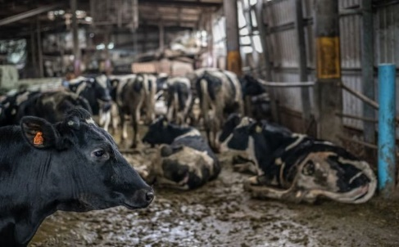

- https://www.bbc.co.uk/programmes/p00545f8 programme on animal experiments and rights by Melvin Bragg aired on 18th Mar 1999 at 9.30pm. visited on 30th Oct 22
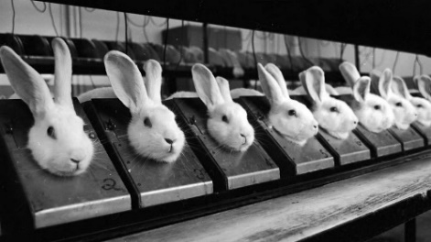

- https://www.peta.org.uk/blog/wdail-2020/ taken from PETA UK website on 30th Oct 2022 at 12.15pm from an article posted by Margarita Sachkova
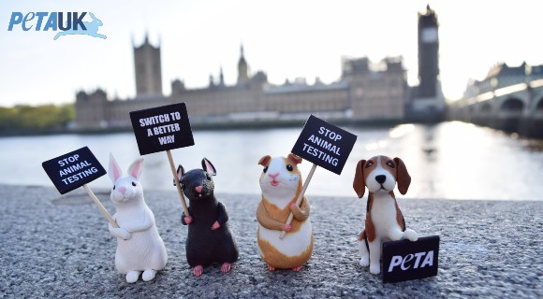

- https://www.prnewswire.com/news-releases/dogs-take-to-the-streets-in-the-worlds-first-un-animal-protest-300587744.html taken from an Animal Rights website prnnewswire.com on 30th Oct 2022 at 12.10pm
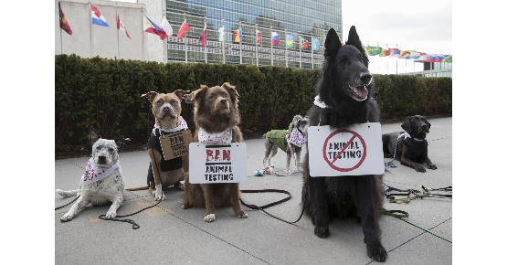

- https://www.elephantvoices.org/threats-to-elephants/killed-for-their-ivory.html Taken from a Blog Elephantvoices.org on 30th Oct 2022 at 11.50am
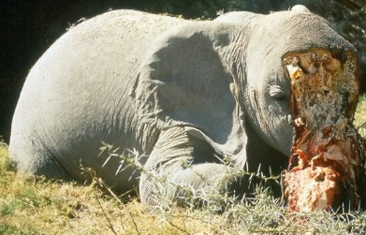

- https://www.change.org/p/u-s-fish-and-wildlife-service-increase-enforcement-for-siberian-tiger-poaching-before-they-become-extinct Taken from a petition website Change.org on 30th October 11.45am
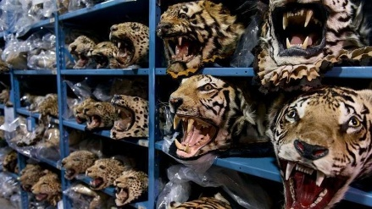

Clive Wynne, Do Animals Think, Ch 1
James Serpell, In The Company Of Animals, 1996, Cambridge University Press
Peter Singer, All animals are equal, Cape. 1976, p702
Lorraine Daston & Gregg Mitman, Thinking With Animals, p5 5
Peter Singer, All Animals Are Equal, p703
Clive Wynne, Do Animals Think, Ch 2
Dr Ann Marie Brennan, Armed to the Teeth, 4th Sept 2018
Catharine Grant, The No-Nonsense Guide To Animal Rights, p14
The Animal Welfare Sentience Act 2022
PETA 2020 Tax Return
Activitsfacts.com visited 8th Nov 2022
Catharine Grant, 2006, p75

