Jennifer Nofisat Ajiboye (2022550)

[Document Subtitle]
[Document Title]

Module Code: BBMSW4001
Academic and Emlpoyability skills

Table of Contents

Introduction

This paper will produce a report reflecting on my learning experience and learning overall throughout this particular module. We've discussed several different topics during this term, but I will be specifically speaking about 'Online Learning Experience', 'Public Speaking' and 'Referencing'. I will be discussing the knowledge I gained, what I already know, how it aided my learning as a whole, and what skills I gained from all of this and how it will help me in the business world and my intended career. I've chosen to speak about these three specific topics as I felt as though I obtained the most knowledge from them and they have gripped my curiosity the most whilst studying this module.

Self-Reflection

What is Self-Reflection? Self-reflection to me is a form of personal analysis which allows me to understand who I am, my values, traits and characteristics, also the person I'm yet to become.
The activity of thinking about your own feelings and behaviour and the reasons that may lie behind them. (Cambridge Dictionary, 2019)

"Reflective practice in learning signifies critical thinking about the learner's learning experience and his existing skills and knowledge that have enabled him to undertake this learning experience and different skills and knowledge which needs to be improved". To produce a reflective report, one can utilize different models of reflection and different methods proposed by other academics. These models or 'frameworks' are used to guide the act of reflection. There are various models such as Gibbs' model, Johns' model, Kolbs' model, and Driscoll's model- these models are the most common ones that are used as a basis of reflection. However, there are others that best suit individual needs. To complete this academic report, I have decided to use Kolbs' model for several different reasons. The most significant contributing factor to this decision is due to the sophisticated and descriptive nature of the diagram Kolb created. This diagram is known as his 'reflective cycle' and was proposed by Kolbs in 1984. This cycle consists of four different categories: Concrete experience, Reflective observation, Abstract conceptualization and finally, Active experimentation. This model will be applied specifically to three skills in this module: Online learning experience, Public speaking, and Referencing.
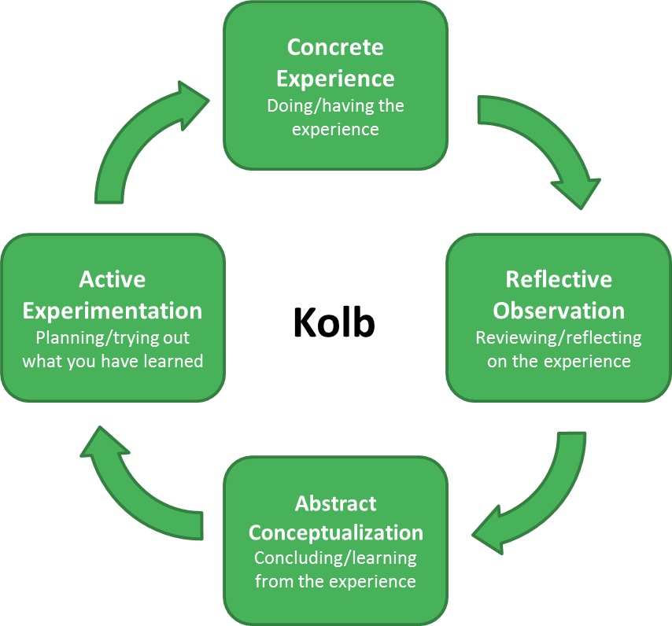

Online Learning Experience

Concrete Experience

My concrete experience with online experience consists of being introduced to many
platforms that I wouldn't have used before. It allowed me to gain the opportunity to use
platforms that I was only briefly familiar with in the past in more depth and also actually gain
new knowledge and new expertise on new platforms. E.g., I had never used Microsoft Teams before this course (neither had I heard of it- I was only familiar with 'Zoom'). Additionally, the platform 'OneDrive' was also new to me. Still, it is something I am incredibly confident with now. I also used Microsoft Excel to create a clearer database for the information/data that I had collected for my assignments, e.g. I created pie charts to allow my data to be more coherent and easier to comprehend.

Reflective Observation

The transition from face-to-face learning to online learning has significantly impacted me due to the quick and rapid change. The uncertainty of the Covid-19 pandemic has ultimately made it more challenging to adapt to this change-making me struggle to achieve my best potential online, and I'm sure many students across the globe will undoubtedly be experiencing this too.
Although I am learning to adapt to this new style of learning, I would say I have encountered many different emotions in regards to online learning, and I would say it has so far been an extremely draining and tiring experience. During my course of learning, there have been feelings of anger, frustration and regret. I have also experienced feeling highly vulnerable at some points in time, and I felt as though there was no support system from the institution (even though we have been reassured that help is available). At times, I felt disappointed within myself as I felt that this form of learning hindered my full potential and did not represent my entire ability to excel. However, the occasional feelings of happiness and relief do come when, for example, I finish an assignment or get through a whole week of learning.
Another reason as to why many students alongside myself have had negative experiences with online experience is due to unexpected technological difficulties. From my experience and from speaking to many of my peers, we have dealt with issues such as random shutdowns of our computers or software such as Microsoft Teams failing on us- making me join lectures late and ultimately jeopardizing my success. This experience has also occurred when, for example, I've been trying to access PowerPoints or assignments through Virtual Learning Site's (VLE's) such as 'Moodle'.

Abstract conceptualization

Taking the experience as a whole and placing it into perspective, my overall conclusions are that everyone has been in the same boat as myself. A vast majority of students across the globe will be in a similar scenario. Therefore, although I may feel alone, I am not necessarily at a disadvantage because everyone has been placed in the same position due to the unfortunate and ongoing Covid-19 Pandemic.
Furthermore, I have also learnt that this shift to online learning from face-to-face may well put us at an advantage for the near future when society ultimately goes paperless. Everything is done via the internet, and all learning and education are through VLE's.

Active experimentation

My end goal from all of this would be to able to capture my knowledge and skills from the subjects I had minimal knowledge on to the ones I had all the knowledge on and adapt it to my later career profession. My intended carer goal is to work in the business sector, specifically in the real estate business sector.

Referencing

Concrete Experience

Initially, I had no prior knowledge whatsoever concerning referencing. I was previously taught in college that it just consisted of inserting website links only. However, from this module, I learnt that referencing overlapped and included skills such as paraphrasing, being able to create a bibliography, being able to avoid plagiarism etc. I was taught that everything that I write/incorporates into my work needs to be referenced if it doesn't come from myself.

Reflective Observation

I've had to adapt to the new referencing techniques that I've learnt. I'm finally starting to understand that when it comes to referencing, I need to go into more depth- from the PowerPoints that we were given, I gained that just putting the author's name and year isn't enough to constitute as a valid reference. This is only needed for short references, but more is required for the reference that goes into the bibliography (Ukachi-Lois, 2021) and is something that takes me a ridiculous amount of time to do sometimes; however, I feel that I have progressed with the more practice I have done (both in and out of lecture).

As this was a new experience, I had lots of doubt that I was referencing wrong and that I was going to get plagiarised. As a result of this fear, it impacted when I would start my assignments as I would procrastinate and postpone when I would make a start on my assignments.

Abstract conceptualization

Again, I have learnt that an immense amount of practice is not necessarily what is needed but a fair amount. Just practicing again and using the resources I was given was enough for me to grasp the concept of referencing. Why exactly we need it (Ukachi- Lois, 2021)-it is required in order to 'allow the reader to locate the source quickly and efficiently. Furthermore, I made use of other platforms such as YouTube to help clarify points that I had confusions with. Therefore, this is something I would definitely recommend doing, as it's not only applying what I've been taught but also expanding on it to create a richer understanding and become more knowledgeable and rounded as a student.

Active experimentation

I will be making use of this when writing reports and completing assignments on this course. As all my information that I will use in any given assignment will be coming from multiple sources, whether that's my lecturer's PowerPoints or whether that's from an online/internet source, books, films, etc. All of my secondary sources will need to be referenced; therefore, future assignments will be where I will put this skill to use. In terms of career-wise, I don't think I will put this skill to much use due to the nature of the job being more practical rather than academic and essay-based.

Public speaking

Concrete Experience

I've always perceived myself to be very outspoken and very capable of presenting my ideas well to others, e.g., with my GCSE spoken language presentation, where I gained a qualification. I have forthcoming assignments that I will be presenting soon, and this gives me the opportunity to demonstrate and apply the skills that I've been taught in this module. During this module, I learnt quite a few skills that are necessary to result to the best outcome and successes when it comes to public speaking.

Reflective observation

Overtime I’ve had to build my confidence in public speaking and taken on board the skills I’ve learnt during this module. Some examples of the skills that this module has taught me include learning ways to engage with my audience, paying a lot of attention to body language, planning beforehand and learning to cope with my nerves. These were the 4 main skills that helped me improve my public speaking skills majorly and allowed me to perform better than I would have done previously. On reflection I wouldn’t say that I was completely unaware and completely oblivious to these skills as I definitely wasn’t, however, I just never took them on board as much as I should have therefore this model has aided me in doing so and will allow me to apply/demonstrate these skills in future presentations or instances where I will be publicly speaking.

Initially I thought it would be simple as I have had previous experience in public speaking as I mentioned above. However, when it actually came down to doing it, I became extremely nervous and quite shy to perform it in front of the big audience (my classmates) but when I actually took the skills that this module taught me into account and put being shy aside it enabled me to gain more confidence in what I was doing and enabled me to perform my presentation confidently. It was a working progress and took some time and practice in order to reassure myself however over time I eventually rejected these doubts and feelings of anxiety and just got it over and one with. Additionally, I feel that performing my presentation online (over Microsoft Teams) allowed me to overcome these fears quickly and gain confidence quickly, however I think that in the future this will change when Covid restrictions are lifted, and I will have to perform face to face with the audience in my presence. However, I will use the skills I learnt in this module, e.g., paying attention to my body language to make in person presentations much easier for myself.

Abstract conceptualization

To conclude, from this experience I have learnt that I am indeed capable of performing in front of a big audience and that it’s just a matter of me evaluating what I am already capable of doing and what I need to be doing. Just taking these skills into account and believing in myself is what’s important when it comes to public speaking therefore is something I need to continue working on.

Active experimentation

One way in which I will be trying out what I have learned will be in my choice of career path. As I am aiming to be a realtor (Real Estate) this skill of public speaking will be needed when presenting and showing my colleagues houses and property that could make us profits. I will need to present this is an effective manner therefore in these occasions I will apply the skills that I have learnt in this module. Furthermore, I also plan to demonstrate these in lectures during the time that I will be studying at the University of Wales.

Reference list
Brockbank, A. (2017). Reflective Learning In Practice. 1st Edition ed. London.
Cambridge Dictionary (2019). SELF-REFLECTION | meaning in the Cambridge English Dictionary. [online] Cambridge.org. Available at: https://dictionary.cambridge.org/dictionary/english/self-reflection [Accessed 30 Mar. 2021].
Cambridge International Education Teaching and Learning Team (2019). Getting Started with Reflective Practice. [online] Cambridge-community.org.uk. Available at: https://www.cambridge-community.org.uk/professional-development/gswrp/index.html [Accessed 30 Mar. 2021].
Mindtools.com. (2009). Better Public Speaking: Becoming a Confident, Compelling Speaker. [online] Available at: https://www.mindtools.com/CommSkll/PublicSpeaking.htm.
Nottingham.ac.uk. (2019). Gibbs Cycle. [online] Available at: https://www.nottingham.ac.uk/nmp/sonet/rlos/placs/critical_reflection/models/gibbs_cycle.html [Accessed 30 Mar. 2021].
Ukachi-Lois, R. (2021). Referencing. [online] Available at: https://www.uwtsd.ac.uk/library/student-essentials/referencing-handbooks/ [Accessed 30 Mar. 2021BC].
‌

