Campus Club Management System (CCMS)

Aaron Miles
2404521
Databases and Application Development

1.Introduction 1
2. Database Design 2
2.1 Conceptual Design and Entity Relationships 2
2.2 Normalizations and Design Rationale 3
3. Database Implementation 3
3.1 Tables and Integrity Constraints 3
3.2 Sample Data and System Validation 4
3.3 Triggers and Auditing 5
3.4 Stored Procedures and Encapsulation of Logic 6
4. Transaction Management and Business Scenario 7
5. Performance Tuning and Query Optimizations 9
6. Conclusion and Reflection 10
7.References 11

1.Introduction

Clubs and societies are an important aspect of university life for students providing intellectual, cultural, and social activities. However, the Students' Union currently supports the activities of clubs and societies using a collection of independent spreadsheets and paper documents which leads to data redundancy, poor data consistency and a lack of ability to monitor student participation. These data quality problems lead to a lack of information for decision making and strategic planning. To overcome these issues, this project proposes the design and implementation of a relational database system, called the Campus Club Management System (CCMS), which serves as a centralized repository for all data concerning students, clubs, memberships, events, attendances and announcements. The CCMS is designed to support data integrity, transactional consistency, auditing, and performance for operational queries. This report critically appraises the design and implementation of decisions using theoretical principles of databases and shows how such principles can be applied in practice.

2. Database Design
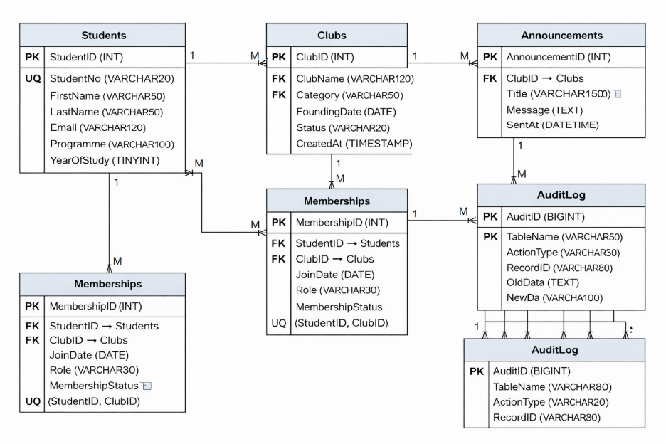

2.1 Conceptual Design and Entity Relationships

An entity-relationship diagram (ERD) describing the conceptual design of the CCMS is shown in Figure 1. The entities in the system are Students, Clubs, Events, Announcements, Memberships, Event Attendance, and Audit Log. Memberships and Event Attendance are used to associate Students and Clubs and Students and Events, respectively. Using these entities, a student can be a member of any number of clubs, and a club can have several members. A student can attend any number of events, and an event can be attended by any number of students.

The members of a club and the attendees of an event can be recorded with the Memberships and Event Attendance entities, respectively. There cannot be membership without a club or a student. Similarly, there cannot be an event of attendance without an event or a student. The reason that we have the Audit Log entity is as follows: For operational data, it should be recorded who inserted, updated, or deleted the data and when it was done. Using the Audit Log entity, we can keep track of such a history for each couple in relation to the entities.

2.2 Normalizations and Design Rationale
Third Normal Form (3NF): CCMS is normalized to 3NF to prevent data redundancy and update, insert and delete anomalies. Each non-key attribute is functionally dependent only on the primary key of the table to which it belongs. For example, data about Students is stored in the students table, and is referenced by foreign keys from other tables. It is not stored in Student Membership or Class Attendance records.
The decision to normalize the CCMS schema is based on relational theory, where normalization is noted as a key technique in ensuring data integrity and ease of maintenance [1] [2] [3]. A possible drawback of a highly normalized schema is that queries may be slowed due to the requirement for increased joints [1] [4]. In the CCMS, this trade-off is solved through indexing, not denormalization, and so is considered good relational system design.

3. Database Implementation

3.1 Tables and Integrity Constraints
In the CCMS implementation, MySQL was used to create tables with specified primary keys, foreign keys, and unique constraints. This means that some business rules (e.g., a student's number cannot be duplicated; a student cannot be recorded as having attended the same event more than once) are enforced at the database level.
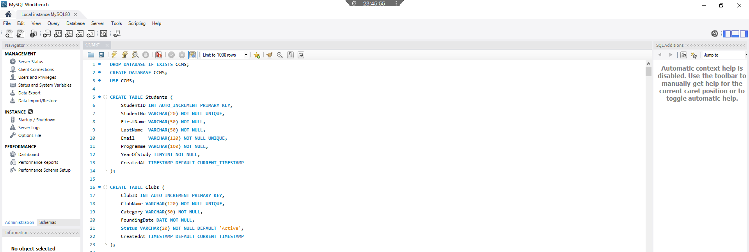

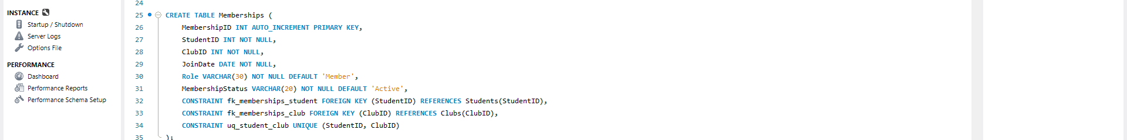

Placing integrity constraints in the database schema minimizes the dependence on application-level checks to ensure data integrity, and guarantees that the constraints will be enforced uniformly, regardless of the way that the database is accessed. In fact, placing the integrity constraints in the database schema is commonly cited in database texts as the best way to ensure data integrity in a multi-user environment [1] [2].

3.2 Sample Data and System Validation
The tables were populated with valid data to test the design as it would be in actual use. For example, some students were members of more than one club, and some clubs had more than one event, and some events had capacity. This data was used to test the referential constraints, triggers, and stored procedures. The resulting queries showed that the design could correctly produce membership lists, event schedules, and counts of attendees. This shows that the design does not only function in theory but in practice.
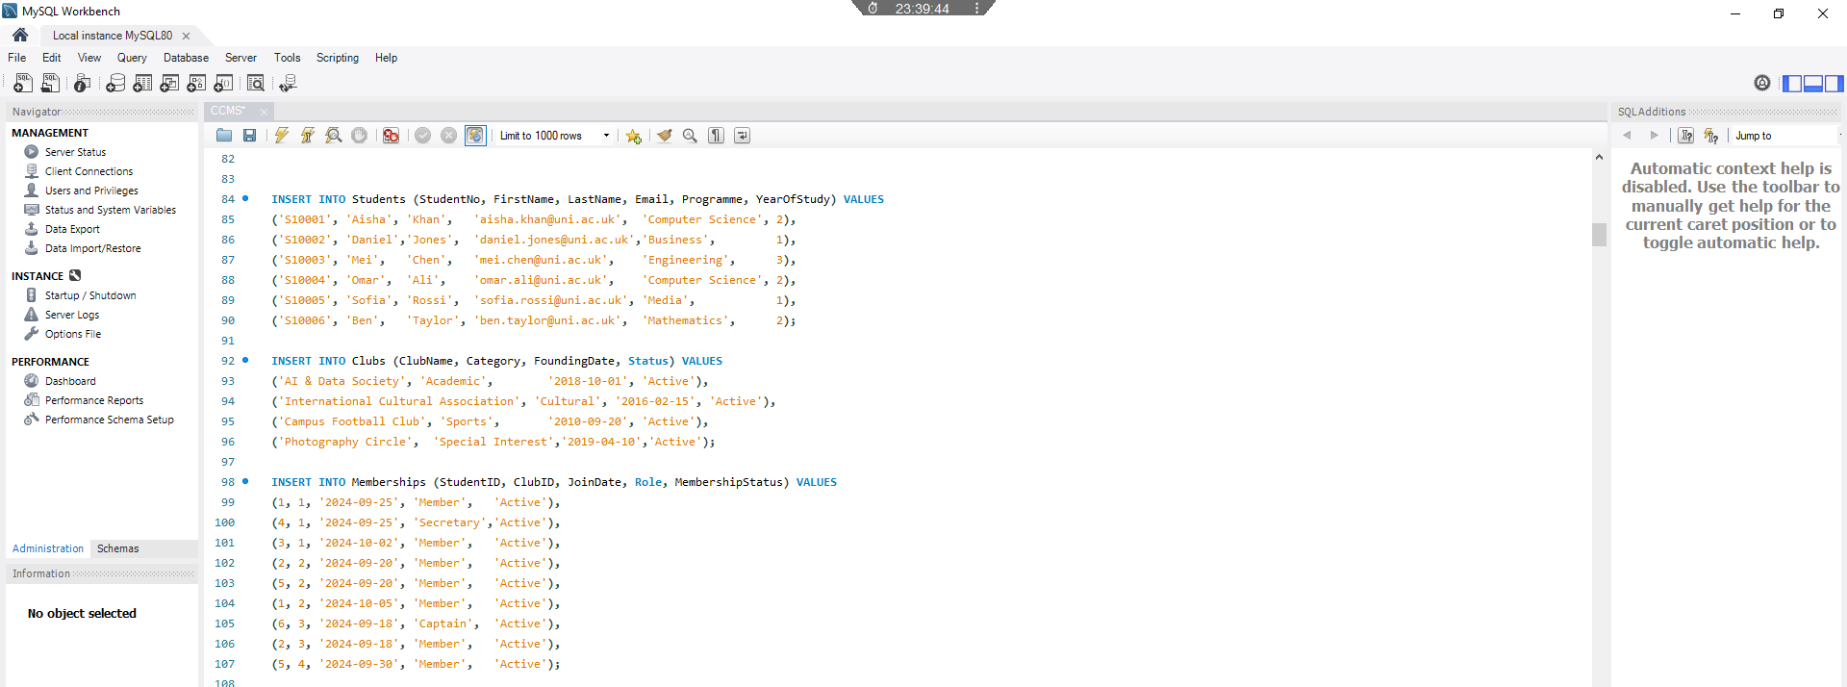
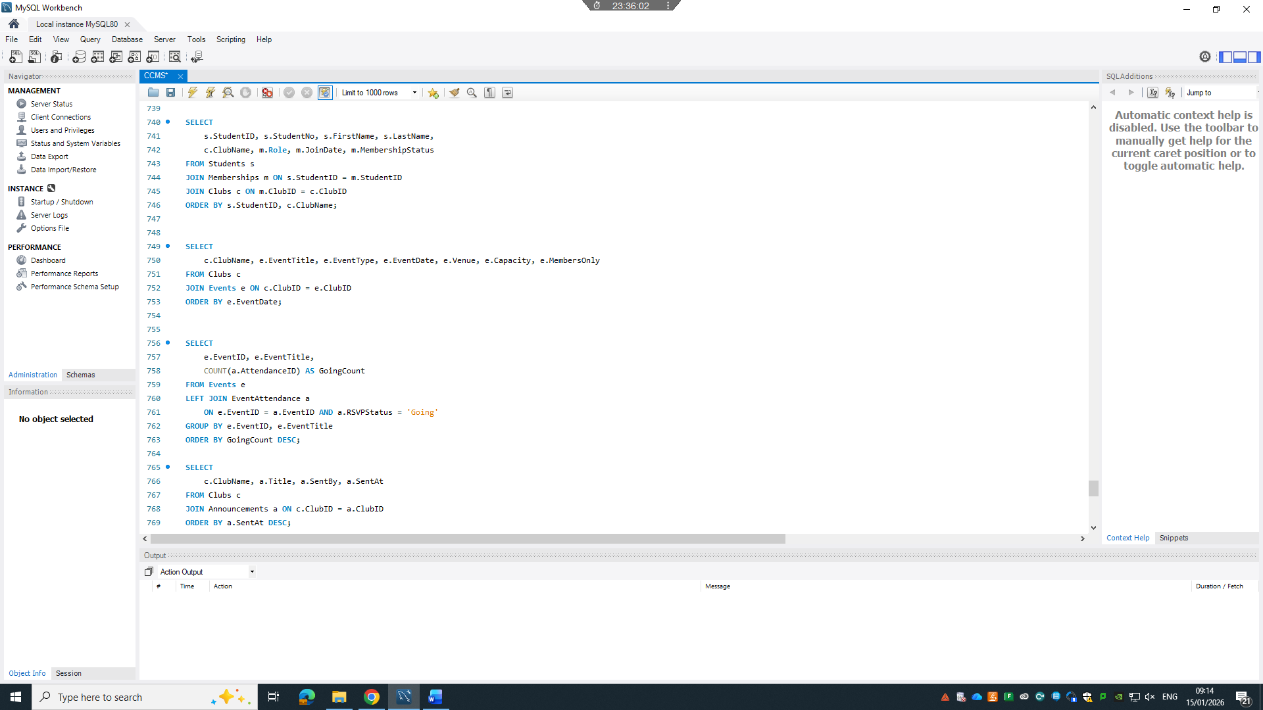

3.3 Triggers and Auditing
Auditing is performed in CCMS via database triggers that insert a record into the Audit Log table whenever an insert, update or delete is performed on a table. This guarantees that this action is performed for every modification to key tables. It also places the onus of performing this action at the right place – inside the database rather than in an application.

Using triggers to implement integrity constraints and other cross-cutting concerns such as auditing inside the database is a well-established technique [3] [5]. In CCMS, it helps with accountability and can be extended to meet needs such as performing a compliance audit or resolving disputes in the future.
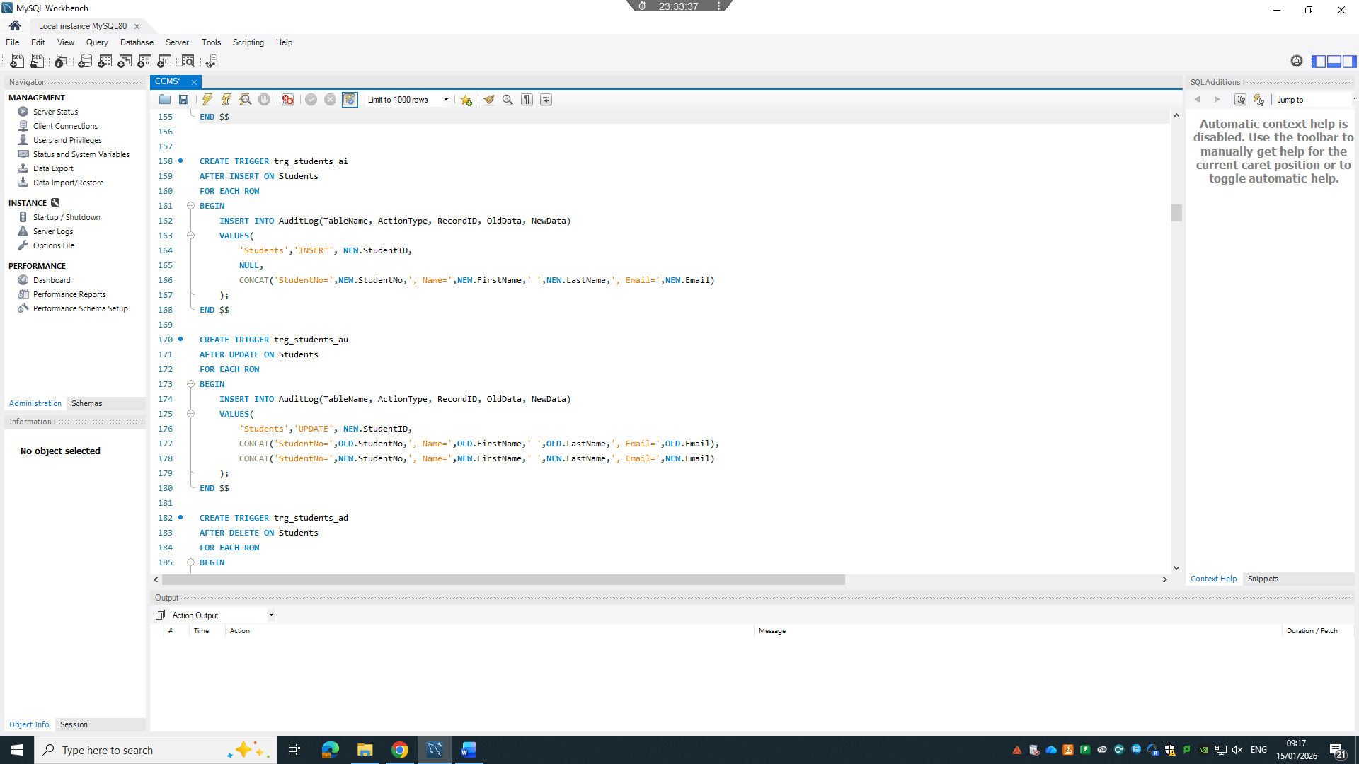
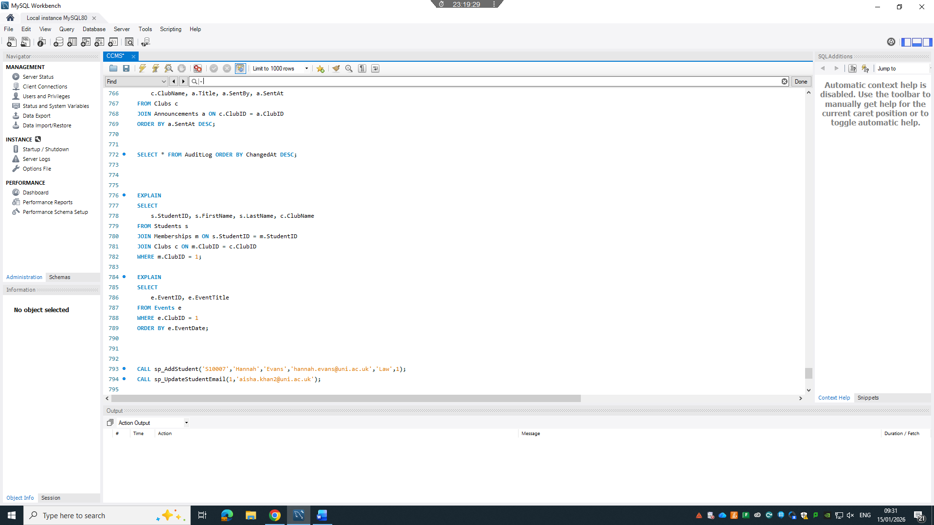

3.4 Stored Procedures and Encapsulation of Logic
Store procedures were developed for the main entities to perform Create, Update, and Delete operations. The procedures contain business logic, perform validation, and provide a uniform way of data access. Making use of stored procedures for data modification provides a level of control over the data changes, minimizing the chance for ad-hoc changes.

The use of stored procedures to enhance maintainability, performance, and security by avoiding repeated client-side SQL code and concentrating on the logic in a single place has been advocated in the database literature [2] [4]. Their implementation in CCMS proves that the designers were aware of the theoretical and practical advantages.
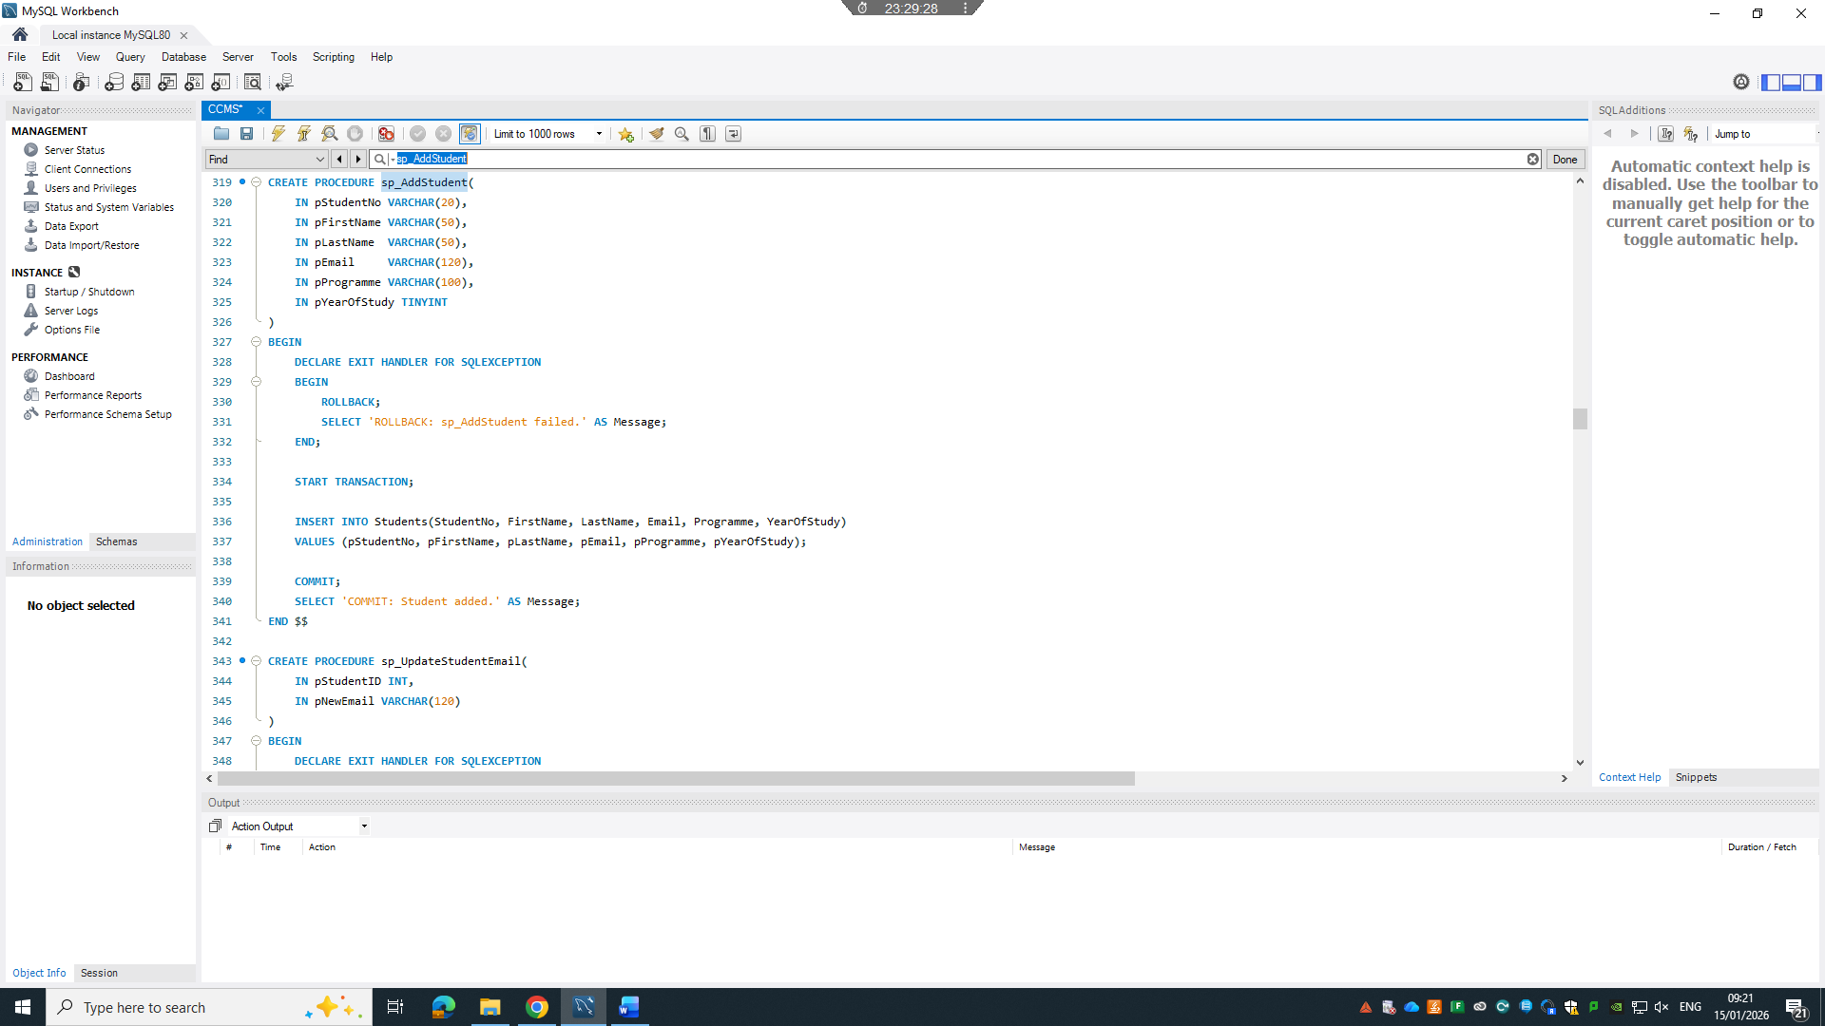
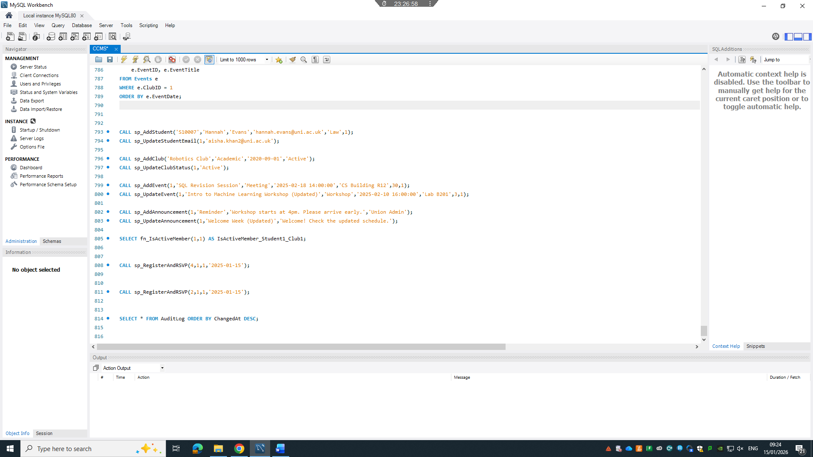

4. Transaction Management and Business Scenario
The implementation of transactional control in CCMS is important, especially for transactions that involve more than one table. The sp_Register and RSVP stored procedure is an example of a multi-table transaction. It checks for space in the event, for valid membership, and then updates the database accordingly, or rolls back if any part of the procedure fails. This implements the properties of ACID and follows the rules of transaction processing and recovery [6]. The inclusion of commit and rollback shows that the designer understands the importance of transactions to real-world systems. Firstly, from a system perspective, the transactional approach in CCMS is essential in a multi-user setting, where multiple users can attempt to register for a membership or attend an event at the same time, and some of them may fail. If the above SQL commands are not enclosed within a transaction, a user’s update for membership expiry date could be mixed with another user’s update for event capacity, for example, resulting in potential lost update problem. Secondly, from a system perspective, conditional rollback in CCMS also presents good practice of defensive database programming. Instead of hoping for the best, i.e., assuming both the update for membership expiry date and event capacity will always succeed, the system is programmed to handle for the worst, i.e., when maximum capacity of an event has been reached or a user is not yet a member. In either of these two cases, a conditional rollback is executed to ensure the data in database remains consistent. This philosophy follows the failure model in the TP model, which assumes failure is a fact of life and must be accommodated. Note that the isolation level of MySQL is set as REPEATABLE READ by default, and in this problem, it works without explicitly set at the beginning of a SQL script file. If contention among the users increases in the future, isolation level can be explicitly set to SERIALIZABLE in the SQL script file to accommodate the increased concurrency.
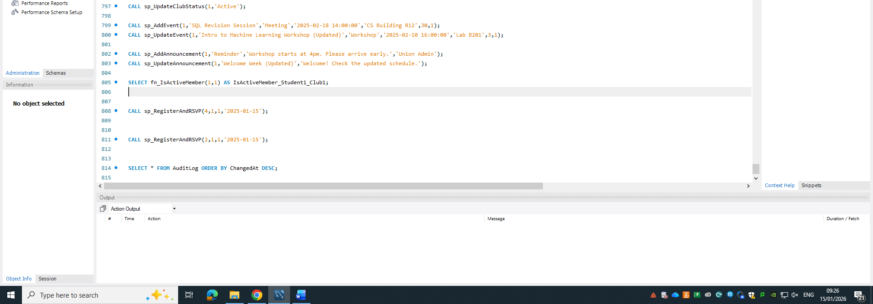

5. Performance Tuning and Query Optimizations
Indexing is aiding frequently accessed and performance sensitive queries; an intentional indexing policy was adopted in the CCMS system. Specifically, indexes were built on foreign keys and columns used for filtering and sorting, such as membership id, event date, and announcement time. These indexes facilitate queries used in reporting and analysis. Their impact can be seen by running the explained command on queries, which reveals a decrease in the amount of table scans needed. Existing research illustrates that an efficient indexing policy is crucial to ensuring the scalability of relational databases, especially if joints and aggregations are prevalent [5] [7]. We see that the policy used in CCMS is a tradeoff between improving performance and increasing storage and maintenance costs, which seems to be a well-considered decision.
While indexes are useful for improving the performance of the system, they also come at a cost. The database must maintain indexes, so they have an additional cost in storage, and it takes longer to insert, update, and delete rows from the tables. To mitigate this, the most used indexes, such as foreign keys, and the event dates, are used for queries in CCMS, but less useful indexes, such as indexes on low selectivity or non-queried columns, are not created. We can also predict that the attendance and member tables will continue to grow, as students continue to attend more events, and participate in more clubs. This will lead to long run times for queries on the table, such as how engaged members are, or to check the capacity of an event. By creating the indexes that were created, the database can find the relevant rows quickly and continue to create optimal execution plans even as the tables continue to grow. Finally, we can see that indexes can always be changed, or new ones created to meet the requirements of the workload, and we can continue to monitor the system, and add new indexes, or create new indexes on queries to continue to improve the system.
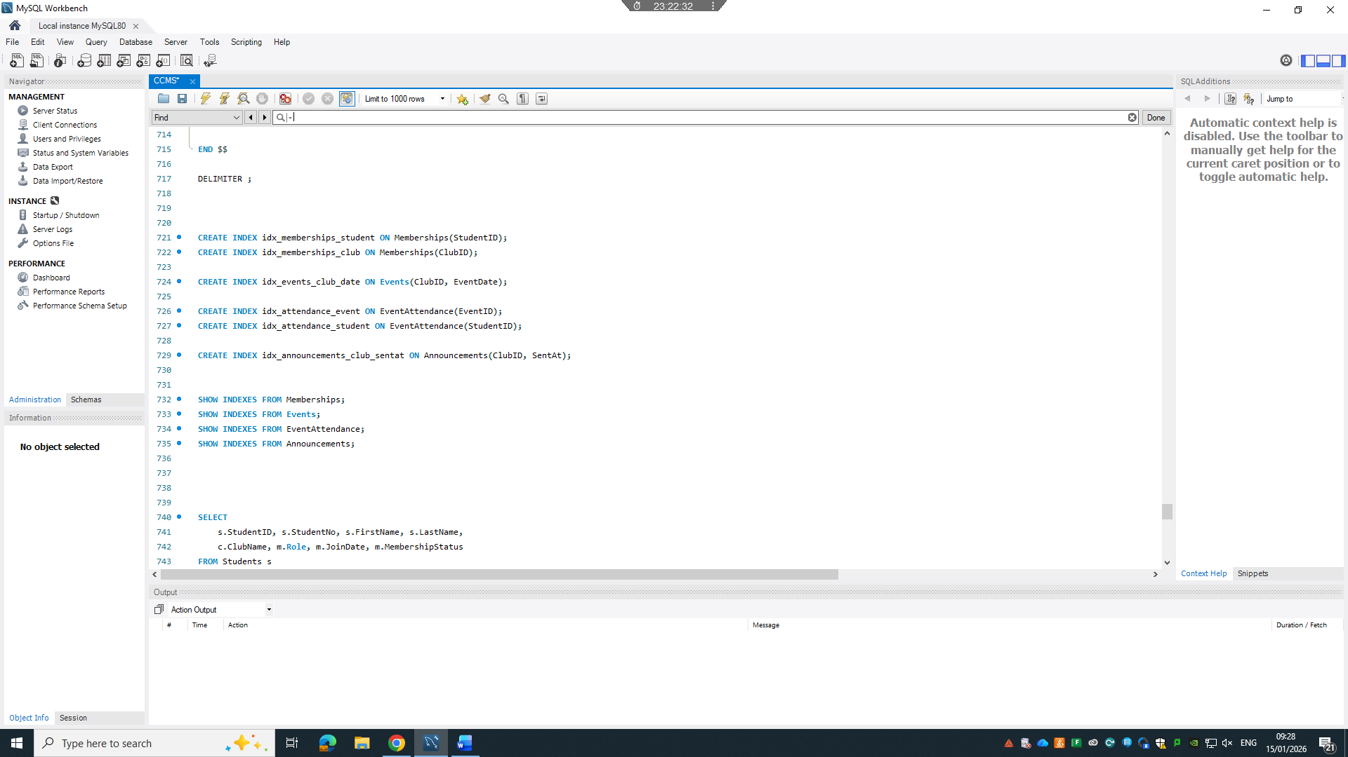
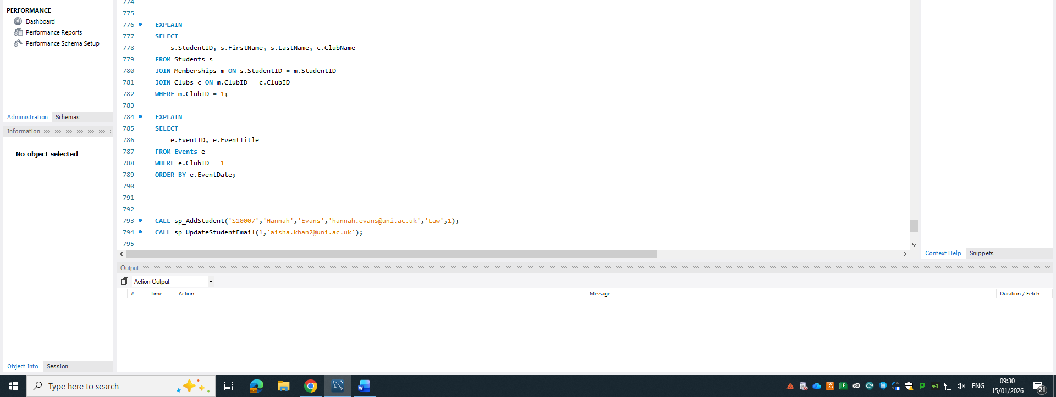

6. Conclusion and Reflection
The proposed system, the Campus Club Management System, is a reliable, efficient, and scalable system that meets the Students' Union requirements. We have implemented all the traditional database design concepts like normalization, referential integrity, transactions, auditing, and indexing to ensure the integrity and performance of the system. The most critical problems that we faced were the representation of the many-to-many relationships and the implementation of the transactions to ensure their atomicity. We effectively solved these problems by introducing associative entities and the use of stored procedures and rollbacks. Potential improvements to our system include the creation of materialized views for trend analysis, the implementation of role-based security, and the use of distributed databases to share data with other university student databases. We are confident that we have shown a high level of understanding and skills in the design and implementation of a relational database system.

7.References

[1] | T. Connolly and C. Begg, Database Systems: A Practical Approach to Design, Implementation, and Management, 7th ed. Harlow, UK: Pearson, 2021.
[2] | H. F. K. a. S. S. A. Silberschatz, Database System Concepts, New York, NY, USA: McGraw-Hill, 2020.
[3] | R. E. a. S. B. Navathe, Fundamentals of Database Systems, 7th ed. Boston, MA, USA: Pearson, 2021.
[4] | J. D. U. a. J. W. H. Garcia-Molina, Database Systems: The Complete Book, 2nd ed. Global Edition. Pearson, 2022.
[5] | M. Stonebraker, “Future of relational database systems,” Communications of the ACM,, vol. 66, pp. 44-50, 2023.
[6] | J. G. a. A. Reuter, Transaction Processing: Concepts and Techniques, San Francisco, CA, USA: Morgan Kaufmann, 1993.
[7] | D. Comer, “The ubiquitous B-tree,” ACM Computing Surveys, vol. 11, pp. 121-137, 1979.

