Elizabeth Stonhold. Student Number: 2003829

Title:

A critical evaluation and the identification of next teaching and learning steps focusing on a case study of an individual learner or a group of learners, based on an observed critical incident.

Introduction:

Observation is a key part to being a good teacher. Focus must be held on all aspects of education. Most importantly pedagogy, as why, how and what you do in the classroom, impacts the individual, the school and the wider community.
This essay aims to highlight how vital to one’s own professional development an observation can be when it is followed with a critical evaluation. This is when the observation leads you to question, analyse, examine, interpret, reflect and then apply your findings in order to improve your methods of teaching. This style of professional development should be sustained throughout your career, as a duty of care, knowing the impact education has on future society.
The observation is formed through a case study; a detailed, in-depth account of a lesson which encourages a neutral perspective to be taken. During this, a critical incident (Tripp, 1993) can be selected, ‘an instance in action’ (Adelman et al,1980 cited in Cohen et al 2018). This is not a significant moment, but yet catches attention as it poses questions of why it is in place in the classroom. From this, in-depth, non-biased research is conducted, which prompts a personal reflection and conclusion so that pedagogy can be improved based on current academic findings.
Paying close attention to a mundane moment highlights the importance your entire actions as a teacher can have on each pupil. It emphasises the importance learning to record and critically evaluate observations will enrich my ability to justify my own actions and foster an enquiring mind.

Observation:
Prior to the observation, personal information was shared regarding any potential social position connecting myself to a member of staff or pupil. This was to ensure the observation was conducted in compliance to the British Educational Research Association (BERA) guidelines and there was no conflict of interest in my observation. Unfortunately, due to a family member developing Covid-19 symptoms, my observed critical incident came from observing a film of a Foundation Phase maths lesson.
In compliance with BERA, the school will remain anonymous throughout this report. However, information was obtained of the school (Appendix 5), which is important to address to provide a background to the observation. As highlighted in Successful Futures (Donaldson, 2015) considering the locality of each school allows the teacher to create a bespoke pedagogy to suit the needs, interests and heritage of it’s pupils. Being socially aware of the school’s situation prevented any dispute or criticism into why the teacher may be delivering a lesson in a certain way.
Equally, to protect the reputation of all involved, recognising the potential consequences that may arise from drawing conclusions, all criticism must be constructive. Should a situation have arisen that created a critical view, it would have been crucial to speak with staff following the incident to gain a deeper perspective on the situation. My identity would be known to all prior to my visit with consent sought and any findings available to be shared.

Methodology:

A case study was selected and not, for example, a classroom-based action research because unlike action research, (when focus is given ‘deliberately’ and intentionally to improving a preconceived area (Creswell, 2012 cited in Cohen et al 2018)), a case study relies solely on the researcher describing the setting as it happens whilst keeping an open mind. This allows for a ‘strong reality’ (Wellington 2015, cited in Cohen et al 2018) to be observed within a universal context i.e. a school setting. Due to the formalities of the shared boundaries provided by the context, there are endless observations to be made that allows for the researcher to then select a critical Incident’ from which to focus research.
It is important to emphasise that the critical incident within the case study comes from a single moment. It is selected on making an observation that brings about change (Dewey 1944, cited within Tripp 1993). The moment to take note and highlight an event is when there is a situation that is not fully understood (Dewey 1944, cited within Tripp 1993). This moment is what Tripp (1993) regards as a ‘Critical Incident’: a moment that should not be left, and requires deep thought and analysis to bring about change.
Concentrating on a small group or an individual, and observing a moment that is not too broad to scrutinise (Pring 2015, cited in Cohen et al 2018) emphasises the abundance of complexities within the entire case study. A case study and a critical incident develops the teacher into becoming ‘intellectually expert about expert practice’ (Tripp 1993. Pg. 5) of a specific situation. This however also highlights one of the criticisms of a case study, as there are multiple factors to consider. Without cross-checking you cannot generalise any findings (Nisbet and Watt 1984 cited in Cohen et al 2018).
It does mean that, because you are witnessing the moment in person, you can allow for the context and wider dynamic of the setting to be considered. Every moment has multiple interactions within it, therefore the researcher can allow for each factor to be taken into account by cataloguing the event chronologically. However, this task in itself is difficult to undertake and risks the individual later embellishing the observation, relying on ‘selective’ memory. (Cohen, 2018) It also can include the personality of the researcher (Cf. Verschuren, 2003, cited in Cohen et al 2018), in the description, the focus of research and in the progressive next steps. Therefore, the result can only ever be one interpretation of a single event.
Using a structured technique by compiling a list of questions prior to the observation, improves focus and keeps the observer ‘deliberate’ (Tripp 1993). Methodically cataloguing the observation in a clinical style removes the potential bias of added emotion. Forming an ‘algorithmic’ (Tripp 1993) approach also limits the potential of the general observation including any preconceived prejudice or emotive description that may impact the selected critical incident. Equally, as supported by Hitchcock and Hughes (1995, cited in Cohen et al 2018), documenting an event in this way is only reliable when the researcher has purely had the role of ‘observer’ i.e. not interacting with the class and therefore manipulating the observation.
This is a significant limitation to a case study. Even if you were to maintain the role of pure observer, the class are aware of your presence and therefore alter the outcome. I considered the affect the camera-man had on the pupil’s behaviour.

The Four Purposes:

The new curriculum of Wales, (Donaldson 2015) is built around the Four Purposes. These purposes encourage pupils to be; 'ambitious, capable learners', ‘enterprising, creative contributors’, ‘healthy, confident individuals’ and ‘ethically informed citizens’. They have been carefully formulated to provide all children studying in Wales with the mindset to promote life long learning and the right attitudes to equip them to live a healthy, balanced life. It covers all aspects of learning, from being confident in numeracy and literacy with developing digital, technology skills, to include ‘softer’ skills, such as supporting every individual’s physical and emotional well-being. (Donaldson, 2015. Pg. 21-28) The research combines all desirable qualities that were identified to be present in children and young people to help develop Wales into becoming a more prosperous, thriving, vibrant, country. (Well-being of Future Generations Act, 2015) As these four purposes are at the very core of the New Curriculum in Wales it is important to link them to the Case Study.
The Foundation Phase class, was split into small groups, where the three Teaching Assistant’s (TA) and the teacher all facilitated different groups. The observed group’s activity was already set up inside a small tent like structure, on the edge of the classroom. At the entrance of the tent was a poster, containing the image of four, simple, hand-drawn smiley faces, under which was clearly hand-written; “4 can play here”. The two pupils who entered the tent worked independently and appeared to focus on the activity. There was no furniture and decorating the walls were a series of different, home-made, interactive panels. Prepared activity props were available in the tent, to do with number sequencing, however, it was observed one child was sequencing incorrectly. Outside, slightly removed from the tent sat a TA observing the children, making notes on a post-it. Prior to the lesson, the teacher was quoted to saying, they aim to “make maths fun and part of everyday activities...getting children interested in numbers through play based activities….the aim is to encourage personalised learning…there’s a balance needed between teacher focus and child initiated activities”.
This case study has links to all of four purposes, however the strongest being ‘enterprising, creative contributors’. The use of ‘play based activities’ appears to allow children the opportunity to use their imagination to mentally construct various roles, problems and rules and experiment with how they apply their skills and interact with their peers. Providing a safe, contained space away from other activities appears to allow the children to freely express themselves, their ideas and emotions, whilst the small group will encourage each child to also understand how people respond to their actions and develop empathy skills. Being an independent task, the pupils will be able to develop skills that will allow them to take measured risks and imagine a variety of different opportunities. Delivering ‘everyday activities’ that include maths, attempts to provide the children with the opportunity to connect different skills to different lines of work, better equipping them for the realities of life beyond education.

Literature Review:
The Critical Incident, was selected, due to curiosity around the use of ‘play’ in engaging children in constructed activities. Currently, the Foundation Phase (FP) framework for schools in Wales is to be ‘creative and imaginative, and makes learning more enjoyable and more effective’. ‘Play’ is described as a ‘serious business’ and is the driving force behind how children ‘practise and consolidate their learning’ with well-being at it’s core.(Welsh Government, 2015). Play is also included as an essential part to all children’s lives (UNCRC, 1989).
However, Goffman (1961, cited in Corsaro, 2000) suggests that ‘play’ used in education may not be ‘play’, rather ‘games’. Although ‘fun’, the difference is that ‘games’ are created to direct the pupil by an adult. This difference is what caused me the biggest perplexity in the critical incident. Further research into play supports that play should be fun, and assumes pleasurable for the child. (Freud 1922/1961; Piaget 1962) Other supporting research to this, is that ‘play’ should not be ‘goal seeking’ or finishing with an end result. Both of these indications towards defining play, is supported by the belief that play should be selected by the child and unhindered by adults; (Rubin et al 1983)
The impact ‘fun’, ‘pleasure’ and ‘happiness' has on learning has been evidenced by a number of researchers. Isen and her colleagues (1987) found that participants performed better at a task after seeing a short comedy. This is reinforced by Kahneman (2012) who observed a clear correlation between good feelings and cognitive ease. More importantly, he recorded that the reverse of the experiment showed that participants who were unhappy prior to being tested, were completely incapable of achieving any form of accuracy.
Being able to re-access a ‘playful’ mood that has been learnt early on in life, is encouraged by Mautner (2020). She discusses ways (that appear to come naturally for children) adults can bring out their ‘silly’ side, and therefore can ‘lighten’ their mood and improve well-being through ‘play’ or ‘games'. This is an essential focus for the Curriculum in Wales, as identified in UNICEF’s report (2020) into the well-being and happiness of children in rich countries. The United Kingdom is still one of the lowest performing countries showing British children are some of the unhappiest in the world. (Guldberg, 2009). The National Council for Hypnotherapy (NCH) described an ‘explosion’ of invested clinically diagnosed mental health problems in the UK, which highlights the importance and urgency for improvement to be sought (cited Howard et al. 2017). As does the findings of Howard et al. (2017) where depression is now a recognised health condition in the UK, including amongst children.
Other research suggests confusion surrounding play due to a lack of a clear definition. Erikson (1950. Pg. 250) refers to play being a ‘phenomenon’ as it ‘playfully eludes definition’. Piaget (1951. Pg. 147) shares this difficulty suggesting the reason for it is that play is often considered as an ‘isolated function’. Although they too contest what counts as play, Wood and Attfield (2005) agree with Piaget and summarise play as: ‘always context dependent’. This is supported by Scott (2019) who suggests when considering pedagogy, play must always be reflected upon to challenge assumptions, ensuring a variety of methods and opportunities to provide diversity of childhood experiences.
To provide a context to the case study, background research into the school states that in comparison to most schools, the school has an above average for the amount of children receiving free school meals. This suggests the school is from an area of deprivation. It also states that a high amount of children start the school with ‘skills which are lower than expected for their age’. Therefore, making fun activities for the pupils will help create a safe, engaging environment for the children to learn skills that can be scaffolded for academic success later on in their education. This research appears to highlight the importance of creating ‘fun’, enjoyable lessons, and suggests that in doing so, a correlation to improved learning and an increase of well-being will be achieved.
The role of the teacher in forming the right context for learning is suggested in the work of Laevers (2000). He suggests that through ‘play’ children are able to harness a ‘flow’ that stimulates deeper cognition and has significant emotive strength, that is felt throughout the whole body. The experience should: encourage collaboration (through peers and the teacher’s own expertise), include challenge that results in achievement, and involve an interaction with the environment (Dewey 1938). Through observing the activity, the teacher can then construct future activities that take shape around the interests of the children, developing the play to entice deeper learning (Laevers and Moon 1997 cited from Wainwright et al. 2019). This is supported by Lazarus (1883) who suggested that play appeared to restore people’s energy.
An increase in energy, where the teacher can facilitate activities that also develop physical literacy, through play rather than a focus on ‘sport’ will, according to The Mental Health Foundation, connect the ‘mind’ and the ‘body’ and improve mental health and well-being. (Whitehead, 2010, Wainwright et al. 2019). Physical literacy, with it’s direct links to increased well-being is evident throughout Successful Futures, where ‘play’ from FP becomes more creative through the arts later on in KS2. This is echoed in the findings of Newman and Holzman (1993 cited in Johnson et al. 2015) who suggest that playful/performance activity is relevant throughout people’s lifetime, and should be developed beyond early childhood.
However, published in the Programme for International Student Assessment (PISA) (Hume, 2016) surveys, Wales was shown as being the lowest achieving country in the UK, with only a slight improvement noticed in their latest report (Welsh Government 2018). In a study by Stigler et al (1999) it was revealed that the students from countries within the top ten for PISA ratings: did not talk in the classroom, the questions only used mathematical language and the teacher directed the lesson. Yet, their findings suggest that high-quality learning took place (Wim et al 2017). Eccleston and Hayes (2009) also present their fear in designing a pedagogy that focuses on well-being and the individual experiences and interests of the child. They suggest that teachers should concentrate on teaching content over attempting to replicate the role of a psychotherapist. However, research into children leaving school with high grades and continuing in a profession related to their subject knowledge, in the top PISA performing countries is lower than it is in British children, who may initially score less, but develop a passion and an invested interest into developing a subject into a life career. (Collard 2016)
Motivation and energy observed in ‘play’ is what Donaldson suggests equips children with the skills to better prepare them to ‘play a full part in life and work’. It is forming an independence and energy that transcribes to life-long learning. A suggested central role to improving independence and motivation, allowing children to scaffold concrete thinking and abstract mental action to skills in different lines of work, is the make-believe play of role-play.(Vygotsky 1967, Elkonin 1978, cited in Bodrova et al 2019) Research that supports this theory of children’s abilities increasing through role play is evident in children recalling more words when playing with a shopping list, and being able to better self-regulate their behaviour than in non-play contexts. (Istomina 1977, Manuilenko, 1975).
This is supported by Bronfenbrenner’s (Leonard, 2011) theory of schools establishing ‘community cohesion’ in order to improve pupil’s levels of attainment, through collaboration. Through engaging with others, ‘all children contribute to their own process of learning’ (Bronfenbrenner and Morris 2006 cited in Siraj and Mayo 2014). Scientific discoveries into ‘Menalization’ even show a specific part of the brain, solely formed for the function of developing the ability to understand another (Fongay, 2016).
For educators of the Reggio Emilia approach, their pedagogy is designed around forming problems, or contexts, for the children to solve and explore as a group. Krechevsky (2001) defines that the group as a collective must share the same emotions and vision so that the individual autonomously learn from each other. Thus, attention must be directed to each individual’s ability to scaffold the learning of others. The relationships that occur within ‘play' mirror this approach to active learning and therefore for Reggio Emilia, role-play is considered essential in childhood, and one of the Hundred Languages. (Hong et al. 2017)
The scaffolding approach, constructed by Loris Malaguzzi, sees projects build over the course of a week, to a year. Within the FP, the idea of a continuum, scaffolding learning has been adopted, and appears to work well (Pyle and Daniels 2017). Children are provided with tasks that are adult-led to self-selected activities, many of which are playful in their nature. As highlighted in Dewey’s work (1930) it is the teacher’s responsibility to add a context to the experience. However, as Lillard et al (2013) showed in their research, if the context for the activity is not based around a problem that is of interest to the child, no matter how momentarily they may be inquisitive to the problem, it is not their problem, and hence motivation, even within the imagination of play, is lost.
Based on this research, it is suggested that the level of independence that a child gains through receiving an active, individually tailored, imaginative approach to teaching, may not produce results at a set time. However, it suggests over the course of a child’s education, the pupil is more likely to develop independence and confidence in their own interests and abilities. Therefore, in adulthood, they will professionally contribute back into society, which could ultimately result in transforming a nation.

Reflection, Evaluation and Next Steps

The importance of personal reflection has been widely discussed since Aristotle’s concept ‘phronesis’ and what Smith (1996 cited in Atkinson and Claxon, 2000) describes as ‘practical wisdom.’ The then Prime Minister, James Callaghan (1976), allegedly began the focus of the importance of reflection in education, during his Ruskin College speech, saying that what education needs is ‘professional accountability’. Hargearves (1999 cited in Atkinson and Claxon, 2000) supports this, suggesting through research, practical knowledge will assist teacher’s understanding and applying ‘what actually works’. For teachers beginning their practice, (Hirst 1996 cited in Atkinson and Claxon, 2000) their focus on research needs to provide a critical grasp on the most ‘defensible goals’ in education. Therefore, this research in gaining ‘practical wisdom’ into the importance of well-being and the impact that has on learning ability, behaviour and independence, are important elements to consider when beginning teaching.
Concluding learning with a reflection, ensures that the thinking, inspired by research, is consolidated and understood, ensuring deep-learning has taken place. Within the classroom setting, reflection that includes multiple perspectives will remove assumptions and provide a less emotional, idiosyncratic view. Using four ‘lenses’ (autobiographical, learner, colleague and theoretical) to analyse the incident, will ensure a broad, experienced, professional perspective is reached (Brookfield, 1998). Without being able to speak to the learners or colleagues in my case study, I have only been able to use two of these lenses in this reflection. However, recognising their importance for future critical evaluations is important, so that they are included in the future.
From an autobiographical lens, the difficulties I experienced in making an observation from a heavily edited ‘you-tube’ film, with the added context of working from home with an unwell child and visiting a Covid Testing Centre on the day of observation, meant that I was upset during the observation. Unable to ‘see’ clearly, impacted my ability to document the observation with enough ‘non-objective’ information that was essential to viewing the event critically.
According to Brookfield (1998), greater learning will happen from personal experience. This research implies the impact emotions have on a child will impact their ability to learn, this is what I too experienced. Identifying my next teaching steps are to develop different methods for assessing children’s emotions and recording them.
This documenting style of observation also needs to include the initial playful activity. Not directly interacting with it, but observing and documenting the child’s interests, ability to interact with others, areas of learning that need to be revisited and areas that the lesson or activity could progress to. This method of forming pedagogy from observation is, as research suggests, vital if you are to consider the child at the centre of their own learning. Considering the feedback of the child, in how they felt they need to progress will be crucial, also listening to the experience of peers and researching theory to deepen subject knowledge and therefore improve methods for future delivery.
Reflection on the experience and learning to identify my next steps is the importance of a detailed observation. The extent of information that is evident from a moment’s observation is huge, granted that enough detail is documented. From reading academic writings, I experienced for myself the enormity of research available, and how difficult it is to read something that you don’t agree with. For example, some research mentioned the importance of a particular type of play, which appears to be missing from some classes. Reflecting back on the observation, however, there was evidence of this: role-play panels on the wall of the tent, but it had been inadvertently overlooked at the time of observation. My research focus could have been misdirected due to lack of detail in my observational notes.
Understanding that, your instincts on how or what you deliver as a teacher (Brookfield 1998, Atkinson and Claxton 2000), is often based on your own memory, not on academic research, suggests that what you believe to work, may not. What the research for this assignment implies is to listen to the pupil and learn what they need, not what you think they should experience, therefore allowing the individual to be confident and independent in their own learning. Next research steps would be to read theory and search techniques into formative assessment, as this, I can see impacts on how you utilise ‘play’ to enhance the well-being of the child and develop the next learning steps for each pupil.

Conclusion:

To conclude, following reflection on the research regarding the use of play in the classroom: ‘to foster independence and improve well-being’, the observed case study showed good practice. Allowing children the freedom to play, whilst recording each pupil’s: interests, motivation, happiness, as well as assessing areas to expand knowledge and skills, will all play a crucial part in successfully creating pedagogy that holistically nurtures deep learning in each pupil.
As a teacher, observing the pupils without impacting on the observation will allow you to detect and reflect on a critical incident that may arise. Looking critically at what and why you do something, then researching academically, will allow professional learning to guide your practice as a teacher. This will also include developing your subject knowledge and understanding of topics that are relevant to the learners, and provide contexts for playful projects that expand pupil knowledge.
Understanding that everything you do is part of a collaboration, primarily between yourself as the teacher and the pupil is of utmost importance. However, in order to maximise the potential for the student, the collaboration needs to extend to all involved in raising the child. This research endorses the importance of using role-play in the classroom to develop characteristics that enable children to collaborate effectively in the future.
The responsibility of leadership in offering support, sharing research, and learning from another’s experience will develop professional accountability. Including colleagues’ reflections will help to remove assumptions, provide justification and contribute towards critical clarity being gained.
Finally, it will be important to be innovative, and embrace change thus allowing research to guide and improve all areas of professional practice. From this research, it suggests the freedom and experience of play that is allowed to a child today will positively impact their ability to learn tomorrow and ultimately throughout life.

Appendices:

Appendix 1:

OBSERVATION / FIELD NOTES
(Questions adapted from Fletcher Wood (2016)
Date and time, year group:
Early Years Foundation Phase Maths – Middle of the Year.
Lesson details: (Context and focus -/AoLE/subject- is it near start of end of unit of study? Indoors/outdoors? Ability range? Any particularly relevant information).

The lesson is indoors and there are three TA’s as well as the class teacher. The pupils are mid unit, having learnt to count, they are now learning to stop when they reach the desired amount and number sequencing, forwards. This will form the start of adding.
There is mixed ability, with an above average amount of pupils at a lower speaking level. The class is mixed ethnicity with 5% English as a second language.

It is the middle of the year, pupils appear to be wearing hats and gloves outdoors, and all appear confident and familiar with the classroom.

Classroom culture
(What is the classroom ‘vibe.’? What do attitudes, dispositions, behavior’s towards learning seem like at this point in time?)

The classroom appears controlled, and there are multiple ‘zones’ for the pupils to work, in small groups. Learning is focused, with pupils quick to engage with activities that are presented as games.

The furniture is constructed in the room to create different ‘zones’ for example, bookshelves jut into the room to create ‘divides’. There is a tent in the middle, outer edge of the main teaching space.

There are multiple props around the room that have been constructed for set activities, such as a washing line.

Objectives
(What happens in the environment that communicates the purpose of the experiences? What can be observed regarding the way lesson activities relate to these purposes?

All activities are repeated in different formats to repeat and play with what the children are learning. – In this instance, counting. – putting numbers in order.

Some activities are led by an adult, or under adult supervision, others are pupil led. Many of the pupil led are direct repeats of what was just experienced under adult supervision, with one of the pupil’s naturally taking the role of ‘teacher’.

Direction
(What can be observed that helps learners understand what they are engaging in? What in the environment helps them understand how to achieve well)?

The teachers are presenting fun activities for the pupils to repeat independently or in small group. All materials are laid out ready for the child to engage in the task. The activities are not ‘new’, they have already been introduced to.
Any ‘new’ task appears to be ‘teacher led’ first.

Access and challenge
(What can be observed in the environment that enables engagement of learners? What can be observed regarding levels of challenge?

Activities repeated in different settings. The ‘teacher’ got some answers wrongs, so the children ‘help’ with the answer.

The teacher has spread big number foam tiles all over the floor, and a child is selected to pick up the numbers in order and give them to the teacher. The teacher indicates when a new child is to take over the game. This is then repeated in smaller groups.

A TA is assisting in children ‘hanging’ numbers on the line in the correct order.

Assessment
(Can anything be observed about how student’s existing knowledge is used? Can anything be observed regarding the development of knowledge during or after the experience)?

All staff make frequent notes on post-it-notes that are then shared and stuck to a board in the classroom under the different subject headings. Sharing the pupil’s learning visibly. As there are many adults in the room, a high level of collaboration needs to be kept.

Specifics / Critical Incidents
(Are there moments which cause you to consider aspects of practice when you come across them in future teaching)?

There are posters on the walls at various intervals around the room where the children are working in smaller groups. The poster is visual (smiley faces) as well as writing, indicating how many pupils are able to ‘play’ in the area.


4 can play here.

The word ‘play’ is noted. Play being one of the Children’s rights.
A fun space to learn
A safe space to learn
A place where you can experiment and make mistakes.

Outside of the tent, slightly removed, a TA sits making notes observing the pupils ‘playing’ but not interacting or correcting mistakes.

Is the activity the children are doing play?
Do the children think they are playing?
How do children play in the school as they get older?
What do children learn through play?
How is play used to teach?

CRITICAL INCIDENT IDENTIFICATION RECORD

Details relevant to the research context.  Date/time.  Age/Stage of group.  People involved.  Contextual  information from field notes. | This was difficult to record as I was watching a highly edited film due to a family member developing Covid symptoms.  The pupils were Early Years Foundation Phase, so presumably between 4 and 5.  There were small groups of pupils in the tent in the class, with a sign on the door, ‘4 can play here.’  There was no furniture in the tent, so the children had to sit on the floor, stand or kneel to work.  The tent walls inside were decorated in different panels, where the children could pretend at turning switches, leavers. Hanging or arranging numbers.  The activities were interactive.  The pupils appeared (from the film) quick to engage in the task. They were familiar with the tent and happy to involve themselves in the activity presented in the tent.  Prior to seeing the learning, the teacher said:  There is a personalised approach to learning in maths.  The aim is to encourage children in confidence in using and working with numbers, hoping that it will impact maths standards throughout the school.  They aim to make maths fun, develop an interest in numbers and shapes through play-based activities.  Activities are set up and the children are allowed to take the lead.  There is a balance between teacher led and child-initiated activities.  The skill in early years is knowing when to intervene.  You have to be creative in how you teach.
What happened? A detailed description of what you observed and what thoughts on pedagogy and practice occurred to you as a result, looking towards your research. | There was a sign on the tent:  4 can play here.  Inside, the tent was decorated on each panel with different number activities. There were 2 pupils in the tent, sharing the space but appearing to be working independently on their tasks.  What was interesting was how well the children were focused on their activities, they were ‘removed’ from the rest of the class, even though they were in the room, being in a tent, that had restrictions allowed them to feel safe. In other areas of the room, the pupils appeared to be looking about whilst they were working, possibly at the camera.  I am interested in the use of the word play. The play was still directed. There was potentially some choice in who worked in this area. Although it was play, it was very much the learning task.  What is defined as play? What is the difference between play and a task?  What is the importance of play and a safe space in the classroom.

Appendix 2:

OBSERVATION / FIELD NOTES
(Questions adapted from Fletcher Wood (2016)
Date and time, year group:
Reception Maths Class
Lesson details: (Context and focus -/AoLE/subject- is it near start of end of unit of study? Indoors/outdoors? Ability range? Any particularly relevant information).

Beginning adding. Whole class introduction. All children gathered around the teacher in a compact space. Teacher dressed up with ‘voice’ acting confused at counting. Excited class. High energy. Indoors.

Classroom culture
(What is the classroom ‘vibe.’? What do attitudes, dispositions, behavior’s towards learning seem like at this point in time?)

Children are excited. Lots of talking over each other. ‘funny’ ‘chaotic’ ‘noisy’
Problem solving? – Many pupils show eagerness to solve/help the fisherman(teacher)

Objectives
(What happens in the environment that communicates the purpose of the experiences? What can be observed regarding the way lesson activities relate to these purposes?

Showing incorrect counting.
Making the lesson fun/silly – stressful?
Showing mistakes being made?

Direction

There is a pantomime style performance each time the teacher’s character suggests an incorrect method of counting the fish.

Access and challenge
Occasionally children are able to give an input to share their ideas – ‘on mass’.

Assessment
(Can anything be observed about how student’s existing knowledge is used? Can anything be observed regarding the development of knowledge during or after the experience)?
Children are responding together or loudest is heard. There is a development in the fisherman/teacher’s monologue towards solving “how many fish have I caught?”

Specifics / Critical Incidents
(Are there moments which cause you to consider aspects of practice when you come across them in future teaching)?
A child wanted to count and even reached over another child to show the teacher he could. The teacher continued with the ‘performance’ Child x took himself off and played with other props. Then was led around back into the group and signalled to sit with the LSA. The performance wasn’t disturbed. Child speaks with LSA. He puts his hand up to say the answer and isn’t given an opportunity to share the answer.
One child at the front of the class who shouts out the answer is listened to.

CRITICAL INCIDENT IDENTIFICATION RECORD

Details relevant to the research context.  Date/time.  Age/Stage of group.  People involved.  Contextual  information from field notes. | The whole class was involved, but one child was ‘misbehaving’ because he wasn’t being heard by the teacher.  The child appeared to be very familiar with the LSA, who spoke with him.  The teacher listened to another child but signalled for child ‘x’ to go to the LSA.
What happened? A detailed description of what you observed and what thoughts on pedagogy and practice occurred to you as a result, looking towards your research. | A child was lost in the performance of the teacher who appeared to have planned well for the performance but was unable to hear everyone. Not all the children could clearly see or be able to interact with the teacher.  The wellbeing of the child.  The ‘poor’ behaviour from child ‘x’ who appeared to be trying to get the attention of the teacher. Poor behaviour followed not being heard.  Child ‘x’ appeared aware of another child being heard.  How was the class designed so that everyone was heard?  Do all the children have the right to speak?

Appendix 3:

OBSERVATION / FIELD NOTES
(Questions adapted from Fletcher Wood (2016)
Date and time, year group:
Early Years
Lesson details: (Context and focus -/AoLE/subject- is it near start of end of unit of study? Indoors/outdoors? Ability range? Any particularly relevant information).

Near the start if unit. Pupils are learning number sequences and to stop when they reach the correct number.

Classroom culture
(What is the classroom ‘vibe.’? What do attitudes, dispositions, behavior’s towards learning seem like at this point in time?)

The classroom appears fun and focused. (Good editing)

Objectives
(What happens in the environment that communicates the purpose of the experiences? What can be observed regarding the way lesson activities relate to these purposes?

Maths is taught through games, the teacher had led the whole class in a fun activity that is then copied, repeated in smaller groups.

Direction
(What can be observed that helps learners understand what they are engaging in? What in the environment helps them understand how to achieve well)?

They have to listen and ‘hold that number in their mind’ to count or gather up the correct number. It is number recognition, ordering and visualising numbers. They are participating and leading.

Access and challenge
(What can be observed in the environment that enables engagement of learners? What can be observed regarding levels of challenge?

The lessons are fun and repeated indoor and outdoor. Physical and repetitive in different contexts.

Assessment
(Can anything be observed about how student’s existing knowledge is used? Can anything be observed regarding the development of knowledge during or after the experience)?

Number recognition. The pupils aren’t just counting, they are reading the number and placing it in order. The task was to ‘stop’ on the correct number, not just keep counting.

Specifics / Critical Incidents
(Are there moments which cause you to consider aspects of practice when you come across them in future teaching)?

The children break into smaller groups to deliver the activity and experiment with it.
Vygotsky, the role of the leader.
Th importance of being shown first.
Modelling
Experimentation

CRITICAL INCIDENT IDENTIFICATION RECORD

Details relevant to the research context.  Date/time.  Age/Stage of group.  People involved.  Contextual  information from field notes. | There were three children imitating the lesson they had just witnessed on their own.  The children had previously ‘played’ the game/activity with the teacher.  The children were physically counting, using big foam numbers to sequence.
What happened? A detailed description of what you observed and what thoughts on pedagogy and practice occurred to you as a result, looking towards your research. | The children adopted different roles, with a ‘leader’ a ‘chosen pupil’ and an ‘extra pupil’.  The activity appeared more role play with two children ‘playing’ leader and teacher and one child independently playing with the number tiles.  The children appeared to be having fun and were aware of the role they needed to act in order to ‘achieve’.  Why leave the children to replicate an activity?  What happens if the children don’t replicate it, or get the answers wrong during the activity?  Can bullying or bad behaviour impact a child in an independent group task, whereas the teacher would have intervened if they had been leading the task.  The importance of showing first, then allowing the children to experiment.

Appendix 4:

OBSERVATION / FIELD NOTES
(Questions adapted from Fletcher Wood (2016)
Date and time, year group:
Physical Literacy KS1
Lesson details: (Context and focus -/AoLE/subject- is it near start of end of unit of study? Indoors/outdoors? Ability range? Any particularly relevant information).
Collaboration with external professionals.
The pupils are confident and relaxed with the teacher so I presume this is into the ‘unit’. This appears to not be their first session.

Classroom culture
(What is the classroom ‘vibe.’? What do attitudes, dispositions, behavior’s towards learning seem like at this point in time?)

The children are having fun but are acutely listening. When the practitioner/teacher says “stop” they stop. All the children are quick to try the exercises.

Objectives
(What happens in the environment that communicates the purpose of the experiences? What can be observed regarding the way lesson activities relate to these purposes?

From the second the pupils enter the room, they are moving. Through easily, simply demonstrated moves, the children engage in the lesson. They use all parts of their body to get stronger – potentially without realising?

Direction
(What can be observed that helps learners understand what they are engaging in? What in the environment helps them understand how to achieve well)?

They have got changed into P.E Kit and are in the school hall, so would be aware they are doing physical exercise.
The teacher/practitioner demonstrates the moves to help show/communicate the moves.

Access and challenge
(What can be observed in the environment that enables engagement of learners? What can be observed regarding levels of challenge?

The exercises are simple and change quickly, keeping interest high and any ‘pain’ to a minimum.

Assessment
(Can anything be observed about how student’s existing knowledge is used? Can anything be observed regarding the development of knowledge during or after the experience)?
The children are imitating the movements of animals. They are acting out something, becoming something other than themselves.

Specifics / Critical Incidents
(Are there moments which cause you to consider aspects of practice when you come across them in future teaching)?
1: On entering the room, and exploring the space; ownership of their environment.
Boundaries being the room.

2: “Are you ok?” Followed by a demonstration and reason for why we keep our arms out in front of us when running around. – there was no panic, that the child fell. It was safe for them to make mistakes and answers/examples given as to why.

3: Don’t use rules/lines as a way to create order in a naturally chaotic environment.

CRITICAL INCIDENT IDENTIFICATION RECORD

Details relevant to the research context.  Date/time.  Age/Stage of group.  People involved.  Contextual  information from field notes. | Whole class, and an external ‘expert’ providing the lesson.  It was a PE lesson, the children were all in PE kit and the school hall was being used.
What happened? A detailed description of what you observed and what thoughts on pedagogy and practice occurred to you as a result, looking towards your research. | The children were encouraged to fill the space. They were moving and listening out for instructions. Through the practitioner talking, giving advice, support and encouragement, the children were confident to keep moving, and listen out to the next ‘game’.  Health and well-being.  Physical literacy.  The room was a ‘safe space’

Appendix 5:

Background research on the school:
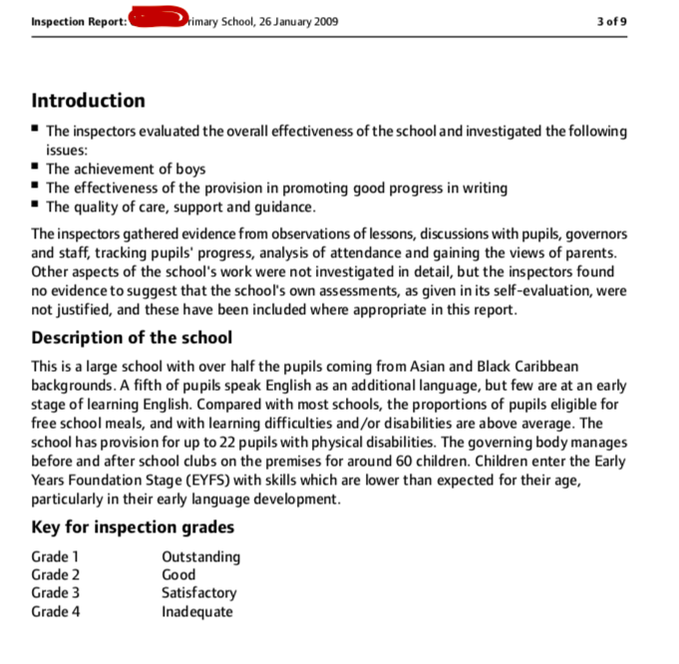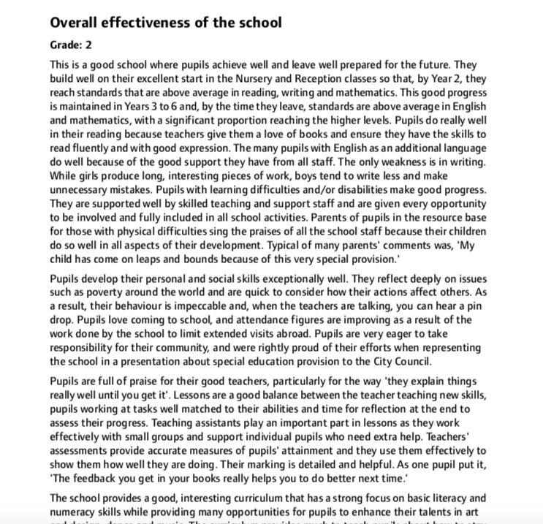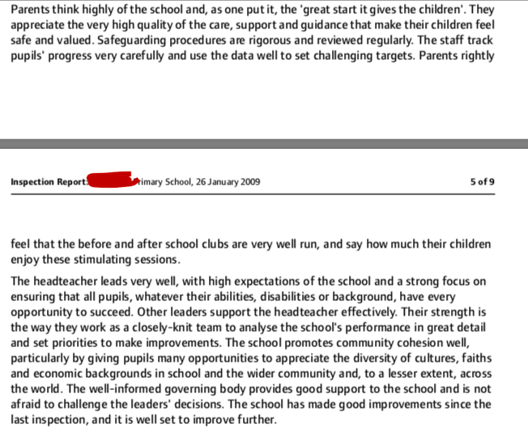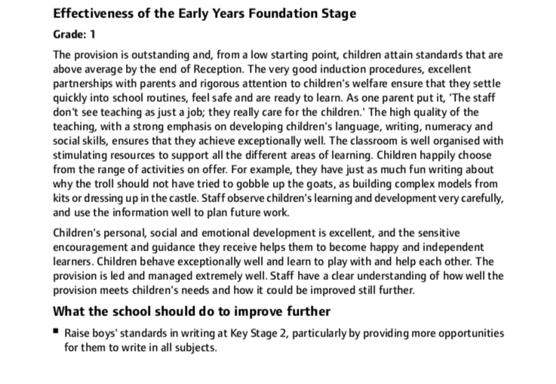

References:

Attkinson, T. and Claxton, G. (2000) The Intuitive Practitioner Buckingham. Open University Press

British Educational Research Association (2018) Ethical Guidelines for Educational Research. Fourth Edition Available at: https://www.bera.ac.uk/publication/ethical-guidelines-for-educational-research-2018 (Accessed October 1st 2020)

Bodrova, E., Leong, D., Germeroth, C., and Day-Hess, C. (2019) Leading children in their “Leading Activity” PLAY. Cambridge. Cambridge University Press
Brookfield, S. (1998) Critically Reflective Practice. The Journal of Continuing Education in the Health Professions, Volume 18

Callaghan, James, (1976)'A rational debate based on the facts'
Speech at Ruskin College, Oxford. Available at: http://www.educationengland.org.uk/documents/speeches/1976ruskin.html (Visited 25th October 2020)

Cohen, L, Manion, L and Morrison, K (2018) Research Methods in Education 8th Edition. Oxon. Routledge.

Collard, P. (2016) Chief Executive of Creativity, Culture and Education. What is a creative education and why is it important? Available at: https://www.youtube.com/watch?v=yiy7ZRSHauE (Accessed October 13th 2020)

Corsaro, W. (2000) Easy childhood education, children’s peer cultures and the future of childhood, European Early Childhood Education Research Journal 8:2, 89-102.

Dewey, J. (1938) Experience and education. New York. Simon and Schuster

Donaldson, G (2015) Successful Futures Independent Review of Curriculum and Assessment Arrangements in Wales Available at: https://gov.wales/sites/default/files/publications/2018-03/successful-futures.pdf (Accessed October 1st 2020)

Ecclestone, Kathryn and Hayes, Dennis (2019) The Dangerous Rise of Therapeutic Education. Classic Edition. Routledge. Oxon.

Elkind, D. (2001) The hurried child: Growing up too fast too soon (3rd Edition)?? 25th Edition. Cambridge, MAL Da Capo Press

Erikson, E (1950) Childhood and Society Middlesex. Penguin Books

Fonagy, P (2016) What is Mentalization? Available at: https://youtu.be/MJ1Y9zw-n7U (Accessed October 10th 2020)

Freud, S. (1922/1961) Beyond the pleasure principle. New York. W. W. Norton

Guldberg, H (2009) Reclaiming Childhood. Freedom and Play in an age of fear. Oxon. Routledge

Holzman, Louis (2009) Vygotsky at work and play, New York. Routledge.

Hong, S., Shaffer. L., Han, J. (2016) Reggio Emilia Inspired Learning Groups: Relationships, Communication, Cognition, and Play Early Childhood Ed. New York. Springer

Howard, C. Burton, M. and Levermore, D. (2017) Children’s Mental Health and Emotional Well-being in Primary Schools, a Whole School approach. 2nd Edition London. Sage

Hume, C. (2016) Wales still worst in the UK education tests BBC 6th December 2016

Isen, A., M., Daubman, K. A., & Nowicki, G. P. (1987). Positive affect facilities creative problem solving. Journal of Personality and Social Psychology, 52, 1122-1131

Istomina, Z., M. (1977) The development of voluntary memory in preschool-age children. In M. Cole (Ed). Soviet Development psychology New York. M. E. Sharpe

Johnson, J. Eberle, S., Henricks, T., and Kuschner, D. (2015) The Handbook of the Study of Play Volume II. Maryland. Rowman & Littlefield

Kahneman, D (2012) ‘Thinking Fast and Slow’ UK. Penguin Books

Krechevsky, M. (2001). Form, function, and understanding in learning groups: Propositions from the Reggio classrooms. In Project Zero & Reggio Children (Eds.), Making learning visible: Children as individual and group learners Cambridge, MA: Reggio Children.

Laevers, F (2000) Forward to basics! Deep-Level Learning and the Experiential Approach. An International Research Journal. Volume 20, 2000 - Issue 2

Lazarus, M. (1883). About the attractions of play. Berlin: F. Dummler

Leonard, Jack (2011) Using Bronfenbrenner’s Ecological Theory to Understand Community Partnerships: A Historical Case Study of One Urban High School. Sage.

Lillard, A. S., Lerner, M. D., Hopkins, E. J., Dore, R. A., Smith, E. D., and Palmquist, C. M. (2013) The impact of pretend play on children’s development: A review of the evidence. Psychological Bulletin, 139

Manuilenko, Z. V. (1975/2014) The development of voluntary memory in preschool-age children. In M. Cole (Ed). Soviet Development psychology New York. M. E. Sharpe

Mautner, K (2020) Anna Freud Centre for Children and Families 'How play can be an important self-care strategy for young adults' https://youtu.be/0pOVlmpjqZ0 (Accessed on 14th October 2020)

Piaget, J. (1962). Play, dreams and imitation in childhood. London. Routledge & Kegan Paul Ltd
Pyle, A., & Daniels, E. (2017) A continuum of play-based learning: The role of the teacher in play-based pedagogy and the fear of Hijacking play. Early Education and Development Vol. 28, No. 3. Routledge

Rubin, K. H., Fein, G., & Vandenberg, B. (1983) Play. In E. M. Hetherington (Ed.) Handbook of child psychology, vol 4: Socialization, personality and social development. New York; Wiley

Scott, F (2019) Troublesome Binaries. Play and learning on Screen and Off. The Cambridge Handbook of Play. Cambridge. Cambridge University Press

Siraj, Iram and Mayo, Aziza. (2014) 'Social Class and Educational Inequality’
Cambridge. Cambridge University Press.

Stigler, J. W., Gonzales, P., Kawanaka, T., Knoll, S., & Serrano, A. (1999). The TIMSS Videotape Classroom Study: Methods and findings from an exploratory research project on eighth-grade mathematics instruction in Germany, Japan, and the United States Washington, Government Printing Office

Tripp, David (1993) Critical Incidents in Teaching Oxon. Routledge.

UNCRC (1989) Convention on the Rights of the Child Available at: https://www.unicef.org.uk/what-we-do/un-convention-child-rights/ (Accessed October 19th 2020)

UNICEF (2020) Worlds of influence: Understanding what shapes child well-being in rich countries. Available at: https://www.unicef.org/reports/worlds-influence-what-shapes-child-well-being-rich-countries-2020 (Accessed October 21st 2020)

Vygotsky, L. S. (1978) Mind in society: The development of higher mental processes. Cambridge, M.A: Harvard University Press

Wainwright, N. Goodway, J. John, A., Thomas, K. Piper, K., Williams, K. & Gardener, D. (2019) Developing children’s motor skills in the Foundation Phase in Wales to support physical literacy, Education 3-13, Issue 5. Routledge

Well-being of Future Generations Act (2015) Available at: https://www.futuregenerations.wales/about-us/future-generations-act/ (Accessed October 15th 2020)

Welsh Government (2015) Foundation Phase Framework Available at: https://gov.wales/sites/default/files/publications/2018-02/foundation-phase-framework-revised-2015.pdf (Accessed October 17th 2020)

Welsh Government (2018) Achievement of 15 year olds in Wales: PISA 2018 National Report. Available at: https://gov.wales/sites/default/files/statistics-and-research/2019-12/achievement-15-year-olds-program-international-student-assessment-pisa-national-report-2018_0.pdf (Accessed October 20th 2020)

Whitehead, M. (2010) Physical Literacy Throughout the Lifecourse. Oxon Routledge

Wim J.C.M. van de Grift, Chun, J. Maulana, R., Lee, O. & Helms-Lorenz, M (2017) Measuring teaching quality and student engagement in South Korea and The Netherlands, School Effectiveness and School Improvement. UK. Informa

Wood, Elizabeth and Attfield, Jane (2005) Play, Learning and the Early Childhood Curriculum. Second Edition. London. Sage.

