Entreprenurial Innovation

Lauren Howells

2110727

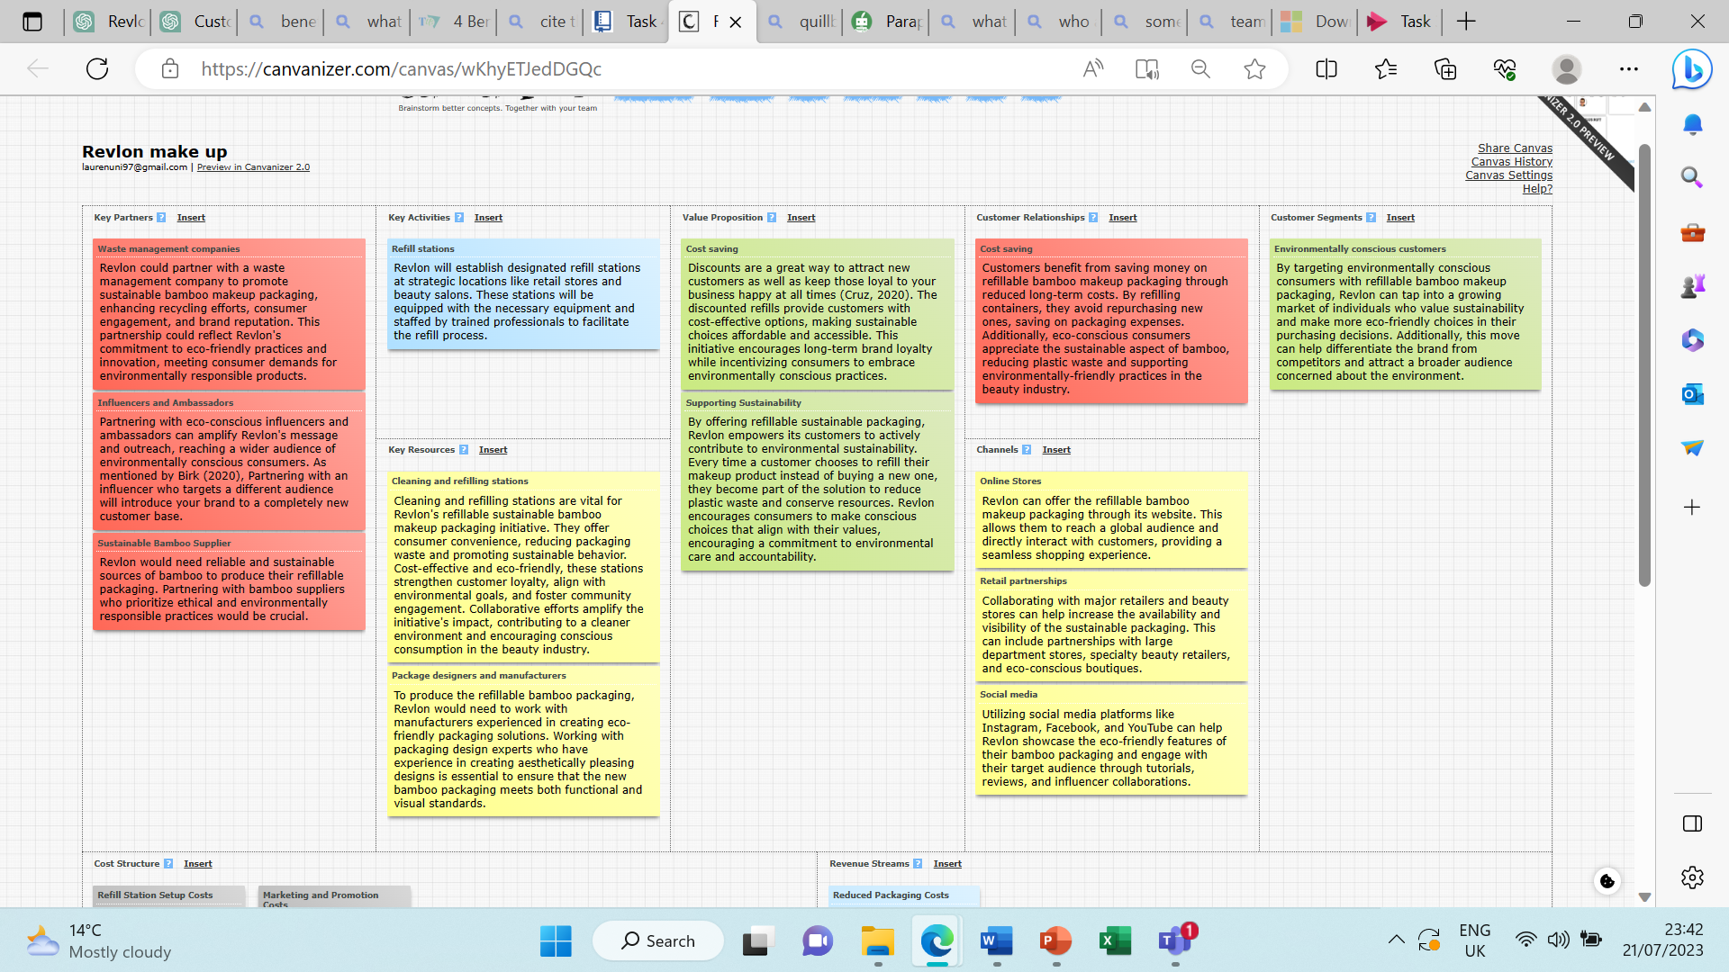

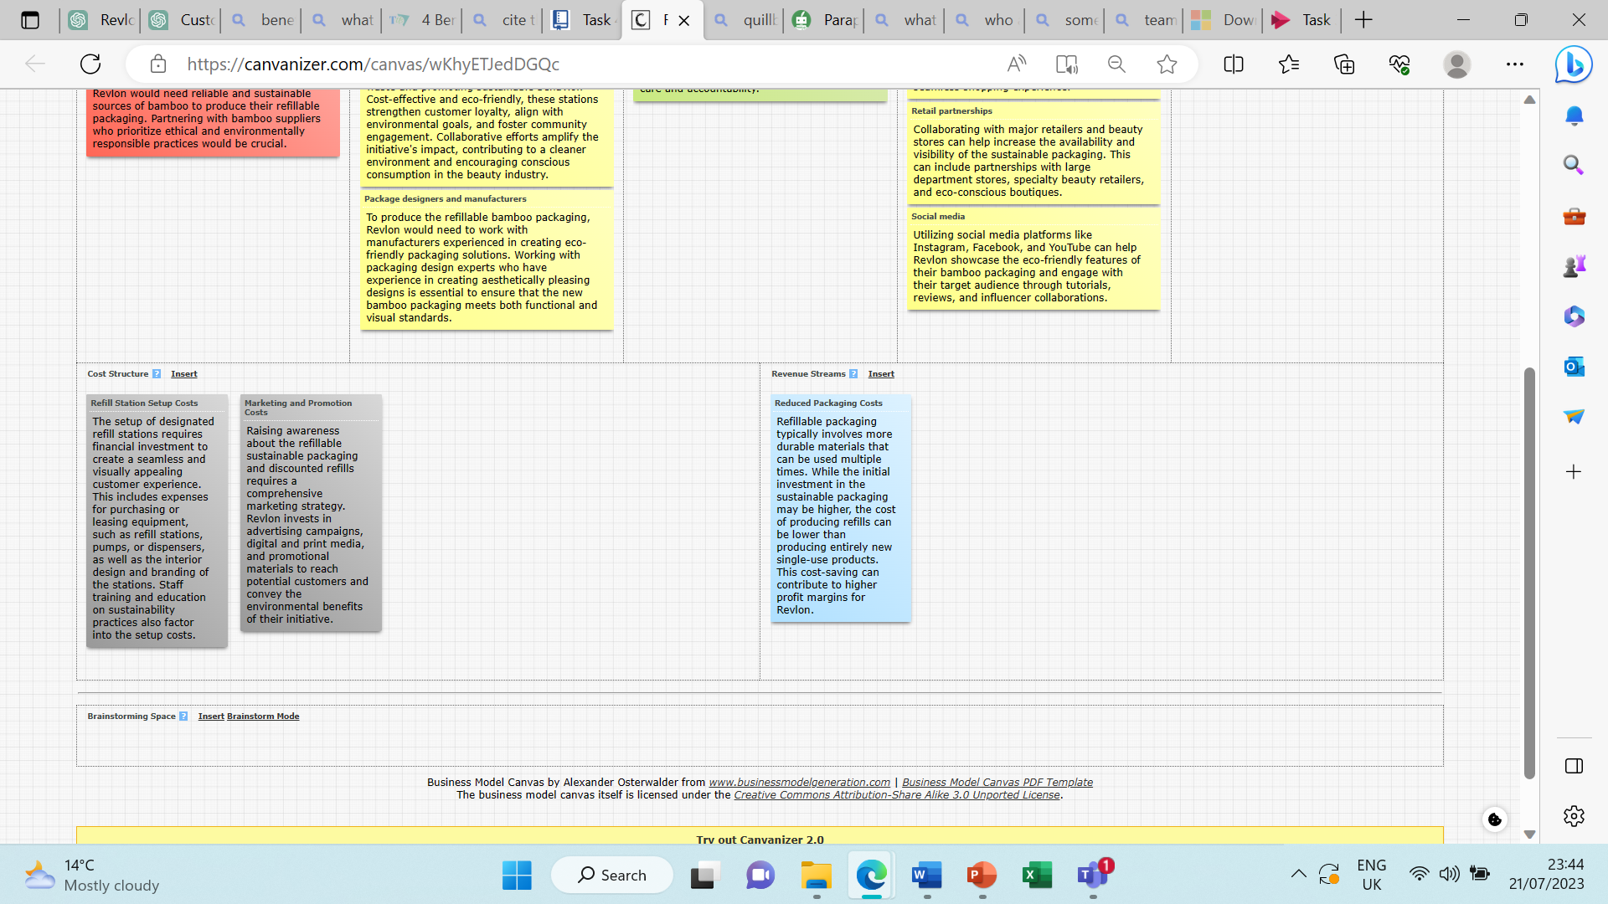

Presentation link

Pitch-20230721_235035-Meeting Recording.mp4 (sharepoint.com)

References

Birk, H. (2020) 4 benefits of partnering with an influencer to grow your brand " Trending us, Trending Us. Available at: https://www.trendingus.com/benefits-of-influencer-partnerships/ (Accessed: 01 May 2023).
Cruz, V. (2020) 4 benefits of offering discounts to customers + advice on how to do it!, Market Business News. Available at: https://marketbusinessnews.com/benefits-offering-discounts-customers-advice-how-to-do-it/247475/ (Accessed: 01 May 2023).

