
Student Name | Jaspreet Kaur
Student ID | 2540478

Task 1 – Reading Task Template
Upload your photo of your A3 in-class notes here:
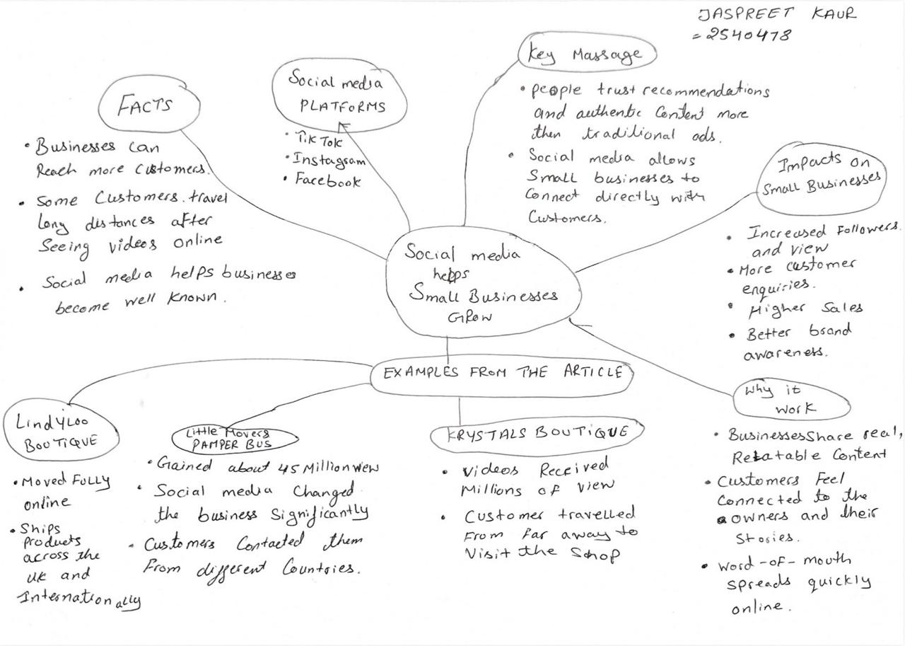

1. Answer these questions using the sentence starters below
a. What is the main idea of the text?
The main idea is that social media helps small businesses attract customers, increase their visibility, and grow their businesses.
b. What are two key points?
One key point is that platforms such as TikTok, Instagram, and Facebook allow businesses to reach large numbers of people quickly.
Another key point is that social media content can encourage customers to travel long distances or make purchases after seeing products and services online.
c. What part of the text did you find most important? Why?
The most important part is the examples of real business owners who improved their businesses through social media because it shows how online marketing can have a real impact on success.
d. Was anything unclear or difficult to understand?
I was not sure about how social media algorithms help some videos become more popular than others.
e. How did your group help you understand the text better?
My group helped me by discussing the main ideas, sharing notes, and explaining information that I had missed while reading.
3. One sentence reflection
Question: What did you find challenging about this task?
The hardest part was selecting the most important information from the text and turning it into clear notes.

