Gethin Purton 2406302

Apprenticeship in Computing (Data and Information Systems)
Introduction to Web and Database Concepts
HTML & CSS Web Development

Contents
Introduction 2
Requirements 2
Implementation 3
Validation 5
HTML Validation 5
CSS Validation 6
Evaluation 7
Website usability 7
Accessibility 7
Search Engine Optimisation 7
Provide an evaluation of your completed website 8
Search Engine Optimisation Applied to ACME Corporation 10
Web Content Accessibility Guidelines (WCAG) 10
Evaluation of the website from an external source 11
Evaluation of Acme Corporation Website 11
Appendices 15
CSS 15
Index / Homepage 18
About Us 20
Contact Us 23
Safety Notices 25
Product 27

Introduction

This report is designed to document the process and report upon the website I have created for this assignment, showcasing the requirements, the implementation of HTML and CSS and evaluation of my code and the website I have created.

Requirements
The requirements of the Acme Corporation website are designed for the fans of the Warner Bros. cartoon series, Looney Tunes. The website is designed to bring back nostalgia of the golden era of cartoons that were prevalent in the sixties. I designed the site around the ‘whacky’ nature of the fictious company Acme Corporation which is a staple in the franchise. The company is mainly known from the classic Wile E. Coyote and Road Runner sketches, the company provides an array of whacky gadgets to aide Wile E. in his pursuit of the Road Runner, mainly ending up failing in slap stick humour.
As the Looney Tunes franchise has evolved since it was first established in the 1930’s, Acme’s presence has expanded from the classic Wile E and Road Runner sketches. It has become a recurring entity throughout the incarnations in the show. Appearing in iconic episodes of the show starring other fan favourite characters such as Bugs Bunny and Daffy Duck. Some uses involving these characters are Acme’s portable holes, exploding carrots and many more. The company’s unique charm and whacky ideas bring charm to the Looney Tune Universe.

The aim of my website was to capture the nostalgia and excitement for any fan, who appreciated the clever humour and timeless enjoyment from the classic cartoons.

Implementation
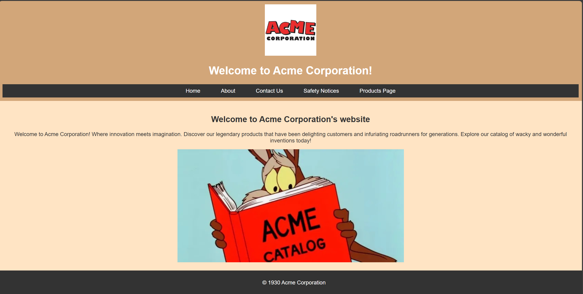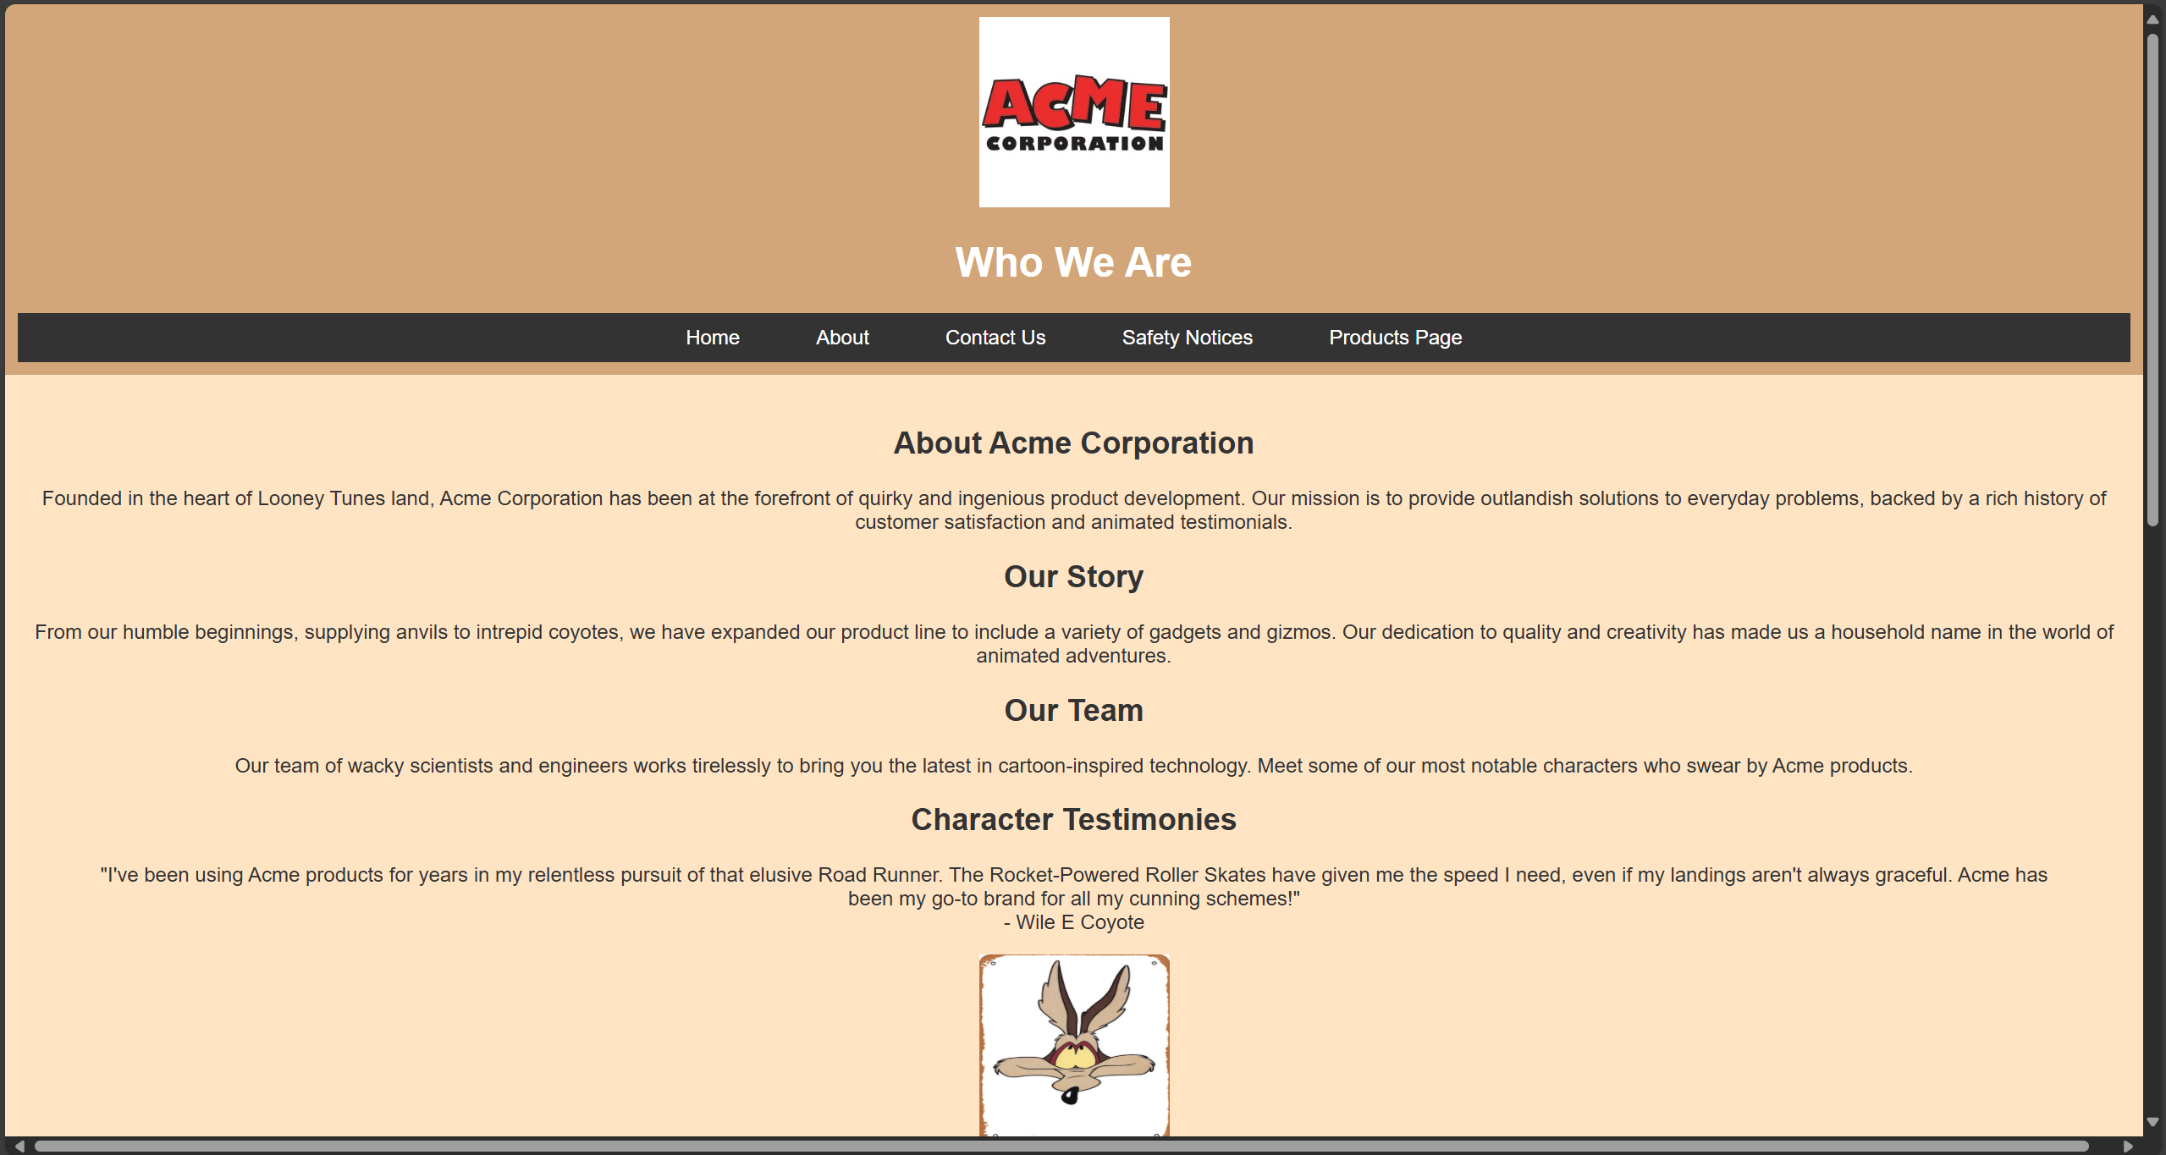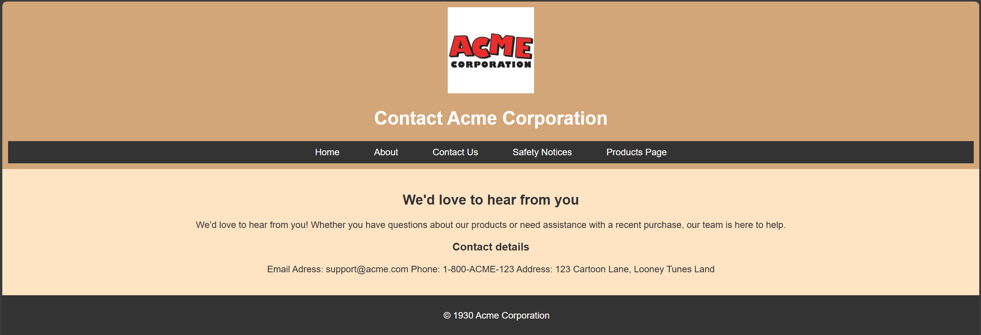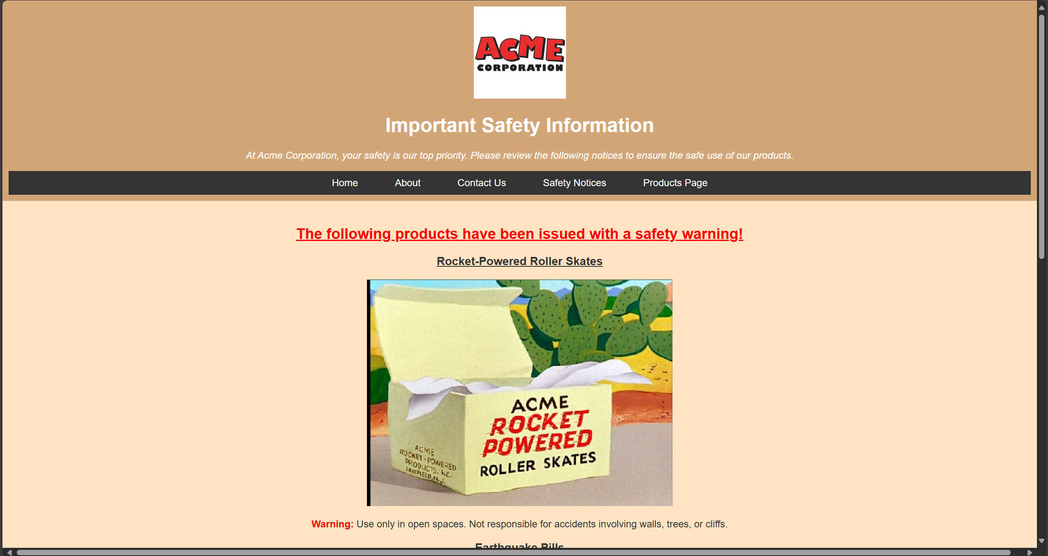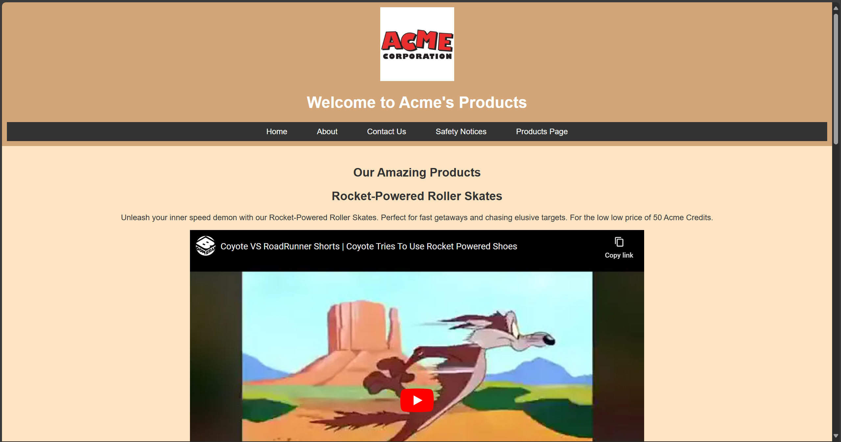

Validation

HTML Validation
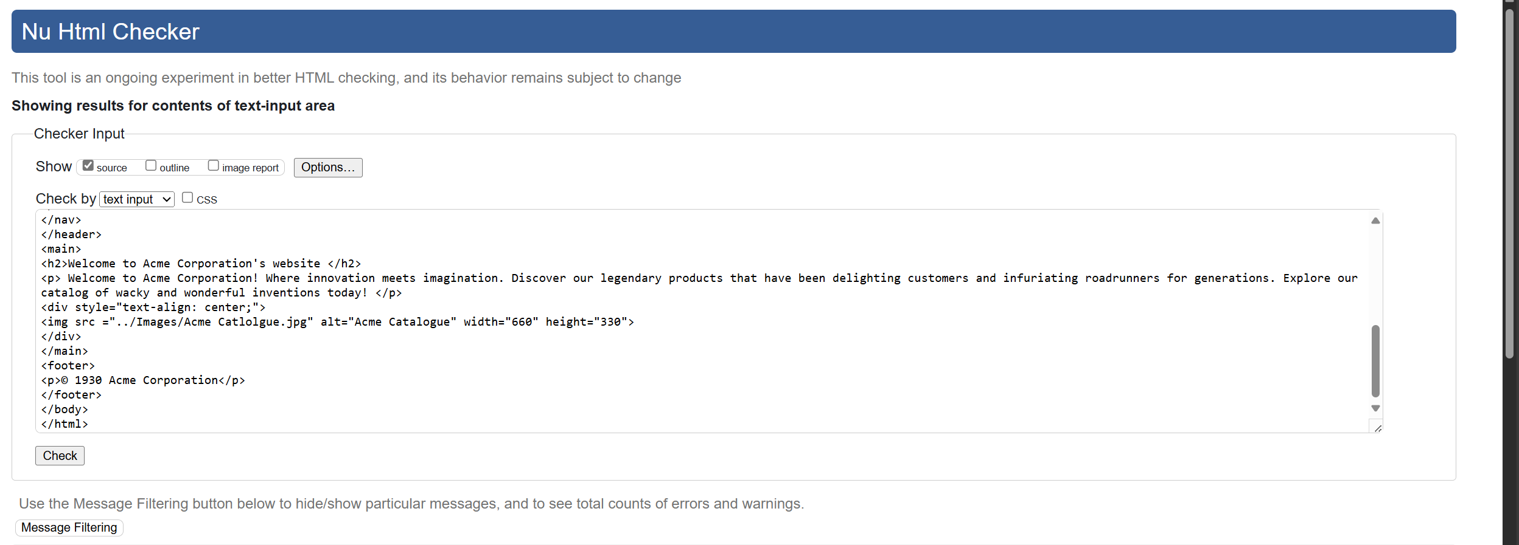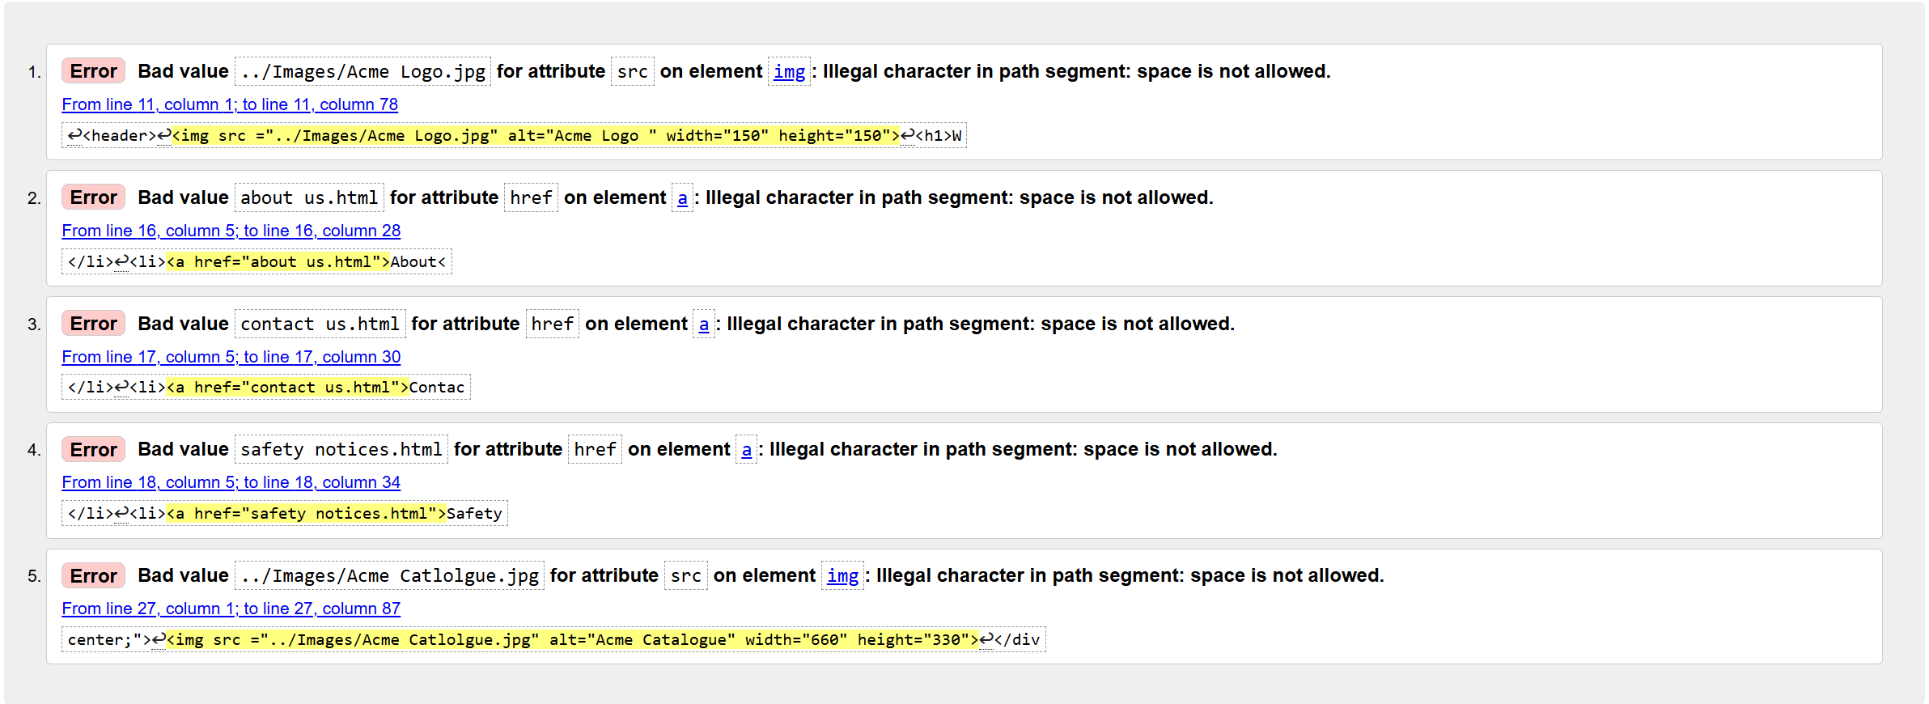
The above sceenshots show me validating my HTML code with https://validator.w3.org/, as you can see I have made some errors with putting spaces where there shouldn’t be.
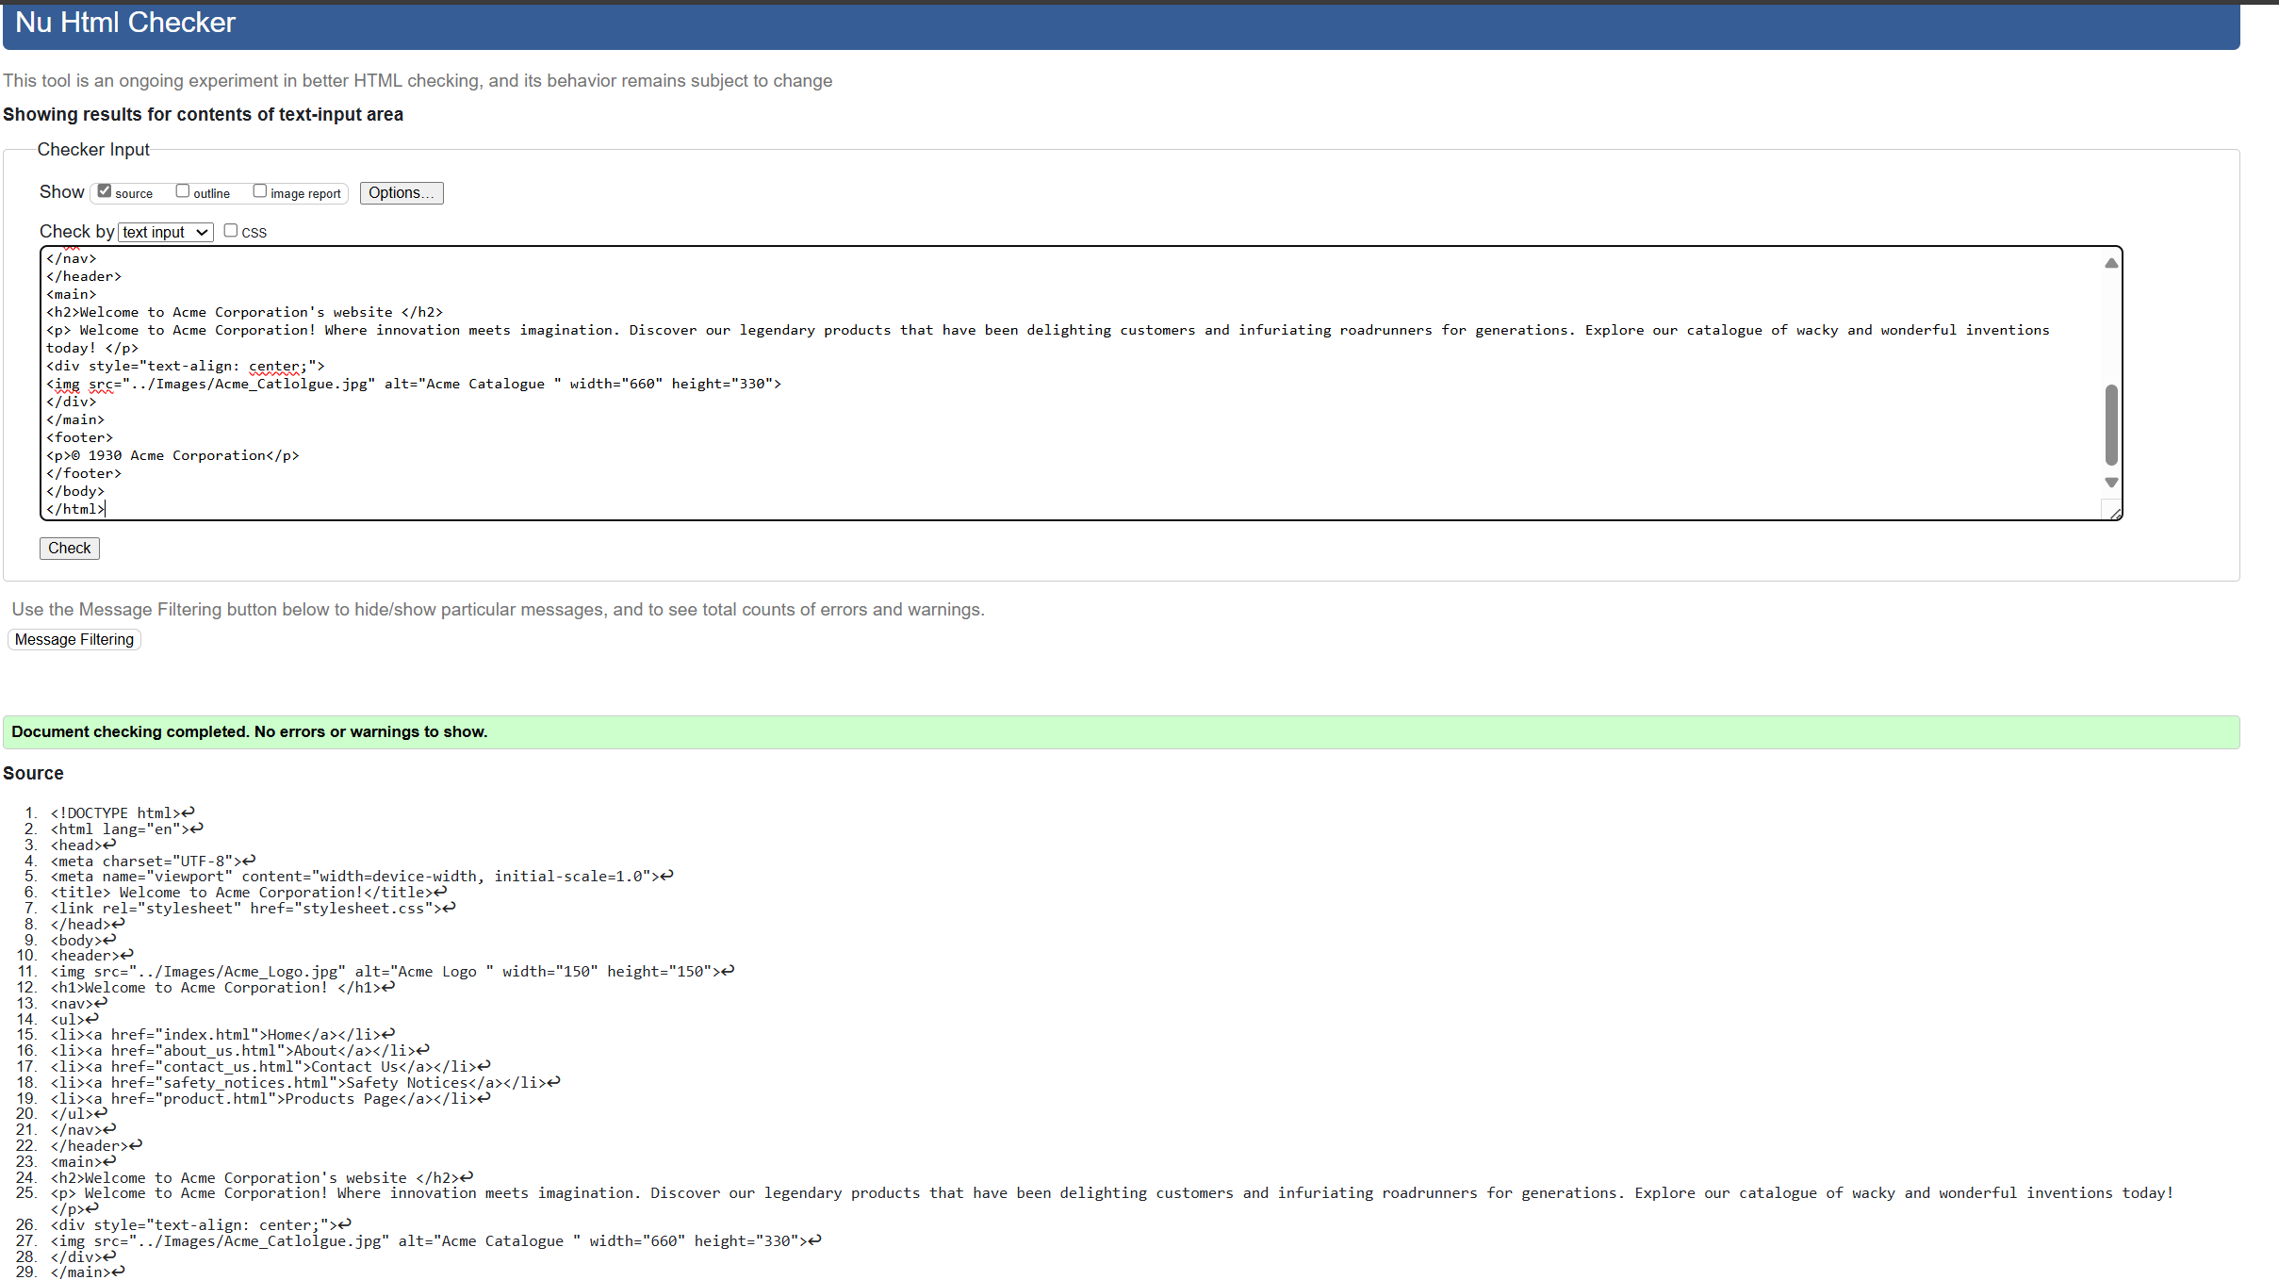The above screenshot shows me going back into the HTML checker and rechecking my code once I made the changes necessary. How I correct the error was by going back into my code and finding where the error in the code was and correcting it. In this case, it was that I had use a space when directing to other pages instead of having it as e.g. contact_us.

CSS Validation
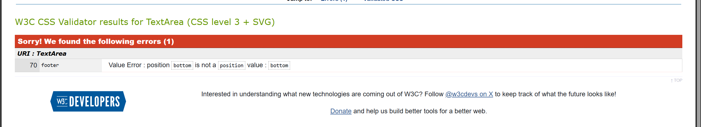
The above screenshot shows that there is an error in my CSS code when putting into the CSS validator http://jigsaw.w3.org/css-validator/ , I have put in a wrong bit of code to get my footer to be at the bottom of the page and styled.
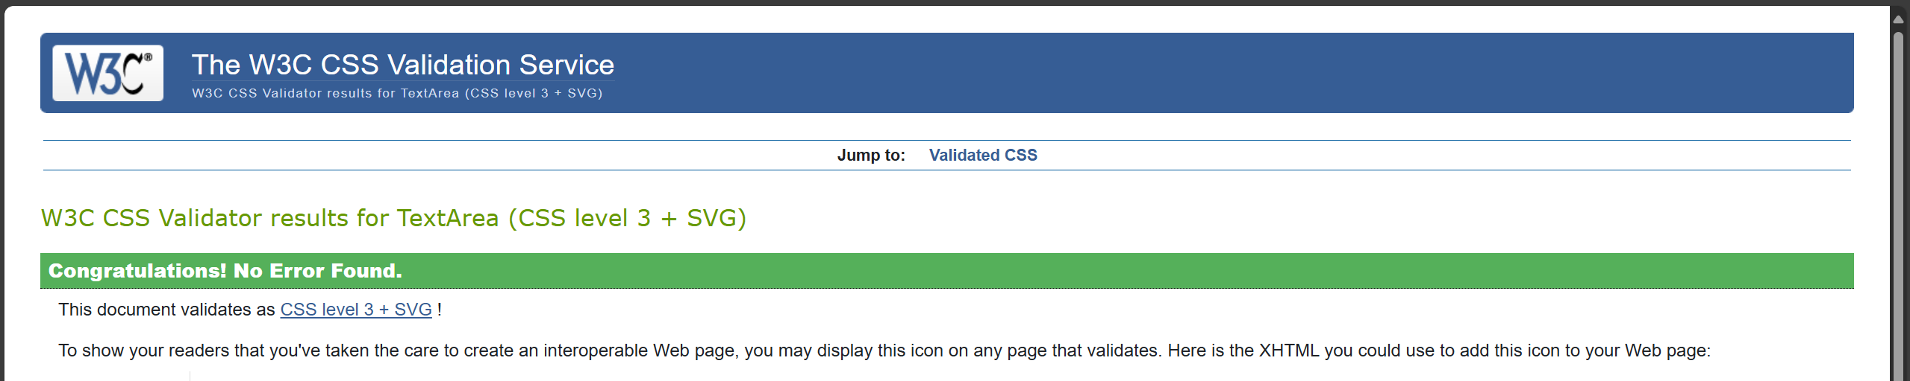
The above screenshot shows that I have gone back and corrected the mistake and revalidated the code, getting a congratulations from the checker that it didn’t find an issue with my code. How I corrected the error was by getting the position to be correct, I had the position as bottom which is not valid. Instead, I went back and corrected my code. To see the correction of the CSS please see the appendices.

Evaluation

Website usability
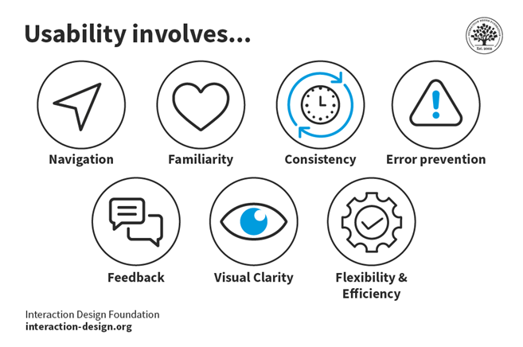[1]
Website usability is broken down into several key aspects. 1) Navigation. Is the website easy for the consumer to navigate and not get lost. 2) Visual Clarity. Is the website easy on the eyes? E.g. are there any distracting elements like animated gifs that create visual noise, stopping the consumer from getting where they need to. And 3) Consistency. Is the design of the website consistent with other pages? For example, if one page had a green header and a green banner on a white background, you wouldn’t expect the next page to be all black with red text on yellow banner and header. [1]

Accessibility
“Web accessibility means that websites, tools, and technologies are designed and developed so that people with disabilities can use them.” [2]

With web accessibility, you need to keep in mind that some people maybe visually impaired or may have other impairments. It’s good to consider how your website will look to someone who is Red Green colourblind as an example. Another consideration would be how the website is navigated and how interactive it is as some consumers may be physically impaired.

Search Engine Optimisation
“Moreover, using meta keywords can be seen as a spam signal, potentially hurting your SEO efforts rather than helping them. As of 2023 and beyond, meta keywords have no importance in SEO.” [3]
As technology has evolved and so have web standards, search engines employ a wide array of techniques to be able to read the content of a webpage and pull up the results
An example of how keywords would be put into the HTML code to help the search engine find your website is below.
<meta name="keywords" content="food, dog, cat, pet, care, pet care">

Provide an evaluation of your completed website
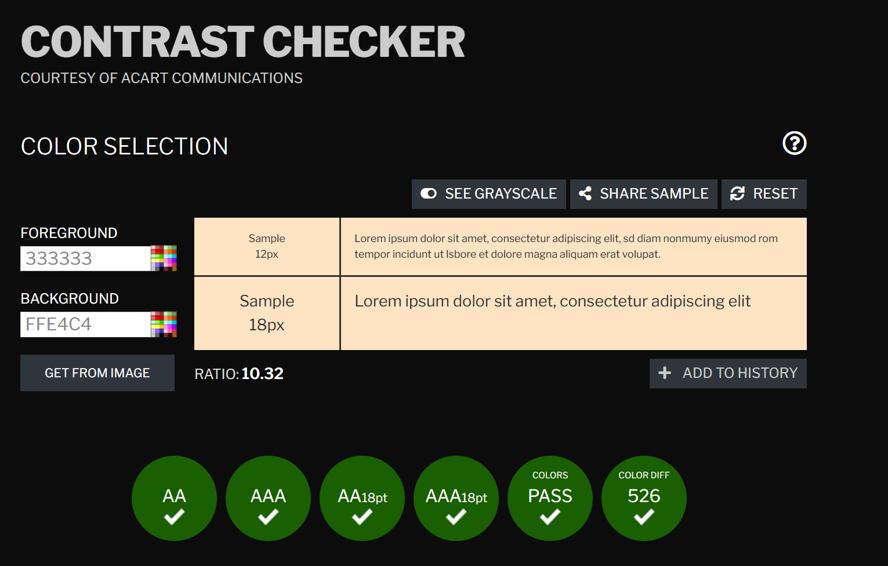
I used WCAG - Contrast Checker to check my websites colour to see if there were any issues with the colour scheme, the screenshot above shows the background colour and the foreground colour (the text) which is not bringing back any issues.
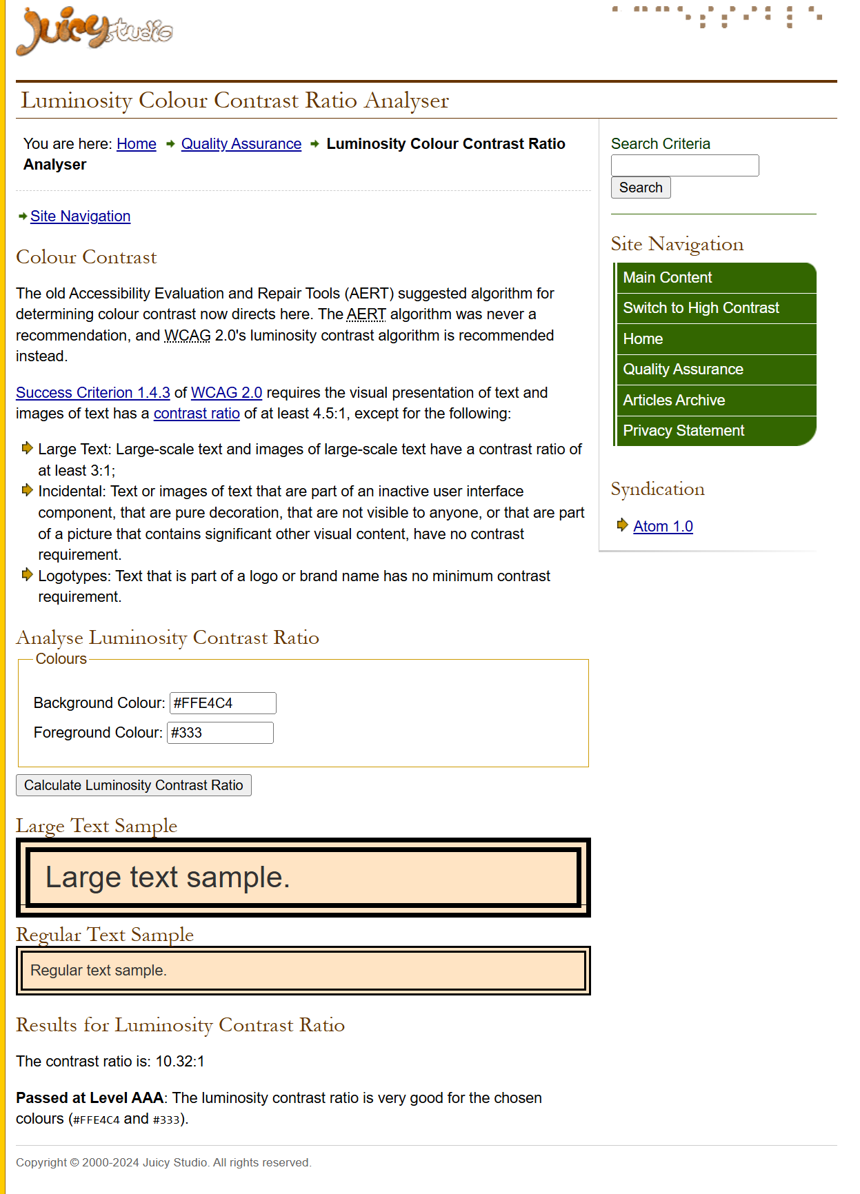
I used http://juicystudio.com/services/luminositycontrastratio.php to get luminosity score to see if it would impact anyone that has visual impairments e.g. Colour Blindness.

Search Engine Optimisation Applied to ACME Corporation
For my website, as it’s not a published website I have not embedded any code to help users search for it. However, if I was to publish the website as it is, I would trust that due to modern technology and how far search engines have improved, anyone would be able to find it by searching terms like “Acme” “Wile E Coyote” and “Bugs Bunny.”

To do this I could either rely on search engines scraping my site for its details, it would be able to scrape the <title> tag in my web pages as well as <header>, <body> and so on. Or I could hard code into every webpage I have for my website, below is an example that would go into my website.
<meta name="keywords" content="Looney Toons, ACME, Looney Tunes Characters, Bugs Bunny, Wile E Coyote.">

Web Content Accessibility Guidelines (WCAG)
“Web Content Accessibility Guidelines (WCAG) 2.1 defines how to make Web content more accessible to people with disabilities. Accessibility involves a wide range of disabilities, including visual, auditory, physical, speech, cognitive, language, learning, and neurological disabilities.”[4]

With the above quote taken from W3C, I used a wide array of tools to make sure that my website is as accessible with my current skill set. Using the JuicyStudio website, I was able to check that my colour scheme for Acme Corporation was good.

Evaluation of the website from an external source

I wanted to get a fresh pair of eyes to look at my website as I would be bias to my own work, so I asked my partner to be a critical as he wanted to be to review my website. I created a word document like the website comparison document we had in class. Below are the questions and my partners responses.

Evaluation of Acme Corporation Website
Website Design and Layout
- How does the website look visually (colors, fonts, images)? – The website has a consistent colour scheme, in keeping with the company that it is based on. The fold is easily legible and clear. The images are large and clear, and are related to the company the site is based upon

- Is the layout clean, modern, and easy to understand – The layout is clear, without unnecessary clutter, and keeps a very good level of visual clarity throughout. It is laid out in a contemporary fashion, in keeping with other sites that are developed and used currently.

- Are the menus, buttons, and links placed logically? - Menus are laid out well, meaning that navigation is simple and all menu tabs are labelled well, meaning the site is easy to navigate and understand. One suggestion for improvement is to not use underlines on body text, as these can be misinterpreted as links.

- Is the layout clear or cluttered? - The layout is clear, laid out logically and does not feel ‘crowded’ or ‘cramped’.

- Are design elements (e.g., images, fonts) appropriate a fictious company? – The design elements in use are somewhat basic, but are appropriate for the company chosen as the basis for the site.

Your Observations:
- Pros: Clear, easy to navigate. Easy to read, and has an appropriate coloir scheme and design language that is in keeping with the company the site is based upon.
- Cons: Use of underlined text in the body of the website, meaning that some text can be misinterpreted as hyperlinks.

Ease of Navigation
- How intuitive is the website? – Due to the layout, clarity of the tabs and menu buttons, the website is intuitive to use for people comfortable with navigating the web. This also applies to people who may be less comfortable, as the site is clear and easily navigable even for the layman.
- Is it easy to find information about the Acme Corporation? – There is a clearly marked, dedicated tab/menu for an ‘About’ section, meaning information is easily accessible.
Your Observations:
- Pros: Well-labelled, clearly marked tabbed menus.

- Cons: Potentially some even cleared delineation around the menu tabs to indicate they are separate buttons
Clarity of Information
- Is the information about Acme Corporation, pricing on products, and character testimonies easy to understand? – Information on products is readily available. The pricing information could be clearer, as it is currently in-line with the product description. Character testimonies are on a separate page, and thus are clear to read due to the fact the are not cluttered by other site content.

- Are key details like products, safety notices, or contact details presented well? – Safety notices are kept on a separate page, and are clear to read and well-presented. Product information is somewhat clear, as it is presented in small body text above product videos. Contact details are presented in-line on their own page.

Your Observations:
- Pros: Clear, easy to access testimonials, contact details and product videos.

- Cons: Product information could be clearer. Pricing information does need to be clearer.

Overall User Experience
- Did you find the overall experience enjoyable or frustrating? Why? – Overall, the experience is mostly positive. The site is easy to navigate, clear to read and understand, and has a nice colour scheme that compliments the company choice well.

- Did the website load quickly, and did navigating between the pages flow smoothly? – The website loads very quickly, and navigating between pages is also quick as they are all low in size.

Your Observations:
- Pros: Quick to navigate, good user experience

- Cons: Some areas of the site do need improvement, ie the product page.

References
[1] "What is Usability - The Ultimate Guide — updated 2024." https://www.interaction-design.org/literature/topics/usability (accessed Dec 9).
[2] W. W. A. Initiative (WAI). "Introduction to Web Accessibility." https://www.w3.org/WAI/fundamentals/accessibility-intro/ (accessed Dec 9).
[3] "Meta Keywords: Are They Still Relevant for SEO?" https://marketing-assets.surferseo.art/wf-cdn/62666115cfab453aacbd513c/66c3a900b3c4ff18c9a6207c_c9cf5f6e4fd3e273d6e98b3d4d5f7ea52149969c.png (accessed Dec 9).
[4] Alastair Campbell (Nomensa), et al., "Web Content Accessibility Guidelines (WCAG) 2.1," Accessed: Jan 1, 2025, [Online]. Available: https://www.w3.org/TR/WCAG21/

Appendices

CSS

/* General Body Styling */
body {
font-family: Arial, sans-serif;
background-color: #FFE4C4;
color: #333;
margin: 0;
padding: 0;
}

/* General Header Styling */
header {
background-color: #D2A679;
color: white;
padding: 10px;
text-align: center;
position: relative;
}

/* Logo Styling */
header .logo {
position: absolute;
top: 10px;
left: 10px;
height: 50px;
width: auto;
}

/* Navigation Menu */
nav ul {
list-style-type: none;
padding: 0;
margin: 0;
display: flex;
justify-content: center;
background-color: #333;
}

nav ul li {
margin: 0 10px;
}

nav ul li a {
color: white;
text-decoration: none;
padding: 10px 20px;
display: block;
transition: background-color 0.3s;
}

nav ul li a:hover {
background-color: #FFDAB9;
}

/* Main Content Styling */
main {
padding: 20px;
justify-content: center;
text-align: center;

}

/*Footer Styling */
footer {
background-color: #333;
color: white;
text-align: center;
padding: 10px;
bottom: 0;
width: 100%;
}

Index / Homepage
<!DOCTYPE html>
<html lang="en">
<head>
<meta charset="UTF-8">
<meta name="viewport" content="width=device-width, initial-scale=1.0">
<title> Welcome to Acme Corporation!</title>
<link rel="stylesheet" href="stylesheet.css">
</head>
<body>
<header>
<img src="../Images/Acme_Logo.jpg" alt="Acme Logo " width="150" height="150">
<h1>Welcome to Acme Corporation! </h1>
<nav>
<ul>
<li><a href="index.html">Home</a></li>
<li><a href="about_us.html">About</a></li>
<li><a href="contact_us.html">Contact Us</a></li>
<li><a href="safety_notices.html">Safety Notices</a></li>
<li><a href="product.html">Products Page</a></li>
</ul>
</nav>
</header>
<main>
<h2>Welcome to Acme Corporation's website </h2>
<p> Welcome to Acme Corporation! Where innovation meets imagination. Discover our legendary products that have been delighting customers and infuriating roadrunners for generations. Explore our catalogue of wacky and wonderful inventions today! </p>
<div style="text-align: center;">
<img src="../Images/Acme_Catalogue.jpg" alt="Acme Catalogue " width="660" height="330">
</div>
</main>
<footer>
<p>© 1930 Acme Corporation</p>
</footer>
</body>
</html>

About Us
<!DOCTYPE html>
<html lang="en">
<head>
<meta charset="UTF-8">
<meta name="viewport" content="width=device-width, initial-scale=1.0">
<title> About Acme Corportation </title>
<link rel="stylesheet" href="stylesheet.css">
</head>
<body>
<header>
<img src ="../Images/Acme_Logo.jpg" alt="Acme Logo " width="150" height="150">
<h1>Who We Are</h1>
<nav>
<ul>
<li><a href="index.html">Home</a></li>
<li><a href="about_us.html">About</a></li>
<li><a href="contact_us.html">Contact Us</a></li>
<li><a href="safety_notices.html">Safety Notices</a></li>
<li><a href="product.html">Products Page</a></li>
</ul>
</nav>
</header>
<main>
<h2>About Acme Corporation </h2>
<p> Founded in the heart of Looney Tunes land, Acme Corporation has been at the forefront of quirky and ingenious product development. Our mission is to provide outlandish solutions to everyday problems, backed by a rich history of customer satisfaction and animated testimonials. </p>
<h2>Our Story </h2>
<p>From our humble beginnings, supplying anvils to intrepid coyotes, we have expanded our product line to include a variety of gadgets and gizmos. Our dedication to quality and creativity has made us a household name in the world of animated adventures.</p>
<h2>Our Team</h2>
<p>Our team of wacky scientists and engineers works tirelessly to bring you the latest in cartoon-inspired technology. Meet some of our most notable characters who swear by Acme products.</p>
<h2>Character Testimonies</h2>
<blockquote>
"I've been using Acme products for years in my relentless pursuit of that elusive Road Runner. The Rocket-Powered Roller Skates have given me the speed I need, even if my landings aren't always graceful. Acme has been my go-to brand for all my cunning schemes!" <br> - Wile E Coyote
</blockquote> <img src ="../Images/Wile Head.jpg" alt="Wile Head " width="150" height="150">
<blockquote>
"Eh, what's up, Doc? When it comes to outsmarting my foes, Acme's Portable Holes are a real lifesaver. Just plop one down and hop to safety! Plus, their Earthquake Pills add a whole new level of chaos to my adventures. Thumbs up from this bunny!" <br> - Bugs Bunny
</blockquote> <img src ="../Images/Bugs Head.jpg" alt="Bugs Head " width="150" height="150">
<blockquote>
"You're despicable if you don't get your gadgets from Acme! I've had my fair share of mishaps, but Acme's wacky inventions always keep things interesting. Their Exploding Carrot Carriers and Instant Jungle Kits are must-haves for any mischievous duck!" <br> - Daffy Duck
</blockquote> <img src ="../Images/Daffy Head.jpg" alt="/Daffy Head " width="150" height="150">
<blockquote>
"Hunting wabbits has never been easier thanks to Acme. Their gadgets are top-notch, even if Bugs always seems to outwit me. My favorite? The Acme Decoy Ducks—they're so realistic, you can't tell the difference! Acme always delivers the goods." <br> - Elmer Fudd
</blockquote> <img src ="../Images/Elmer Head.jpg" alt="Elmer Head " width="150" height="150">
<blockquote>
"Beep Beep" <br> - Road Runner
</blockquote> <img src ="../Images/Runner Head.jpg" alt="Runner Head " width="150" height="150">
</main>
<footer>
<p>© 1930 Acme Corporation</p>
</footer>
</body>
</html>

Contact Us
<!DOCTYPE html>
<html lang="en">
<head>
<meta charset="UTF-8">
<meta name="viewport" content="width=device-width, initial-scale=1.0">
<title> Contact Us Page </title>
<link rel="stylesheet" href="stylesheet.css">
</head>
<body>
<header>
<img src ="../Images/Acme_Logo.jpg" alt="Acme Logo " width="150" height="150">
<h1>Contact Acme Corporation </h1>
<nav>
<ul>
<li><a href="index.html">Home</a></li>
<li><a href="about_us.html">About</a></li>
<li><a href="contact_us.html">Contact Us</a></li>
<li><a href="safety_notices.html">Safety Notices</a></li>
<li><a href="product.html">Products Page</a></li>
</ul>
</nav>
</header>
<main>
<h2>We'd love to hear from you</h2>
<p>We’d love to hear from you! Whether you have questions about our products or need assistance with a recent purchase, our team is here to help. </p>
<h3>Contact details </h3>
<p>Email Adress: support@acme.com Phone: 1-800-ACME-123 Address: 123 Cartoon Lane, Looney Tunes Land </p>
</main>
<footer>
<p>© 1930 Acme Corporation</p>
</footer>
</body>
</html>

Safety Notices
<!DOCTYPE html>
<html lang="en">
<head>
<meta charset="UTF-8">
<meta name="viewport" content="width=device-width, initial-scale=1.0">
<title> Safety Notices </title>
<link rel="stylesheet" href="stylesheet.css">
</head>
<body>
<header>
<img src ="../Images/Acme_Logo.jpg" alt="Acme Logo " width="150" height="150">
<h1>Important Safety Information </h1>
<p><i>At Acme Corporation, your safety is our top priority. Please review the following notices to ensure the safe use of our products.</i></p>
<nav>
<ul>
<li><a href="index.html">Home</a></li>
<li><a href="about_us.html">About</a></li>
<li><a href="contact_us.html">Contact Us</a></li>
<li><a href="safety_notices.html">Safety Notices</a></li>
<li><a href="product.html">Products Page</a></li>
</ul>
</nav>
</header>
<main>
<h2><b style="color: red;"><u>The following products have been issued with a safety warning!</b></u></h2>
<h3><u>Rocket-Powered Roller Skates</u></h3>
<img src ="../Images/rocket skates.jpg" alt="Rocket Skates" width="497" height="369">
<p><b style="color: red;">Warning:</b> Use only in open spaces. Not responsible for accidents involving walls, trees, or cliffs.
<h3><u>Earthquake Pills</u></h3>
<img src ="../Images/earthquake pills.jpg" alt="Earthquake Pills" width="478" height="357">
<p><b style="color: red;">Caution:</b> Take one pill at a time. Excessive use may result in structural damage to surroundings.</p>
<h3><u>Batsuit</u> </h3>
<img src ="../Images/Batmans Suit.jpg" alt="Batmans Suit" width="500" height="374">
<p><b style="color: red;">Warning:</b> Use only in open spaces clear of any obstacles. Acme are not responsible for accidents involving walls, trees, or cliffs.</p>
</main>
<footer>
<p>© 1930 Acme Corporation</p>
</footer>
</body>
</html>

Product
<!DOCTYPE html>
<html lang="en">
<head>
<meta charset="UTF-8">
<meta name="viewport" content="width=device-width, initial-scale=1.0">
<title> Safety Notices </title>
<link rel="stylesheet" href="stylesheet.css">
</head>
<body>
<header>
<img src ="../Images/Acme_Logo.jpg" alt="Acme Logo " width="150" height="150">
<h1>Important Safety Information </h1>
<p><i>At Acme Corporation, your safety is our top priority. Please review the following notices to ensure the safe use of our products.</i></p>
<nav>
<ul>
<li><a href="index.html">Home</a></li>
<li><a href="about_us.html">About</a></li>
<li><a href="contact_us.html">Contact Us</a></li>
<li><a href="safety_notices.html">Safety Notices</a></li>
<li><a href="product.html">Products Page</a></li>
</ul>
</nav>
</header>
<main>
<h2><b style="color: red;"><u>The following products have been issued with a safety warning!</b></u></h2>
<h3><u>Rocket-Powered Roller Skates</u></h3>
<img src ="../Images/rocket skates.jpg" alt="Rocket Skates" width="497" height="369">
<p><b style="color: red;">Warning:</b> Use only in open spaces. Not responsible for accidents involving walls, trees, or cliffs.
<h3><u>Earthquake Pills</u></h3>
<img src ="../Images/earthquake pills.jpg" alt="Earthquake Pills" width="478" height="357">
<p><b style="color: red;">Caution:</b> Take one pill at a time. Excessive use may result in structural damage to surroundings.</p>
<h3><u>Batsuit</u> </h3>
<img src ="../Images/Batmans Suit.jpg" alt="Batmans Suit" width="500" height="374">
<p><b style="color: red;">Warning:</b> Use only in open spaces clear of any obstacles. Acme are not responsible for accidents involving walls, trees, or cliffs.</p>
</main>
<footer>
<p>© 1930 Acme Corporation</p>
</footer>
</body>
</html>

