

Marketing Fundamentals
  - LCBB4004

  - Programme: BABM
  - LEVEL: 4
  - CREDITS: 20
  - Student ID NO: 2247307
Module Leader: Dr Piyumika Gamaze
  - Assignment Title: Assessment 1: Individual blog
  - Word count: 1945 without executive summary, references and table of contents
  - Submission Deadline: 26/11/2023

Critical analysis and evaluation of Aldi UK’s STP and its current marketing mix strategies

Executive Summary

The follow blog was written as a coursework for Marketing Fundamentals course. The main aim of the work was to provide a critical analysis and evaluation of a chosen firm’s segmentation, targeting and positioning strategies in addition to describing the organization’s current marketing mix strategies. For the blog, Aldi UK, one of the leader discount supermarket chain was chosen. To justify the findings and critical analysis, and in order to draw a conclusion, a portfolio approach was utilized: visuals, such as own pictures, screenshots, and written commentary were used to illustrate the STP and 4P strategies of the firm.

Table of Contents

Executive Summary 3
Aldi UK 5
STP marketing 6
Aldi UK’s segmentation strategy 6
Targeting 8
Positioning 10
Aldi UK’s marketing mix 11
Products 12
Price 12
Place 13
Concluding thoughts 14
Reference List 15

Aldi UK

Aldi was founded in 1913 in Germany and started as single store. From 1961 onwards, the business has been operated as 2 groups, which together runs over 10,000 stores and is present in 11 countries. Aldi group’s marketing strategy and its success is based on an extensive and aggressive global growth. The organization employs more than 155,000 people globally. The first store in the UK was opened in 1990, and currently has nearly 1,000 stores across the country. Despite the Covid-19 hit the global economy in 2020, Aldi generated a record sale of £13.bn, a 10% increase compared to the previous year. Therefore, it decided on investing £1.3billion to open 16 further stores nationwide and create additional 2,000 jobs, with the aim of accelerating further share of the UK’s grocery market. (Aldi, 2023) Aldi UK’s market share has been growing rapidly since 2019 and currently stands at over 9%. (Statista, 2023)
Figure 1:
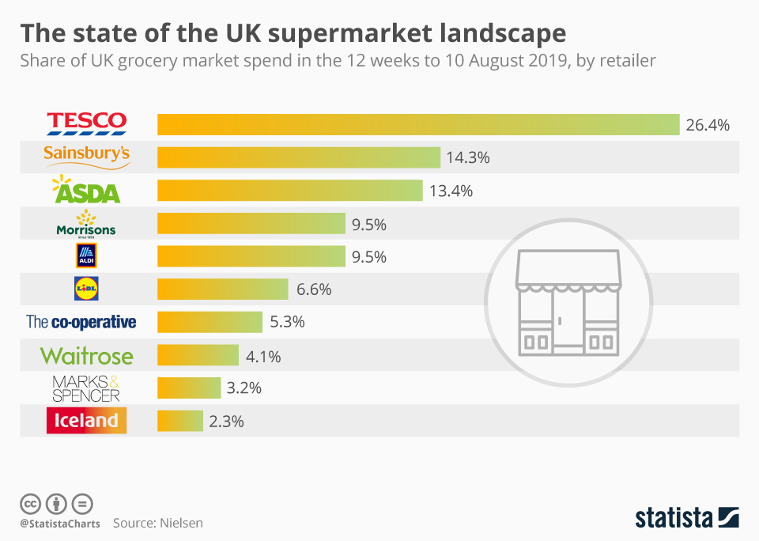
(Source: Statista, 2023)

STP marketing

In the modern business era, the STP model is widely used by firms as a strategic tool to enhance the maximum efficiency of their marketing strategies. (Kotler et al., 2017) Blythe (2014) argued that firms would be able to develop an effective marketing mix without utilizing the segmenting, targeting and positioning (STP) framework, as subdividing the entire market into smaller segments enhances the maximum efficiency of the streamlined marketing communications. Additionally, determining which segment should be targeted in order to achieve the highest conversion rate that result in higher profitability, and positioning, such as deciding on how the organization wants to be perceived by that particular targeted segment enable them to develop more efficient and relevant marketing approaches. (Jobber, 2016)

Aldi UK’s segmentation strategy

Most of the multinational firms utilize the geographic segmentation bases. Even though, according to Hooley at al. (2020), grocery store chains widely use behavioural and psychographic bases for sub-dividing the market into more homogenous segments, in which the customers’ same or similar behaviours and needs can be identified. Some of the firms have enough available resources to supply and meet the entire market’s needs. However, those firms who lack resources tend to use demographic bases as well to segment the entire market, to ensure their equipped enough to supply. (Baines et al.,2014) As a matter of international presence, Aldi group split the entire market into sub-markets geographically, such as China, US and Europe. (Mehta, 2022) Apart from the geographic segmentation, Aldi noticeable utilizes behavioural and psychographic bases to ensure streamlined marketing approaches. Aldi identified that especially in metropolitans like London, there are large number of people who tend to do grocery shopping more frequently but in small quantities. These customers do not consider the price as the main deciding factor. They seek convenience and prefer to shop at the closest location is possible. To win this group over from the rivals who have “local shops”, Aldi opened its own “Local” shops that are located in busy town centres, high streets and malls. (Tesseras, 2023)
Figure 2:
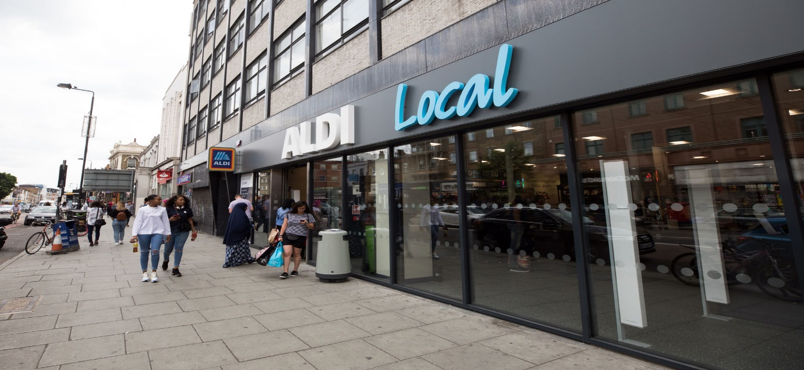
(Source: Aldi,2023)
To satisfy the needs of the technology-savvy customes, it opened the first Shop&Go store where customers can purchase goods without having to scan them. Which is also indication of a behavioural segmentation strategy. (Spanou,2022) Whilst the different store sizes and locations indicate psychographics segmentation base. (Kotler and Armstrong, 2018)
Figure 3:
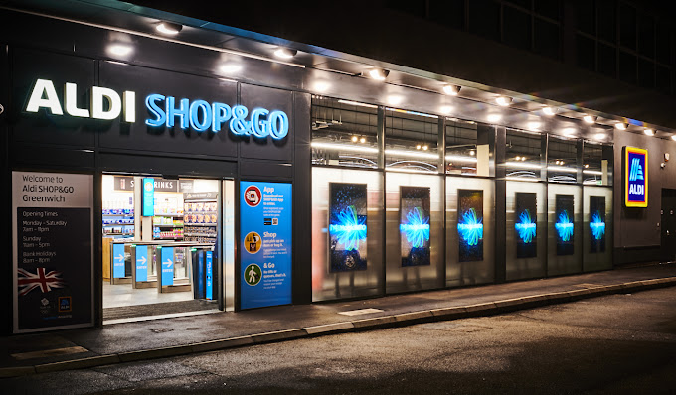
(Source: Daily Express, 2023)

Targeting

Aldi is famous from being a discounted supermarket giant that offers approximately 900 own-labelled core items, high quality at low prices. (Aldi,2023) Hooley at al. (2020) identified that supermarket chains tend to focus fulfilling a specific segment’s preferences with the aim of better cater that customer niche which has the highest profitability potential. Aldi took the lifestyles and attitudes of the consumers into account and identified those consumers as the most profitable niche, who seek low prices at high quality. Aldi offers food on the go, groceries, household items and many more. Despite this does not mean the firm would want to fully move into the convenience store market, it is a clear indication of targeting the consumer segment that seek convenience. (Tesseras, 2023)
Figure 4:
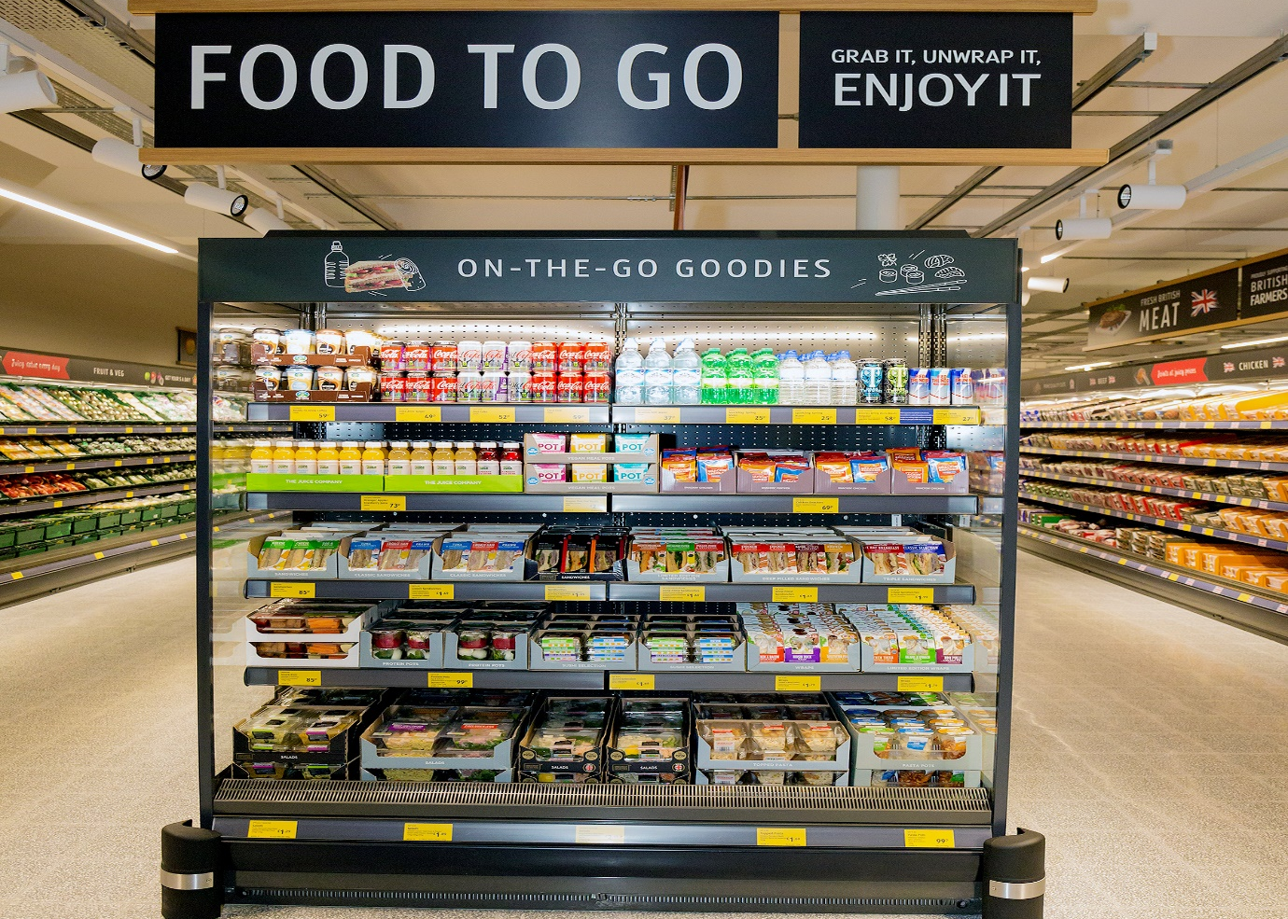
(Source: Aldi,2023)
Since the Covid-19 pandemic, the interest, inflation and unemployment rates have increased in the UK, which suggest a slight decline of the UK’s economy. (Statista,2023). The average income level and the economic indicators significantly impact on the consumers’ purchasing decision and the essential products’ demand. Krugman and Wells (2021) stated that declining or stagnating economy increases the demand for no-frill discounts. This benefitting Aldi, as the firm mainly targets the customers who seek no-frill discounts. As above explained, apart from geographic, Aldi uses psychological and behavioural bases for segmenting. Based on these segments, Aldi UK offers slightly different product range to the diverse segments, though no-frill discounts can be found in each store. (Jefferson, 2023)
As figure 5&6 illustrate, Aldi UK offers wide range of products, targeting health conscious, convenience seekers and economic shoppers. By offering high quality and low prices, the middle- and low-income level consumer groups are targeted by using segmented marketing strategy. (Metha,2022)
Figure 5: Aldi food to go
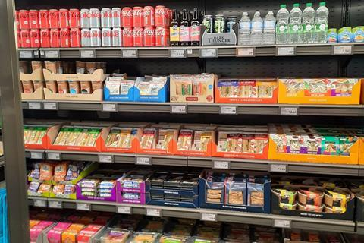
(Source: Farrell, 2022)

Figure 6: Aldi protein products
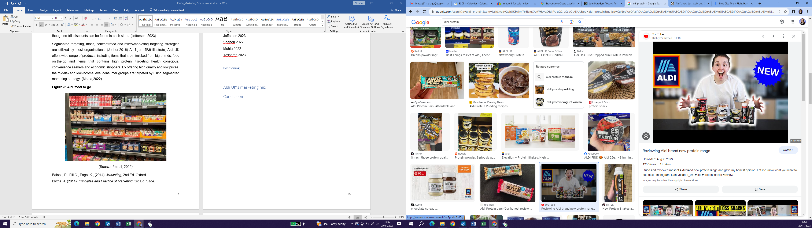
(Source: YouTube,2023)
Organizations identify their main target audience to enhance the efficiency of their more specific targeting and promotional strategies. Despite some brands that low competition may benefit from undifferentiated and mass targeting, a single strategy cannot suit an entire market. (Fifield, 2016). The grocery store industry in the UK is saturated. Hence, Aldi uses its segmentation bases and instead of mass-marketing, the segmented-targeting strategy is utilized. (Hooley et al., 2020) The wide range of own label line signals that despite the demographics, the consumers belong to low- and middle-income level are the main targeted segment. The variety of store sizes of Aldi, the behavioural and psychological segmentation bases suggests that Aldi UK also aims to enhance the efficiency of its marketing strategy by multi-segment targeting. Which can be associated with higher inputs and resource requirements. (Kotler and Armstrong, 2018)

Positioning

The process of classifying a brand’s or product’s place within the market is referred to positioning strategy. This process consists of a set of variety of marketing activities that are aiming to ensure the customers associate the given brand in a particular area. The mainly used brand positioning strategies to differentiate from the rivals are based on attribute positioning, quality, product price, offered benefits and competitors. (Kotler et al, 2017).Aldi successfully disrupts the supermarket industry by the point of difference, and it has established a strong brand image of being a discounted supermarket chain that offers high quality products. Positioning based on the low price and excellent value is unarguably part of Aldi’s positioning strategy. (Spanou, 2022) Compared to the main rivals, Aldi positions itself as a brand who redefines the market with mimicking big brands’ products, offering the highest possible quality at the lowest prices. Aldi offers opportunity to the targeted audience to shop differently, take advantage on the no-frill discounts to save money and by the Aldi local and diverse store sizes to shop faster. Aldi is a value brand, targets the budget and discount conscious consumer groups that constantly seek value for money. By multi-segment targeting strategy, the high-income level customers are also tempted. (Bhasin, 2018)
Figure 8: Positioning map
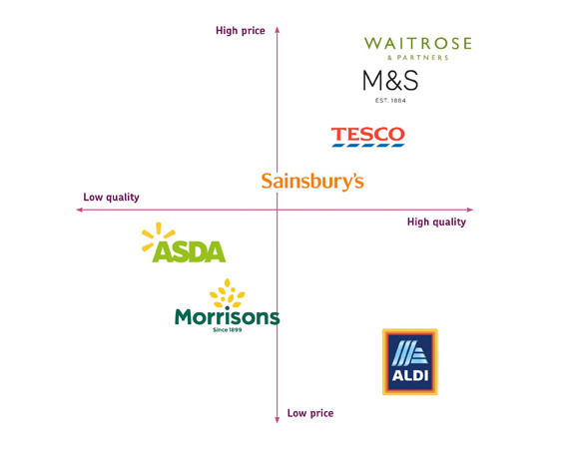
(Source: Ritson, 2012)

Aldi UK’s marketing mix

To ensure marketing strategies are effective, marketers should consider wide range of areas when developing a comprehensive marketing plan. For this purpose, the marketing mix framework is used, which focuses diverse areas, referred to Ps. Such as price, product, place and promotion. If all these areas are in focus, organizations have better ability to make more informed decisions and to reach out to wider audience. Firms often integrate focus approaches on people, physical evidence and process, too into their marketing mix, to develop a reinforced and more customer-centric marketing strategy that enhances the ability to expand beyond the only product-focused marketing approach. (Kotler et al., 2017)

Products

Aldi’s brand image is reputable, and the firm positions itself as a discount supermarket chain that offers the highest quality products at the lowest prices. The firm utilizes large number of suppliers locally to enhance the ability to keep the prices low, offer a wide range of locally sourced and produced products, which ultimately increases the efficiency and profitability, too. (Aldi,2023) The products are ranging from groceries, household items, bakery, electronics, fresh meet, pet care, baby care, and many more. Despite Aldi’s product range is lower than its rivals’ in order to maintain cost-leadership (Andrews & Shimp,2017), started producing own-label products that are mimicked from famous brands. This helps quicker brand association of the consumers. What more, the consistent omni-channel presence lowers the frictions laterally the journey of the consumers. To eliminate risks of the product life cycle’s decline phase and to stimulate the demand, firms often reinvent their products or introduce new ones. (Andrews&Shimp,2017). Aldi uses this technique, and in each store there is a specific isle that has plenty seasonal products displayed in, including world-food and household items. The product extension strategy enables Aldi to increase the products’ offering life prior to show decline.
Figure 9: Aldi’s own label products
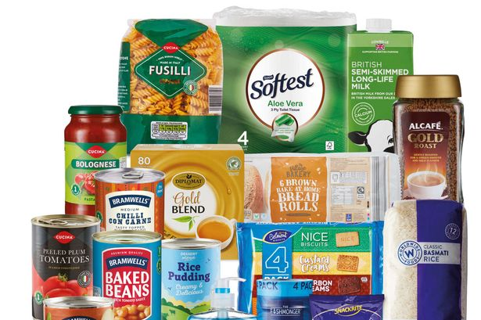
(Source: Aldi,2023)

Price
The marketing mix’ price element can be directly linked to the firm’s STP. Price element of the marketing mix is one of the most powerful strategic tools. (Hollensen,2020) Nationwide in the UK, Aldi’s product prices are standardised regardless the geographical location. Depending on the stock and inventory management practices, some promotional prices may differ in the variety of stores. As differentiation and cost-leadership are mainly focused by Aldi, enhancing profit margin maximization is one of the main objectives. To increase the number of customers and market share, the no-frill discounts are used to increase the sales volume. To sum up, Aldi can be observed to penetrate the market and set its prices to be perceived lower than its competitors’. Additionally, the firm’s unique processes, such as larger barcode to speed up the check-out, the simplified layout of the stores to shorten the time spent on helping customers all help Aldi to keep its margins high, operating-costs and product prices low. Indeed, phycological-pricing strategy is also noticeable. For example, several products are offered for 99p, instead of £1. However, Aldi UK’s main targeted segment are the consumers seeking bargains and low prices, which is indication of economy pricing strategy. (Fifield, 2016)

Place

Aldi has over 1000 stores nationwide, that has simple layouts. They can be found in different locations. By launching the online shop, Aldi increases its omni-channel strategies efficiency. The physical stores have easy access and great visibility and located in areas with at least 30,000 residents around. Whilst the Aldi Local stores in town centres can comfortably accessed, the superstores have large parking area and can be accessed by public transport, too. (Farrel, 2022)
Figure 10: Aldi’s locations

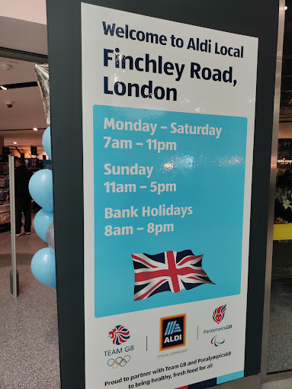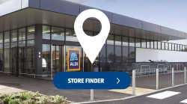

Promotion

Aldi uses a differentiation strategy, to distinguish itself from rivals. Additionally, the high quality and low prices are also competitive factors, which suggests penetration-pricing strategy. Aldi’s traditional and digital promotion campaigns follow the elaboration likelihood model. The ads have emotive copies, whilst the images have sharp focuses, which can be used to change the attitude of the customers via the peripheral route. (Fazio and Petty,2008) Aldi’s social media presence is strong, engaging with customers on Twitter,Instagram and many platforms. On social media, Aldi comes across as a funny brand with the aim of increasing customer engagement.
Figure 11: Aldi’s twitter post

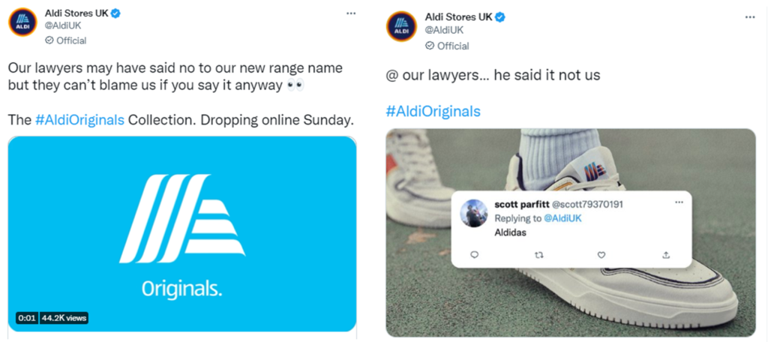

Concluding thoughts

Aldi’s main focus is on maximizing the operational efficiency to have the ability to keep the prices low, whilst keeping the quality high, which can be observed in all marketing strategies utilized by the firm.

Reference List

Aldi. (2023). About us. [online] Available at: https://www.aldi.co.uk/about-aldi/corporate-responsibility/people. [Accessed: 20 November 2023]
Aldi.co.uk. (2023). Responsible Marketing - ALDI UK. [online] Available at: https://www.aldi.co.uk/corporate/corporate-responsibility/healthier/responsible-marketing. [Accessed 21 November 2023]
Andrews, J., & Shimp, T. (2017). Advertising, promotion and other aspects of integrated marketing communications. 10th ed. Cengage Learning.
Baines, P., Fill C., Page, K., (2014). Marketing, 2nd Ed. Oxford.
Bhasin, H. (2018). Marketing strategy of Aldi. Marketing91. [online]. Available at: https://www.marketing91.com/marketing-strategy-of-aldi/. [Accessed 23 November 2023[]
Blythe, J. (2014). Principles and Practice of Marketing, 3rd Ed. Sage.
Daily Express. (2023). Aldi shoppers left furious at barrier change in - ‘Not everyone has a smarphone!’ (2023). Daily Express. [online] 9 Jun. Available at: https://www.express.co.uk/life-style/life/1779262/Aldi-shop-and-go-Greenwich-London. [Accessed 19 November 2023)
Farrell, S. (2022). Aldi’s new ‘just walk out’ Greenwich store: what’s it like inside?. The Grocer. [online]. Available at: https://www.thegrocer.co.uk/store-design/aldis-new-just-walk-out-greenwich-store-whats-it-like-inside/663633.article [Accessed 19 November 2023]
Fifield, P. (2016). Marketing strategy. 6th ed. London: Routledge.
Hollensen, S. (2020). Global Marketing. 8th Ed. Harlow: Pearson.
Hooley, G.J., Piercy, N., Nicoulaud, B. and Rudd, J.M. (2020). Marketing strategy & competitive positioning. 7th ed. Harlow, England: Pearson.
Jefferson, M. (2023). Discounters boost TV investment as they look to maintain market share momentum. [online] Marketing Week. Available at: https://www.marketingweek.com/discounters-boost-tv-investment-market-share-momentum/. [Accessed 22 November 2023]
Jobber, D., (2016). Principles and Practice of Marketing, 8th Ed. McGraw Hill.
Kotler, P., Armstrong, G., Harris, L., Piercy, N. (2017). Principles of Marketing, 7th Ed. Pearson.
Kotler, P. and Armstrong, G. (2018). Principles of Marketing. 17th ed. Harlow: Pearson Education Limited.
Mehta, K. (2022). The Thrifty Business Model of Aldi. [online] The Strategy Story. Available at: https://thestrategystory.com/2022/02/02/aldi-business-model/. [Accessed 22 November 2023]
Ritson, M. (2012) Brand equity is dead. Long live Aldi! – Marketing Week, Marketing Week. Available at: https://www.marketingweek.com/brand-equity-is-dead-long-live-aldi/ [Accessed 18 November 2023]
Spanou, S. (2022). ALDI’s marketing strategy: The key growth ingredients of the FMCG titan. [online] ContactPigeon | Blog. Available at: https://blog.contactpigeon.com/aldi-marketing-strategy/. [Accessed 21 November 2023]
Tesseras, L. (2023). Switch to own label accelerates as grocery inflation passes 17% for the first time. [online] Marketing Week. Available at: https://www.marketingweek.com/own-label-grocery-inflation/. [Accessed 23 November 2023]

