Consultancy Report: Addressing Room Sales and Occupancy Issues at Hotel Best Western Allegro Nation [Paris]
Department Consultation: [all the Hotel departments].
Student Name: Farid Lezaar
Student Number: 2117388
Name of Consulting Company: Farid Consulting
Report Delivered Date: 26 February 2024

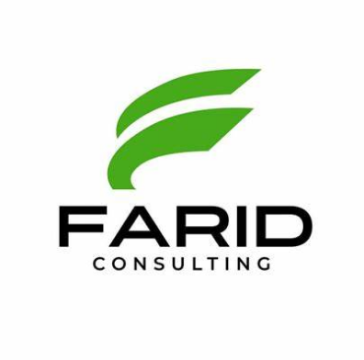

Executive Summary:
Hotel Best Western Allegro Nation is 4-star hotel in Paris is ideally located near the Bercy Palais Omnisport complex and Place Nation, The Best Western Allegro Nation hotel offers 49 stylish, colourful rooms with designer décor for a relaxing experience. The Hotel faces challenges in optimising room sales and occupancy rates despite his modern amenities, and strategic location. In response, Farid Consulting, a specialised business in the hospitality industry, conducted a comprehensive consultancy to analyse the current state of operations and market dynamics.
The Issue:
The hotel is experiencing a decline in room sales and occupancy rates, impacting both its financial health and market standing. Factors contributing to this decline include ineffective marketing strategies, suboptimal pricing strategies, the absence of a loyalty program, and concerns related to service quality and customer satisfaction.
Identifying Root Causes:
A detailed analysis of online presence revealed strengths in website design but opportunities for improvement in detailed information and social media engagement. Pricing strategies showed instances of both overpricing and under-pricing, impacting revenue and occupancy rates.
Market Trends and Competitor Analysis:
Analysing market trends revealed shifts in travel patterns, increased emphasis on technology integration, and a focus on sustainability. Competitor analysis highlighted the importance of active engagement with customers, particularly through social media, an area where Best Western Allegro Nation showed limited participation compared to competitors.
Tools Analysis:
The consultancy firm will use framework swot & tows to analyse and evaluate the internal and the external factors that impact the hotel's performance. the goal of this analysis is to guide is to give a comprehensive and effective strategic plan for the hotel to generate more sales and attract a new guests. By understanding the interplay of internal and external factors, Farid consultancy will provide tailored recommendations to enhance the hotel's competitiveness, generate more profit, and overall performance in the dynamic hospitality industry.
Recommendations:
The consultancy recommends addressing cleanliness concerns, enhancing staff responsiveness, expanding dining options, streamlining check-in/check-out processes, optimising pricing strategies, and introducing a comprehensive loyalty program to encourage repeat business. These recommendations aim to improve guest satisfaction, increase revenue, and strengthen the hotel's market position.
Potential Challenges and Risks:
Implementation of these recommendations may face challenges such as staff resistance to change, external economic factors, technological integration difficulties, pricing strategy adjustments, and uncertainties in the competitive landscape. Adapting to these challenges will require agility and flexibility throughout the implementation process.
conclusion
Farid Consulting proposes a strategic roadmap for Hotel Best Western Allegro Nation, encompassing improvements in operations, technology adoption, pricing strategies, and the introduction of a loyalty program. The successful implementation of these recommendations is expected to position the hotel for sustainable growth and enhanced competitiveness in the dynamic hospitality industry.

Table of Contents:
- Introduction.......................................................................................................6
  - Background of Hotel Best Western Allegro Nation.............................................6
  - Farid consultancy overview ……………………………………………………6
  - Purpose of the Consultancy...................................................................................7
  - Overview of the Hotel issue..................................................................................7
- Identifying Root Causes.....................................................................................7
  - Poor Social Media Presence .................................................................................7
  - Lack of interaction with Customers on online platforms………………………..8
  - Pricing Strategies...................................................................................................9
- Factors Contributing to the Issues ..................................................................10
  - Ineffective Marketing Strategies...........................................................................10
  - Pricing Strategies...................................................................................................11
- Package Deals and Bundles......................................................................11
- Loyalty Programs......................................................................................12
  - Service Quality and Customer Satisfaction............................................................13
  - Customer Reviews and Feedback………………………………………………...14
- Market Trends .....................................................................................................14
  - Market Research......................................................................................................14
    - Changing Travel Patterns.................................................................................14
    - Technology Integration....................................................................................15
    - Sustainability Focus.........................................................................................15
- Competitor Analysis..............................................................................................15
- SWOT Analysis.....................................................................................................16
- Strengths.................................................................................................................16
- Weaknesses ………………………………………………………………………17
- Opportunities..........................................................................................................18
- Threats …………………………………………………………………………...18
- TOWS Analysis.....................................................................................................19
- Strengths and Opportunities (SO)............................................................................19
- Strengths and Threats (ST).......................................................................................20
- Weaknesses and Opportunities (WO).......................................................................20
- Weaknesses and Threats (WT).................................................................................20
- Recommendations....................................................................................................20
- Action Plan………….................................................................................................22
- Potential Challenges and risks associated with the implementation of Recommendation…………………………………………………………………...23
- Conclusion..................................................................................................................24
- References...................................................................................................................26

1. Introduction:
  - Background of Hotel Best Western Allegro Nation:
Hotel Best Western Allegro Nation is 4-star hotel in Paris is ideally located near the Bercy Palais Omnisport complex and Place Nation, The Best Western Allegro Nation hotel offers 49 stylish, colourful rooms with designer décor for a relaxing experience. (Allegro Nation, 2024). This prime location not only provides convenient access to key landmarks but also ensures that guests can immerse themselves in the dynamic energy of the city.
The hotel features a range of accommodation options, including exquisite guest rooms, charming club and duplex rooms, and diverse suites. Each space is meticulously designed to cater to the highest standards of comfort and sophistication, ensuring a delightful stay for guests (allegro nation, 2024).
One of the notable advantages of Hotel Best Western Allegro Nation is its strategic location. With high-speed express rail links from Charle de Gaulle Paris Airport and excellent connectivity to major public transport networks, guests can easily access Paris’s finest attractions. This prime location not only places visitors within reach of the city's best offerings but also ensures a seamless transition between vibrant urban adventures and a tranquil retreat. (Stephen, 2023).
Despite these distinctive offerings, the hotel is currently facing challenges in optimising room sales and occupancy rates. The management is actively seeking innovative strategies to enhance the hotel's market presence and address the current hurdles. By leveraging its modern amenities, and strategic location, Hotel Best Western Allegro Nation aims to overcome these challenges and continue providing a memorable and enchanting experience for its guests.
1.2 Farid Consulting Background:
Farid Consulting, established in 2012, stands out as a specialised consulting firm dedicated to the hospitality industry. With a core focus on providing expert guidance and tailored solutions, Over the years, the firm has played a pivotal role in contributing to the success stories of various businesses in the hospitality sector. By offering strategic insights, implementing innovative solutions, and staying abreast of industry trends, Farid Consulting has proven instrumental in helping clients adapt to the fast-paced and competitive nature of the hospitality market.

1.3 Purpose of the Consultancy:
The consultancy aims to employ a comprehensive analytical approach, leveraging frameworks SWOT and TOWS to thoroughly examine the current state of the hotel's operations and market dynamics (Visual paradigm, 2023). The SWOT framework encompasses Strengths, weaknesses, opportunities, and threats factors (De Bruin, 2017). TOWS analysis which combining the external environment’s opportunities and threats with the internal organisation’s strengths and weaknesses (De Bruin, 2017). this methodical analysis, intend to gain a nuanced understanding of the multifaceted influences affecting the hotel Allegro nation in Paris.
Through swot & tows analysis, the consultancy aims to pinpoint the root causes of low room sales by considering a wide range of factors that influence the hotel's performance. Subsequently, strategic recommendations will be developed to enhance the hotel's market positioning, attract a larger guest base, and ultimately increase revenue (Beon,2022). This approach ensures a holistic understanding of the challenges and opportunities, enabling the formulation of effective and tailored solutions for sustainable business growth.
1.4 Overview of the Hotel issue:
Hotel Best Western Allegro Nation, situated in the heart of Paris, is facing critical challenges related to room sales and occupancy rates. The decline in these key performance indicators has significant implications for the hotel's overall financial health and market standing. (Jaya, et AL, 2023, p182). This overview provides a concise summary of the issues, their impact on the hotel, and the need for a strategic intervention to reverse the downward trend.
The hotel is experiencing a noticeable decrease in room sales and occupancy rates, indicating a pressing issue in attracting and retaining guests. This decline is adversely affecting the hotel's revenue streams, highlighting the urgency of addressing the root causes. The impact is not only financial but extends to the hotel's reputation and market positioning.
- Identifying Root Causes:
2.1. Poor Social Media Presence:
The hotel currently faces a challenge with its social media presence, as it is notably lacking visibility on popular platforms such as Facebook, Instagram, and Twitter. The absence of an active and engaging presence across these social media channels means that the hotel is missing valuable opportunities to connect with its target audience and build brand awareness (Social Media Marketing, 2023).
In today's digital age, social media serves as a powerful tool for marketing and communication (Lara, 2023). The hotel's limited or non-existent activity on platforms like Facebook, and Instagram, not only hinders its ability to reach potential guests but also diminishes its competitiveness within the hospitality industry.
By establishing a robust social media presence, the hotel can effectively showcase its unique offerings, share engaging content, and interact with both current and potential guests. This presence plays a pivotal role in influencing travellers’ decisions, as many individuals turn to social media for recommendations, reviews, and a glimpse into the experiences of others (Liu, et AL, 2020). Furthermore, Tourism relies heavily on social media platforms, and this plays a significant role in many aspects of tourism, especially in information search, decision-making, tourism promotion, and interactions with consumers (Cimbaljević, 2015).
Additionally, a strong social media presence contributes to the hotels or any business overall online reputation, influencing its perceived value and credibility (Guest Revu, 2023). It allows the hotel to highlight its amenities, share promotions, and respond promptly to customer inquiries or feedback, fostering a sense of transparency and accessibility.
2.2 Lack of interaction with Customers on online platforms
Online reviews on platforms like TripAdvisor, Google Reviews, and Booking.com highlight both positive and negative aspects. Positive feedback often emphasises the hotel's central location and the friendly behaviour of the staff. However, negative comments frequently revolve around cleanliness issues and occasional maintenance issues in rooms. The hotel's responses to reviews not on timely, However, From the hotels’ perspective, generating reviews and responding in a timely and appropriate manner, are becoming a crucial sales driver. If prospective guests cannot read reviews about your hotel, then they’re not going to book with you, it’s becoming as basic as that (Guest Touch, 2022). there is an opportunity for improvement by addressing recurrent themes in negative reviews, focusing on enhancing cleanliness standards, and ensuring consistent maintenance to uphold the hotel's reputation for quality service. while the Best Western Allegro Nation has a solid platforms presence on Booking, Expedia and Trip Advisor, there are areas for refinement to elevate the user experience, social media engagement, and overall guest satisfaction.
2.3 Pricing Strategies:
Examining the pricing strategies of the Best Western Allegro Nation in comparison to competitor within the same market segment such as Hotel Novotel Paris Les Halles, Allegro nation hotel pricing does not reveal a delicate balance between perceived value and pricing.
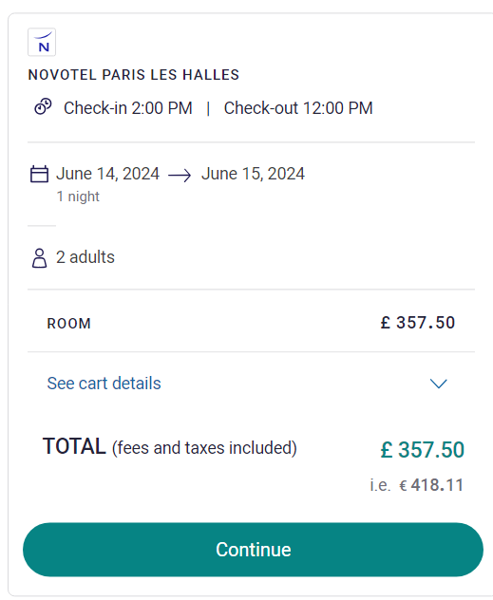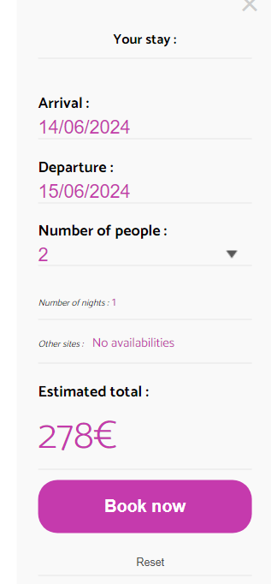
(Novotel Hotel Paris, nd). (Best Western Allegro Nation Website, nd)
Firstly, when analysing the price difference between the two pictures, each representing one night at the Novotel Paris Hotel and Allegro Nation Paris in June, these reveal valuable insights into the dynamics of supply and demand during peak season.
In one hand, the higher price 418 euro for one night in Novotel Hotel suggests increased demand during this period. June is often considered a peak tourist season in many places, including Paris, due to favourable weather and various events or festivals (Roaming Paris, 2023). As a result, Novotel Paris hotel reflects the economic principle and Price Elasticity of supply and demand, when demand is high, businesses often adjust their prices to maximise revenue (Investopedia, 2023).
On the other hand, Allegro Nation Paris Hotel, being priced lower 278 Euro/ Night, while this may attract budget-conscious guests, it raises concerns about the hotel's overall profitability. The lower price doesn't necessarily mean lower quality, the consumers may see it as a good deal or they may see it as not worth their time or money (Anziano, 2024), However Allegro Nation Hotel is missing the opportunity to maximise its profit during the peak season or when the demand is higher.
Secondly, it appears that Allegro Nation Hotel is not implementing a dynamic pricing strategy, especially during periods of lower room occupancy or off-peak seasons. The evidence for this is reflected in the pricing displayed on their website, where higher prices are maintained even during off peak seasons.
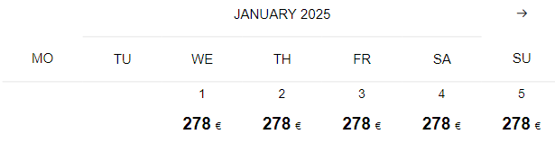
Allegro Nation Hotel
Dynamic pricing involves adjusting prices based on real-time factors such as demand, occupancy rates, and seasonal variations. In the context of hotels, a dynamic pricing strategy would typically mean offering lower room rates during off-peak seasons or when room occupancy is lower and adjusting prices upward during peak seasons when demand is higher (Hospitality Technology, 2018). Using a dynamic pricing strategy, Allegro Nation Hotel can easily increase the room rate during high seasons and lower room rates during off seasons.
The hotel's pricing strategies does not demonstrate flexibility in response to dynamic factors such as seasonal demand and local events. However, there is room for improvement in optimising pricing during off peak and peak periods to maximise revenue without deterring potential guests.
- Factors Contributing to the Issues:
Several factors contributing to the observed decline in room sales and occupancy rates:
  - Ineffective Marketing Strategies:
The hotel has not a strong social media presence, making it difficult for potential guests to find information about its services, and amenities. In today's digital age, guests heavily rely on the internet to research and book accommodations (linked in, 2023). If the hotel lacks an optimised and user-friendly website, or if it is not effectively leveraging online travel agencies and social media platforms, it may struggle to attract online bookings (Hotel Speak, 2023).
Social media is a powerful tool for engaging with potential guests and building brand awareness (Sales IQ, 2023). the hotel is not utilising platforms like Instagram, Facebook, or Twitter, this is a missing valuable opportunity to highlight its amenities, share guest experiences, and run targeted promotional campaigns. Engaging content, regular updates, and responding promptly to guest feedback are crucial for creating a positive online presence (Furoore, 2023).
Negative reviews or a lack of positive online feedback can significantly impact the hotel's reputation (PWC, 2016). If the marketing strategy does not address reputation management effectively, potential guests may be deterred from booking (Forbes, 2018). Encouraging satisfied guests to leave positive reviews and actively addressing and resolving issues raised in negative reviews, the hotel can contribute to a more positive online reputation. In this context, according to search engine land, 88% Of Consumers Say They Trust Online Reviews as Much as Personal Recommendations (search engine land, 2014). This mean for 9 in 10 consumers, an online review is equally as important as a personal recommendation. However, this trust comes with a caveat. There is almost a 50/50 split in what drives trust for this 88% of consumers. For one half, this trust will only be granted if there are multiple reviews to read. For the other half, this trust is dependent on the reviews being authentic. In this case, quality is equally as important as quantity.
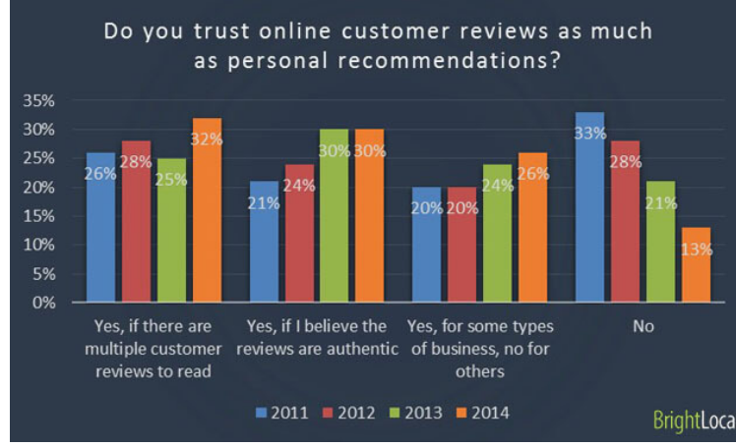
  - Pricing Strategy
- Package Deals and Bundles:
Hotel Best Western Allegro Nation not offering package deals and bundles poses both challenges and opportunities for the hotel (ESoft, 2023). the absence of bundled offerings limit the hotel's appeal to certain segments of the market that actively seek package deals for convenience and cost savings. Many travellers, especially those on leisure trips, often look for bundled packages that include accommodations, meals, and additional benefits.
As an example, According to APPINIO RESEARCH “(36%) British travellers are increasingly willing to invest in premium amenities that enhance their overall travel experience. These amenities can include spa services, fine dining, private pools, and more. The willingness to pay extra for such features demonstrates a desire for a higher level of comfort and indulgence during their trips” (Appinio, 2023).
Not offering package deals could potentially result in a missed opportunity to attract a broader audience and compete more effectively with other hotels that provide such bundled offerings. Customers who prefer the simplicity of semi board or full board packages may opt for competitors that fulfil this demand (Independent, 2016).
- Loyalty Programs:
The absence of a loyalty program at Hotel Best Western Allegro Nation poses challenges and missed opportunities in terms of customer retention and revenue generation. Loyalty programs are widely recognised as effective tools for building and sustaining customer relationships in the hospitality industry (linked in, 2023). By not having a loyalty program, the hotel misses a strategic mechanism to incentivise repeat business, foster brand loyalty, and encourage direct bookings.
Loyalty programs not only provide tangible benefits to guests, such as discounts, room upgrades, or exclusive benefits, but they also contribute to a sense of belonging and appreciation (Forbes, 2022). Guests enrolled in loyalty programs often feel more connected to the brand, leading to increased brand advocacy and positive word-of-mouth marketing (Loyalty lion, 2023). The absence of such a program at Hotel Best Western Allegro Nation result in a competitive disadvantage compared to other hotels that offer loyalty incentives. Moreover, loyalty programs serve as valuable data-gathering tools. They allow hotels to collect and analyse guest preferences, behaviour, and spending patterns, enabling personalised marketing strategies and targeted promotions (Rate gain, 2023). Without a loyalty program, Hotel Best Western Allegro Nation miss the opportunity to gather valuable customer insights that could inform future marketing initiatives and enhance overall guest satisfaction.
In hospitality industry where repeat guest is highly coveted, the implementation of a well-designed loyalty program could not only strengthen customer loyalty but also contribute to increased direct bookings, reducing dependency on third-party booking platforms (shops and goods, 2023). Therefore, the introduction of a loyalty program could be a strategic move for Hotel Best Western Allegro Nation to enhance guest retention, build a loyal customer base, and stay competitive in the dynamic hospitality market.
Implementing a robust loyalty program encourage repeat business or guest (linked in, 2023). Offering exclusive discounts, complimentary services, or room upgrades to loyal customers can foster a sense of appreciation and keep them coming back
  - Service Quality and Customer Satisfaction:
The idea behind overall service quality is that it depicts the gap that exists between customer expectations and actual service performance (Liu, et AL, 2020). It encompasses various elements, including prompt and courteous customer service, cleanliness, efficiency, and the overall atmosphere of the establishment (Hotel Chantelle,2023). When negative feedback arises in relation to service quality, amenities, or the overall guest experience, it can have substantial implications for the hotel's reputation and business. In the case of the Hotel Best Western Allegro Nation, they are a lot of unfavourable comments and negative reviews related to service quality which are affecting potential guests to book a room at Hotel Best Western Paris.
Modern consumers heavily rely on online reviews and ratings when making decisions about accommodations (Forbes, 2022). Negative feedback, whether it pertains to slow service, unclean rooms, or any other aspect of the guest experience, can spread rapidly and discourage prospective customers from choosing the hotel (Costumer Alliance, 2023).
According to empirical study conducted by the ITB and the University of Worms in Germany, over 35% of internet users are inclined to avoid making a booking if they come across more negative reviews than positive ones about a hotel online. Approximately 20% of users would go as far as sharing their unfavourable findings with others. The study estimates that an establishment faces the risk of losing about 22% of potential bookings due to the presence of negative reviews. This percentage escalates significantly when multiple negative reviews are found across various online platforms, potentially resulting in a substantial 70% loss of potential guests for a hotel. (Costumer Alliance, 2023). The implication for a hotel's online reputation is evident: a frequency of negative reviews in the online domain can lead to a decline in the number of bookings and, consequently, a reduction in revenue.
3.4 Customer Feedback and Reviews:
Analysing customer feedback on various platforms such as Expedia, booking and TripAdvisor reveals valuable insights into areas for improvement and potential expansion. Firstly, guests frequently mention the hotel's central location and stylish ambiance. However, a recurring theme in negative reviews pertains to issues with room cleanliness and maintenance. This signals a need for enhanced housekeeping protocols and a more rigorous maintenance schedule to address guests' concerns (Mich, 2017).
Additionally, several guests express frustration with slow response times to service requests. Improving staff responsiveness, through the implementation of a more efficient communication system, would contribute to a more positive guest experience. moreover, there are occasional remarks about the need for more diverse dining options within the hotel. Considering the importance of culinary experiences to guests, exploring the addition of new restaurants, change, or expanding the existing menu offerings could enhance overall satisfaction (Eat, 2023).
The feedback also highlights the significance of seamless and efficient check-in/check-out processes. Some guests mention delays and confusion during these procedures, emphasising the need for streamlined systems, including the possibility of investing in advanced technology for contactless transactions.
Finally, positive reviews consistently praise the friendly and helpful staff. Capitalising on this strength by providing ongoing training programs to further elevate customer service could result in even more favourable guest experiences and reviews (Hotel Management, 2023).
- Market Trends
4.1Market Research:
4.1.1 Changing Travel Patterns:
Travel preferences and patterns shifted during the pandemic, such as Staycations and domestic travel gained popularity as international travel faced uncertainties (webster, 2022). In response to the shifting travel landscape post-pandemic, hotels in Paris implemented strategic adjustments in their marketing approaches to appeal to local visitors and move towards non-mature markets where there are potential distressed assets (Perret, 2022).
Hotels have developed unique packages that highlight the distinctive features of Paris and surroundings. As an example, Bob Hotel in Paris offer packages that include relaxation package, and romantic package with hammam. Additionally, Bob hotel offer a late complimentary check out, and open the door to its facilities to local businesses to conduct the business and mix life with work for just few euros a day (Hotel Bob, 2024). This approach aims to create an all-encompassing experience that appeals to the interests of local businesses and local guests.
4.1.2 Technology Integration:
The hotel industry continued to integrate technology to enhance the guest experience. Online booking platforms, contactless check-ins, and digital services became more prevalent to address safety concerns and improve efficiency (The Insider, 2023).
4.1.3 Sustainability Focus:
In response to the global emphasis on sustainability and the rising awareness of environmental concerns, the hospitality industry, including hotels in Paris and nearby Best Western Allegro Nation Hotel, has been increasingly adopting measures to minimise their environmental impact (Press Office UK, 2022). This shift reflects a growing demand from guests who prioritise eco-friendly practices and sustainability when choosing accommodations (Ecobnb, 2017). However, due to unclear and unpublished data that shows the Allegro Nation Hotel specifically effort toward sustainability, led to creating a gap in transparency between the Best Western Allegro Nation Hotel and environmentally conscious consumers. This lack of information hindered guests from making informed choices aligned with their values, and potentially impacting the occupancy rate (EHotelier, 2023).
- Competitor Analysis:
Hotels are increasingly leveraging technology and innovation to enhance guest experiences and stay competitive in the hospitality industry, in addition, Hotels have embraced user-friendly online booking platforms and mobile apps to streamline the reservation process (Hospitality technology, 2024). this allows guests to easily book rooms, select preferences, and even check-in online, reducing waiting times at the front desk.
Contactless Check-In/Check-Out, in response to the COVID-19 pandemic, hotels has adopted contactless solutions for check-in and check-out processes. Mobile check-in and check-out options, as well as keyless entry systems, minimise physical contact and enhance overall guest safety and convenience (Cloud beds, 2020).
The active engagement with customers and responsiveness to online reviews are crucial aspects of managing a hotel's online reputation (Guest Touche, 2021). By comparing Hotel Gabriel in Paris to Best Western Allegro Nation Hotel as they use same market segment and with same four stars hotels, it becomes evident that there are distinctions between the two establishments. Hotel Gabriel is actively promoting exclusive offers and ticket events on its social media and its website platforms respectively, highlighting a proactive approach to engaging with potential guests. Also, Regular engagement on social media and commitment to customer communication and a desire to keep the audience informed about the latest offerings (Instagram, 2024). In addition, The Hotel Gabriel responds to customer feedback on review platforms, such booking, trip advisor, Expedia and addressing comments related to cleanliness, staff friendliness, amenities, and overall guest experience whether positive or negative. However, Best Western Allegro Nation Hotel have limited social media engagement which can affect costumers’ decision making to book a room at Allegro Nation Hotel.
Non-responsiveness reviews impact potential guests' confidence to the hotel's commitment to customer service and addressing concerns (response scribe, 2023). From this context, the observation is Best Western Allegro Nation Hotel is not actively responding to customer reviews online platforms and are less engaged social media strategy. This Limited engagement affect the perception of the hotel's commitment to customer communication and addressing feedback promptly. As a result, Non-Responsiveness to Reviews, and lack of responses to customer reviews, especially on review platforms like TripAdvisor, Google Reviews, led to missed opportunities for public acknowledgment and issue resolution.
- SWOT Analysis:
- Strengths:
Best Western Allegro Nation Hotel prides itself on providing a seamless and enjoyable experience for its guests, and part of that commitment includes offering high-speed Wi-Fi throughout the hotel premises. This ensures that guests can stay connected, whether for business or leisure purposes, and enjoy a smooth online experience during their stay.
The high-speed Wi-Fi at Best Western Allegro Nation Hotel is designed to meet the demands of modern guests’ who rely on digital connectivity for work, communication, entertainment, and more (Skift, 2023). Whether you are catching up on emails, streaming your favourite shows, or staying connected with friends and family through video calls, the robust Wi-Fi infrastructure ensures a reliable and fast connection.
The hotel recognises the importance of staying connected in today's fast-paced world, and the high-speed Wi-Fi is just one of the many amenities provided to enhance the overall guest experience. Whether you are in your room, the lobby, or any other public area within the hotel, you can count on the Wi-Fi to be both fast and secure. Best Western Allegro Nation Hotel official website is well-designed, offering a clean layout and straightforward navigation. The booking process is user-friendly.
- Weaknesses:
Guests have noted concerns about noise disturbances within the hotel, potentially from neighbouring rooms, external sources, or inadequate soundproofing. This issue poses a significant challenge for hotel guests, disrupting their nighttime sleep and impacting their overall experience. Surprisingly, most guests opt not to voice their concerns during their stay, leaving hotel owners and operators unaware of the issue, on contrary, they go to online platforms and write negative reviews. this can lead to the development of an online reputation for being a "noisy" hotel, adversely affecting the hotel ability to attract new customers, face challenges in retaining repeat customers, and encounter difficulty in filling specific rooms (Hotel Business, 2022).
According to TripAdvisor survey asking if visitors take sleep quality into consideration when choosing a hotel, 55 percent of respondents said they look for online hotel reviews that address sleep quality, compared with 27 percent who do not (HuffPost, 2015). To address this, the hotel management could invest in improving the sound insulation of rooms, ensuring that guests enjoy a quieter and more peaceful environment. Regular assessments of noise-related concerns and swift responses to guest complaints can contribute to a more serene stay. Also, Negative feedback related to the check-in and check-out process suggests that guests might have experienced delays, confusion, or inefficiencies during these key interactions. To enhance the overall experience, the hotel can streamline these processes by implementing efficient systems, providing clear communication, and possibly leveraging technology to expedite check-in, check-out and implementing guest room acoustic control to allows guests to adjust their room’s ambience the same way they control temperature and lighting, providing a solution to one of the hotel industry’s most persistent complaints: noise (Space Hotel, 2019). Ensuring that staff is well-trained to handle these procedures efficiently can also contribute to a smoother experience for guests. Furthermore, Reviews indicating concerns about outdated facilities suggest that guests have found certain aspects of the hotel, such as room furnishings or amenities, to be in need of an update (EF, 2020).
- Opportunities:
Best Western Allegro Nation Hotel currently has a standard check-in time of 14:00 and a check-out time of 12:00 (Best Western Allegro Nation, 2024). there is an opportunity to appeal to a broader range of guests by introducing more flexible booking policies such as extending check in out to 15:00 and early check-in at 11:00.
Flexible booking policies, including adjustable check-in and check-out times, allow guests to adapt their plans based on their needs and schedules (The independent, 2022). This is particularly attractive to those arriving early or departing late, as they can request more accommodating check-in or check-out times.
Travel itineraries often vary, and guests may arrive at unconventional hours or require late check-out due to late flights or other logistical reasons. Providing the option for adjustable times caters to the diverse needs of guests with different travel schedules.
Business guests, in particular, may benefit from flexible check-in/check-out options. Meetings, conferences, and other work-related commitments might not always align with standard hotel check-in and check-out times, making flexibility a key consideration for this demographic.
Offering flexibility contributes to overall guest satisfaction. Guests appreciate a hotel that understands their individual needs and is willing to accommodate them, creating a positive and memorable experience that can lead to repeat business and positive reviews (Site Minder, 2023).
- Threats:
Negative reviews on platforms like TripAdvisor, booking or Expedia can indeed have a profound impact on the reputation of the Allegro Nation Hotel. These platforms serve as influential sources for potential guests to gather information and make informed decisions about where to stay (Trip Advisor, 2019).
According to Statista, the main influencing factors in European consumers place greater importance on online reviews than on hotel star classifications when making purchasing decisions. The data suggests that 54% of consumers either agree or strongly agree that online reviews have a more significant influence on their choices compared to star ratings (Statista, 2022). Negative reviews can create doubt and uncertainty, making it less likely for potential guests to choose Best Western Allegro Nation Hotel for their stay. Also, Guests often perceive online reviews as authentic and unbiased opinions from fellow guests. Negative reviews can erode trust and credibility, making it challenging for the hotel to convince potential guests that their experience will be positive (linked in, 2023). Furthermore, Travelers frequently use review platforms to compare different hotels in the same location. Best Western Allegro Nation Hotel has a higher number of negative reviews on platforms such booking, and Expedia compared to its competitors, these led the hotel lose out on potential bookings as guests opt for alternatives with better feedback.
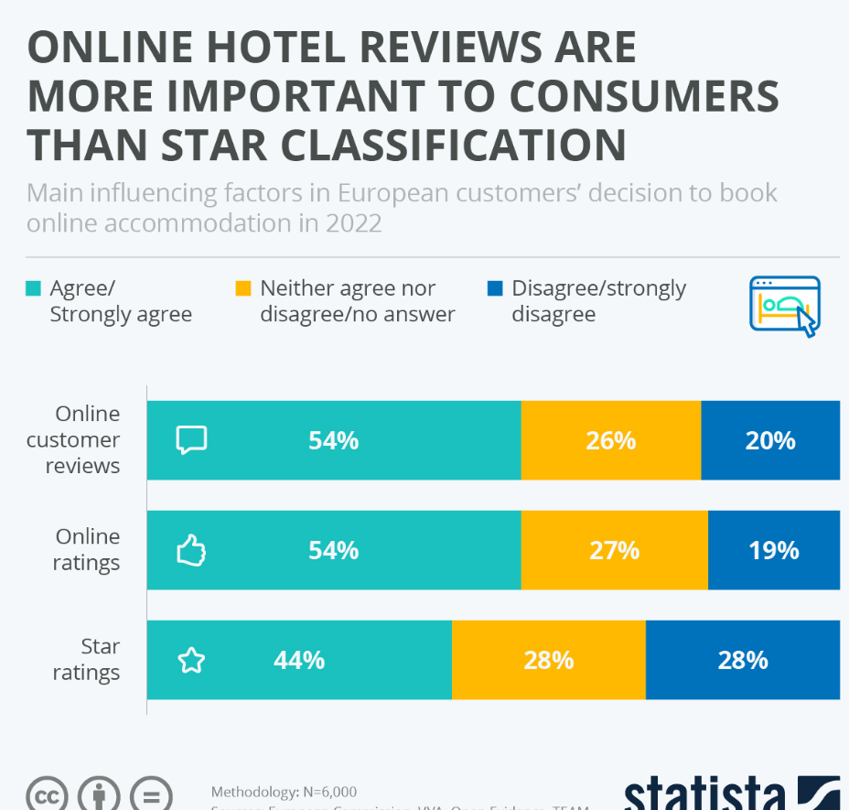
As highlighted above, Negative reviews can directly impact a hotel's revenue. Potential guests may cancel reservations or choose a different hotel based on unfavourable feedback, leading to a decline in occupancy rates and overall revenue.
A Results of the research revealed that reviews with positive valence do not affect booking intention, while reviews with negative valence have a strong impact on brand image (El-Said, 2020).
negative reviews can harm the overall brand image of the hotel. A negative reputation on popular review platforms may discourage not only potential guests but also repeat customers who may have had a positive experience in the past.
- TOWS Analysis:
- Strengths and Opportunities (SO):
Utilise the hotel's commitment to providing high-speed Wi-Fi as a competitive advantage in marketing to tech-savvy travellers (Star Hub, 2017). Emphasise the convenience of staying connected and consider offering exclusive packages or promotions for business travellers who rely on digital connectivity. Additionally, leverage the positive guest experience with Wi-Fi to attract and cater to remote workers or those in need of a reliable online environment.
- Strengths and Threats (ST):
To mitigate the impact of negative reviews on online platforms, the hotel proactively highlighting its strengths through targeted marketing campaigns and promotions. Emphasise positive aspects such as the high-speed Wi-Fi, or 5G Wi-Fi, convenient location, and commitment to guest satisfaction. Engage with guests through social media and encourage satisfied customers to share their positive experiences, helping counteract potential threats to the hotel's reputation.
- Weaknesses and Opportunities (WO):
Address concerns about noise disturbances by investing in soundproofing improvements and regularly monitoring and responding to guest feedback. Simultaneously, take advantage of the opportunity to introduce flexible booking policies. Communicate these improvements in marketing materials to demonstrate a commitment to guest comfort and satisfaction. The combination of improved facilities and flexible policies can enhance the overall guest experience.
- Weaknesses and Threats (WT):
To minimise the impact of negative reviews and occupancy rate, implement a strategic plan for periodic renovations or refurbishments. Simultaneously, address concerns related to the check-in and check-out process by streamlining procedures and leveraging technology for efficiency. Proactively communicate these improvements to guests and potential customers through various channels to counteract potential threats to the hotel's reputation.
- Recommendations:
Following the comprehensive analysis of Best Western Allegro Nation, several recommendations emerge to address the identified issues:
Firstly, implementing effective strategies within the hospitality industry involves a multifaceted approach that addresses various aspects of the operation. For the housekeeping team, comprehensive training sessions should be conducted to ensure that they are well-equipped with the necessary skills and knowledge. These training sessions can cover a range of topics, including updated cleaning protocols, use of new equipment or technologies, and customer service standards. In addition to training, it's crucial to engage with the housekeeping team to discuss the shift working pattern. This dialogue ensures that the team is comfortable with the new arrangements and that any potential concerns or challenges are addressed.
The hotel should focus on the presence on social media, having a strong presence and active engagement on social media is a valuable strategy for hotels to connect with their audience, enhance brand visibility, and effectively market their services (Michalis, 2023).
To boost online ratings, a targeted effort should be made to increase the platform ratings on Booking.com to 9.0 and TripAdvisor to 4.5. This can involve encouraging satisfied guests to leave positive reviews and responding promptly and professionally to any negative feedback. Additionally, implementing measures to address specific areas mentioned in customer reviews can demonstrate a commitment to continuous improvement and guest satisfaction.
To enhance staff responsiveness reviews, particularly in addressing service requests, it is advisable for Allegro hotel to consider the implementation of a more efficient communication system. This involves making strategic investments in advanced communication technology that facilitates prompt and streamlined responses to guest needs and inquiries. Such technology may include integrated messaging systems, automated task assignment platforms, or customer relationship management (CRM) tools that centralise and prioritise service requests. Additionally, the implementation of the new communication system should be accompanied by a commitment to continuous improvement through periodic reviews.
To enhance the efficiency of check-in and check-out processes, hotel can greatly benefit from investing in contactless technology. One effective approach involves the integration of mobile check-in and check-out options. This innovative solution not only streamlines the entire experience for guests but also aligns with modern preferences for convenient and efficient transactions.
Developing effective pricing strategies is crucial for the success of a hotel, and a comprehensive review is essential to eliminate instances of both overpricing and under-pricing during off-peak and peak seasons, respectively. This process involves implementing dynamic pricing models that take into account various factors, including seasonal demand, local events, and fluctuations in competitor pricing.
Dynamic pricing allows hotels to adjust their rates in real-time based on demand, ensuring that prices are competitive and reflective of market conditions. During peak seasons or high-demand periods, the hotel can capitalise on increased demand by adjusting prices accordingly. Conversely, during off-peak seasons or lower demand periods, the hotel can implement lower price or a strategic discounts or promotions to attract more guests.
The success of these pricing strategies can be measured through various key performance indicators. Revenue growth is a direct reflection of the effectiveness of pricing strategies, as it indicates the hotel's ability to optimise income from room sales. (Counting Up, 2021). Improved occupancy rates, another important metric, demonstrate the hotel ability to attract and retain guests. Positive changes in guest booking patterns, such as an increase in direct bookings or longer stays, also indicate the success of pricing strategies in meeting guest expectations and preferences.
To address the issue of room noise, it is highly recommended to implement a comprehensive guest room acoustic system. This system aim to effectively reduce the overall noise levels within the rooms, thereby enhancing the overall guest experience. By adopting a holistic approach to acoustics, hotels can create a more serene and comfortable environment for guests, positively impacting their satisfaction and well-being.
Beyond the immediate benefits to guest satisfaction, implementing a guest room acoustic program can have long-term positive effects on a hotel's reputation. Satisfied guests are more likely to leave positive reviews, contributing to a favourable online presence. In contrast, a reputation for quiet and comfortable rooms can attract new customers and foster customer loyalty, ultimately benefiting the hotel's overall success and profitability.
To enhance customer loyalty and encourage repeat guests, Best Western Allegro Nation Hotel must consider implementing a comprehensive loyalty program. This program should focus on creating a personalised and rewarding experience for loyal customers. The success of this initiatives can be measured to more guests booking and hotel occupancy rate more than 75%.

- Action Plan:
issues | solutions | Desired outcome | Time scale | Completion date | Cost implementation
Poor room cleanliness and maintenance | Enforce Staff & housekeeping training | staff to undertake a training before joining and yearly training updates. | 6 months | 26/08/2024 | £8.000
Lack in contactless technology | invest in contactless technology | reduce waiting times, and provide a hygienic interaction for customers | 12 months | 26/02/2025 | £10.000
The absence of a loyalty program | Create loyalty program | Loyalty program to retain guest and | 3 months | 26/05/2024 | £5.000
Lack of response to costumers on online platforms | Change of management and new employee only for online presence | management to responding to reviews on online platforms in timely manner. | 3 months | 26/05/2024 | £3.000
Outdated amenities | improving shared areas | Reassurance & Communicate to the guests, their voice are heard. | 12 months | 26/02/2025 | £20.000
Room Noise | Implementing guest room acoustic | Reduce the level noise. | 6 months | 26/08/2024 | £30.000

- Potential Challenges and risks associated with the implementation of the proposed recommendations:
Firstly, the implementation of proposed strategies for Best Western Allegro Nation Hotel, may encounter various challenges and associated risks. One potential challenge could be resistance to change among the existing staff, as new strategies may require adjustments to established processes and procedures. Additionally, external factors such as economic downturns or unforeseen events, such as a global pandemic, could impact the effectiveness of the strategies (Duve, 2023).
Secondly, maintaining a delicate balance between pricing adjustments and perceived value may be challenging, as overpricing or under-pricing could affect customer satisfaction and profitability (Retentely, 2023).
Lastly, the competitive landscape and evolving customer preferences may introduce uncertainties, requiring Best Western Allegro Nation Hotel to remain agile and adaptable throughout the implementation process.
- Conclusion:
The analysis of Best Western Allegro Nation Hotel has provided a comprehensive understanding of the challenges it faces in optimising room sales and occupancy rates. The hotel, with its strategic location, and commitment to providing a seamless guest experience, is poised to overcome these challenges through strategic interventions. the analysis identify the root causes of low room sales, The situational analysis highlighted critical issues, including ineffective marketing strategies, suboptimal pricing strategies, the absence of a loyalty program, and concerns about service quality. These issues were further dissected to reveal specific factors contributing to the challenges faced by the hotel.
The proposed recommendations aim to address these root causes systematically. Strategies include improving online presence, optimising pricing strategies, introducing a comprehensive loyalty program, and enhancing service quality. These recommendations are designed to leverage the hotel's strengths, mitigate weaknesses, capitalise on opportunities, and tackle threats.
Implementing these strategies will undoubtedly lead to a transformative journey for Best Western Allegro Nation Hotel. By prioritising cleanliness, streamlining processes, enhancing staff management to responsiveness to reviews, and embracing modern technologies, the hotel can elevate its service quality and guest satisfaction. Introducing flexible booking policies, strategic pricing adjustments, and a well-crafted loyalty program can attract a broader guest base and increase revenue.
However, the implementation journey is not without its challenges and risks. Resistance to change among existing staff, external economic factors, and the need for seamless technological integration are potential hurdles. Striking the right balance between pricing adjustments and perceived value is crucial to maintaining customer satisfaction and profitability. The dynamic nature of the competitive landscape and evolving customer preferences necessitate a continuous commitment to adaptability and agility.
In terms of resources, the hotel needs to allocate financial, human, and technological resources for staff training, technology investments, and potential collaborations. Regular financial reviews and performance assessments will be essential to measure the return on investment and overall success of the implemented changes.
The proposed implementation plan includes a detailed timeline, resource allocation specifications, a monitoring and evaluation framework. These elements are crucial for tracking the success of each strategy and ensuring continuous improvement.
The roadmap presented here is not just a set of recommendations but a comprehensive approach toward sustainable business growth for Best Western Allegro Nation Hotel. By addressing the identified challenges strategically, the hotel can solidify its market presence, enhance guest satisfaction, and emerge as a leader in the dynamic and competitive hospitality industry. The success of these strategies lies in the commitment to change, adaptability, and a relentless pursuit of excellence in guest service.

- References:
Allegro Nation, (no date), 4-STAR HOTEL IN PARIS, available at http://www.hotelallegroparis.com/en/ (accessed: 12/02/2024).
Anziano, (2024), Why Low Prices Can Scare Off Customers, available at https://www.businessnewsdaily.com/3455-cheap-prices-customers.html (accessed, 23/02/2024)
Appinio, (2023). Jet-set Britain: Exploring Trends and Insights for Travel and Tourism in the UK in 2023, available at https://www.appinio.com/en-gb/blog/insights/travel-tourism-industry-trends-statistics-uk (accessed: 15/02/2024).
Beon, (2022), The importance of hotel market positioning and how to benefit from it, available at https://www.beonx.com/knowledge/articles/the-importance-of-hotel-market-positioning-and-how-to-benefit-from-it/ (accessed: 13/02/2024).
Best Western Allegro Nation, (2024). Room & Rates, available at https://www.bestwestern.co.uk/hotels/best-western-allegro-nation-93761 (accessed: 20/02/2024).
Cimbaljević, M. (2015), Social media marketing in tourism and hospitality. Annals of Tourism Research 54, 236–238., https://doi.org/10.1016/j.annals.2015.05.006 Available at (accessed: 23/02/2024).
Cloud beds, (2020), A New Reality: The Contactless Guest Experience, available at https://www.cloudbeds.com/articles/contactless-guest-experience/ (accessed: 20/02/2024).
Costumer alliance, (2023), What is the cost of a negative review for your hotel? Available at https://www.customer-alliance.com/en/resources/article/cost-of-negative-review-for-hotels/ (accessed: 16/02/2024).
Counting Up, (2021), How can a business measure its success?, Available at https://countingup.com/resources/how-can-a-business-measure-its-success/ (accessed: 24/02/2024).
De Bruin, L, (2017), SWOT Analysis: Bringing Internal and External Factors Together, available at https://www.business-to-you.com/swot-analysis/ (accessed: 12/02/2024).
Duve, (2023), Understanding Hotel Revenue Management: Sources, Factors, and Strategies, available at https://duve.com/hotel-revenue-management-strategies/ (accessed: 24/02/024).
Eat, (2023). How to Elevate Guest Experience with Dynamic Menu Changes, available at https://restaurant.eatapp.co/blog/menu-changes (accessed: 24/02/2024).
Ecobnb, (2017), Two-thirds of tourists prefer eco-friendly hotels, available at https://ecobnb.com/blog/2017/03/tourists-prefer-eco-friendly-hotels/ (accessed: 16/02/2024).
Ef, D, (2020), ‘It Ain’t No 4-star’ available at https://www.tripadvisor.co.uk/Hotel_Review-g187147-d229593-Reviews-Best_Western_Allegro_Nation-Paris_Ile_de_France.html (accessed: 20/02/2024).
EHotelier, (2023). What’s Stopping Travellers from Making the Sustainable Choice? , available at https://hoteliermaldives.com/whats-stopping-travellers-from-making-the-sustainable-choice/ (accessed: 24/02/2024).
El-Said, O. A. (2020). Impact of online reviews on hotel booking intention: The moderating role of brand image, star category, and price. Tourism Management Perspectives, 33, page 1 100604, available at https://doi.org/10.1016/j.tmp.2019.100604 (accessed: 24/04/224).
ESoft, (2023), Why is bundling strategy optimal to increase market share? Available at https://esoft.com/int/bundling-strategy-optimal-to-increase-market-share/ (accessed: 15/02/2024).
Eve, S, (2019), Never again, Available at https://www.tripadvisor.co.uk/Hotel_Review-g187147-d229593-Reviews-Best_Western_Allegro_Nation-Paris_Ile_de_France.html (accessed: 20/02/2024).
Forbes, (2018). The Age Of Online Reputation Management: How Consumers Now Govern Brands, available at https://www.forbes.com/sites/tompopomaronis/2018/02/02/the-age-of-online-reputation-management-how-consumers-now-own-brands/?sh=6ec677b65d5b (accessed: 24/02/2024)
Forbes, (2022). Loyalty Programs: The New Pillar For Next-Gen Customer Engagement, available at https://www.forbes.com/sites/forbesbusinesscouncil/2022/02/18/loyalty-programs-the-new-pillar-for-next-gen-customer-engagement/?sh=1b1b3395427d (accessed: 24/02/2024).
Forbes, (2022), Online Reviews: The Customer Reference That Never Sleeps, available at https://www.forbes.com/sites/forbestechcouncil/2022/08/16/online-reviews-the-customer-reference-that-never-sleeps/?sh=bc804dd29213 (accessed: 16/02/2024).
Furoore, (2023), Encouraging Hotel Guest Feedback: Improve Guest Satisfaction, available at https://furoore.com/hotel-guest-feedback/#:~:text=Responding%20to%20guest%20reviews%20and%20feedback%20is%20a,addressing%20concerns%20or%20issues%20raised%20in%20negative%20feedback. (accessed: 14/02/2024).
Guest Revu, (2023), 5 Things To Do Today To Improve Your Hotel's Online Reputation, available at https://blog.guestrevu.com/5-things-to-do-today-to-improve-your-hotels-online-reputation (accessed: 21/02/2024).
Guest touch, (2021), Why Is Hotel Reputation Management Important, available at https://www.guesttouch.com/blog/why-is-hotel-reputation-management-important (accessed: 19/02/2024).
Guest Touch, (2022). Best Practices For Responding to Online Reviews (With Templates), available at https://www.guesttouch.com/blog/best-practices-for-responding-to-online-reviews#:~:text=In%20terms%20of%20responding%2C%20according%20to%20this%20research,to%20online%20reviews%2C%20compared%20with%20one%20that%20doesn%E2%80%99t. (accessed: 23/02/2024).
Hotel Business, (2022), Noise and guest sleep satisfaction, available at https://hotelbusiness.com/noise-and-guest-sleep-satisfaction/ . (accessed: 24/02/2024).
Hotel Chantelle, (2023). What Is Service Quality in A Hotel? Available at https://hotelchantelle.com/what-is-service-quality-in-a-hotel/ (accessed: 15/02/2024).
Hotel Management, (2023). How to Train Hotel Staff for Exceptional Customer Service Skills, available at https://hoteltips101.com/how-to-train-hotel-staff-for-exceptional-customer-service-skills/ (accessed: 24/02/2024).
Hotel speak, (2023), Social Media Marketing For The Hotel Industry: A Comprehensive Guide, available at https://www.hotelspeak.com/2023/06/social-media-marketing-for-the-hotel-industry-a-comprehensive-guide/ (accessed: 21/02/2024).
Hospitality Technology, (2018). How Your Hotel's Pricing Strategy Can Affect Profitability, available at https://hospitalitytech.com/how-your-hotels-pricing-strategy-can-affect-profitability (accessed: 23/02/2024).
Hospitality technology, (2024), 2024 Hospitality Revolution: Tech, Sustainability, and Personalization Drive Industry Transformation, available at https://hospitalitytech.com/2024-hospitality-revolution-tech-sustainability-and-personalization-drive-industry-transformation (accessed: 20/02/2024).
HuffPost, (2015), How Hotels Are Engineering A Better Night's Sleep, available at https://www.huffingtonpost.co.uk/entry/hotels-sleep_n_4073574 (accessed: 24/02/2024).
Independent, (2016), Why it is sometimes worth buying a package holiday - even if you do not want it, available at https://www.independent.co.uk/travel/news-and-advice/package-holidays-last-minute-prices-cheap-flights-december-christmas-a7449071.html (accessed: 15/02/2024).
Instagram, (2024). Hotel Gabriel Paris, available at https://www.instagram.com/hotelgabrielparis/ (accessed: 19/02/2024).
Investopedia, (2023). How Does the Law of Supply and Demand Affect Prices?, Available at https://www.investopedia.com/ask/answers/033115/how-does-law-supply-and-demand-affect-prices.asp (accessed: 23/02/2024).
Jaya, I. G. T. Y. P., Pitanatri, P. D. S., & Suastini, N. M. (2023). How room rates drive occupancy: A case study from The Laguna, a Luxury Collection Resort & Spa, Nusa Dua. JOURNAL OF TOURISM, CULINARY AND ENTREPRENEURSHIP (JTCE), page 182 https://doi.org/10.37715/jtce.v3i2.4089
Lara, c, (2023), Understanding Social Media in Digital Marketing, available at https://www.theedigital.com/blog/understanding-social-media-in-digital-marketing (accessed: 21/02/2024).
Linked in, (2023), Attracting Guests in the Digital Age: Best Practices for Hotel Online Reputation Management", available at https://www.linkedin.com/pulse/attracting-guests-digital-age-best-practices-hotel-online-kipping (accessed: 14/02/2024).
Linked in, (2023), How customer and guest loyalty programs can build TRUST and BRAND, available at https://www.linkedin.com/pulse/how-customer-guest-loyalty-programs-can-build-trust-brand-maughan (accessed: 15/02/2024).
Linked in, (2023), How to implement a loyalty program that drives repeat business, available at https://www.linkedin.com/pulse/how-implement-loyalty-program-drives-repeat-business-mark-dilks (accessed: 15/02/2024).
Linked in, (2023). The power of online guest reviews: How they impact your hotel's business, available at https://www.linkedin.com/pulse/power-online-guest-reviews-how-impact-your-hotels-business- (accessed: 20/02/2024).
Liu, X., Mehraliyev, F., Liu, C., & Schuckert, M. (2020). The roles of social media in tourists’ choices of travel components. Tourist Studies, 20(1), 27–48., Available at https://journals.sagepub.com/doi/epub/10.1177/1468797619873107 (accessed: 22/02/2024)
Liu, Y., Huang, D., Wang, M. and Wang, Y. (2020), “How do service quality, value, pleasure, and satisfaction create loyalty to smart dockless bike-sharing systems?”, Review of Business Management, Vol. 22 No. 3, p45, available at https://www.emerald.com/insight/content/doi/10.1108/TRC-12-2021-0026/full/pdf?title=effect-of-hotel-overall-service-quality-on-customers-attitudinal-and-behavioural-loyalty-perspectives-from-zimbabwe (accessed: 24/02/2024).
Loyalty lion, (2023). 9 Benefits of Loyalty Programs — And How to Get Started with Yours (With Examples), available at https://loyaltylion.com/blog/five-benefits-of-a-loyalty-program#:~:text=The%20benefits%20of%20loyalty%20programs%20for%20your%20customers,fun%21%20...%205%20A%20feeling%20of%20belonging%20 (accessed: 15/02/2024).
Mich, (2017), ‘Not 4 star’ [review], available at https://www.tripadvisor.co.uk/Hotel_Review-g187147-d229593-Reviews-Best_Western_Allegro_Nation-Paris_Ile_de_France.html (Accessed: 20/02/024).
Michalis, B, (2023), Social Media Marketing Strategy For Hotels: 11 Best Practices, available at https://www.canarytechnologies.com/post/social-media-marketing-strategies-for-hotels (accessed: 24/02/2024).
Novotel Hotel Paris, advance saver rate - bed and breakfast, available at https://all.accor.com/ssr/app/accor/rates/0785/index.en.shtml?dateIn=2024-06-14&nights=1&compositions=2&stayplus=false&snu=false&accessibleRooms=false&hideWDR=false&hideHotelDetails=false&utm_campaign=desktop-14062024-2-1&utm_medium=partenariats&hmGUID=40849fb0-a1da-418f-1dc7-4cf4dfff6a37&utm_source=TripAdvisor&utm_content=GB-EN-0785 (accessed: 23/02/2024).

Park grand hotel, (2024), Welcome to Park Grand London Hyde Park, available at https://www.parkgrandhydepark.co.uk/welcome-to-park-grand-london-hydepark-352.html (accessed: 14/02/2024).
Perret ,S, (2022), Paris Hotel Market: A Spectacular Start to the recovery, available at https://www.hvs.com/article/9352-Paris-Hotel-Market-A-Spectacular-Start-to-the-Recovery (accessed: 16/02/2024).
Press Office UK, (2022), Going green: France’s steps to become a leading European destination for sustainable tourism, Available at https://franceuncovered.com/2022/09/28/going-green-frances-steps-to-become-a-leading-european-destination-for-sustainable-tourism/ (accessed: 20/02/2024).
PWC, (2016), Online reputations. Why hotel reviews matter and how hotels respond, available at https://www.pwc.com/m1/en/publications/documents/online-reputations-why-hotel-reviews-matter.pdf (accessed: 3/02/2024).
Rate gain, (2023), Hotel Loyalty Programs: Building Customer Loyalty and Maximizing Rewards, available athttps://rategain.com/blog/hotel-loyalty-programs/(accessed:15/02/2024).
Response scribe, (2023), Hotel Review Responses (A Detailed Guide on Responding for Beginners), available at https://www.responsescribe.com/blogs/hotel-review-responses (accessed: 20/02/2024).
Retently, (2023), How Does Your Product Pricing Affect Customer Satisfaction? , Available at https://www.retently.com/blog/product-pricing-satisfaction/ (accessed: 24/02/2024).
Roaming Paris, (2023), Best Time to Visit Paris By Month & Season, available at https://www.roamingparis.com/best-time-to-visit-paris/ (accessed: 23/04/2024).
Sales IQ, (2023), How to increase brand engagement on social media?, available at https://www.zoho.com/blog/salesiq/the-role-of-social-media-in-brand-engagement.html#:~:text=Social%20media%27s%20prowess%20lies%20in%20extending%20a%20brand%27s,and%20augmenting%20brand%20awareness%20and%20social%20media%20engagement. (accessed: 13/02/2024).
Search engine land, (2014), 88% Of Consumers Trust Online Reviews as Much as Personal Recommendations, available at https://searchengineland.com/88-consumers-trust-online-reviews-much-personal-recommendations-195803 (accessed: 15/02/2024).
Shops and goods, (2023), Loyalty Programs and Their Impact on Consumer Behaviour, available at https://stores-goods.com/blog/consumer-behavior/loyalty-programs-and-their-impact-on-consumer/ (accessed: 15/02/2024).
Site Minder, (2023), Guest experience in hotels: How to achieve complete customer satisfaction, available at https://www.siteminder.com/r/trends-advice/hotel-guest-experience/guest-experience-hotels-customer-satisfaction/ (accessed: 24/02/2024).
Skift, (2023), Why Hotel Connectivity Is the Foundation of an Exceptional Guest Experience, available at https://skift.com/2023/06/14/why-hotel-connectivity-is-the-foundation-of-an-exceptional-guest-experience/ (accessed: 20/02/2024).
Social Media Marketing, (2023), Why Your Brand Needs to Maintain Engaging Presences Across a Variety of Social Platforms, [blog], available at https://digitalagencynetwork.com/why-your-brand-needs-to-maintain-engaging-presences-across-a-variety-of-social-platforms/ (accessed: 23/02/2024).
Space Hotel , (2019), A NEW APPROACH TO GUESTROOM NOISE , available at https://hotelspaceonline.com/products/a-new-approach-to-guestroom-noise/ (accessed: 24/02/2024).
Star Hub, (2017), Wi-Fi as a Competitive Advantage for Hotels, available at https://www.starhub.com/business/resources/blog/hotels-step-into-the-cloud-connectivity.html (accessed: 24/04/2024).
Statista, (2022), Online hotel reviews are more important to consumers than star classification, available at https://www.statista.com/chart/28992/influenceing-factors-in-accommodation-booking-online/ (accessed: 24/04/2024).
Stephen, (2023), ‘The hotel met all of our expectations and the location was perfect’. Available at https://www.booking.com/reviews/fr/hotel/hotelallegroparis.en-gb.html (accessed: 14/02/2024).
The independent, (2022). Goodbye to the 11am kick-out? Why hotels are axing traditional check-in times, available at https://www.independent.co.uk/travel/news-and-advice/trends-hotels-check-in-out-times-flexibility-b2232182.html (accessed: 24/02/2024).
The insider, (2023), Technology in the hotel industry and gaining its full benefits, available at https://www.glion.edu/magazine/technology-hotel-industry/ (accessed: 16/02/2024).
Trip Advisor, (20219), Online Reviews Remain a Trusted Source of Information When Booking Trips, Reveals New Research, available at https://tripadvisor.mediaroom.com/2019-07-16-Online-Reviews-Remain-a-Trusted-Source-of-Information-When-Booking-Trips-Reveals-New-Research (accessed: 24/02/2024).
Visual paradigm, (2023), Using TOWS Analysis to Develop Strategic Action Plans: A Comprehensive Guide for Businesses, available at https://guides.visual-paradigm.com/using-tows-analysis-to-develop-strategic-action-plans-a-comprehensive-guide-for-businesses/ (accessed: 13/02/2024).
Webster, J.,(2022), the rise of UK staycations: the ongoing demand in a rapidly changing tourism landscape, available at The rise of UK staycations: the ongoing demand in a rapidly changing tourism landscape — The Seventy Ninth Group (the79thgroup.co.uk)(accessed: 19/02/2024).

