Module | Changemakers – Building your personal brand for sustainable employment
Module code  Assignment Title | BMHP5015_BIRM  E- Portfolio Evidence of learning
Module lecturer | Kennedy Obohwemu
Student Name | Sabah Kauser
Student I.D Number | 2026079

Contents

- Introduction .................................................................. Pg 3
- Professional health and social care CV …................. Pg 4
- Cover letter …............................................................... Pg 7
- Pitch ….......................................................................... Pg 8
- References ………………………………………………. Pg 13

Introduction
I have produced an E-Portfolio, evaluating my personal employability skills. I have prepared a health and social care CV, a cover letter and also a pitch a documentary on Anxiety to convince Netflix to accept my proposal.

Sabah Kauser
85 Greenridge Road
Handsworth Wood Birmingham
B20 1JN
Mobile: 07791 988 786 sabah.kauser@hotmail.com

Professional health and social care CV
I have over eight years experience in the care sector which has helped me to become hard working, with a strong dedication to caring for others which comes across in my enthusiasm and motivation for the role.I am flexible and able to adapt to changing demands and circumstances. I have completed NVQ levels 2, 3, 4 and 5 of the NVQ, and I am working towards level 6. I prefer working in the care setting as I like helping improve people's lives, especially when they're struggling or, occasionally, severely ill and unable to operate as they once could. I have good knowledge of the health and social care Act and of the care quality commission regularity framework. I have knowledge about social care laws, regulations, and various government programmes as well as about abuse and the various manifestations it can take, as well as how to support people in regaining control of their lives. I have outstanding communication skills, I enjoy listening to and taking my time with each patient I have worked with.
I have experience with working with the elderly and people with physical and mental health disabilities. Working with individuals who have learning difficulties has given me an insight of how communication functions and how it should be used. I have always made an effort to make a difference because of my kind and caring character. I urge patients to participate in new activities and to complete both group and individual chores to aid them in carrying out their daily routine.
I feel that I have improved my communication abilities and can interact with people on many various levels. I also believe I can relate effectively to those who need guidance and support in their lives. I am mentally and physically ready to handle a variety of challenges. I enjoy coming up with new activities to do with the patients and believe that doing so is crucial to maintaining their enthusiasm, which is crucial at that stage of their lives. Additionally, I have worked in rehabilitation, assisting those who had been injured or ill to get back on their feet. I find this work to be very rewarding.
I am able to carry out personal care, administer medication and also carry out food preparation. I can work independently and within a team. I have a flexible yet in an organised time-management attitude.
My passion is working with those who are less fortunate. I am always willing to undertake additional training to help advance my knowledge and career.

Key Skills
▪ Professional carer with 8 years of experience working in care
▪ Ability to communicate effectively with empathy and compassion
▪ Proven aptitude for dealing with complex patients.
▪ Experience of working in a busy environment.
▪ Writing care plans
▪ Aware of the importance of Health and safety Laws.
▪ Able to identify and act upon potential hazards and risks

Education and Qualifications
▪ St. John Ambulance First Aid Certificate
▪ NVQ Level 2 – Food hygiene
▪ NVQ Level 3 – Care
▪ NVQ Level 4 – Health and Social Care
▪ NVQ Level 5 – Health and social Care
▪ GCSE – English (C), English Literature(B), Maths (C)

Employment History

Secure HealthCare Solutions – Mental health support care worker - (December 2018 – to date)
▪ Implement individual detailed care plans
▪ Ensuring welfare of each individual resident
▪ Continually assessing needs of residents
▪ Participating and engaging with residents activities
▪ Preparing meals
▪ Assisting residents with washing, dressing and eating

Anne Marie Centre care home - Residential Care assistant - (September 2016 – December 2018)
▪ providing clients with regular care and support and stepping in during times of crisis
▪ Collaborating with other medical experts to create support strategies
▪ Looking out for behavioural changes
▪ interacting with clients in therapy sessions, and if necessary their families
▪ Ensuring and monitoring patient safety
▪ Effectively recording and maintaining clients records

Prestige Nursing – Rehabilitation Support Worker (July 2014 – September 2016)
▪ Assessing patients needs and developing care plane
▪ Administrating medication
▪ Monitoring patients vital signs and reporting changes to physician
▪ Encourage patients to be independent and motivate to engage in activities

Hobbies and Interests

▪ Keeping upto date with local news
▪ Socialising with friends and family,
▪ Reading books/magazines

References Available Upon Request

Cover Letter
Sabah Kauser
85 Greenridge Road
Birmingham
B20 1JN
07791988786
Sabah.kauser@hotmail.com
Health Care Assistant
Spires Care
Robert Spires
Job Reference: JT173◘
Job ID: 217733973
Location: Handsworth, City and Borough of Birmingham

Dear Mr Spires,

I am writing to apply for the health care assistants position advertised on indeed. I have extensive amount of experience in the care sector, and I have learned many life lessons from my employment as a health care assistant in my previous jobs, including how simple it is to take one's health and independence for granted when they are not jeopardised by disabilities.

I take pleasure in being able to reassure my clients, add a smile to their faces, assist them, and listen to their concerns and worries. My passion for the profession is matched with a strong desire to thrive and progress within the care sector.
It has become much more obvious to me that my true interests belong in the care of the vulnerable and ensuring their welfare is as secure as possible, in preserving their dignity in the face of illnesses, and in providing them with whatever comfort I am able to. I am currently working as a mental health support care worker, and because of the patients obvious needs and the diversity of problems this line of work may provide, I am particularly drawn to nursing vulnerable clients.
I am a dedicated worker who is organised, dependable, on time, and careful in my attention to detail. I sincerely hope you will take my application into consideration. I look forward to hearing from you.

Your Sincerely,
Sabah Kauser
Pitch
Since 1992, April has been the month that focuses on anxiety and stress awareness, in an effort to raise public awareness of the causes and treatments and how anxiety can become a mental health problem, which not many people are aware of.
Over 8 million people are in the current situation of experiencing an anxiety disorder. According to champion health an estimated 822,000 workers have been affected by either work related stress anxiety and or depression every year. (Pindar, 2022).

The number of people who require support and the severity to which certain groups are impacted by anxiety are revealed by examining UK anxiety data.
- In any given week in England, 6 in 100 people will be diagnosed with generalised anxiety disorder (Mind)
- In the UK, over 8 million people are experiencing an anxiety disorder at any one time (Mental Health UK)
- Less than 50% of people with generalised anxiety disorder access treatment (Mental Health Foundation)
- An estimated 822,000 workers are affected by work-related stress, depression or anxiety every year (Health and Safety Executive). (Pindar, 2022)
In my four part documentary which will be aired on Netflix. I will be addressing the importance of anxiety and stress and its effects to reduce the stigma attached to it by openly talking about it with family, friends and colleagues.
According to mind.org most people occasionally experience anxiety, when dealing with difficult situations or changes, especially those that potentially have a significant impact on your life, anxiety is a common side effect. (Mind, 2017).
Experiencing anxiety over a long period of time can lead to anxiety disorder.

Types of Anxiety
There are several types of anxiety and the awareness for the different types is very important these will all be highlighted in the episodes.
- Panic disorder - Recurring frequent panic attacks. You can experience an acute flood of mental and physical symptoms during a panic attack. It can strike suddenly and seemingly out of the blue for no apparent reason and be very distressing and frightening. Some of the symptoms can include a racing heartbeat, sweating, feeling nauseas, chest pains and shortness of breath.

- Phobias – Extreme fear of anything and in some instances, just thinking about the cause of a phobia might cause anxiety or panic. Anticipatory anxiousness is what is meant by this. Treating complex phobias take longer and involve therapy.

- Agoraphobia – the fear of being alone, leaving home to go out alone or being in crowded places

- Obsessive compulsive disorder - Repetitive behaviour, or the urge to do something out of character
- Post traumatic stress disorder - caused by frightening or distressing events. (NHS, 2021).

Coping with anxiety is really important NHS UK suggests:
- Talking therapy – talking to friends, family, colleagues, health care professionals or counsellors,
- Practice breathing exercises, to help stay calm
- Exercising – yoga, running, swimming and walking which all help to relax
- Sleeping - Get advice on how to sleep better
- Healthy diet – eating regular meals to keep up energy
- Peer support – using own experiences to help each other
- Listen to mental wellbeing audio guides (NHS, 2021).

Helping someone with anxiety can help them to feel more inspired and motivated to feel at ease. Simple gestures such as the following can make a big difference.

- Reassurance – giving plenty of reassurance that everything will be ok can help the person relax and cause the intense sensations of anxiety to subside
- Empathise – Understand and sympathise
- Being available – Let them know you are always there without the fear of being judged
- Learn about anxiety – Knowledge is power, the more you know the more you can help
- Celebrate the small - Make a big deal of small victories
(AnxietyCentre.com, n.d.).

Reaching Out to a professional
Online support , hotlines and text services are staffed by qualified volunteers or staff members whose responsibility it is to pay attention to individuals who reach out. Speaking with an unfamiliar person can make you feel more comfortable revealing sensitive information, and strangers may be able to provide more objective feedback. (MHA Screening, n.d.).

Four-part documentary on Anxiety

Episode 1 – Monday 3rd April 2023 – 1 hr – 20:00hrs – 21:00hrs
This episode will be an introduction into anxiety, explaining different types of anxiety disorders and the coping mechanisms

Episode 2 – Monday 10th April 2023 – 1hr – 20:00hrs – 21:00hrs
This episode will look at how we can help someone who is going through an anxiety disorder.

Episode 3 – Monday 17th April 2023 – 1hr – 20:00 – 21:00hrs
This episode will be focused on a professional organisation called mind.org, who will be giving guidance and sharing valuable information on how to get help.

Episode 4 – Monday 24th April 2023 – 1hr – 20:00 – 21:00hrs
This episode will be focusing on selfcare and the importance of putting yourself first.

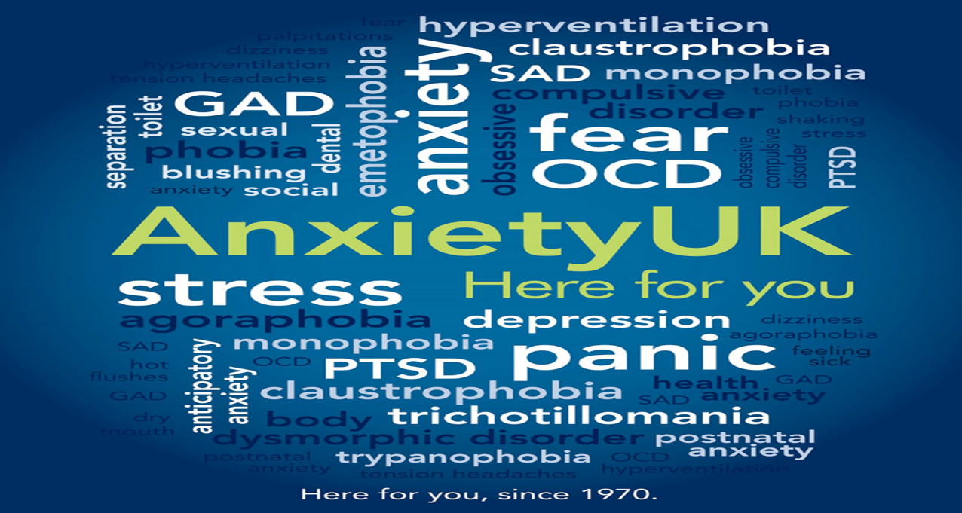

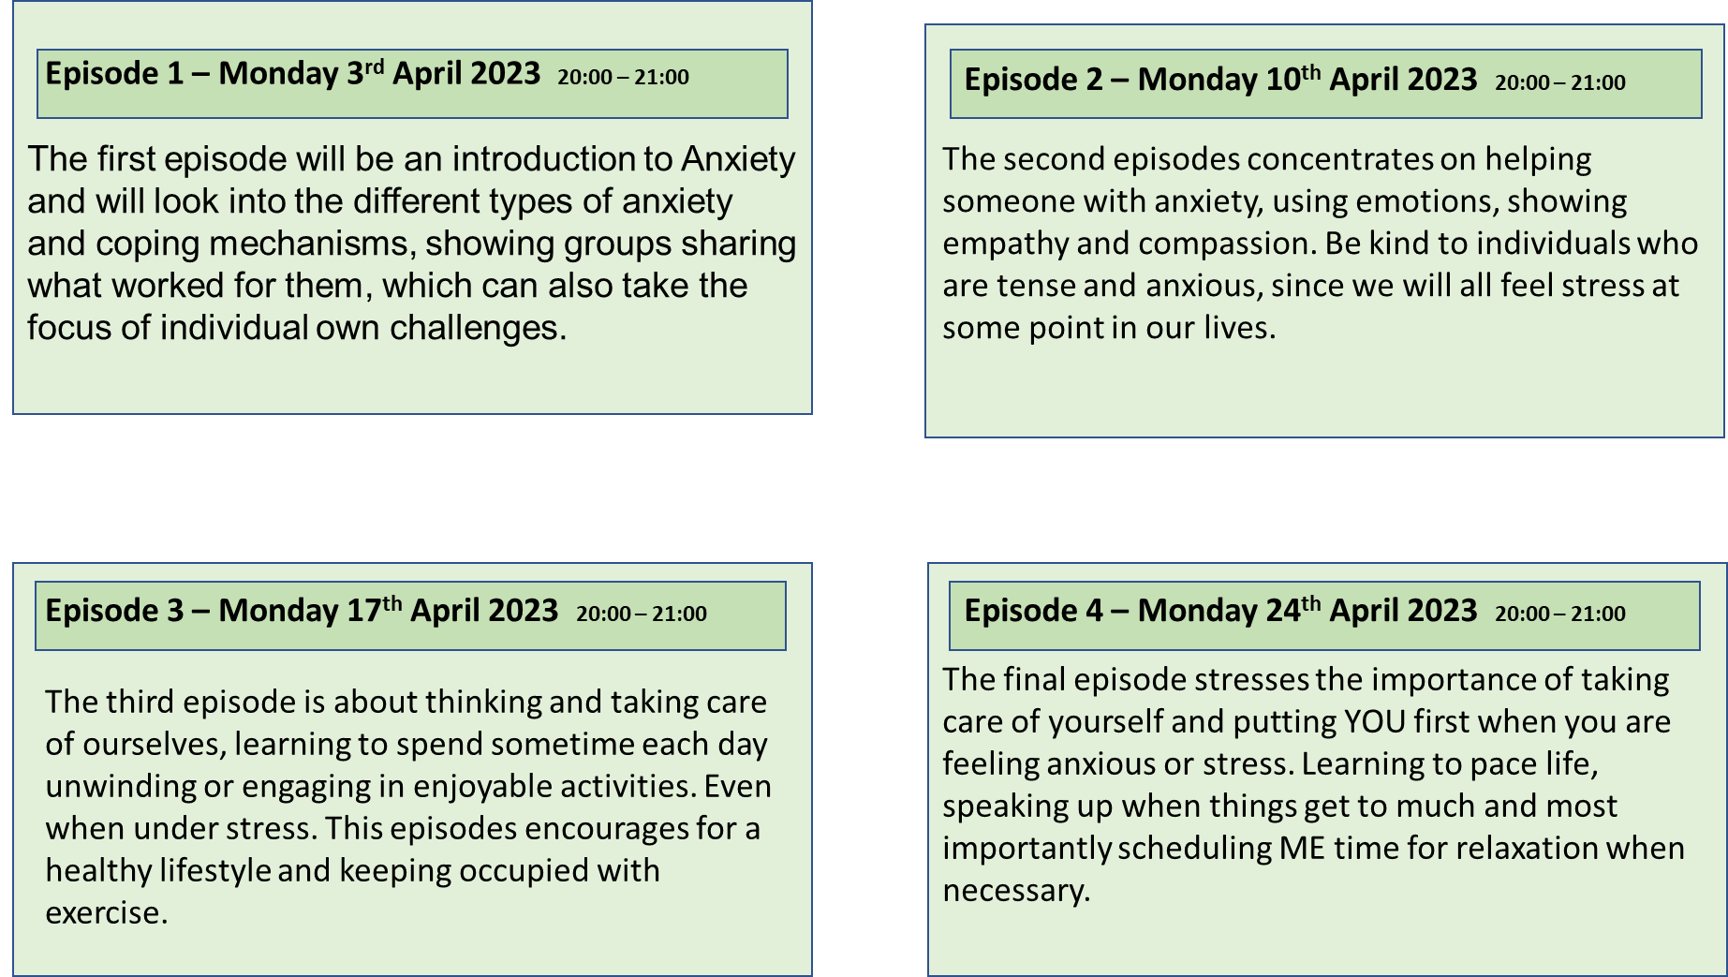
Episode 3 – Monday 17th April 2023 20:00 – 21:00
This episode involves professionals from an
organisation called mind.org sharing guidance and importance
to seeking help. Discussing the different approaches
and support available. It does not have to be a G.P,
it can be the anonymous helplines or text services,
run by trained volunteers.
Contact us
0121 777 1000
anxiety.support@awareness.com

I have selected Netflix due to how popular it is and also one of the most widely used streaming services which enables you to view movies, TV series, and documentaries on a variety of gadgets.
Netflix enables users to stream, pause, and resume watching high-quality video without interruptions or commitments.
New documentaries will be available on the home page and if a user has previously watched a similar documentary it will highlight it as favourite.

References

AnxietyCentre.com. (n.d.). 15 Ways to Help Someone With Anxiety Disorder. [online] Available at: https://www.anxietycentre.com/tips/15-ways-to-help-someone-with-anxiety-disorder/.

MHA Screening. (n.d.). Who can I talk to about my anxiety? [online] Available at: https://screening.mhanational.org/content/who-can-i-talk-about-my-anxiety/ [Accessed 4 Nov. 2022].

‌Mind (2017). About anxiety. [online] www.mind.org.uk. Available at: https://www.mind.org.uk/information-support/types-of-mental-health-problems/anxiety-and-panic-attacks/about-anxiety/.

NHS (2021). Get help with anxiety, fear or panic. [online] nhs.uk. Available at: https://www.nhs.uk/mental-health/feelings-symptoms-behaviours/feelings-and-symptoms/anxiety-fear-panic/.

NHS (2021). Signs of an anxiety disorder. [online] nhs.uk. Available at: https://www.nhs.uk/mental-health/feelings-symptoms-behaviours/feelings-and-symptoms/anxiety-disorder-signs/.

Pindar, J. (2022). Anxiety Statistics UK | 2022 Data. [online] Champion Health. Available at: https://championhealth.co.uk/insights/anxiety-statistics/.

Pindar, J. (2022). Anxiety Statistics UK | 2022 Data. [online] Champion Health. Available at: https://championhealth.co.uk/insights/anxiety-statistics/.
‌ReViewMeMedia (n.d.). Website Review: Netflix.com Streaming Service. [online] HubPages. Available at: https://discover.hubpages.com/entertainment/Website-Review-Netflixcom-Streaming-Service [Accessed 2 Nov. 2022].
‌Twitter. (n.d.). https://twitter.com/anxietyuk/status/877921726822322176. [online] Available at: https://twitter.com/anxietyuk/status/877921726822322176 [Accessed 2 Nov. 2022].
‌

