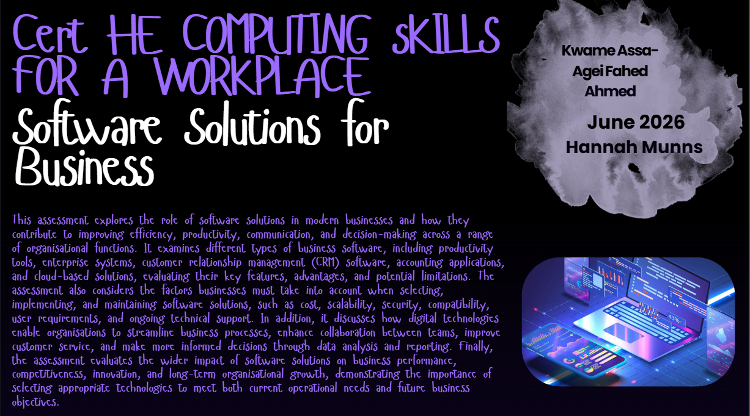
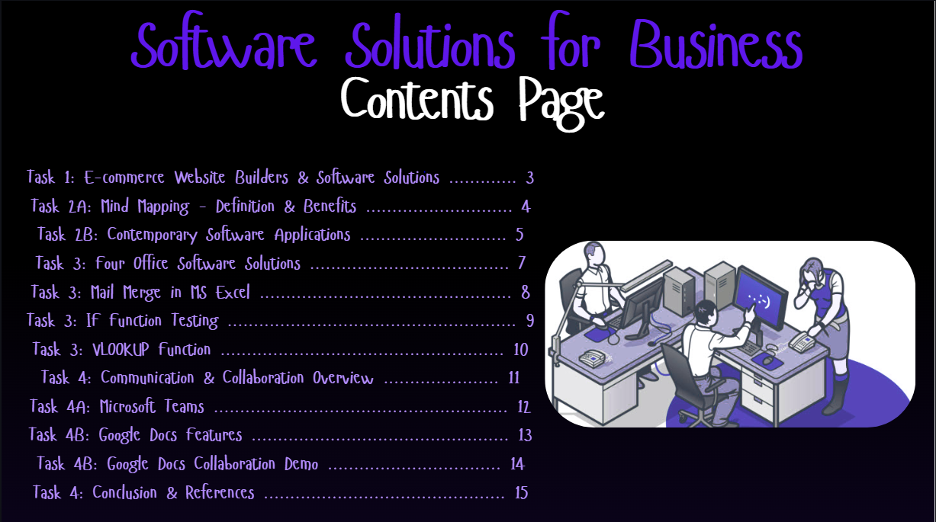
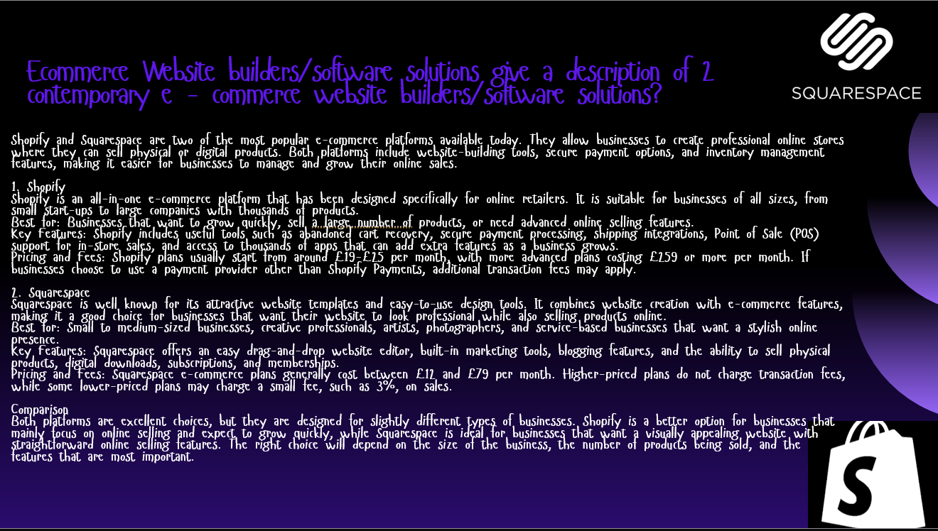
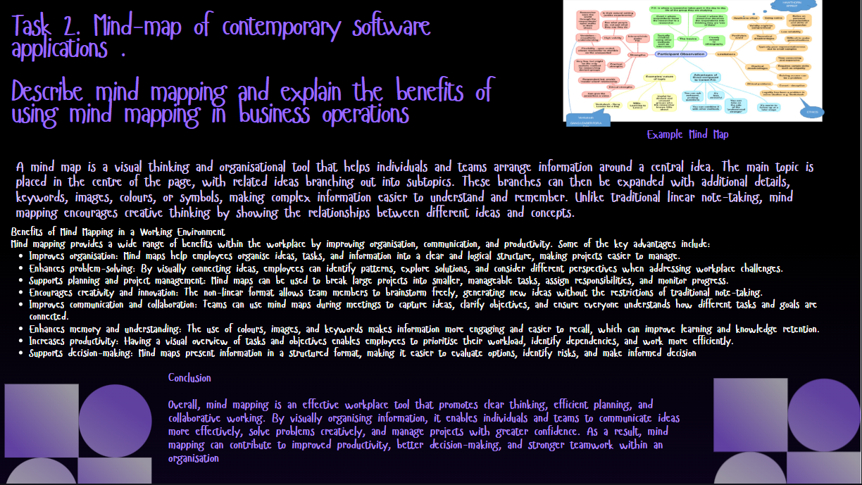
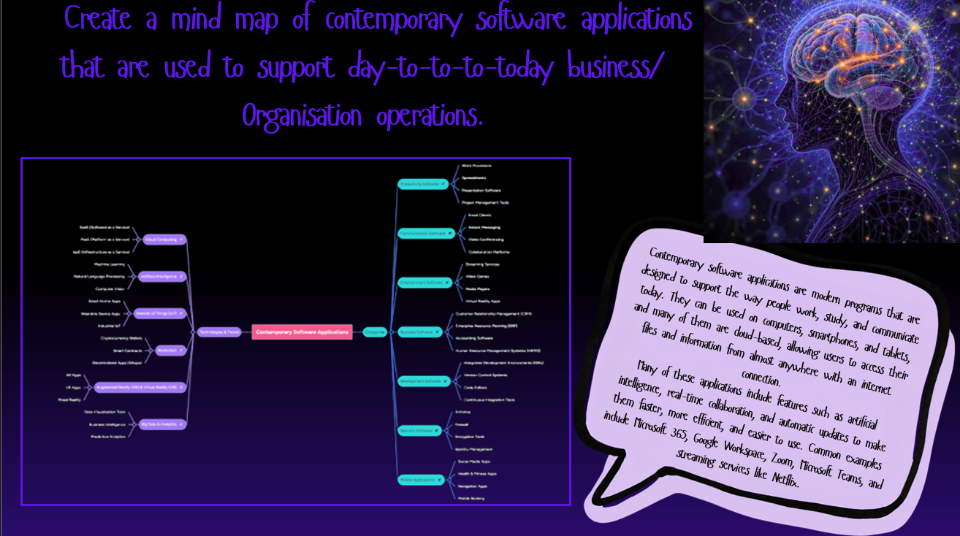
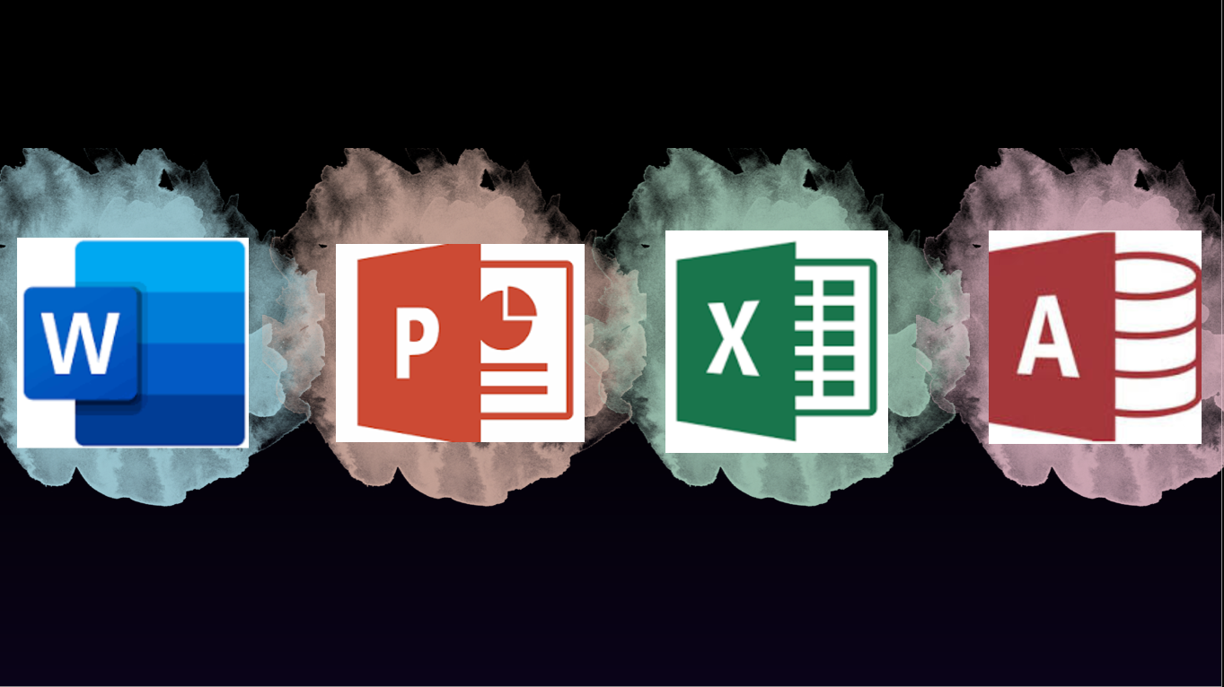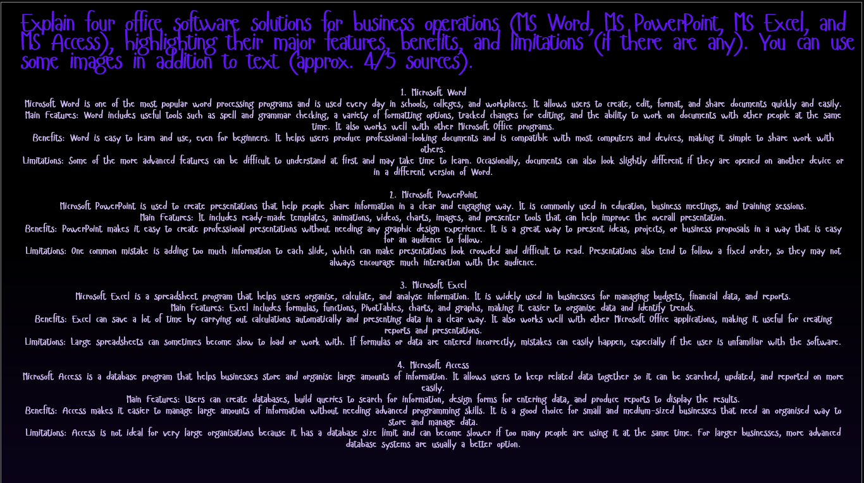
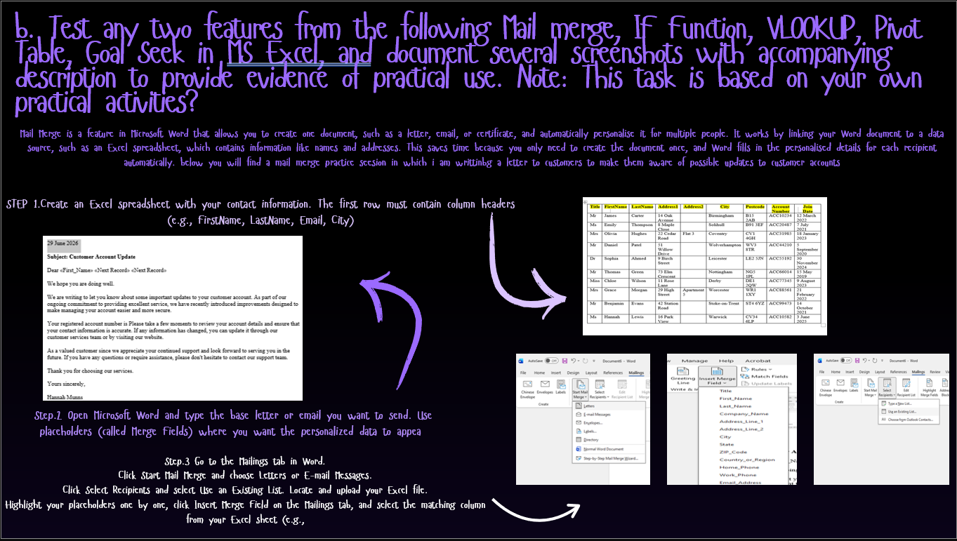
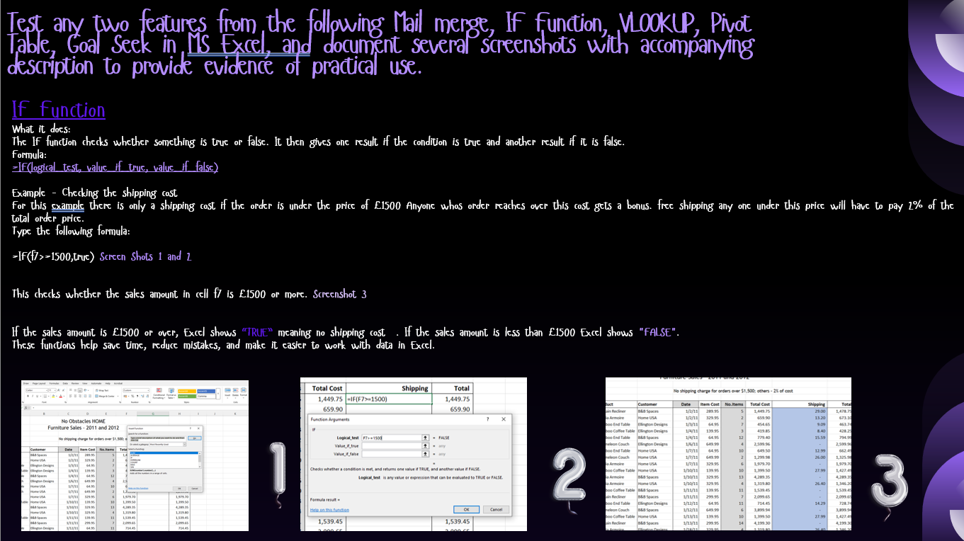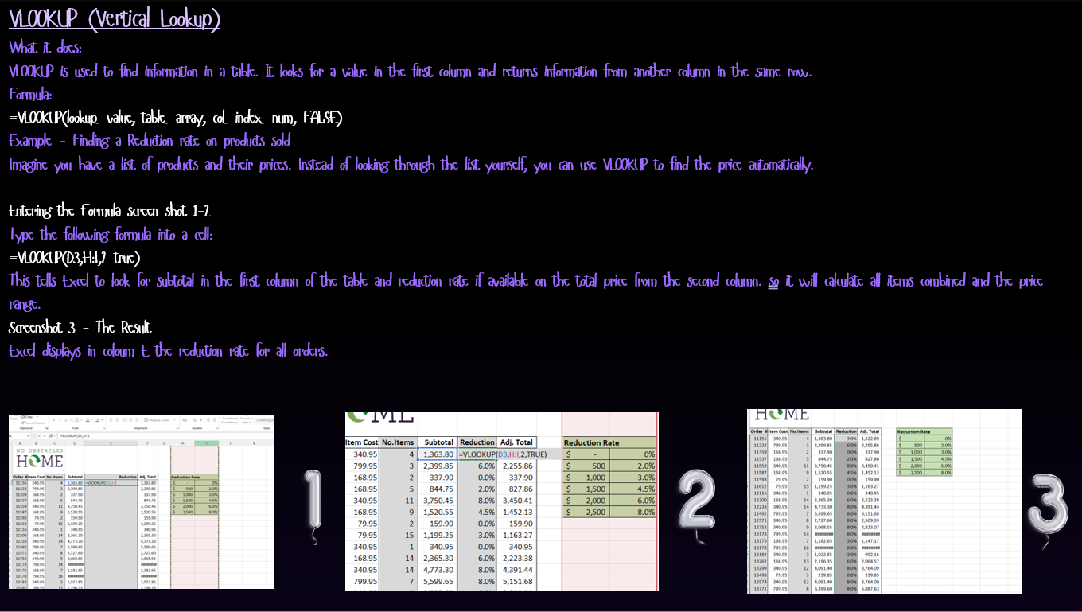
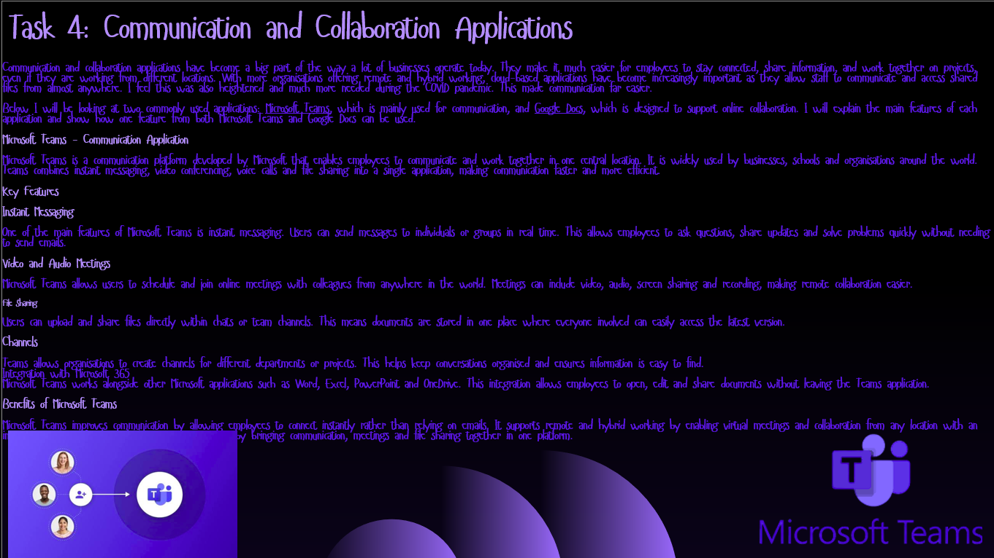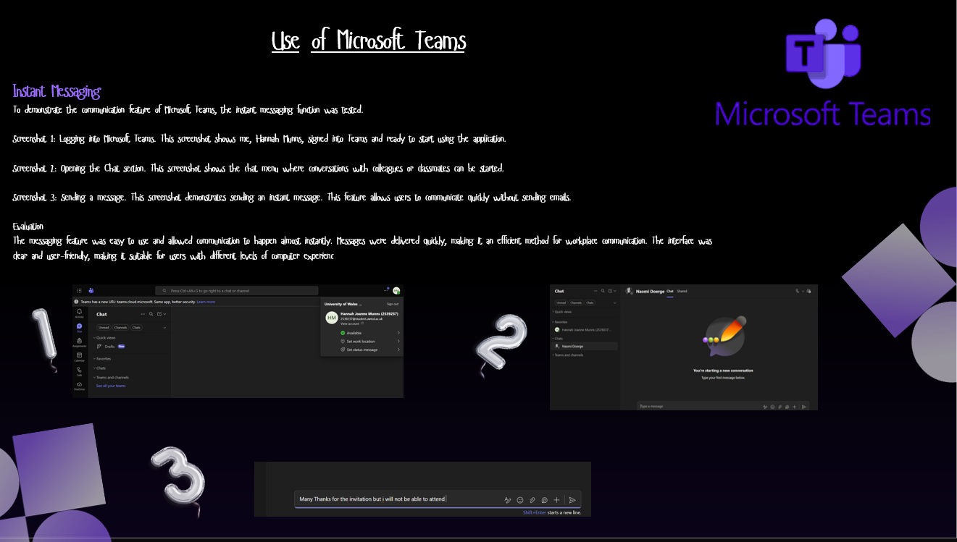
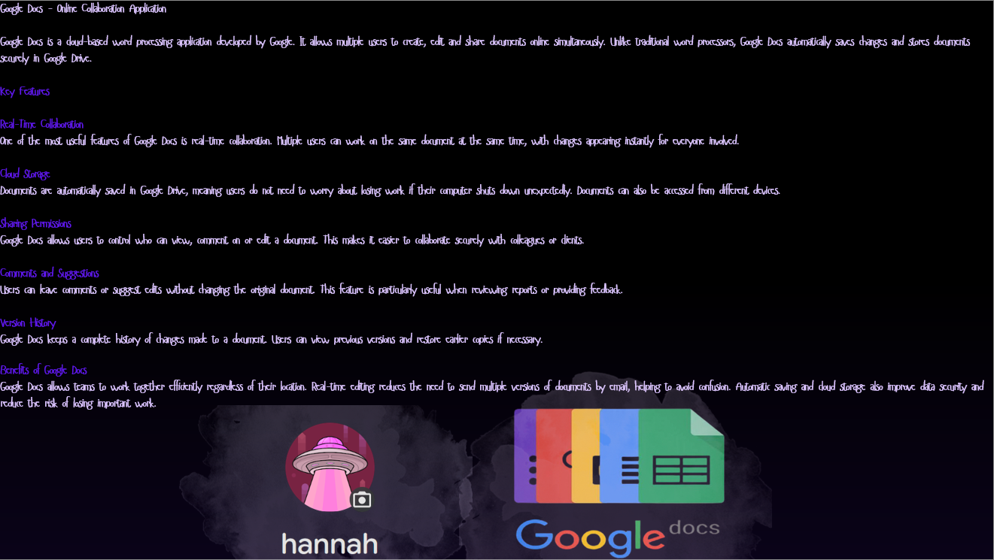
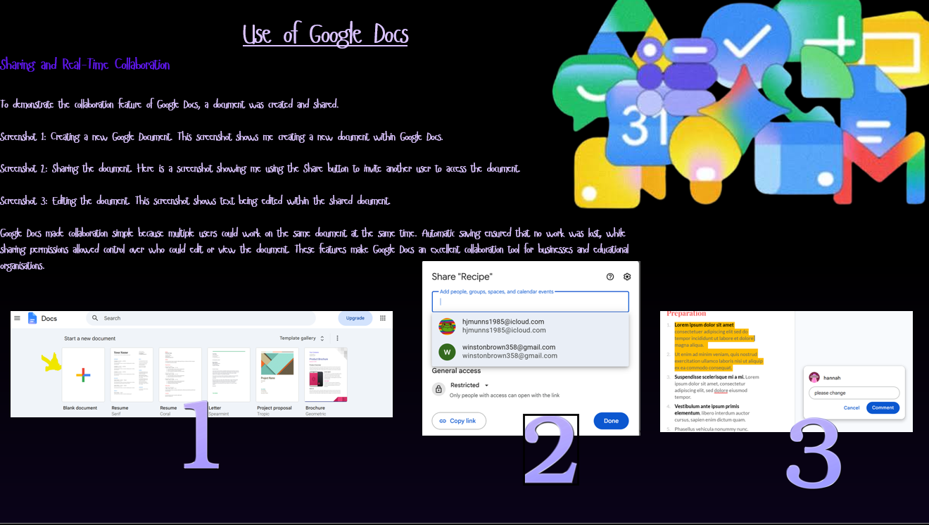
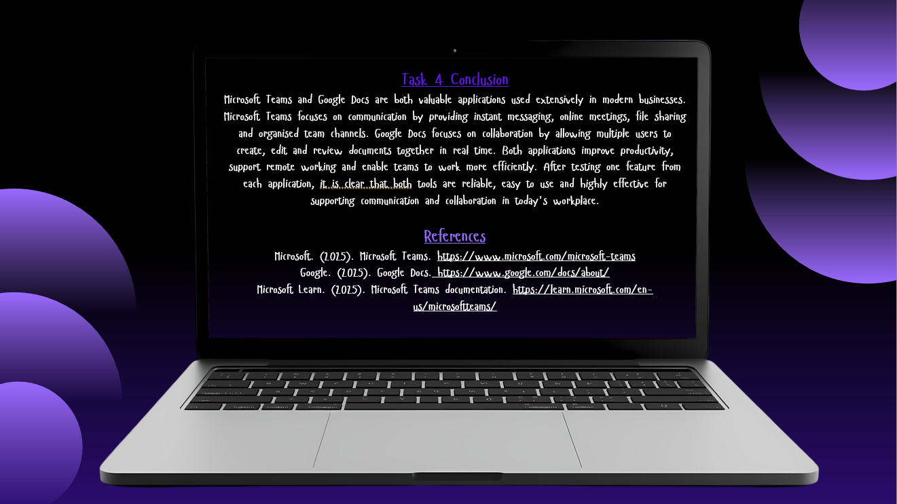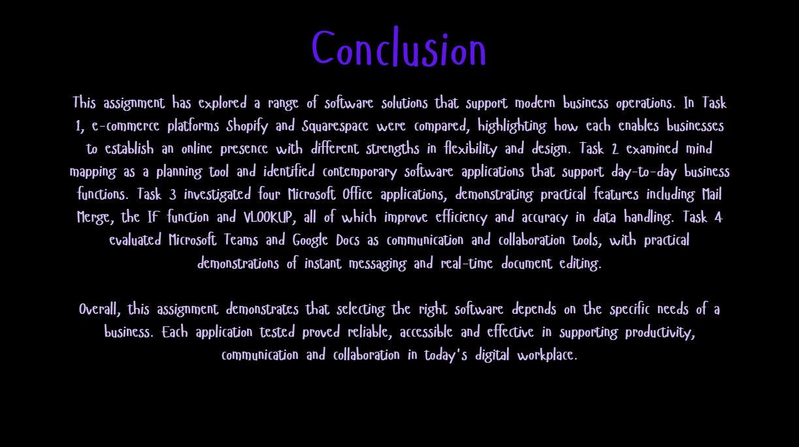
References
Microsoft. (2025). Microsoft Teams. Available at: https://www.microsoft.com/microsoft-teams (Accessed: June 2026).
Google. (2025). Google Docs. Available at: https://www.google.com/docs/about/ (Accessed: June 2026).
Microsoft Learn. (2025). Microsoft Teams documentation. Available at: https://learn.microsoft.com/en-us/microsoftteams/ (Accessed: June 2026).
Shopify. (2025). Shopify - Start and grow your business. Available at: https://www.shopify.com (Accessed: June 2026).
Squarespace. (2025). Squarespace - Build a website. Available at: https://www.squarespace.com (Accessed: June 2026).
Microsoft. (2025). Microsoft 365 - Word, Excel, PowerPoint. Available at: https://www.microsoft.com/microsoft-365 (Accessed: June 2026).
Microsoft. (2025). Microsoft Access. Available at: https://www.microsoft.com/microsoft-365/access (Accessed: June 2026).
Lucidchart. (2025). What is Mind Mapping? Available at: https://www.lucidchart.com/pages/mind-mapping (Accessed: June 2026).

