Michael Oldham (2235684)

L&D Investment analysis and feedback dashboard
Industrial Based Research Proposal

Contents
Introduction 2
Literature Review (Background to the research) 3
Research problem statement 5
Aim & Objectives 6
Research Methodology 7
Research Design 7
Methods and materials 7
Research Philosophy 7
Research Approach 7
Research Strategy 8
Research Choice 8
Research Data 8
Project Planning 10
Resource and Time plan 10
Gantt Chart / Time Plan 12

Introduction

In today's business world, organisations invest a lot of money in Learning and Development (L&D) training programmes and courses to boost employee skills, performance, and overall business growth. These efforts aim to keep staff engaged, productive, and ready for new challenges. However, many companies struggle to see clear results from their spending because they lack effective ways to measure the return on investment (ROI). Without proper tracking, it's hard to know if training leads to real benefits like better job performance, higher engagement, or financial gains. This gap often results in wasted budgets, poorly designed programmes, and missed chances to improve the organisation.

The background reason for this project comes from the growing need for data-driven decisions in human resources. Studies show that while organisations spend billions on L&D each year, only a small number measure ROI properly. For example, traditional feedback methods like surveys give some insights, but they don't connect training costs to outcomes like productivity or revenue. This project is motivated by the desire to bridge that gap, creating a L&D Dashboard that looks at both financial ROI and qualitative results, such as improved employee morale and skills.

The importance of this project lies in its potential to transform how organisations handle training. By developing an interactive dashboard, senior leaders can easily view key metrics, like costs, completion rates, performance changes, and ROI in one place. This tool will help make smarter choices, ensure training aligns with business goals, and justify future investments. Research highlights that interactive dashboards streamline processes, uncover hidden trends, and boost decision-making speed. In the end, it could lead to more effective programmes, happier employees, and stronger organisational success. This approach not only addresses current shortcomings but also sets a model for ongoing improvement in L&D.

Literature Review (Background to the research)

Learning and Development (L&D) is central to building employee capabilities and sustaining business growth. Organisations worldwide invest billions in training each year, with the expectation that it will improve performance, engagement, and retention. However, measuring the return on investment (ROI) of these initiatives remains a persistent challenge. Traditional evaluation methods often fail to capture whether training contributes to productivity, profitability, or business objectives [1]. This literature review examines existing approaches to measuring ROI in L&D, emerging trends in analytics and dashboards, and the research gaps that motivate the planned development of an interactive L&D ROI dashboard.

The most cited framework for training evaluation is Kirkpatrick’s Four Level Model, which assesses reaction, learning, behaviour, and results. Although widely adopted, organisations often stop at measuring satisfaction or completion rates rather than long-term business outcomes [2]. To extend this model, the Phillips ROI methodology incorporates financial calculations by comparing net programme benefits against training costs [3]. Even though these models are strong in theory, many companies don’t use them fully and instead just depend on surveys or informal feedback.

Calculating ROI in monetary terms provides clarity for executives. The formula ((Net Programme Benefits – Training Costs) ÷ Training Costs × 100) has gained traction in aligning training with organisational performance [4]. However, critics argue this narrow focus risks overlooking qualitative benefits, such as improved employee morale, innovation, and knowledge sharing. Studies also highlight the difficulty of isolating training effects from external business factors, such as market conditions or managerial changes [5].

As HR has become more digital, the use of learning analytics has grown. These tools collect data from systems like LMS, performance trackers, and HR databases to monitor results. They can show details such as employee engagement, skill growth, and knowledge sharing, which traditional surveys often miss [6]. Many companies now see the importance of linking training data with financial and business results [7]. However, studies show that a lot of L&D teams do not yet have the skills or systems needed to use analytics well.

A big trend in managing people at work is using interactive dashboards. These dashboards bring together key measures like course completions, performance gains, costs, and return on investment into clear, real-time visuals that senior leaders can see [8]. They make reporting easier, reveal hidden patterns, and help leaders make quicker, evidence-based decisions. Dashboards are already common in areas such as sales and finance, but they are not yet widely or consistently used in learning and development. A 2023 review of learning dashboards showed that, although their use is increasing, very few studies have looked at how they affect overall business performance or long-term return on investment [9].

Many organisations rely too much on limited measures of training, such as participation rates and satisfaction surveys, while often ignoring behavioural change or financial impact.

There is also weak integration of qualitative and quantitative outcomes, financial ROI tends to be prioritised, while employee engagement and skill development are overlooked.

Current tools are not comprehensive. While HR dashboards exist, very few bring together both financial and non-financial learning and development (L&D) measures in a single, interactive platform.

The literature shows that although frameworks like Kirkpatrick and Phillips provide useful theory for measuring ROI, organisations often apply them inconsistently. Financial ROI methods give clarity but fail to capture the less tangible benefits of training. Learning analytics and dashboards could provide deeper insights, but their use in L&D is still limited.

This project addresses that gap by developing a dashboard that combines financial ROI data with qualitative learning outcomes. The tool will present the results in an accessible, interactive way, supporting senior managers to link training investments with strategic goals, make better use of resources, and strengthen employee development.

Research problem statement

Organisations often spend a lot of money on Learning & Development (L&D) training programmes to improve employee skills and performance. However, many do not have a good way to properly measure the return on investment (ROI). This means they lack clear views on skill gains and other benefits, such as better employee engagement and productivity. As a result, training budgets are not used well, programmes are not designed effectively, and chances for company growth are missed. This project tackles this issue by creating an interactive dashboard that combines key measures like costs, completion rates, performance improvements, and ROI to help senior leaders make decisions based on data and improve future training investments.

Aim & Objectives

Aim:

To evaluate the return on investment of training and development opportunities within the ITS department in the agency and identify the most effective way to measure and present their impact to senior management.

Objectives:

- To analyse existing training and development data within the ITS department by reviewing course bookings, participation levels, and associated costs, in order to establish a baseline for return on investment (ROI).

- To evaluate the effectiveness of training through systematic collection and comparison of delegate feedback at different stages, identifying trends and areas for improvement.

- To research and critically assess different methods of presenting training impact data, including written reports, visual summaries, and digital dashboards, to determine the most effective format for senior management.

- To design and develop an interactive Power BI dashboard that integrates key metrics from bookings, feedback, and ROI analysis, providing senior leaders with clear, actionable insights.

Research Methodology

Research Design

This section outlines the research methodology used to evaluate the return on investment (ROI) of training and development opportunities in the ITS department of the agency, and to identify the most effective ways to measure and present their impact to senior management. The methodology is designed to be practical and aligned with the project's aim, using a mix of methods to gather strong evidence. Choices are justified based on their suitability for exploring both measurable outcomes (like cost savings) and subjective experiences (like employee feedback).

Methods and materials

Research Philosophy

The research take on a pragmatic philosophy, which combines elements of positivism and interpretivism. Pragmatism is chosen because it focuses on what works best to answer the research question, allowing flexibility in methods rather than sticking to one fixed view. Positivism is used for the quantitative parts, as it assumes an objective reality that can be measured through facts and statistics (for example, training costs and attendance data). This fits well with evaluating ROI, where numerical data can provide clear, verifiable results. Interpretivism is applied to the qualitative aspects, recognising that people’s experiences and opinions (from survey feedback) are subjective and shaped by their context. This is why the qualitative data helps explain why certain training has specific impact, as this adds to the numerical data which alone cannot provide the same insight. By blending both of these methods, the research avoids any limitations of using a single philosophy. Positivism may overlook personal insights whilst interpretivism could lack general facts from the data. This will ensure a balanced approach and a comprehensive evaluation.

Research Approach

A deductive approach is followed, starting with existing theories on ROI in training (models like the Kirkpatrick’s four levels of training evaluation) and testing them through data collection. This is appropriate because the aim is to evaluate and measure impact based on established concepts rather than creating new theories from scratch (this would be inductive). Deductive reasoning allows hypotheses, such as ‘Higher training attendance leads to better ROI’, to be tested using collected data, which will make the findings more structured and applicable to the agency’s context.

Research Strategy

The strategy is a case study focusing on the ITS department, which involves examining training courses, their costs, outcomes and perceptions over a period of time (a year or two). A case study is justified as it suits the project’s aim by allowing a detailed exploration of a specific organisational setting. It is more appropriate than other alternatives like experiments or action research as these can be hard to control in the workplace or involve changes during the study and not just evaluating them. Surveys are embedded within this strategy as the main tool for data gathering, targeting delegates who have completed training, along with the statistical data captured by teams making the bookings for delegates.

Research Choice

A mixed method approach has been selected to for the research, combining quantitative and qualitative methods. Quantitative methods provide numerical data for analysis (statistics on the training bookings and ROI calculations), while qualitative methods offer further insights into delegate experiences (open ended surveys). This is appropriate for the topic because ROI evaluation needs hard metrics (quantitative) to convince senior management, but also the understanding of the context (qualitative) to identify effective measurement and presentation methods. Using mixed methods helps cover both goals, measuring impact with numbers (quantitative) and showing it clearly with people’s views (qualitative). This makes the results more trustworthy and useful than relying on just one method.

Research Data

Data sources will primarily come from that within the agencies internal systems and databases used for capturing the details of bookings and feedback via surveys. Additional data may come from existing reports on training outcomes.

For data collection methods and tools, Quantitative data on bookings will be collected by exporting from such databases and confirmation that delegates have attended the course. Qualitative and quantitative survey data will be gathered using online tools like Microsoft Forms and sent to delegates at the end of the training course and a follow-up 2 months later, as well as specific manager feedback to capture longer-term impacts. Surveys will record satisfaction rating style questions with strongly disagree to strongly agree, along with open ended questions to gather more specific personal information related to the training materials, trainer, objectives etc.

These choices are appropriate because internal sources provide accurate, relevant data directly relating to the ITS department, with surveys allowing direct input from participants, aligning with the aim to evaluate ROI. Tools like Forms are easy to use, free and through promotion of the information, can ensure high response rates utilising other tools like Power Automate to autonomise the process of these feedback surveys being sent to delegates. I will also be exploring the use of an interactive integrated dashboard through Power Bi.

No specialised hardware will be needed for this project. Standard office computers with internet access will suffice for the data collection and analysis. No GPUs, servers or cloud resources are required, keeping the project low cost and accessible.

Ethical issues include ensuring participant consent (where required), anonymity, and data security. Delegates will receive clear information about the study's purpose and their right to withdraw, with surveys being voluntary and anonymous (no names collected). Data will be stored securely on password-protected agency servers, complying with GDPR and agency policies. This minimises risks like privacy breaches and ensures findings are trustworthy.

Project Planning

Resource and Time plan

This project will be managed using a structured approach, ensuring that resources are allocated effectively and timelines are met. Key resources include access to training records, delegate feedback, and relevant HR data, alongside the technical tools required for data analysis and dashboard development (Microsoft Excel, Power Bi, SharePoint Lists, Power Automate).

Time management will be supported by setting clear milestones for data collection, analysis, and dashboard research and design. Stakeholder engagement within the ITS department and senior management, will also be a critical resource to make sure the outputs are relevant and aligned with the organisational needs.

From a financial perspective, the project will primarily make use of existing systems and software licences already available within the organisation, which will keep costs to a minimum. The main investment will be within staff time, gathering, cleaning and analysing the data as well as developing and testing the dashboard.

The initial impact of the project will be the creation of a tool that enables senior management to view the financial and non-financial returns on training investments in one place. By making these insights easily and readily accessible, the project will help the ITS senior managers make informed decisions about the future training spend and highlight areas and courses that contribute most toward employee development.

In the longer term, the dashboard could be expanded and enhanced to incorporate AI tools and predictive analytics and integrate with additional systems and software within the agency. This could help to increase the value in the tool, ensuring that learning and development remains aligned with organisational goals and financial budgets.

Here are some of the criteria which the project must have, should have, could have and won’t have.

M – Must Haves

- Integration of key data sources, training bookings, attendance records, statistical data regarding the courses, and delegate feedback.
- A functioning Power BI dashboard with clear visualisations and data points for senior management.
- Training support for users of the dashboard.
- Secure handling of sensitive staff and training data in line with data protection policies.
- Ability to filter and view data by financial year, course, department, or time period.

S – Should Haves

- Automated data refresh from booking and feedback systems to reduce manual updates.
- Comparative analysis of different training courses to highlight best value.
- Visual indicators to flag high or low performing programmes.

C – Could Haves

- Predictive analytics to forecast training impact and ROI over time.
- Export options (PDF / PowerPoint / Excel) directly from the dashboard.
- Historical trend data
- Customisable dashboard views for different user groups (HR and senior management).

W – Won’t Haves (for now)

- Full integration with all wider HR systems.
- Mobile app version of the dashboard.
- Advanced machine learning models for prediction

Gantt Chart / Time Plan
Stage 1: Project Initiation & Planning - (2 weeks)
Stage 2: Data Collection & Preparation – (3 weeks)
Stage 3: Data Analysis & Evaluation – (3 weeks)
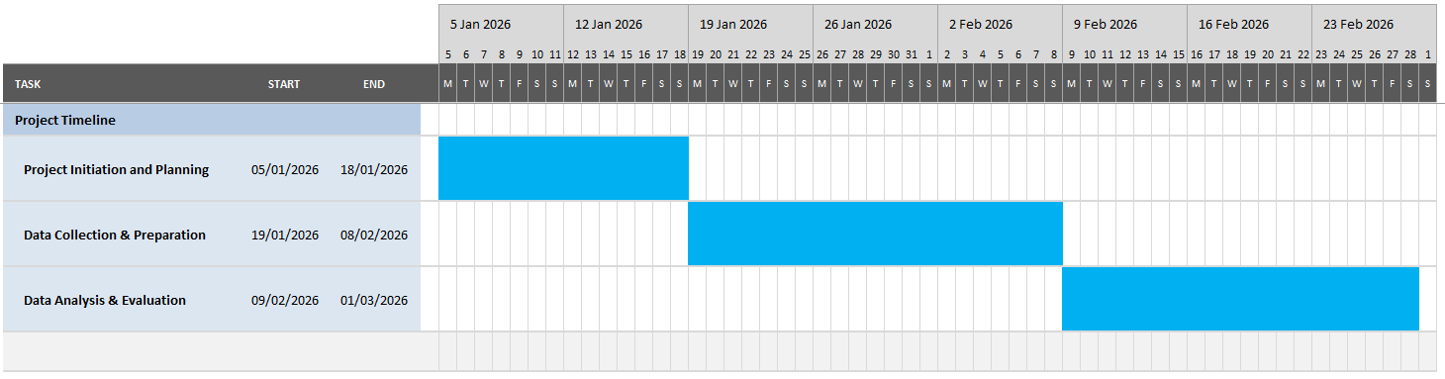
Stage 4: Dashboard Design & Development (Power BI)
Stage 5: Testing & Refinement – (2 weeks)
Stage 6: Training & Implementation – (2 weeks)
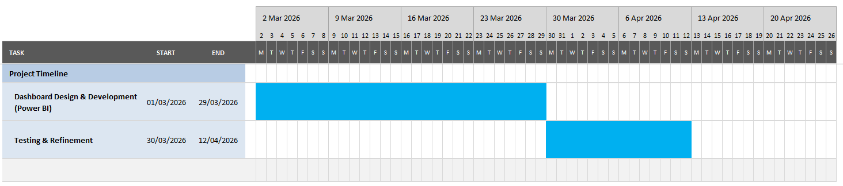
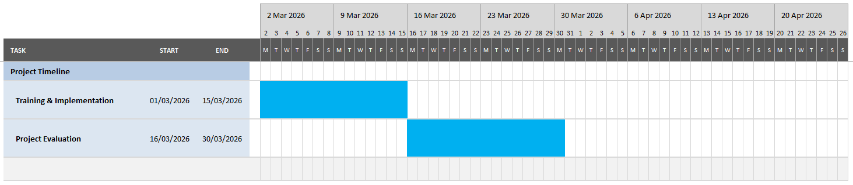
Stage 7: Project Closure & Evaluation – (2 weeks)

References
[1] B. C. Rudy, "Evaluating ROI on Your Company’s Learning and Development Initiatives," Harvard Business Review, Available: https://hbr.org/2023/10/evaluating-roi-on-your-companys-learning-and-development-initiatives, https://hbr.org/2023/10/evaluating-roi-on-your-companys-learning-and-development-initiatives.
[2] E. v. Vulpen, "3 Ways to Measure Training ROI + Useful Tips," 2022. Available: https://www.aihr.com/blog/training-roi/?utm_source=chatgpt.com.
[3] Anonymous . The Phillips ROI Model (Phillips Learning Evaluation Model). Available: https://www.accessplanit.com/en-gb/ap-blogs/phillips-roi-model.
[4] Anonymous . How to Calculate ROI of Employee Training and Development. Available: https://www.peoplehum.com/blog/how-to-calculate-roi-of-employee-training-and-development.
[5] I. Romero, "Measuring the Long-Term Impact of L&D Initiatives on Business Performance," 2025. Available: https://clarityconsultants.com/blog/long-term-impact-of-ld-initiatives.
[6] Anonymous . Learning Analytics - 9 Key Metrics to Evaluate Learning ROI. Available: https://disprz.ai/blog/how-to-leverage-learning-analytics.
[7] D. Muller, "The Ultimate Guide to HR Data Analytics in 2025: Key Metrics, Tools and Use Cases," 2025. Available: https://www.hracuity.com/blog/hr-data-analytics/.
[8] Anonymous . HR Dashboard: 7 Key Examples and Best Practices. Available: https://www.qlik.com/us/dashboard-examples/hr-dashboard.
[9] R. Kaliisa et al. (December 22). Have Learning Analytics Dashboards Lived Up to the Hype? A Systematic Review of Impact on Students' Achievement, Motivation, Participation and Attitude. Available: http://arxiv.org/abs/2312.15042.

