Software Development (ACCB4017_LON) Assessment 1
Lecturer
Renuga Jayakumar
University of Wales Trinity St David, London
Lyudmil Simeonov

Contents
Introduction 2
Part A 2
Variables 2
If/else Statements 2
Loop 4
While loop 4
For Loop 4
Part B 5
Exercise 1: Inputting and displaying vehicle details 5
Exercise 2: Calculating land 6
Exercise 3: Shopping list 7
Exercise 4: Treasure Hunt 9
Appendix 11
References 11

Introduction
This study covers two related tasks: learning the fundamentals of Python and putting them into practice with four exercises. There are two sections to the task. The first step is to write about a simple Python functions. The second portion consists of writing code for four exercises using the variables, if/else statements, and loops that have been learned.

Part A

Variables
A variable is how we store data in code. Programs we write are all about storing and manipulating data, so we use variables to track this data as the program runs.
In computer programing languages there are constants. These are predefined values that cannot be changed. This is known as strongly-typed. However, the difference between Python and other languages is, it does not work with them. We can assign and re-assign values as the program state changes. This means, every value can change at some point. It is known as weakly or dynamically-typed [1].
x = 15
print(x)
# variable changing from int to float
x = 15.0
print(x)

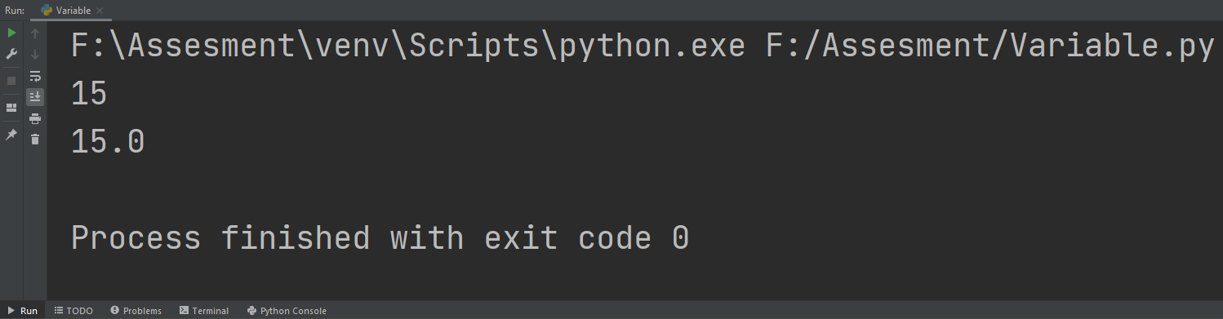
This is simple code the demonstrates how variable can change. In this case it is from integer to float

If/else Statements
If/else checks the conditions and execute the code if the statement is true. In programing you will need to execute a code based on certain conditions. With if/else statement (along with Loops) allows to implement logic [2].
key = input("Press A or D to move the character left or right ") #presenting to the user two inputs
key = key.lower() #displaying always lower case letters
if key == "d":
print("The character moved right")
elif key == "a":
print("The character moved left")
#one of the two inputs is true, prints the respected output
else:
print("invalid key") #wrong input

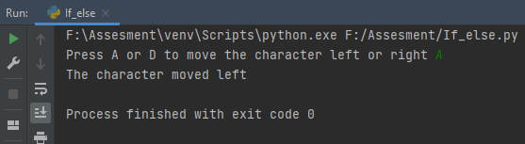
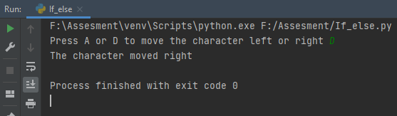
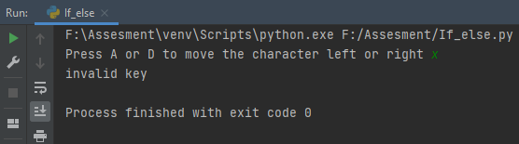
The code is written with a game in mind. The character can move left and right with a press of A or D, respectively. For avoiding errors in the code, a lower case line was written. That way despite what the user is pressing, capital or lower case letter, it will always display lower.
The first two screenshot shows the code working as intended and the last one it displays what happen if the user press a wrong button.

Loop
A loop is a way to execute some sort of code over and over again. The benefit of this is we can write the statements once, execute them once, and run it as much as we have to. However, the danger comes from the way code is written. If it is not done properly, the program can be stuck in an infinite loop that will eventually causing the program to crash. [3]
There are two type of loops – while and for.

While loop
#starting two variables
beginning = 0
end = 5
while beginning < end: #true condition statement
beginning += 1
print(beginning) #while loop executing multiple times and adding +1 every loop until the condition becomes false
print("You have reached the end!")
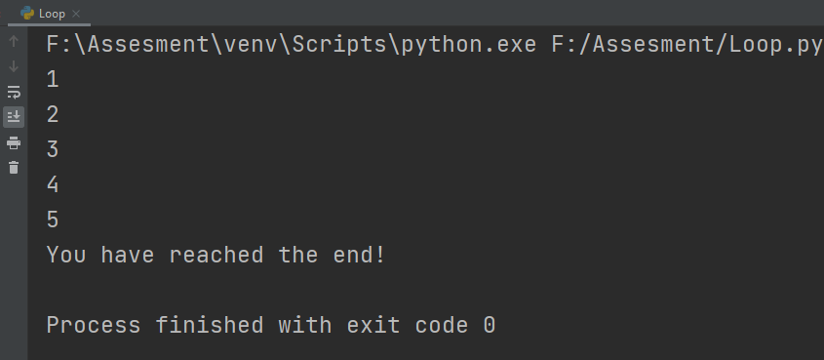

The code in this is example use a while loop. The loop will continue the execute until the condition, beginning < end, becomes false. This is achieved by adding + 1 to beginning on each cycle.
For Loop
The difference between while and for loop is, for loop run set number of times, whereas while loop can be executed many times (potentially infinitely), less times, depending on the situation on what the user is trying to achieve. Basically, set the start and end point, and the number of times it will run.

allies_positions = [5, 10, 15] #list of values
for allies_position in allies_positions:
print(allies_position) #for loop prints each value from list separately
for i in range(0, 5): #using range to print a set number of times
print("I am happy to see my allies")
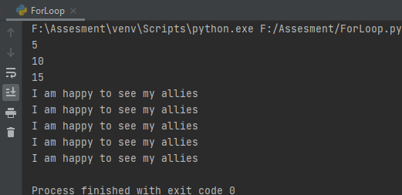
The first part of the code is showing how a for loop is used to print the list (range of numbers). Using for in loop guarantees visiting every member of the list. It will start with the first item and it will end with the last. This means, it will terminate at some point. This is exactly the case here.
The second part of the code is for loop using range to execute the code set number of times. By using range, it was created a range of numbers that span from 0 to 5, not including 5. This is a way to execute a code that has nothing to do with the numbers, in this case, a set number of times.

Part B

Exercise 1: Inputting and displaying vehicle details
print("Please, enter your vehicle details") #prompting the user for an input
maker = str(input("Enter your vehicle manufacturer: ")) #str(string) for letters
model = str(input("Enter your vehicle model: ")) #str(string) for letters
mileage = int(input("Enter the vehicle mileage: ")) #int(integer) for whole numbers
doors = int(input("Enter the vehicle number of doors: ")) #int(integer) for whole numbers
print("\nVehicle details\n" + "Vehicle manufacturer", maker, "\nVehicle model", model, "\nVehicle mileage", mileage, "\nNumber of doors", doors)
#\n used to print each output in a new row

For this exercise were used two strings (str) for typing just letters and two integers (int) for whole numbers and prompting the user for an input. Float is not needed in this case. It is for decimal numbers, and for the exercise the user cannot put and is not expected to put decimal numbers.
For the final output it is used “\”, which is a special character. In combination with “n” (\n), which means newline, prints each output on a new line for the user.

Exercise 2: Calculating land
print("Please, enter the dimensions (length and width) in cm for the land you want to calculate")
length = int(input("Length: ")) #int(integer) for whole numbers
width = int(input("Width: ")) #int(integer) for whole numbers
area = length * width #multiplication for having knowing the whole are in cm2
print("The land dimensions are", length, "cm length and", width, "cm width = ", area, "cm2")
row = length//4 #rounding the result to the lower digit and diving by 4 (4 sides of the bed)
column = width//4 #rounding the result to the lower digit and diving by 4 (4 sides of the bed)
print("Number of tiles in a row is:", row, "and number of tiles in a column is: ", column) #rows and columns for the bed
tilesBeds = row*column #multiplication for the total number of the land
beds = tilesBeds//4 #rounding the result to the lower digit and diving by 4 (4 sides of the bed)
print("You can plant", beds, "carrots") #how many beds the user can plant carrots

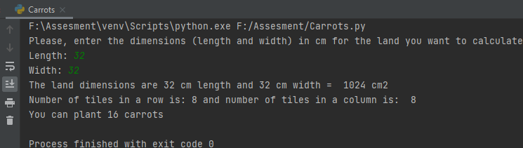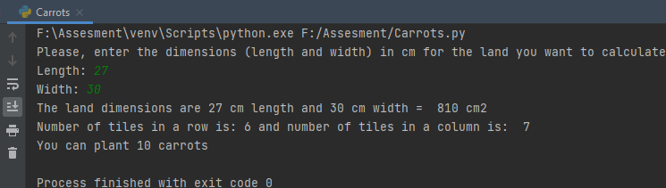
This exercise offers a series of calculations, mostly multiplications and divisions. A user has to find how many beds with carrots he can plant by entering the size of the land. One condition that is stated is that the size of one bed is 8cm x 8cm.
First two variables are presented to the use – length and width. Both are integers, because of the second condition in the task description – the output result should be rounded to the lower number, because it is need full rectangular beds, not part of one. Float can be used too, but for this exercise does not matter.
The user enters the values, they are multiplied to find the whole size of the land in cm2, and the output is shown. After that, two new variables are entered – row and column – to see how many of them the user has in his land. We display the output by dividing the length and width by 4 for row and column respectively (4 being the size of the bed). Finally, the row is multiplied with column to receive the end result – in how many beds the user can plant carrots.
One important note. To achieve the second condition from the task, double slash “//” operator is used. It is also known as Floor Division. This operator round a decimal number to the smallest whole number.

Exercise 3: Shopping list
grocery_item = {} #empty dictionary
grocery_history = [] #empty list
stop = False #code starts executing
print("This is your product list. Choose item, quantity and price of each")
while not stop: #while loop for the variables
item_name = input("Item name:\n") #variable
quantity = input("Quantity purchased:\n") #variable
cost = input("Price per item:\n") #variable
grocery_item = {'name': item_name, 'number': int(quantity), 'price': float(cost)} #dictionary containing all all objects
grocery_history.append(grocery_item) #adds all the items
user_input = input("Would you like to enter another item?\nType 'y' for continue or 'n' to quit:\n")
if user_input == 'n':
stop = True #if statement to stop or continue the input
grand_total = 0
for index, item in enumerate(grocery_history): # enumaerate makes it easier to keep track of the content of an iterable object
item_total = item['number'] * item['price']
grand_total = grand_total + item_total
print('%d %s £%.2f each, total = £%.2f' % (item['number'], item['name'], item['price'], item_total)) #%s acts a placeholder for a string while %d acts as a placeholder for a number.
item_total = 0
print('Grand total: £%.2f' % grand_total) #% makes the outcome be float point type and 2f prints only the 2 digits after the decimal point
percentage = float(15) #15% discount as float
discount = grand_total/percentage #division for the discount
end_sum = grand_total - discount #substraction for the end output
print("The total sum after the 15% staff discount is: £", round(end_sum, 2)) #round makes the numbers round, 2 makes the output print only the first 2 digits after the decimal point

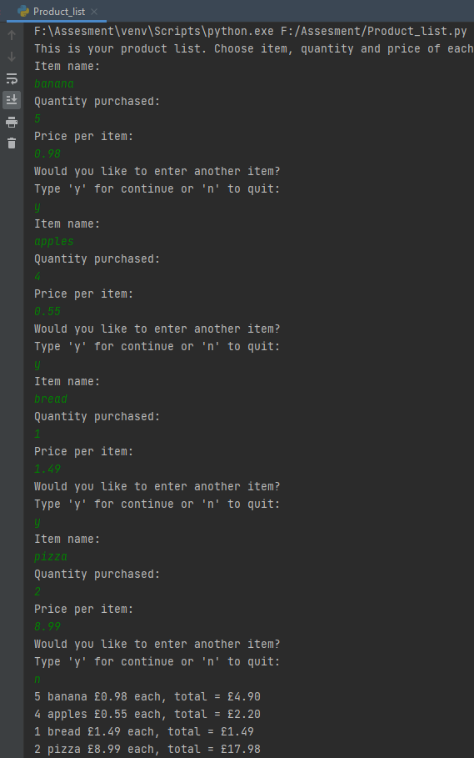
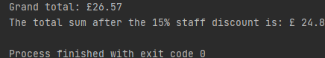
The code starts with setting up a dictionary (grocery_item = {}) and a list (grocery_history = []) to be called later and filled. After that, a condition is set with stop = false. If it is met, the programs stop, and displays the results. A while loop is set if the stop condition is not true. The user puts 3 variables, Item name – item_name; Quantity purchase – quantity; and Price per item - cost. Then the dictionary is called and stores with the 3 variables - item_name, quantity, cost – for later use.
grocery_history appends grocery_item, which means it allows the program to add new items if there is an input.
At the end of the while loop, it is set up the stop condition. If the user does not want to continue, he types n and the conditions becomes true. Then the program calculates and shows the output.
A for loop is set up with enumerate(). The enumerate() function assigns an index to each item in a iterate object that can be used to reference the item later. It makes tracking the items easier.
Printing the output uses two placeholders %d and %s for numbers and string, respectively. Their associated values are passed via tuple through % operator. It is also used %2f to tell the code the show only the first two digits after the decimal point.
Printing the output Grand total also uses %2f. After that the 15% discount is set up. The final output uses a round() function to round the output. The 2 in the brackets means it will display only the first two digits after the decimal point.

Exercise 4: Treasure Hunt
import random #importing randomness to the game
print("It's Treasure hunting time!")
board = [] #empty list
for x in range(0, 5):
board.append(["0"] * 5) # displaying up the board
def print_board(board):
for row in board:
print(" ".join(row)) #displaying the rows of the board
print_board(board)
choice = "y" #setting up the loop
print("Choose a column and a row from 1 to 5")
while choice == "y": #setting up the user choice
r = int(input("Enter the row: "))
c = int(input("Enter the col: "))
if r and c == random: #two integers match the random to win
print("You win")
else:
print("You lost")
choice = input("Would you like to continue? Y or N ")
choice = choice.lower()
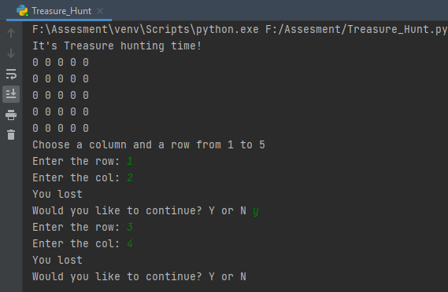
The code starts with importing random. Instead of setting up predetermine points where the treasure is, random is imported add replayability to the game.
After that board is created as an empty list for later use when the playing field have to be displayed. For that to happen for loop and def function is written. With their help the board, containing zero’s (0) will be in the output.
The end of the code is about the user’s choice to try and guess again where the treasure is. It is done by creating the choice variable and then a while loop around it, along side user’s input about the row and column of his choice. If both are equal to the randomly assign answer, it displays “You win”. The use of lower() assures there will not be errors with the user inputs lower or capital letter.
Due to the randomness, a “You win” result was not achieved.

Conclusion
The report presents a clear understanding of the basics in Python and their implementation in the 4 exercises. During the second part of the assignment were successfully implemented the basic function – variables, if/else statements, loops, and even more functions.

Appendix

References

[1]
J. Sturtz, “Variables in Python – Real Python,” realpython.com. https://realpython.com/python-variables/ (accessed Apr. 20, 2021).
[2]
D. Agarwal, “Python if else,” GeeksforGeeks, Dec. 27, 2017. https://www.geeksforgeeks.org/python-if-else/ (accessed Apr. 20, 2021).
[3]
A. Sharma, “loops in python - GeeksforGeeks,” GeeksforGeeks, Jun. 07, 2017. https://www.geeksforgeeks.org/loops-in-python/ (accessed Apr. 25, 2021).
‌

