INTERNATIONAL BUSINESS COMMUNICATIONS
Student Name: Elena Goranova
Student Number: 2122365
Lecturer: Zainab Atta

Table of Contents
1. Introduction 3
2. A brief introduction to Unilever 3
3. Evaluation of two EU countries 4
3.1 Country facts to understand Cultural Differences 4
3.2 Communication Barriers 6
4. Recommendations 8
4.1 Recommended Nation with Justification 8
4.2 Strategies to Overcome Communication Challenges 10
5. Conclusion 11
References 12

1. Introduction
This report intends to highlight the crucial factors associated with British business communication while conducting any business. The British business communication includes a mix of direct and indirect communication. It is worth mentioning that wheat is business Communications foster inclusivity as a paramount area for effective and harmonious professional interaction. British business landscape is a combination of a diverse workforce and demands diversification and inclusion while managing communication. Communication is the key pillar that allows companies to thrive in succeed. British business communication indicates the effectiveness of open communication, respect, and understanding. The British are used to interacting via email and are also focused on maintaining other forms of more direct communication such as face-to-face meetings and conference calls. In this regard, it can be stated that British business communication involves both direct communication and indirect communication style. The British also utilize language in a coded manner favouring saying offensive and negative things by using more acceptable, positive phrases. For example, British business personnel use the phrase “I think you have made several excellent points there but have you ever considered….” in place of “I disagree”. The British business personnel include honesty with open confrontation and concern that bluntness may offend the other party. This type of business communication allows British businesses to maintain a diverse workforce and interact with employees from different backgrounds and cultures.

2. A brief introduction to Unilever
Unilever has secured a leading position and a renowned Global force in the consumer goods industry. This company is known for its diverse product portfolio such as food products, beauty items, and household. This company is devoted to enhancing sustainable living and innovation, which has permitted this company to make it distinguishable among its competitors. This company started its journey in 1929 and has expanded internationally (Unilever, 2023). This company has extended its business in more than 190 countries and 3.4 billion people use its products on a daily basis (Unilever, 2023). This business progression indicates the accuracy of business communication of this company to maintain its position. It is worth mentioning that this company has made €59.6 billion in turnover in 2023 (Unilever, 2023). This company has employed 127,000 employees across the globe and has secured the No.1 FMCG employer of choice (Unilever, 2023). One of the most significant factors of this company is its sustainable and ethical business practices. Each of the employees of this company from top to bottom focused on enhancing ethical and sustainable business practices that can impact positively on the environmental society. It is worth mentioning that this company has included several strategies to maintain sustainable business practices such as 21% of its packaging made of recycled products (Unilever, 2023). Another initiative of this company towards sustainable and ethical business is that 48% of its product portfolio offers positive nutrition. In order to handle sustainable and ethical business initiatives and maintain the international Business landscape, Universe also has to implement accurate and effective business communication.

3. Evaluation of two EU countries

3.1 Country facts to understand Cultural Differences
Social context and profile
Unilever has extended it is business in many different EU countries but not has extended is business in Croatia and Lithuania. Unilever Mein has to face a distinct cultural context while expanding in Croatia and Lithuania. Croatia is rich in history and Mediterranean influence, which indicates the perspectives of the people of Croatia to value familial bonding and close-knit communities. On the contradictory of, the social aspects of Lithuania are dissimilar to Croatia. Lithuania is conscious of a unique blend of cultures and is concerned about hospitality and strong social connections. From the perspective of Kshetri (2021), it can be stated that evaluating social concepts is meaningful for companies to extend to new countries. Croatian culture is deeply influenced by Slavic traditions and customs. On the other hand, Lithuanian culture is deeply shaped by the culture of Nordic, Germanic and Slavic cultures. Therefore, Unilever needs to understand in-depth perspectives of the society of both countries and define strategies as per the significance of both societies. Political stability and cost of living are very high in Croatia compared to Lithuania.
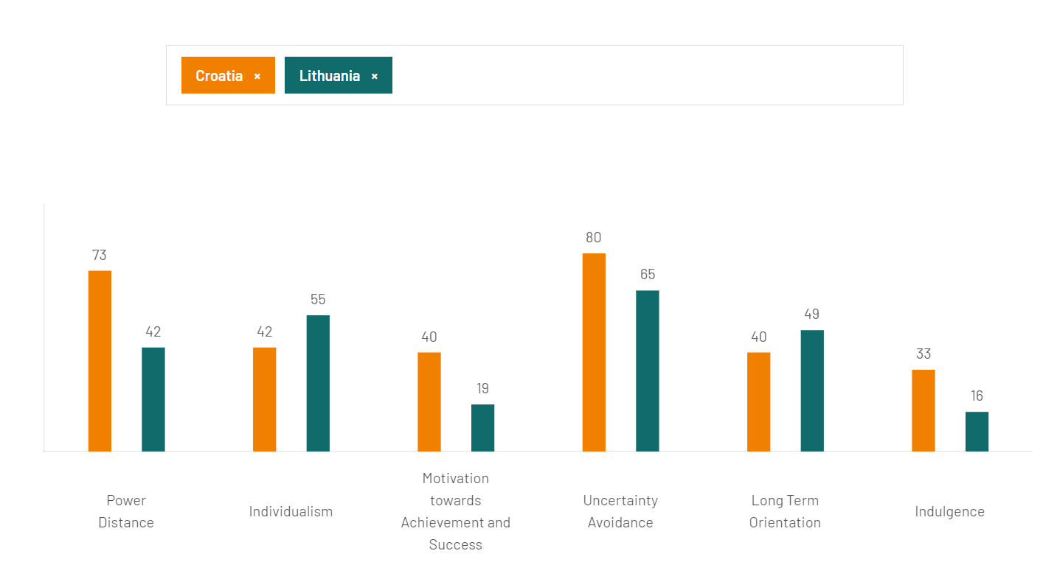
Figure 1: Hofstede cultural dimension
(Source: Hofstede-insights.com, 2024)
The information on power distance, individualism, long-term orientation, and uncertainty avoidance of both countries can be gathered by conducting Hofstede analysis. The above-mentioned figure has analysed different factors associated with cultural dimensions in both countries. Lithuania has scored low at power distance as its score is 42 whereas the score of Croatia is 73 in the same category. Individualism is one of the prominent factors while evaluating the social background of countries and Lithuania has scored 55 which is high compared to Croatia. Croatia scored 42 in individualism. This figure highlights Lithuania remained individualist during the Soviet occupation. On the other hand, Croatia is focused on a collaborative approach while maintaining business for completing any tasks. Croatia is very high in uncertainty avoidance as this country scored 80 and Lithuania scored 65. All of this analysis will be beneficial for Uninor to understand the social concept and profile of Croatia and Lithuania. As a result, this company can develop productive and relevant strategies for matching its operations and working procedures with the social context of these countries.
Language, risks, and labour Outlook
Language serves as a salient rule in business interaction and maintaining connections among employees. It is worth mentioning that the selection of language and communication style prominently is mandatory for companies while planning for international expansion. According to the explanation of Qi et al. (2020), it can be indicated that language barriers often cause unsuccessful business expansion in new countries. Language is integral to business introductions and understanding linguistic approaches is essential for business. The official language of Croatia is Croatian and Lithuania is Lithuanian. However, English is commonly spoken in both countries. Employees of Unilever need to learn and communicate with local people in the local language, which can be effective for business progression in these countries. Unilever may have to face risk in Lithuania due to its smaller market size and economic dependency on certain sectors. On the other hand, possible risks in Croatia are bureaucratic challenges and regulatory complexities. It is worth mentioning that the workforce of Croatia values teamwork and developing interpersonal relationships. According to the observation of Farida and Setiawan (2022), it can be stated that a positive team-building capacity allows companies to achieve goals. The working procedure of Unilever also matches the concept of teamwork and interpersonal relationships with Croatia. On the other hand, Lithuania values diverse and skilled labour support, which also matches the concept of diversity and inclusion of Unilever.

3.2 Communication Barriers
Communication barriers are one of the most crucial challenges faced by companies while intending to expand they are business in the international landscape. Based on the suggestion of Dana et al. (2022), international communication barriers can result in significant challenges to businesses intending to expand into new markets. It is worth mentioning that even experienced companies can face difficulties in maintaining interaction with suppliers or partners when language differences, create misunderstandings and threaten their business plans abroad. Language differences are one of the significant communication barriers that may have to face by Unilever in expanding business in Croatia and Lithuania. Croatian people use crucial language whereas Lithuanian people use the Lithuanian language on a broad spectrum. However, English is the common language used in both countries but employees of Unilever may have to face difficulties in maintaining introduction with local people in these countries. Based on the observation of Tay et al. (2022), it can be discussed that connecting with local people in new countries is helpful for companies to extend in international countries. Employees of Unilever need to communicate with different stakeholders in new countries such as suppliers, partners, other employees, and consumers. Therefore, it can be stated that a lack of proper pronunciation, vocabulary, and cultural idioms can lead to misunderstanding and confusion in the international business landscape. In this regard, it can be discussed that employees of Unilever need to pronounce each word clearly and eliminate jargon to ensure effective communication.
Differences in cultural communication style can be another communication barrier for companies in international expansion. It has been observed that Croatia is high in power distance culture that suggests respect for authority and hierarchical structures. In contrast to Lithuania, the people of this country prefer a collaborative decision-making approach. From the information of Asatiani et al. (2020), it can be asserted that formal and precise communication is always acceptable in the business landscape. Nonverbal communication such as attitude, gestures, and body language are integral parts of communication. It is worth mentioning that different countries have different attitudes and gestures of maintaining communication. The body language and gestures of Communication reflect emotional expression. Therefore, British business communication needs to clearly identify certain body language, attitudes, and gestures of certain countries to maintain communication. Business communication includes business etiquette, which plays a significant role in developing relationships with stakeholders in new countries.
Different country's business patterns and communication styles are different. For instance, business personnel in Croatia prefer formal business etiquette and greetings are essential in this business landscape. On the other hand, the business landscape in Lithuania focused on maintaining politeness and continued business interaction with an informal approach. According to the opinion of Fayard et al. (2021), it can be stated that the informal approach often allows companies to develop positive relationships among team members. However, employees of Unilever may have to learn both formal and informal interaction approaches to reduce communication barriers. The decision-making approach can be another significant aspect that barriers effective and adequate communication. It is worth mentioning that business personnel in Croatia are more likely to involve key stakeholders and follow a more centralized decision-making approach. On the contradictory of, Lithuanian’s business structure involves a wide input while making any decisions. Based on the point of Pal and Yasar (2020), it can be stated that communication barriers can cause challenges in sharing information on time. In this regard, it can be stated that employees of Unilever need to differentiate the communication patterns in Croatia and Lithuania while making any decision. In Lithuania, they can communicate with each stakeholder engaged in the business but in Croatia, they need to maintain accurate communication with key stakeholders.

Figure 2: Communication barriers
(Source: Self-developed)

4. Recommendations

4.1 Recommended Nation with Justification
Recommendation 1: Analysing business goals and market potential
Unilever needs to conduct a thorough analysis of goals and market potential in each Croatia before implementing an accurate communication strategy. In order to be very specific, it can be discussed that the company need to have robust and clear planning related to consumer demographics, market saturation, and growth projections associated with the expansion in Croatia. As suggested by Varadarajan (2020), the benefit of analysing business goals and market potential will allow companies to identify their required stakeholders, suppliers, and partners. As a result, they can develop communication practices and define communication strategies as per selected stakeholders.
Recommendation 2: Identifying and setting target market segments
The identification of target market segments is also crucial for companies to develop communication strategies. It is worth mentioning that different people of different regions and demographic in Croatia continue different language and communication pattern. Therefore, defining customer segment will narrow down the wide communication style. Based on the point of view of Olson et al. (2022), it can be indicated that defining a target customer segment is effective for companies to narrow the consumer base. Therefore, it can be stated that the company can identify a specific communication strategy and pattern based on the identified customer segment. British Communication can plan to provide relevant communication training to employees to maintain interaction with stakeholders in new countries. Hence, defining a target market segment is effective as it can help companies design planning program that aligns with the communication patterns of the target market segment. From the perspective of Hamzah and Shamsudin (2020), the benefits of defining customer segmentation for businesses include enhancing customer satisfaction by understanding and meeting their specific needs, boosting customer retention with the help of personalized communication, and enabling sales and revenue by targeting high-value customers.

Figure 3: Recommendations for reducing communication barriers
(Source: Self-developed)

4.2 Strategies to Overcome Communication Challenges
Companies need to incorporate multifaceted strategies to overcome communication challenges and promote a positive environment for each employee. Developing a positive culture is fundamental for companies to create a learning environment for employees. It is worth mentioning that companies need to implement language training programs to bridge the linguistic gap. The benefit of implementing these training programs is that they can allow employees to enhance their language proficiency specifically in English to enable clearer communication. From the perspective of Campbell et al. (2020), it can be stated that clear communication can reduce the risk of misunderstandings. For instance, English is the common language of both Croatia and Lithuania. Therefore, proficiency in the English language will allow employees of Unilever to maintain interaction with customers and other stakeholders in these new countries. Respecting cultures and showing dignity to individual cultures is equally essential for maintaining positive communication in a new country (Figure 4). As opined by Roberson and Perry (2021), employees need to have the capacity to acknowledge and appreciate diverse cultural backgrounds and need the organisation to create a positive and inclusive working environment. In this regard, it can be stated that employees need to be equipped with the required knowledge and skills to navigate different cultural backgrounds. According to the opinion of Shore and Chung (2021), it can be informed that treating employees of different cultures equally is mandatory to generate a positive and inclusive work culture. Therefore, showing dignity and respect to each culture can help employees in building mutual understanding and respect in new countries.
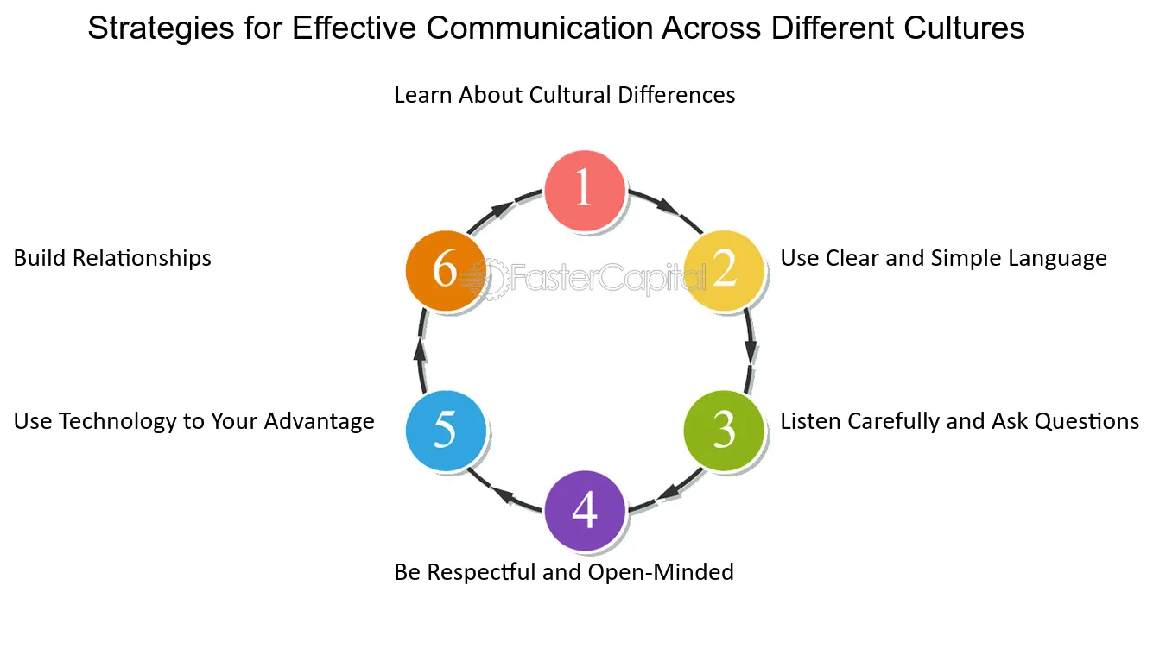
Figure 4: Communication pattern
(Source: FasterCapital, 2024)

5. Conclusion
The purpose of this report is to highlight the factors of British business communication And highlight the significance of maintaining effective communication in international business. In order to do so, this report has discussed the international expansion of Unilever as this company has expanded to more than 190 countries. This report has explained the social contexts of Croatia and Lithuania in the case of the expansion of Unilever in these countries. Therefore, Hofstede cultural model has helped to compare can power distance, individualism, uncertainty avoidance, and long-term business goals of both countries. This report has highlighted the communication barriers that may have to face by companies in the international business landscape. Primary communication barriers like language differences, cultural communication styles, nonverbal communication procedures, business etiquette and formality, and decision-making processes have been identified in this study. It has been observed that different countries possess different patterns of communication styles such as formal, informal, and intercultural communication styles. This report also unfolds other factors such as different body language, gestures, and attitudes while maintaining communication in the business landscape. Analysing business goals and market potential and identifying and setting target market segments are two potential recommendations for companies that can be implemented to reduce communication barriers. Developing communication training programs, enhancing cultural sensitivity, and inclusion of technological solutions can be effective for companies to reduce communication barriers.

References
Asatiani, A., Hämäläinen, J., Penttinen, E. and Rossi, M. (2020). Constructing continuity across the organisational culture boundary in a highly virtual work environment. Information Systems Journal, [online] 31(1). doi:https://doi.org/10.1111/isj.12293.
Campbell, S., Campbell-Phillips, S. and Phillips, D. (2020). Lack of Communication between Management and Employees. SIASAT, [online] 5(3), pp.32–39. doi:https://doi.org/10.33258/siasat.v5i3.67.
Dana, L.-P., Salamzadeh, A., Mortazavi, S. and Hadizadeh, M. (2022). Investigating the Impact of International Markets and New Digital Technologies on Business Innovation in Emerging Markets. Sustainability, [online] 14(2), p.983. Available at: https://www.mdpi.com/2071-1050/14/2/983.
Farida, I. and Setiawan, D. (2022). Business Strategies and Competitive Advantage: The Role of Performance and Innovation. Journal of Open Innovation: Technology, Market, and Complexity, [online] 8(3), p.163. doi:https://doi.org/10.3390/joitmc8030163.
FasterCapital. (2024). Cross Cultural Communication: Navigating the Crossover of Global Business. [online] Available at: https://fastercapital.com/content/Cross-Cultural-Communication--Navigating-the-Crossover-of-Global-Business.html.
Fayard, A.-L., Weeks, J. and Khan, M. (2021). Organizational Culture Designing the Hybrid Office. [online] Available at: https://s3.eu-west-2.amazonaws.com/construo-storage/attachments/57bddbf73518df3dbdff113d61741d469be6cd3dc7b67e09cdeadfdb8483690a/Hybrid_Office_Zoom.pdf.
Hamzah, A.A. and Shamsudin, M.F. (2020). Why Customer Satisfaction Is Important To Business? Journal of Undergraduate Social Science and Technology, [online] 1(1). Available at: http://abrn.asia/ojs/index.php/JUSST/article/view/58.
hofstede-insights.com. (2024). Country comparison tool. [online] Available at: https://www.hofstede-insights.com/country-comparison-tool?countries=croatia%2Clithuania [Accessed 11 Mar. 2024].
Kshetri, N. (2021). Blockchain and sustainable supply chain management in developing countries. International Journal of Information Management, 60, p.102376. doi:https://doi.org/10.1016/j.ijinfomgt.2021.102376.
Olson, E.M., Olson, K.M., Czaplewski, A.J. and Key, T.M. (2021). Business Strategy and the Management of Digital Marketing. Business Horizons, 64(2). doi:https://doi.org/10.1016/j.bushor.2020.12.004.
Pal, K. and Yasar, A.-U.-H. (2020). Internet of Things and Blockchain Technology in Apparel Manufacturing Supply Chain Data Management. Procedia Computer Science, [online] 170, pp.450–457. Available at: https://www.sciencedirect.com/science/article/pii/S1877050920305251.
Qi, X., Chan, J.H., Hu, J. and Li, Y. (2020). Motivations for Selecting cross-border e-commerce as a Foreign Market Entry Mode. Industrial Marketing Management, 89(1), pp.50–60.
Roberson, Q. and Perry, J.L. (2021). Inclusive Leadership in Thought and Action: A Thematic Analysis. Group & Organization Management, 47(4), pp.755–778.
Shore, L.M. and Chung, B.G. (2021). Inclusive Leadership: How Leaders Sustain or Discourage Work Group Inclusion. Group & Organization Management, 47(4), p.105960112199958. doi:https://doi.org/10.1177/1059601121999580.
Tay, L.-Y., Tai, H.-T. and Tan, G.-S. (2022). Digital financial inclusion: A gateway to sustainable development. Heliyon, 8(6), p.e09766. doi:https://doi.org/10.1016/j.heliyon.2022.e09766.
Unilever (2023). Unilever at a Glance. [online] Unilever. Available at: https://www.unilever.com/our-company/at-a-glance/.
Varadarajan, R. (2020). Customer Information Resources advantage, Marketing Strategy and Business performance: a Market Resources Based View. Industrial Marketing Management, 89(1), pp.89–97. doi:https://doi.org/10.1016/j.indmarman.2020.03.003.

