

Name: Judith Churcher
Student Number: 2101153
Module: Economics of Sustainability (BMSP6007)
Assessment 2: Report 2,500 Words – 3rd of May 2024

Executive Summary
This report will analysis the World Economic Forum's (WEF) Global Risks Report to provide insights into the current global risk landscape and its implications for sustainable development efforts in 2024. By examining the risks outlined by the WEF and their potential impact on various aspects of global sustainability, it aims to offer a comprehensive understanding of the challenges at hand. Additionally, it will provide an assessment of these risks, highlighting key areas of concern and potential avenues for mitigation. Through this analysis, it seeks to contribute to a deeper understanding of the complex challenges facing the world today and offer actionable insights for policymakers, businesses, and other stakeholders striving to promote sustainable development in an increasingly uncertain world.

Table of Contents
1. Introduction 4
2. Natural Resource Shortages – what does this mean? 6
2.1 What causes Natural Resource Shortages? 6
2.2 How does it impact the Sustainable Development Goals? 6
2.3 The Malthusian theory 8
2.4 The Kuznets Curve 8
3. Conclusion 10

Introduction
The World Economic Forum's (WEF), founded by Klaus Schwab in 1971. It is an independent international organisation that is “committed to improving the state of the world” (World Economic Forum, 2024). It brings together business, political, academic, and other leaders from around the world to discuss and address pressing global issues. The WEF holds annual meetings in Davos, Switzerland, where members engage in discussions, workshops, and networking sessions aimed at finding solutions to global challenges.
They produce reports to examine in detail some of the global issues we are facing and bring together leaders and stakeholders to help address the challenges collaboratively. In this report, two risks identified in the World Economic Forum's Global Risks Report will be explored along with their potential implications for sustainable development (Kagan, 2023).
In this report, will be the analysis on natural resource shortages, a critical environmental risk highlighted in the World Economic Forum's Global Risks Report. By delving into this particular risk, I aim to explore its potential implications for sustainable development goals and how it aligns with sustainability theories. This narrow focus will allow for a deep dive into the complex interactions between lack of resources, environmental degradation, and the pursuit of long-term sustainability objectives.
The WEFs Risk Report shows that nearly all the environmental risks are included in the top 10 of risks ranked by severity over the long term. The top three being: extreme weather events, critical change to earth systems and biodiversity loss and ecosystem collapse.
(World Economic Forum, 2024)
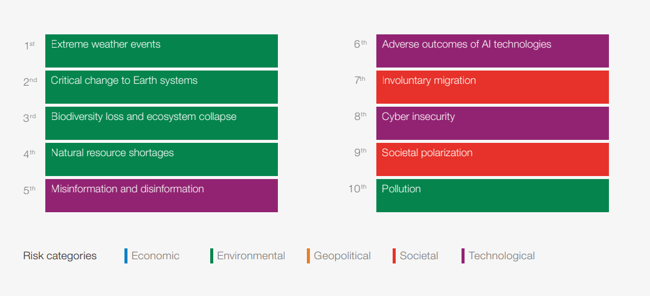
Taken from the most recent report, the figure above shows that natural resource shortages sits at number 4 in the top ten in severity over the next 10 years. This suggests that natural resource shortages are considered a significant concern in the coming decade. Understanding and addressing this risk is crucial for ensuring sustainable development and mitigating potential negative impacts on various aspects of society and the environment. Therefore, it would be prudent to examine this risk in more detail to develop effective strategies for managing it.

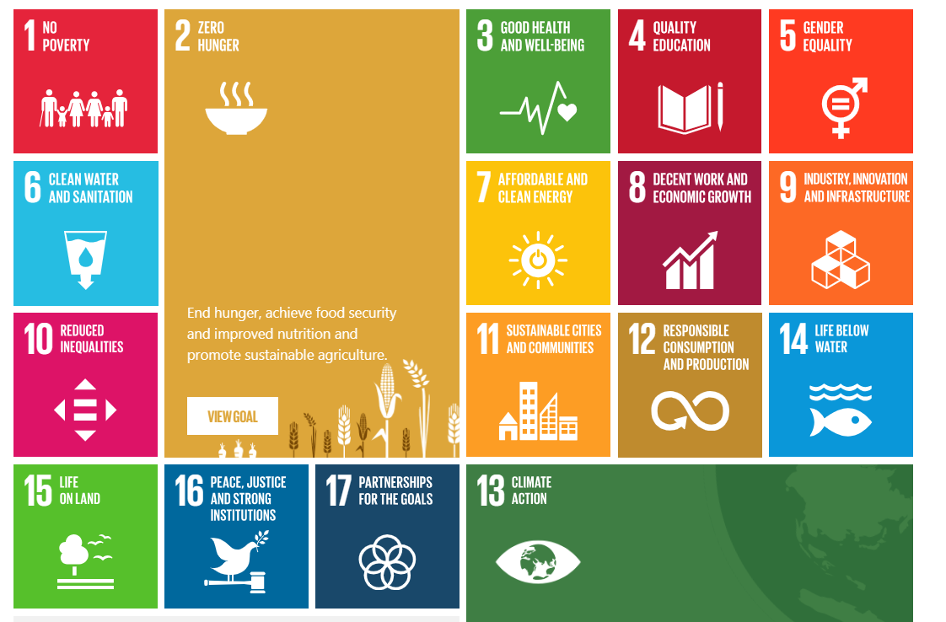
(The Global Goals, 2024)
The above figure shows the Sustainable Development Goals (SDGs) is made up of 17 integrated objectives created by the United Nations in 2015 as part of the 2030 Agenda for Sustainable Development. These goals provide a universal framework for addressing global challenges and achieving a more sustainable, equitable, and prosperous future. The SDGs cover a wide range of social, economic, and environmental issues, including poverty eradication, education, health, gender equality, clean energy, climate action, and sustainable cities (United Nations Development Prgoramme, 2024). The goals were set for 2030, and now we are over halfway there, they have said that only 15% of the Global Goals are on track and have stated that numerous things have set them back like Covid-19, rise of living costs, conflicts and the climate crisis (The Global Goals, 2024). Natural resource shortages can significantly impact our ability to achieve global goals, especially those related to sustainable development.

Natural Resource Shortages – what does this mean?
The WEF describes natural resource shortages as shortages of food or water, which can occur at various scales (local, regional, or global) due to human overexploitation and mismanagement of critical natural resources, as well as factors such as climate change, including drought and desertification, and a lack of adequate infrastructure. These shortages can lead to food and water insecurity, affecting not only human populations but also industries and ecosystems (World Economic Forum, 2024). The UN Commission, (2018), forecasted that by 2030 human demand on the Earth's ecosystem will surpass nature's ability to replenish by 100%. This implies that we would require the recourses equivalent to two Earths to fulfil human needs, the projection is concerning because it indicates an unsustainable level of resource consumption.

What causes Natural Resource Shortages?
Due to the steady growth of the global population and the expansion of economies worldwide, there has been a significant increase in the demand for natural resources, with a particular emphasis on fossil fuels.
There are many ecological regarding the risk of natural resource shortages. Industries are constantly extracting resources like metals and fuels which has a significant impact on the environment. The European Environment Agency, (2024) said that half of the world's greenhouse gas emissions stem from the processing and extraction of raw materials, and with this to increase would make the impact worse. Not only this, but oil is becoming more costly and global demand is only expected to rise. It has been said that if it does not change, it is likely that we could run out in around 47 years (Lorenz, 2023).
As the population is ever growing and in 2022 sat at 7.95 billion (O'Neill, 2024), this means that there is an increased demand for food production. Food production already has a huge impact on the environment. We're using a lot of land for farming, which contributes to deforestation and greenhouse gas emissions. Although currently we do produce enough food to feed the population, in 2012 it was estimated that the avoidable amount of food and drink waste in the UK reached 810 thousand tons (Statista, 2024).
There is also a looming water crisis from increased demand and quality concerns. Climate change is main reason for water scarcity as it is so unpredictable. Agriculture is also noted as a significant consumer of water, often wasting it due to inefficiencies. WWF, (2024), warns that if current consumption rates persist, the situation will worsen, with two-thirds of the world's population potentially facing water shortages by 2025, further impacting ecosystems worldwide.

How does it impact the Sustainable Development Goals?
Natural resources shortages effects many of the SDG, one in particular, climate action. This goal addresses the impacts of climate change and aims to reduce greenhouse gas emissions to mitigate its effects. The 13th SDG is Climate Action, and their second target 13.2, is to ‘strengthen resilience and adaptive capacity to climate related disasters’. Through reducing greenhouse gas emissions which helps resource shortages can lower emissions and meet their targets. The UN, (2024), says that it is still something that we are working towards, and we can turn it around as more solutions, and affordable ones, are helping countries to accelerating the pace of change towards sustainability.
Agriculture meeting the demands of a growing population is an important part of the global economy, but, the increasing demand for agricultural products is creating a pressure on natural resources, which could lead to scarcity issues (Hassan , et al, 2021). The UN Food and Agriculture Organization (FAO) predicts a 70% increase in food demand by 2050 (McGill, 2013). There are some actions that can be taken to improve agricultural productivity, enhance resilience to climate change, and ensure access to nutritious and affordable food for all, thereby contributing to the achievement of the Zero Hunger goal. Platts Agriculture in the UK speak about their sustainable farming practices. They prioritise animal welfare to enhance farm productivity and embrace technological innovations to enhance efficiency and reduce environmental impact. They also state how they turn cow manure into renewable energy to help reduce greenhouse gas emissions. They don’t stop there, they make sure that they partner with sustainable businesses, incorporate water recycling, create renewable energy with solar power and help reduce food waste (Platts Agriculture, 2024). These all provide valuable insights into how individuals, businesses, and communities can take practical steps to promote sustainability in various aspects of farming and agriculture which in turn will help reduce natural resource shortages.
As climate change has a big part to play in water shortage, the Elemental Water Foundation emphasises the importance of sustainable water management practices, particularly in light of the risks posed by climate change. They highlight their mission which aims to provide communities in Africa with access to clean drinking water that is both reliable and affordable, and powered by renewable energy sources (Elemental Water Foundation, 2020). By doing so, the foundation contributes to improving community health and safety while also enhancing their resilience to the challenges presented by climate change. Clean water and sanitation sits at number 6 on the Global Goals and it includes 8 targets. Elemental Water Foundation plays a significant role in addressing several SDGs targets through its initiatives and projects related to water management, sanitation, and community empowerment. UN Water says that we need to treat water as a scarce resource due to increasing demands and limited availability. Integrated Water Resources Management has been suggested for governments to manage water resources effectively. It emphasizes aligning water use patterns with the needs of various users while considering environmental sustainability. They explain the importance of looking at new way to manage water, using technology and data, and raising awareness to address water scarcity and ensure sustainable water use for present and future generations (UN Water, 2024).
Natural resource shortage doesn’t only fall into those three categories. It can also fit into SDG 7, Affordable and Clean Energy, as energy shortages can hinder progress towards ensuring affordable and clean energy for all. There are some barriers to achieving sustainable goal number 7. There can be, policy framing, the integration of renewable energy and technological changes (Jayachandran, et al., 2022).
Industrial ecology is all about looking at how industries use materials and energy, and how this affects the environment. It's like seeing the big picture of how everything is connected. Instead of just focusing on one part, it considers how everything works together as a system (Kapur & Graedel, 2024). Industrial ecology helps industries use resources better and make less waste. They can do this by recycling materials, reducing pollution, and designing things in a way that's good for the environment. When there's a shortage of natural resources, industrial ecology helps by showing how industries can be more sustainable. This means using resources wisely, recycling more, and following principles like the circular economy, where things are reused instead of thrown away. This helps protect natural resources and deal with shortages.

The Malthusian theory
British economist, Thomas Robert Malthus, is known for developing the Malthusian growth model (Kagan, 2024). He wrote, population growth tends to outpace the growth of resources, leading to scarcity, poverty, and social unrest. While Malthus primarily focused on the relationship between population growth and food supply, his theory can be applied more broadly to the management of natural resources (Hussen, 2019). The Malthusian theory can be applied here, as it serves as a reminder of the potential consequences of unchecked population growth and resource exploitation although due to the advancements in modern farming techniques, which have enabled food production to increase at a rate far beyond what Malthus could have predicted, the theory has been largely dismissed. The figure below represents the point of crisis in which the population is rapidly increasing crossing the resources curve, which cannot keep up with the demand.
It had been criticised for pessimistic view of population growth, and also for overlooking technological advancements, innovation and social change. Critics also argue that focusing solely on population control may divert attention from addressing other issues such as inequality, consumption patterns, and sustainable resource management. They suggest that a more general approach is needed to address the causes of resource challenges and achieve sustainable development (Geographic Book, 2024).

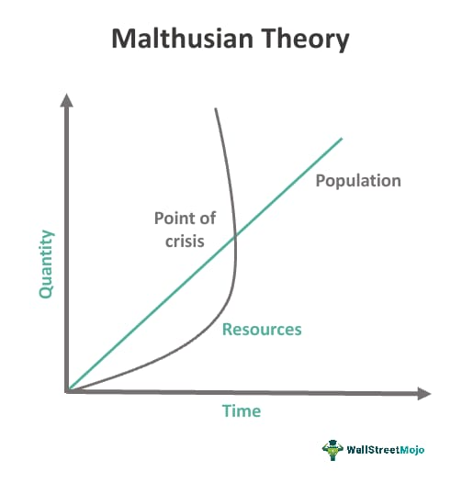

(Gajendrakar, 2024)

The Kuznets Curve
Known as the Environmental Kuznets Curve, Simon Kuznets developed a framework suggesting inequality initially increases as a country develops economically, but eventually decreases as income levels rise and the benefits of development are more evenly distributed. In relation to natural resource shortages, the Kuznets curve implies that environmental degradation, including issues like water pollution and resource depletion, would initially worsen during the early stages of economic development. As countries industrialize and urbanize, there may be increased pressure on water resources due to factors such as industrial pollution and inefficient agricultural practices (Stern, 2004).
However, as economies mature and income levels rise, societies become more aware of environmental issues and invest in technologies and policies to mitigate pollution and promote sustainable water management practices. This says that it may worsen but there is potential for improvement when societies become wealthier and prioritise the issues, this will allow policymakers to implement strategies to transition towards better practices.

Conclusion
This report concludes the importance of addressing global challenges and achieving long-term prosperity. The report covers some of the impacts that natural resource shortage can create how they impact the SDGs and how the Malthusian and Kuznets theories are relevant. natural resource shortages, particularly in water, pose significant threats to environmental stability, human well-being, and economic development. However, the report covers different approaches that some organisations and business have already taken to promote sustainable practices.
There report explains the transition to sustainable energy practices and the struggles that it may come with such as policy framing, infrastructure development and restructuring power systems that would require coordinated efforts across various sectors. It also finds that introducing renewable energy sources into existing energy systems could also prove difficult and requires overcoming technical challenges, but doing so will offer potential for reducing carbon emissions and promoting economic development. If organisations and business prioritise innovation, collaboration and strategic planning, stakeholders can work towards a more sustainable and resilient energy future for all.
Furthermore, it included economic theories like the Kuznets curve which offered insights into the relationship between economic development and environmental degradation. There is hope that as societies continue to progress, they will prioritise environmental protection and work towards a more sustainable future.
Overall, the report shows the importance of proactive measures, collaborative efforts, and innovative solutions to address sustainability goals.

