Joseph Tutton
Connecting Rod Dynamic Forces

Student Number: P152112

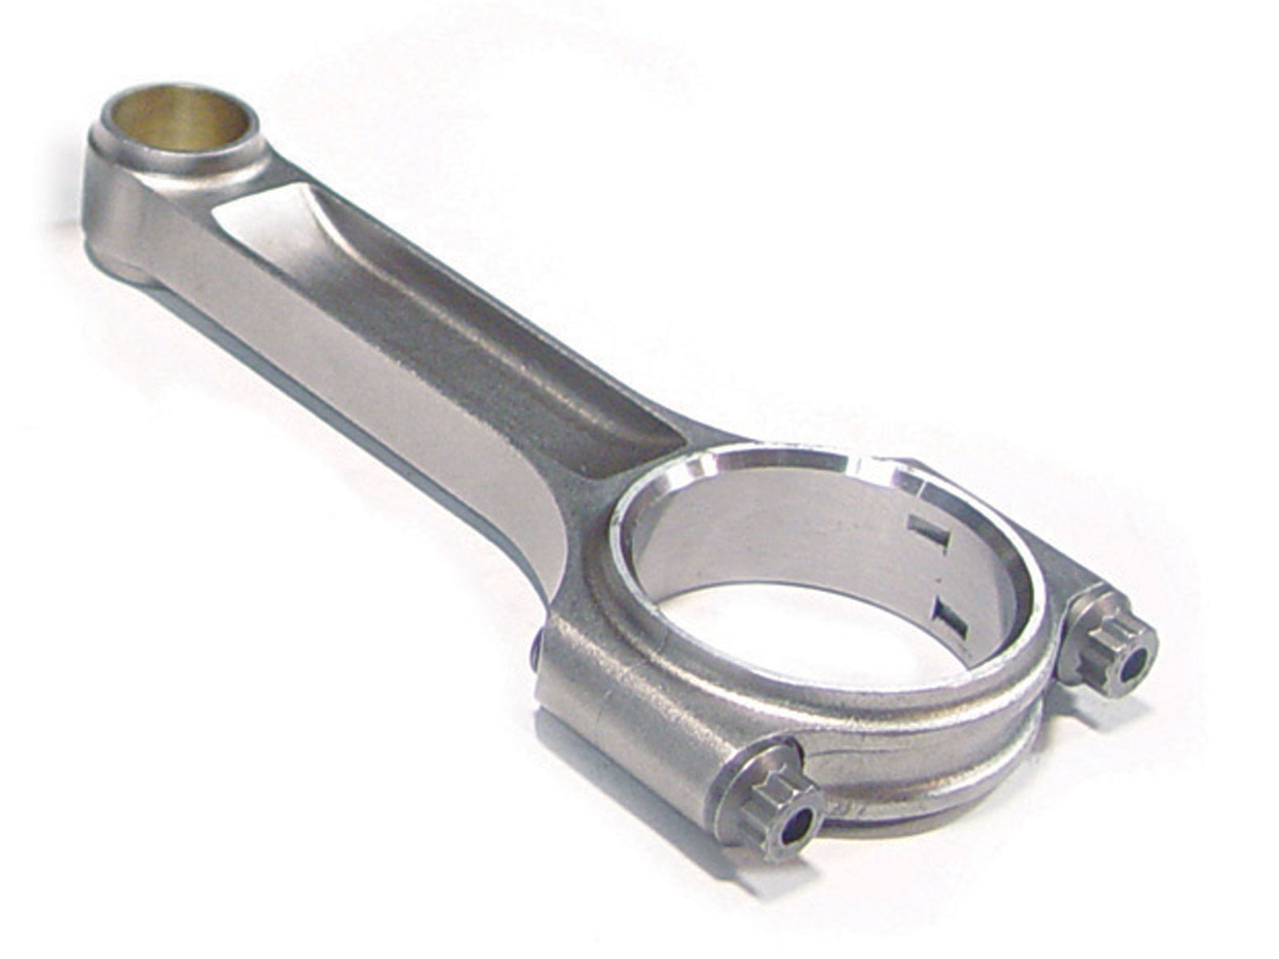

Abstract
This assignment will show the dynamic forces of a particular connecting rod. With the aid and understanding of excel spreadsheets and the use of graphs will help visualise what is happening at different RPMs.
Contents
- Introduction……………………………………………………….………………………………………………….Page 3
- Research………………………………………………………………………………………………………………..Page 3
- Methodology…………………………….…………………………………………………………………………..Page 3
- Analysis…………………………………………………………………………………………………..……………..Page 4
- Conclusion……………………………………………………………………………………………………………..Page 7
- References………………………………………………………………………………………..…………………..Page 7
- Introduction
From this assignment it is thought that others can get a better understanding of forces applied to a connecting rod. It is thought that the forces will be different as the rpm is changed. Graphs will help show the reader this. Forces will be affected by things such as engine speed, the mass of the piston, connecting rod length and the crank radius.
- Research
Research can be done by looking for parts online as some websites may show the dimensions. In other cases, practical research is also an option. This would involve measuring using a Vernier calliper or even looking at technical drawings to find these measurements.
As for the use of excel, there are plenty of tutorials online that will help give an understanding of the use of formulas etc.
- Methodology
The methods used to find the data are through the use of excel. Once the data has been inputted to the spreadsheet a noticeable change will occur. This will be found through analysis of graphs and data shown.
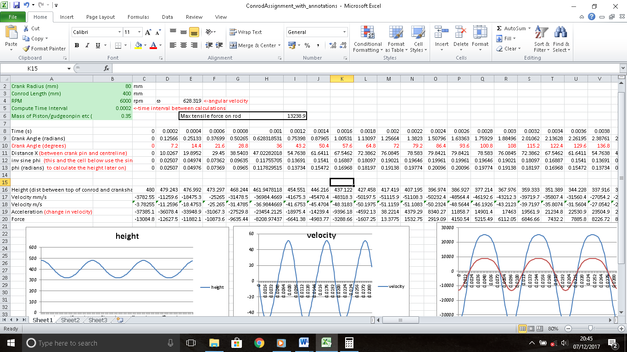
(Figure 1)
As you can see in figure 1 above, the screenshot shows a spreadsheet with the data and graphs. This is what will be used to find the change in forces.

- Analysis
In the analysis a few things will be looked at. To start you will notice in figure 1 that the maximum tensile force on the rod is 13238.9. If the rpm were to decrease by 1000, it would result in the force to also decrease. This tells us that the forces applied are not as much.
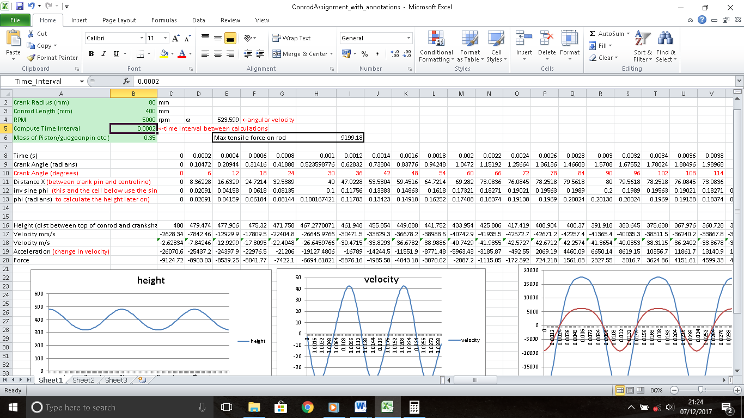(Figure 2)
The force on the rod is now 9199.18 as shown in figure 2.

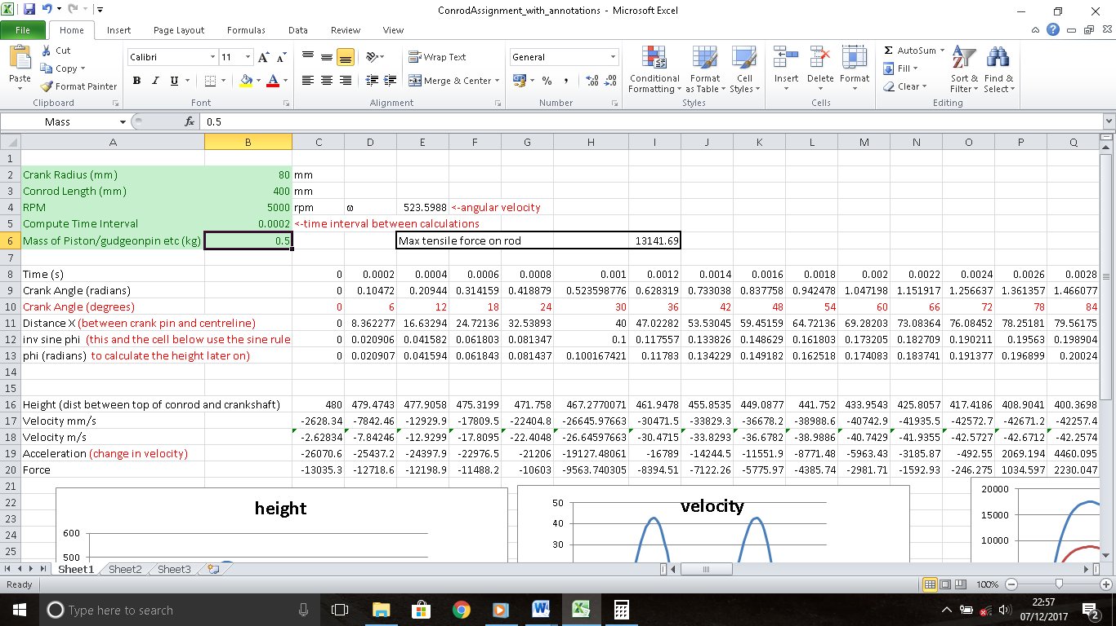(Figure 3)
If the mass of the piston were to increase this would also have an effect on the force increasing it to 1314.69. This would be expected as the more mass the piston has, the more force would be generated at the rod.

If you look at the two graphs below in figure 4 and figure 5 we can compare then from 6000rpm with a piston mass of 0.35 kilograms in figure 4 to 5000rpm with a mass of 0.5 kilograms in figure 5
(Figure 4)
(Figure 5)
As you can see on the graphs above the acceleration has decreased with a heavier mass piston although the rpm is only at 5000rpm when compared to a lighter piston at 6000rpm.

- Conclusion
To conclude it is found that the forces on the rod are affected by various parts such as the mass and rpm. When these are increased it causes the forces to also increase. When the rpm is decreased along with a higher piston mass the forces on the rod tend to increase but only slightly. The acceleration decreases as the mass of the piston increases.
- References
- G. Naga Malleshwara Rao (July 2013) International Journal of Science and Research, Design Optimisation and Analysis of a Connecting Rod using ANSYS
- URL: www.maxspeedingrods.co.uk/h-beam-connecting-rods.html
- MS Motorservice International GmbH URL: www.ms-motorservice.com/en/products-applications/products-in-the-engine/connecting-rod/
- Jim McFarland (September 2010) Connecting Rods – Enginology URL: www.google.co.uk/amp/www.hotrod.com/articles/ctrp-1011-connecting-rods/amp/
- Paul Mcfedries (November 2015) Building Basic Formulas in Excel
URL: www.quepublishing.com/articles/article.aspx?p=2446209
- S. Doughty, A. J. Smalley and B. F. Evans (September 1987) Internal Dynamic Force Analysis for V-Type Engine/Compressor with Articulated Power Cylinder Connecting Rod Mechanism

