TITLE PAGE

NAME: NDEY YASSIN LOWE

STUDENT NUMBER: 1815270

MODULE: DEVELOPING WORKPLACE CRITICAL THINKING

MODULE CODE: BMSK5101

LECTURER NAME: ERNEST OVIA

TITLE: HOW INDIVIDUAL’S BELIEFS, ATTITUDES AND VALUES IMPACT ON WORKPLACE BEHAVIOUR

TABLE OF CONTENT
- Title page…………………………………………………………………………...Page 1
- Table of contents…………………………………………………………………..Page 2
- Introduction………………………………………………………………………...Page 3
- Individual beliefs, values in the workplace……………………………………...Page 4
  - Beliefs……………………………………………………………………………...Page 4
  - Values……………………………………………………………………………...Page 5
- Sources of Values…………………………………………………………………Page 6
- Attitudes…………………………………………………………………………… Page 7
- Impact of beliefs and values in the workplace………………………………….Page 8&9
- Henri Mintzberg’s Management theory…………………………………………Page 10
- Critical thinking in modern day……………………………………………………Page 11
- Reflection on my critical skills module……………………………………………Page 12
- Deductive and Inductive Reasoning………………………………………………Page 13
- Bloom taxonomy…………………………………………………………………….Page 14
- References…………………………………………………………………………..Page 15

INTRODUCTION
As human beings, we all have our beliefs, values and attitudes that we developed during our lifetime. They contribute to who we are and how we see the world. You need to be conscious of your personal values, beliefs and attitudes and how they might impact on your workplace.
Values are someone’s core beliefs about what they consider most important. Our values dictate and predict our actions. Our values can differ as individuals, but it is something that we hold dear. Values have an impact on workplace behaviour as it may influence many of the judgement we make. Values can come from different source. For example, family, religion, culture, the workplace, education, media, significant event, peers and much more. It is important to be aware of your values as it will have an impact on how you make decisions and carry yourself in the society. Understanding your values and beliefs will help your work effectively and avoid it clashing with your work.
Beliefs is an internal feeling that something is true. Your beliefs do have an impact on your workplace behaviour in many ways. It therefore important to be aware of your own personal beliefs, values and attitudes and how they might impact on your work. Beliefs sometimes come from actual experiences and it can affect our relationships and the quality of our work. As a responsible worker, you should not impose your beliefs on people you work with regardless of the power invested in you. Everyone is entity to their own beliefs and should be respected.

INDIVIDUAL BELEIFS AND VALUES ON WORKPLACE BEHAVIOUR
BELIEFS
According to Anderson and De Silva (2009), “A belief is an internal feeling that something is true, even though that belief may be unproven or irrational.” Your beliefs are your walls of protection created from an early age and strengthened through experience over time. Your beliefs do affect your workplace behaviour in many ways. As human, we are driven by the force of our beliefs and our actions, decisions and communication are all drive by it. This can have an impact on what we do, how we do it and how we see our achievements in relation to other people. According to Peter Halligan, “Belief has been a most powerful component of human nature that has somewhat been neglected,” We apply our beliefs whether consciously or unconsciously occasionally. Most beliefs or habit of mind is derive from the culture we grow up in. Belief is so powerful that it can influence life and death.
Your beliefs do have an impact on your workplace behaviour in many ways. Workplace cultures play a massive role in impacting and strengthening beliefs.

VALUES
Value is a measure of the worth or importance a person attaches to something. Values are the foundation for your beliefs, they give a meaning to your life and guide your behaviour. Your values include being respectful, independence, financial security, modesty, kindness, privacy, happiness, trust, perfection, success, confidence, optimistic, team worker, being there for families and friends and much more. Everyone have a different set of values with level of importance given to each value. Knowing your values makes you more tolerant of others and it can a motivator factor. Your feel fulfilled if you live your live in line with your values. You may feel stressed and unhappy if your values are in conflict with each other or how you are living your life. People with different value of chain of command identified the focus on behaviours differently.
Supporting and energising your work
When your values are affiliated with your job or workplace it energise and support your work. If you do have a value of respect and you do feel respected by everyone at work and you respect them, it energised and motivate you.
Conflicting with your life
Whereas, if some of your values conflict with your work, it will have an impact on your job. You are more likely to be stressed and feel unsettled. Understanding the root cause of the reason you are stress, tackling the cause and, hence reducing the stress.
Impacting your relationship at work
Relationships at the workplace may be impacted if your value clashes with others. You may behave differently or in a particular way based on your values which can become a problem if you do not share the same values as the other employees. Considering the values of others as well as yours will improve workplace relationship.
Influencing your leadership style
Good leaders normally have a great sense of leadership value and are usually self-aware of that. Being a leader, you should consider how your values affect your leadership and the potential impact this could have on the organisation. If a leader value being real, he or she is likely to lead in an authentic way.
As you can see from the above, your values can impact on your workplace behaviour

SOURCES OF VALUE
An individual values can come from different sources like family, culture, religion, peer pressure, culture, the workplace, significant life event. There is a relationship between values, beliefs and attitudes.

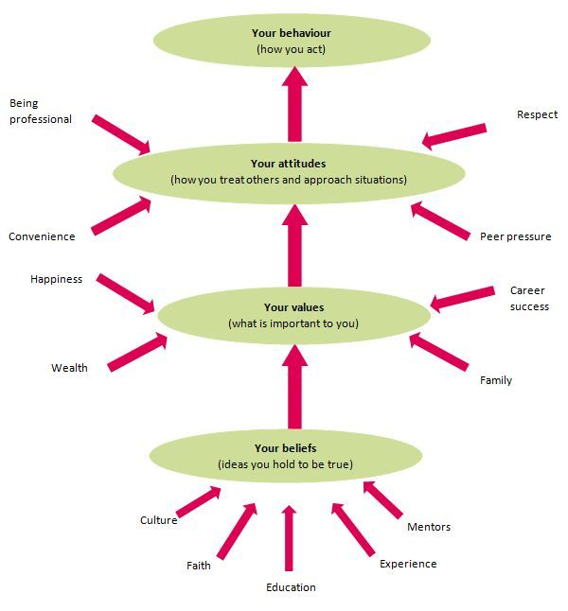

ATTITUDES
Anderson & De silva, (2009) describe attitudes as” the way a person expresses or applies their beliefs and values, and is expressed through words and behaviour.” In another word, an attitude is a settled way of thinking. Attitude is a belief about something and could be directed towards a particular group, ideas, people or object.

IMPACT OF VALUES, BELIEFS AND ATTITUDES IN THE WORKPLACE
Your beliefs and values have an impact on your workplace behaviour. You need to understand your own beliefs and values to be able to work effectively. It is vital to leave your personal values out of your professional relationship. Everyone have their own values, attitudes and beliefs as they are entitled to, but it should not have a negative impact in your workplace. It is important to recognised and respect other people’s values and beliefs even when they are different than yours. You could face instances where your beliefs, values or attitudes are challenge or compromise at the workplace. That is why shared values are important in the workplace as it can avoid conflict. For example, if a leader values hard work, trust and discipline, he or she will likely want his employees to follow those traits in the workplace. If values are not clear and widely accepted, employees will not know what are supposed to do or what is expected of them. Identifying individual and companies’ values will lead to a committed workforce that function well. Value led organisations outperform others; growth in revenue, rate of job creation is higher, growth in stocks is higher, profit performance is higher and turn over is lower. Kotter and Hekett (reported in Dearlove and Coomber, 1999). Being a value led organisation also attract people who have the same values and help to create a “Win - Win” result.
Most organisation have a written down cores values that employees need to adhere to in the day to day running of the company. Most values support the organisation values that are already within the organisation. Organisation can build values based on personal attitude, but it is important to separate our personal beliefs and attitude from our professional life to avoid any negative impact at the workplace.
Studies contend that your beliefs, values and attitudes do affect workplace behaviour. Our manners, pride, family life can impact on our daily activities at the work. If you do not value good manners, it will be hard to exercise it at work and when you value pride, it can stop you from engaging in certain activities like stealing, disrespectful. Vis versa, valuing pride can have a negative impact at the workplace as it can make you think that you are better than certain people and hence, look down on them at the workplace. This can create problem especially if you are a leader as it is a policy to treat all your employees the same way.

Our beliefs like religion can also impact on our workplace behaviour. If you are a pious Muslim, your five daily prayers are an important part of your everyday activities. Being in a setting where you are not allow a break to perform your prayers but see other employees having cigarette break every now and then can have an impact on your relationship with your employer. There was a time when a friend of mine duties at work involved taking an elderly man he works with to church every Sunday and sat with him throughout the service because he was blind. That duty had an impact in his job because at the end, he resign. For him, going to church was not the issue but he felt that he was disrespecting other faith by not prayer with them and just sitting there.
Your settled way of thinking or feeling about something can influence your workplace. Our attitude varies as human. It have a lot to do with your beliefs and values and is influenced by family, friends and experience. It is important to think about our attitude as it helps us to understand ourselves better to avoid the risk of decision making in the workplace based on our perception of our attitude and to be professional. Having an attitude that every black person is a criminal or every Muslim is a terrorist can an impact on how you treat your employees who fit in those categories. You can denied them employment just because of your misconception of them and how you perceived them. Attitudes are hard to change as it is a powerful characteristic of the human being and difficult to change but not impossible.
It is vital for an organisation to have core values that each and every employee should abide by to be successful. Tolerating and respecting each other’s different values and beliefs make us human. You should not impose your beliefs and values on others

HENRI MINTZBERG’S THEORY (MANAGEMENT ROLES) AND ITS EFFECTIVENESS USING CRITICAL THINKING METHODS.
Management theories are associated with organisational issues such as leadership, change and motivation, and their usage to practical situations and problems. As a manager, you have to fulfil many different roles all the time. Management expert and Professor Henry Mintzberg recommended breaking down management role to different roles. He recognised ten primary roles or behaviours that can be use to categorize manager’s different functions in the workplace. The ten roles are:
- Disturbance Handler – if an organisation have a disturbance, the manager is suppose to take control and bring sanity back to the workplace.
- Monitor - Seeking the relevant information in relation to your organisation and monitoring your employees
- Leader - Providing leadership for your subordinates and managing the duties and responsibilities for everyone in your team or the organisation as a whole.
- Figurehead – Managers are supposed to be a source of inspiration which legal authority that people look up to as a figurehead.
- Liaison – Networking on behalf of the organisation both internally and externally.
- Spokesperson – A manager is suppose for be mediator between the organisation and its stakeholders by being the spokesperson.
- Entrepreneur – Generating new ideas, solving problems and controlling change is part of entrepreneurship.
- Disseminator – Relaying important information to your team or colleagues is another role of the manager.
- Resource Allocator – Resources should be allocated properly within the organisation and it is the role of the manager to ensure that funding and staffs are assign properly.
- Negotiator – A manager may have to negotiate with stakeholders on behalf of the organisation.
Mintzberg’s then divided these ten roles into three categories, as follow:
- Interpersonal – Figurehead, leader and Liaison.
- Informational – Monitor, Disseminator and spokesperson.
- Decisional – Entrepreneur, Disturbance, Handler. Resource, Allocator and negotiator.
Interpersonal category – This managerial role involve providing ideas and information.
Informational category – This managerial role involve the processing information.
Decisional category – This managerial role involve using information.
CRITICALLY THINKING
According to (Ennis, 1985, p.45), Critically thinking is defined as a “reflective and reasonable thinking that is focused on deciding on what to believe or do”. There are two backgrounds of critically thinking namely, philosophy and psychology. The definition of critical thinking have evolved in modern day. It enable you to build a successful and effective problem solving skills that are very important in the workplace and in life. Critical thinking have five top techniques that are similar to Henri Mintzberg’s theory but more filtered and easier to use in modern day. Critical thinkers are creative, open-minded, problem solvers, time savers and analysers.
In contracts to Mintzberg’s theory, critical thinking methods means that one critical thinker can perform all the different roles that Mintzberg come with. Nowadays, it is common for one person to perform different roles in the same settings or a totally different environment.

REFLECTION ON MY CRITICAL THINKING SKILLS DEVELOPED BY THIS MODULE
Critical thinking is “judging in a reflective way what to do or what to believe” (Facione, 2000, p. 61). During class, I have learned a lot about critical thinking. As a critical thinker, it was good learning more about it. Most decisions I have make in life was critically evaluated, even though some turned out to be good and others regretted. No matter, how skill a thinker you tend to be, you can sometimes make mistake in reasoning. Improvement is always necessary. Critical thinkers will identify, evaluate and solve problems systematically rather than instinct.
Studying critical thinking helps me to understand the different types of reasoning and thinking. I learned about the background of critical thinking, arguments, logic, inductive and deductive reasoning, Socratic questioning and many more.
There are two background of critical thinking:
- Philosophy
- Psychology
Critical thinking helps to detect irregularities and common mistakes in reasoning, identify the importance of ideas and reflect on the justification of one’s own beliefs and values. There is a misconception that critical thinkers are not creative because of the rules of logic which is not factual. Critical thinkers are skilful, judgemental and sceptical in what in nature.
Reflecting on argument, there should be a claim, proof and a conclusion. You can agree or disagree on matters, but must provide a fact for or against your statement. You should always be ready to back your point of views with evidence.
Logic and reasoning was another topic that helps me in my reasoning. Logic is a part philosophy that is described as the science of correct reasoning and reasoning is the conclusions from known or assumed facts. You cannot be a good critical thinker if you can logic and reason.

DEDUCTIVE AND INDUCTING REASONING
There are two types of Logic: Deductive and Inductive reasoning.
Deductive reasoning: Involves necessary reasoning and moves from general principles to special case. When you start with things you assume to be true. You outlined the generic truth first and then the specific truth. For example, all mammal are animals, lions are animals therefore lions are mammal.
Inductive reasoning: inductive reasoning involves thinking that the truth of the premises makes the conclusion probable. Inductive reasoning specific case could be error based depending on truth of the premises. It allows the possibility of a false conclusion even if all premises are true.
Learning about these two kinds of reasoning, I realised that you have to critical evaluate whether claim is valid or invalid and be ready argue and provide proofs or evidence. It develop my skills on how to make an argument, claims whether contested or uncontested and providing evidence to back your claims.
In conclusion, critical thinking module have help me understand more about the human being in general. How we act, the driving force behind our behaviour and how to conduct yourself in the workplace to avoid infringing on the rights and duties of the people you work with. Most importantly, critical thinking module have pave my way to be an excellent manager in the future.

BLOOM’S TAXONOMY
Bloom’s taxonomy (1956) was developed under the leadership of educational psychologist Dr Benjamin Bloom. I learned that the original version of Bloom’s taxonomy three domain of learning – Cognitive, affective and Psychomotor. It can be use to help teachers teach and students learn. You can use Bloom’s taxonomy to create assessment, develop online course, design curriculum maps, self-assessment, evaluate the complexity of assignments and more. Lorin Anderson and David Krathwohl (2001) revised the Bloom’s theory. They removed Synthesis and added Creation as the highest level of Bloom’s taxonomy. Many educators prefer Bloom’s because it ‘give them a way to think about their teaching and the subsequent learning of their student.’ As a student, learning Bloom’s six levels of taxonomy helps me developed more skills on critical thinking by remembering, understanding, applying, analysing, evaluating and creating my ideas.

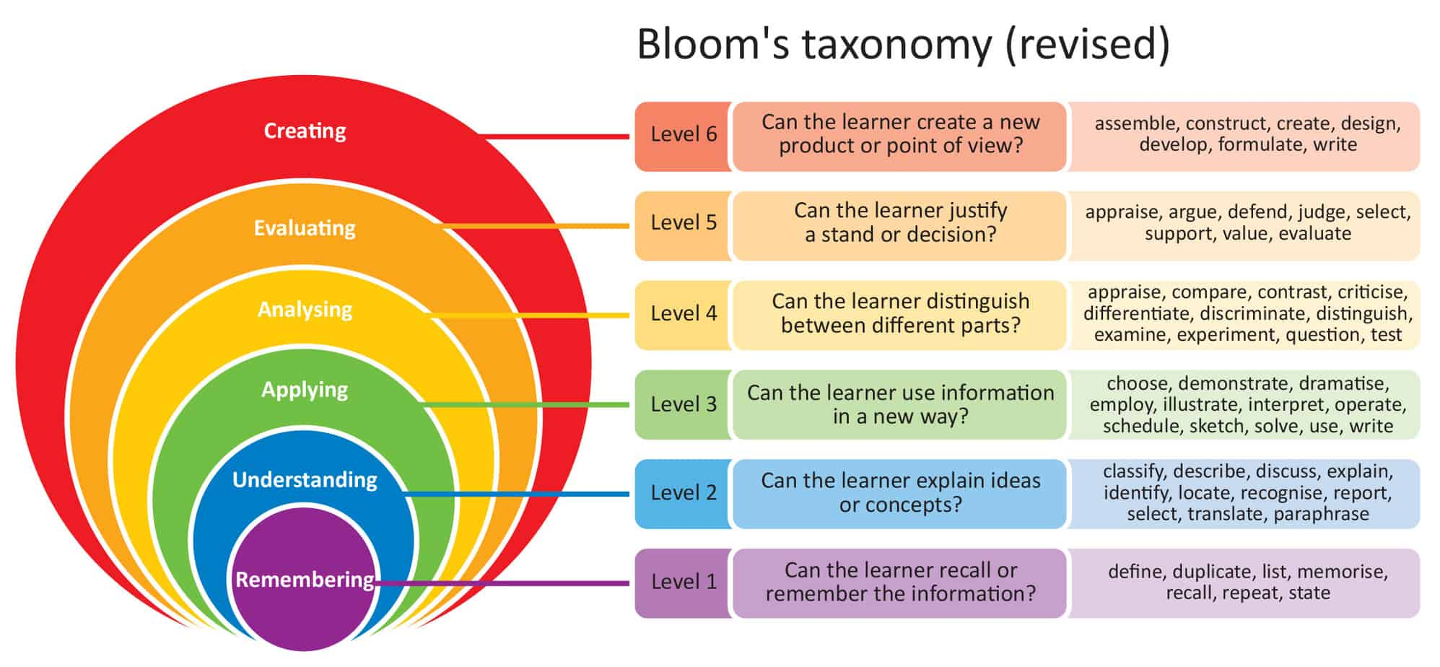

REFERENCES
Altman, L. (2020) “The power of beliefs at work- intentional communication”. Available at: http://www.intentionalcommunication.com/the-power-of-beliefs-at-work/ (Accessed: 22/07/20).
- Anshel, M.H. (2015) Do your behaviour reflect your values. Available at: http://www.eu.tennessean.com/story/life/2015/10/11/behaviors-reflect-values/73164444/ (Accessed: 22/07/20).
- Barling, J. and Loughlin, C. (2010) ‘Young worker’s work value, attitude, and behaviours.’ Available at: http://www.doi.org/10.1348/096317901167514. (Accessed: 21/07/2020).
- Department of Education and training (2009) Personal values, belief and attitudes: Available at: https://www.sielearning.tafensw.edu.au/MCS/CHCAOD402A/chcaod402-csw/knowledge/values/values.htm. (Accessed: 23/07/2020).
- Dictionary (2020) Argument. Available at: https://www.dictionary,com/browse/argument. (Accessed: 24/07/2020).
- Finegan, J. (1994) Journal of Business Ethics 13 (9), pp 747-755
- Glaser, E.M. (1941) Defining critical thinking – Foundation for critical thinking. Available at: https://www.criticalthinking.org/pages/defining-critical-thinking/766. (Accessed: 24/07/2020).
- Kelloway, E.K, Harvey, S (1999) Learning to work: The development of work beliefs. In J. Barling and E.K. Kelloway (Eds.), Young workers: Varieties of experience ( p. 37-57) Available at: https://www.doi.org/10.1037/1039-002. (Accessed: 22/07/2020).
- Makin, L. (2014) How do your values impact you at work or in your business. Available at: http://www.makinithappen.co.uk/Articles/How-Do-Your-Values-Impact-You-At-Work-Or-In-Your-Business.html. (Accessed: 22/07/2020).
- Mintzberg’s Management Role (2020) Identifying the Roles managers Play. Available at: http://www.mindtools.com/pages/article/management-roles.htm. (Accessed: 21/07/2020).
- What is Bloom’s taxonomy (2020) A definition for teachers. Available at: https://www.teachthought.com/learning/what-is-blooms-taxonomy-a-definition-for-teachers/. (Accessed: 24/07/2020).
- Regan, K. (2015) 6 Benefits of Critical thinking. Available at: http://www.learn.filtered.com/blog/6-benefits-of-critical-thinking. (23/07/2020).
- Tickle, E.L., Brownlee, J. and Nailon, D. (2005), “Personal epistemological beliefs and transformational leadership”, Journal of Management, Vol. 24. No. 8, pp 706-719.

