

Programme Name – Master of Business Administration

Student Name: Vraj Patel

Student ID: 2538982

Module Name: LCMB 7024 - Marketing Management

Title: Dyson Pure: A Sustainable Brand Extension into Home Water Purification

Lecturer’s Name: Taonga Kaonga Sobere Snithers

Submission Date: 14th August 2026

Word Count – 2572

Table of Contents

Element 1: Poster 3
Element 2: Segmentation, Targeting, Differentiation and Positioning 4
Segmentation 4
Targeting 5
Differentiation 5
Positioning 6
Element 3: The Marketing Mix 8
Product 9
Price 9
Place 9
Promotion 9
People 10
Process 10
Physical evidence 10
Element 4: Reflection 12
Reference List 14

Element 1: Poster
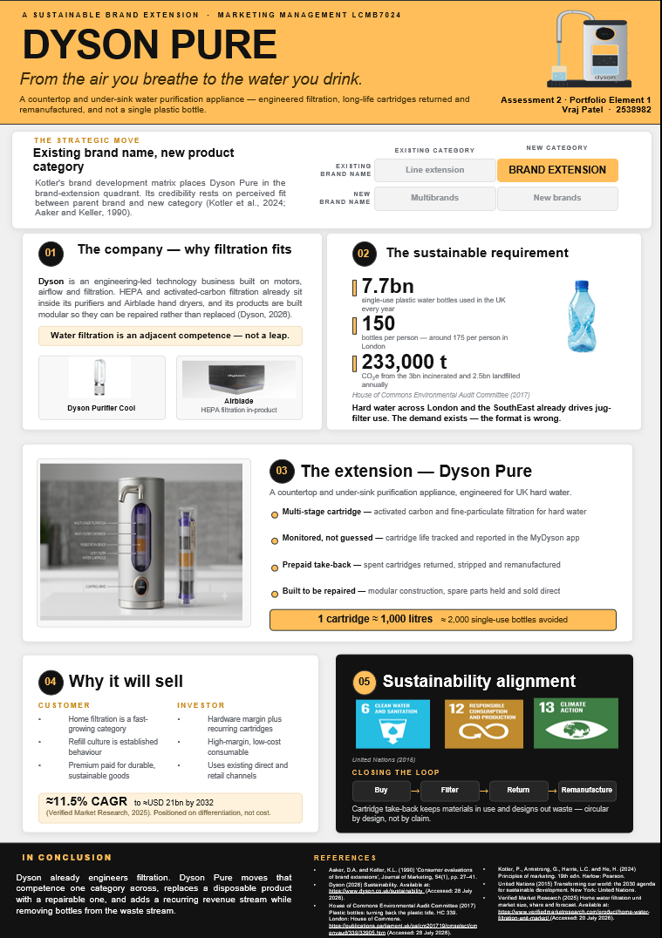

Element 2: Segmentation, Targeting, Differentiation and Positioning
Dyson Pure enters a mature category that has seen little meaningful innovation. Domestic water filtration in the United Kingdom (UK) is dominated by the pour-through plastic jug — cheap, widely owned, and disposable by design. The process that transforms the sustainability offer of the extension into a sustainable commercial offer instead of an environmental aspiration is called Segmentation, Targeting, Differentiation and Positioning (STDP) (Kotler et al., 2024).

Segmentation
The segmentation process involves the subdivision of a heterogeneous market into measurable, substantial, accessible, differentiable and actionable groups of buyers (Smith 1956; Kotler et al. 2024). An application throughout has been used: a segment is only useful if it will react differently to marketing effort, and each of the four bases listed below makes a difference in what Dyson Pure needs to offer, charge and say. The UK domestic water treatment market has been segmented according to the table below.
Table 1: Segmentation of the UK domestic water treatment market
Base | Segment profile | Implication for Dyson Pure
Geographic | Hard and very hard water areas – London, the South East, East Anglia and the East Midlands, which account for about 60% of UK households. | The limescale and taste issue is locally felt in areas where the direct and return logistics are already heavy.
Demographic | ABC1 households, buyer aged 30-55, income more than £55,000; owner-occupiers and long-term renters, families and dual income couples. | Accepts a high price tag and a continuous subscription model instead of a single, one-time payment.
Psychographic | They are concerned with the environment, but they are motivated by convenience; value demonstrated engineering over eco-styling and are not fond of abstract green statements. | The claims have to be measurable and verifiable, and the design language has to indicate engineering, and not green packaging.
Behavioural | High consumption of bottled or jug filtered water and regular purchasers of consumables who are looking for taste, less limescale, convenience and less waste. | Subscription is not about changing a habit, it's about changing a format.

Targeting
A differentiated approach is used, with focus on a single primary segment: the hard-water home optimiser, an ABC1 professional Londoner, South East or East Anglian who already filters their water every day and many of whom already have a Dyson machine. The selection is based on four criteria. First, the market segment is large and is expected to grow at a CAGR of around 11.5% till it reaches USD 21bn by 2032 (Verified Market Research, 2025). Secondly, it shows proven willingness to pay for longevity. Third, it can be accessed using Dyson's own direct-to-consumer channels – this is not incidental, but rather it relies on a direct relationship to an identified owner; cartridge take-back relies on a maintained relationship. Fourth, it doesn't eat into any existing Dyson categories. Two secondary segments — small offices and premium build-to-rent developments — are identified for a later phase but are not resourced at launch. Only one risk has to be mentioned. Ottman, Stafford and Hartman (2006) define green marketing myopia as the downfall when a company is not delivering on the functional benefit that the consumer is purchasing, but instead it is delivering more than the consumer is expecting on the environmental aspect. Communication to this target audience should therefore focus on taste, limescale and convenience while circularity will serve as a reinforcement and not the reason to buy.

Differentiation
Differentiation is the reason why the target should opt for this offer instead of the other offers competing for that spend (Kotler et al., 2024). Table 2 compares Dyson Pure with the four other sets on the market competing in the segment.

Table 2: Competitive differentiation of Dyson Pure
Competitor set | What it offers today | Dyson Pure’s point of difference
Jug filters (Brita, ZeroWater) | Cheap and installation-free, but disposable plastic housing and filter life guessed by calendar. | Engineered multi-stage cartridge, saturation monitored in-app, no disposable housing.
Plumbed and reverse-osmosis systems (Osmio, Waterdrop) | Strong filtration, but installer-dependent and generating wastewater at the point of use. | Modular and owner-serviceable, spare parts sold direct, no wastewater penalty.
Bottled water and delivery (Evian, AquAid) | Convenience and perceived purity bought through continuous single-use plastic. | Removes the bottle entirely — around 2,000 avoided per cartridge.
Premium taps and dispensers (Quooker, Grohe Blue) | Design-led fixtures requiring plumbing works and usually replaced rather than repaired. | Repairable by design, closed-loop take-back, and inherited filtration equity.

There are 3 points of difference that are defensible. Credibility is passed on from the parent brand, and this type of perceived fit is the most important factor determining consumer acceptance of a brand extension (Aaker and Keller, 1990). The performance of the cartridge is measured and reported, not assumed. All used cartridges are returned and stripped and remanufactured. These are desirable, deliverable and genuinely differentiating against Keller's (2013) criteria – take-back is hard for jug incumbents to duplicate, and they need reverse logistics, and a direct connection to the customer, which Dyson has.

Positioning
Positioning is consciously creating an offer that fits into a unique and desired slot in the target market's mind (Ries and Trout, 2001). Plotting the category by the combination of the unit price and the product circularity reveals an empty quadrant. Jug filters are low-price and low-circularity, plumbed and reverse osmosis are high price low circular, and bottled delivery is low-price and environmentally negative. The high-circularity position is offered by Dyson Pure, at a premium price, and currently without an incumbent.
POSITIONING STATEMENT
Dyson Pure is an under-sink and counter-top purification device designed for hard water homes in the UK who desire better tasting water without needing to buy a new bin of plastic filters, since Dyson engineers the filters instead.
This is a more for more position (Kotler et al., 2024) and can only be sustained as long as the performance premium can be proved. Where the claim outruns the evidence, the position collapses into greenwashing — and the damage does not stay with the extension; it attaches to the parent brand.

Element 3: The Marketing Mix
The classical 4 Ps is not appropriate here in the extended 7 element mix (Booms and Bitner, 1981) because Dyson Pure is not a one-off transaction. Dyson Pure is not a one-off transaction but a recurring cartridge relationship supported by a prepaid return process and an app-mediated service. Each of the decisions is outlined in Table 3, and is explained below in terms of the sustainable brand extension strategy defined in Elements 1 and 2.
Table 3: The Dyson Pure marketing mix at a glance
Element | Decision
Product | Countertop and under-sink variants sharing one monitored, multi-stage cartridge; modular and repairable.
Price | £399–£549 for the appliance; cartridges £30 each or £96 per year including prepaid returns.
Place | Direct-led through dyson.co.uk and Demo stores; selective retail via John Lewis and Currys.
Promotion | Engineering demonstration, published laboratory testing, quantified environmental claims only.
People | Dyson Experts running live demonstrations; service teams measured on repair-first resolution.
Process | Buy, filter, return, remanufacture — app-prompted, prepaid, no additional customer effort.
Physical evidence | Visible cartridge, designed return mailer, in-app bottles-avoided counter, moulded fibre packaging.

Product
The sustainability strategy is carried, not decorated, by two design decisions. Modularity allows the appliance to be repaired and not replaced, thereby increasing the useful life, which is one of the main environmental factors to consider throughout the life of an appliance (Ellen MacArthur Foundation, 2013). More importantly, the treatment of about 1,000 litres by a single cartridge replaces about 2,000 individual bottles, making a promise of the environment tangible in the customer's hands. What lies with the extension is the augmented product, i.e., app, take back service, directly sold spares etc., as it would have been an ordinary filter without the extra value offered by the extension.

Price
The razor-and-blade architecture is a value-based (rather than cost-plus) and the strategic decision is the anchor selected (Hinterhuber, 2008). When it is compared to the bottled water it is replacing, which means that the price a household pays for two bottles a day comfortably exceeds £400 a year, it seems like a saving — but if the cost of replacing the filter jug is compared to a £25 filter jug, it's an indulgence. This is important because consumers state their environmental preference much more easily than they do pay for it (Peattie and Crane, 2005). It's when you put the subscription just a little bit under the habit that you get the premium you need to overcome sustainable position.

Place
Intensive distribution is deliberately rejected as a practice – putting a £399 product next to a £25 product invites comparison precisely on the wrong scale. The direct channel is more of a structural need than a preference in margin, as the take-back loop requires knowledge of the ownership of each unit, the expiry date of the cartridge, and where the prepaid label should be sent. Selective retail is therefore dependent on demonstration space and retail partners are provided with collection points to ensure that third-party buyers are not excluded from the loop.

Promotion
Promotion is based on Dyson's rules of demonstration before assertion, and featuring the theme "from the air you breathe to the water you drink", which leverages trust in the parent brand. Restraint is not only an ethical, it is also a legal obligation. The Green Claims Code requires environmental claims to be truthful, unambiguous and substantiated (Competition and Markets Authority, 2021) and the Digital Markets, Competition and Consumers Act 2024 enables regulatory action without needing to go to court. All claims are quantified – litres filtered, bottles displaced, etc. – and no carbon-neutrality claim is made.

People
It is a manufactured offer but one that is sustained by people, and internal marketing is not secondary here (Booms and Bitner, 1981). It's experiential, and very difficult to communicate in copy, and these taste and limescale demonstrations do what advertising doesn't. The higher risk is downstream: If the service staff defaults to sending a replacement, that is at the same time the customer is putting it to the test, the repairability claim is undermined. Thus, the service performance measures include repair-first resolution, which is not at the discretion of the service.

Process
The MyDyson app records the exhaustion of any cartridge and then sends a prepaid mailer to the customer when the time has come, and the cycle continues: buy, filter and return, remanufacture. Participation in recovery schemes falls sharply wherever the customer is asked for extra effort, packaging or cost (Ellen MacArthur Foundation, 2013), which is why the return step is designed to demand none of the three. The process also creates the proof of the promotional plan's success: you can measure and publish return rates and percentages of material recovered, becoming the business with which you can be held accountable for achieving circularity.

Physical evidence
Physical evidence makes the intangible verifiable. It is engineered, not plastic household products, that are visible when the customer views the cartridge and the exposed filtration stages; the return mailer is designed, not utilitarian, as the customer is the only one who has physical contact with it; and the customer's own litres filtered/bottles avoided is reported on the app dashboard. These signals serve a similar purpose to the brand experience that Keller (2013) talks about and enable checking the positioning, not taking it on faith.
The seven elements are not a checklist, but are interdependent elements; the mixture has been criticised exactly for that (Constantinides, 2006). All the dependencies here are explicit: This is a case of the promotional claims being justified only because of the process generating return-rate data that proves it, and the pricing anchor assumes that the process gets people to repair, rather than replace. One tension, however, remains unresolved. But while selective distribution helps to preserve the position and allows for the take-back loop to be put into practice, it also limits reach—all of which supports the sustainability case, which is really about displacing bottles at volume. A plan that won’t reach many households will displace many bottles – regardless of how beautiful its circularity is. Therefore, the idea of selectivity is not an ongoing principle or behavior; rather, this is a launch phase, with a broader distribution encouraged if the return infrastructure proves to be able to scale to a target 60% return rate in year one.

Element 4: Reflection
This reflection is guided by Gibbs' (1988) reflective cycle to account for the development of the Dyson Pure sustainable brand extension and the preparation and presentation of the related poster.
Description. The task required me to act as a marketing consultant, select a company and construct a sustainable brand extension supported by a poster, an STDP analysis and a marketing mix. I selected Dyson and proposed a household water purification appliance.. Created an A4 poster, using the brand's colour scheme, structured it around Kotler's brand development matrix and presented it in class within the 5 minute time limit.
Feelings. I'm not as confident as I thought I was. Choosing Dyson was easy, but I did not realize the amount of effort required to convince management and the rest of the world that I had made a good switch from one product category to another. I was initially worried about getting a 2,500-word strategy into five minutes, and I was happy with the results, but not satisfied: I got the content in, but I rushed through the sustainability.
Evaluation and analysis. The key was to build on an existing competence. The concept of 'perceived fit' rather than creativity was the driver for product acceptance for consumers as a whole and when I processed this, Aaker and Keller (1990) turned the whole project upside down. Where it didn't work so well for me is that my first draft was too much environmental language, not quantified. When reading the account by Ottman, Stafford and Hartman (2006) of green marketing myopia, and the Green Claims Code (Competition and Markets Authority, 2021) with them, a rewrite was required, with each claim having a figure alongside, and the functional benefit taking the lead in the argument. The poster format gave me a new form of discipline which was a discipline I hadn't previously appreciated: When you have to fit so much into such little space, a weak argument cannot come with a lot of volume, all claims must be justified.
Conclusion. This led to the emergence of three capabilities. Now, I can apply the segmentation and positioning frameworks analytically to make decisions, not merely to describe and fill them in. From a commercial point of view, I know a sustainability business proposition only exists when the business model is capable of providing what the marketing champions it to provide. In the professional realm, I developed my skills in visual argument and in standing up for a recommendation when questioned, which are applicable to client-facing consultancy.

Action plan. In future projects I will use primary evidence to validate some of the assumptions and not only rely on secondary market data, a short survey of a few hard-water households would have enriched the segmentation significantly. I will practise timed presentations from the beginning not in the last few days before they are presented. Finally, I will create an implementation plan with my strategy, the weakest part of my work still being the gap between what I recommend and what it will take to get it done.

Reference List
Aaker, D.A. and Keller, K.L. (1990) 'Consumer evaluations of brand extensions', Journal of Marketing, 54(1), pp. 27–41.
Booms, B.H. and Bitner, M.J. (1981) 'Marketing strategies and organization structures for service firms', in Donnelly, J.H. and George, W.R. (eds.) Marketing of services. Chicago: American Marketing Association, pp. 47–51.
Competition and Markets Authority (2021) Green claims code: making environmental claims. Available at: https://www.gov.uk/government/publications/green-claims-code-making-environmental-claims (Accessed: 02 August 2026).
Constantinides, E. (2006) 'The marketing mix revisited: towards the 21st century marketing', Journal of Marketing Management, 22(3–4), pp. 407–438.
Digital Markets, Competition and Consumers Act 2024, c. 13. Available at: https://www.legislation.gov.uk/ukpga/2024/13 (Accessed: 29 July 2026).
Dyson (2026) Our journey towards sustainability. Available at: https://www.dyson.co.uk/sustainability (Accessed: 28 July 2026).
Ellen MacArthur Foundation (2013) Towards the circular economy Vol. 1: economic and business rationale for an accelerated transition. Cowes: Ellen MacArthur Foundation.
Gibbs, G. (1988) Learning by doing: a guide to teaching and learning methods. Oxford: Further Education Unit, Oxford Polytechnic.
Hinterhuber, A. (2008) 'Customer value-based pricing strategies: why companies resist', Journal of Business Strategy, 29(4), pp. 41–50.
House of Commons Environmental Audit Committee (2017) Plastic bottles: turning back the plastic tide. First Report of Session 2017–19, HC 339. London: House of Commons. Available at: https://publications.parliament.uk/pa/cm201719/cmselect/cmenvaud/339/33902.htm (Accessed: 28 July 2026).
Keller, K.L. (2013) Strategic brand management: building, measuring and managing brand equity. 4th edn. Harlow: Pearson.
Kotler, P., Armstrong, G., Harris, L.C. and He, H. (2024) Principles of marketing. 19th edn. Harlow: Pearson.
Ottman, J.A., Stafford, E.R. and Hartman, C.L. (2006) 'Avoiding green marketing myopia', Environment: Science and Policy for Sustainable Development, 48(5), pp. 22–36.
Peattie, K. and Crane, A. (2005) 'Green marketing: legend, myth, farce or prophesy?', Qualitative Market Research: An International Journal, 8(4), pp. 357–370.
Ries, A. and Trout, J. (2001) Positioning: the battle for your mind. 20th anniversary edn. New York: McGraw-Hill.
Smith, W.R. (1956) 'Product differentiation and market segmentation as alternative marketing strategies', Journal of Marketing, 21(1), pp. 3–8.
United Nations (2015) Transforming our world: the 2030 agenda for sustainable development. A/RES/70/1. New York: United Nations. Available at: https://sdgs.un.org/2030agenda (Accessed: 28 July 2026).
Verified Market Research (2025) Home water filtration unit market size, share and forecast. Available at: https://www.verifiedmarketresearch.com/product/home-water-filtration-unit-market/ (Accessed: 20 July 2026).

