CHOLOGICAL THEORIES
“A child’s experience between the ages of 0 – 5 years will affect the rest of their lives”
Student Name: NORBERT IBEAWUCHI ORJI
Student Number: 1816289.

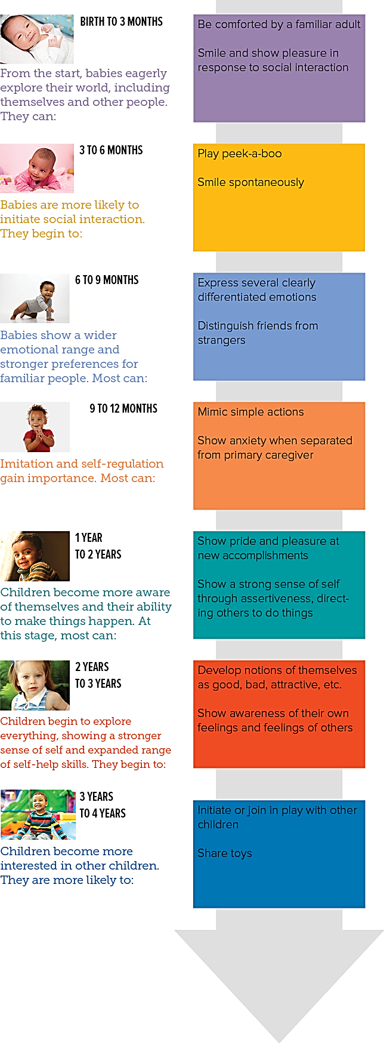
Practical Activity Ideas
According to the NHS childhood development timeline, at 11 to 12 months, children are willing to explore more of what is exposed to them. Parents can use this opportunity to establish a conducive environment for learning small words (Hostinar et al., 2015). Moreover, continuous speaking of alphabets in front of the child can aid in teaching the child at early stages (Urban Child Institute, 2021). Also, since mothers are present with the child frequently, they can incorporate the use of safe and educative objects such as alphabets and small black or whiteboards to enhance the fine motor skills needed for writing in later stages of development (Abanto et al., 2015). This, according to the NHS timeline (NHS GGC, 2017) should be done between 13 and 15 months. Furthermore, Gronski and Doherty (2020) noted that parents can use ride-on toys to build child confidence, balance, and strength which reflects in the rest of their lives.
Psychological Theories:
Vygotsky’s Social Constructivism Theory
The social constructivism theory relies on the cognitive functions that evolve because of social interactions that children have with their surroundings. Siu et al., (2019) noted that this theory relates to the concept of cognitive abilities of children which are guided and constructed by social facilitation. Positive child development is aided by combining social and cognitive constructivism. In the opinion of Landers et al., (2018), each child possesses a different learning style which is married with the culture he/she is exposed to and hence implying that culture acts as a mediator for specific abilities including learning, memory, attention, and problem-solving. Abanto et al., (2015) highlighted that social constructivism can be applied in a classroom setting for children aged 3 to 5 while parents can put significant inputs in enhancing the mind of children at home from birth. Besides, Baiden et al., (2020) outlined that the early years of a child’s life is essential for creating a functional base and mind to better comprehend the experiences in later stages and years of life. This functional base comes from social interactions and negotiations through collaborative learning both in schools and at home. The study of Gronski and Doherty (2020) denoted that parents are responsible for interacting with their children while at home. These interactions are influenced by cultural tools since every child has differing backgrounds from one another which is what creates diversity in the global environment. The social constructivism theory further notes that the interactions of children with their environment and society using language is what creates the social world and hence is considered a shared experience. It is of no doubt that language plays a key role in shaping the thought of children and so, parents and the rest of the community is required to use simple and positive words to facilitate the learning process of the child and keep him/her away from negativity in early years of life.

Piaget’s Theory of Cognitive Development
According to Jean Piaget’s theory of cognitive development, children develop, mentally through four stages, sensorimotor, preoperational, concrete operational and formal operational stage. This theory not only outlines the ways in how children acquire knowledge but also focuses on comprehending the intelligence nature of children there is high consistency cognitive advancement on children (Boyed and Bee, 2013). In the opinion in of Hostinar et al., (2015), children when in the sensorimotor stage, they tend to learn about and understand the world using their movement and sensations which further stimulates the process of growth. This is further elaborated by the NHS childhood development timeline which emphasizes that children in this stage start to make sense of their sensory skills using their experiences with the surrounding environment. This timeline also discusses that children during the initial stage (0 to 4 weeks) are not only actively, eating and sleeping but they also visualize their environment, in that they are aware of the attitudes their parents display towards them. Moreover, children at this stage begin to feed for longer periods which implies that they should be given adequate food to stimulate the growth process. The child also begins to develop self-awareness understanding the reactions that their actions can induce in people around them (Baiden et al., 2020). For this reason, Abanto et al., (2015) stated that children should be responded with positive reactions to allow for positive and smooth growth. Moreover, children use symbolism to understand and interpret words and objects around them when in the preoperational stage. However, egocentrism is at its peak among children at the preoperational stage, in that they do not want to see or understand things as per the perspective of others. There is minimal flexibility among children at this stage as they reflect concreteness in their attitudes towards several concepts.

Introduction
This poster looks at the experiences of children at early ages - from birth to five years - of their lives and how these experiences affect the rest of their lives. Highlighting the concepts of Vygotsky’s social constructivism theory and Piaget’s theory of cognitive development, this poster will discuss the developments children undergo in their early years of life. Information presented in this poster will be linked to existing literature to draw a clear picture for parents facing challenges in supporting the development of their child.
Source: (Urban Child Institute, 2021)
Conclusion
The mental development of children needs to be taken care of with proper attention as their experiences during initial stages of life will reflect in their actions in later stages of lives. Children should be provided with the opportunity to interact with their environment to develop social relationships as well as cognition. Moreover, interaction helps in the sharing of information and resources which creates an expanded and advanced forum for the development and growth of the child. Both schools and parents need to play a significant role in the development of the child, in that the latter can incorporate practical activities within the house to stimulate the learning interest of the child. On the other hand, the schools come into play after the child has undergone full sensory and pre operational stage.
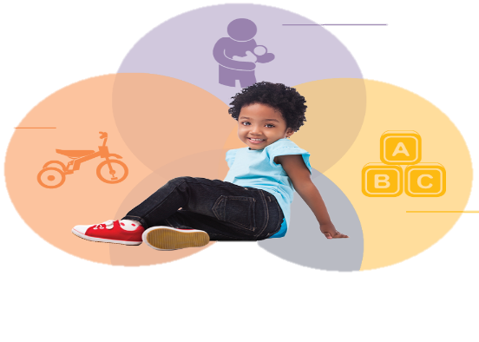
Source: (Urban Child Institute, 2021)

Annotated Bibliography
1. Baiden, P., LaBrenz, C., Thrasher, S., Asiedua-Baiden, G. & Harerimana, B. (2020) Adverse childhood experiences and household food insecurity among children aged 0–5 years in the USA. Public Health Nutrition. pp. 1-9. [Online]. DOI: 10.1017/s1368980020002761 [Accessed: 21 February 2021].
The source is about the negative consequences of adverse childhood experiences, how it impacts children 0-5yrs Psychological health
Credibility and Reliability: Authors of the article’s affiliation with Social work and health sciences, published in a reliable institution, Published online by Cambridge University Press. It is current. The researcher used a survey questionnaire for collecting data and information gathered from the sample size of 17,543 children of ages between 0-5. With a large sample size, this research reflects a professional perspective of the study making it reliable and credible
This source has helped me in poster as it reflects the stages covered under cognitive theory and social-constructivism theory of development. These theories highlight the background, social status, and child’s deprivation from a surrounding element like food, shelter, parents love and others.
2. Boyd, D. & Bee, H. (2013) Lifespan Development, Global Edition. Pearson Education Limited.
Denise Boyed is a licensed psychologist, one time instructor of psychology in the Houston Community College. Presenter at various workshop for teachers with student even at preschool she has presented several papers in professional meetings conducted reporting, research in child, adolescent, and adult development, this makes the source reliable and credible
The source deals with how age contribute to changes in our thinking, behavior, personality and emotion, psychoanalytic theories
The author has a PhD in psychology, she has written other books related psychology cited and referenced by other authors, the book has current data and evidence. Researchers, journals, and articles use this book as a reference this proves its reliability and credibility
It helped me to explain with clarity on the difference between Piaget and Vygotsky theories while developing the poster.
3. Eysenck, M. & Keane, M. (2015) Cognitive psychology. 7th Ed. Hove: Psychology P.
Michael William Eyseneck is an academic psychologist from Britain. Professor in Psychology at Royal Holloway., University of London. A Professorial Fellow at Roehampton University. His research concentrates on cognitive issues affecting. anxiety. He has over 30 distinct work on cognitive psychology. Mark T. Keane an Irish co-author has a BA (UCD) and PhD (TCD) in Cognitive Psychology and previously worked in University of London, the Open University, Cardiff University and Trinity College Dublin (FTCD, 1994). Prof. Keane has published 200+ articles, has a H index of 49.
The source is about Cognitive Psychology
Credibility and Reliability authors with credible, and vast experience, the book has, current
information on research and development. It is the latest edition, the book is reviewed,
supported and by other authorities in Cognitive Psychology
This source has helped me in the poster to highlight the impact early experience
has on future development.
4.Gronski, M. & Doherty, M. (2020) Interventions Within the Scope of Occupational Therapy Practice to Improve Activities of Daily Living, Rest, and Sleep for Children Ages 0–5 Years and Their Families: A Systematic Review. American Journal of Occupational Therapy. 74 (2). pp. 7402180010p1. [Online]. DOI: 10.5014/ajot.2020.039545 [Accessed: 21 February 2021].
This article is researched by Gronski and Doherty (2020), both researchers are Assistant professor in the Department of Occupational Therapy at different well-known universities
This source is about the functional development of young children and how these developmental. stages can be reflected through improved family practices.
Reliability and Credibility: the data used is extracted from five major databases that are MEDLINE, PsycINFO, CINAHL, OTseeker and ERIC the article was published in American jornal occupational therapy and this Journal, has current information, reliable, and Authentic.
I have used this source in my poster and use the concepts of the theory related to social constructivism which outlines in brief that how a family can help and support in developing a strong social image in a child
5.Gross, R. (2015) Psychology. 7th Ed. London, England: Hodder Education.
Richard Gross, is a Professor in the School of Psychological & Social Sciences at York St
John University, he has authored several key textbooks in psychology such as
Psychology for Nurses and Health Professionals, Gross Guide to Psychology,
Understanding Grief, Social Psychology etc. his special area of interest is philosophical
Psychology
The source is credible and reliable because the author is credible and reliable having
having., written so many books on Psychology. the information is accurate and rational
the book has constantly been reviewed and supported by other scholers.
This source has helped me in the poster to highlight the impact early experience has
on future development.
6. Hashmi, S. (2017) Psycho-Social development & academic achievement of a single parent child in Nagaland. International Journal of Psychology and Psychiatry. 5 (1). p. 54. [Online]. DOI: 10.5958/2320-6233.2017.00005.0 [Accessed: 21 February 2021]..
The author of this article holds the designation of an Assistant Professor in the Department of Education and Psychology.
This source is about the examination of individuals who were raised by a single parent.
This article is reliable and credible as it is based on a survey which was conducted by a professor associated with the education of psychology. This article credible because is one that is unbiased and is backed up, with evidence. Therefore, the selection criteria used by the professor has made this article reliable and valid for my study.
I used this article in my poster to cover the content related to social constructivism. As social constructivism highlights the self-identity of an individual child’s development, this article has helped in related to the adoption of this theory in
.
8. “Landers, A.L., McLuckie, A., Cann, R., Shapiro, V., Visintini, S., MacLaurin, B., Trocme, N., Saini, M. and Carrey, N.J., 2018. A scoping review of evidence-based interventions available to parents of maltreated children ages 0-5 involved with child welfare services. Child Abuse & Neglect, 76, pp.546-560. https://doi.org/10.1016/j.chiabu.2017.09.012”
This source is about how parents’ behaviour and attitude can impact child development.
This source is credible as it is a reference with a variety of other literature related to a similar topic, the reliability of these sources is maintained through a tough selection criterion for an online archival research.
This helped in developing the background for the poster. My poster is based on one of the important developmental theory, which is social constructivism, this implies how a Childs’ growth is influenced by a positive social environment constructed by parents and interventions practised by parents
8. “Siu, G., Batte, A., Tibingana, B., Otwombe, K., Sekiwunga, R. and Paichadze, N., 2019. Mothers’ perception of childhood injuries, child supervision and care practices for children 0–5 years in a peri-urban area in Central Uganda; implications for prevention of childhood injuries. Injury Epidemiology, 6(1), pp.1-7.”
This source is related to the mother handling children from 0-5 years of age and how mother perception and handling can impact child psychology during the growth stages of a child.
This source is reliable as the authors are renown in the field of child health and health sciences. A point of validity is attained for this source as covers transcripts in English and can also be taken for low-income parents in developed countries
The study helped to understand that mother’s perception in the early five years in low-income countries. I have used this source in my poster to highlight how mother attention, supervision, playfulness, and importance in the cognitive stage can help in the developmental progress of children
Poster Reference:
NHS GGC. 2017. Interactive Child Development Timeline. [Online] Available at https://www.nhsggc.org.uk/kids/child-development/interactive-child-development-timeline/
Image Reference:
Urban Child Institute, 2021. Social and Emotional Development. [online] Urbanchildinstitute.org. Available at: http://www.urbanchildinstitute.org/resources/publications/good-start/social-and-emotional-development [Accessed 20 February 2021].

