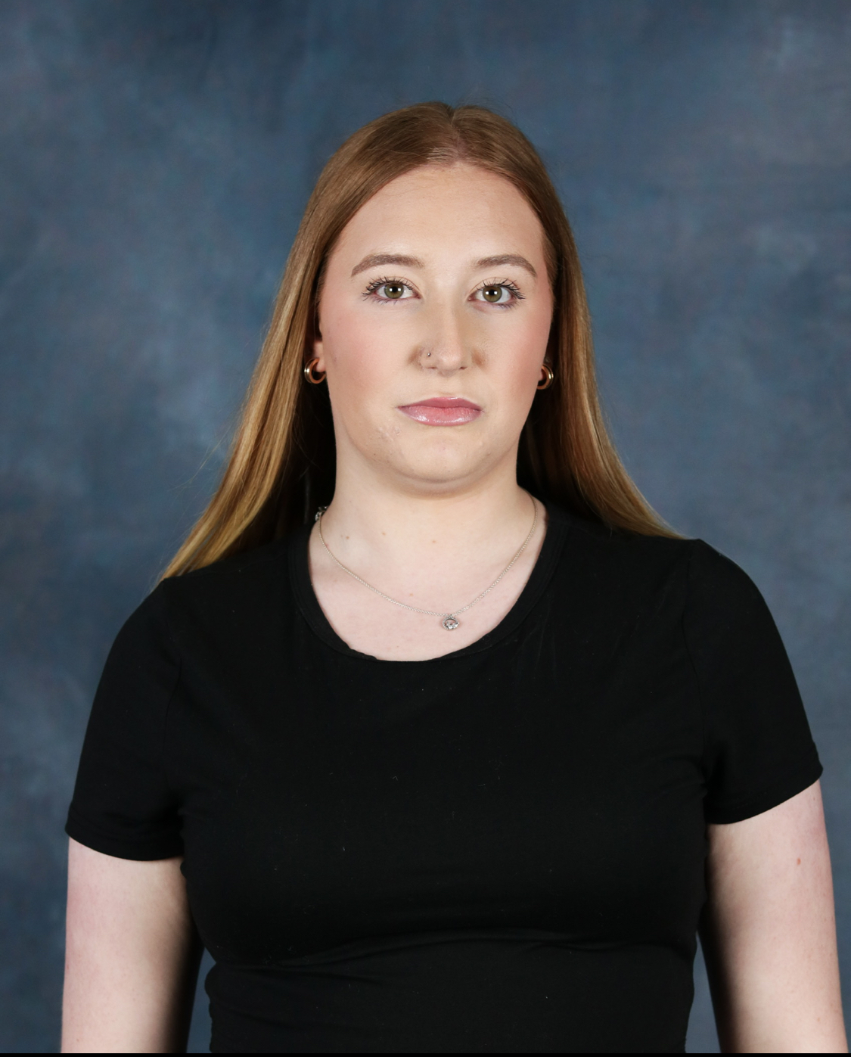
Ella Fostersmith
Email - ellafostersmith@gmail.com
Phone - 07488393508

Playing Age - 18-25
Height - 5’9
Hair - Ginger
Eye colour - Green
Gender - Female
Pronouns - she. Her
Build - Medium
Nationality - British / Welsh
Training.
Performing Arts Level 3 UAL Extended Diploma - Coleg Menai - Graduated 2023
Performing Arts Level 4 Musical Theatre Professional Diploma in performance - Coleg Menai - Graduated 2024.
BA Hons Theatre Gerddorol - Wales Academy of voice and dramatic arts - Present.
Credits Include:

Production | Roles | Venue / Company | Director
Made in Dagenham | Rita O’Grady | Coleg Menai Theatre Bryn Terfel | Darren Stoke
Pippin | Ensamble | Coleg Menai Theatre Bryn Terfel | Darren Stoke
The Hunger Pang Gang | Shotmister | BBC It’s My Shout | Ceri Bostock
Night of Musicals | Cinderlla | ShowZone | Steffie Williams/ Eirian Williams
Footloose | Ensamble | Coleg Menai Theatre Bryn Terfyel | Darren Stoke

Skills
Accents: Standard English / Welsh / Cockney
Singing: Mezzo Soprano
Dance: Jazz / Tap / Basic Ballet / Commercial
Languages: English / Welsh
Stage Combat: Unarmed (Merit)

