  LOCATION Swansea | LLEOLIAD abertawe
LEVEL 4 | LEFEL 4
EXAMINATION PERIOD | CYFNOD ARHOLIADAU
May 2025 | Mai 2025

MODULE CODE: ACCA4022
COMPUTER ARCHITECTURE and OPERATING SYSTEMS
TIME: 2 Hours
answer all questions

Equipment or materials required – None
The Candidates are not permitted to bring calculators, dictionaries; text books/case studies or any other reference materials into the exam room.
Show all your calculations in your exam book
Marks add up to 100.
This assessment constitutes 50% of the overall module and all of the Comp. Arch. aspect.

ANSWER ALL FOUR QUESTIONS

QUESTION ONE (35 marks total)

Attempt all of the following. Electronic Calculators are not permitted. Write down and show all your manual calculations in your exam book.

a) Convert the following decimal numbers to Binary (3 marks each)

- 62
- 125

b) Convert the following binary numbers to base 10 (3 marks each)

- 10011001
- 11110

c) Convert the following hex numbers to binary (2 marks each)

- 2F
- 36

d) Convert the following Hex numbers to decimal (3 marks each)

- C3
- 66

e) How many different/unique values can be represented by a 5 bit number? (3 marks)

f) You are given an uncropped image from a digital camera image that comprises 4000*3000 pixels. where each pixel can be one of 16 million colours. Calculate:
i) How many megapixels was the camera? (3 marks)

If the uncompressed image file size is 36MB when stored as a .BMP, what would the compressed storage size be if:
ii) you saved it as a JPG with a compression ratio of 10:1 (3marks)

g) Approximately how long it would take to download the 36MB file if you were using an internet link with a 80Mb/s transfer speed (4 marks)

QUESTION TWO (20 marks total)

- The diagram below is of a generic, single ‘system bus’ based computer architecture.
Explain the purpose of each of the six labelled items/rectangles (12 marks)
Also ensuring that your answer includes a description of the overall operating principle of this computer system – as an example, explain the general flow of instructions and data if a program was to read text from an attached keyboard, store the text in temporary/working volatile storage, before then permanently saving the data into a file on an attached non volatile hard disk (8 marks)
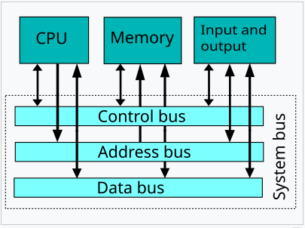

QUESTION THREE (20 marks total)

- Quote typical data capacities for the following devices: (2 marks each)
i) A double layer DVD optical disk
ii) A typical £80 rotating Hard Disk in a desktop computer
iii) A £100 M.2 SSD

- Quote typical data transfer rates for the following: (2 marks each)
- Modern, high specification M.2 NVME ‘sticks’
ii) An average rotating Hard Disk
iii) Typical LAN port on a modern laptop

- You are given two 3TB hard drives . Explain what would be the pros and cons between configuring them in
i) RAID 0
ii) RAID1
(8 marks)

QUESTION FOUR (25 marks total)

You are required to build a desktop computer (workstation) that will be used for editing 4K video. Your budget is very roughly around the £2000 mark (for the hardware only – don’t include any software costs for this exercise)
Produce a general specification for a suitable system with, as a minimum, detail on:
- A suitable CPU
- What is a sensible amount of RAM
- What type and size of non-volatile storage would be suitable
- The input/output features/ports needed
- The features a suitable graphics card would require.
- An example of what typical software could be used for the video editing
For all of the above areas, you should justify your choice with reasoning and where possible, explain why you chose that particular option, over the alternatives.

