ACMA4003

L4 Quality & Business Improvement

Replacement of B7 reheater desuperheater spray water flow control valve (FCV)

Lecturer: R Morgan

Contents
ACMA4003 1
L4 Quality & Business Improvement 1
Replacement of B7 reheater desuperheater spray water flow control valve (FCV) 1
Lecturer: R Morgan 1
1. Background/ Process 3
1.1 overveiew Diagram 3
2. Problem identification/ Problem Statement 4
3. Effect on process 6
4. Data Collection 6
5. Data Analysis 11
6. Root cause analysis 15
6.1 5 Whys? 15
6.2 Fishbone diagram 15
6.3 Flow Chart 16
7. Action plan 17
8. Risk Management considerations 18
Risk Assessment 18
9. Background Reading 19

Background/ Process

No7 EHP boiler at Margam C was manufactured by NEI international combustion ltd and has been in service since the early 1980’s. It is a natural circulation boiler, with a MCR capacity of 44Kgs of steam at 127bar and 538°C. This steam supplies No7 turbine alternator and exhausts at 44bar where a de-superheater spray reduces the temperature ready for the steam to pass back through a re-heater section of the boiler. After this reheater section the steam exits the boiler and enters 44bar main range at 44bar and the temperature should be 438°C. This in turn feeds the blowers at Margam B and the turbines at Margam A as well as some smaller auxiliaries.
Water for the boiler is taken from Margam C demin plant, which in turn gets its water from The Afan and Frwydd rivers as well as domestic water. The water is treated to remove all impurities and oxygen to prevent damage and inefficiency in the boiler.
The fuels used in the boiler are Blast Furnace Gas (BFG), Coke Oven Gas (COG), Natural Gas (NG) and Heavy Fuel Oil (HFO). BFG and COG are indigenous by-products of steel and coke making facilities on site, so are much more cost effective to use where possible. NG and HFO are used to supplement BFG and COG if required. Basic Oxygen Steelmaking (BOS) Gas is another of the by-products of the site we use but only for enrichment.

1.1 overveiew Diagram

Problem identification/ Problem Statement

The current average steam outlet temperature for number 7 boiler is 420⁰C against a design temperature of 438⁰C. The current spray control valve seems to be unfit for purpose and has several faults or variations in operation which cause the system to deviate away from the required outlet temperature.
There are occasions where this temperature has gone as low as 404⁰C. This is a valuable loss of thermal energy output from the boiler which reduces the 44bar header temperature. There would be significant gains to be made in the efficiency if a new reheater spray valve was to be installed. It is suspected that the main reasons for the fault of this valve is the type of valve, age of valve, current set up of system (such as manual isolation valve set up) Fig. 2, valve tuning as well as different issues which will be picked up in this assignment.
The Boiler works at various loads(steam Output) which are dependent of the fuels available and the demand on the Port Talbot site. Due to the 14 kg/s swing in demand of the boiler the manual isolation valves need to be used to alter the spray required. After these have been set up at a certain load it has then been left when the load drops back causing a loss in steam temperature.
Fig. 1 (bellow) is a screen shot of the system and the operations page the operators use to complete operate the boiler. Highlighted are the areas of the boiler being focused on.
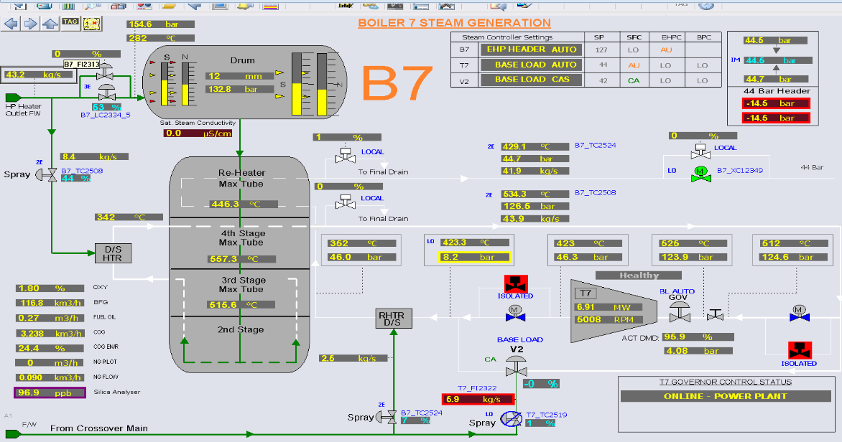
Fig. 1

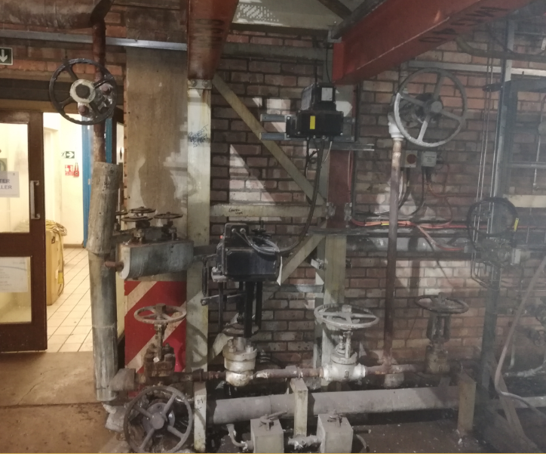
Fig. 2

Effect on process

Due to the steam temperature being low coming from the re-heater, the Margam A, B and C 44 bar headers are working below the required standard and as a result this effects the efficiencies and if put right significant savings can be achieved through steam outlet temperature increase by increasing thermal input in the 44 bar header which would reflect in increased power generation at no additional cost.

Data Collection

The Delta V system used on the boiler has a historian function allowing graphs and data to be extracted from the system. Data was taken from a 12 hour period where 2 trials took place to identify how the control valve was performing and how the movement of the manual isolation valves were effecting the process. Table 1

Data was also collected to identify the control standards of the steam for each turbine. This enables the set point to be increased to improve efficiencies whilst not over heating the steam. Table 2

Data was then collected to identify the effects of the steam increase on 7 Boiler and what effects it has on the steam turbine inlet temperatures. Table 3

 | Start | 11/12/2020
 | Interval - MINS | 10
 | B7  Final  Steam  Temp  Control  Output | B7 Final Steam Temp Control Feedback | B7 Final  Steam Mode  Temp Control Feedback | B7  Superheater  Spray  Valve  Flow | B7  Reheater  Steam  Inlet  Temp | B7 Final  Steam Temp  Control  Set Point | B7  Final  Steam  Temp  Control  Output | B7 Reheater Steam Outlet Flow
 | What  the  System  is asking for | Actual Position of the valve
 | B7_  TC2524  /PID1/  OUT.CV | B7_  TC2524  /AO1/  PV.CV | B7_  TC2524  /PID1  /MODE.  ACTUAL | B7_  FI2323  /PV.CV | B7_  TI2521/  PV.CV | B7_  TC2524/  PID1/  SP.CV | B7  _TC2524  /PID1/  PV.CV | B7_FI2529/PV.CV
 | % | % | MODE | Km3/h | ⁰C | ⁰C | ⁰C | KM3/H
08:00 | 0.00 | 21.88 | AUT | 2.54 | 352.22 | 438.00 | 431.79 | 41.49
08:10 | 0.00 | 21.87 | AUT | 2.54 | 352.18 | 438.00 | 430.94 | 41.48
08:20 | 0.01 | 21.85 | AUT | 2.54 | 352.32 | 438.00 | 432.32 | 41.47
08:30 | 0.01 | 21.84 | AUT | 2.54 | 352.06 | 438.00 | 430.62 | 41.46
08:40 | 0.01 | 21.84 | AUT | 2.54 | 348.19 | 438.00 | 431.58 | 41.22
08:50 | 0.00 | 21.83 | AUT | 2.54 | 350.11 | 438.00 | 427.69 | 42.38
09:00 | 0.00 | 21.83 | AUT | 2.54 | 351.67 | 438.00 | 429.67 | 42.04
09:10 | 0.01 | 21.83 | AUT | 2.54 | 350.98 | 438.00 | 429.42 | 41.51
09:20 | 0.01 | 21.82 | AUT | 2.54 | 352.94 | 438.00 | 431.47 | 41.39
09:30 | 0.01 | 21.83 | AUT | 2.54 | 352.22 | 438.00 | 431.23 | 41.30
09:40 | 0.01 | 21.83 | AUT | 2.54 | 353.19 | 438.00 | 430.39 | 41.20
09:50 | 0.01 | 21.84 | AUT | 2.54 | 352.96 | 438.00 | 431.33 | 41.11
10:00 | 0.01 | 21.85 | AUT | 2.54 | 351.36 | 438.00 | 428.62 | 41.01
10:10 | 0.00 | 21.86 | AUT | 2.54 | 352.20 | 438.00 | 429.59 | 41.02
10:20 | 0.00 | 21.87 | AUT | 2.54 | 353.35 | 438.00 | 431.09 | 41.24
10:30 | 0.01 | 21.88 | AUT | 2.54 | 353.30 | 438.00 | 431.88 | 41.28
10:40 | 0.01 | 21.88 | AUT | 2.54 | 353.04 | 438.00 | 430.08 | 41.31
10:50 | 0.01 | 21.88 | AUT | 2.54 | 350.45 | 438.00 | 429.03 | 41.35
11:00 | 0.01 | 21.88 | AUT | 2.54 | 353.32 | 438.00 | 432.31 | 41.38
11:10 | 0.01 | 21.89 | AUT | 2.54 | 351.28 | 438.00 | 429.30 | 41.42
11:20 | 0.01 | 21.88 | AUT | 2.54 | 351.84 | 438.00 | 429.18 | 41.45
11:30 | 0.01 | 21.88 | AUT | 2.54 | 353.39 | 438.00 | 431.18 | 41.49
11:40 | 0.01 | 21.88 | AUT | 2.54 | 352.53 | 438.00 | 429.62 | 41.56
11:50 | 0.01 | 21.88 | AUT | 2.54 | 351.98 | 438.00 | 429.90 | 41.64
12:00 | 0.01 | 21.87 | AUT | 2.54 | 353.26 | 438.00 | 430.93 | 41.72
12:10 | 0.01 | 21.87 | AUT | 2.54 | 352.67 | 438.00 | 430.06 | 41.80
12:20 | 0.01 | 21.87 | AUT | 2.54 | 351.88 | 438.00 | 430.23 | 41.66
12:30 | 0.01 | 21.86 | AUT | 2.54 | 352.48 | 438.00 | 430.43 | 41.45
12:40 | 0.01 | 21.85 | AUT | 2.54 | 352.53 | 438.00 | 431.53 | 41.25
12:50 | 0.01 | 21.86 | AUT | 2.54 | 351.49 | 438.00 | 429.88 | 41.04
13:00 | 0.01 | 21.86 | AUT | 2.54 | 352.22 | 438.00 | 431.25 | 41.03
13:10 | 0.01 | 21.88 | AUT | 2.54 | 352.81 | 438.00 | 431.66 | 41.09
13:20 | 0.01 | 21.88 | AUT | 2.54 | 352.93 | 438.00 | 432.02 | 40.91
13:30 | 0.01 | 21.87 | AUT | 2.54 | 351.55 | 438.00 | 430.08 | 40.73
13:40 | 0.00 | 21.87 | AUT | 2.54 | 350.23 | 438.00 | 419.58 | 38.48
13:50 | 0.00 | 21.87 | AUT | 2.54 | 341.44 | 438.00 | 414.50 | 34.03
14:00 | 0.00 | 21.88 | AUT | 2.54 | 338.54 | 438.00 | 407.64 | 31.90
14:10 | 0.01 | 22.01 | AUT | 2.54 | 341.51 | 438.00 | 411.72 | 31.82
14:20 | 0.00 | 22.02 | AUT | 2.54 | 340.26 | 438.00 | 411.23 | 31.74
14:30 | 10.02 | 14.47 | AUT | 2.54 | 349.27 | 438.00 | 419.37 | 31.66
14:40 | 0.00 | 12.57 | AUT | 2.54 | 350.69 | 438.00 | 421.50 | 31.58
14:50 | 0.00 | 12.57 | AUT | 2.54 | 348.07 | 438.00 | 420.41 | 31.50
15:00 | 26.16 | 26.08 | AUT | 1.86 | 377.70 | 438.00 | 436.91 | 30.32
15:10 | 28.12 | 28.06 | AUT | 1.87 | 379.49 | 438.00 | 437.53 | 30.22
15:20 | 32.43 | 32.39 | AUT | 1.89 | 380.71 | 438.00 | 439.34 | 30.27
15:30 | 35.82 | 35.80 | AUT | 1.90 | 380.00 | 438.00 | 439.19 | 30.31
15:40 | 39.47 | 39.47 | AUT | 1.92 | 380.00 | 438.00 | 440.47 | 30.36
15:50 | 42.83 | 42.83 | AUT | 1.93 | 379.81 | 438.00 | 437.62 | 30.40
16:00 | 45.93 | 45.95 | AUT | 1.95 | 379.34 | 438.00 | 438.24 | 30.45
16:10 | 48.85 | 48.85 | AUT | 1.96 | 379.61 | 438.00 | 439.63 | 30.50
16:20 | 52.77 | 52.76 | AUT | 1.97 | 380.32 | 438.00 | 437.20 | 30.30
16:30 | 55.67 | 55.66 | AUT | 1.97 | 378.93 | 438.00 | 437.28 | 30.19
16:40 | 57.92 | 57.91 | AUT | 1.96 | 378.73 | 438.00 | 436.42 | 30.07
16:50 | 60.92 | 60.93 | AUT | 1.96 | 378.68 | 438.00 | 436.19 | 29.95
17:00 | 62.48 | 62.50 | AUT | 1.96 | 377.98 | 438.00 | 437.35 | 29.84
17:10 | 65.36 | 65.36 | AUT | 1.95 | 379.25 | 438.00 | 439.42 | 30.60
17:20 | 70.60 | 70.62 | AUT | 1.95 | 377.91 | 438.00 | 440.35 | 36.47
17:30 | 0.01 | 21.78 | MAN | 2.54 | 350.36 | 438.00 | 428.81 | 39.27
17:40 | 0.01 | 21.78 | MAN | 2.54 | 350.59 | 438.00 | 428.28 | 39.25
17:50 | 0.01 | 21.78 | MAN | 2.54 | 350.20 | 438.00 | 428.25 | 39.24
18:00 | 0.01 | 21.78 | MAN | 2.54 | 351.97 | 438.00 | 430.41 | 40.24
18:10 | 0.01 | 21.77 | MAN | 2.54 | 350.99 | 438.00 | 428.19 | 40.36
18:20 | 0.01 | 21.78 | MAN | 2.54 | 351.14 | 438.00 | 427.82 | 40.23
18:30 | 0.01 | 21.78 | MAN | 2.54 | 351.39 | 438.00 | 428.35 | 40.07
18:40 | 0.01 | 21.78 | MAN | 2.54 | 350.21 | 438.00 | 428.32 | 39.92
18:50 | 0.01 | 21.78 | MAN | 2.54 | 351.07 | 438.00 | 427.21 | 39.76
19:00 | 0.01 | 21.78 | MAN | 2.54 | 351.25 | 438.00 | 428.99 | 39.77
19:10 | 0.01 | 21.78 | MAN | 2.54 | 351.70 | 438.00 | 428.95 | 39.78
19:20 | 0.01 | 21.78 | MAN | 2.54 | 351.06 | 438.00 | 428.45 | 39.79
19:30 | 0.01 | 21.77 | MAN | 2.54 | 351.11 | 438.00 | 430.12 | 39.80
19:40 | 0.01 | 21.76 | MAN | 2.54 | 351.10 | 438.00 | 430.28 | 39.82
19:50 | 0.01 | 21.76 | MAN | 2.54 | 348.97 | 438.00 | 426.90 | 39.85
20:00 | 0.00 | 21.76 | MAN | 2.54 | 344.51 | 438.00 | 418.80 | 34.51
20:10 | 0.00 | 21.76 | MAN | 2.54 | 340.07 | 438.00 | 416.54 | 33.53
Table 1
Asset | Design Pressure | Design Temperature
Boiler 3 | 44.8 bar (a) | 455°C
Boiler 5 | 43.4 bar(g) | 443°C
Boiler 6 / TA6 | 43.1 bar(g) | 538/438°C
Boiler 7 / TA7 | 43.1 bar(g) | 538/438°C
Mitchell Boiler | 44.8 bar(g) | 449 °C
TAB1 | na | na
TA2 | na | na
TA3 | na | na
TA4 (FY20/21) | 44 bar(g) | 430°C (Max)
 | 41.65 bar(g) (Min) | 417 °C (Normal)
TA8 | 43.09 bar(g) | 437 °C
TA9 | 43 bar(g) | 440 °C
TA10 | 43 bar(g) | 443 °C
TB3 | 44 bar(a) (Max) | 430°C (Max)
TB3 | 42 bar(a) (Normal) | 405°C (Normal)
TB3 | 40 bar(a) (Min) | 380°C (Min )
TB5 | 44 bar(a) (Max) | 430°C (Max)
TB5 | 42 bar(a) (Normal) | 405°C (Normal)
TB5 | 40 bar(a) (Min) | 380°C (Min )
HLP1 | 44.8 bar(g) (Max) | 454°C (Max)
HLP1 | 37.9 bar(g) (Normal) | 400°C (Normal)
HLP2 | 44.8 bar(g) (Max) | 454°C (Max)
HLP2 | 37.9 bar(g) (Normal) | 400°C (Normal)
B6 FWP | 43.1 bar(g) 41.4 bar(g) minimum | 438°C 427°C minimum
B7 FWP | 43.1 bar(g) 41.4 bar(g) minimum | 438°C 427°C minimum
PRSs | 51.2 bar(a) (Max), 43.1 bar(a) minimum | 449°C (Max) 438°C (min)
Table 2
 | 7 SP | 7 Boiler | 2TA | 3TA | 8 TA | 9 TA | 10 TA
9/17/2020 9:00:00 | 438.00 | 416.58 | 420.30 | 421.99 | 414.10 | 422.72 | 423.32
9/17/2020 10:00:00 | 438.00 | 424.88 | 421.76 | 422.56 | 413.87 | 422.96 | 422.89
9/17/2020 11:00:00 | 438.00 | 425.60 | 407.81 | 399.15 | 423.71 | 398.75 | 418.60
9/17/2020 12:00:00 | 438.00 | 426.02 | 408.56 | 402.11 | 413.83 | 402.15 | 414.79
9/17/2020 13:00:00 | 438.00 | 417.92 | 422.19 | 424.06 | 408.17 | 423.82 | 425.97
9/17/2020 14:00:00 | 438.00 | 428.89 | 419.55 | 417.03 | 422.40 | 418.11 | 422.55
9/17/2020 15:00:00 | 438.00 | 419.68 | 415.90 | 418.46 | 415.40 | 419.33 | 423.70
9/17/2020 16:00:00 | 438.00 | 419.22 | 416.17 | 416.20 | 416.39 | 416.53 | 422.06
9/17/2020 17:00:00 | 438.00 | 419.25 | 416.62 | 418.15 | 416.04 | 418.48 | 423.39
9/17/2020 18:00:00 | 438.00 | 435.03 | 423.65 | 414.27 | 421.20 | 414.41 | 420.69
9/17/2020 19:00:00 | 438.00 | 422.17 | 416.77 | 415.73 | 417.05 | 416.02 | 421.82
9/17/2020 20:00:00 | 438.00 | 420.06 | 416.81 | 415.64 | 415.86 | 416.02 | 422.79
9/17/2020 21:00:00 | 438.00 | 419.09 | 415.78 | 415.51 | 414.51 | 415.83 | 422.81
9/17/2020 22:00:00 | 438.00 | 409.66 | 411.77 | 416.43 | 409.76 | 416.61 | 422.26
9/17/2020 23:00:00 | 438.00 | 421.12 | 416.74 | 416.39 | 416.03 | 416.78 | 423.33
9/18/2020 0:00:00 | 438.00 | 418.29 | 423.27 | 427.02 | 417.72 | 428.80 | 425.71
9/18/2020 1:00:00 | 438.00 | 429.22 | 423.96 | 423.55 | 425.15 | 429.99 | 428.99
9/18/2020 2:00:00 | 438.00 | 420.38 | 415.23 | 417.47 | 418.80 | 430.67 | 428.90
9/18/2020 3:00:00 | 438.00 | 416.27 | 414.13 | 419.48 | 419.16 | 430.59 | 429.78
9/18/2020 4:00:00 | 438.00 | 417.35 | 414.08 | 428.60 | 418.08 | 430.15 | 427.31
9/18/2020 5:00:00 | 438.00 | 420.32 | 416.30 | 424.19 | 419.71 | 429.40 | 427.16
9/18/2020 6:00:00 | 438.00 | 418.46 | 420.49 | 428.20 | 420.24 | 429.58 | 426.89
9/18/2020 7:00:00 | 438.00 | 419.72 | 415.79 | 419.35 | 418.72 | 429.86 | 428.28
9/18/2020 8:00:00 | 438.00 | 411.59 | 408.76 | 423.00 | 413.20 | 428.67 | 427.70
9/18/2020 9:00:00 | 438.00 | 419.33 | 413.04 | 414.30 | 417.15 | 429.22 | 427.54
9/18/2020 10:00:00 | 438.00 | 421.80 | 419.06 | 420.54 | 420.51 | 430.39 | 428.15
9/18/2020 11:00:00 | 438.00 | 422.28 | 416.70 | 418.23 | 418.54 | 429.78 | 428.32
9/18/2020 12:00:00 | 438.00 | 440.22 | 435.15 | 430.69 | 433.32 | 431.25 | 427.96
9/18/2020 13:00:00 | 438.00 | 434.93 | 433.17 | 430.95 | 430.48 | 430.00 | 427.04
9/18/2020 14:00:00 | 438.00 | 437.12 | 433.71 | 431.52 | 430.78 | 428.36 | 426.31
9/18/2020 15:00:00 | 438.00 | 440.57 | 436.68 | 432.85 | 433.39 | 428.70 | 425.57
9/18/2020 16:00:00 | 438.00 | 446.38 | 442.43 | 433.37 | 438.26 | 428.44 | 425.57
9/18/2020 17:00:00 | 438.00 | 442.10 | 437.50 | 431.36 | 433.69 | 429.68 | 425.95
9/18/2020 18:00:00 | 438.00 | 437.08 | 433.84 | 429.23 | 431.88 | 429.99 | 427.30
9/18/2020 19:00:00 | 438.00 | 440.51 | 437.73 | 431.83 | 433.73 | 429.92 | 426.12
9/18/2020 20:00:00 | 438.00 | 436.57 | 432.58 | 430.33 | 429.75 | 429.77 | 426.49
9/18/2020 21:00:00 | 438.00 | 439.37 | 436.51 | 430.96 | 431.53 | 429.20 | 425.87
9/18/2020 22:00:00 | 438.00 | 443.09 | 438.56 | 432.62 | 433.58 | 428.40 | 426.84
9/18/2020 23:00:00 | 438.00 | 439.78 | 436.14 | 434.24 | 432.22 | 430.68 | 427.08
9/19/2020 0:00:00 | 438.00 | 439.75 | 438.12 | 437.07 | 433.86 | 430.33 | 426.83
9/19/2020 1:00:00 | 438.00 | 440.27 | 436.51 | 432.44 | 432.55 | 429.63 | 426.98
9/19/2020 2:00:00 | 438.00 | 439.95 | 436.50 | 431.94 | 433.05 | 429.17 | 426.20
9/19/2020 3:00:00 | 438.00 | 436.99 | 434.74 | 431.81 | 431.93 | 429.31 | 427.54
9/19/2020 4:00:00 | 438.00 | 439.02 | 436.22 | 431.41 | 432.96 | 428.96 | 426.41
9/19/2020 5:00:00 | 438.00 | 439.40 | 436.05 | 432.70 | 431.89 | 428.86 | 426.04
9/19/2020 6:00:00 | 438.00 | 441.60 | 439.04 | 437.86 | 433.57 | 428.73 | 427.31
9/19/2020 7:00:00 | 438.00 | 439.53 | 435.98 | 434.85 | 431.81 | 429.95 | 426.83
9/19/2020 8:00:00 | 438.00 | 437.84 | 435.88 | 434.24 | 432.39 | 429.54 | 426.21
9/19/2020 9:00:00 | 438.00 | 438.69 | 435.97 | 433.53 | 431.83 | 429.65 | 425.99
9/19/2020 10:00:00 | 438.00 | 443.25 | 441.08 | 440.81 | 436.11 | 429.96 | 427.18
Table 3
Process flow condition of water | Min |  |  | Norm | Max
Flowrate |  |  | 1.5 | 2.21 |  | 2.94 |  | M3/h
Flowrate |  |  | 29.48 | 30.45 |  | 40.50 |  | GPM
Inlet pressure |  |  | 154 | 154 |  | 154 |  | Bar g
Outlet pressure |  |  | 56 | 56 |  | 56 |  | Bar g
Pressure drop |  |  | 98 | 98 |  | 98 |  | Bar g
Temperature |  |  | 110 - 121 | 110-121 |  | 110-121 |  | °C
Pipe inlet diameter |  | 2.07 |  | 2.07 | 2.07 |  | Inch
Pipe Outlet diameter |  | 2.38 |  | 2.38 | 2.38 |  | Inch
Existing control valve size |  | 1.5 |  | 1.5 | 1.5 |  | Inch
Table 4

Data Analysis
Whilst performing the testing of the system and the collection of the data it was clear to see that the valve has points where it sticks failing to control the temperature.
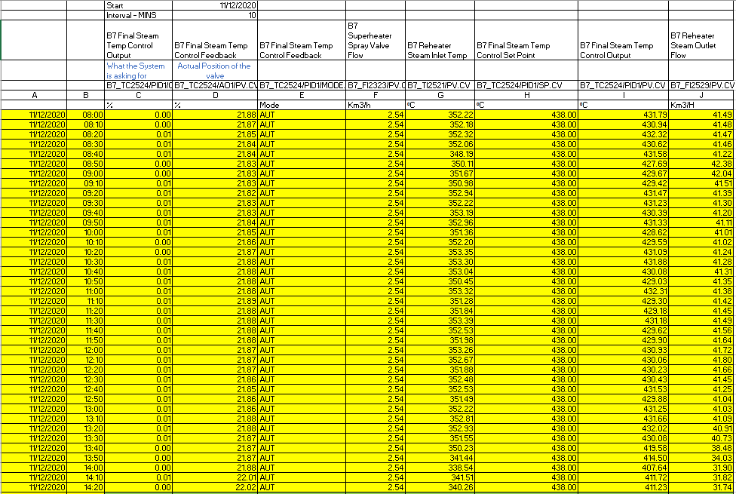

Whilst the valve is asking to close to 0% (column C) from the control system the feed back is indicating that the valve is over 21% open (column D) . With this sticking point, the manual isolation valve will then be adjusted by the operator (see Fig. 2) so that they keep the steam within a band of temperature. With a constant de-superheater spray flow of 2.54 km3/H (Column F) there is no control at any boiler loading. Throughout this period before the trial started the boiler did not reach the desired set point for an extended period of time meaning that there was a significant period where plant performance could have been improved.
Between 08:00 and 13:00 the boiler load is relatively stable with the steam temperature still low this indicates it was set up when the boiler was at its maximum continuous rating (MCR) 44.1 Kg/s. When the loading has decreased to 40-42kg/s from 44.1 kg/s the de-superheater valve cannot close past 21% and the temperature moved further away from the set point.
At 14:00 the boiler load has been reduced further to 32 Kg/s and the temperature has dropped to 411⁰C, an alarm will activate and the operator takes action with Manual intervention.
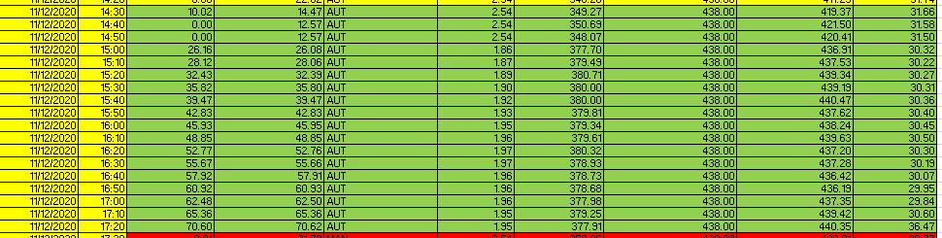

At 14:30 the control valve has been closed in Fig. 3 manually moving it away from the sticking point and the manual isolation Fig. 4 valve has been closed slightly to allow the valve to operate at a higher percentage. As can be indicated in the table the control valve has then started to operate through the various positions to allow the boiler to meet the required set point.
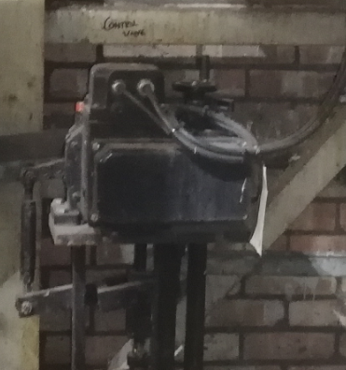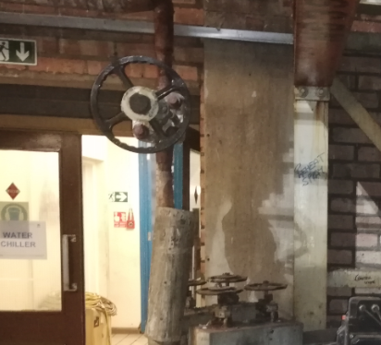
Fig. 3 Fig. 4

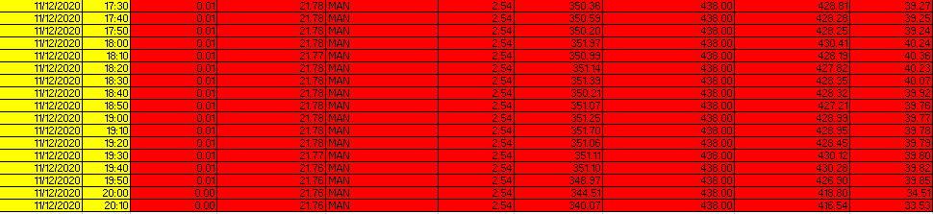
When the boiler is put back into its original position it reacts the same way. This indicates that there is a fundamental issue with the control valve. This also indicates that until the valve can be changed then there are operating parameters that can be observed to enable the set point to be achieved.

In the chart below it is clear to see that over the selected period of time that until manual intervention was taken the boiler was not reaching set point .

Manual intervention
The other aspect of the data looked at was the effects of a lower steam temperature coming from 7 boiler has on the turbines Table 3. When this is lower than set point there is a knock on effect to the possible efficiencies of the Power plant as a whole.

When the steam temperature from 7 Boiler is increased then there is a clear and obvious correlation to the increase in turbine performance.
Current Scenario
TA7 exhaust steam temperature | 420 | °C
TA7 exhaust steam pressure | 44 | bar(g)
Steam enthalpy | 3,266.81 | kJ/kg
TA7 average steam load | 36 | kg/s
Proposed Scenario
TA7 exhaust steam temperature | 438 | °C
TA7 exhaust steam pressure | 44 | bar(g)
TA7 average steam load | 36 | kg/s
Steam enthalpy | 3,297.38 | kJ/kg
Increased energy output | 1.1006 | MWth
Efficiency of electrical gen.(overall)* | 27% | *
Increased electrical generation | 0.30 | MW
Achieved increase (heat losses etc.) | 0.178 | MW
Operating hours | 8000 | h/a
Electricity price 2019/2020 | 55 | £/MWh
Benefit of increased steam gen. | 78,454 | £/annum

With the increase in the temperature there is the potential to make an annual saving of £78,454.

Root cause analysis

5 Whys?

Why is are we not Reaching the set point?
Why? 1 | Manual isolation valve Wrong position
Why? 2 | Having to adjust du to unsuitable/ failing auto valve
Why? 3 | Boiler loads change regularly causing the Reheater spray to be adjusted constantly. When the load is hight the operators set up the valve to work. This is not adjusted when the load drops back.
Why? 4 | Auto valve sticking at various points, Fails to drop below 21% causing excess spray cooling the steam.
Why? 5 | Valve is failing. New design as well as new manifold of valves required so manual intervention is no longer required after set up.

Fishbone diagram
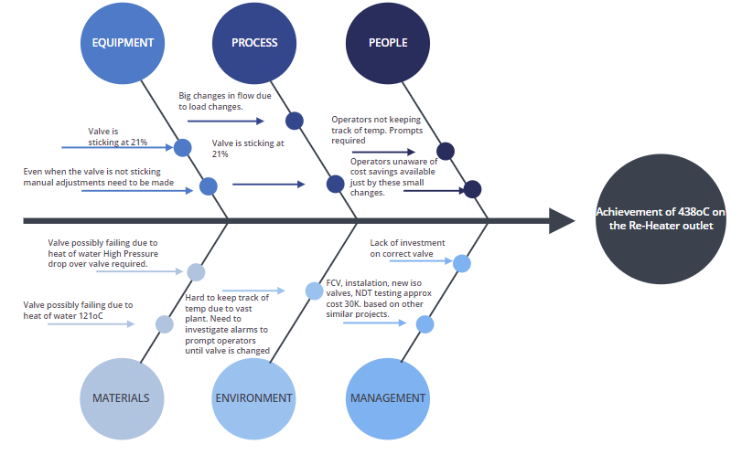

Flow Chart
To be used by the operators until valve is replaced.
Start
Document in shift report. Create a SAP notification
yes
No
No
Is the valve controlling to the 438⁰C set point
Wind valve manually away from sticking point and adjust Manual isolation valve so the valve is away from sticking point
yes
Does the valve output meet the input
No
yes
No
Is the control valve 100%
Is the reheater outlet temperature 438⁰C

yes
End
Adjust manual isolation valve

Action plan
Action | Targets | Due date | Owner | Completed
Set low alarm to 425⁰C, This will allow the temperature to fluctuate without causing too many nuisance alarms. This alarm will alert the operator to adjust the manual valves as required | Short Term | December 2020 | PC&A
Roll out a Standard operating procedure to correspond to the operators the parameters they need to work to, also highlighting the potential savings by this small operation. | Short Term | December 2020 | Operations
Continue to monitor temperature on a weekly basis, Monitoring the valve condition until statutory outage is set to change manifold | Medium/ long Term | Until Valve is replaced | PC&A and operations
Set up spray valve at medium loading so there is ability to move up and down on the valve to try and keep the valve away from the identified sticking point. Mark the valves clearly for position. | Short Term | Jan 20201 | Operations
Identify suitable valve to use. Engineering department to approve. | Medium term | April 2021 | Mechanical Engineers
Acquire funds to put replace the whole manifold. This includes the whole manifold, FCV, and installation. Based on similar project approx.. 30K | Medium/long term | April 2021 | Engineering/ Management
Use findings from this project to use on other boilers and poor spray control. | Long term | August 2021 | Operations/ Engineering/ PC&A
After installation complete set up of control valve | Medium term | May 2021 | PC&A
Monitor performance of the new valve | Long term | August 2021 | Operations
Complete all new paperwork/ inspections after installation | Medium- long term | May-June 2021 | Engineering
Update training manuals after installation. | Medium/ long term | August 2021 | Operations

Risk Management considerations

Risk Assessment
Step1 | Step2 | Step3 | Step4
What are the potential hazards created by the change and how could they happen?  Consider Memory Jogger and Deviation Checklist! | What effect could this change have on people’s safety (S), environment (E) or process/asset (A)? | What control measures are already in place?  List what is already in place to reduce the likelihood of harm occurring should the change ‘fail’. i.e. what additional layers of protection can you rely on? | What further control measures are required (Task List)?  You need to ensure you have reduced the risks ‘so far as reasonably practicable’ by considering and implementing as many additional protection measures as is practical.
Leakage from the new FCV due to the bad welding. | (SAE) Integrity failure, which could result in water leak and ultimately lead to boiler shutdown | Approved contractor will carry out welding and shall adhere to requirements of NDT for welding work. | Ensure QA documentation is according to Tata standard (weld, material, maintenance strategy, etc).
Wrong specification of the FCV. | - Failure of valves would result in uncontrolled steam temp in 44 barg header. | Valves specification carried out according to the site valves and PSSR standards. | Manufacturer’s certification (valve flow characteristics) is required to confirm the suitability of FCV
New valves installed leading to confusion when isolation required due to new installation. | (A) Incorrect valve isolated when isolation required. | Works schematic drawings in place and valves would be installed at same places. | New valves once installed, operators need to be informed. New valves will also be numbered and labelled.
New FCV position (fully open or fully closed) in case of power failure. | (A) Inability to control spray water flow when required resulting in high/low 44 barg header temperature. | - Handwheel on new FCV to operate manually.  - There is a by-pass line which can be used for manual operation instead of auto mode. | Confirmation of “Fail in Position” from FCV supplier
Burning injury from the new pipework. | (S) Potential injury to the personnel due to hot surfaces. | Only trained and authorised personnel will operate the valves | Ensure the new pipework is insulated and cladded

Summary

In Summary there are obvious fundamental issue with the operation of this valve. Previous Changes on similar systems have come in at around £30k. This investment will not only allows a cost saving of approximately £78K but it also eliminates the human factors relied on currently. The current valve is not fit for purpose and feedback from the operations teams and personal experience is that it has not worked for a very long time (but due to the historian limits this cannot be demonstrated). If the funding can be secured it will allow a valuable cost saving which is very important in the current climate. There is very little scope for control with the current valve the manual operation needs to be relied on more frequently, which is easily missed. There are actions that can be performed for the short term to try and met the set point, but a full new install is required to meet the required set point and make the money saving outlined.

Background Reading – bibalography

De superheater spray
https://www.spiraxsarco.com/learn-about-steam/desuperheating/basic-desuperheater-types

Possible valve to use

https://trends.directindustry.com/sipos-aktorik/project-24372-126346.html
https://www.sipos.de/uploads/media/sp-imports/betriebsanleitungen/profitron-himod_-_2s_7/ba_7-profitron-himod-en.pdf
https://www.sipos.de/uploads/media/sp-imports/betriebsanleitungen/profitron-himod_-_2s7-kurzanleitung/kurzanleitung_profitron-himod-en.pdf

Flow Rate calculator

https://www.tlv.com/global/UK/calculator/water-flow-rate-through-valve.html?advanced=on
https://checalc.com/calc/desuperheat.html

CV Ratings

https://www.fujikin.co.jp/en/support/calculator/

Valve requirements

https://www.teesing.com/en/page/library/tools/flow-and-cv-calculator

Thermodynamics

https://www.brighthubengineering.com/power-plants/38111-how-long-term-overheating-tube-failures-happen-in-boilers/
https://beta.spiraxsarco.com/learn-about-steam/steam-engineering-principles-and-heat-transfer/superheated-steam
https://www.sciencedirect.com/topics/engineering/economizer

