!i!i!i!-Digital Safety-!i!i!i!i
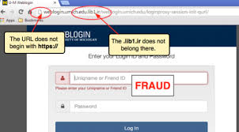
VPN
- encrypts your data so hackers can't have your personal information

SECURE PASSWORDS
- Mixed Letters & Numbers

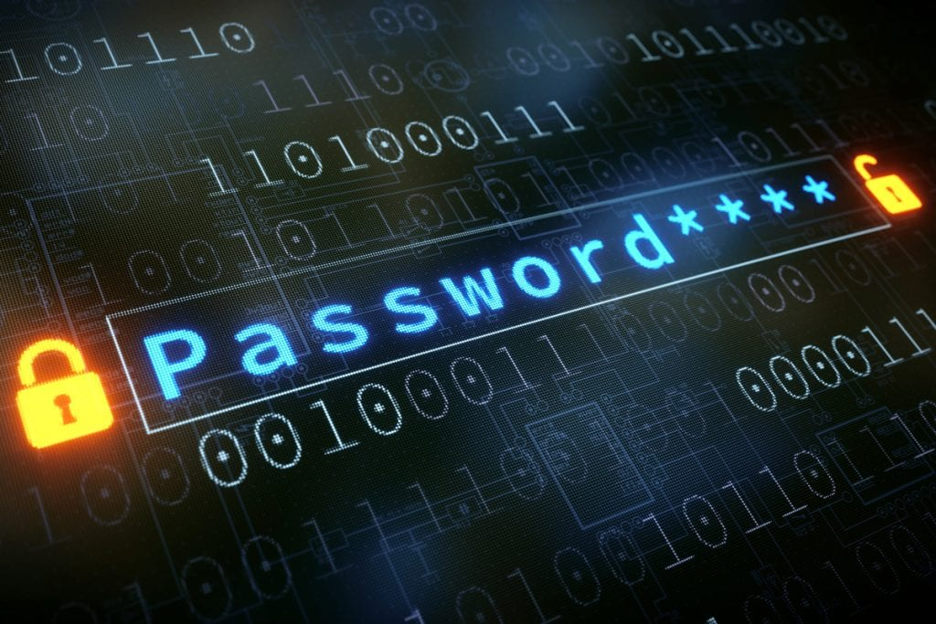
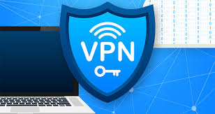
Two factor authentication (2-FA)
- This adds extra security by needing more information on another platform to access
- apps or websites.

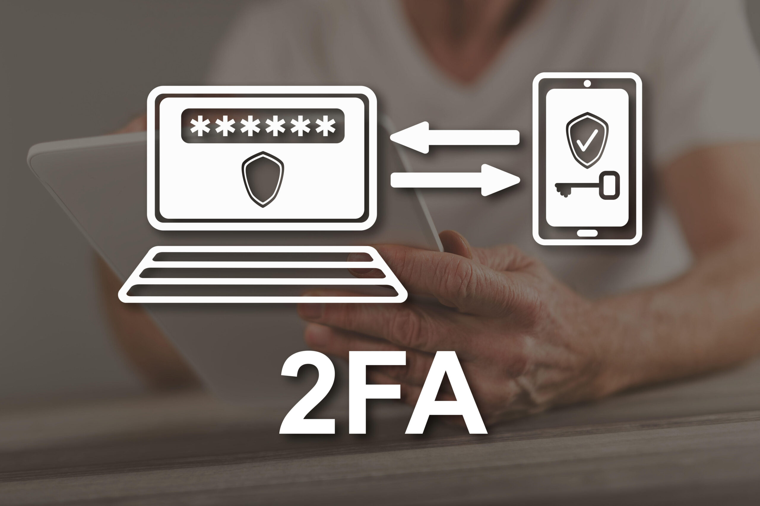
BE CAREFUL OF FALSE WEBSITE LINKS TRICKING YOU INTO CLICKING SCAMS OR FASLSE WEBSITES

