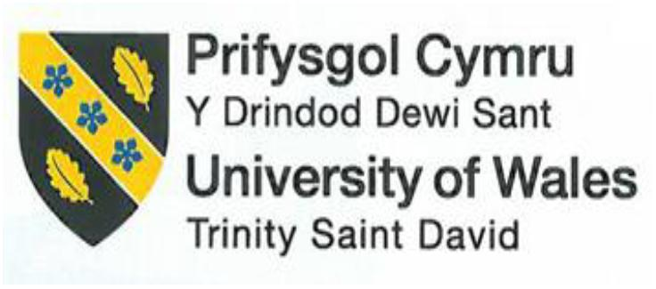

Assignment 2:
Organisational Report - InterContinental Hotels Group (IHG)

Student Name: VICTORIA CHILIANU
Student ID Number: 2208500
The Module Title: Management and Organisational Behaviour BMIH5004
Lecturer’s Name: Dr ERNEST BALUTIE WAVEI
Submission Date: 30th May 2024
Word count: 2195

Executive Summary
InterContinental Hotels Group (IHG) is a major global player in the hospitality industry, offering a diverse range of brands (IHG, 2024a). This report examines IHG's organisational structure, corporate culture, strategic objectives, initiatives, and business performance.
IHG's hierarchical structure facilitates global coordination, with decentralisation empowering local managers to respond swiftly to market demands, enhancing efficiency and competitiveness (IHG Governance, 2022).
IHG's culture, which is based on integrity and inclusivity, is demonstrated by its dedication to the UN Global Compact and various employee resource groups. IHG prioritises responsible practises via its "Journey to Tomorrow" initiative, aligning with UN Sustainable Development Goals to lead sustainability (IHG Annual Report, 2023).
Striving for growth and industry leadership, IHG adapts strategies informed by SWOT analysis while acknowledging areas for improvement in customer satisfaction, employee engagement, and diversity practises. To sustain growth and competitiveness, IHG aims to enhance the customer experience, engage employees, and promote diversity.

Table of Contents
Executive Summary 1
List of Figures and Tables 2
1. Introduction 3
2. Organisational Structure 4
3. Organisational Culture 6
4. Organisational Goals and Commitments 7
5. Impact of Recent Initiatives and Managing Change 9
6. Strategic Direction and Current Business Performance 11
7. Comparison with Competitors 14
8. Conclusion 15
9. Recommendations 16
References 17
Appendices 21
Appendix 1: IHG Brands 21
Appendix 2: IHG’s Boston Matrix Analysis 22
Appendix 3: IHG’s Supported Communities 23
Appendix 4: IHG ESG Goals 23
Appendix 5: IHG Strategy 24
Appendix 6: IHG Competitors Comparison 24

List of Figures and Tables
Figure 1. IHG Board and Committee Governance Structure 5

Table 1. The Impact of Recent Initiatives and Managing Change at IHG 10
Table 2. IHG SWOT Analysis 13

Introduction
InterContinental Hotels Group (IHG) is a leading global hotel company with over 6,000 hotels in more than 100 countries (IHG, 2024a). IHG's diverse portfolio of brands caters to market segments such as Crowne Plaza, Holiday Inn or Kimpton (see Appendix 1). Boston Matrix Analysis provide a general overview of how some of IHG's major brands might be positioned within the matrix based on their market position and growth potential (see Appendix 2).
This report aims to understand IHG's global organisational dynamics, strategy, and future direction by examining its hierarchy, culture, strategic objectives, and recent initiatives. It critically evaluates IHG's performance at both corporate and individual levels, highlighting strengths, weaknesses, opportunities, and challenges.
The analysis is based on primary and secondary research, academic literature, industry reports, company publications, and theories from organisational behaviour, strategic management, and hotel management.

Organisational Structure
Organisational structure refers to how a company arranges its resources, processes, and responsibilities to achieve its objectives (Mullins and Dosser, 2013). This includes establishing authority relationships, defining communication channels, and assigning individual duties within the organisation.
In the hospitality industry, the organisational structure is crucial in ensuring an excellent customer experience and effectively managing operational activities. The IHG corporate organisational chart presents a hierarchical structure, with the Board of Directors at the top of the pyramid, followed by the management team and subdivisions by regions and departments (see Figure 1).
Figure 1. IHG Board and Committee Governance Structure
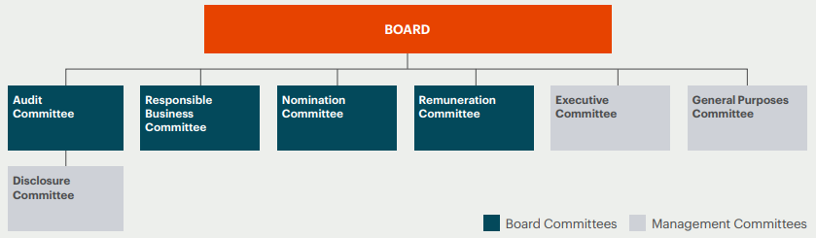
Source: IHG Governance, 2022
IHG's specialised internal divisions, including sales, marketing, operations, HR, and finance, promote efficient task distribution and knowledge sharing, contributing to the organisation's success (IHG Corporate Governance, 2024). The structure ensures effective communication and coordination globally.
Brand-specific groups manage IHG's global locations within a decentralised structure (IHG, 2024b). This allows IHG to maintain unified control over plans and guidelines while enabling brand teams to adapt to regional market demands quickly.
Decentralisation empowers hotel managers to make independent decisions, optimising performance and enhancing customer satisfaction (e.g., raising rates during high demand and offering discounts during off-peak periods). It enables local managers to drive operational excellence and effectively achieve business goals.

Organisational Culture
Organisational culture encompasses shared values, norms, beliefs, and behaviours that shape interactions and the work environment (Mullins, 2019). It influences employee attitudes, behaviours, and performance, crucial for organisational success and stability.
IHG aligns with the United Nations Global Compact (UNGC), committing to its principles on human rights, labour, environment, and anti-corruption (IHG Annual Report, 2023). Its culture emphasises business ethics, integrity, and responsibility, fostering mutual respect, diversity, and inclusion (IHG, 2024b). Internal rules ensure legal compliance and quality standards, promoting a professional, collaborative work environment. The HR policy prioritises employee satisfaction and includes initiatives like the "IHG Academy" Programme, offering training and development opportunities for disadvantaged youth and communities (IHG, 2024b).
IHG's commitment to human resource development is evident through its programme, promoting global employment access. With over 4,000 members and allies in 29 chapters worldwide, IHG celebrates the growth and impact of its Employee Resource Groups in fostering a culture of belonging and equality (IHG Progress Report, 2023). ERGs like BERG, SOMOS, DAWN, Hype, FAVE, EMbrace, and PATH support IHG's diverse and inclusive culture (see Appendix 3).
Organisational culture in the hotel industry greatly influences both employee and customer experiences. This involves training, recognition, open communication, and promoting values. A strong culture enhances employee and customer satisfaction, bolsters the hotel's position, and yields positive financial outcomes.

Organisational Goals and Commitments
Organisational goals and commitments are specific objectives and promises guiding actions and decisions toward desired outcomes (Robbins et al., 2017). Aligned with the mission, vision, and values, they serve as benchmarks for measuring short or long-term success and progress.
IHG underscores the importance of its actions to the world, recognising guests, owners, and investors as pivotal to its reputation (IHG Annual Report, 2023). The "Journey to Tomorrow" initiative outlines responsible business practises, extending commitments to 2030, prioritising support for IHG's people, communities, and the planet, aligning closely with UN Sustainable Development Goals and IHG's core mission of providing True Hospitality for Good (see Appendix 4).
IHG's organisational goals and commitments shape its operations and strategy: Guest Satisfaction, Employee Engagement, Brand Excellence, Environmental Stewardship, Community Engagement, and Ethical Business Practises. With a focus on environmental stewardship, IHG aims for a 46% reduction in carbon emissions by 2030. They plan for all new hotels to operate with minimal to zero emissions by that year and to phase out single-use items by adopting reusable or recyclable alternatives throughout guest stays (IHG Annual Report, 2023). Such goal-setting leads to financial savings, fulfils social responsibility, enhances employee engagement, and contributes to overall business success in the hotel industry.
Hotel objectives can be attained through practises, programmes, and process optimisation (Gagné, 2018). For instance, by 2025, Hotel X targets a 15% revenue increase and 5% customer satisfaction enhancement. This involves raising room occupancy, rates, and service revenue, gathering feedback, and improving services. Collaboration across all organisational levels is crucial to achieve these goals.

Impact of Recent Initiatives and Managing Change
Recent initiatives encompass new actions, strategies, projects, or policies to enhance performance or address specific issues (MAÇÃES et al., 2022). The hotel industry may include digital transformation, sustainability practises, health and safety protocols, personalised services, and innovative marketing strategies. Managing change involves methods and techniques to transition from the current state to a desired future state within an organizstion (Cameron and Green, 2019). This involves planning, implementing, and monitoring change in the hotel to ensure the successful integration of new initiatives and the achievement of organisational objectives.
The InterContinental Group implemented management initiatives for Sustainability Efforts, Diversity and Inclusion, and Community Engagement (see Table 1).
Table 1. The Impact of Recent Initiatives and Managing Change at IHG
Recent Initiatives | Sustainability Efforts | - Eco-Friendly Amenities  - IHG Green Engage
Recent Initiatives | Diversity and Inclusion | - Employee Resource Groups (ERGs)
Recent Initiatives | Community Engagement | - Philanthropic Initiatives  - IHG Foundation  - IHG Academy (IHG Corporate Responsibility, 2024)
Managing Change | Strategic Planning | - Journey to Tomorrow
Managing Change | Communication and Training | - Internal Communication  - Employee Training
Managing Change | Operational Adjustments | - Process Optimisation  - Feedback Mechanisms (Voegeli, 2021)
Impact on the Organisation | Environmental Impact  Employee Engagement  Guest Satisfaction  Community Relations
Source: Author Analysis
IHG's initiatives have reduced its environmental footprint, boosted employee engagement, increased guest satisfaction, and improved community relations, reflecting its commitment to sustainable growth and positive societal and environmental impact.
Under the InterContinental Hotels Group, Holiday Inn experienced significant organisational change failures in the late 1990s and early 2000s, falling behind industry standards and consumer preferences. To counter declining performance, IHG launched a $1 billion global rebranding in 2007 to modernise properties and enhance service (McLaughlin, 2023). However, the delayed response led to lost ground to competitors. Despite some improvements, Holiday Inn faces challenges in regaining its former market dominance.

Strategic Direction and Current Business Performance
Strategic planning entails analysing internal and external environments and identifying resources and gaps (Walker, 2021). The hotel sets its strategic direction based on market requirements and needs, anticipating future trends in the industry and adapting its strategies accordingly.
In 2023, the IHG strengthened its capacity to stimulate future growth by developing critical elements of its strategy, including growth-enhancing ambitions, strategic pillars, and behaviour (see Appendix 5). These changes are based on investments made in recent years to transform the business, expanding the portfolio from 11 to 19 brands and significantly strengthening the company (IHG Investor Presentation, 2024). These achievements include transforming the IHG One Rewards loyalty programme, the master brand update, new partnerships, an improved web and mobile offering, and the Journey to Tomorrow initiative focused on investing in people and sustainability.
IHG's core mission, "True Hospitality for Good," emphasises growth acceleration to become the preferred choice for guests and owners. The refined strategic pillars and new behaviours aim to cultivate a successful mindset and stimulate growth, building on past successes. IHG's strategy targets brand growth in high-value markets, creating value for all stakeholders and achieving sustained cash flow and profit growth for reinvestment and shareholder distribution (IHG Investor Presentation, 2024). Positioned to navigate the competitive hospitality landscape, IHG ensures long-term profitability and leadership through strategic market expansion, technological advancements, and sustainability.
A SWOT analysis offers insight into IHG's current strategic position, identifying areas for potential growth and challenges to address (see Table 2).
Table 2. IHG SWOT Analysis
Strengths | Weaknesses
Extensive Global Presence: Over 6,300 hotels and 946,000 guest rooms in 100+ countries;  Diverse Brand Portfolio: 19 brands catering to diverse guest needs globally;  IHG One Rewards: Major loyalty programme with over 130 million members;  Revenue Delivery: 80% from room revenue;  Commitment to Cleanliness: Enhanced protocols through IHG Way of Clean;  Sales Force: Large and effective global team;  Technological Investments: User-friendly, mobile-compatible branded websites;  System Fund: Annual fund for marketing and system maintenance (IHG, 2024c). | Dependency on Franchise and Management Fees: Heavy reliance may limit direct control over operations and quality;  Brand Dilution Risk: Managing many brands can dilute brand identity and confuse consumers;  Operational Challenges: Maintaining consistent service quality globally poses challenges;  High Competition: Pressure from other major hotel chains and alternative lodging options like Airbnb (Bastias, 2022).
Opportunities | Threats
Market Expansion: Targeting high-growth regions like Asia-Pacific and Africa for future expansion;  Sustainability Initiatives: Increasing focus on sustainability to attract eco-conscious travellers and enhance brand reputation;  Technological Advancements: Utilising AI and big data to enhance guest experience and operational efficiency;  M&A Opportunities: Strategic mergers and acquisitions to strengthen market position and brand portfolio;  Enhanced Customer Experience: Innovations in personalised services to improve guest satisfaction and loyalty (Stoimenov, 2023). | Economic Fluctuations: Downturns can reduce travel and tourism, affecting occupancy rates and revenue;  Geopolitical Risks: Political instability and regulatory shifts may disrupt operations and growth;  Health Crises: Pandemics can severely impact global travel and hotel occupancy rates;  Cybersecurity Risks: Rising threats jeopardise customer data security and operational integrity;  Environmental Regulations: Stringent laws may increase costs and require investments in sustainability (Alonso et al., 2020).
Source: Author Analysis
The company's strengths include a strong global brand, a diverse hotel portfolio, and partnerships. However, it faces challenges due to dependence on foreign markets and intense competition. There are opportunities to expand into emerging markets and diversify services, but it faces threats from economic fluctuations, regulations, and changing customer preferences. SWOT analysis can help IHG adjust its strategies to capitalise on opportunities and reduce risks.

Comparison with Competitors
IHG contends with competition from major players like Hyatt, Belmond Ltd., Marriott, Hilton, and Wyndham Worldwide Corp (Comparably, 2023). This diverse array of competitors spans various market segments and global regions, presenting a dynamic and challenging landscape for IHG.
The latest survey of Cmparably.com (2023) compares IHG with competitors across rankings like CEO, Product and Services, NPS, Pricing, Customer Service, Global Culture Score, eNPS, and Gender and Diversity Scores (see Appendix 6). 1,170 IHG employees and 6,851 customers provided feedback on the company's culture, evaluating elements from leadership to the work environment.
In 2023, 860 employees at IHG rated CEO Keith Barr 70 out of 100, placing him fourth behind Marriott's CEO Anthony Capuano. Customer ratings for IHG's product quality (3.6/5), pricing (3.5/5), and customer service (3.6/5) rank IHG fourth against its competitors, below Hilton. IHG's Net Promoter Score (17) ranks fifth, below Marriott. Employees rated IHG's overall culture 65/100, and employee net promoter score 0, ranking fourth. Gender and diversity scores were 60/100 and 61/100, respectively, ranking IHG fifth, below Wyndham Worldwide Corp.
This analysis underscores areas where IHG lags behind competitors, signalling opportunities for improvement. Lower rankings in customer satisfaction and employee experience indicate a need for IHG to address these aspects to bolster its competitive position. Moreover, the emphasis on gender and diversity scores underscores the necessity for more inclusive practises to enhance employee satisfaction.

Conclusion
In summary, IHG's competitiveness in the hospitality industry is influenced by its organisational structure, culture, goals, recent initiatives, and strategic direction. Its decentralised structure facilitates efficient communication and empowers local managers to prioritise customer satisfaction. IHG's commitment to values, ethics, and sustainability fosters a positive organisational culture, demonstrated through initiatives like the IHG Academy and Employee Resource Groups.
The organisation's strategy prioritises guest satisfaction, employee engagement, and environmental stewardship, aligning with its goals. Recent sustainability and diversity initiatives have improved IHG's ecological footprint and community relations. However, challenges like past organisational change failures and competition from industry leaders remain.
IHG's strategic direction prioritises growth acceleration and brand excellence, leveraging opportunities in emerging markets and technological advancements. Despite economic fluctuations, IHG aims to enhance customer experiences and address areas for improvement highlighted by competitor comparison, including customer satisfaction and diversity and inclusion. These efforts are crucial for IHG to sustain its competitive edge and achieve continued growth in the evolving hospitality industry.

Recommendations
Customer Experience Enhancement: IHG should prioritise enhancing customer satisfaction by improving product quality, pricing competitiveness, and customer service standards. Implementing feedback mechanisms and leveraging customer insights will refine offerings and elevate the guest experience.
Employee Engagement and Diversity: To improve lower rankings in employee culture and diversity scores, IHG should invest in initiatives to enhance employee engagement and provide opportunities for professional growth. This will boost employee satisfaction, improving guest experiences and overall organisational performance.

References
Alonso, A.D., Kok, S.K., Bressan, A., O’Shea, M., Sakellarios, N., Koresis, A., Solis, M.A.B. and Santoni, L.J. (2020) ‘COVID-19, aftermath, impacts, and hospitality firms: An international perspective’, International journal of hospitality management, 91, p.102654. Available at: https://www.sciencedirect.com/science/article/pii/S0278431920302061 (Accessed: 21 May 2024).
Bastias, R.D.F. (2022) Equity Research-InterContinental Hotels Group. Doctoral dissertation. Instituto Superior de Economia e Gestão. Available at: https://www.repository.utl.pt/bitstream/10400.5/26913/1/DM-RFB-2022.pdf (Accessed: 21 May 2024).
Cameron, E. and Green, M. (2019) Making sense of change management: A complete guide to the models, tools and techniques of organizational change. 5th edn. London: Kogan Page Publishers.
Comparably (2023) IHG Competitors [website]. Available at: https://www.comparably.com/companies/342644/competitors (Accessed: 21 May 2024).
Gagné, M. (2018) ‘From strategy to action: Transforming organizational goals into organizational behavior’, International Journal of Management Reviews, 20, pp. S83-S104. Available at: https://doi.org/10.1111/ijmr.12159 (Accessed: 20 May 2024).
IHG (2024a) About IHG. Available at: https://www.ihgplc.com/about-us (Accessed: 29 May 2024).
IHG (2024b) What we stand for: Our culture of Diversity, Equity and Inclusion. Available at: https://www.ihgplc.com/en/about-us/what-we-stand-for (Accessed: 15 May 2024).
IHG (2024c) Our Strategy. Available at: https://www.ihgplc.com/en/about-us/our-strategy#:~:text=Our%20strategy%20is%20to%20use,most%20valuable%20markets%20and%20segments. (Accessed: 21 May 2024).
IHG Annual Report (2023) Available at: https://www.ihgplc.com/~/media/Files/I/Ihg-Plc/investors/annual-report/2023/annual-report-2023.pdf (Accessed: 20 May 2024).
IHG Corporate Governance (2024) Available at: https://www.ihgplc.com/en/investors/corporate-governance (Accessed: 15 May 2024).
IHG Corporate Responsibility (2024) Responsible Business. Available at: https://www.ihg.com/content/gb/en/about/corporate-responsibility (Accessed: 17 May 2024).
IHG Governance (2022) Annual Report and Form 20-F 2022. Available at: https://www.ihgplc.com/~/media/Files/I/Ihg-Plc/investors/corporate-governance/governance.pdf (Accessed: 15 May 2024).
IHG Investor Presentation (2024) Available at: https://www.ihgplc.com/~/media/Files/I/Ihg-Plc/results/2024/Q1-trading-update/IHG%20Investor%20Deck%20May%202024.pdf (Accessed: 20 May 2024).
IHG Progress Report (2023) How we’re creating Room to Belong. Available at: https://admin-ihgcareers.stghavaspeople.com/media/3agndvov/2023-progress-report-jan-11-final.pdf (Accessed: 15 May 2024).
MAÇÃES, M., ALBERTO RAMOS and ROMÁN-PORTAS, M. (2022) ‘The effects of organizational communication, leadership, and employee commitment in organizational change in the hospitality sector’, Communication & Society, 35(2), pp.89-106. Available at: https://www.proquest.com/scholarly-journals/effects-organizational-communication-leadership/docview/2666602688/se-2?accountid=130472 (Accessed: 20 May 2024).
McLaughlin, J. (2023) ‘Unveiling the Holiday Inn Marketing Strategy’, Brand Credential. Available at: https://www.brandcredential.com/post/unveiling-the-holiday-inn-marketing-strategy (Accessed: 20 May 2024).
Mullins, L. (2019) Organisational Behaviour in the Workplace. 12th edn. Harlow: Pearson.
Mullins, L. and Dosser, P. (2013) Hospitality Management and Organisational Behaviour. 5th edn. Harlow: Pearson.
Robbins, S. P., Coulter, M., and DeCenzo, D. A. (2017) Fundamentals of Management: Management Myths Debunked! 10th edn. Harlow: Pearson.
Stoimenov, V. (2023) ‘GOOD PRACTICES IN HOTEL BRANDING–SUSTAINABILITY TRENDS OF INTERCONTINENTAL HOTEL GROUP’, Предприемачество, 11(1), pp.108-131. Available at: https://www.ceeol.com/search/article-detail?id=1117000 (Accessed: 21 May 2024).
Voegeli, C. (2021) ‘A Case Study of Knowledge Management Practices at the Intercontinental Hotels’ Group’, SSRN, 3819409. Available at: https://papers.ssrn.com/sol3/papers.cfm?abstract_id=3819409 (Accessed: 15 May 2024).
Walker, J.R. (2021) Introduction to hospitality. 8th edn. (Global Edition). Harlow: Pearson.

Appendices

Appendix 1: IHG Brands
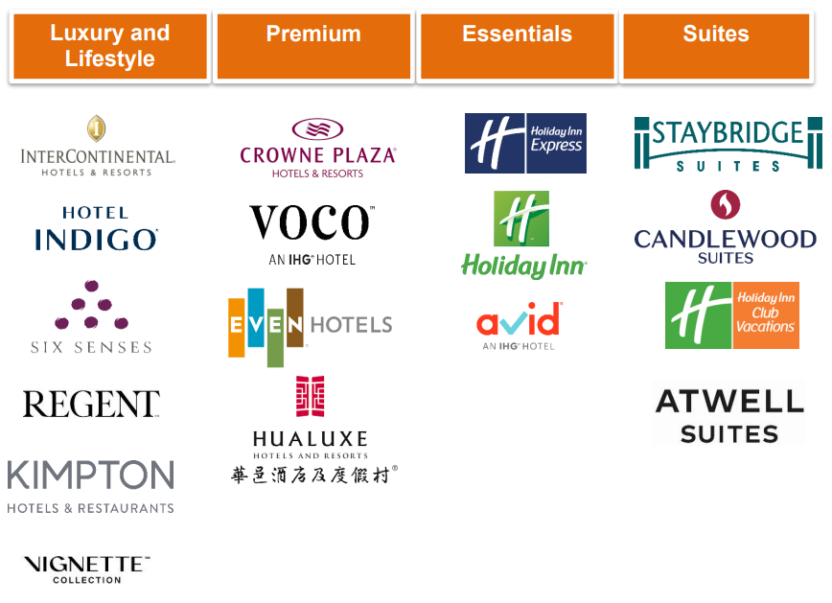
Source: IHG Annual Report, 2023

Appendix 2: IHG’s Boston Matrix Analysis
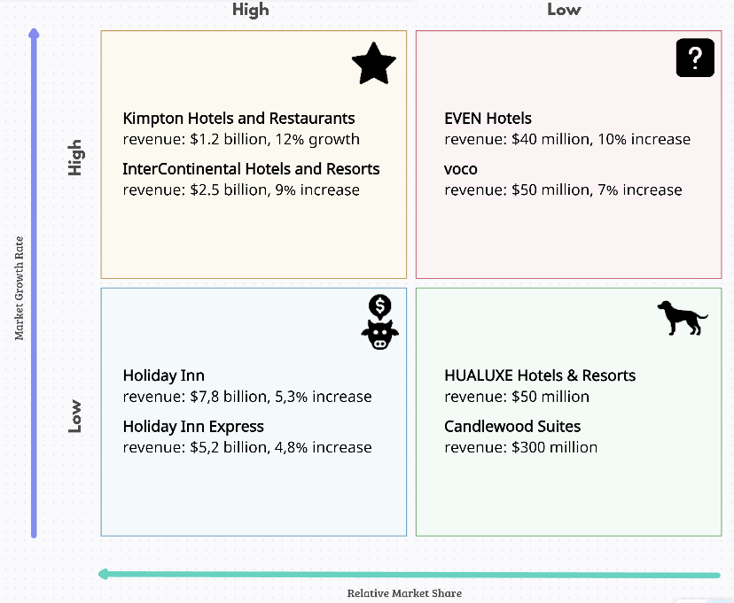
Source: Author Analysis based on
IHG Governance (2022) and IHG Annual Report (2023)

Appendix 3: IHG’s Supported Communities
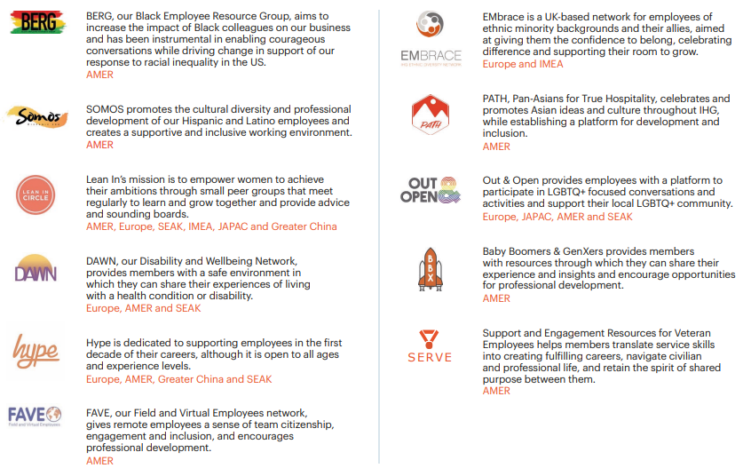
Source: IHG Progress Report, 2023

Appendix 4: IHG ESG Goals
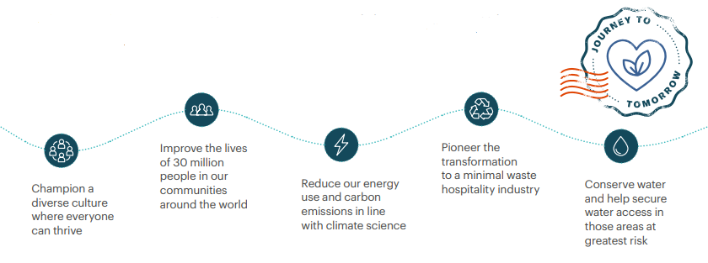
Source: IHG Annual Report, 2023

Appendix 5: IHG Strategy
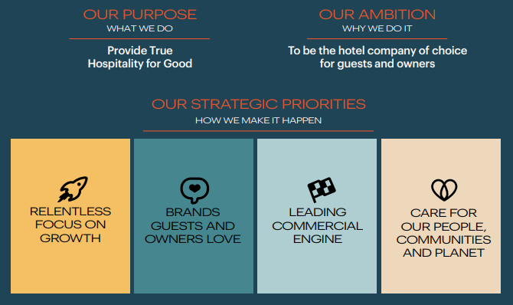
Source: IHG Investor Presentation, 2024

Appendix 6: IHG Competitors Comparison
Overall Culture Score | 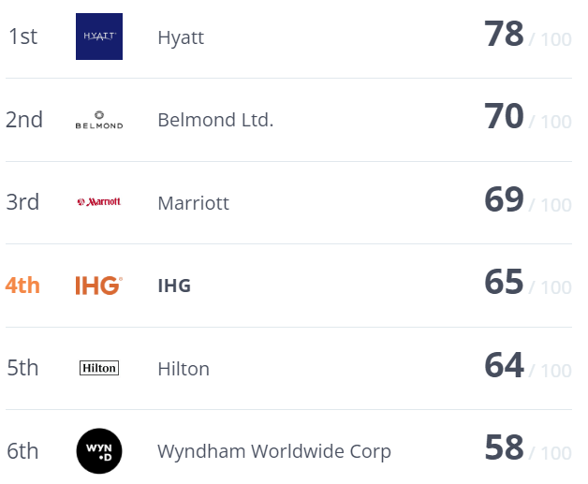
CEO Score | 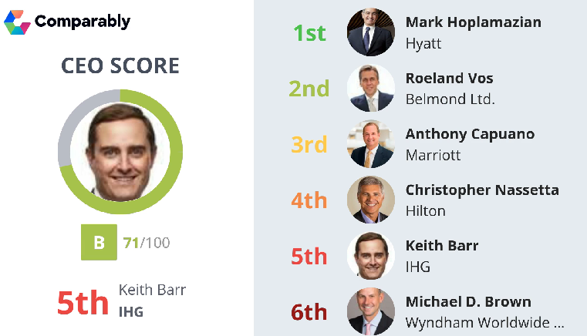
Product Quality Score | 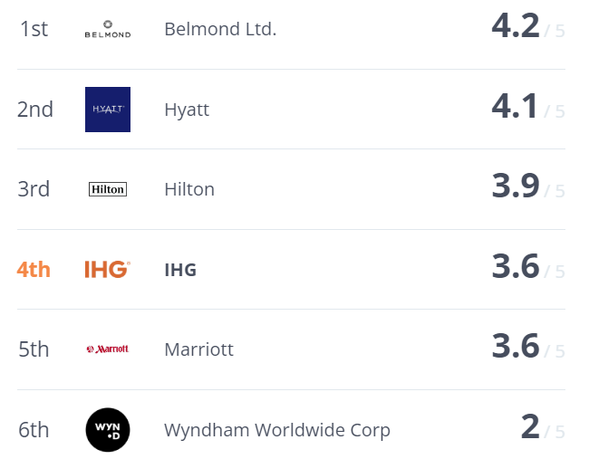
Net Promoter Score (NPS) | 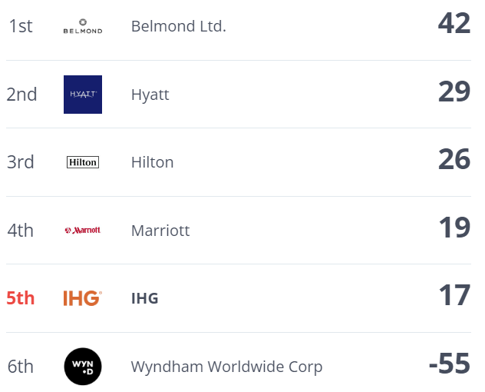
Pricing Score | 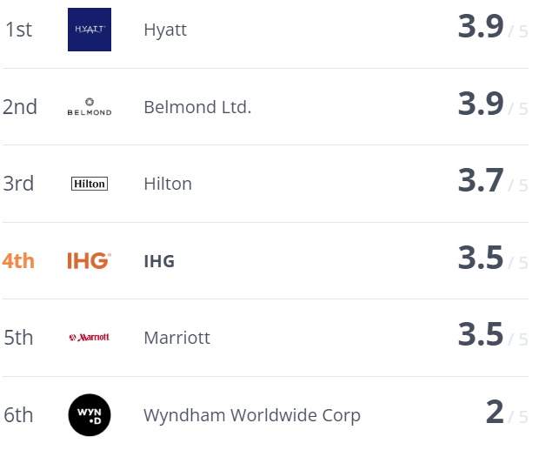
Customer Service | 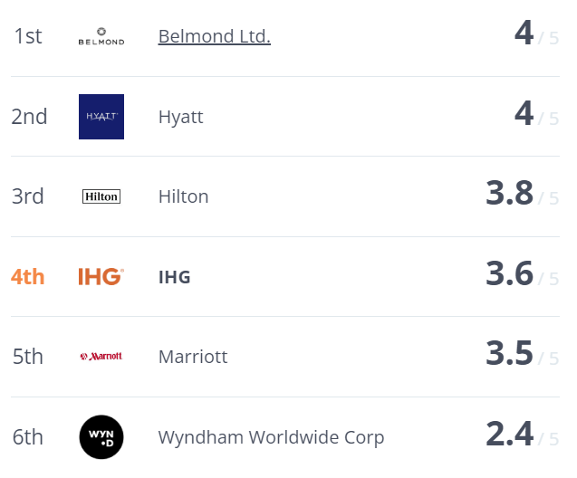
Employee Net Promoter Score  (eNPS) | 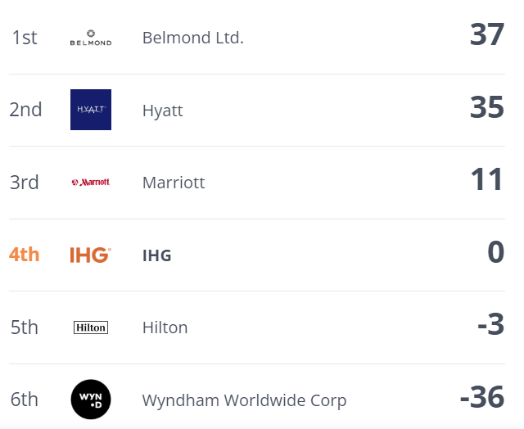
Gender Score | 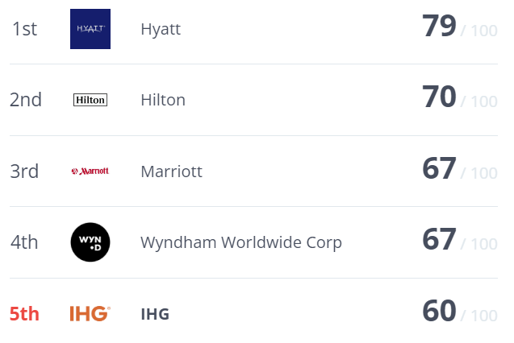
Diversity Score | 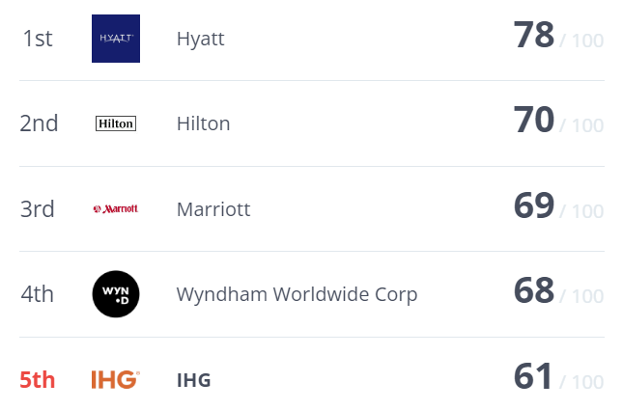
Source: Comparably, 2023

