

Cover Page

Task 1 – Personal Brand
Write about your own person brand and how you could develop this to enable you to reach your employment goals (250 words- Minimum of 2 referenced sources)
A personal brand is the professional image and reputation that an individual presents to others. It reflects a person’s values, skills behaviours and the unique qualities they bring to a role. Developing a strong personal brand is important because it helps employers understand the value that an individual can contribute to an organisation and supports long-term career development (Montoya and Vandehey, 2008).
My current brand is built around compassion, resilience, professionalism and organisation. As student and a part time support worker, I regularly demonstrate these qualities when supporting individuals with diverse needs. Colleagues and service users often describe me as friendly, reliable and hardworking, which reinforces my professional reputation. I believe these strengths align well with my long-term goal of becoming a social worker, where empathy, trust and effective communication are essential. Furthermore, my ability to remain organised and professional helps me manage responsibilities effectively while balancing work and study commitments.
However, there several areas of my personal brand that I would like to strengthen. I would like to improve my digital skills to meet the increasing use of technology within social care practice. I also aim to develop my public speaking, leadership and decision-making abilities to increase my confidence in professional settings. Creating a Linkedin profile and engaging with professional networks would further enhance visibility and employability. Developing these skills will help me become a more confident and effective practitioner and support my progression towards a career in social work.
In conclusion, continually developing my personal brand will improve my employability and professional identity. By building on my strengths and addressing areas for development, I will be better prepared to achieve my career goal of becoming a successful social worker.

Task 2 - Network Map and Rationale
Create a map of your own network considering career, support, social and community dimensions. Additionally you should provide a supporting rationale explaining and critically assessing this (250 words-Minimum of 2 referenced sources).

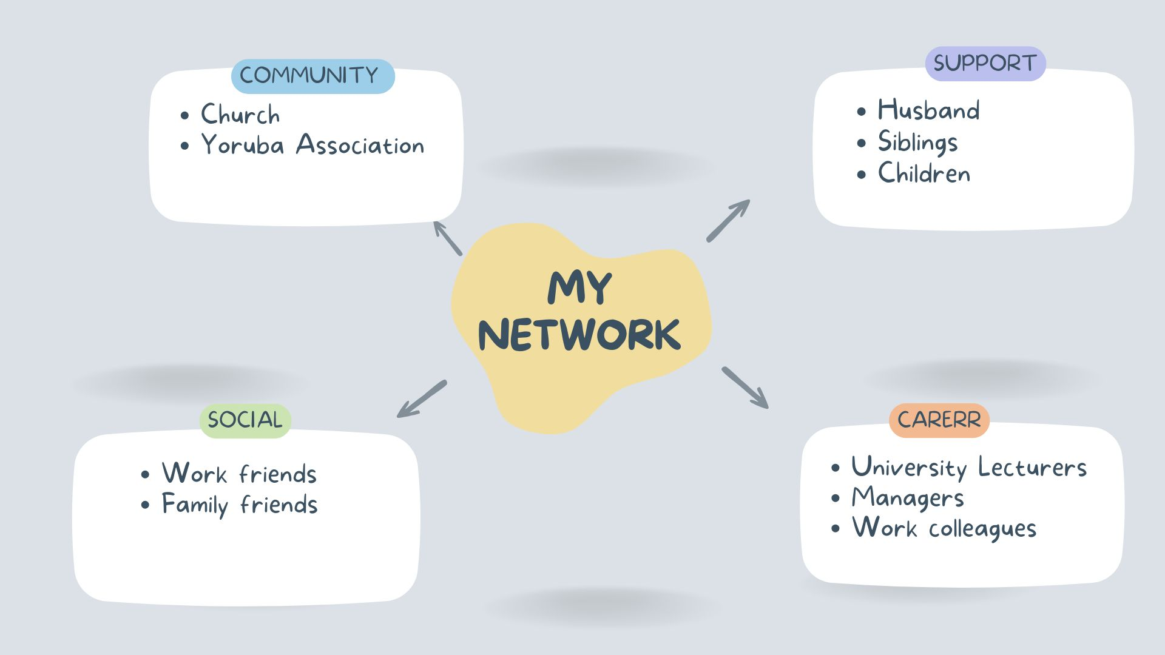

After reflecting on my network, I believe I have a hybrid network. My network consists of a combination of close personal relationships, professional contacts and community connections. The largest part of my network is made up of family members, which reflects my strong support system. I also maintain relationships with university lectures, work colleagues and my manager, who contribute to my professional development. In addition, my involvement in my church and the Yoruba Association provides opportunities for engagement and social interaction.
A key strength of my network is the strong bonding social capital that I have through my husband, siblings, children and extended family. These relationships provide emotional support, encouragement and practical assistance. However, there are weaknesses within my network. Although I have some bridging social capital through university and work, I have limited connections with professionals outside my immediate environment. Furthermore, my linking social capital is relatively weak because I don’t currently have a mentor, professional social work contacts or membership in professional organisations.
To strengthen my network, I need to build relationships with qualified social workers, seek mentorship opportunities and join professional networking platforms such as LinkedIn, I would also benefit from attending professional events and engaging with social work organisations. According to Putnam (2000), social networks can create valuable social capital that supports personal and professional development. Developing a broader network will improve my access to knowledge opportunities and career guidance, helping me achieve my goal of becoming a social worker.

Task 3- Blog
Write a blog exploring a current topic or issue of your choice within the health and social care sector in the UK. The purpose of this is to inform a specific target audience of your choosing (400 words) Referencing of your sources of information is not a compulsory requirement but could be beneficial.
Social Media and Young People’s Mental Health: What Health and Social Care Professionals Need to Know.
Social media has become a central part of young people's lives. Platforms such as TikTok, Instagram, Snapchat and X provide opportunities for communication, self-expression and access to information. While social media can have positive effects, growing concerns remain about its impact on the mental health and wellbeing of young people in the UK.
Research suggests that excessive social media use can contribute to anxiety, depression, low self-esteem and poor body image among young people. Constant exposure to idealised comparisons and feelings of inadequacy. In addition, cyberbullying and online harassment continue to be significant risks, with some young people experiencing emotional distress that affects their daily lives and relationships.
However social media is not entirely negative. Many young people use online platforms to access mental health information, seek support and connect with others who share similar experiences. Online communities can help reduce feelings of isolation, particularly for young people who may struggle to access support in person.
Health and social care professionals working with young people have an important role in promoting in promoting safe and responsible social media use. Practitioners should encourage open conversations about online experiences and help young people develop digital resilience. This includes recognising harmful content, understanding privacy settings and balancing screen tine with offline activities. Professional should also be alert to signs that social media may be negatively affecting a young person’s mental health and provide appropriate support or referrals when necessary.
As technology continues to evolve, understanding the relationship between social media and mental health is becoming increasingly important. By working collaboratively with young people, families and educational settings, health and social care professionals can help maximise the benefits of social media while reducing potential risks, supporting young people to use digital platforms safely can contribute to better mental health outcome and overall wellbeing.
Task 4- NHS Equality, Diversity and Inclusion Quiz (250 words equivalent)
- What is the primary goal of the NHS Equality, Diversity, and Inclusion Improvement Plan?
(Answer in one or two sentences.)
The primary goal is to create a fair, inclusive and supportive working environment where all NHS staff are valued and have equal opportunities to succeed regardless of their background

- How does the NHS EDI Improvement Plan propose to tackle the gender pay gap?
(Answer in one to two sentences.)
The plan aims to improve transparency, monitor workforce data and promote equitable recruitment, development and progression opportunities for all staff.

- What is meant by the term ‘intersectionality’ as used in the NHS EDI Improvement Plan?
(Answer in one to two sentences.)
Intersectionality refers to how different aspects of a person’s identity, such as race, gender and disability, can combine to create unique experiences of discriminations or disadvantage.

- Why is it important for the NHS to create a psychologically safe work environment?
(Answer in one to two sentences.)
A psychologically safe environment encourages staff to speak up , share concerns and contribute ideas without fear of blame, discrimination and unfair treatment.

- How does the NHS EDI Improvement Plan suggest improving the experience of internationally recruited staff?
(Answer in one to two sentences.
The plan recommends providing better induction, pastoral support, career development opportunities and measures to address discrimination and unfair treatment.

- What role does leadership play in advancing EDI objectives according to the NHS Improvement Plan?
(Answer in one to two sentences.)
Leaders are responsible for promoting inclusive culture, modelling positive behaviours and ensuring that EDI objectives are embedded throughout the organisation

- Identify one way the NHS EDI Improvement Plan aims to reduce health inequalities within the workforce.
(Answer in one to two sentences.)
One approach is improving access to health and wellbeing support for staff from underrepresented or disadvantaged groups.

- Why does the NHS EDI Improvement Plan emphasise the importance of collecting and analysing data on protected characteristics?
(Answer in one to two sentences.)
Collecting and analysing data helps identify inequalities, monitor progress and ensure that interventions are targeted effectively.

- Explain how flexible working policies can contribute to equality and inclusion in the NHS workforce.
(Answer in one to two sentences.)
Flexible working enables staff to balance work with personal responsibilities, making employment more accessible for people with different need and circumstances.

- What is one strategy mentioned in the NHS EDI Improvement Plan to combat bullying and harassment in the workplace?
(Answer in one to two sentences.)
One strategy is strengthening reporting mechanisms and ensuring that incidents of bullying and harassment are addressed promptly and fairly.

Task 5- A Letter to Yourself
Think of a time in the past when you may have been experiencing issues or difficulties, and after considering what you have learned in this module about emotional intelligence and resilience write a letter to your younger self explaining how these attributes were important at that time and perhaps how developing these areas could have been useful (300 words)

Dear 28-Year-Old Me,
I know this is one of the hardest times in your life. You have just moved from Nigeria to the UK with your husband and your two-year-old daughter, leaving behind the comfort of your extended family, friends and everything familiar. It is understandable that you feel lonely, overwhelmed and uncertain about your new environment. Remember that these feelings are temporary and it is okay to ask for help.

If I could give you one piece of advice, it would be to trust yourself and be patient.
Emotional intelligence will help you recognise and accept your emotions instead of feeling guilty for them. Being self-aware will allow you to understand that homesickness and loneliness are normal responses to such a significant life change. Learning to manage these emotions will help you focus on building a new life rather than dwelling on what you have left behind.

Resilience will become one of your greatest strengths. Every challenge you face, whether it is adjusting to different culture, making new friends or balancing family responsibilities, will make you stronger. Instead of isolating yourself, take small steps to build connections through your church, local community and other families. These relationships will provide encouragement and remind you that you are not alone.

Most importantly, be kid to yourself. You do not have to adapt overnight, and you do not have to be perfect. The experiences you are living through now will shape you into a compassionate, resilient and empathetic person, They will also inspire your ambition to become a social worker who understands the emotional and practical challenges people face when starting over in a new country.

Keep believing in yourself. One day, you will look back on this chapter with pride, knowing that every helped you become the strong woman you are today.

Task 6- GANTT Chart (200 words equivalent)
Compile a Gantt chart which illustrates the tasks you have to complete to achieve your future employment goals
Becoming a Social Worker
- Complete Level 5 Health and Social Care qualification – July 2026
- Complete Level 6 Health and Social Care qualification – July 2027
- Continue gaining experience as a support worker- July 2026 to July 2027
- Develop digital skills – July 2026 and ongoing
- Improve leadership and decision-making skills – July 2027
- Create and maintain a LinkedIn profile - July 2026 and ongoing
- Attend networking events and career fairs – July 2027 and beyond
- Find a mentor in social work – July 2027 to July 2028
- Complete social work social work qualification/ placement July 2028- 2029
- Apply for social worker roles – 2028- 2029
- Prepare for interviews
Dependencies:
Level 6 Coursework includes Social Work Placements.
HCPC Registration is necessary before applying for Social Worker Positions.
Visualisation:
The Gantt chart will display the continuous process from Level 5 Coursework to Level 6, including Placements and steps leading to a Social Worker role.

Task 7- Making Changes- Report
You are the manager of a care home and want to make changes your workplace. Identify one specific change that you want to implement and write a brief report on how this is going to be achieved considering the necessary skills needed and addressing possible barriers to success. Relevant change models can be highlighted (350 words Minimum of - 3 referenced sources).
Implementing a Staff Wellbeing Programme to Reduce in a Care Home
As a manager of a care home, I have identified staff burnout as a significant issue that can negatively affect employee wellbeing, job satisfaction and the quality of care provided to residents. Care home staff often work long hours, manage demanding workloads and provide emotional support to residents, which can increase stress and risk burnout. To this address this I propose introducing a comprehensive staff wellbeing programme aimed at improving staff morale, reducing stress and promoting a healthier working environment.
The staff wellbeing programme will include monthly wellbeing meetings, access to mental health support, flexible working arrangements where possible, and a staff recognition scheme to reward good performance. Regular wellbeing surveys will also be introduced to gather staff feedback and identify areas requiring improvement. The programme will encourage open communication and ensures employees feel valued and supported
To implement this change, I would use Kotter’s Eight-Step Change Model (Kotter,1996) The first step is creating a sense of urgency by presenting evidence on the impact of burnout on staff retention and resident care. A leadership team would then be formed to champion the initiative and communicate a clear vision for improving staff wellbeing. Staff would be involved throughout the process by contributing ideas and providing feedback, helping to create ownership of the change. Short-term successes, such as improved staff satisfaction and reduced sickness absence, would be celebrated to maintain motivation before embedding the programme into everyday practice.
As the manager, I would need to listen to staff to staff concerns, motivate the team and encourage collaboration throughout the implementation process. Good problem-solving skills would also be essential when responding to challenges and adapting the programme where necessary.
A main barrier may be resistance to change, with some staff believing the programme will increase their workload or have little impact. Financial constraints and staffing shortages may also limit the resources available to implement new initiatives. These barriers can be reduced by involving staff in decision-making, communicating the benefits of the programme clearly and introducing the changes gradually. Monitoring staff wellbeing through regular surveys and supervision sessions will ensure the programme remains effective and responsive to staff needs
Introducing a staff wellbeing programme would create a healthier and more supportive working environment, helping to reduce burnout and improve staff retention. In turn, a motivated and resilient workforce is more likely to provide high-quality person-centred care for resident. By developing effective leadership and communication strategies, the proposed change can be implemented successfully and sustained over the long term.

Reference List
Keles, B., McCrae, N. and Grealish, A. (2020) ‘A systematic review: The influence of social media on depression, anxiety and psychological distress in adolescents’, International Journal of Adolescence and Youth, 25(1), pp. 79–93.
Kotter, J.P. (1996) Leading Change. Boston, MA: Harvard Business School Press.
Lin, N. (2001) Social Capital: A Theory of Social Structure and Action. Cambridge: Cambridge University Press.
Maslach, C. and Leiter, M.P. (2016) ‘Burnout: A Multidimensional Perspective’. In: Cooper, C.L. and Quick, J.C. (eds.) The Handbook of Stress and Health. Chichester: John Wiley & Sons.
Montoya, P. and Vandehey, T. (2008) The Brand Called You: Make Your Business Stand Out in a Crowded Marketplace. 2nd edn. New York: McGraw-Hill.
Putnam, R.D. (2000) Bowling Alone: The Collapse and Revival of American Community. New York: Simon & Schuster.
Royal Society for Public Health (2017) #StatusofMind: Social Media and Young People's Mental Health and Wellbeing. London: RSPH.
Shepherd, I.D.H. (2005) ‘From Cattle and Coke to Charlie: Meeting the Challenge of Self Marketing and Personal Branding’, Journal of Marketing Management, 21(5–6), pp. 589–606.
Skills for Care (2023) The State of the Adult Social Care Sector and Workforce in England. Leeds: Skills for Care.

