2020
City Books Data
User manual
Edward Patch (1801492)
Table of Contents
1. Setting Up 2
2. User Interfaces 2
2.1. Main Board 2
2.1.1. Navigation and Form Tools 3
2.1.2. Form Errors and Fixes 3
3. Data Management 4
3.1. Staff 4
3.1.1. Transactions 4
3.1.2. Customer Register 5
3.1.3. Book Register 5
3.2. Administration 6
3.2.1. Supplier Register 6
3.2.2. Staff Register 6
4. Informational 6
4.1. Access Reports 6
4.2. Access Queries 6

Setting Up
Open the Microsoft Access software. Click on open and find the pinned Bookstore database as shown in the screenshot below.

Once the database has loaded, click on the frmMainBoard form as shown in the screenshot below.
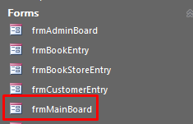
The City Book Store database is ready to use.

User Interfaces

Main Board
The Main Board controls the whole database. The sales tab is specifically for floor staff use. Whereas, the administration tab is for management staff. The close database tab closes the database, which serves a purpose on store closing times.
The sales section controls transactions, customer information and book stock.
The administration section controls staff, supplier and book store management.
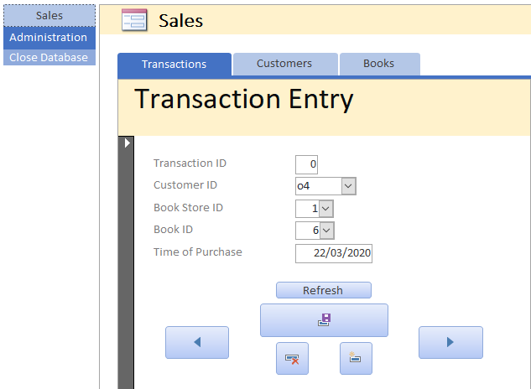

Navigation and Form Tools

Navigation
Each form has navigation tools to move from record to record. A set of arrow buttons are used to navigate forms. The floppy disk symbol would save the record. The red x will remove a record and the yellow * will create a new record.
When entering a new record, the user must enter a new ID for each record.

Form Errors and Fixes
Whenever there is a refresh button on a form, it is important to remember, after saving the form, the refresh button is clicked. This will update queries to prevent any errors in the future.
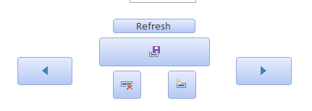

Data Management

Staff

Transactions
When handling transactions, enter a unique transaction ID and then ask for the customers first name and last name. The customer ID dropdown will display customers that have already signed up. If the customer is not in the database, navigate to the customer tab and record their information, refer to 3.1.2 Customer Register (Page 5).
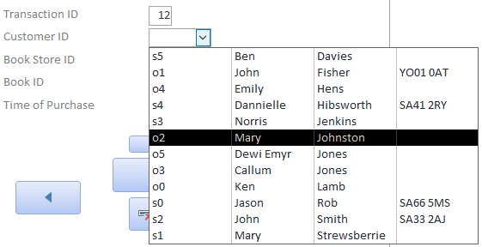
After the Customer ID has been selected, choose the book store ID, it will never be online as online customers are handled on an automated system.
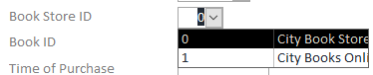
Next, find the book ID. The product should be recorded, if not, the book has already been sold.
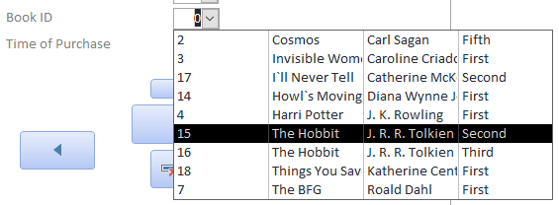
For the time of purchase, choose today. Save, refresh and the transaction has successfully been processed.
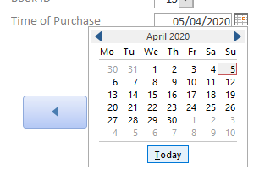

Customer Register
When registering a customer make sure to enter the unique ID as s2, s3 etc. The s indicates that the customer has registered via the store. The book store ID will also be a store.
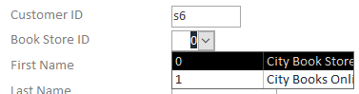
Fill the customer information out and save. The customer is now available to make a transaction.
Note: DO NOT ENTER ADDRESS UNLESS THE CUSTOMER IS ON THE MAILING LIST.
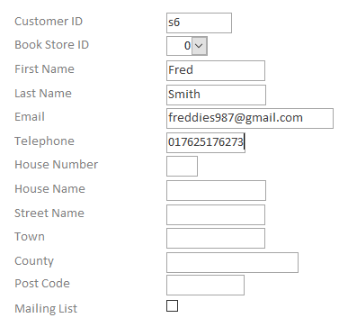

Book Register
The book register requires a unique book ID. When choosing the book store ID, select where the book is stored. The online store will store books that are available from third party suppliers, otherwise, physical copies will be stored in a book store.
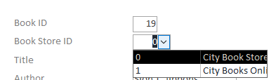
Enter the title, author and edition of the book. The checkbox should be ticked if the book is Welsh. Save and continue.
Note: Books with the same author, title and edition can be added again with a unique ID. Never add the same copy of the book twice. Once a book is sold, the book becomes unavailable but will remain in the database.
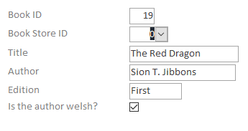

Administration

Supplier Register
When filling out the supplier register, a unique supplier ID should be assigned. The supplier requires a name, telephone number, email address and building’s address.
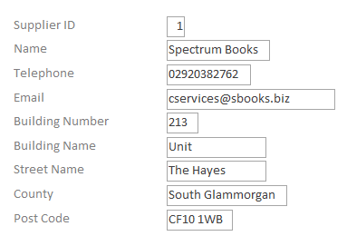

Staff Register
The staff register requires a unique staff ID. The staff can be placed at different stores, the online store is for staff that handle the online store like stock and offers. The online store works by using the database, to track available stocks, with no extra work necessary.
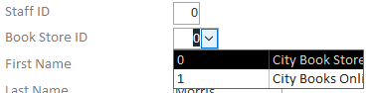
Enter the first name, last name, telephone, email and role of the staff member. Once the fields have been entered save and continue.
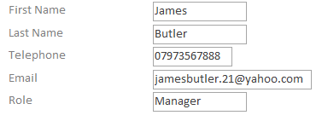

Book Store Register
When registering a new book store, a unique ID and a supplier ID is required. The supplier ID can be found by selecting the drop-down and selecting the supplier’s name.
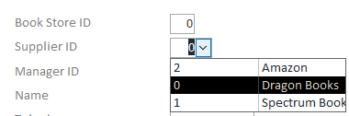
The manager ID assigns a staff manager to the selected store. The drop-down box shows only available managers. To refresh the list, press refresh and open the drop-down again.
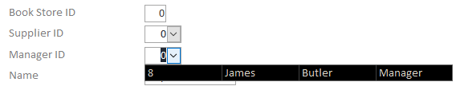
Before:
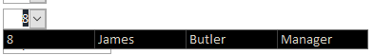
After:
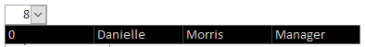
The book store fields require the name, telephone, email address and building address of the store.
Note: If the store has no physical address, keep blank.
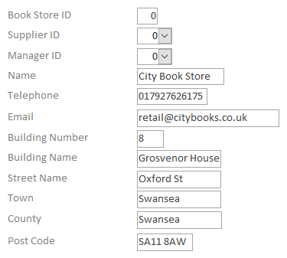

Informational

Access Reports
Administrative teams can access reports via the Administration, Reports tab.
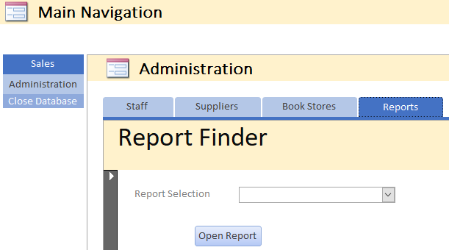
To browse reports, click the report selection’s drop-down menu. Once a report is picked, click open report. The chosen report should open.
Action 1:
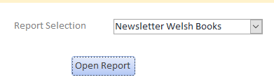
Action 2:

Note: If any errors occur then try to open frmReportFinder directly, and try again.

Access Queries
Administrative teams can access queries by browsing on the left navigation menu, the Microsoft Access package offers. SQL can be a good place to look for already made codes, which can be applied for external access for the database. The image shows how to find queries.
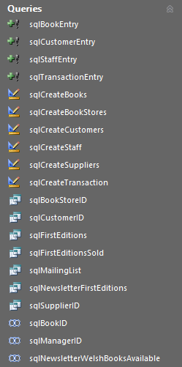
All SQL scripts use the naming convention sql_.
Note: Tables/data cannot be duplicated. However, the SQL code can be manipulated and changed for future development.

